

**A Mini Project Report on**

**COLLEGE MANAGEMENT SYSTEM**

***Submitted by***

**D SUMANTH SHREYAS N**

**USN: 16MCAL4064 USN: 16MCAL4066**

**VENKAT PANI RANGARAJA R**

**USN: 16MCAL4067**

***in partial fulfillment of the IV Semester***

***Of***

**MASTER OF COMPUTER APPLICATIONS**

**(Specialization - Storage and Cloud Technology)**

**DEPARTMENT OF COMPUTER SCIENCE & IT**

**JAIN UNIVERSITY**

**BANGALORE- 560069.**

**MAY- 2018**



**DEPARTMENT OF COMPUTER SCIENCE & IT**

**JAIN UNIVERSITY**

**BANGALORE- 560069**

**MINI PROJECT WORK**

**MAY 2018**

This is to certify that the mini project entitled

**COLLEGE MANAGEMENT SYSTEM**

is the bonafide record of mini project work done by

**D SUMANTH SHREYAS N**

**USN: 16MCAL4064 USN: 16MCAL4066**

**VENKAT PANI RANGARAJA R**

**USN: 16MCAL4067**

during IV semester MCA (DECEMBER 2017 – MAY 2018)

**Project Guide Head**

**Mr.** **Pankaj Kumar Prof. M. N. Nachappa**

**Assistant Professor, Dept. of Computer Science & IT**

**Department of MCA**



**Department of MCA**

**CERTIFICATE**

This is to certify that the mini project work entitled **“COLLEGE MANAGEMENT SYSTEM”** is a bonafide work carried out by **D SUMANTH (16MCAL4064), SHREYAS N (16MCAL4066), VENKAT PANI RANGARAJA R (16MCAL4064)** in partial fulfillment of **Master of Computer Applications (Specialization - Storage and Cloud Technology)**, **Jain University, Bangalore** during the IV Semester. The mini project report has been approved as it satisfies the academic requirements in respect of the mini project work prescribed by Jain University in partial fulfillment of IV Semester of Master of Computer Applications.

**Project Guide Head**

**Dept. of Computer Science & IT**

**Name of the Examiners Signature with Date**

**1)……………………… …………………..**

**2)……………………… ……………………**

**DECLARATION**

I affirm that the mini project work titled “**COLLEGE MANAGEMENT SYSTEM**” being submitted in partial fulfillment of IV Semester of **MCA Specialization - Storage and Cloud Technology** is the original work carried out by me. It has not formed the part of any other project work submitted for award of any degree or diploma, either in this or any other University.

**Name of the Student:**

**USN: 16MCAL4064**

**Name of the Student:**

**USN: 16MCAL4066**

**Name of the Student:**

**USN: 16MCAL4067**

**ACKNOWLEDGEMENT**

It is not the completion of the project that is most important but more so, the interaction of roles played by various people in the satisfactory completion. I take this opportunity to express my deep gratitude and appreciation of all those who encouraged me to successfully complete the project.

With profound sense of gratitude and regards, I acknowledge with great pleasure the guidance and support extended **by**, I thank **Dr. Eshwaran Iyer,** Dean, Jain Knowledge Campus, Bangalore, **Dr. B.A Vasu,** Center Head, Jain Knowledge Campus Bangalore, **Prof.M. N. Nachappa,** Head, Department of Computer Science & IT, Bangalore for their interest & encouragement throughout the project

I would like to express my deep sense of gratitude to my Guide **Mr.** **Pankaj Kumar, Assistant Professor, Department of MCA, Jain University, Bangalore** for his accomplishment and valuable information, direction and sense of perfection to work. He had been main source of inspiration for completion of work and strengthening confidence.

I would also thank my parents for their understanding & encouragement, Department Staffs, teaching and non-teaching, my friends, one and all those who helped me to complete this project successfully

**D SUMANTH (16MCAL4064)**

**SHREYAS N (16MCAL4066)**

**VENKAT PANI RANGARAJA R (16MCAL4067)**

**ABSTRACT**

The College Management System is software application which is built to automate a college's basic functionalities like attendance calculation, marks calculation and other activities involved in school college to proposed calendar. This application can help us to explore all the activities happening inside the college. There are mainly three users in this project like admin, teachers and students. Administrator is responsible for managing the teachers and students record for the school. Teachers will look after the student’s assessments of the respective class. Students can view their assessments that are uploaded periodically.

It has an automated feature that tracks and manages the multiple leaves of an employee. Employees can submit the leave, view the leave balance and check the status of the leave after the leave has been applied. This application eliminates the time consumed for applying the leave and helps the employees in utilizing the time into productive work.

And it also provides details of events, which gone be conducted in a college. so that user can get complete details of an event through online itself and the user can book an event easily through online process.

**TABLE OF CONTENTS**

|  |  |  |
| --- | --- | --- |
| Sl. No. | CONTENTS | Page No. |
|  | INTRODUCTION |  |
|  | OBJECTIVES OF THE PROJECT |  |
|  | SYNOPSIS |  |
|  | HARDWARE AND SOFTWARE REQUIREMENTS |  |
|  | FEATURES OF EXISTING APPLICATION/ ENVIRONMENT |  |
|  | FEATURES OF PROPOSED APPLICATION/ ENVIRONMENT |  |
|  | FRONT END LANGUAGES AND VERSION |  |
|  | BACK END TOOLS AND VERSION |  |
|  | FLOW CHART and E R DIAGRAM |  |
|  | TABLE DESIGN |  |
|  | FRONT END SCREEN (SCREEN SHOT) |  |
|  | CODING |  |
|  | TEST CASE |  |
|  | CONCLUSION |  |
|  | BIBLIOGRAPHY / REFERENCES |  |

**LIST OF FIGURES**

|  |  |  |
| --- | --- | --- |
| Sl. No. | NAME OF THE FIGURE | Page No. |
| Figure 9.1 | Context Diagram |  |
| Figure 9.2 | Use case Diagram |  |
| Figure 9.3.1 | Activity diagram of admin |  |
| Figure 9.3.2 | Activity diagram of Teacher |  |
| Figure 9.3.3 | Activity diagram of Student |  |
| Figure 9.4 | E R Diagram |  |
| Figure 9.5 | Conceptual Schema |  |
| Figure 11.1 | Home Screen |  |
| Figure 11.2 | Admin Home Screen |  |
| Figure 11.3 | Student Registration Screen |  |
| Figure 11.4 | Teacher Registration Screen |  |
| Figure 11.5 | View all Teacher |  |
| Figure 11.6 | Add Event |  |
| Figure 11.7 | Student Home Screen |  |
| Figure 11.8 | View Attendance |  |
| Figure 11.9 | View Result |  |
| Figure 11.10 | View Event |  |
| Figure 11.11 | Register for an event |  |
| Figure 11.12 | Teacher Home screen |  |
| Figure 11.13 | View result and attendance |  |
| Figure 11.14 | View attendance based on criteria |  |
| Figure 11.15 | Add result and attendance |  |
| Figure 11.16 | Teacher pannel |  |
| Figure 11.17 | Leave application Status |  |
| Figure 11.18 | Hod Pannel |  |

**LIST OF TABLES**

|  |  |  |
| --- | --- | --- |
| Sl. No. | NAME OF THE TABLE | Page No. |
| Table. 10.1 | Teacher table |  |
| Table. 10.2 | Attendance table |  |
| Table. 10.3 | Student table |  |
| Table. 10.4 | Booking table |  |
| Table. 10.5 | Exam_results table |  |
| Table. 10.6 | Event_ad table |  |
| Table. 10.7 | Employee table |  |
| Table. 10.8 | Leave_master table |  |
| Table. 10.9 | Leave_transaction |  |
| Table. 13.1 | Login Testcase |  |
| Table. 13.2 | Add student/teacher Testcase |  |
| Table. 13.3 | Add event Testcase |  |
| Table. 13.4 | Leave balance Testcase |  |
| Table. 13.5 | Adding marks Testcase |  |
| Table. 13.6 | Adding attendance Testcase |  |
| Table. 13.7 | Logout Testcase |  |

**1. INTRODUCTION**

The advancement in technology is growing rapidly and people are adapting the software in their daily basis. A software environment is absolutely necessary for a college to improve its operations that are carried by the college in their academic year which helps in creating a common platform for all the college related users.

College Management System is developed so that the requirements of the college operations are met. The main intent of this project is to develop a software solution for managing different type of tasks like providing a full detail of the student’s attendance status and result, in which the application allows the students to view their status online. This application also allows the teacher to apply/view their leaves online and provides the details of the events that are going to be conducted in the college. It reduces the complexity involved in the current system.

College Management System helps the students and parents can view their attendance, exam results and event details that are conducted by the college. The periodic assessment is uploaded by the respective class teacher. With this information it helps the parents to keep a record on their student’s assessment.

The class teacher will upload the marks of the subjects and the software helps to calculate the grade for that specified range of marks and also makes the work easier for the teacher in order to validate whether a student is eligible to write an exam according to the student’s attendance.

The main functions of admin are adding students and teachers to the system, creating and managing events. Admin take care of entire responsibility of the event. the admin will be able to do the following. Adding student, adding teachers, Adding Event, Registration, Feedback.

This application also allows the teacher to apply/view their leaves status online by logging on in a management section. Admin login is mainly used for teacher’s registration. Teacher login enables the employee to apply leaves, view the leave balance and check for the leave status after the leave application has been sent. The HOD login is for the chairperson who logs in to find the employee’s leaves who views the employee’s details and then approves/rejects the leave application from that particular employee. The chairperson can also view the history of Approved/Rejected leaves.

College Management System keeps track of all the leaves pertaining to a particular employee and also calculates the leave balance of each employee. Hence, each employee can view how many leaves are left to apply before applying the leave.

1. **OBJECTIVE OF THE PROJECT**

The main purpose of this project is to reduce the complexity that is involved in a college operations or tasks.

Salient features of this software are as follows:

* Administrator can manage the users by maintaining the records of the students and teachers and managing their provided details.
* Teacher assigned to the class makes his/her work more easily as some major calculations that has to be done to the current periodical assessments.
* The system keeps track of multiple sorts of leaves and allows the teacher to request leave via the online and check their leave balances.
* Student or the parent can view his assessment and events that are going to be conducted in a college with ease by just logging in to their respective profile.

**SCOPE**

This application is developed mainly so that it can be used by any organization that has the concept of college management.

* This online platform can be used by students and parents to view the assessments and teachers to upload the assessments and apply a leave online.
* This platform can be used 24*7 to provide benefits to make their work easier.
* Make it easy to keep track of multiple types of leaves.
* Reduce the amount of hazels it creates.

**BENEFITS TO TEACHERS**

* Upload the results instead of maintaining records.
* Less paper work.
* Ease of calculations of marks and attendance.
* Categorizing students according to their performance in exams and marking in attendance.
* Apply a leave online and can view the status.

**BENEFITS TO STUDENTS**

* View their marks and attendance whenever necessary.
* To know the status whether he/she is eligible for writing the exam.
* View/Book an event that going to be conducted in a college.
* Edit their personal information whenever necessary.

**3.SYNOPSIS**

**LITERATURE REVIEW**

Until recently the place of the College Management System (CMS). Now-a-days, education is playing very significant role in the society. Day-by-day, the percentage of illiterates are decreasing and the percentage of literates is increasing. Education will change the society in all the aspects and everyone wants to study higher professional degrees. Admissions are increasing day by day so there by. Ratio of establishment new colleges and schools are also increasing. But the actual challenge is starting from now. Most of the schools and colleges are maintain student information in records.

When the number of records increased, it is difficult to maintain the information of each student in the old manual system. Maintaining the records manually leads to error prone and required more man power and it consumes more time for processing the records.

**Existing System**

The existing system is found to be working manually and it work very difficult and it is time consuming process. Updating of attendance and viewing of results is unavailable on the existing system which actually is done manually by the staff in a book. Applying a leave for a teacher is a tedious process where a teacher has to wait for the head to apply the leave. When an Event is hosted, all works are done on papers. In existing system user may not get the complete schedule of a particular event. It is less user friendly. When user try to find events, the application may not give much details about an event.

**Proposed System**

The proposed system will overcome the drawbacks of the existing system. The main idea of this project is to provide a full details of the student’s attendance status, in which this application allows the students to view their status online. This application also allows the teacher to apply/view their leaves online by avoiding their man power in writing a letter and waiting for it to get accepted by the admin. It provides details of events with schedule so that user can get complete details of an event where the event is going to take place, It allows user to book online for an event. In this application the results are updated online where the students can view their results.

**PROBLEM STATEMENT**

Today in colleges, student details are entered manually. The student details in separate records are tedious task. Referring to all these records and updating is needed. There is a chance for more manual errors.

**Problems:**

* It was limited to a single system.
* It was less user-friendly.
* It has a lots of manual work (Manual system does not mean that we are working with pen and paper, it also includes working on spread sheets and other simple software's)
* It requires more no of employees need to work.
* It was time consuming process.
* The present system was very less secure.

**Solution to these problems:**

The development of the new system contains the following activities, which try to automate the entire process keeping in view of the database integration approach.

* User friendliness is provided in the application with various controls.
* The system makes the overall project management much easier and flexible.
* It can be accessed over the Internet.
* Various classes have been used to provide file upload and mail features.
* There is no risk of data mismanagement at any level while the project development is under process.
* It provides high level of security using different protocols like https etc.

**4. HARDWARE AND SOFTWARE REQUIREMENTS**

**HARDWARE REQUIREMENTS:**

|  |  |
| --- | --- |
| Processor | 2.5GHz minimum per core |
| Hard Disk | 5 GB or above |
| RAM | 2 GB or above |
| Keyboard and Mouse | PS2/Serial |

**SOFTWARE REQUIREMENTS:**

|  |  |
| --- | --- |
| Frontend | HTML, CSS, JavaScript, PHP, Bootstrap. |
| Database | MySQL |
| Server | Apache |
| Operating System | Windows 7 or above |

**5. FEATURES OF EXISTING APPLICATION**

The existing system is found to be working manually and it work very difficult and it is time consuming process. Updating of attendance and viewing of results is unavailable on the existing system which actually is done manually by the staff in a book. Applying a leave for a teacher is a tedious process where a teacher has to wait for the head to apply the leave. When an Event is hosted, all works are done on papers. It is less user friendly. When user try to find events, some application may not give much details about an event.

**LIMITATIONS**

* Large records which are kept requires lot of attention against the external factors like fire accident, misplace of records and other factors like thefts.
* Management should employ more users in order to maintain these records and work performance will be slow.
* Teachers should update the marks on the records and calculate the total and attendance management is done manually.
* Parents cannot view their child’s assessments whenever necessary.
* The teacher/employee used to manually fill a leave application and submit it to the chairperson for approval. After the chairperson has signed, this is recorded in a database and reviews his/her leave availability.

**6. FEATURES OF PROPOSED APPLICATION**

The proposed system aims to remove most of the limitations found in the existing system. It is designed to simplify the complex and redundant process of the existing system that the college is handling.

* User interface has been designed to its best.
* Digital retrieval of records is easy and quick.
* Easy for the management to maintain the records of all the users in the college.
* Security is provided in order to safe guard all the details from external or internal threats.
* Students can view their periodic assessments whenever necessary.
* Automated calculations of marks to generate grade and attendance status of a student are made easier for the teacher.
* Enables employees with capabilities to apply the leave online, check their leave balance on how many casual/earned leaves are left. And also enables to view their status of the leave whether it has been approved/rejected by the chairperson.

**7. FRONT END LANGUAGES**

* HTML AND CSS3

HTML and CSS3 are important features while developing website. The HTML has features to add the information by the tags like headings, lists and tables. By using HTML, we can insert the images in website. It can be used to refer the link of other page so when we click on the link it will navigate to other page. CSS3 is style sheet which can be used to provide different design.

* PHP

PHP is a server-side scripting language which can easily blend in with HTML. In this software PHP is used because of its wide range of uses like sessions, cookies and is connected with the server and is easy for backend developer to design the project. PHP has some strong features which is used for building up a secure and safe project.

* JavaScript

Java script is scripting language which is used in the above proposed system is to make it more interactive and effective to the users. JavaScript donate a lot of advantages and features from java language. JavaScript can communicate with HTML code and let the programmers to boost up the web application with dynamic content and features.

**8. BACK END TOOLS AND VERSION**

* MySQL

MySQL is an open source is the only and most used relational database that makes use of Structured query language (SQL). Sql is used for adding, accessing and managing information in a database. Sql is most popular for its quick processing. Sql is the one of the most essential part of the proposed system as there is lot of data to handle which has to go into the server and a lot of data to be retrieved from the server.

* XAMPP SERVER v3.2.2

The Xampp server is a software which is mainly used to build an environment for the development of web applications which allows you to create a local server with a database of its own. This software allows to unite PHP MyAdmin along with MySQL. Apache is one of the most vital component of this software which helps in creating a local server which helps the programmer to verify the web pages on his/her own device without the need of hosting the website online.

**9. DESIGN ARCHITECTURE**

**9.1 CONTEXT DIAGRAM**

The context diagram or Level -0 Data flow Diagram gives an overview of the project.

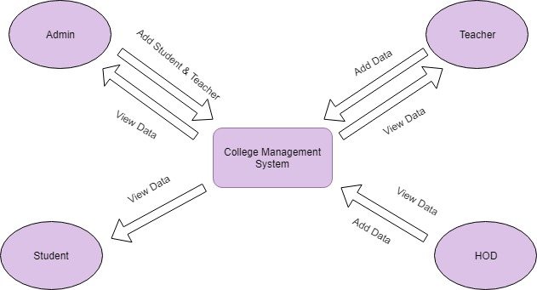

Fig 9.1 Context Diagram

**9.2 USE CASE DIAGRAM**

The use case diagram defines the interaction between the system and the users for achieving a particular task successfully.

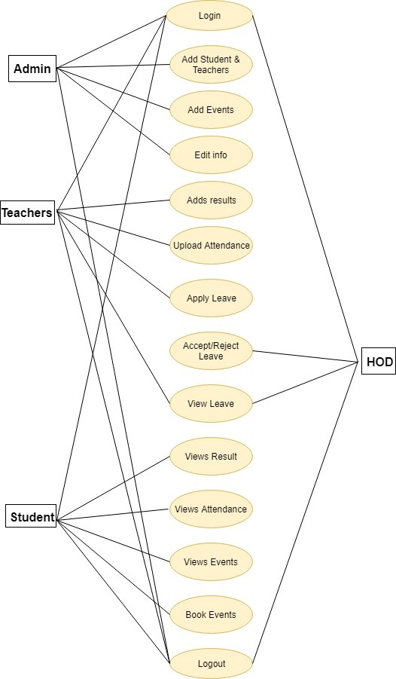

Fig. 19.2 Use case Diagram

**9.3 ACTIVITY DIAGRAM**

An activity diagram depicts the flow of actions that different users do according to their respective roles.

* ADMIN

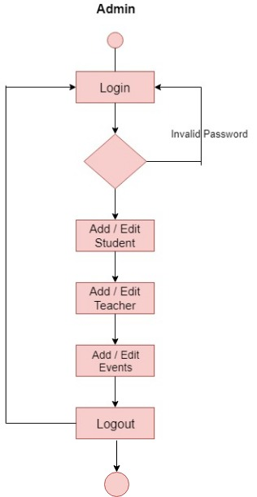

Fig. 9.3.1 Activity diagram of admin

* Teacher

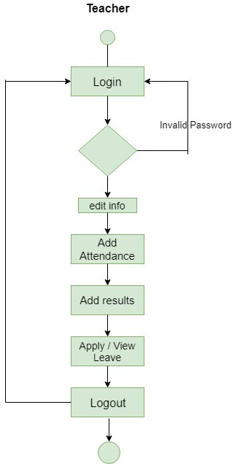

Fig. 9.3.2 Activity diagram of Teacher

* STUDENT

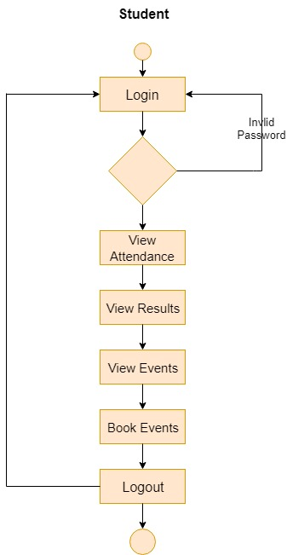

Fig. 9.3.3 Activity diagram of Student

**9.4 ER DIAGRAM**

The ER diagram will give a brief description about the entities that are involved in the project along with the relationships between them which would help in explaining about the logical structure of the system.

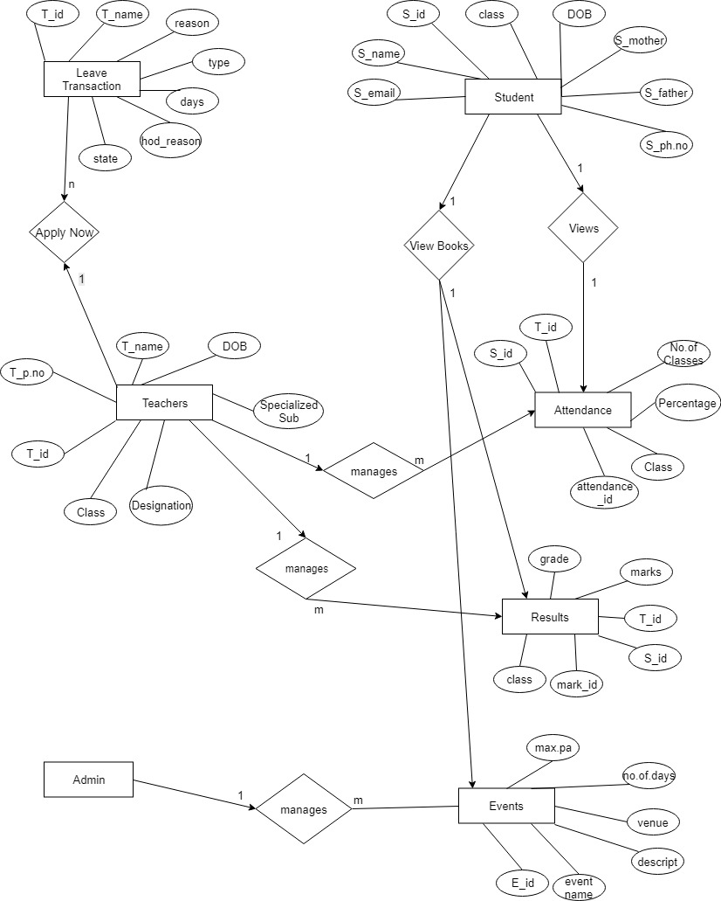

Fig. 9.4 E R diagram

**9.5 CONCEPTUAL SCHEMA**

The conceptual schema depicts the actual database of the system along with the connections between the tables. The schema also shows the different attributes and their connections from parent table and child table.

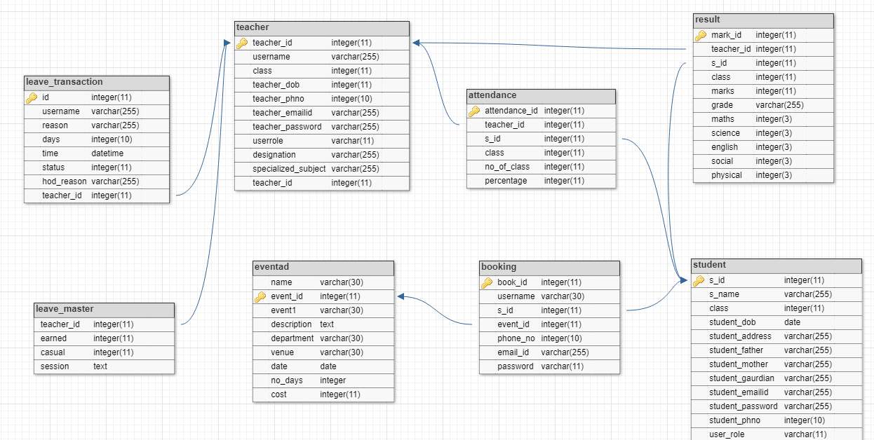

Fig. 9.5 Conceptual Schema

**10. TABLE DESIGN**

Database: College

* Teacher

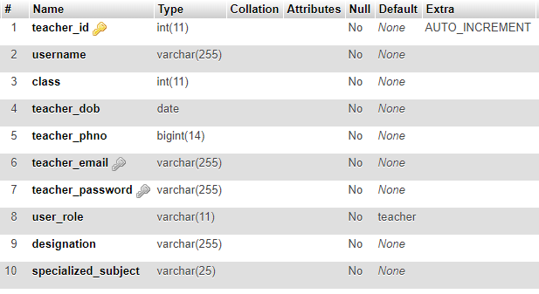

Table. 10.1 Teacher

* Attendance

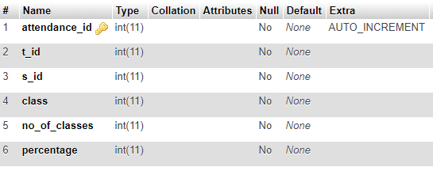

Table. 10.2 Attendance

* Student

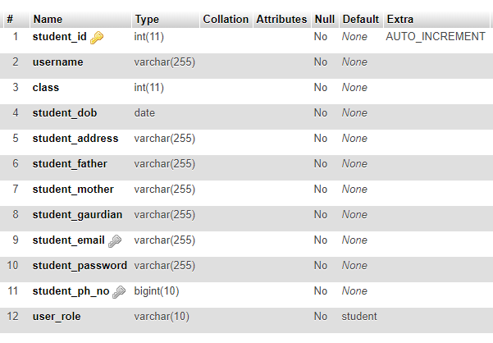

Table. 10.3 Student

* Booking

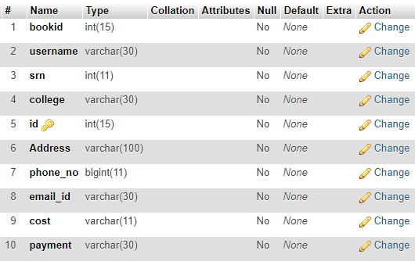

Table. 10.4 Booking

* Exam_results

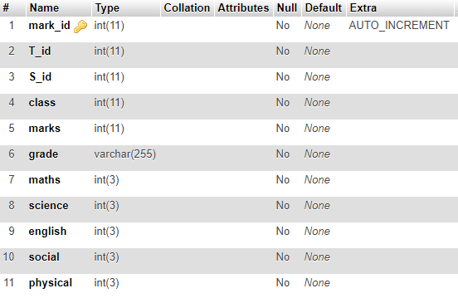

Table. 10.5 Exam_results

* Eventad

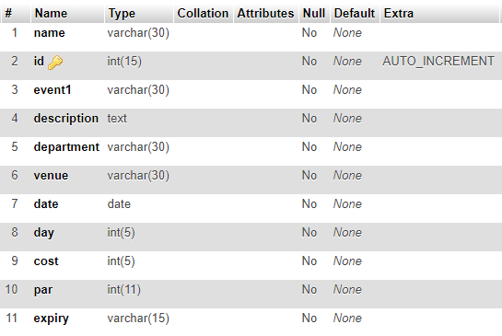

Table. 10.6 Eventad

Database: leave

* Employee

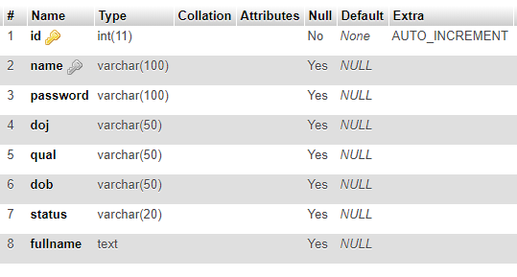

Table. 10.7 Employee

* Leave_master

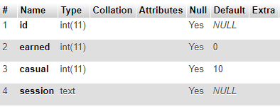

Table. 10.8 Leave_master

* Leave_transaction

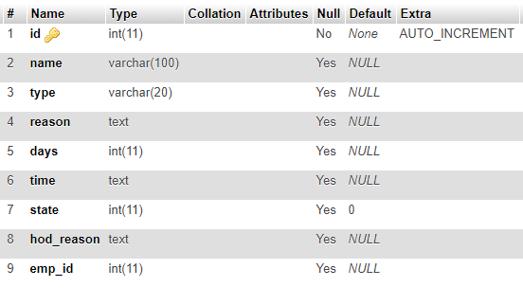

Table. 10.9 Leave_transaction

**11. FRONT END SCREEN (SCREEN SHOT)**

**Home Screen**



Fig 11.1 HOME SCREEN

The home screen is the first screen which would be displayed when the application is started, which will display the links to different portal for users like admin, teacher and students.

**ADMIN HOME SCREEN**

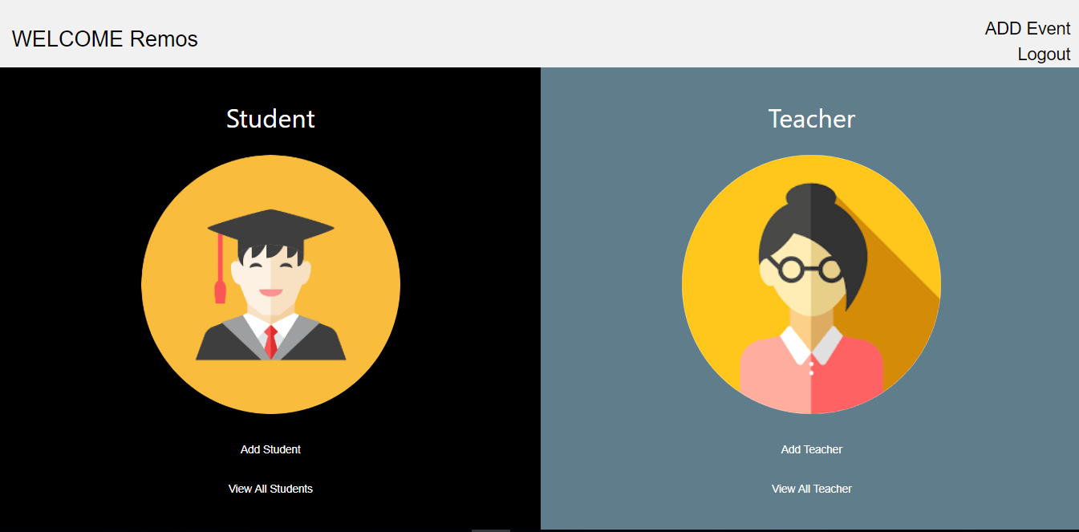

Fig 11.2 Admin Home Screen

On the admin home screen, the admin can view the options of registration of both students and teachers during the admission. The admin gets to view and update the registered user details. Admin adds the event that going to be conducted in the college.

STUDENT REGISTRATION SCREEN

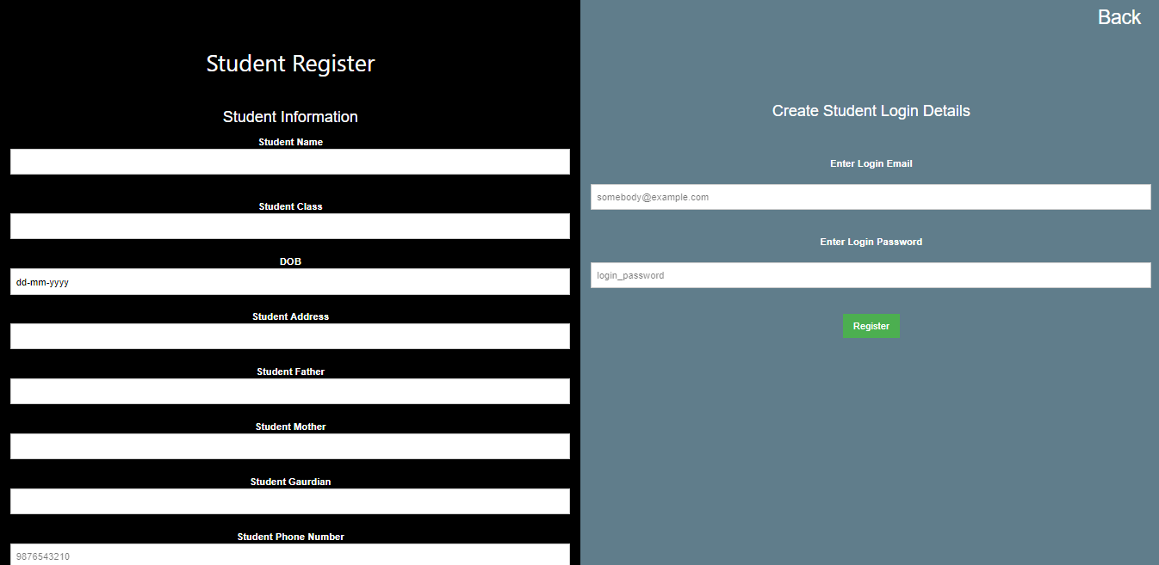

Fig 11.3 Student Registration Screen

Each student registration fields will be validated. The Emails which will be registered must be unique for all users and password length should not be less than 5 characters.

TEACHER REGISTRATION SCREEN

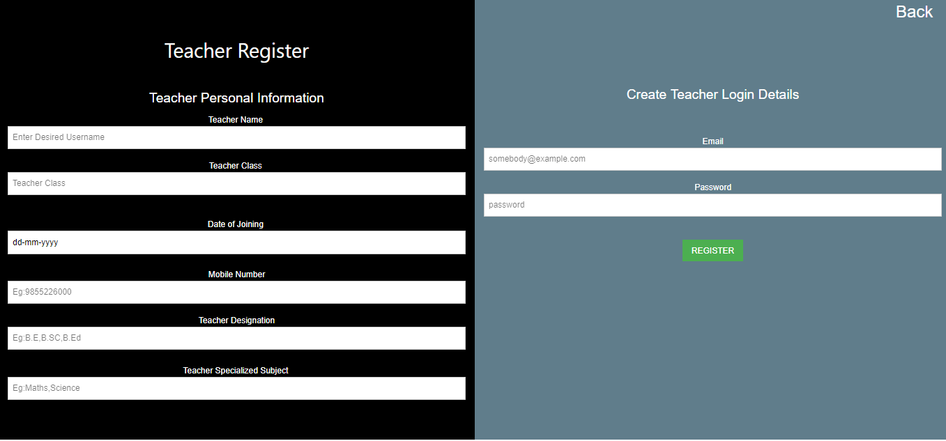Fig 11.4 Teacher Registration Screen

Each teacher registration fields will be validated. The Emails which will be registered must be unique for all users and password length should not be less than 5 characters.

VIEW ALL TEACHERS SCREEN

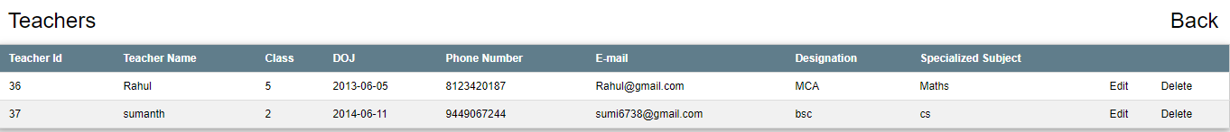

Fig 11.5 View All Teachers Screen

This screen would display all the teachers who are registered with the school and the admin can perform the operations like delete and update the data registered.

ADD EVENT

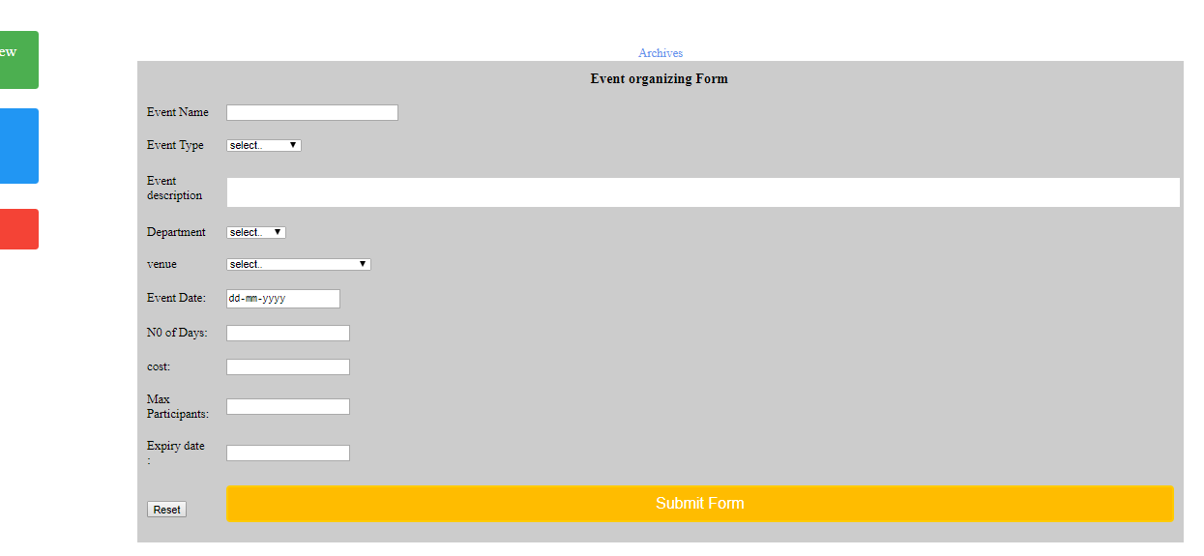Fig. 11.6 Add event

The above page signifies the event page and the features in it.

* By clicking on green button it navigates to adding a new event.
* By clicking on blue button it navigates to display the list of events.
* By clicking on red button it navigates to editing an event by specifying the id of it.
* By clicking on black button it navigates to view the details of attendees who has booked an event.

STUDENT HOME SCREEN

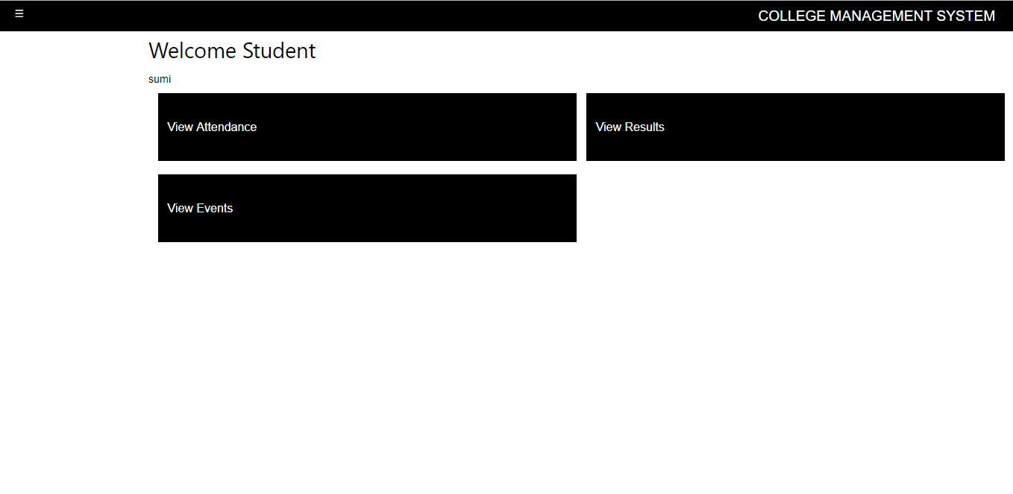Fig. 11.7 Student Home Screen

This is the student home screen which includes the option of viewing his/her exam results, attendance and events that going to be conducted in college. Results and attendance will be uploaded by the teacher periodically. The student can update his personal information whenever needed.

VIEW ATTENDANCE SCREEN

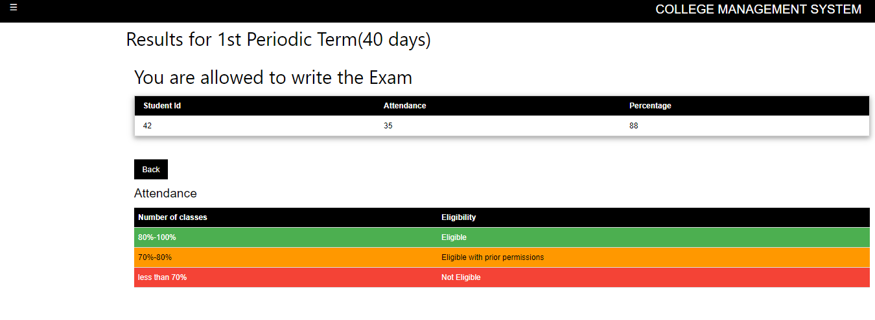

Fig. 11.8 View Attendance Screen

In this page the student can view his attendance which includes his eligibility criteria based on his classes attended with the percentage.

VIEW RESULTS SCREEN

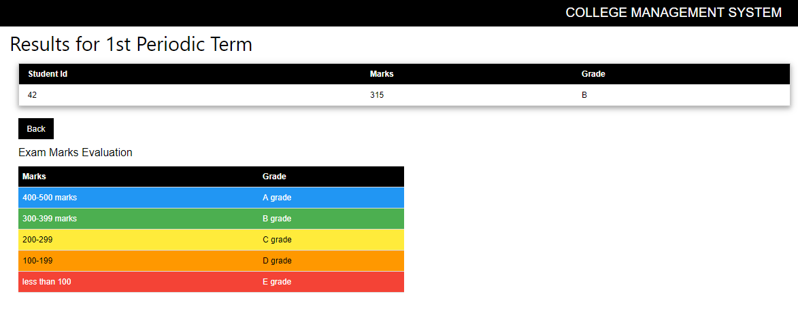

Fig. 11.9 View Results Screen

In this page the student can view his exam results which includes of total marks obtained along with the grade.

VIEW EVENTS SCREEN

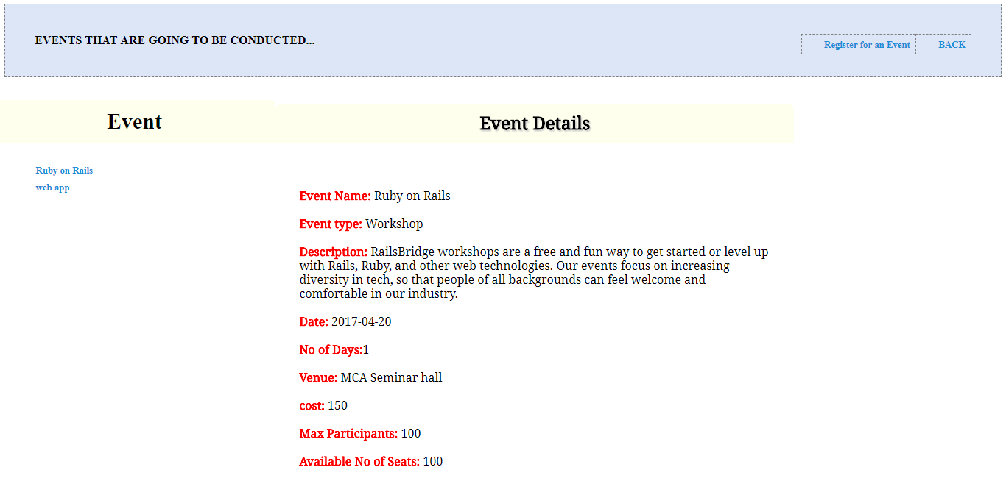

Fig. 11.10 View Events Screen

Here the students can view the upcoming events details like event name, description, event date, venue, cost that are conducted in college, by clicking on event name in event column.

REGISTER FOR AN EVENT PAGE

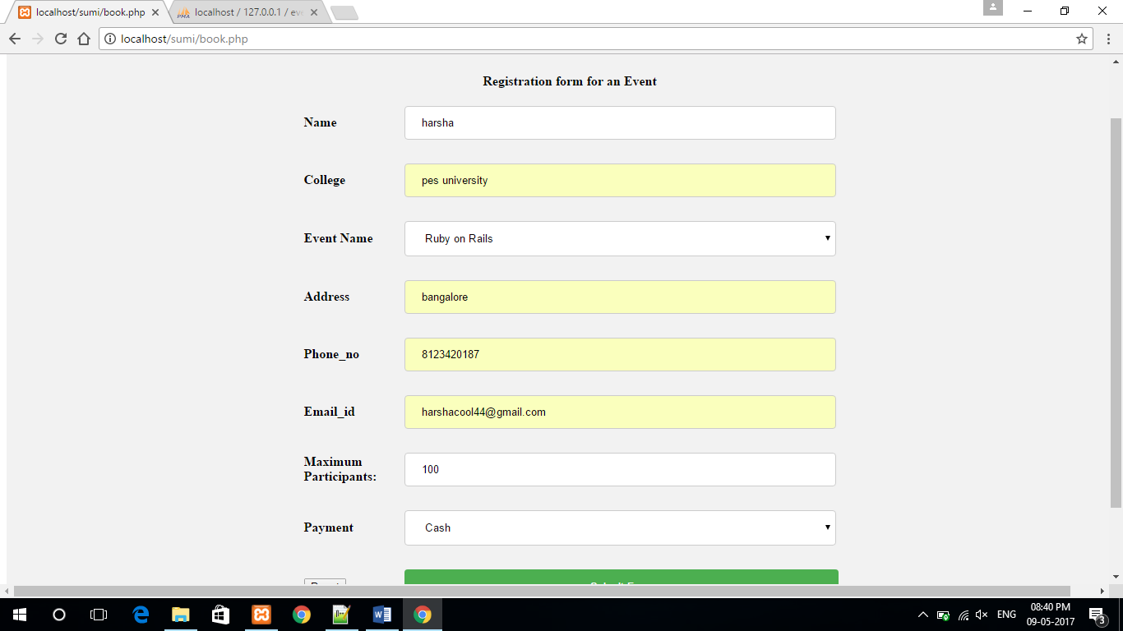

Fig. 11.11 Register for an Event Page

Here the participant can register for an event by filling all the details like participant name, college, event name, address, phone no, emailid and payment

TEACHER INDEX SCREEN

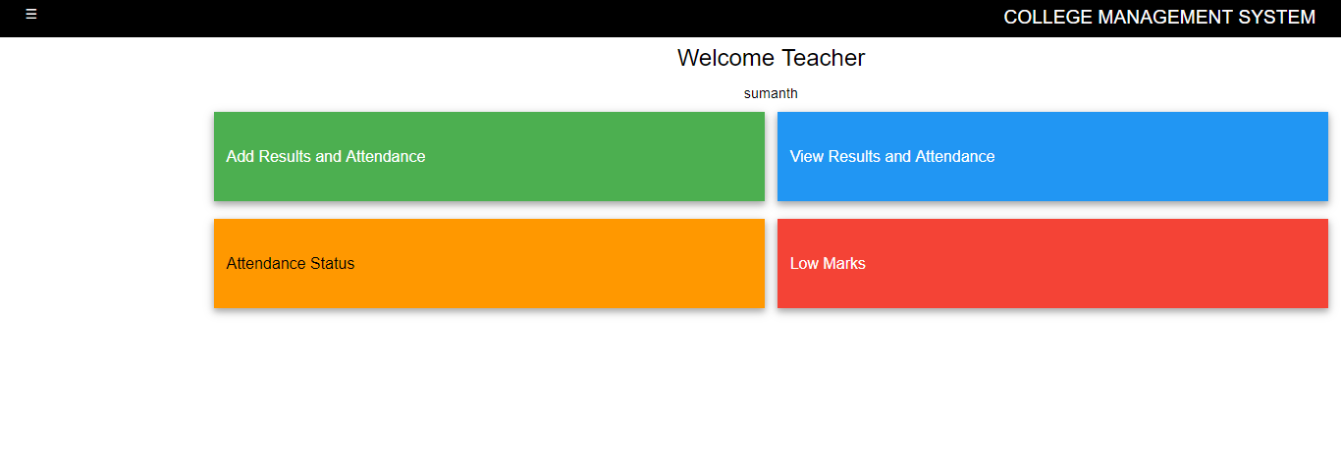Fig. 11.12 Teacher Index Screen

This is the teacher home screen which has the option of adding the students’ results and attendance of the respective class which is assigned to the teacher.

ADDING RESULTS AND ATTENDANCE SCREEN

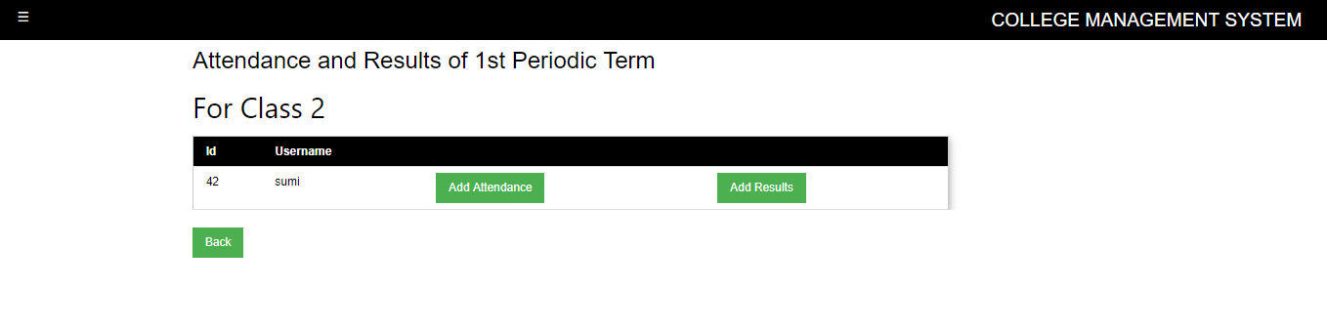

Fig. 11.13 Adding Results and Attendance Screen

The teacher gets to add the marks and attendance of all the students who are present in that particular class.

**VIEW ATTENDANCE SCREEN BASED ON CRITERIA**

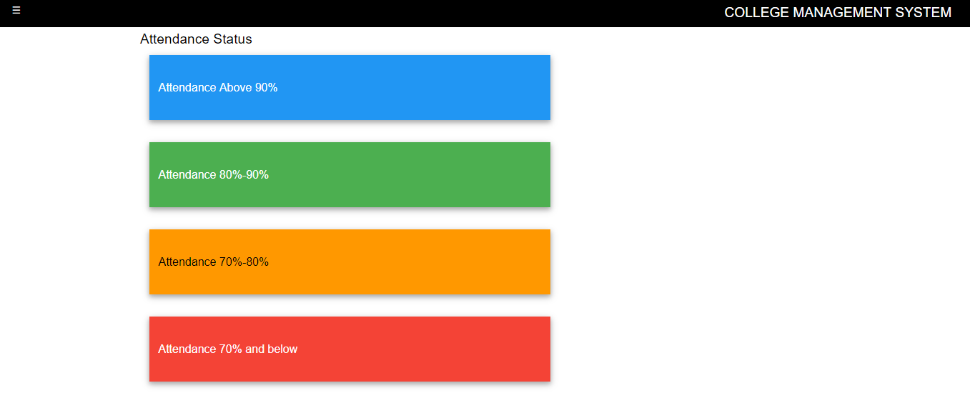

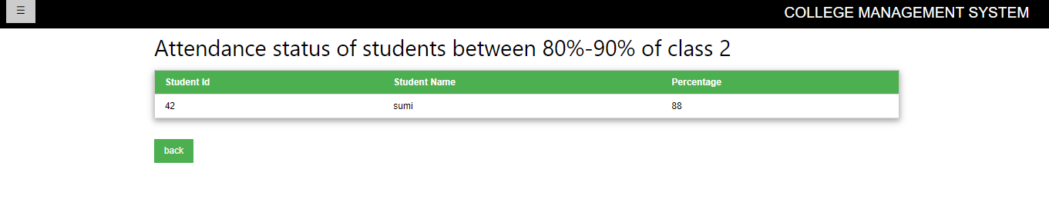Fig. 11.14 View Attendance Screen Based On Criteria

The teacher has the option of viewing the attendance status of different eligibility criteria.

ADDING RESULTS AND ATTENDANCE SCREEN

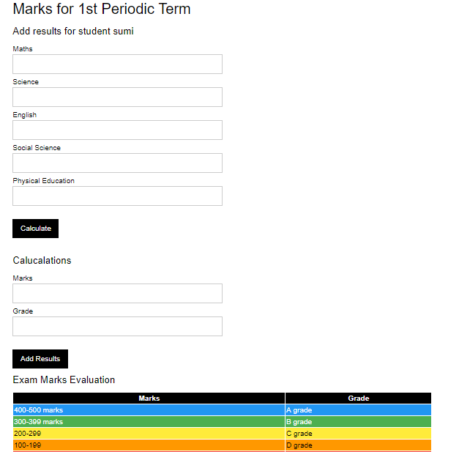

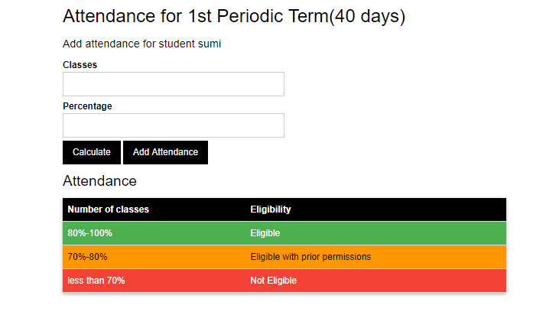

Fig. 11.15 Adding results and attendance screen

In this page the teacher will be uploading different subject marks which is obtained by the student, the automated software helps the teacher in solving total marks and grade calculation. In this page the teacher will be uploading number of classes attended by the student.

**TEACHER PANEL**

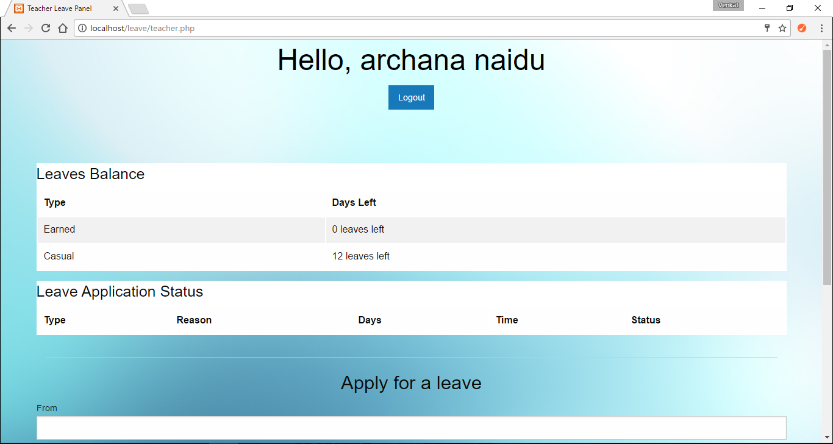

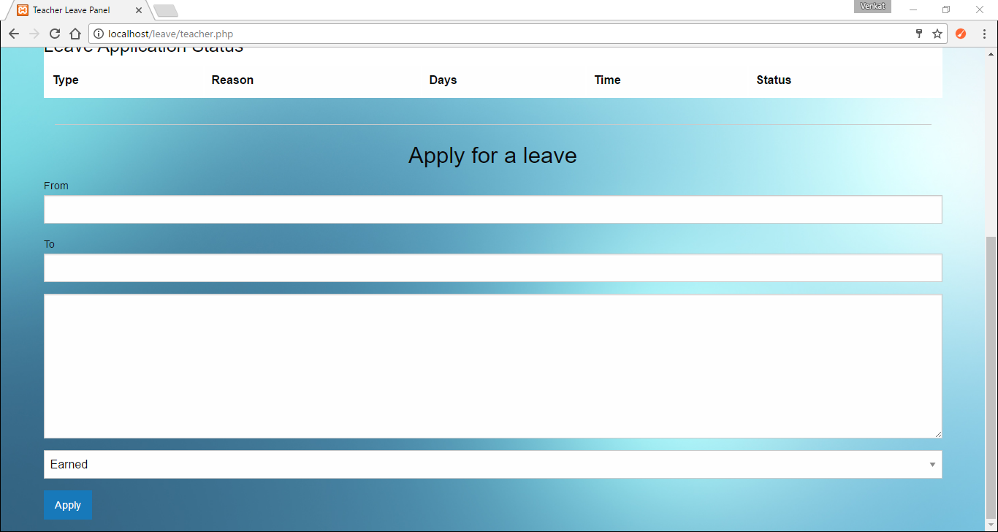

Fig. 11.16 Teacher Panel

The above images show the teacher panel where the teacher can view the leave balance on how many leaves are left for him/her to apply. And also can view the leave application status to check id HOD has approved/rejected her leave request. If not, it just says pending.

LEAVE APPLICATION STATUS

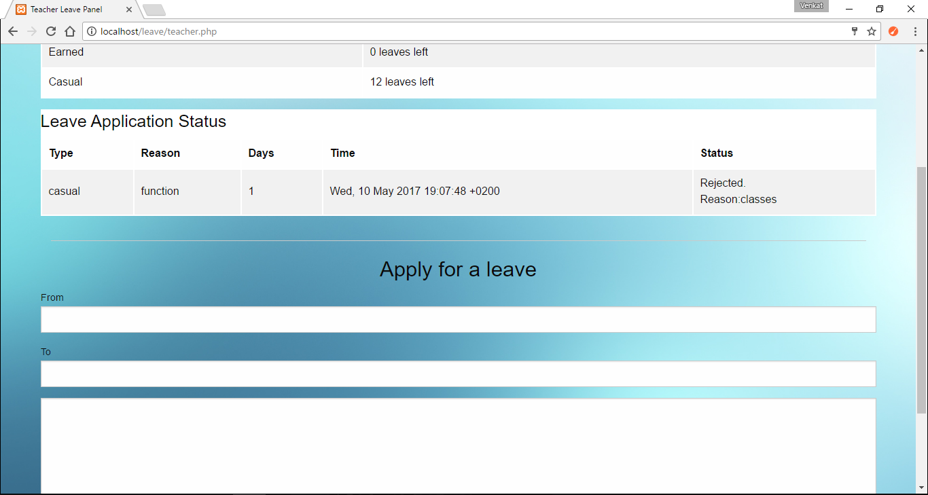

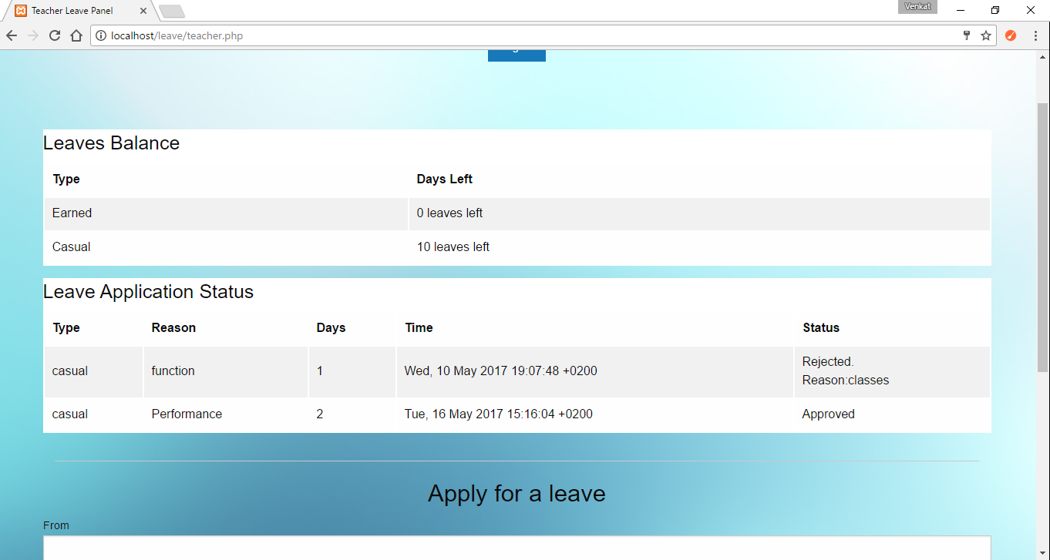

Fig. 11.17 Leave Application Status

In this above image, it shows the leave application status, where the teacher has applied the leave, but the HOD has rejected it with a reason. Similarly, when the HOD approves a request the status reads Approved (as shown in fig 7.1.6) and the number of leaves reduces.

HOD PANEL

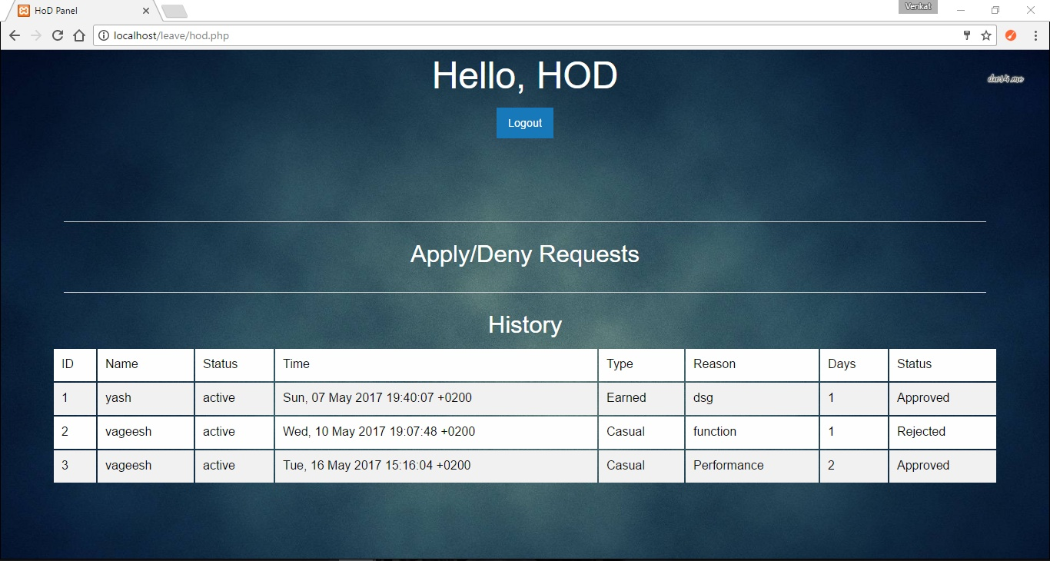

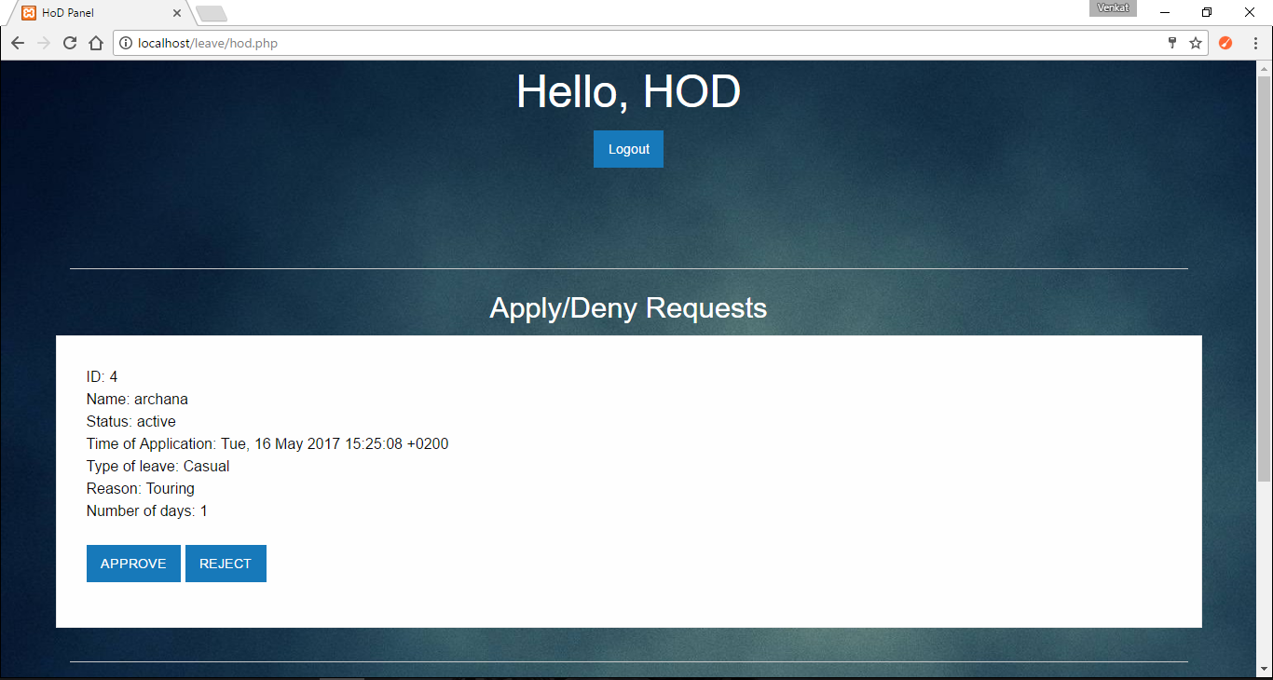

Fig. 11.18 HOD Panel

The above images represent the HOD panel where the HOD gets the leave applications from the teacher, to which she can approve/reject them. And also she can view the history of the leave applications the HOD has approved and rejected.

**12. CODING**

<!DOCTYPE html>

<html>

<head>

<title>Your Home Page</title>

<link href="style.css" rel="stylesheet" type="text/css">

</head>

<body>

<div id="profile">

<b id="welcome">EVENTS THAT ARE GOING TO BE CONDUCTED... </b>

<b id="logout"><a href="student_index.php">BACK</a></b>

<b id="logout"><a href="book.php">Register for an Event</a></b>

</div>

</body>

</html>

<br>

<br>

<br>

<!DOCTYPE HTML>

<html lang="en">

<head>

<meta content="noindex, nofollow" name="robots">

<link href="style.css" rel="stylesheet" type="text/css">

<style>

@import url(http://fonts.googleapis.com/css?family=Droid+Serif); /* to import google font style */

.divA {

width:70%;

float:left;

margin-top:30px;

}

.form{

width:800px;

float:left;

font-size:20px;

font-family: 'Droid Serif', serif;

padding-left:60px;

}

.divB{

width:100%;

height:100%;

background-color:white;

}

.divD{

width:400px;

height:400px;

padding:0 20px;

float:left;

font-size:25px;

margin-top:-8px;

}

p{ text-align:center;

font-family: 'Droid Serif', serif;

color:#5678C0;

font-size:25px;

text-shadow:2px 2px 2px #cfcfcf;

}

.back{

background-image:url("images/texture.png");

}

.form h2{

text-align:center;

text-shadow:2px 2px 2px #cfcfcf;

}

a{

text-decoration:none;

font-size:16px;

margin:20px 0 0 30px;

padding:3px;

color:#1F8DD6;

}

a:hover{

text-shadow:2px 2px 2px #cfcfcf;

font-size:18px;

}

.clear{

clear:both;

}

span{

font-weight:bold;

}

.formget{

float:right;

margin-top:10px;

clear:right;

}

</style>

<script src="https://ajax.googleapis.com/ajax/libs/jquery/1.11.3/jquery.min.js"></script>

<script type='text/javascript'>

$(document).ready(function(){

$(window).scroll(function(){

if ($(this).scrollTop() > 100) {

$('#scroll').fadeIn();

} else {

$('#scroll').fadeOut();

}

});

$('#scroll').click(function(){

$("html, body").animate({ scrollTop: 0 }, 600);

return false;

});

});

</script>

<script>

function centerModal() {

$(this).css('display', 'block');

var $dialog = $(this).find(".modal-dialog");

var offset = ($(window).height() - $dialog.height()) / 2;

// Center modal vertically in window

$dialog.css("margin-top", offset);

}

$('.modal').on('show.bs.modal', centerModal);

$(window).on("resize", function () {

$('.modal:visible').each(centerModal);

});

</script>

<link href="https://fonts.googleapis.com/css?family=Indie+Flower" rel="stylesheet">

<style>

#fo {

font-family: 'Indie Flower', cursive;

font-size: 20px;

text-align:center;

}

</style>

<div class="back">

<div class="divD">

<h2>Event</h2>

<hr/>

<?php

//Establishing Connection with Server

error_reporting(E_ALL ^ E_DEPRECATED);

$connection = mysqli_connect("localhost", "root", "","sms");

//Selecting Database

//MySQL Query to read data

$query = mysqli_query($connection,"select * from eventad where id=id");

while ($row = mysqli_fetch_array($query)) {

echo "<b><a href=\"view_events.php?id={$row['id']}\">{$row['name']}</a></b>";

echo "<br />";

}

?>

<?php

if (isset($_GET['id'])) {

$id = $_GET['id'];

$query1 = mysqli_query($connection,"select name,event1,description,date,day,venue,cost,par from eventad where id=$id");

while ($row1 = mysqli_fetch_array($query1)) {

?>

</div>

<div class="form">

<h2>Event Details</h2>

<hr/>

<br><br>

<!-- Displaying Data Read From Database -->

<span>Event Name:</span> <?php echo $row1['name']; ?>

<br><br>

<span>Event type:</span> <?php echo $row1['event1']; ?>

<br><br>

<span>Description:</span> <?php echo $row1['description']; ?>

<br><br>

<span>Date:</span> <?php echo $row1['date']; ?>

<br><br>

<span>No of Days:</span><?php echo $row1['day']; ?>

<br><br>

<span>Venue:</span> <?php echo $row1['venue']; ?>

<br><br>

<span>cost: </span> <?php echo $row1['cost']; ?>

<br><br>

<span>Max Participants: </span> <?php echo $row1['par']; ?>

<br><br>

<span>Available No of Seats: </span> <?php $result=mysqli_query($connection,"SELECT count(id) as total from booking where id='$id'");

$data=mysqli_fetch_assoc($result);

$par=$row1['par'];

$a=$par-$data['total'];

echo $a; ?>

<br><br>

</div>

<?php

}

}

?>

</div>

</body>

</html>

CSS file:

#main {

width:960px;

margin:50px auto;

font-family:raleway

}

span {

color:red

}

h2 {

background-color:#FEFFED;

text-align:center;

border-radius:10px 10px 0 0;

margin:-10px -40px;

padding:15px

}

hr {

border:0;

border-bottom:1px solid #ccc;

margin:10px -40px;

margin-bottom:30px

}

#login {

width:300px;

float:left;

border-radius:10px;

font-family:raleway;

border:2px solid #ccc;

padding:10px 40px 25px;

margin-top:70px

}

input[type=text],input[type=password] {

width:99.5%;

padding:10px;

margin-top:8px;

border:1px solid #ccc;

padding-left:5px;

font-size:16px;

font-family:raleway

}

input[type=submit] {

width:100%;

background-color:#FFBC00;

color:#fff;

border:2px solid #FFCB00;

padding:10px;

font-size:20px;

cursor:pointer;

border-radius:5px;

margin-bottom:15px

}

#profile {

padding:50px;

border:1px dashed grey;

font-size:20px;

background-color:#DCE6F7

}

#logout {

float:right;

padding:5px;

border:dashed 1px gray

}

a {

text-decoration:none;

color:#6495ed

}

i {

color:#6495ed

}

**13.TEST CASE**

Test cases are generated to find out whether the conditions used satisfy the application requirement or not. It is used to find pass or fail of each authorization part.

**Login Page**

|  |  |  |  |  |  |
| --- | --- | --- | --- | --- | --- |
| **Test Case ID** | **Test case name** | **User action** | **Expected Result** | **Actual result** | **Test status** |
| **TC01** | Login | Correct Username and Correct password | Control transferred to appropriate module. | Control transferred to appropriate module (timeline). | Pass |
| **TC02** | Login info | Incorrect Username and Correct password | Error message “Username or Password is Invalid.” | Error messages displayed | Pass |
| **TC03** | Login info | Correct Username and Incorrect password | Error message “Username or Password is Invalid.” | Error messages displayed | Pass |
| **TC04** | Login validation | Blank Username and correct password | Warning messages “ Please fill out this field.” | Warning messages displayed | Pass |

**Table. 13.1 Login Page**

**Adding New Student/Teacher**

|  |  |  |  |  |  |
| --- | --- | --- | --- | --- | --- |
| **Test Case ID** | **Test case name** | **User action** | **Expected Result** | **Actual result** | **Test status** |
| TC01 | Adding new User Details | Filling fields | New User details should store into database. | New User details stored into database. | Pass |
| TC02 | Adding new User Student Details | Empty any of the field | Warning message user field cannot be empty | Warning message displayed ”Please fill out this field”. | Pass |
| TC03 | E-mail validation | Email address without “@” symbol | Warning message  “@ is missing” | Warning message “@ is missing” | Pass |
| TC03 | E-mail validation | Email address with “@” symbol | Email address is validated | The E-mail address is accepted | Pass |
| TC04 | Password Validation | Password with minimum 8 chars | Password accepted | Password accepted | Pass |

**Table. 13.2 Adding New Student/Teacher**

**Adding an Event**

|  |  |  |  |  |  |
| --- | --- | --- | --- | --- | --- |
| **Test Case ID** | **Test case name** | **User action** | **Expected Result** | **Actual result** | **Test status** |
| TC01 | Adding an Event. | Filling fields | Details are stored into database. | Details are stored into database. | Pass |
| TC02 | Adding an Event. | Empty any of the field | Warning message “Please fill out the field”. | Warning message “Please fill out the field”. | Pass |

**Table. 13.3 Add an event**

**Teacher page- Leave Balance Test Case**

|  |  |  |  |  |  |
| --- | --- | --- | --- | --- | --- |
| **Test Case ID** | **Test case name** | **User action** | **Expected Result** | **Actual result** | **Test status** |
| **TC01** | Applying Leave. | Applies earned leave when earned leave=0 | Invalid Dates. | Error messages displayed. | Pass |
| **TC02** | Applying Leave. | Applies casual leave when earned leave=0. | Invalid Dates. | Error messages displayed | Pass |
| **TC03** | Applying Leave. | Applies earned leave when earned leave equals atleast 1. | Leave Applied | “Successfully applied for leave” | Pass |
| **TC04** | Applying Leave. | Applies casual leave when casual leave equals atleast 1. | Leave Applied | “Successfully applied for leave” | Pass |

**Table. 13.4 Leave Balance Validation**

**Adding Marks page test case**

|  |  |  |  |  |  |
| --- | --- | --- | --- | --- | --- |
| **Test Case ID** | **Test case name** | **User action** | **Expected Result** | **Actual result** | **Test status** |
| TC01 | Adding Student’s Marks Details | Filling fields | Details are stored into database. | Details are stored into database. | Pass |
| TC02 | Missing any Marks Details | Empty any of the field | Warning message “Please fill out the field”. | Warning message “Please fill out the field”. | Pass |

**Table. 13.5 Adding Marks page test case**

**Adding Attendance page test case**

|  |  |  |  |  |  |
| --- | --- | --- | --- | --- | --- |
| **Test Case ID** | **Test case name** | **User action** | **Expected Result** | **Actual result** | **Test status** |
| TC01 | Adding Student’s attendance Details | Filling fields | Details are stored into database. | Details are stored into database. | Pass |
| TC02 | Missing Student’s No_of_classes Details | Empty any of the field | Warning message “Please fill out the field”. | Warning message “Please fill out the field”. | Pass |

**Table. 13.6 Adding Attendance page test case**

**Logout**

|  |  |  |  |  |  |
| --- | --- | --- | --- | --- | --- |
| **Test Case ID** | **Test case name** | **User action** | **Expected Result** | **Actual result** | **Test status** |
| TC01 | Logging out | On-click | Control transferred to index page. | Successfully logged out. | Pass |

**Table. 13.7 Logout**

**14. CONCLUSION**

College Management System has been developed in local host and project has been tested with sample data and outputs are obtained as per the requirements and design. The final output of the project is it allows the admin to manage teachers and students. Students can view their attendance, results and the events that are going to be conducted in college. which will be uploaded periodically they can as well manage their profile details. The teachers will be able to successfully add attendance and results of all the students in the respective class assigned to the teacher. And it keeps track of multiple types of leaves and enables the teacher to request leave via the Web and check their leave-time balances.

**15. BIBILOGRAPHY**

[1] Head first PHP and MySQL Lynn Beighley and Michael Morrison

[2] Learning jQuery by Jonathan Chaffer, 3rd Edition.

* <https://www.w3schools.com/mysql>
* <http://www.sourcecode.com/>
* <https://www.tutorialspoin.com/php>