*ACCOUNT MANAGEMENT*

*Use Case Diagram:*

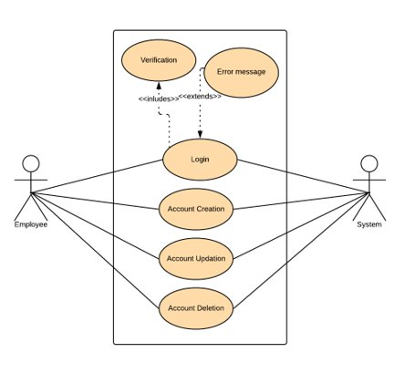

*Sequence Diagram for Add Account:*

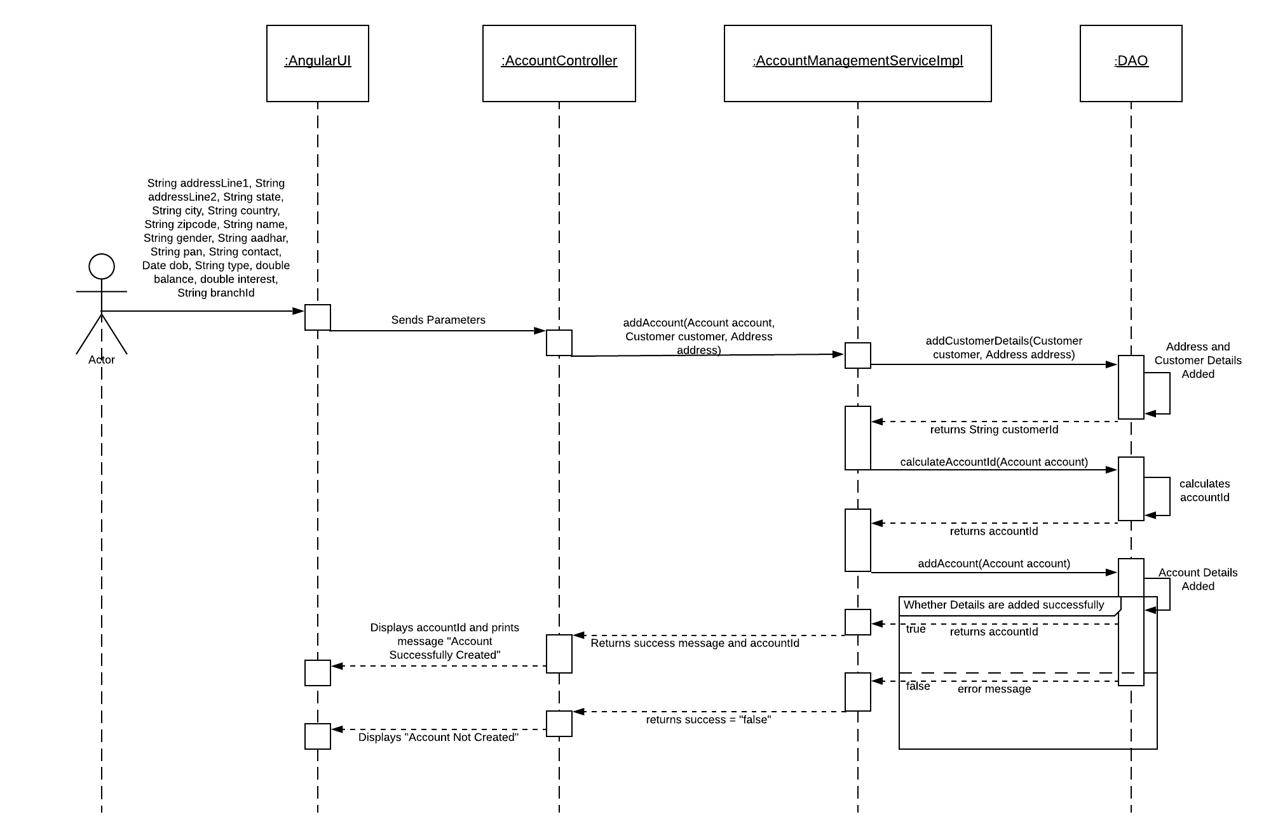

*Sequence Diagram for Update Account:*

i. Update Customer Name:

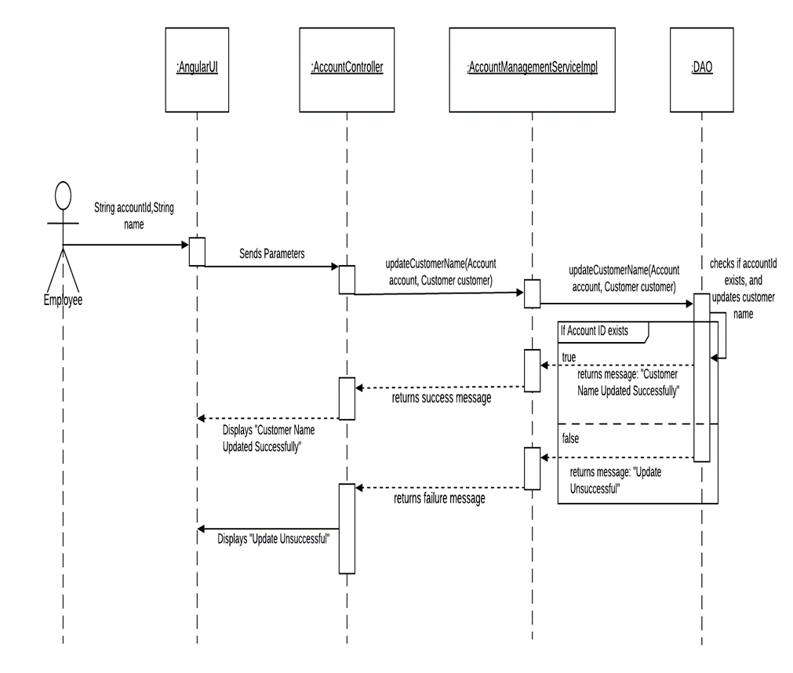

ii. Update Customer Contact :

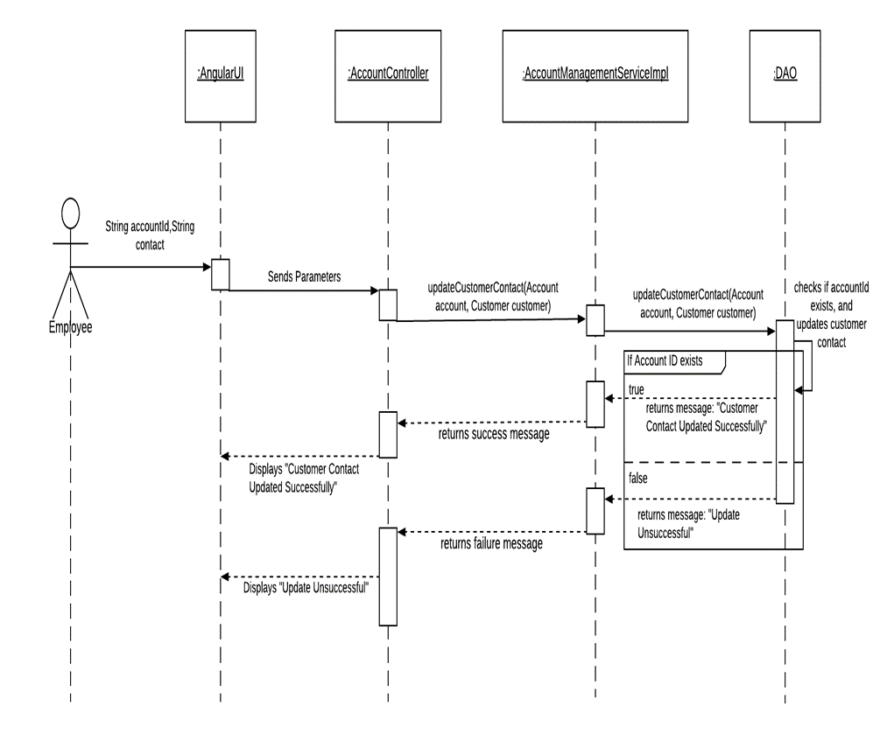

iii. Update Customer Address:

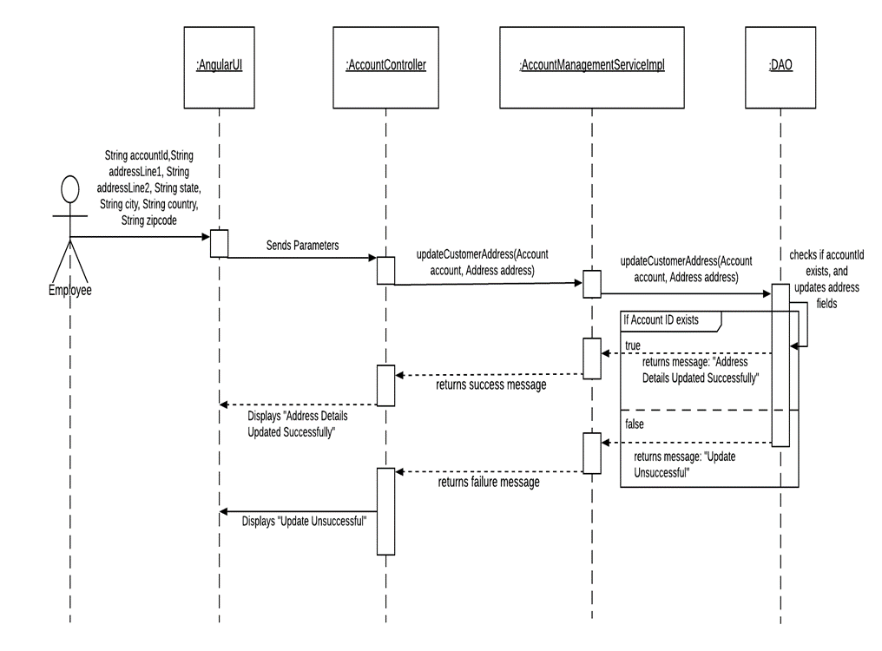

*Sequence Diagram for Delete Account:*

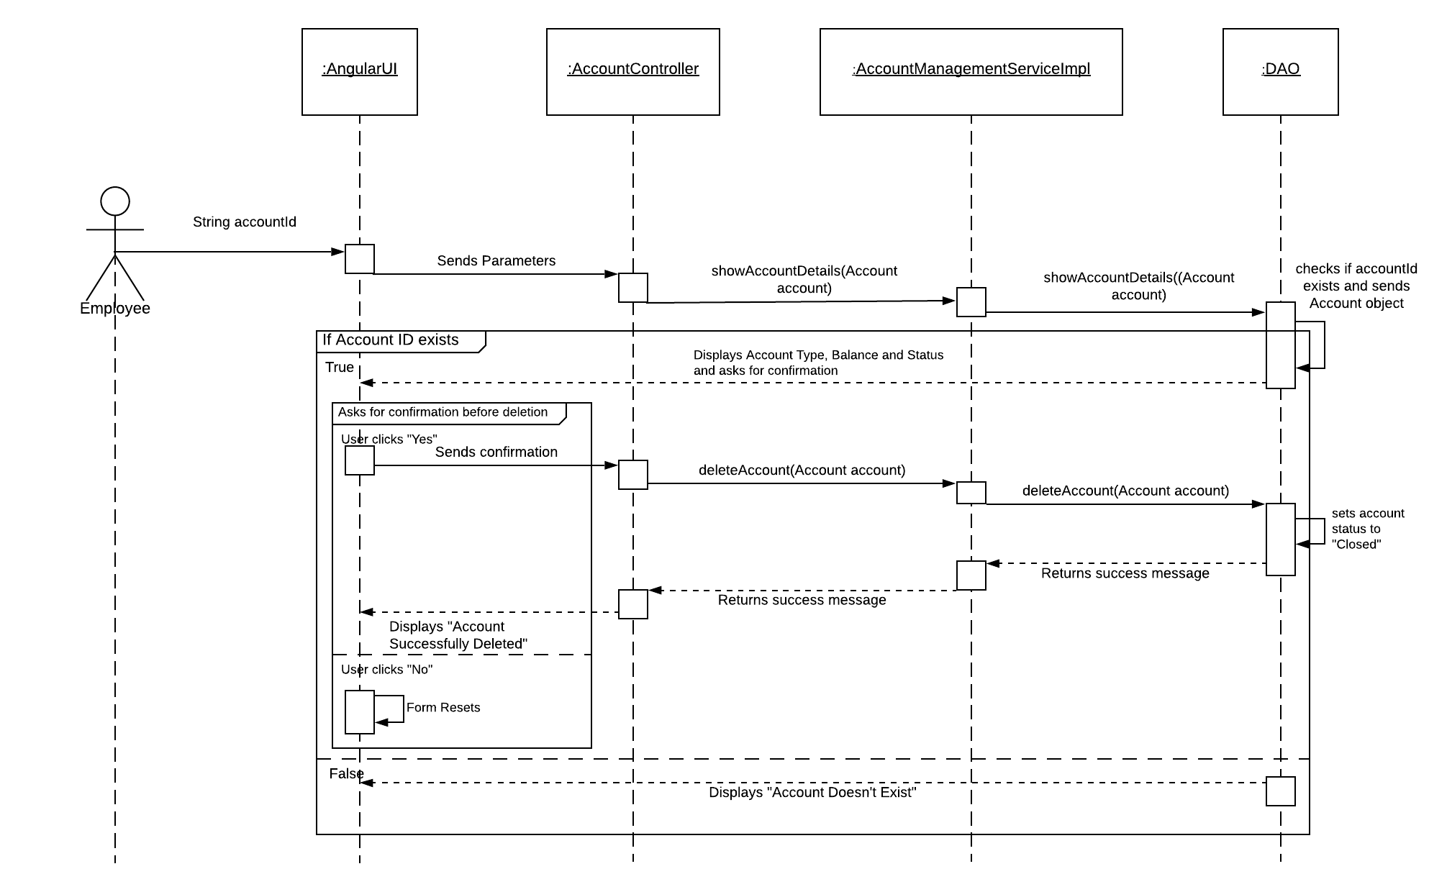

*TRANSACTION*

*Use Case Diagram:*

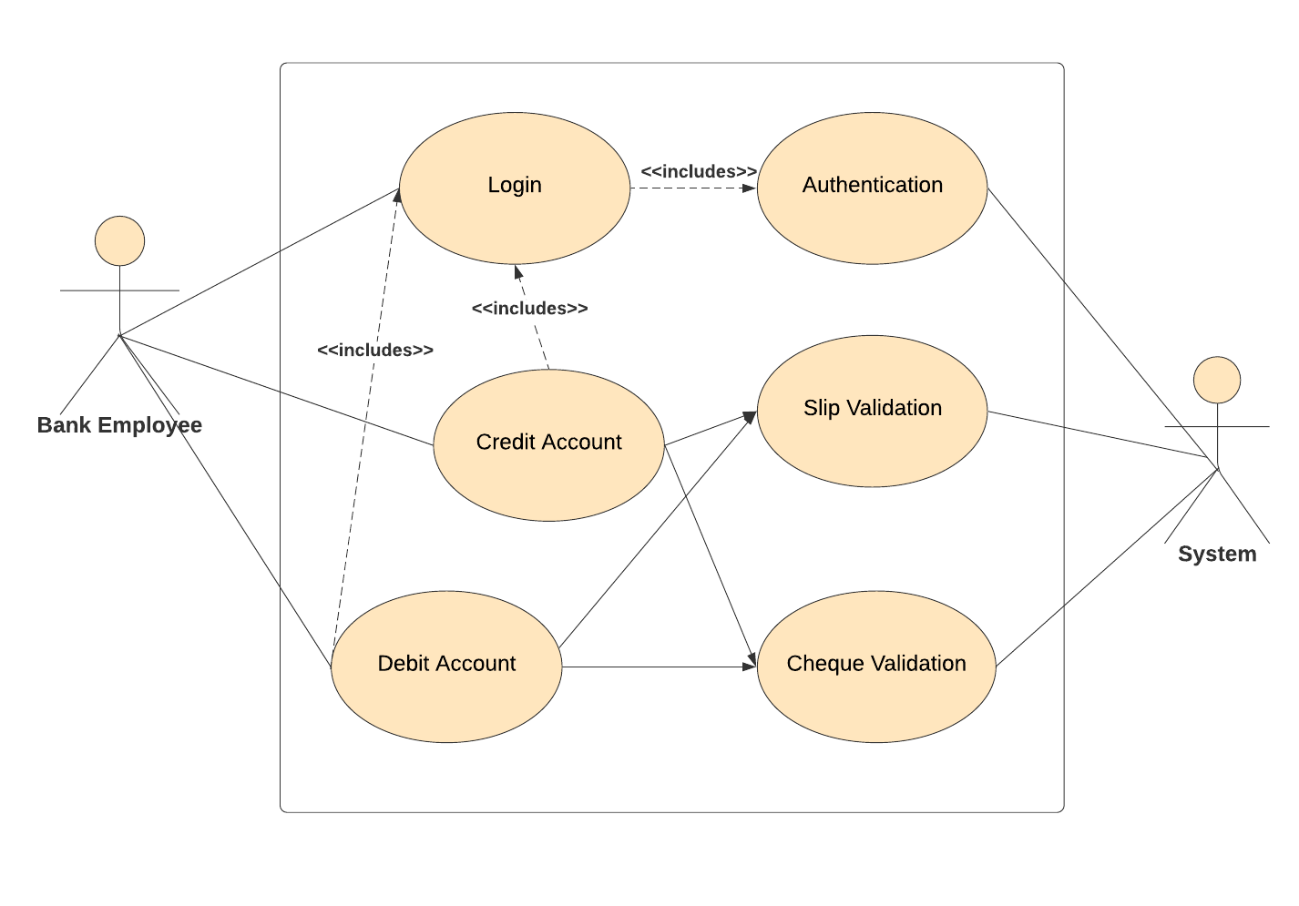

*Sequence Diagram for Credit Using Slip:*

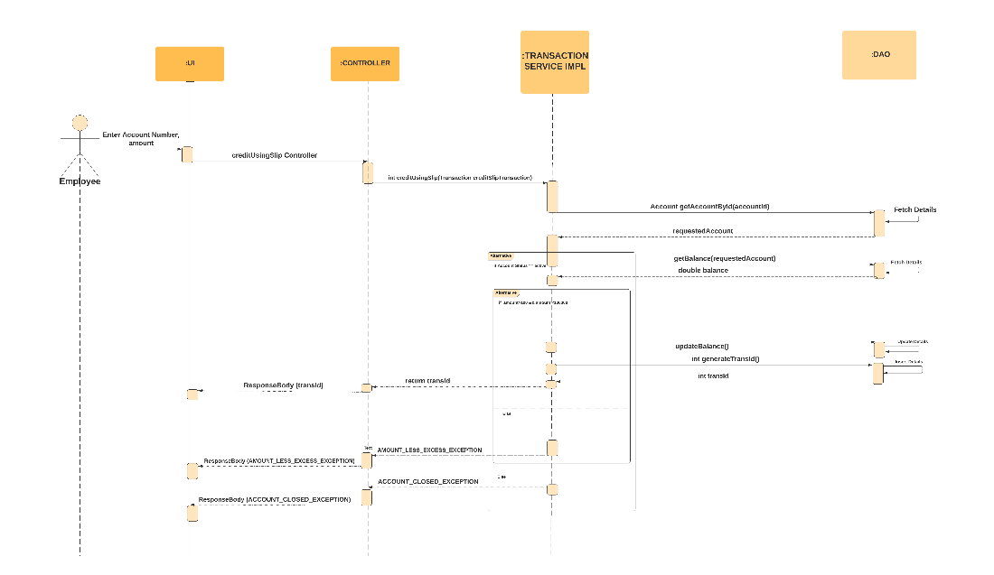

*Sequence Diagram for Debit Using Slip:*

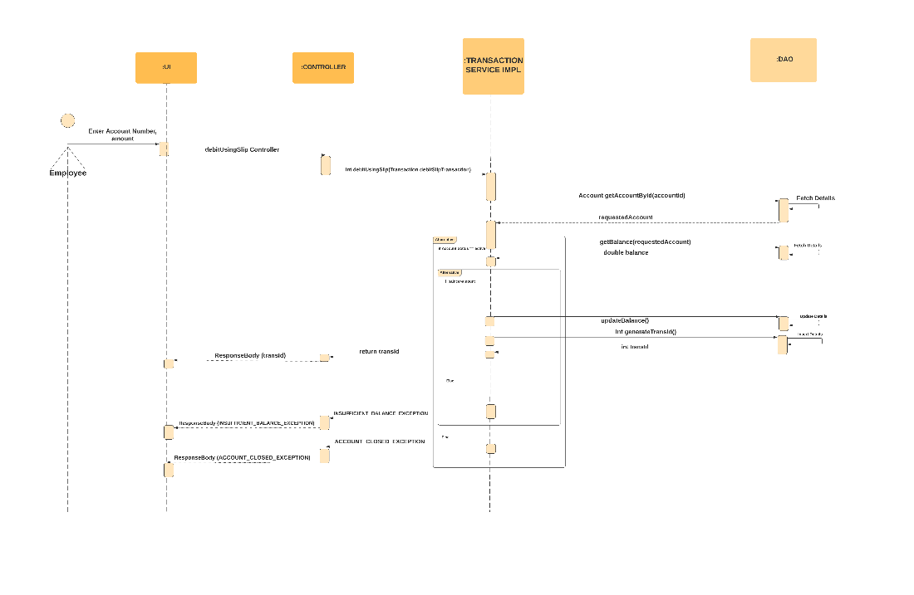

*Sequence Diagram for Debit Using Cheque:*

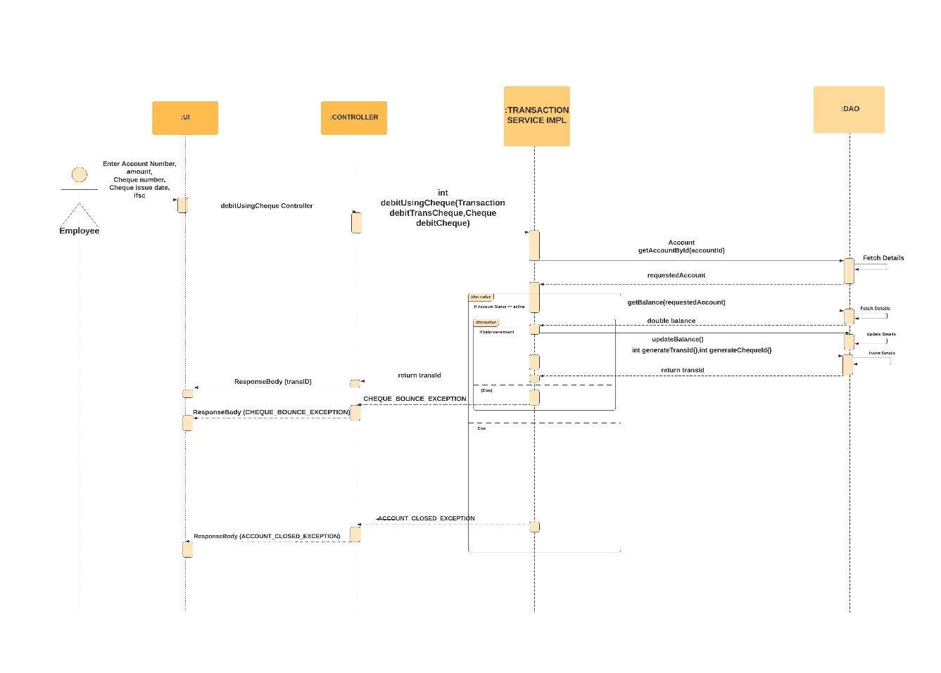

*Sequence Diagram for Credit Using Cheque:*

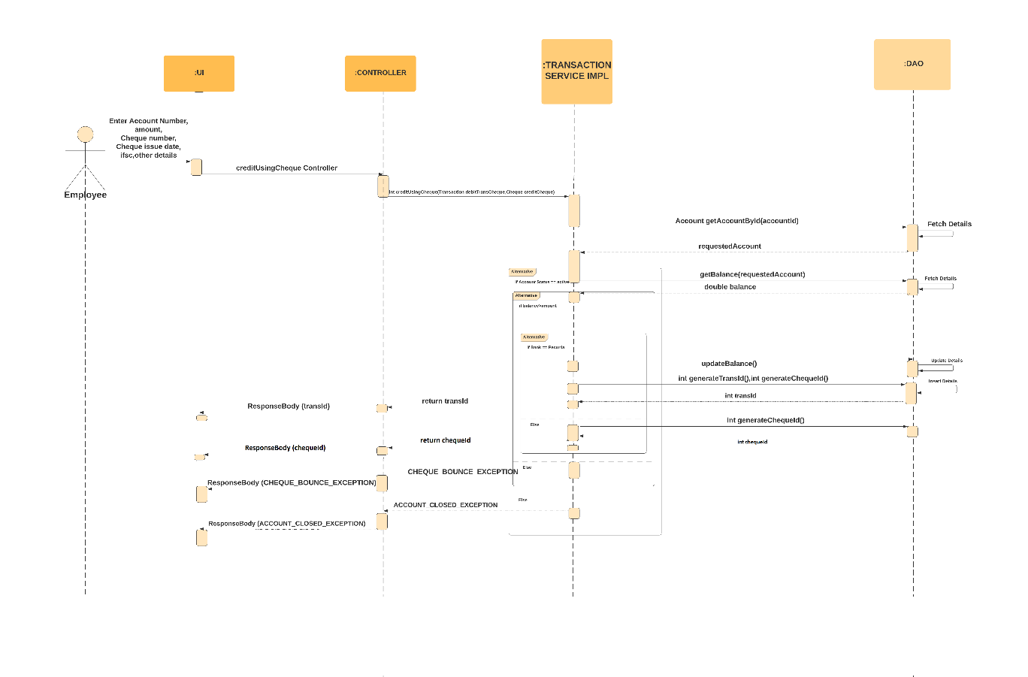

*PASSBOOK MAINTAINANCE*

*Use Case Diagram:*

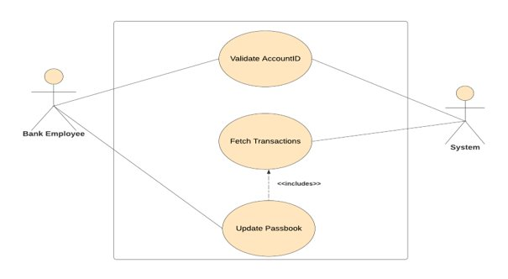

*Sequence Diagram for Passbook Update:*

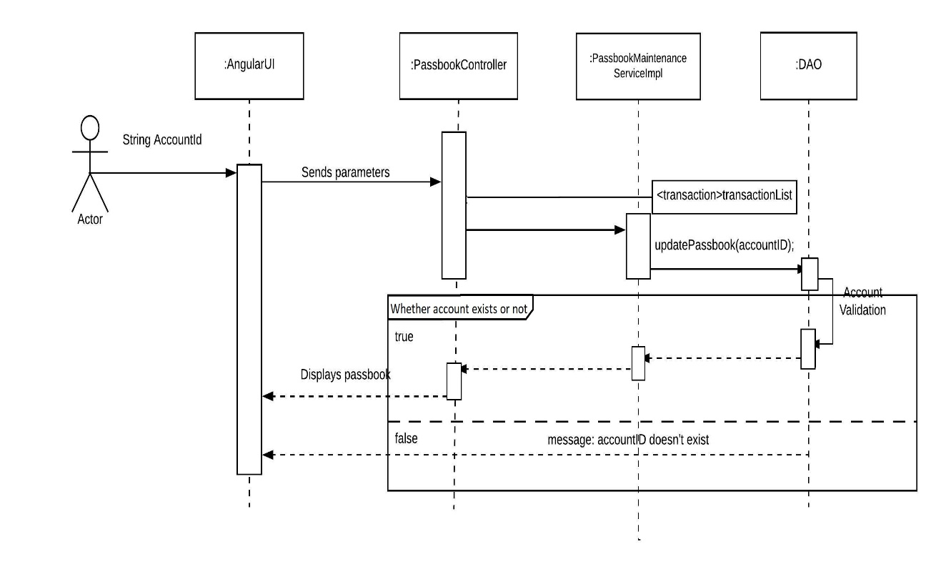

*Sequence Diagram for Account Summary:*

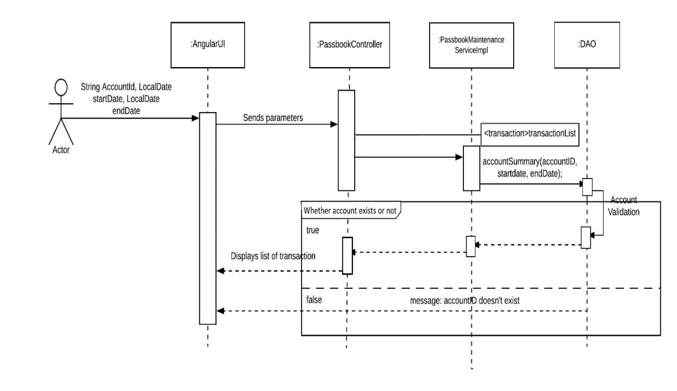

*LOAN*

*UseCase Diagram:*

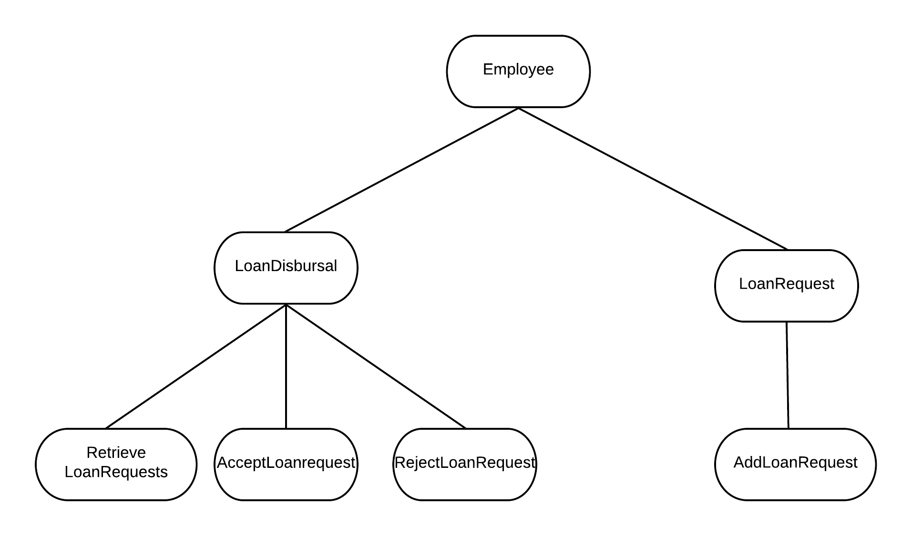

*Sequence Diagram for Loan Request:*

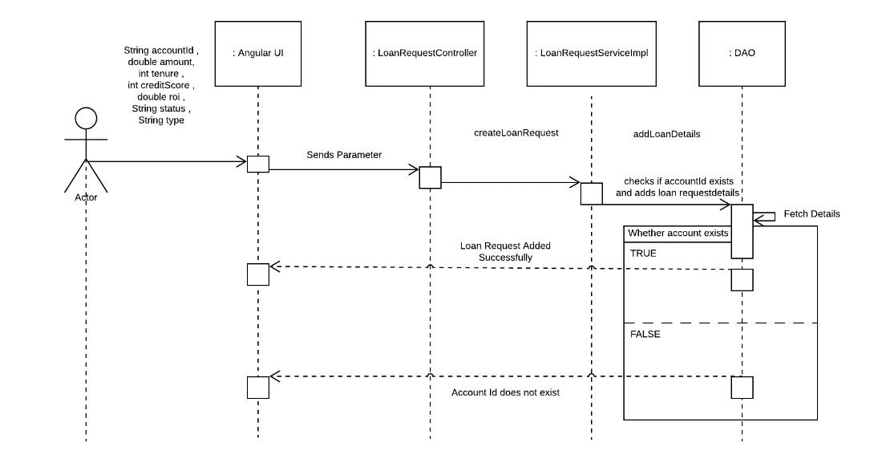

*Sequence Diagram for Loan Disbursal:*

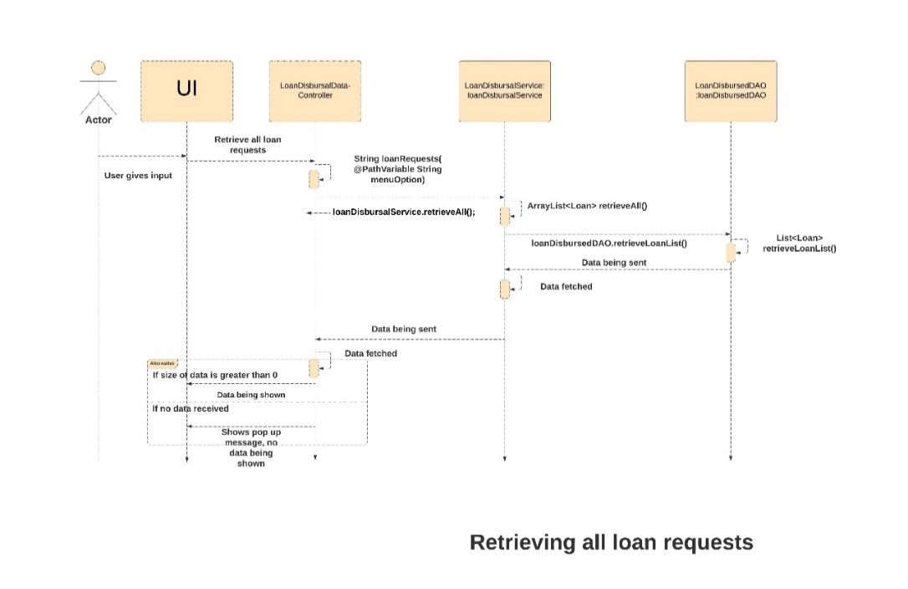

*Sequence for Retrieving all the loans:*

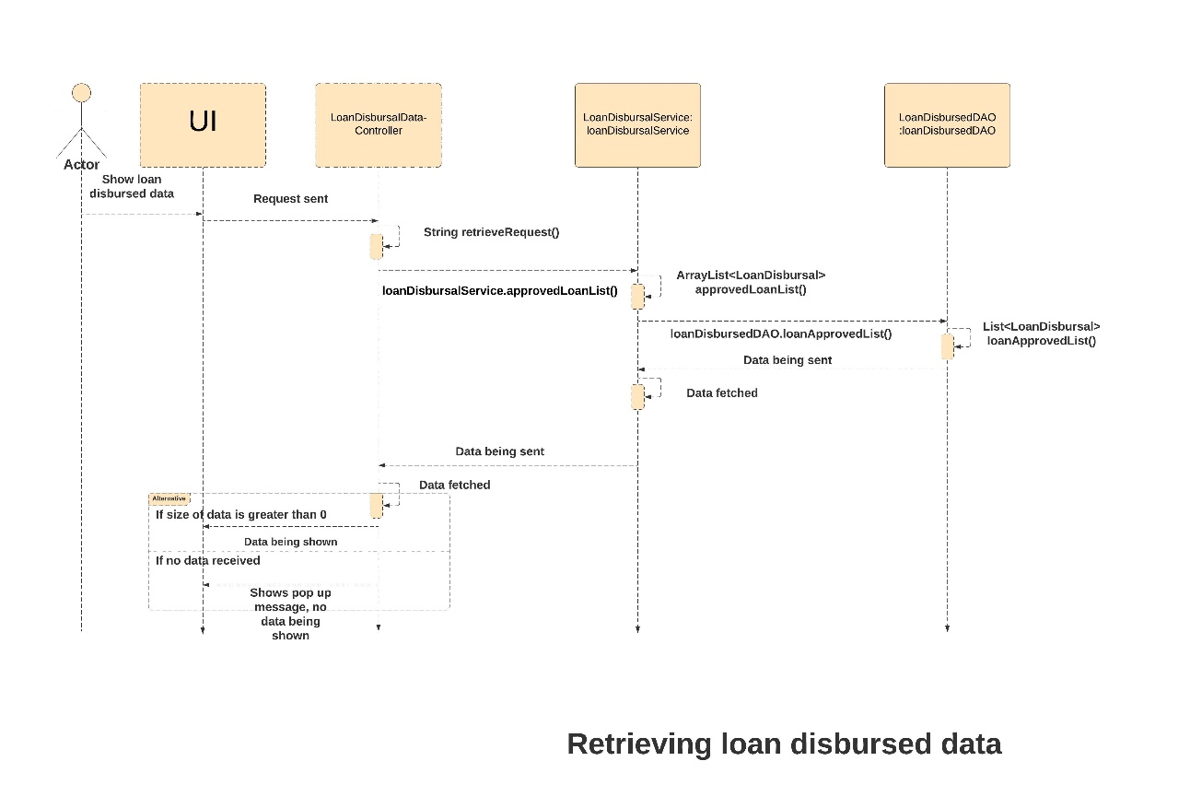

*Sequence Diagram for Updating Balance:*

