### **Webservers:**

#### **Httpd:**

Running httpd service with 444 port

First add security group with 444 port

And create a configuration file in instance

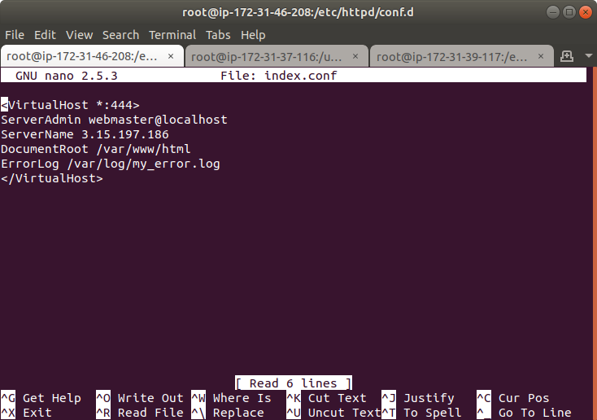

Edit httpd.conf file in etc/httpd/conf

Comment the listen 80 line and add a new line listen 444

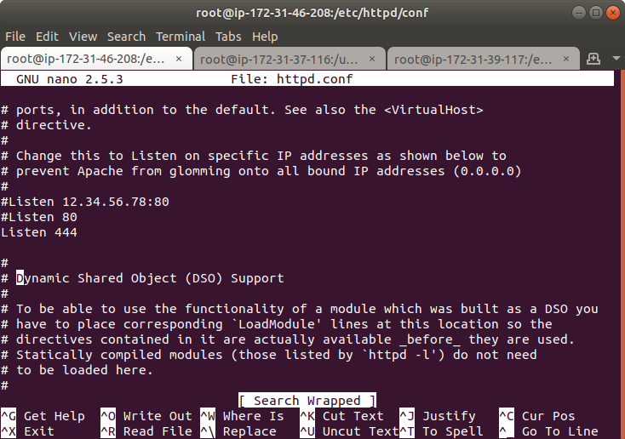

Start the httpd service and enter the ip address of instance along with port 444 we can see the webpage running.

#### **Nginx load balancer:**

Create 3 instances one for load balancer and another two for servers

In the load balancer instance create a configuration file

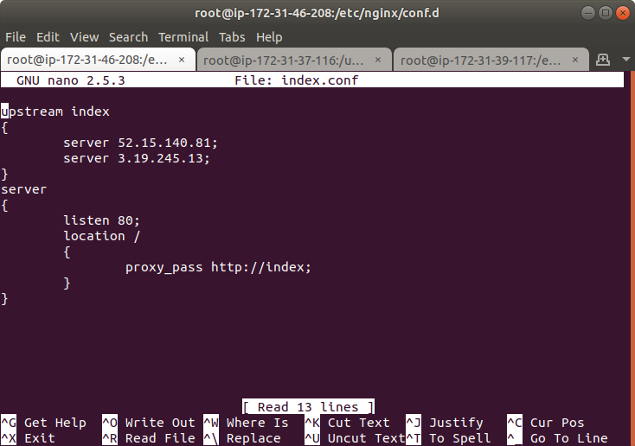

Comment the server part in nginx.conf in /etc/nginx

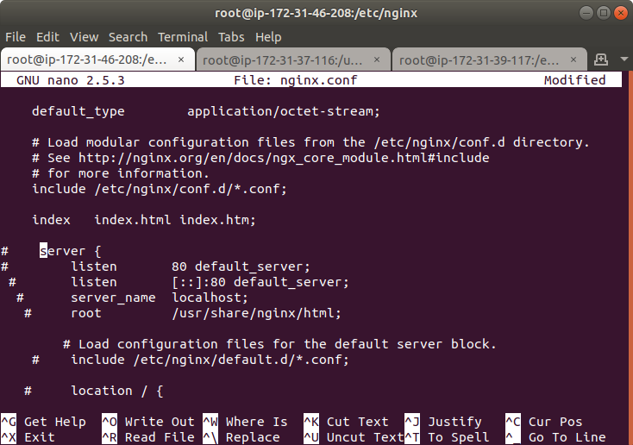

And in the servers create a configuration file in /etc/nginx/conf.d

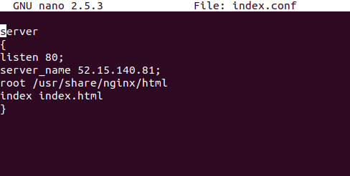

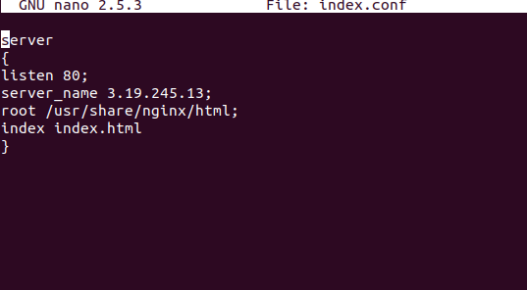

And create an html file in both the servers in /usr/share/nginx/html

Enter the ip address of the load balancer and the html page of 1st server will be displayed and refresh the page html page of second server will be dispalyed.





#### **HAProxy:**

Create 3 instances one for load balancer and another two for servers

Install haproxy and edit its configuration file

nano /etc/haproxy/haproxy.cfg

Define the name for frontend and give ip and port

Define backend

In the backend give the ip address of servers along with port numbers.

Start haproxy service

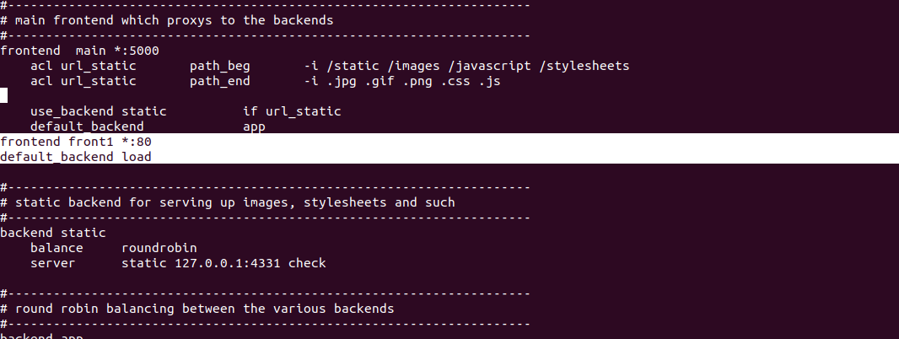

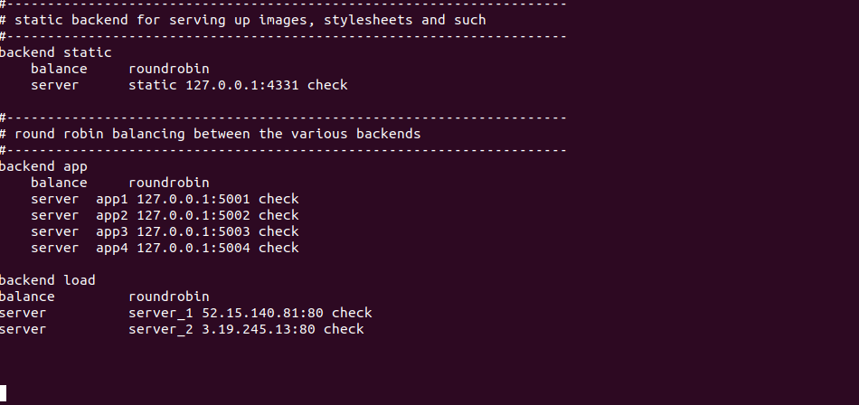

Enter the ip address of load balancer and check whether it is working as load balancer or not

