### **SSL:**

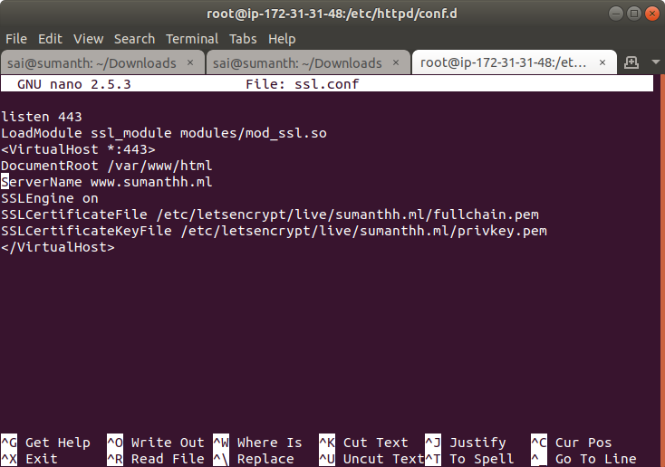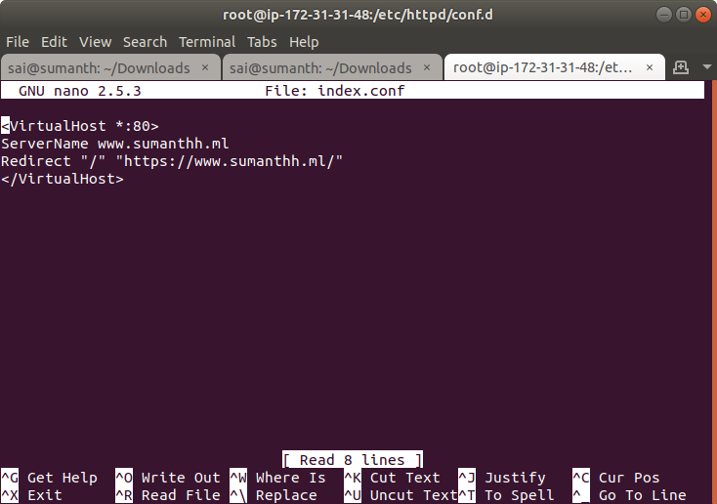

sudo yum update && sudo yum upgrade

sudo git clone https://github.com/letsencrypt/letsencrypt /opt/letsencrypt

cd /opt/letsencrypt

sudo -H ./letsencrypt-auto certonly --standalone -d sumanthh.ml -d [www.sumanthh.ml](http://www.sumanthh.ml)

sudo ls /etc/letsencrypt/live

