To install jenkins you need the latest version of java

In amazon linux java 1.7 is installed default remove java 1.7 and install java 1.8

To remove java 1.7

*yum erase java-1.7.0-openjdk*

To install java 1.8

*yum install java-1.8.0-openjdk.x86_64*

Check the java version by using

*java -version*

And install jenkins

Add the Jenkins repository so that yum knows where to install Jenkins from.

*sudo wget -O /etc/yum.repos.d/jenkins.repo* [*http://pkg.jenkins-ci.org/redhat/jenkins.repo*](http://pkg.jenkins-ci.org/redhat/jenkins.repo)

We’re adding the Jenkins GPG key to our trusted keys so that we’re able to install Jenkins, verifying that the files are being sourced from a trusted location.

*sudo rpm --import http://pkg.jenkins-ci.org/redhat/jenkins-ci.org.key*

We’ve prepared our environment with the required dependancies so we can now install Jenkins.

*sudo yum install jenkins*

Before starting jenkins make sure that port 8080 is opened and no other process is running on port 8080

*service jenkins start*

Ffdsa

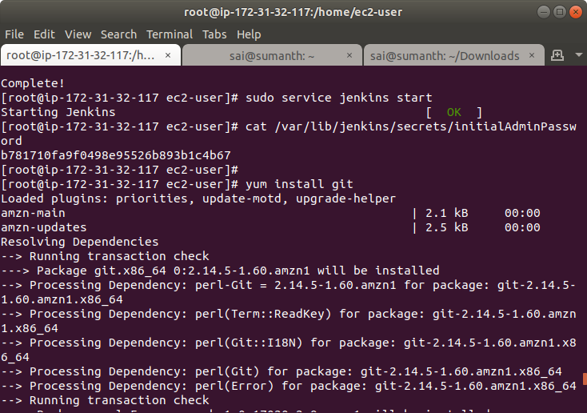

Open a web browser and type the ip address of the instance along with port 8080

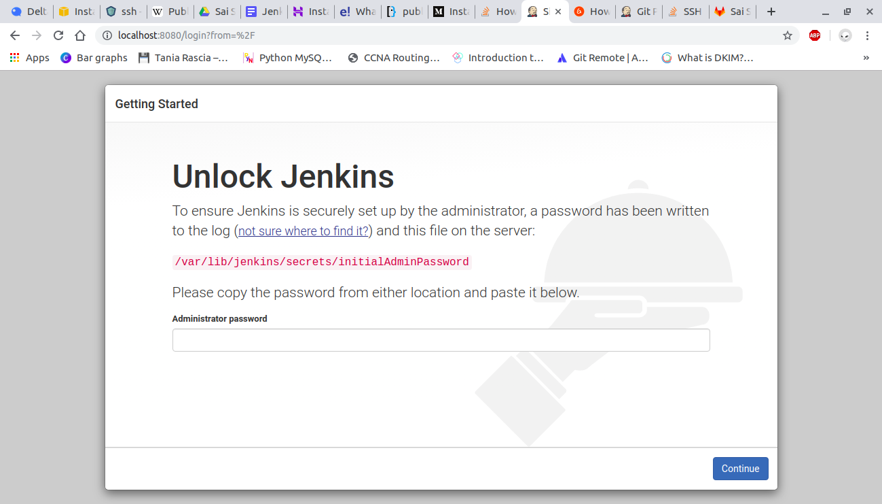

Open the file /var/lib/jenkins/secrets/initialAdminPassword and login using that password

1.Install suggested plugins

2.After installing it will ask to create a user

3.Once you have filled the above data, finally it will ask for URL information where you can configure the default instance path for Jenkins. Leave it as it is to avoid any confusions later.

4.Jenkins is ready to use now.

First install git plugin

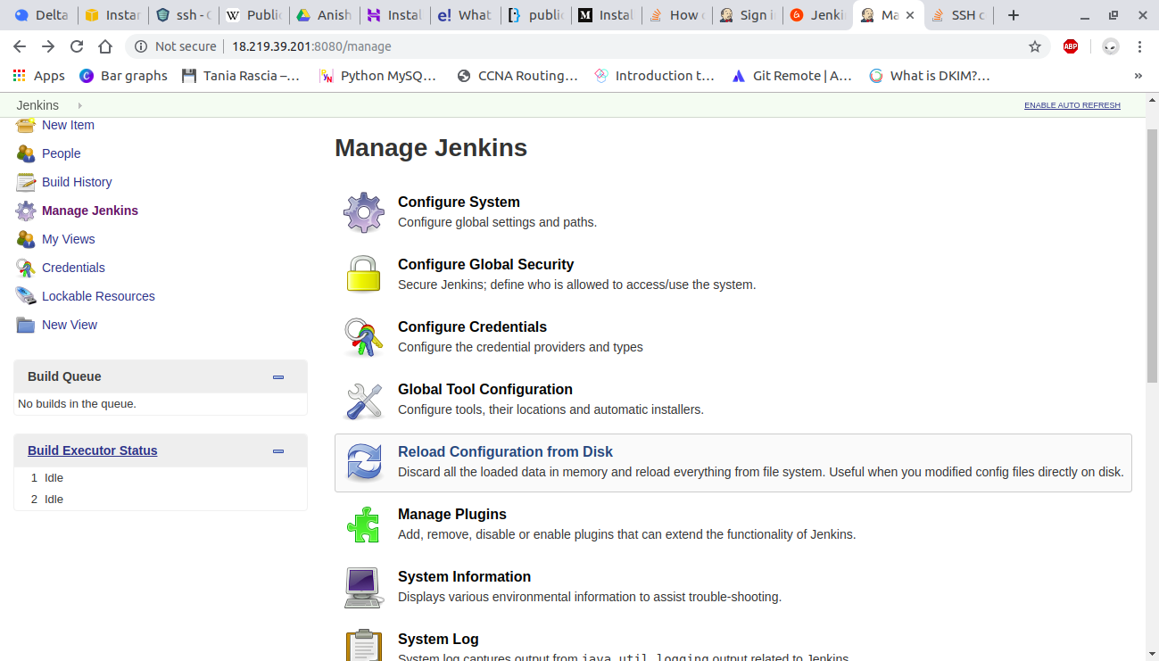Click on manage jenkins on left side and click on manage plugins

And install git plugin

A plug-in is a software component that adds a specific feature to an existing computer program

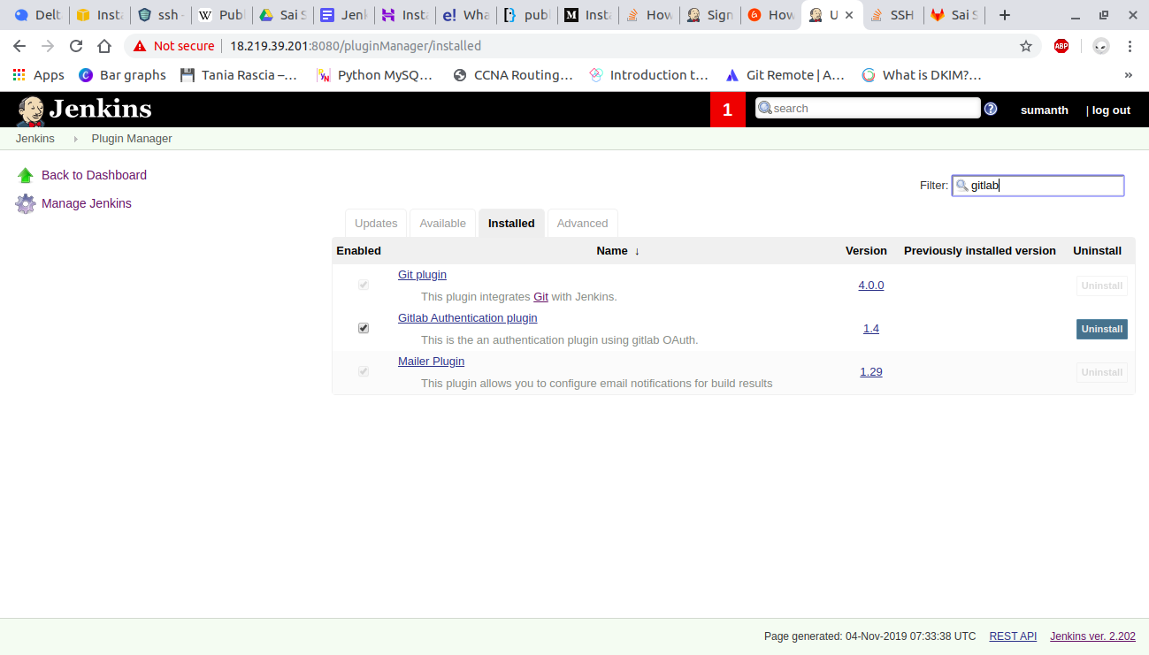

Create a new job in the dashboard

And in the source code management select git

And in the url add the url of git repository

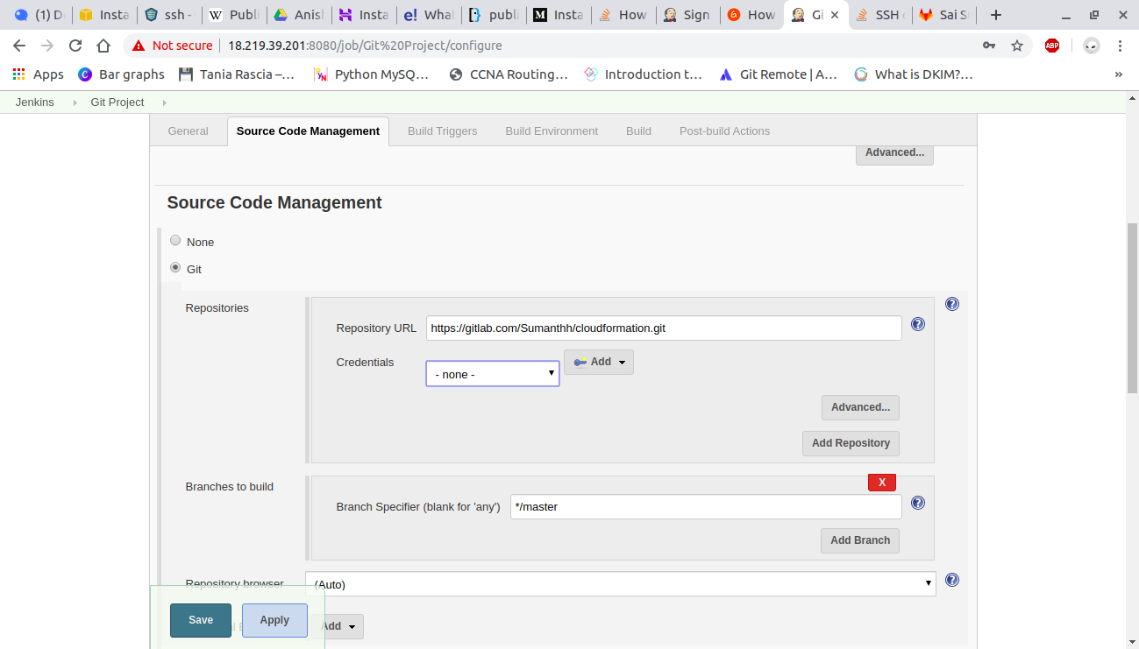

And in build select execute shell

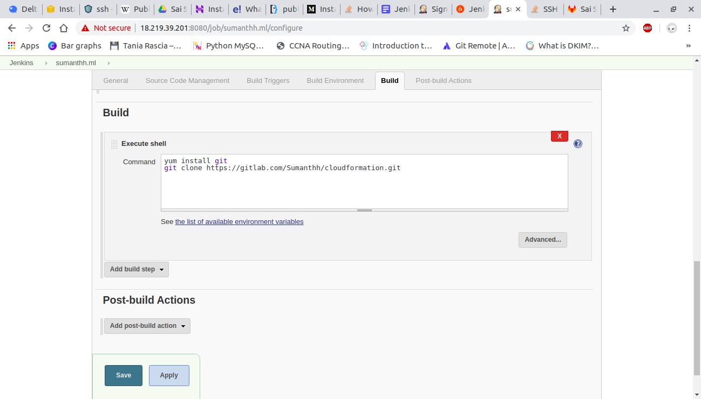

Save and exit

Open the project and build it.

And open workspace there we can see the cloned repository.

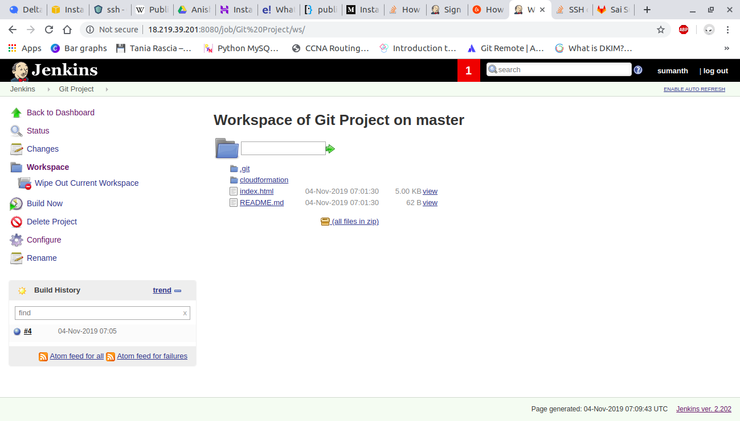

To push the contents into s3 bucket:

First create an IAM role of ec2 with s3 access attach it to ec2 instance

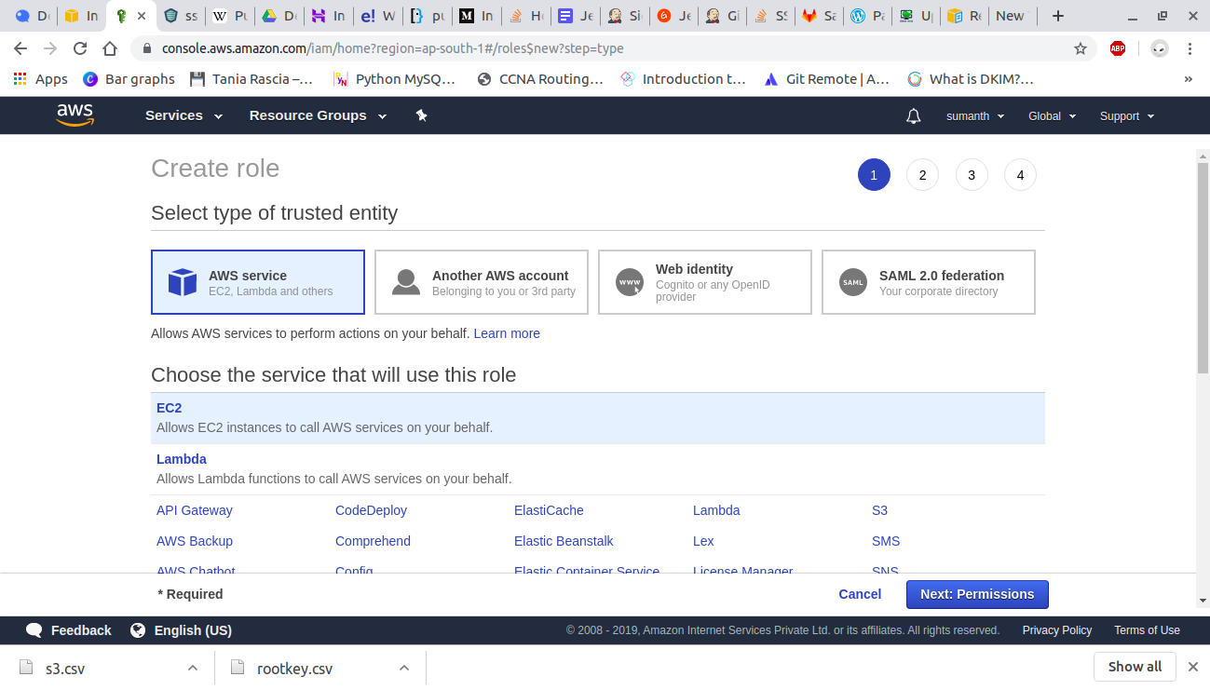

Giving s3 permissions:

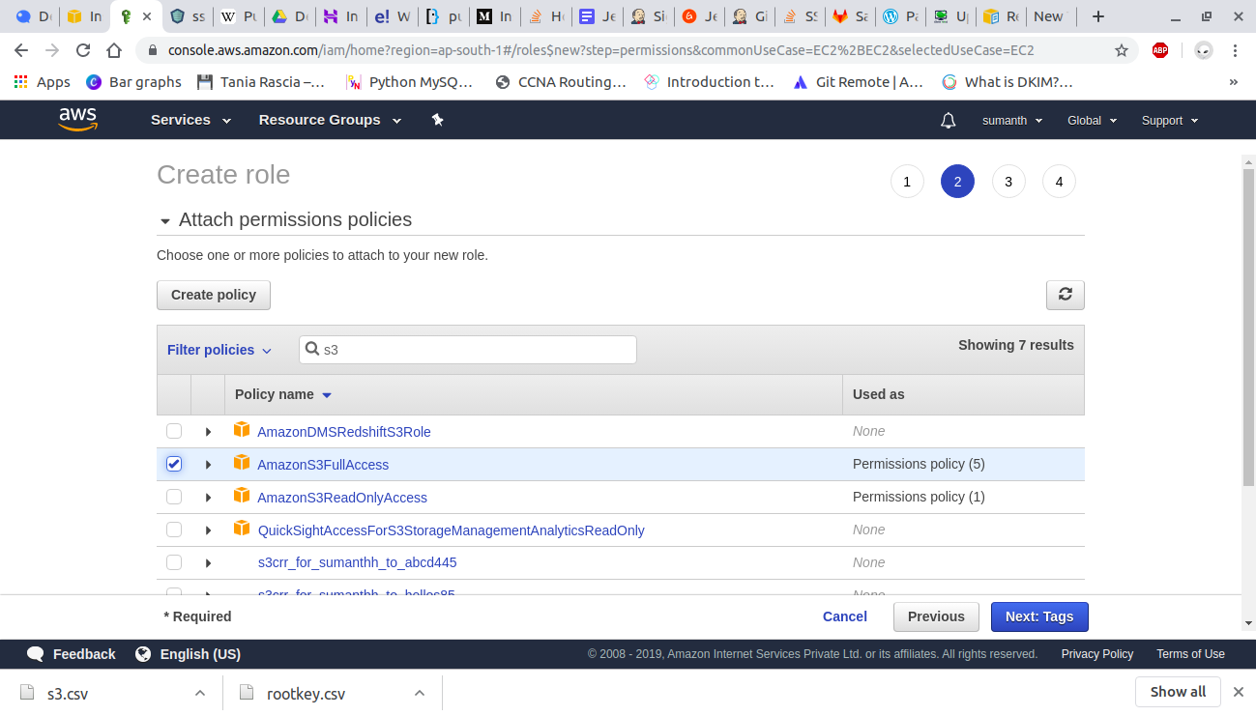

Create IAM user with s3 permissions.

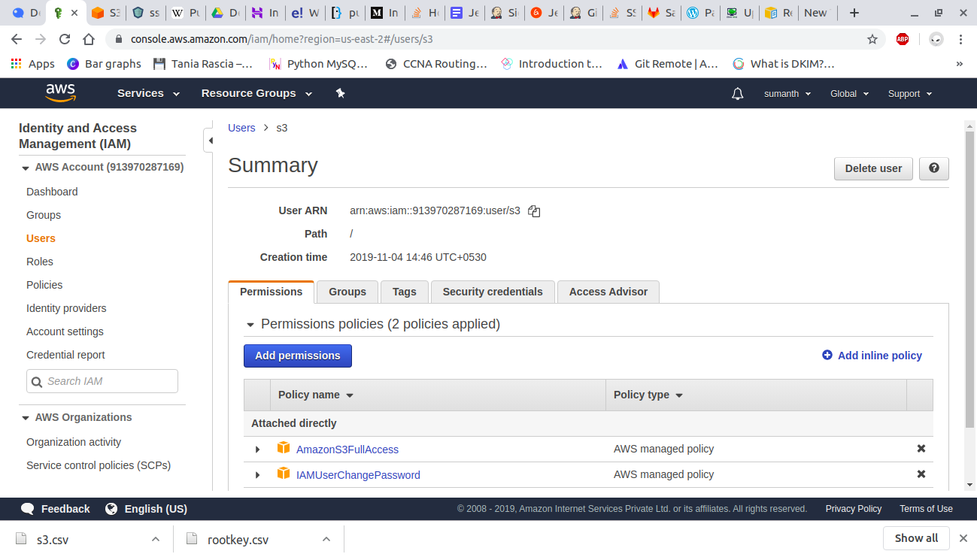

Go to Manage Jenkins and select Configure System. look for Amazon S3 Profiles.

Click on Add button for add S3 profile.

Please provide a profile name, access key and secret access key for your AWS account. also, Create an IAM user with the relevant S3 Permissions.

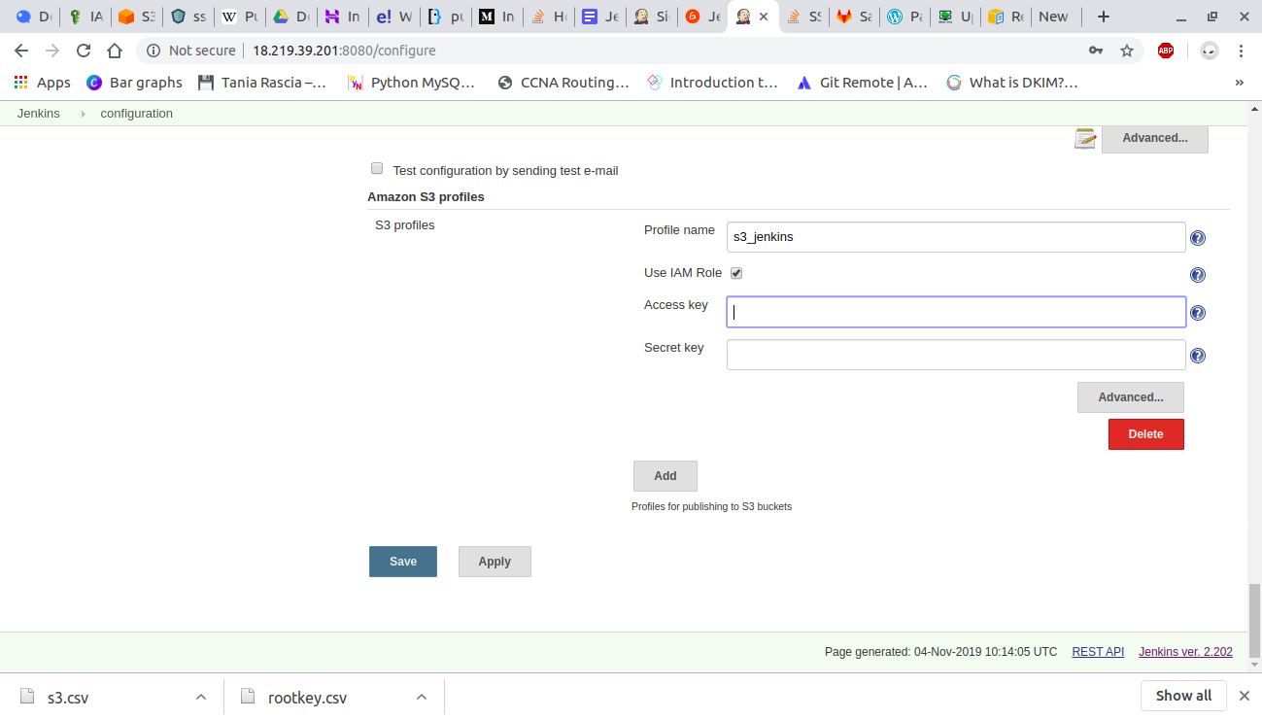

Configure in jenkins job

Go to Jenkins job and find Post Build Actions and add a new Post Build Action and select Publish Artifacts to S3 Bucket.

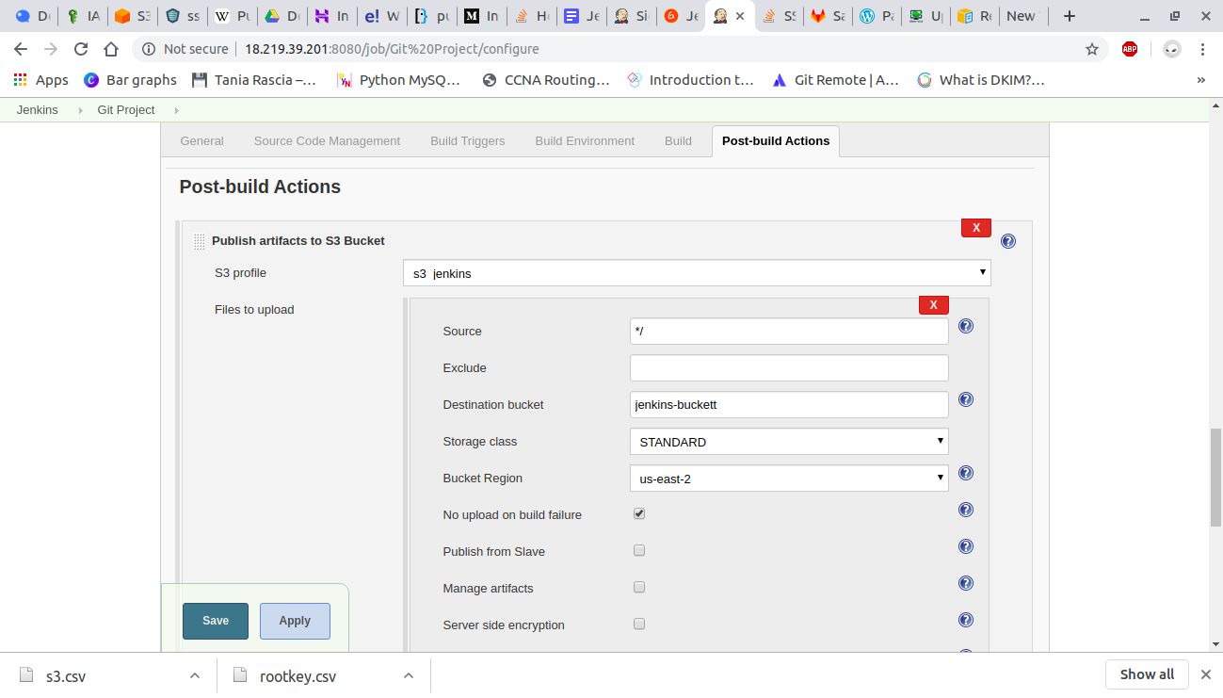

Click Build Now

Go to AWS S3 and verify it's upload or not.

