### **Shell:**

A shell is a special user program which provides an interface to user to use operating system services. Shell accept human readable commands from user and convert them into something which kernel can understand. It is a command language interpreter that execute commands read from input devices such as keyboards or from files. The shell gets started when the user logs in or start the terminal.

#### **Types of shell:**

##### **Bourne Shell**

- Bourne shell (sh)

- Korn shell (ksh)

- Bourne Again shell (bash)

- POSIX shell (sh)

If you are using a Bourne-type shell, the default prompt is the $ character.

##### **C Shell**

- c shell (csh)

- TENEX/TOPS C shell (tcsh)

If you are using C type shell, the default prompt is % character.

Shell Prompt:

The shell prompt (or command line) is where one types commands.

##### **How to change default shell:**

To display the default shell write *echo $0*

1. *Fdisk*

To check the partitions on your linux system

sudo fdisk -l

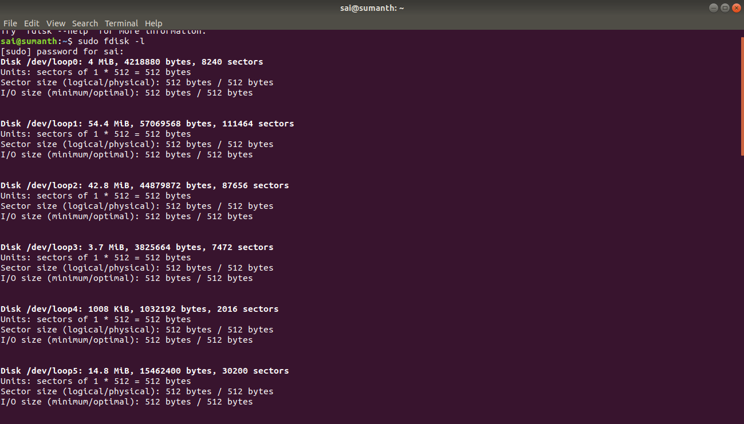

2.cfdisk

cfdisk can be used to list out the existing partitions as well as create or modify them.

cfdisk works with one partition at a time. So if you need to see the details of a particular disk, then pass the device name to cfdisk.

sudo cfdisk /dev/sda

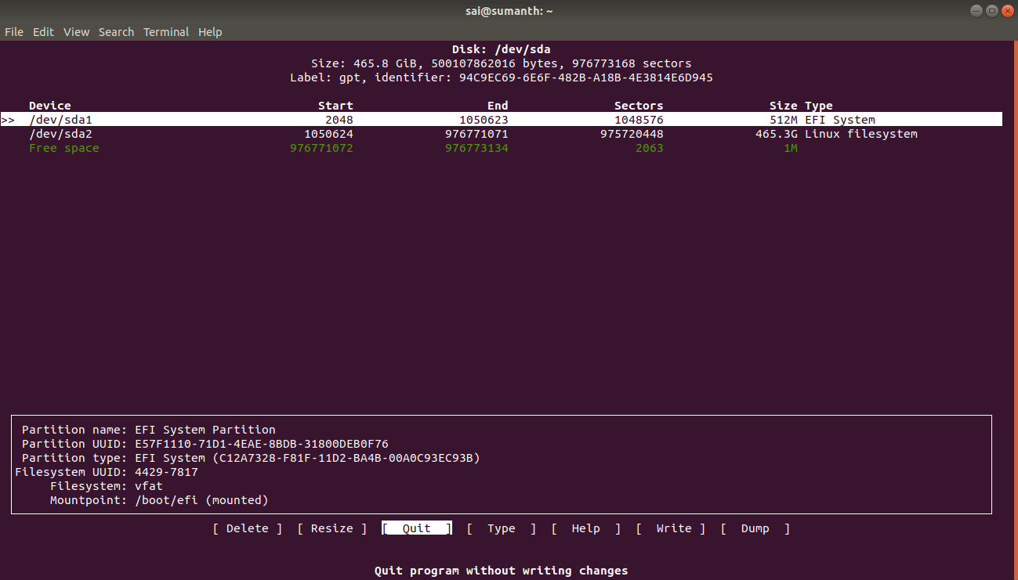

3.df

df -h

Df is not a partitioning utility, but prints out details about only mounted file systems. The list generated by df even includes file systems that are not real disk partitions.

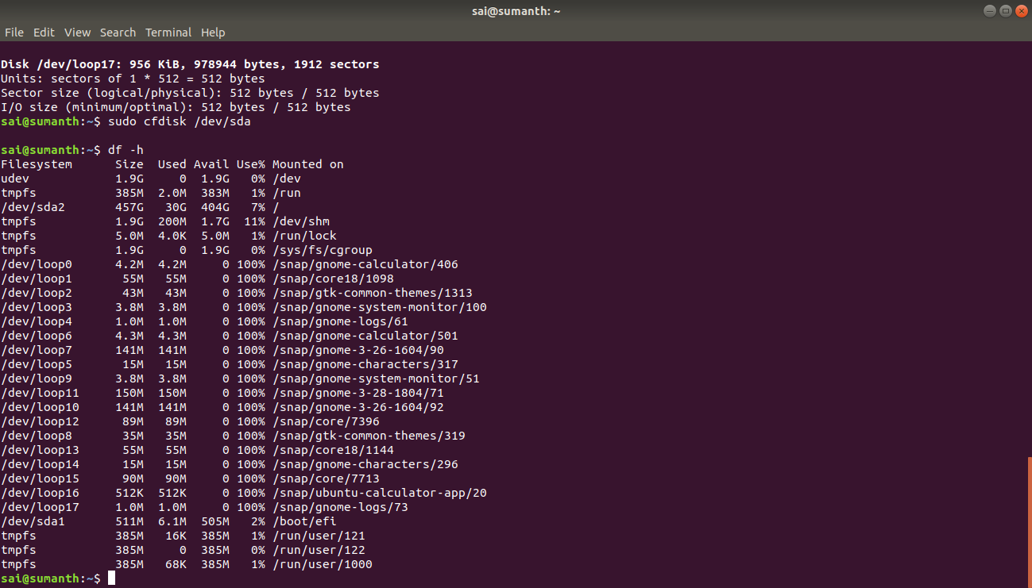

4.sed:

sed 's/unix/linux/' abc.txt //replaces unix with linux

sed ‘s/unix/linux/2’ abc.txt //replaces 2nd occurence of unix with linux

sed ’s/unix/linux/3g’ abc.txt //replaces all unix with linux from 3rd occurance

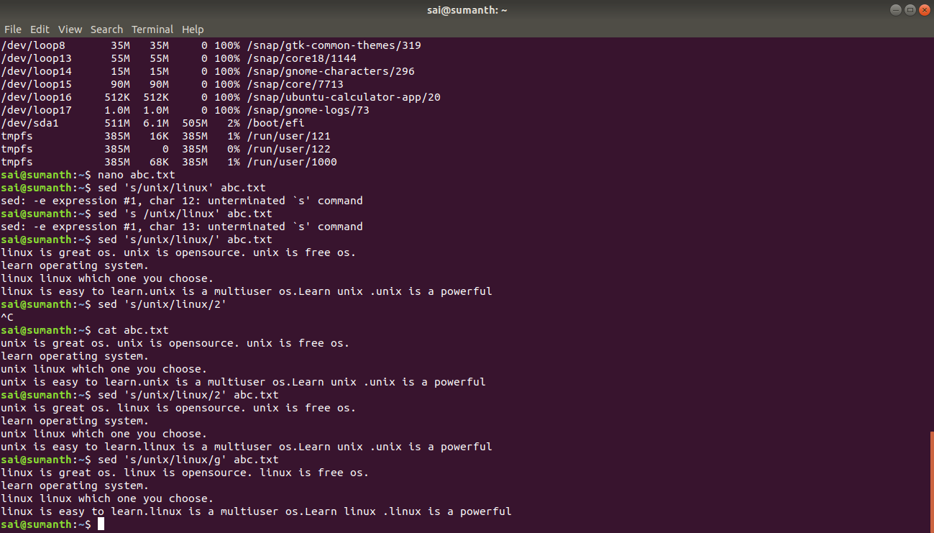

5.top:

Top command is used to know the cpu usage and memory usage

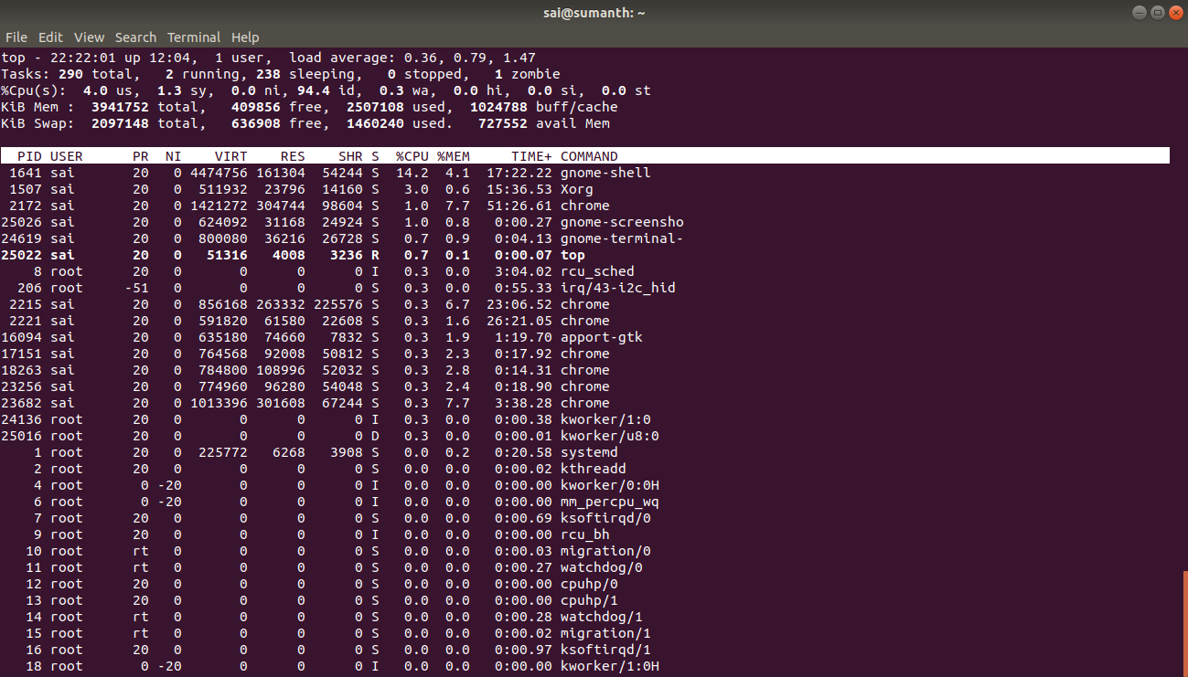

6. iostat

The iostat command reports Central Processing Unit (CPU) statistics and input/output statistics for devices and partitions. It can be use to find out your system's average CPU utilization since the last reboot.

Iostat

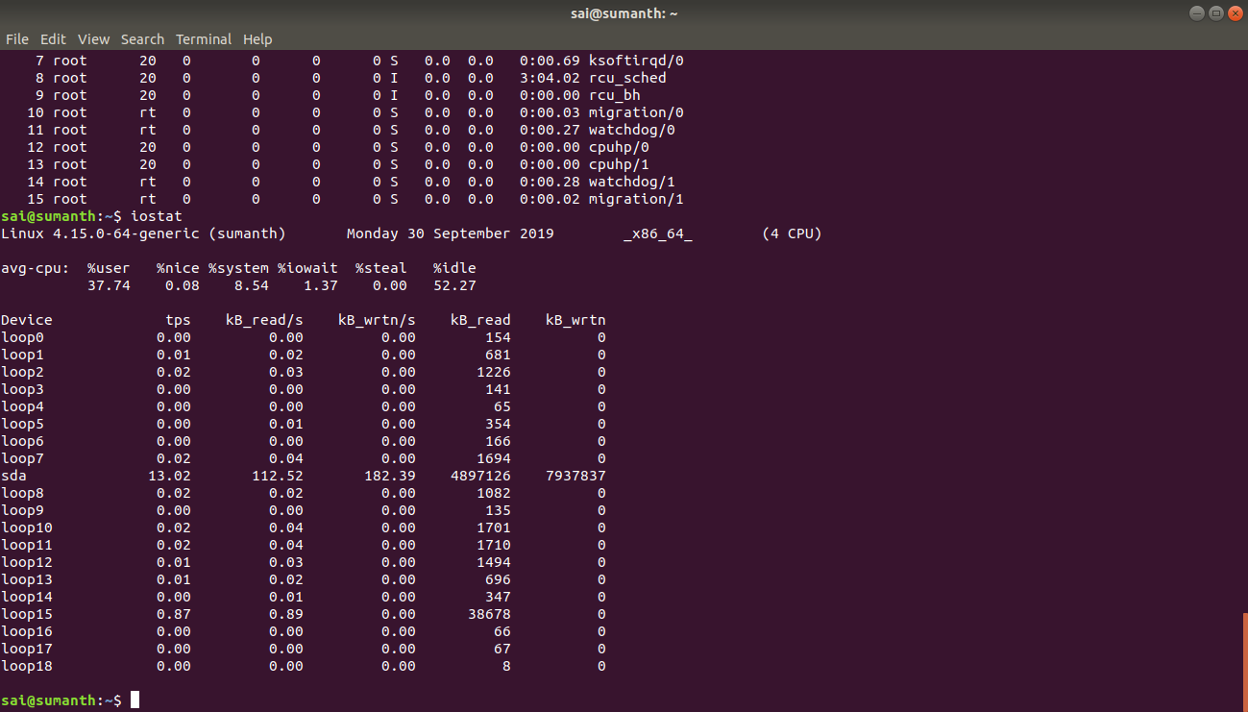

7. Tree

Sudo apt install tree

Tree -L 1

The instruction above can be translated as “show me only the 1st Level of the directory tree starting at / (root)“. The -L option tells tree how many levels down you want to see.

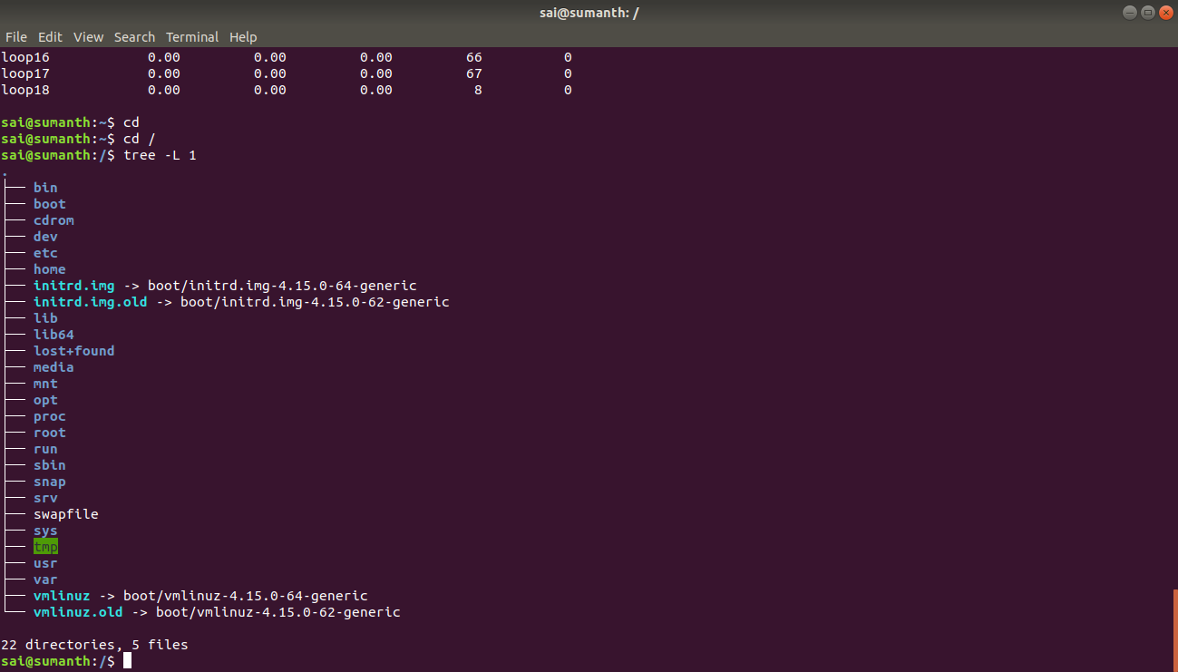

8. Grep command:

Grep command is used to search file that have a certain pattern.

Various options that can be used along with grep command

-v prints all the lines that do not contain specified pattern

-n prints the matched line and line number

-c prints count of matching lines or files

-i either uppercase or lowercase

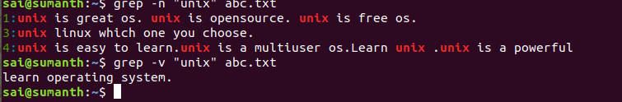

9.vmstat:

vmstat -a //List Active and Inactive Memory

vmstat 2 6 //vmstat execute every two seconds and stop automatically after executing six intervals.

vmstat -t 1 5 //t parameter shows timestamps with every line printed

vmstat -s //s switch displays summary of various event counters and memory statistics.

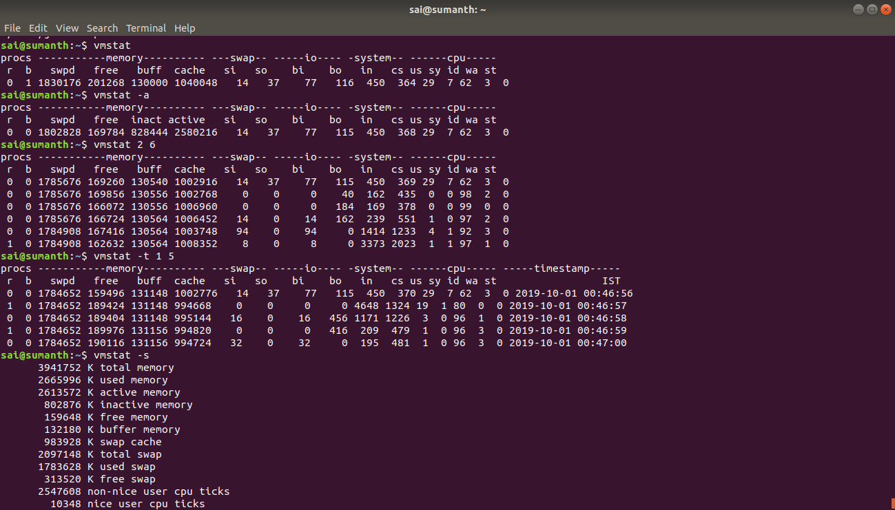

10.less

less /proc/meminfo

Less command is linux utility which can be used to read contents of text file one page(one screen) per time. It has faster access because if file is large, it don’t access complete file, but access it page by page.

less filename

11.find:

find //lists all files found in current directory and its hierarchy

find ./home/sai //List all files found in the current hierarchy, and all the hierarchy below /home/sai

find ./ -name abc.txt //Search for a file by the name abc in the current directory and its hierarchy

find ./ -type d name abc //Search for a directory by the name xyz in the current directory and its hierarchy

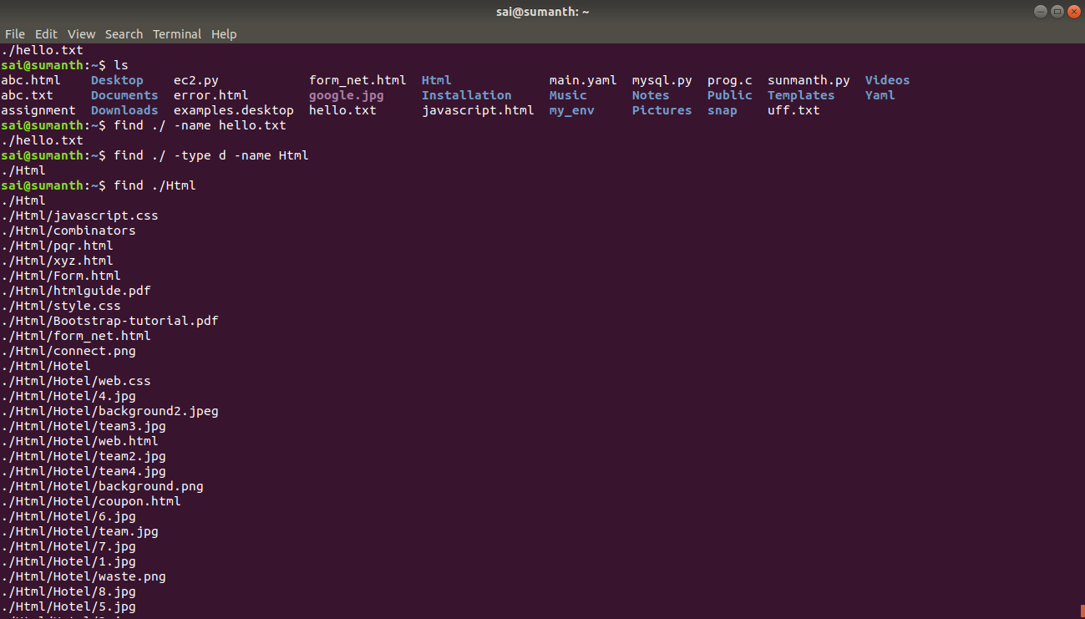

12. Dpkg:

dpkg -l //To view and list all the installed packages, use the “-l” option along with the command.

dpkg -l apache2 //-l” along with package-name. For example, check whether apache2 package installed or not.

dpkg -L package name //To list location of files to be installed to your system from package-name.

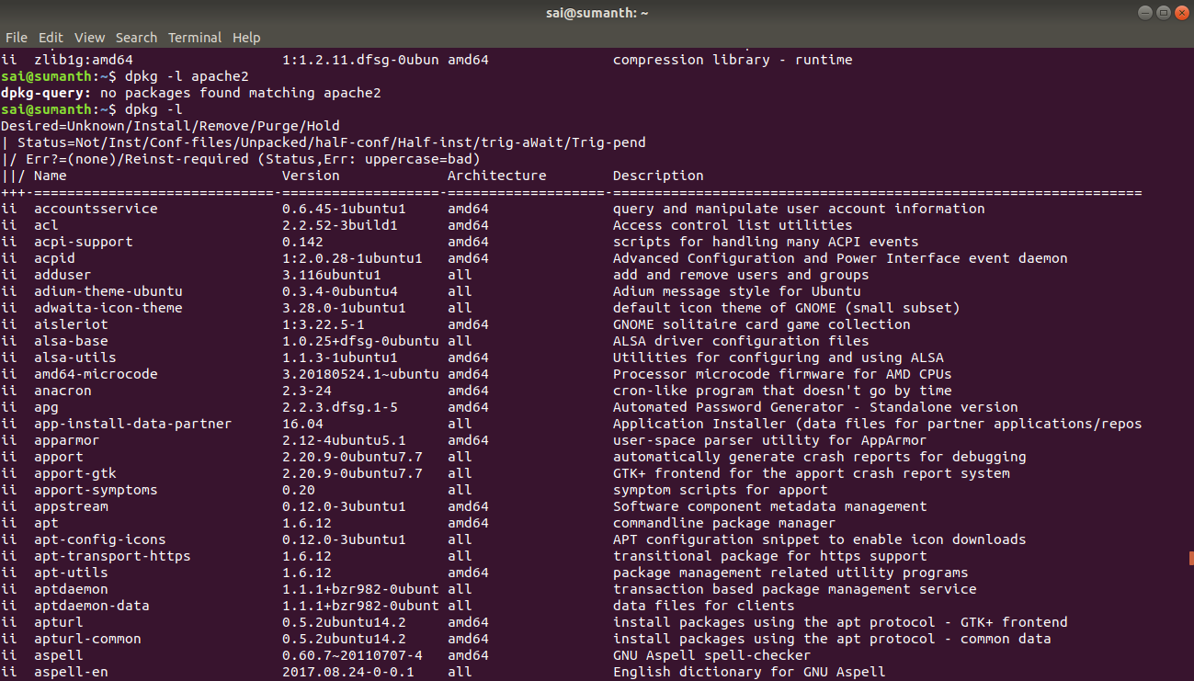

13. Wget:

Wget is the non-interactive network downloader which is used to download files from the server even when the user has not logged on to the system and it can work in the background without hindering the current process.

wget [option] [URL]

Options:

-b background

-i This option is used to read URLs from file.

wget -i abc.txt

-tries=number This option is used to set number of retries to a specified number of times.

14. Awk:

Awk command searches files for text containing a pattern. When a line or text matches, awk performs a specific action on that line/text.

The awk command in specific provides a scripting language for text processing. With awk scripting language, you can make the following:

Scans a file line by line

Splits each input line into fields

Compares input line/fields to pattern

Performs action(s) on matched lines

Print the lines which matches with the given pattern.

awk '/manager/ {print}' employee.txt

In example, the awk command prints all the line which matches with the ‘manager’.

Splitting a Line Into Fields :

awk '{print $1,$4}' employee.txt

In the above example, $1 and $4 represents Name and Salary fields respectively.

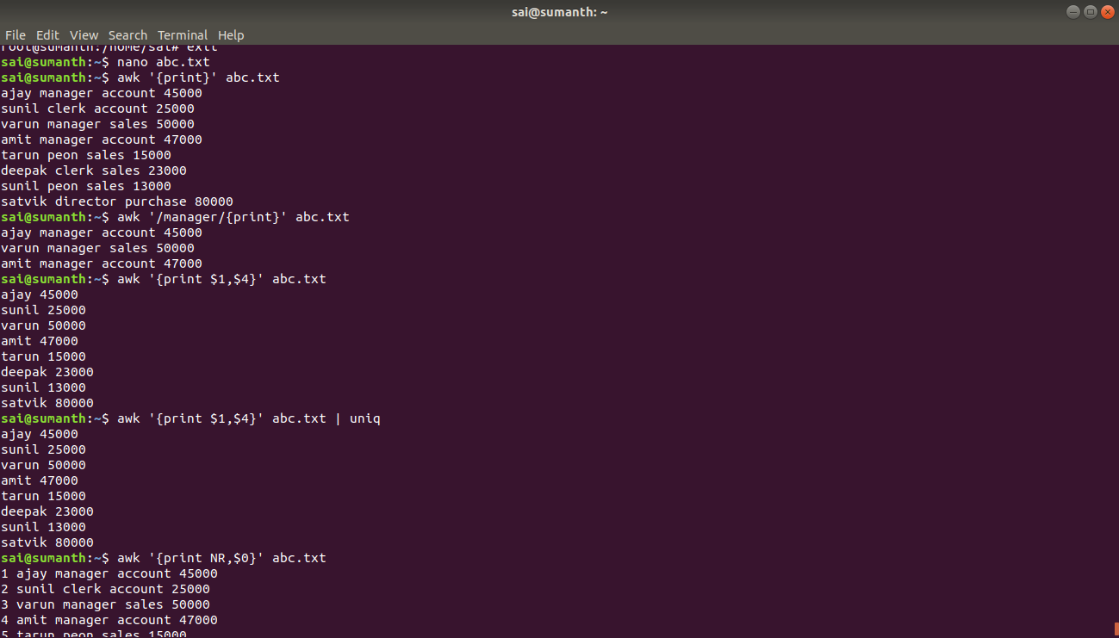

15.Cron:

The cron is a software utility, offered by Linux-like operating system which automates the scheduled task at a predetermined time. It is a daemon process, which runs as a background process and performs the specified operations at the predefined time when a certain event or condition is triggered without the intervention of a user.

cron [-f] [-l] [-L loglevel]

16. Tail:

Tail command is used view last 10 lines of file

-n to specify number of lines.

-f parameter to stay on the file and continue to watch the last lines you specified like monitoring, and this is very important when looking at log files.

Head command is used to display first 10 lines of the file.

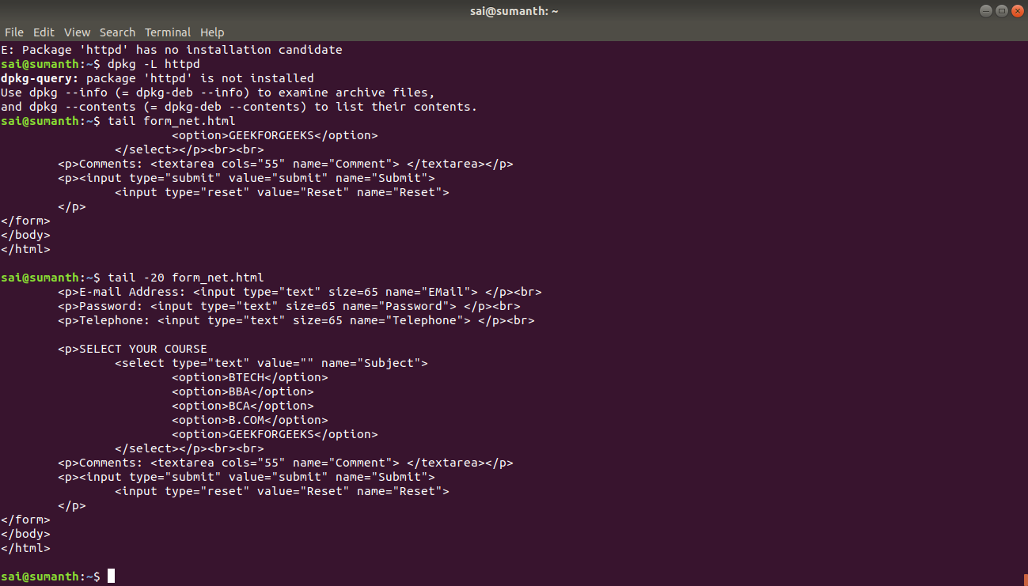

17. Sort command:

The sort command arranges lines of text alphabetically or numerically.

sort abc.txt | uniq

This will sort the given file and prints all the unique values.

Sort command arranges lines or text alphabetically by default. There are many options that control the string

-n sorts numerically

-r reverses the order of sort

+x ignores the x fields when sorting

ls -l | grep “html” | sort +4n

The sort option +4n skips four fields (fields are separated by blanks) then sorts the lines in numeric order.

18. Ls command:

ls -l //display the contents of the current directory in a long list format.

ls -lh // Displaying Size in Human Readable Format

ls -lhS //Sort According to File Size

ls -l --block-size=K //displays size in kilobytes

K = Kilobyte

M = Megabyte

G = Gigabyte

T = Terabyte

P = Petabyte

E = Exabyte

Z = Zettabyte

Y = Yottabyte

ls -a //displays hidden files

ls -d */ //displays only subdirectories

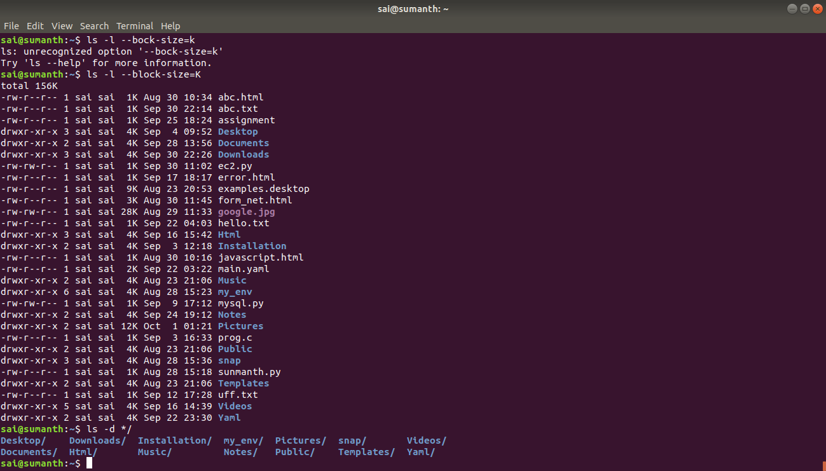

19. Dig:

Dig is a tool for querying DNS nameservers for information about host addresses, mail exchanges, nameservers, and related information.

dig google.com +nocomments //turn off all comments

dig google.com +noadditional //turn off additional section

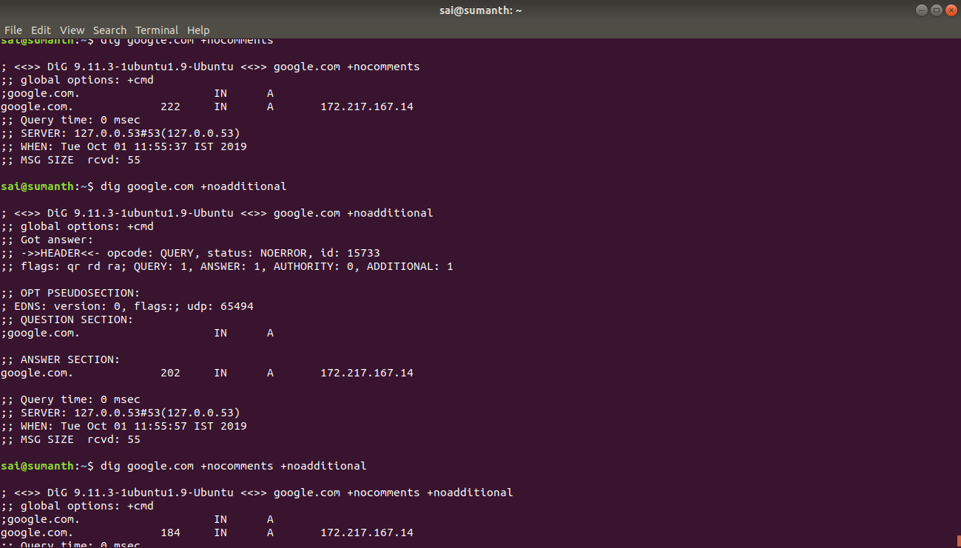

20. Mkpasswd:

The makepasswd command generates true random passwords using /dev/urandom.

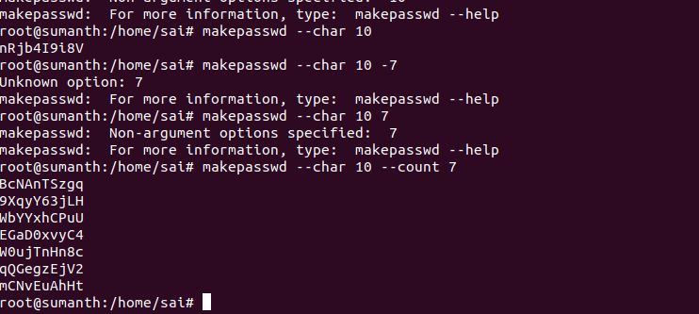

sudo apt-get install makepasswd

21.pwgen:  
The pwgen command generate pronounceable passwords.

*sudo apt-get install pwgen*

*pwgen*

*pwgen -N 1*

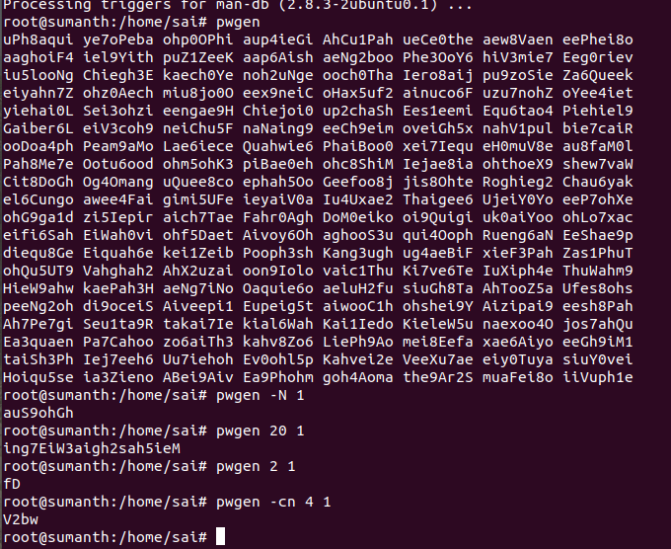

pwgen

pwgen -N 1

pwgen [options]

Options:

-c //include atleast one capital letter in password

-A //donot include capital letter in password

-n //include at least one numerical in password

-0 //no numericals

-s //secure generate completely random passwords

pwgen 4 1 //create one password with four characters.

### **Shell scripting:**

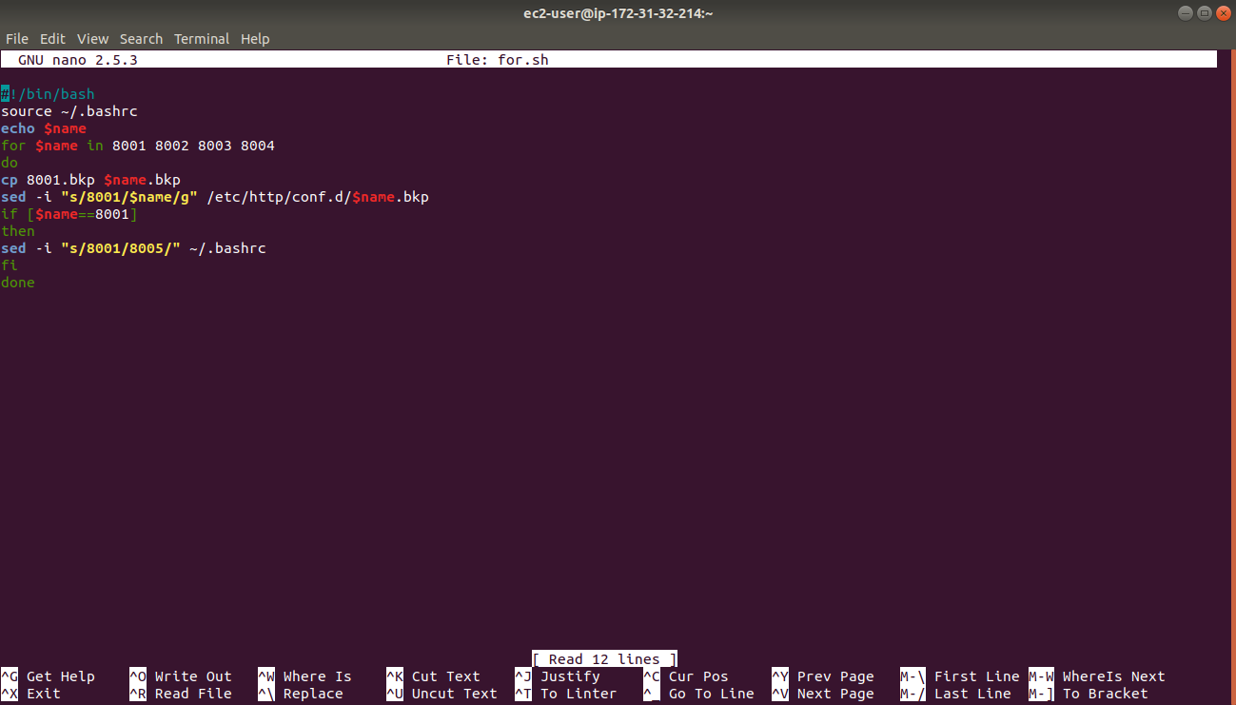

I created a .bkp file in ~/.ssh with and declared a variable name in .bashrc

And created five more .bkp files using for loop and changed the value of variable

Shell script to create a user in ec2 instance and ssh the user:

