### **New Relic:**

First install node js in server using

*curl -sL https://rpm.nodesource.com/setup_10.x | sudo bash -*

*sudo yum install nodejs*

Verify node js and npm installation using

*node --version*

*npm --version*

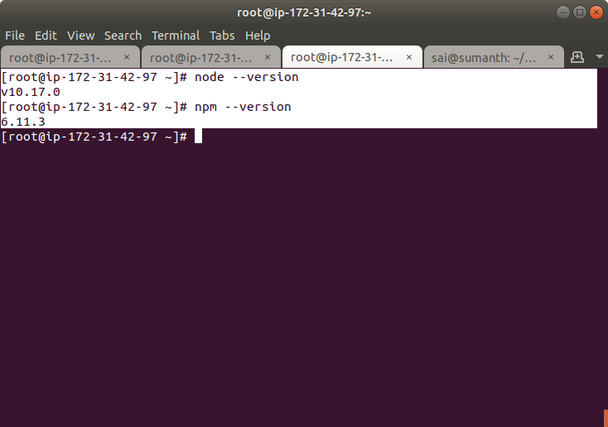

Install the New Relic Node.js agent

*npm install newrelic*

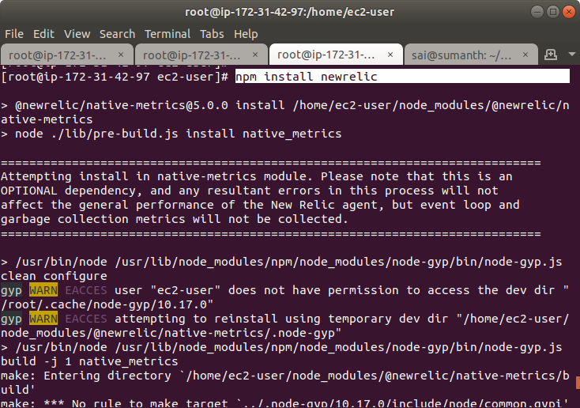

Copy the newrelic.js from node_modules/newrelic to root directory of application

*cp ./node_modules/newrelic/newrelic.js .*

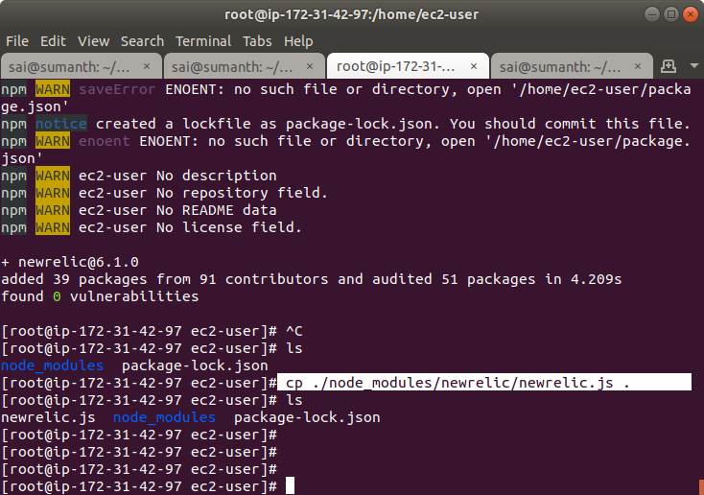

Open the newrelic.js file and add the license_key and app_name

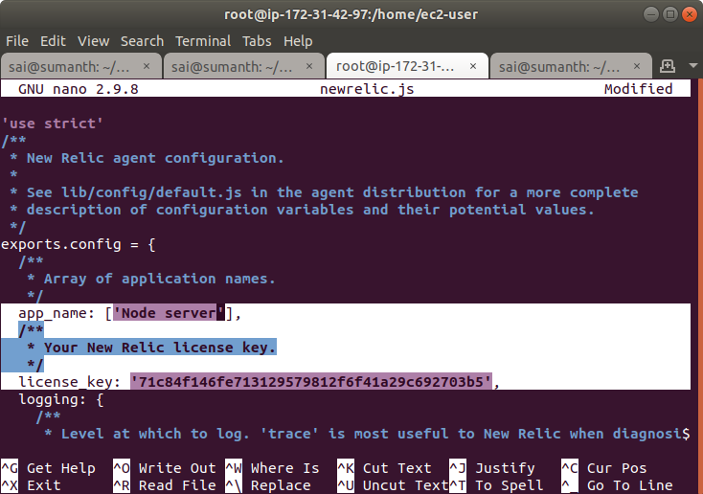

Create an app.js and execute it

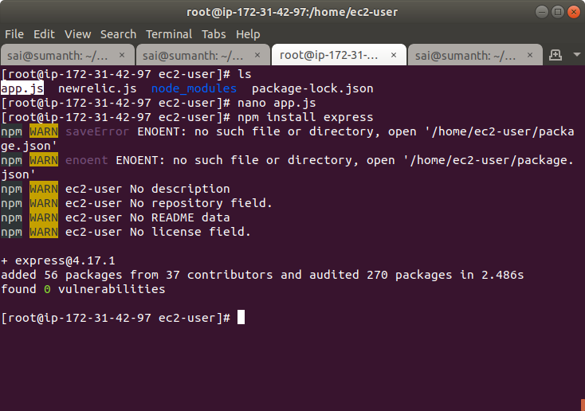

Include new relic in your application

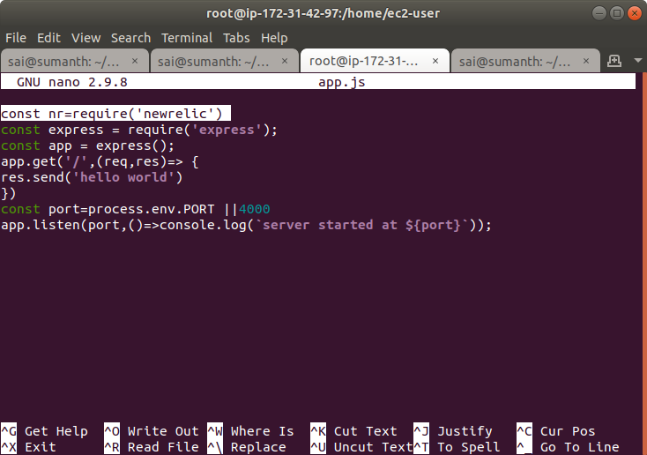

Open the 4000 port in the security group for the server because here we are running our application on port number 4000

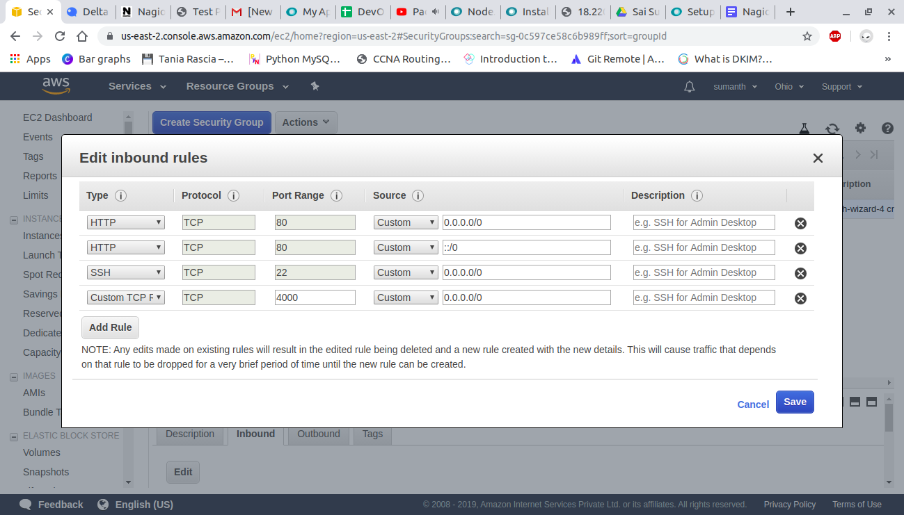

Execute your application using node

node app.js

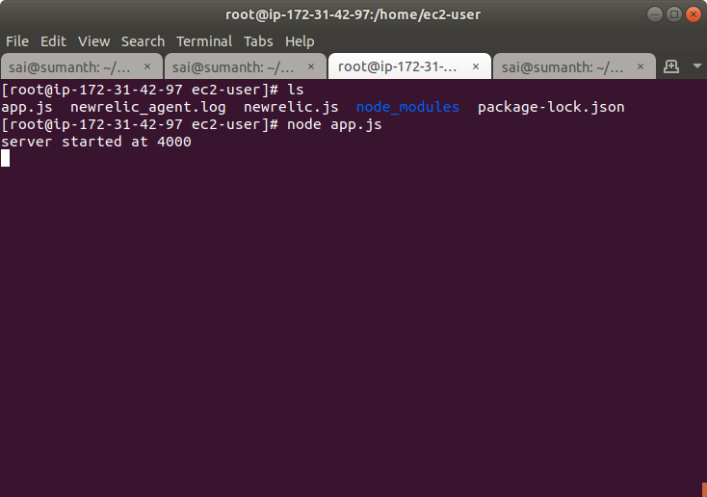

You can see the service is running on port 4000

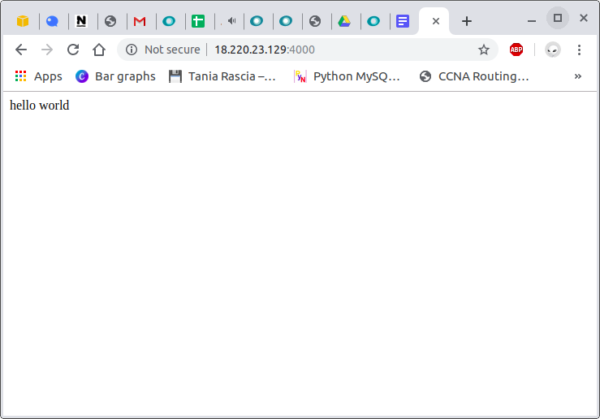

Now your application will be automatically detected in new relic

