**Version control or SCM(Source code management)**

GIT is not for only developers, it used for many purposes

* To store coding
* To store documents

**Install GIT:** Go to Google and search with “git-SCM” and install. Once install we can see below screen when you search in task bar as GIT

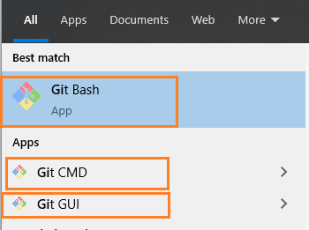

GIT is application where as GIT-HUB/Bitbucket/Azure Repo/GitLab are repositories

Currently GitHUB takenover by Microsoft.

**Create GITHUB account:**

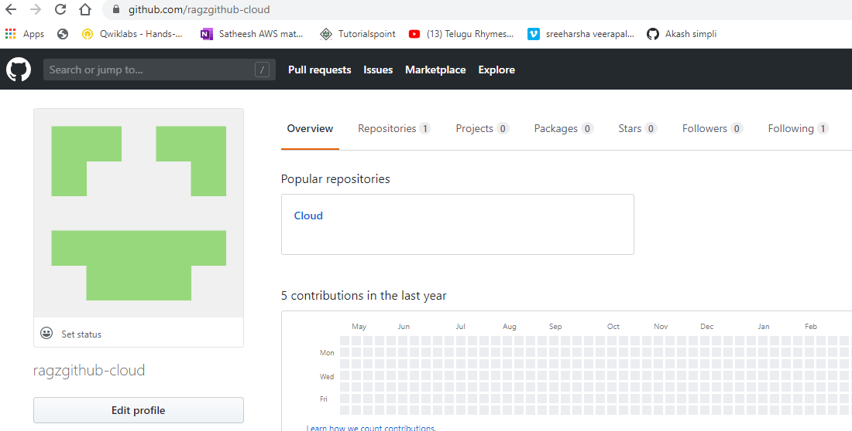

**Open Git CMD🡪Create directory in CMD**

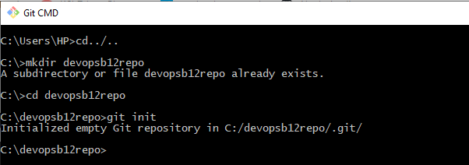

**Dir /s : will display hidden files**

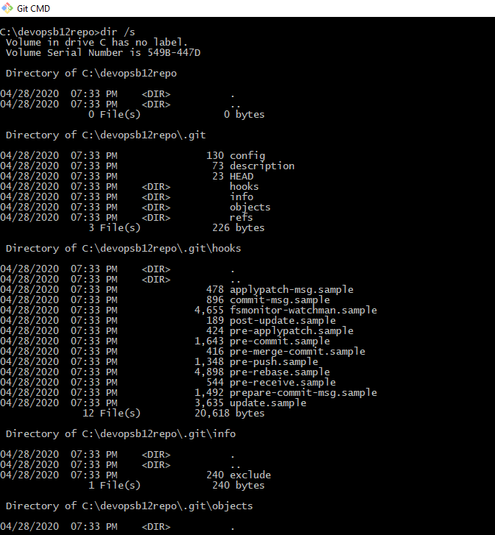

**Code .: It will open visual studio application**

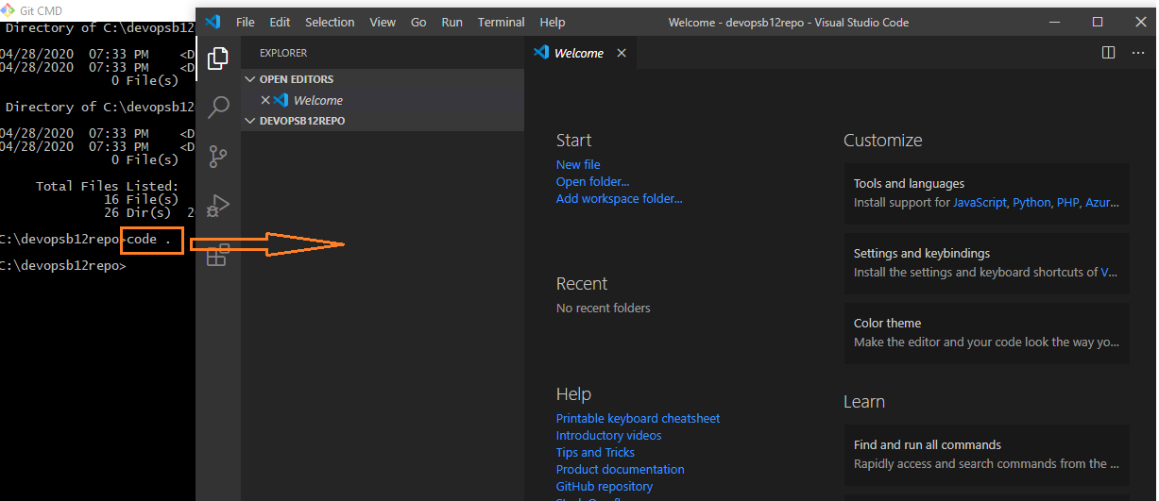

**Create new file🡪Name it as Readme.md**

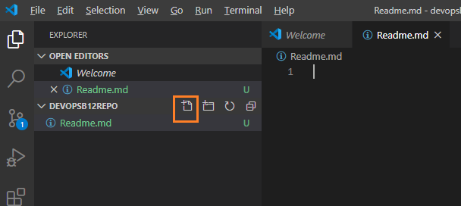

**Create Readme file content as below**

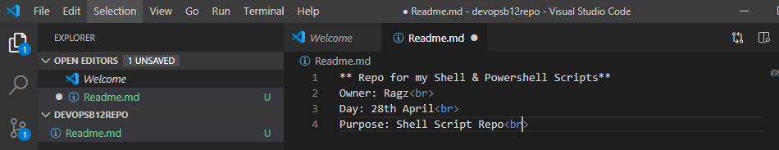

**Write a shell script in visual studio**

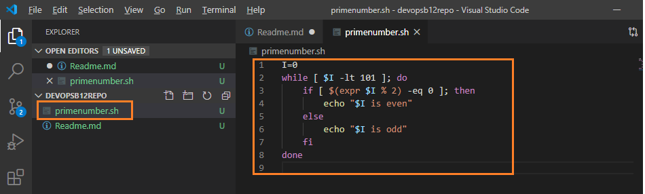

**git status command will show how many files are existed in repository**

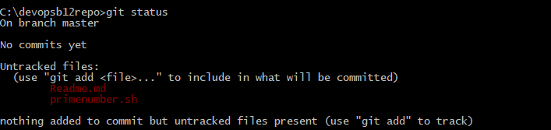

**Add one by one files like below**

**git add Readme.md🡪It will add from local repository to git repository**



**Again execute git status🡪readme.md file addedsuccessfully , still primenumber.sh not added.**

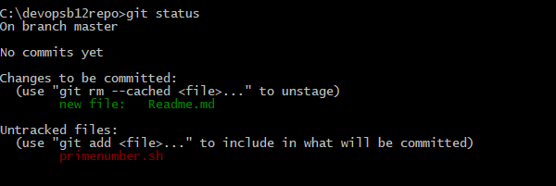

**Add all files to git repository:**



**Again check status: All files added now**

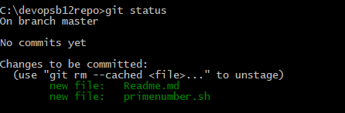

**To commit : git commit -m “added primarynumber script”**

**If you try to commit, you will get below error.**

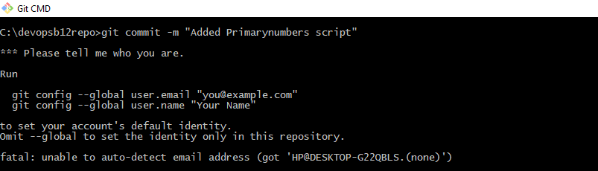

**Execute below config then try for commit.**

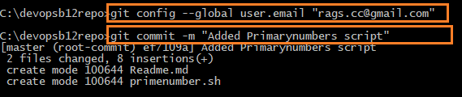



**git log: will display log id**

**in git application it will display only 7 characters in CMD it will display lengthy charater(in full)**

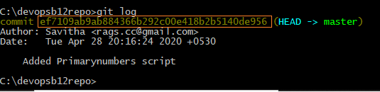

**Now add some modification to existing code**

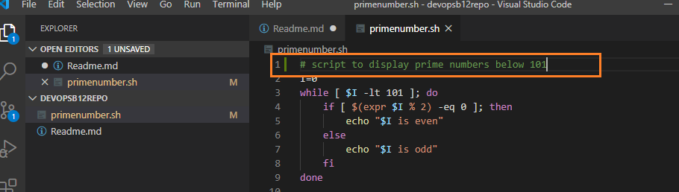

**Again do get status, get add. & git commit then see git log🡪It will display multiple version of changes**

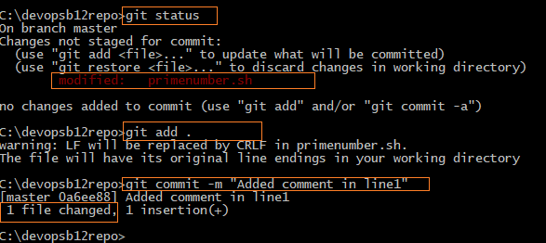

**Added two versions of code changes, can see in log history with time stamp, latest will display on top.**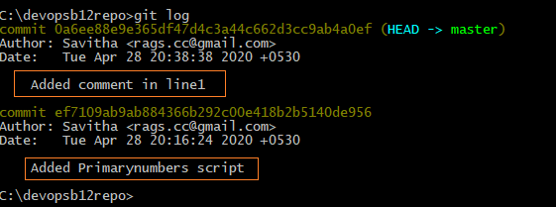

**To display log in oneline**



**Go back to previous version: git reset -keep pervious version number**

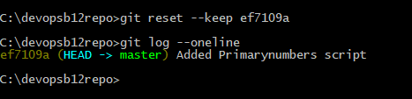

**Now how to exclude few files to commit like access key files, exe files should not be added in public access git hub**

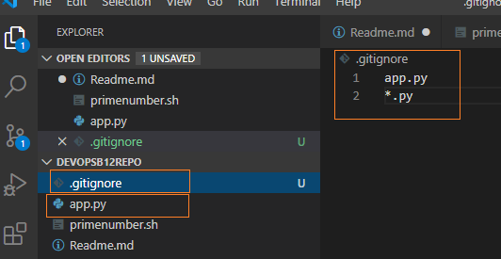

**App.py file is ignored because we kept code to exclude in “.gitignore”**

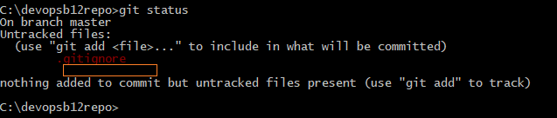

**How to push local to github repository**

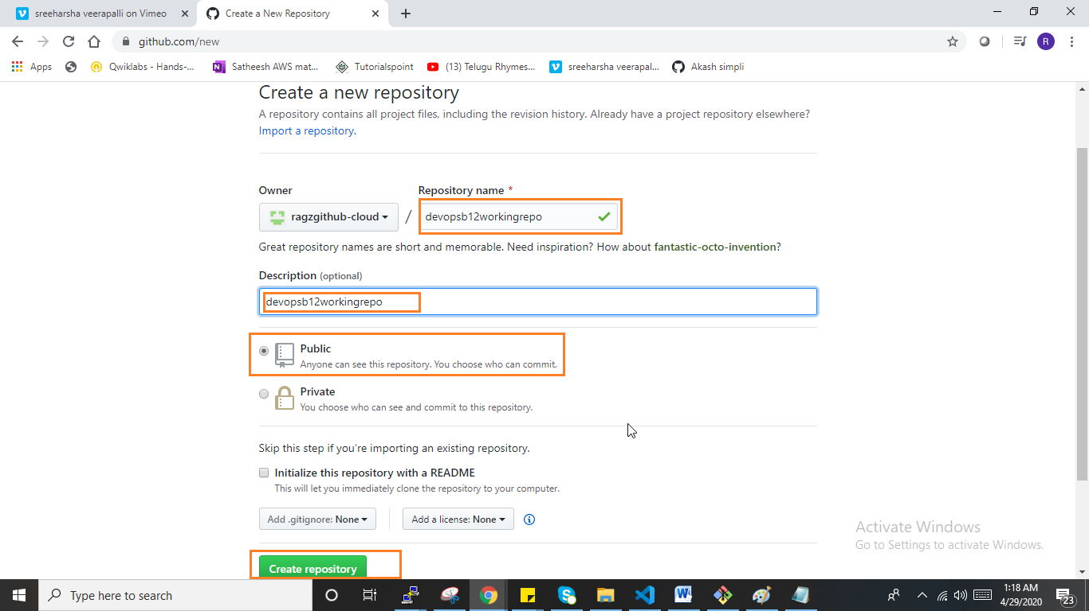

**If no files created,**

echo "# devopsb12workingrepo" >> README.md

git init

git add README.md

git commit -m "first commit"

git remote add origin https://github.com/ragzgithub-cloud/devopsb12workingrepo.git

git push -u origin master

**Since we have already created files in visual studio and added to local repository we can directly pull to github repository**

**It will ask you to provide email credentials.**

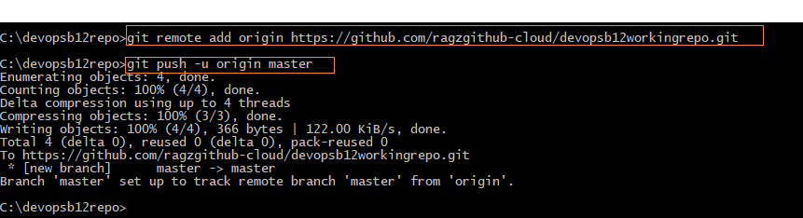

**Files successfully exported to github**

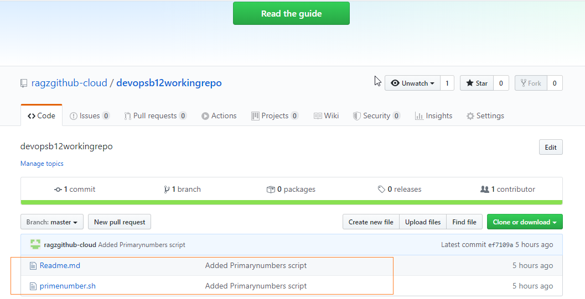

**Important Note:**

**When you want to push the code to existing repository , best recommendation is first pull the github repository to local then , add your code then push it to github, so that no errors will occur**

**When we want to keep local repository forcefully in gethub without looking in github repository.**



**How to create branching and merge in to main branch**

**Master**

**Development branch**

**Feature1 branch**

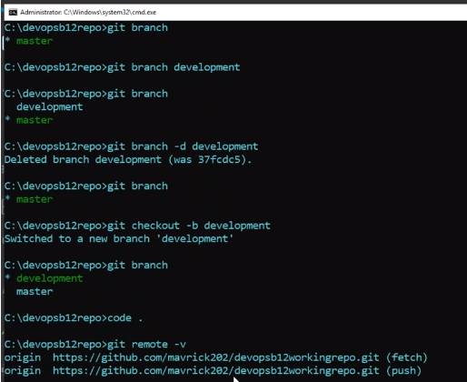

**PR:Pull request**

**As of now only one branch ie Master branch existed, we will create development branch**

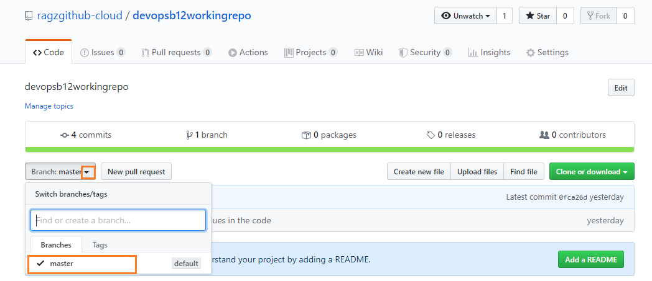

New branch we will create “development”

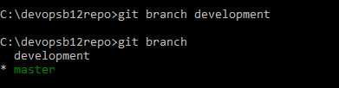

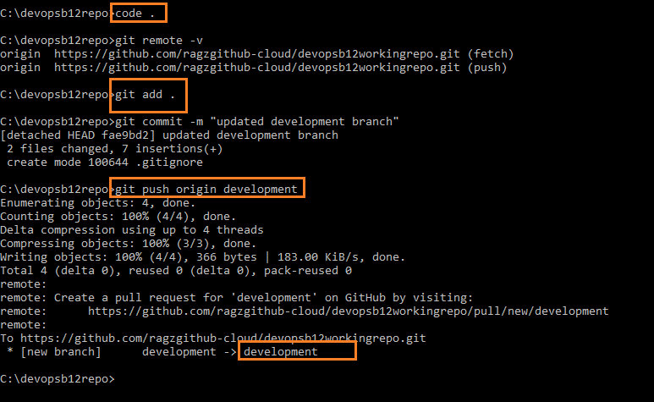

Development branch created.