IF, WHILE, FOR, operators (lt,gt,etc), read

|  |  |
| --- | --- |
| Syntax1  if < expression>  then  Stat 1------  else  Stat 2------  fi | Syntax2  if <expression>  then  Stat 1------  elif <expression>  then  Stat 2------  else  Stat 3------  fi |

Note : Test $A -gt $B or [ $A -gt $B ] – different ways of writing condition

1. Sample example using if-elif-else, elif, lt, eq

#!/bin/bash

A=50

B=10

if [ $A -lt $B ]

then

echo "$A less than $B"

elif [ $A -eq $B ]

then

echo "$A is equal to $B"

else

echo "$A is greater than $B"

fi

Result



1. Instead of hardcoded values in script, provide input dynamically from outside script.

!/bin/bash

while true; do

    read -p "Enter The Value Of A:" A

    read -p "Enter The Value Of B:" B

    if [ $A -lt $B ]; then

        echo "$A less than $B"

    elif [ $A -eq $B ]; then

        echo "Both Are Equal"

    else

        echo "$A greater than $B"

    fi

done

1. Instead of hardcoded values in script, provide input dynamically from outside script.
2. How to use while

|  |
| --- |
| Syntax  While [ Expression ]  do  Stat……  Increment  done |

**Example:**

I=0

while [ $I -lt 11 ]; do

echo "Welcome To DevOp Training Class $I"

I=$(($I + 1))

done

Output:

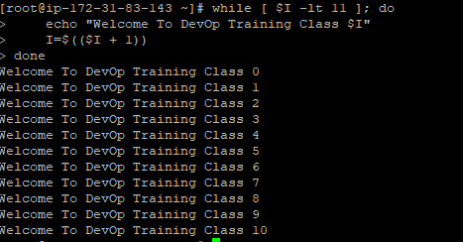

1. How to use for

|  |
| --- |
| Syntax:  For  do  Stat  done |

**Example1:**

Create regions file to read all the regions

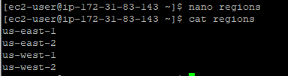

for region in $(cat regions)

do

aws s3api create-bucket --bucket ragz123${region} --region $region

sleep 3

done

Note: Only us-east-1 got created, read the note for the reason

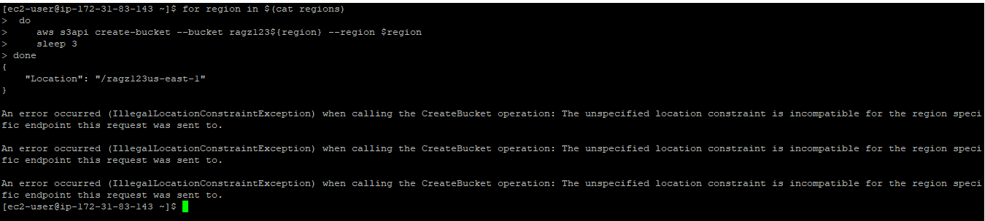

Note: Regions outside of us-east-1 require the appropriate LocationConstraint to be specified in order to create the bucket in the desired region.( In below example updated with location constratint)

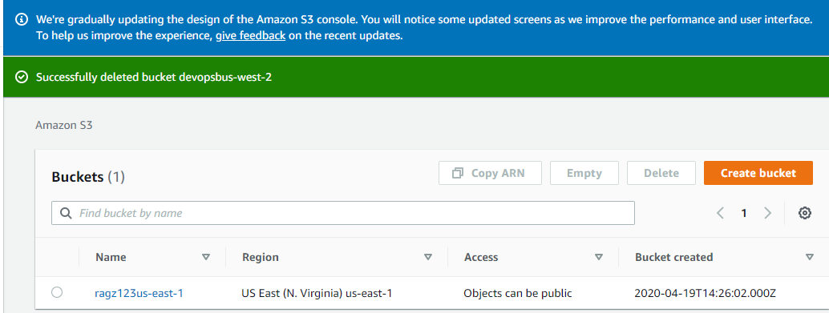

**Example2:**

for region in $(cat regions)

do

aws s3api create-bucket --bucket ragz123${region} --region $region --create-bucket-configuration LocationConstraint=$region

sleep 3

done

Note:Except us-east-1(as its duplicated buket name its no created, rest all got created.

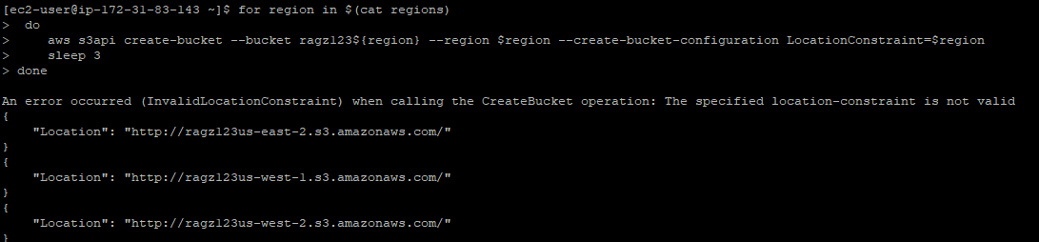

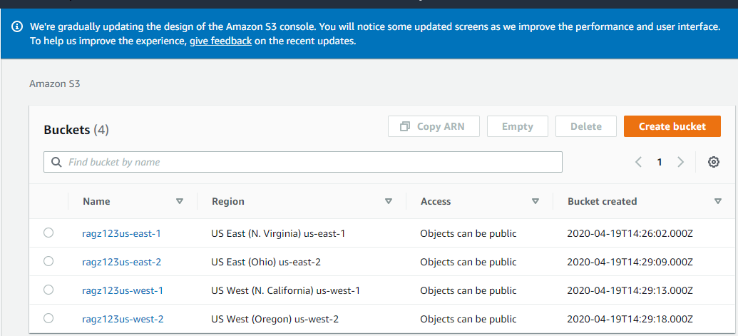

**Example3:**

for region in $(cat regions); do

aws s3 rb s3://devopsb12class3-${region} --force

sleep 3

done

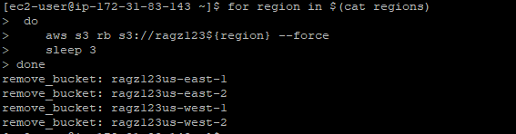

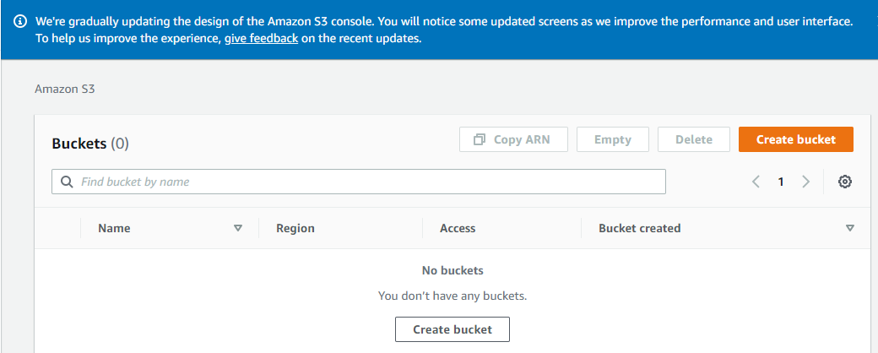

**Example4:**

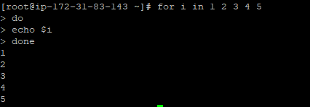

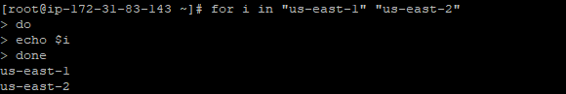

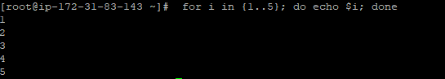

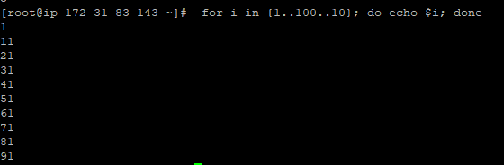

$?: previous execution status(exit codes)

set -x -e: will stop if any error occurs.

DEBUGGING:

#!/bin/bash

set –x -e

read -p "Enter the command:" COMM

$COMM

if [ $? -eq 0 ]; then

    echo "You have entered a right command."

else

    echo "Comand Not Found"

fi

for I in {2..100}; do

    if [ $(expr $I % 2) -eq 0 ]; then

        echo "$I is an ODD Number."

    fi

done

Exit code list.

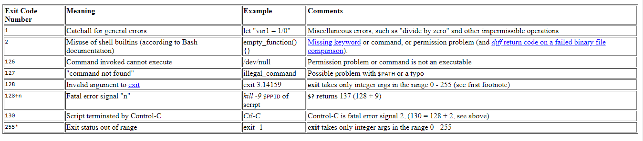

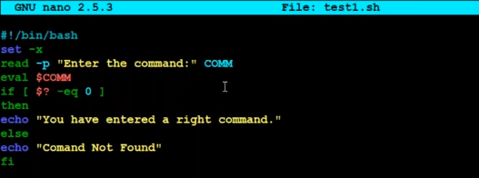

Exit code 127 because eval sree is not a command

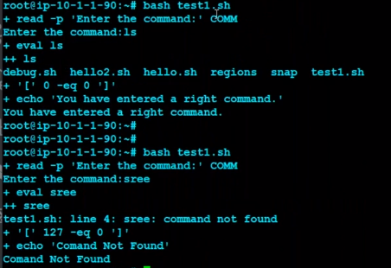

How to use modulus symbol & ne operator

