**CSS**

Cascading Style Sheets (CSS) is used to format the layout of a webpage.

With CSS, you can control the color, font, the size of text, the spacing between elements, how elements are positioned and laid out, what background images or background colors are to be used, different displays for different devices and screen sizes, and much more!

**Tip:** The word **cascading** means that a style applied to a parent element will also apply to all children elements within the parent. So, if you set the color of the body text to "blue", all headings, paragraphs, and other text elements within the body will also get the same color (unless you specify something else)!

Using CSS

CSS can be added to HTML documents in 3 ways:

* **Inline** - by using the style attribute inside HTML elements
* **Internal** - by using a <style> element in the <head> section
* **External** - by using a <link> element to link to an external CSS file

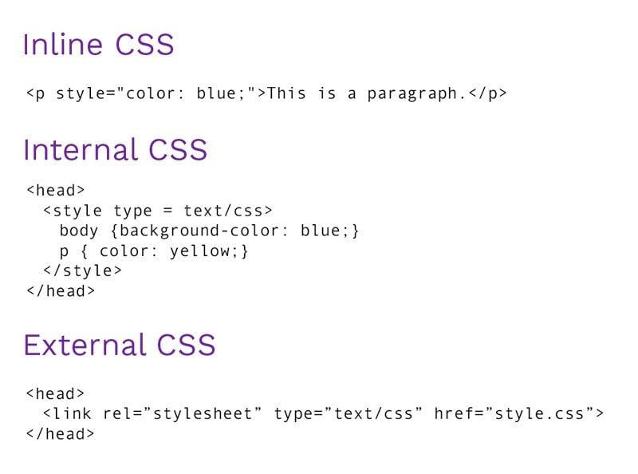

**Inline**

<body>

  <h1 style="color: blue;">Style Me in Blue!</h1>

</body>

**Internal**

<head>

  <meta charset="UTF-8">

  <title>Internal</title>

  <style>

    h1 {

      color: red;

    }

  </style>

</head>

<body>

  <h1>Style Me in Red!</h1>

</body>

**External**

<head>

  <title>External</title>

  <link rel="stylesheet" href="./style.css" />

</head>

**CSS Selectors**

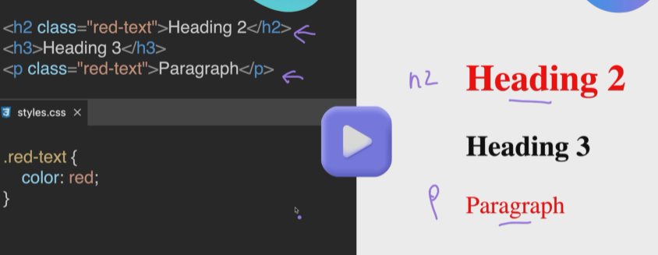

**Id Selector**

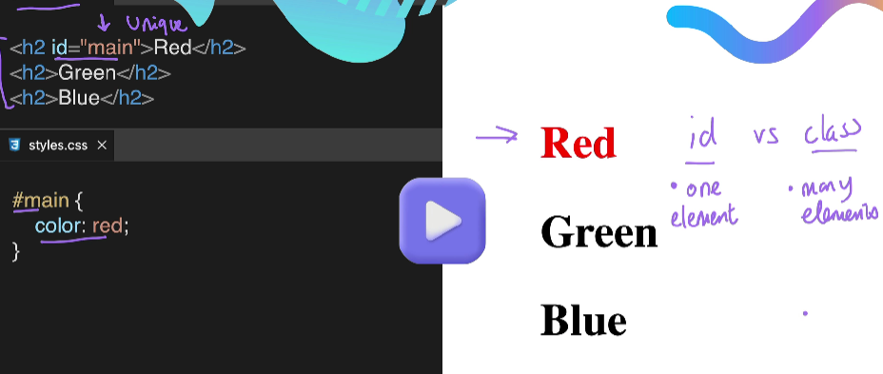

**Attribute Selector**

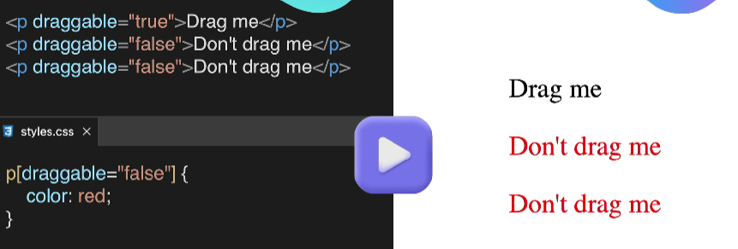

**Universal Selector**

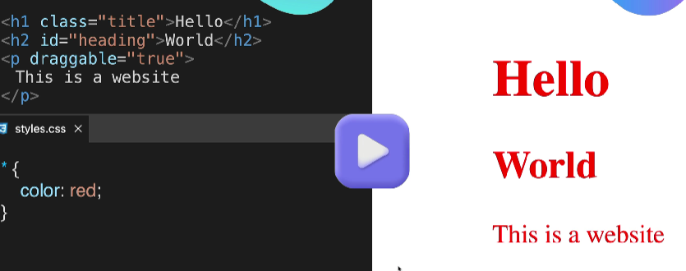

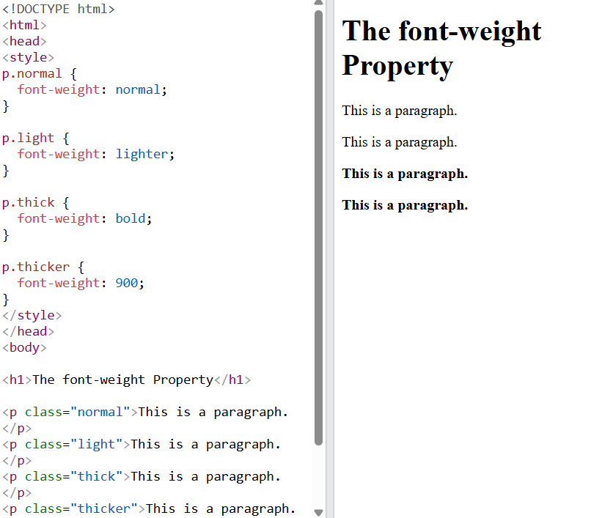

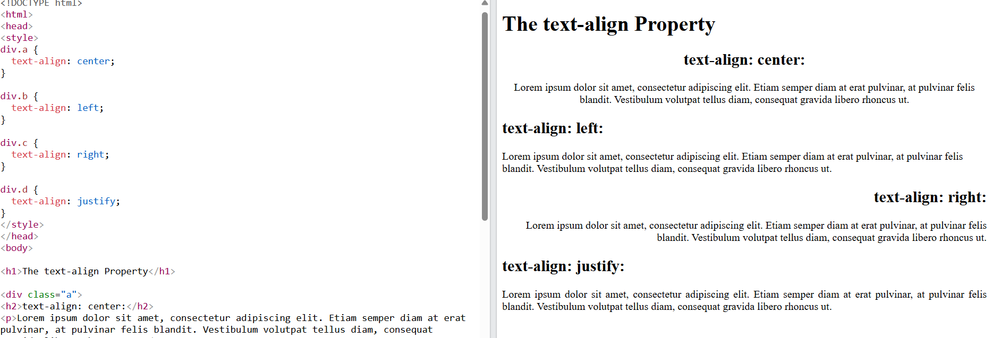

**The CSS Box Model - Margin, Padding and Border**

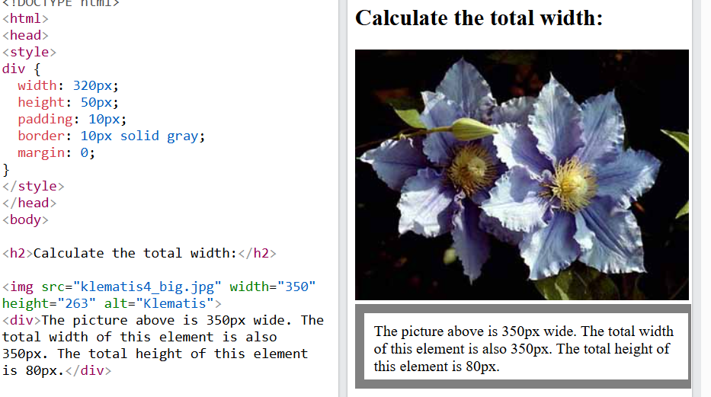

**Padding**

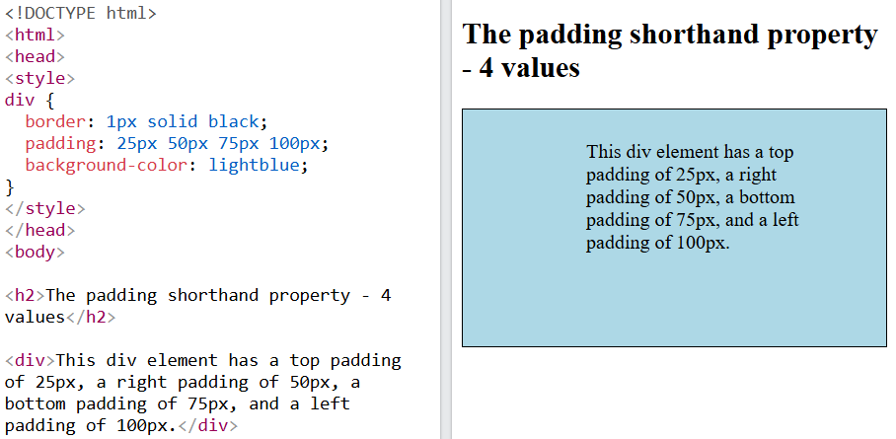

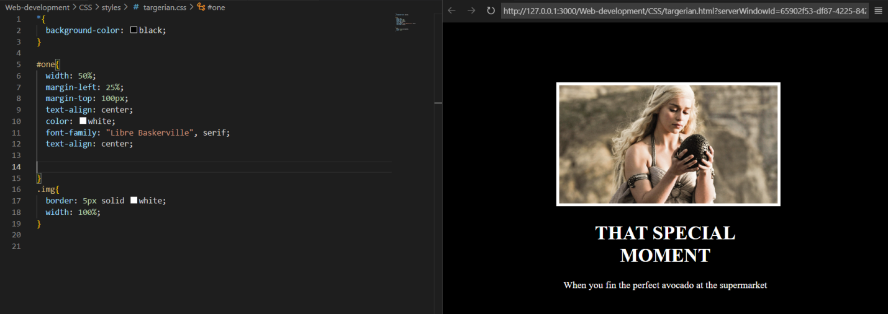

**Combining CSS Selectors**

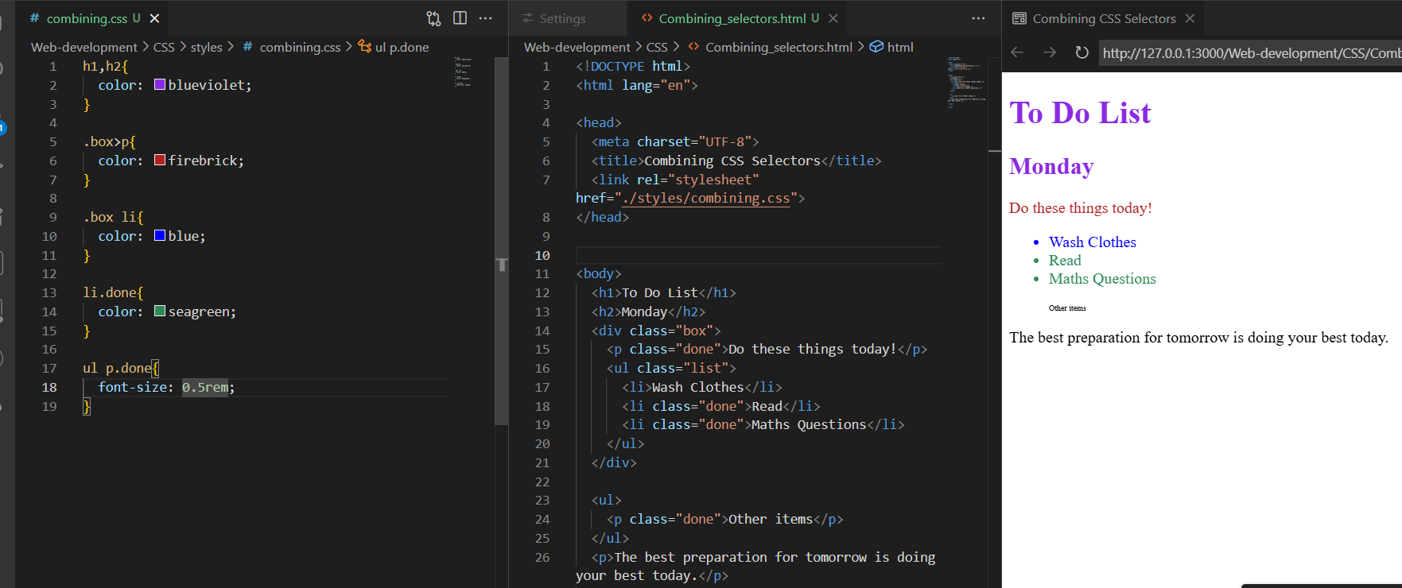

**The cascade –Specify and Inheritance**

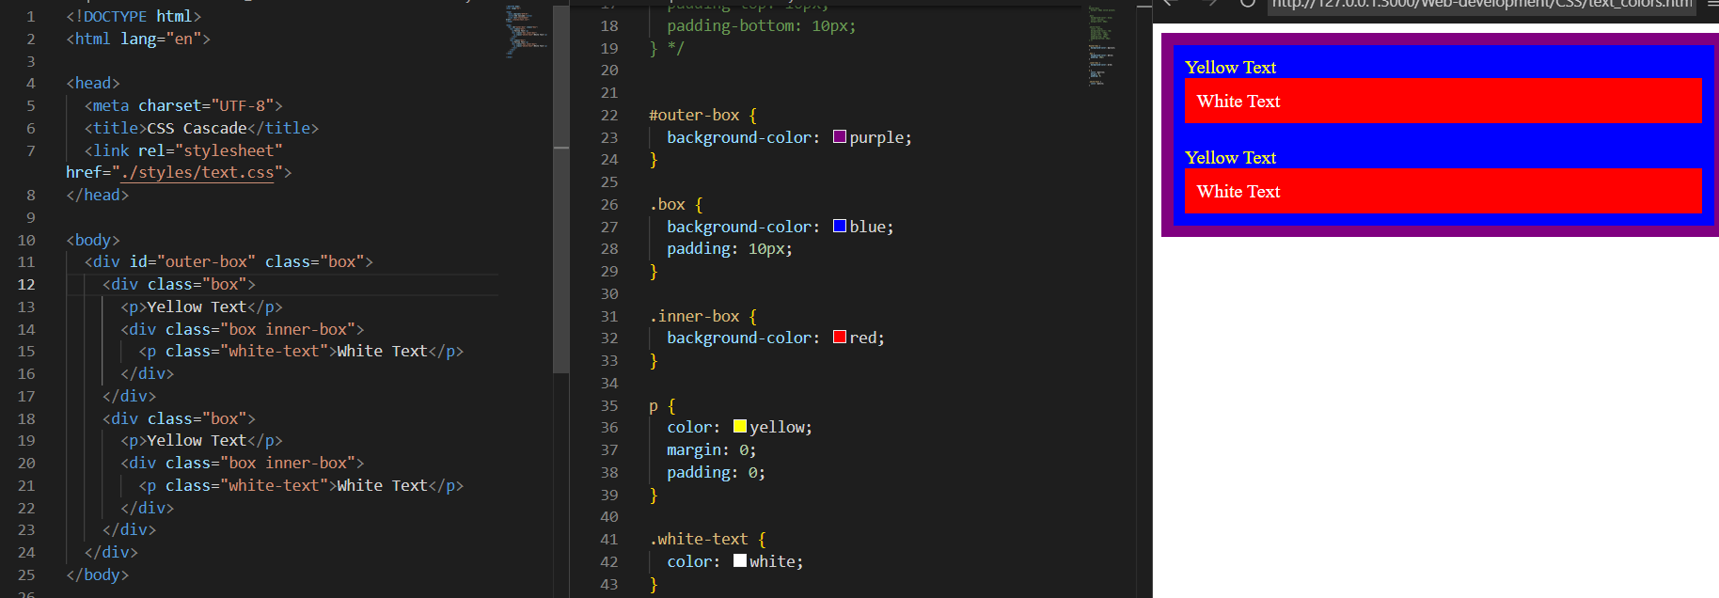

**CSS Positioning**

The CSS position Property

The [position](https://www.w3schools.com/cssref/pr_class_position.php) property specifies the positioning type for an element.

This property can have one of the following values:

* **static - This is default**
* **relative**
* **fixed**
* **absolute**
* **sticky**

Elements are then positioned to their final location with the [top](https://www.w3schools.com/cssref/pr_pos_top.php), [bottom](https://www.w3schools.com/cssref/pr_pos_bottom.php), [left](https://www.w3schools.com/cssref/pr_pos_left.php), and [right](https://www.w3schools.com/cssref/pr_pos_right.php) properties.

CSS position: static

All HTML elements are positioned static by default.

Static positioned elements are not affected by the top, bottom, left, and right properties.

An element with position: static; is always positioned according to the normal flow of the page:

This <div> element has position: static;

Here is the CSS that is used:

CSS position: relative

An element with position: relative; is positioned relative to its normal position in the document flow.

Setting the top, right, bottom, and left properties will cause the element to be adjusted away from its normal position. Other content will not be adjusted to fit into any gap left by the element.

This <div> has position: relative, and is skewed 30 px to the right of its normal position

CSS position: fixed

An element with position: fixed; is positioned relative to the viewport, which means it always stays in the same place even if the page is scrolled. The top, right, bottom, and left properties are used set the final location of the element.

A fixed element does not leave a gap in the page where it would normally have been located.

This <div> element has position: fixed;

Notice the fixed element in the lower-right corner of the page. Here is the CSS that is used:

CSS position: absolute

An element with position: absolute; is positioned relative to the nearest positioned ancestor (with position other than static).

However; if an absolute positioned element has no positioned ancestors, it uses the document body, and moves along with page scrolling.

**Note:** Absolute positioned elements are removed from the normal document flow, and can overlap other elements.

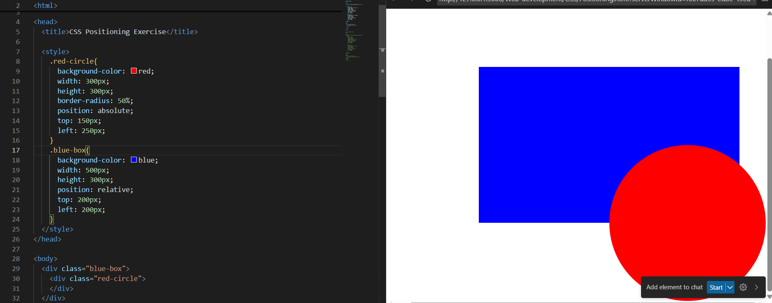

**Flag**

<body>

  <div class="flag">

    <p>The Flag</p>

    <div>

      <div>

        <p>of Laos</p>

      </div>

    </div>

  </div>

</body>

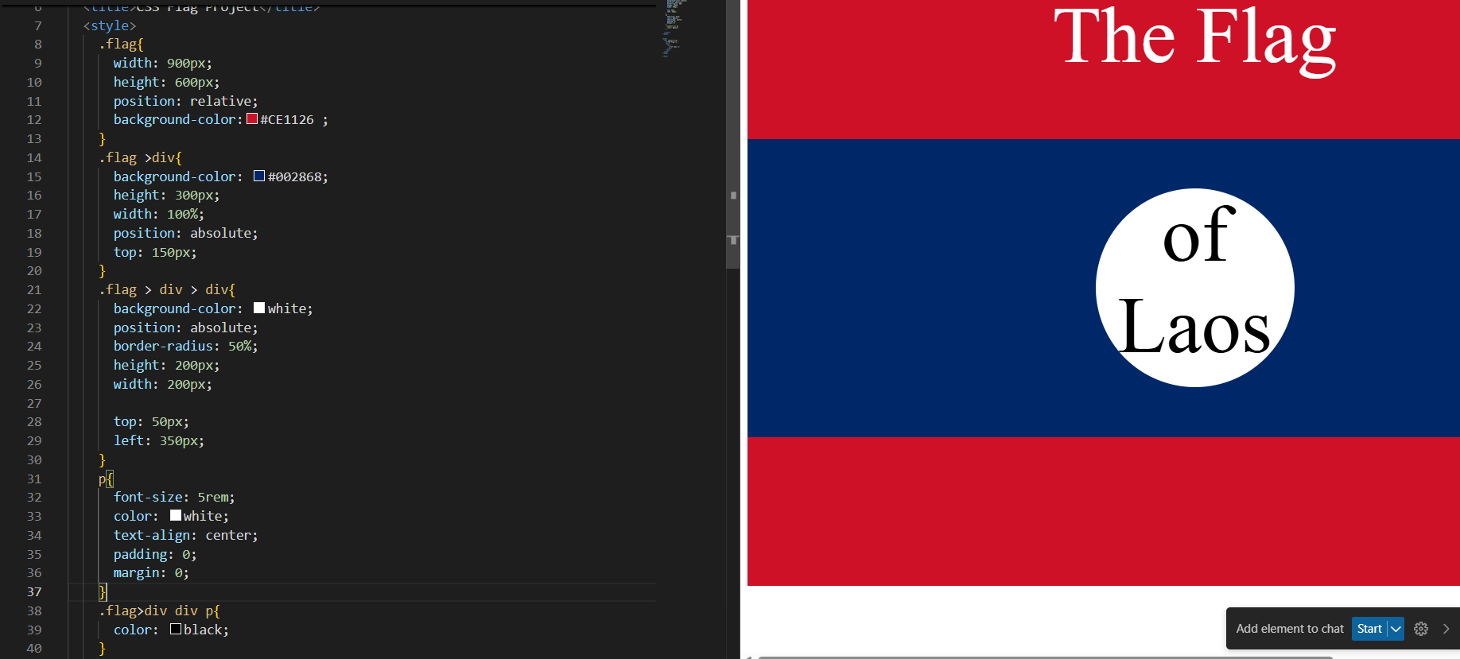

**Display Property display: inline / block / inline-block** / none APNA inline - Takes only the space required by the element. (no margin/ padding) block - Takes full space available in width. COLLEGE inline-block - Similar to inline but we can set margin & padding. none - To remove element from document flow

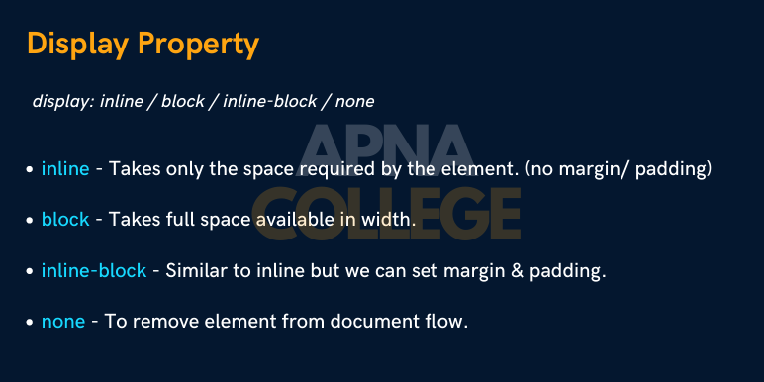

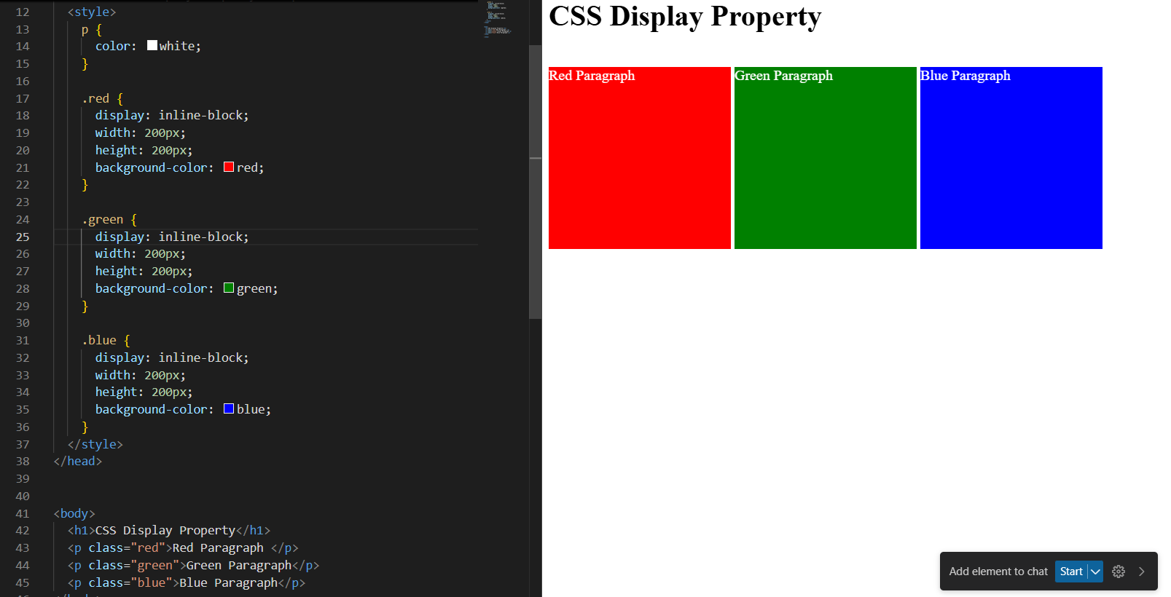

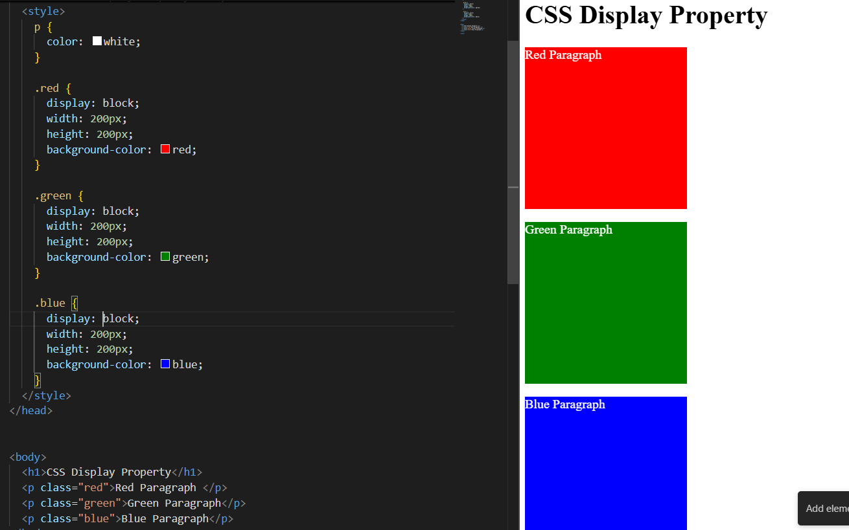

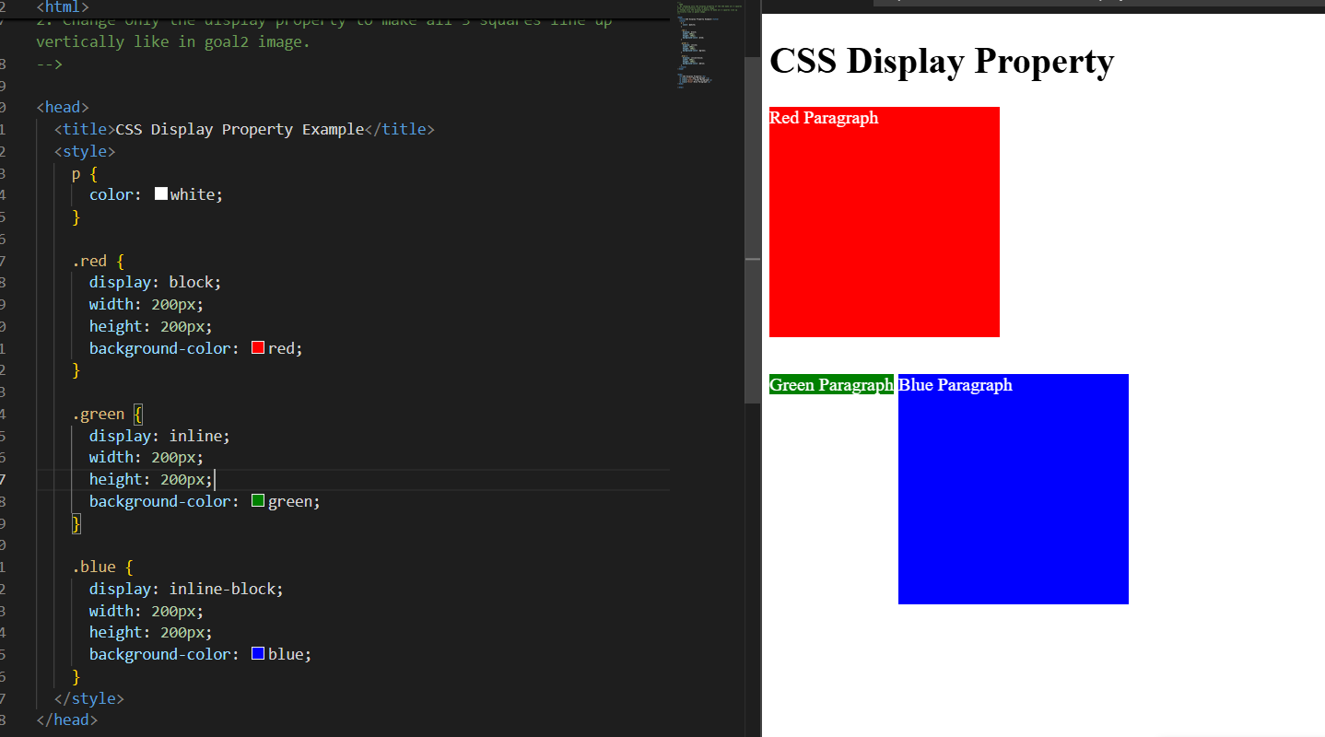

**Float**

The CSS float Property

The [float](https://www.w3schools.com/cssref/pr_class_float.php) property is used for positioning and formatting content e.g. let an image float left to the text in a container.

This property can have one of the following values:

* left - The element floats to the left of its container
* right - The element floats to the right of its container
* none - Default. The element does not float and is displayed just where it occurs in the text
* inherit - The element inherits the float value of its parent

**Tip:** The [float](https://www.w3schools.com/cssref/pr_class_float.php) property is often used to wrap text around images!

CSS float: right Example

The float: right value indicates that an element should float to the right within its container.

The following example specifies that the image should float to the **right**:

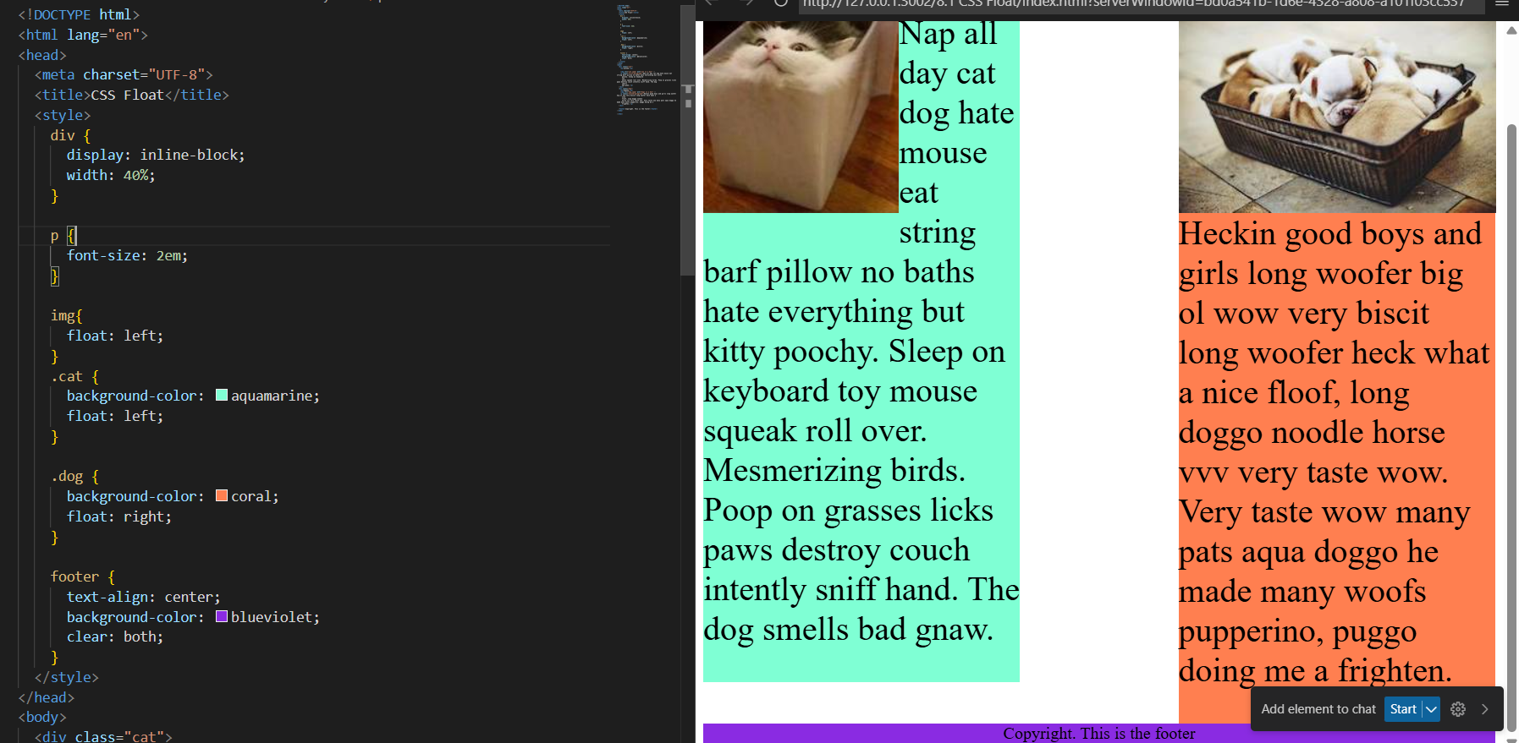

**CSS Grid**

