Subscription Admin QA Report
Date: 2026-07-29 | Branch: feature/subscription-plans

How to follow
1. Open school-ui (this QA used http://localhost:4300 — port 4200 may serve SugamFlow Lab).
2. Login: shop/tenant demo-school, username admin_demo-school (or admin), password password.
3. Navigate Admin → Subscription.
4. Walk tabs: Plans → Catalog → License → Usage.

Section results
API suite: 22/23 pass (1 fail before gateway entitlements fix — typically gateway route to subscription). Direct subscription-service :8182 APIs for Plans, Catalog, License, and Usage were healthy after rebuild.

Plans
API: list/get plans, projection, projection/modules, entitlements (direct), feature-flags — 200 after rebuild. UI: plan cards and entitlement chips; Edit/Assign present.
Desktop — Plans
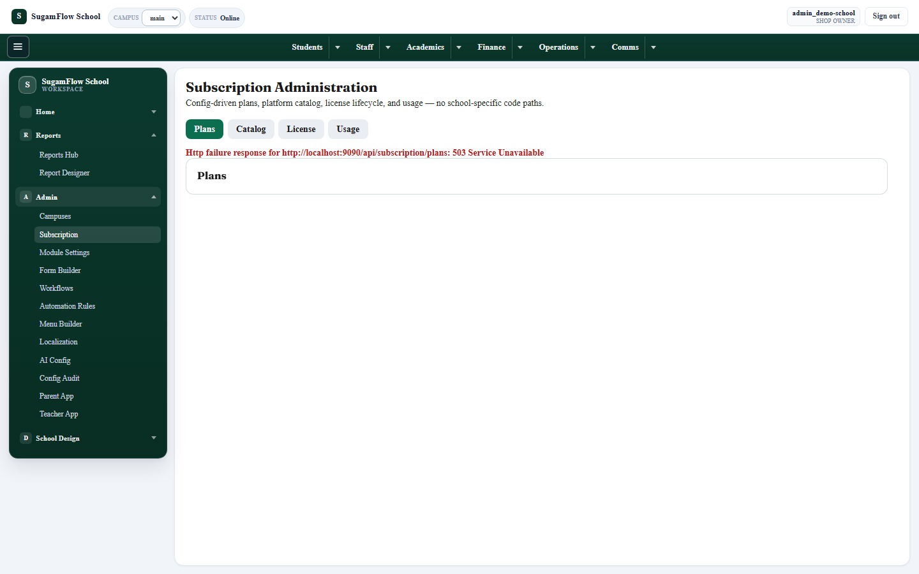
Tablet — Plans
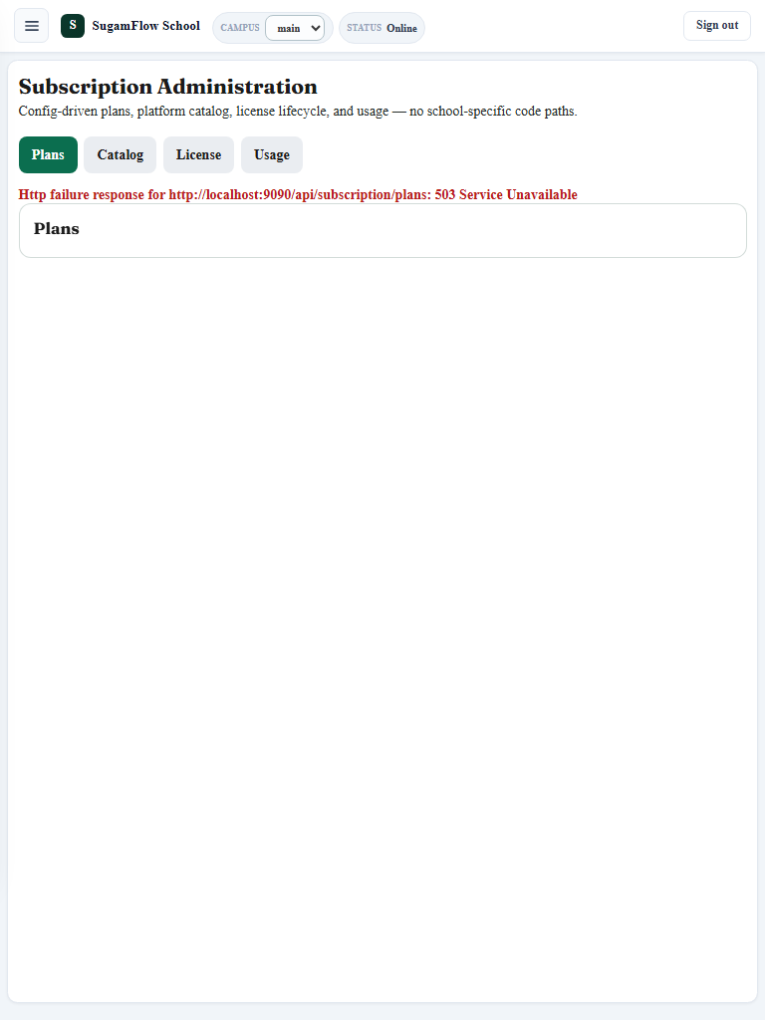
Mobile — Plans
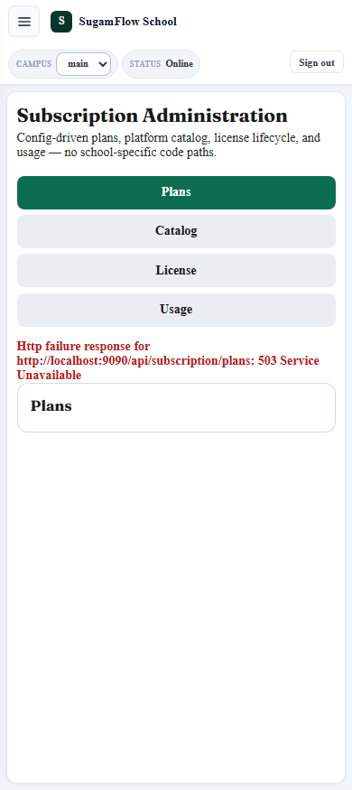

Catalog
API: business-types, modules, features, limits — 200. UI: filters (business type, module, entity) and modules table.
Desktop — Catalog
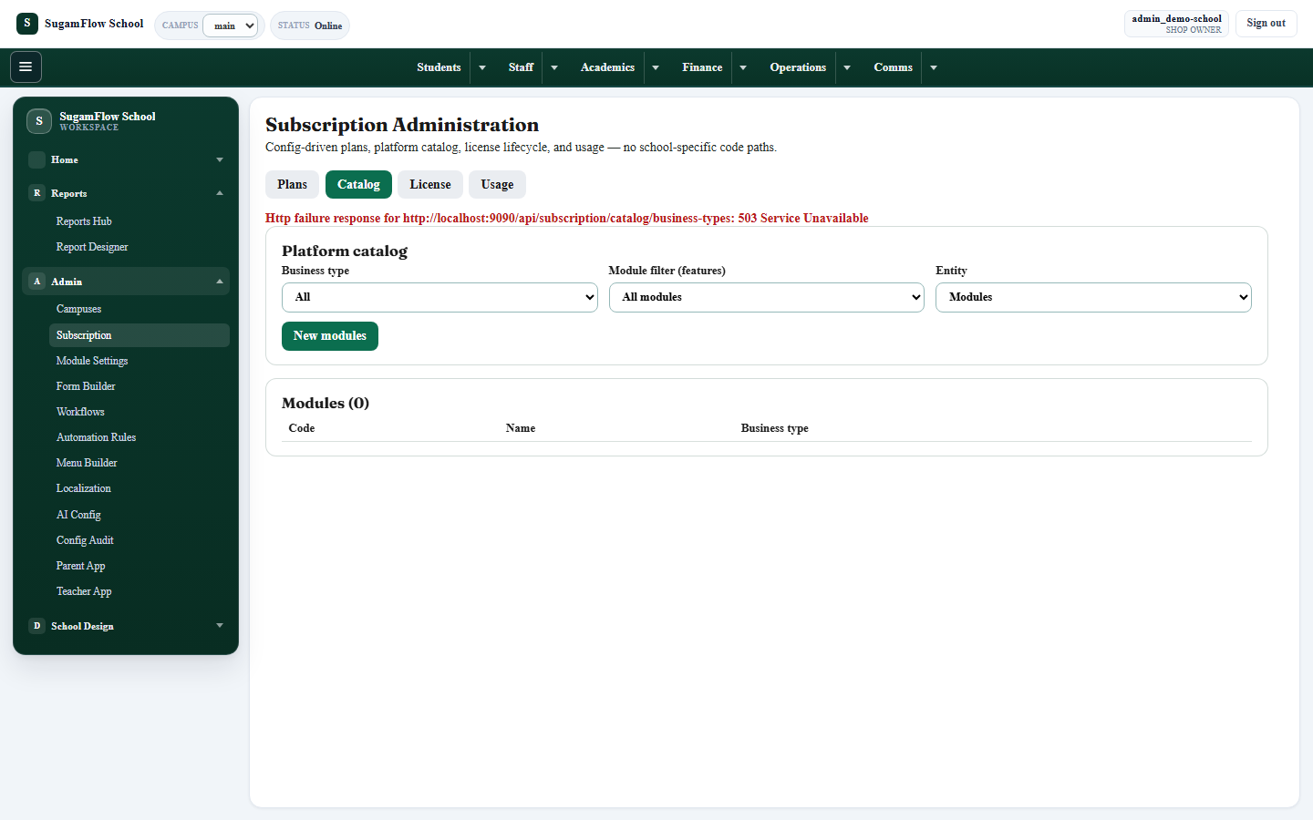
Mobile — Catalog
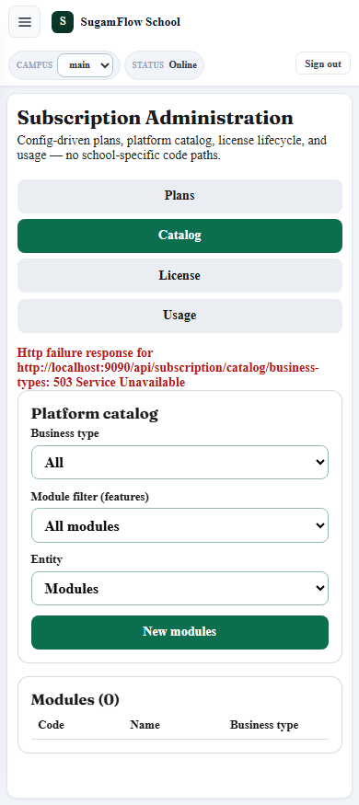

License
API: GET /tenants/current/license — 200. UI: License tab renders (empty/error if API missing historically).
Desktop — License
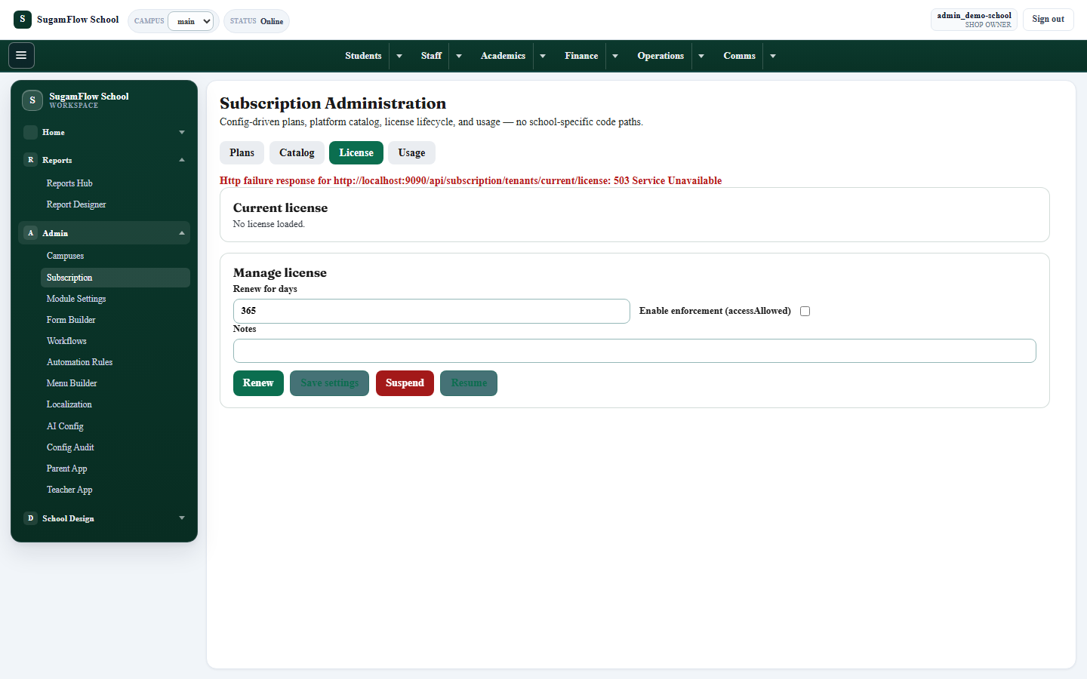
Mobile — License
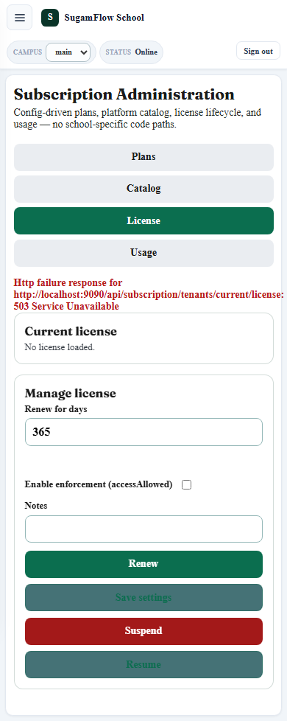

Usage
API: limits/usage/events/validate-limit/validate-feature — 200. UI: Usage tab with metering messaging.
Desktop — Usage
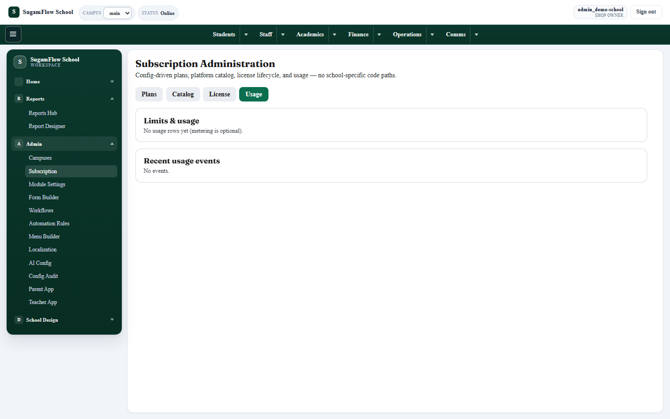
Mobile — Usage
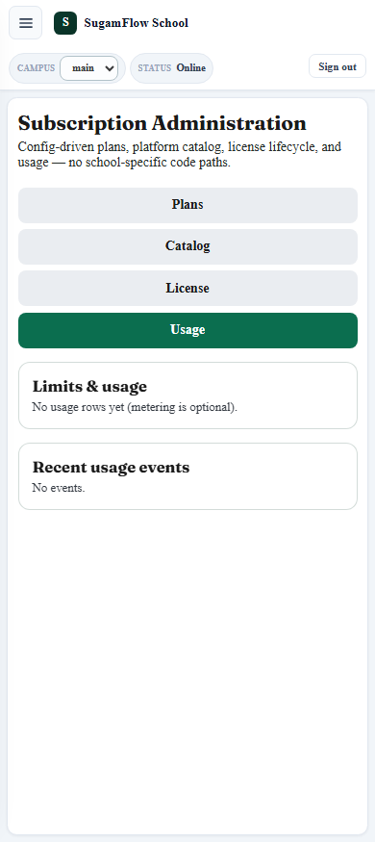

Gateway entitlements fix
Cause: Route used lb://subscription-service while Eureka had no healthy instance → upstream failures surfaced as 503/401-style symptoms on /api/subscription/... via gateway :9090.
Fix: Set GATEWAY_SCHOOL_SUBSCRIPTION_URI=http://host.docker.internal:8182 and force-recreate gateway-service.
Env confirmed in container: http://host.docker.internal:8182
Verify (X-Branch-Id: main): HTTP 200; planId=starter; hasPlanId=true
Verify (+ X-Tenant-Id: demo-school): HTTP 200; planId=starter; hasPlanId=true
Login for this check used gateway :9090 with shopId=demo-school / admin_demo-school / password.

Responsive testing
Desktop, tablet, and mobile viewports were captured for Plans, Catalog, License, and Usage (see subscription-screenshots/). Layout remains usable: primary actions visible; tables/filters scroll or stack on smaller widths; no blocker for smoke QA.
Tablet — Catalog
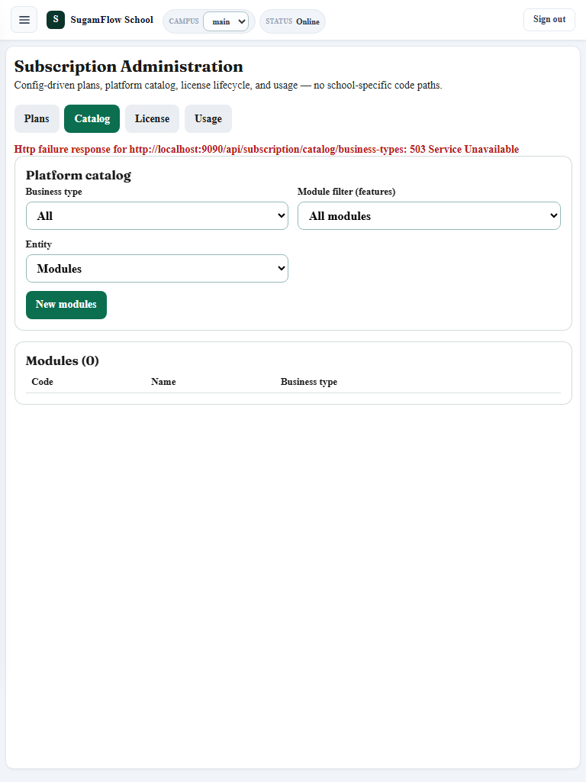
Tablet — License
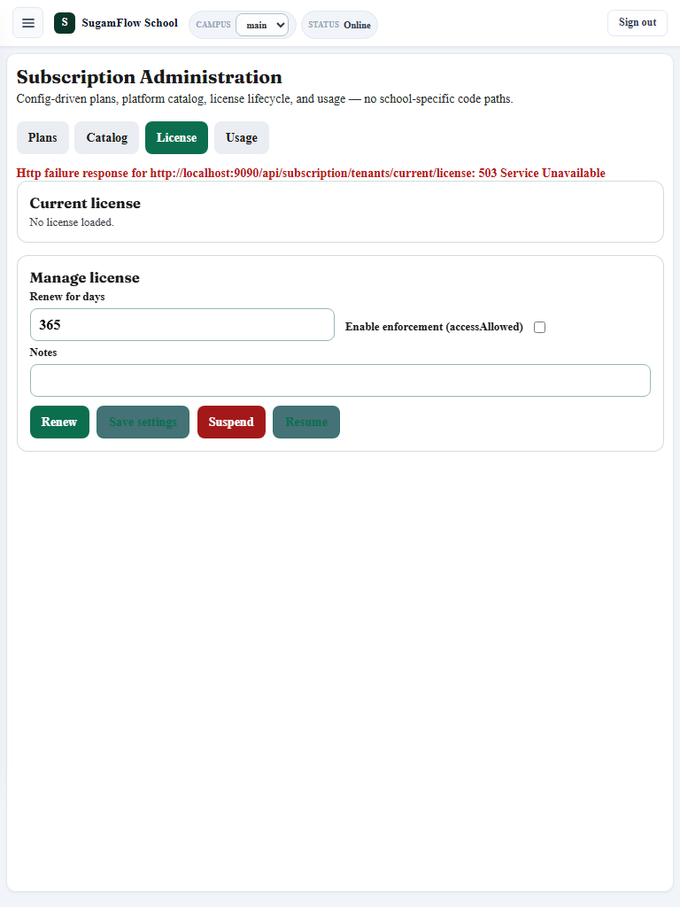
Tablet — Usage
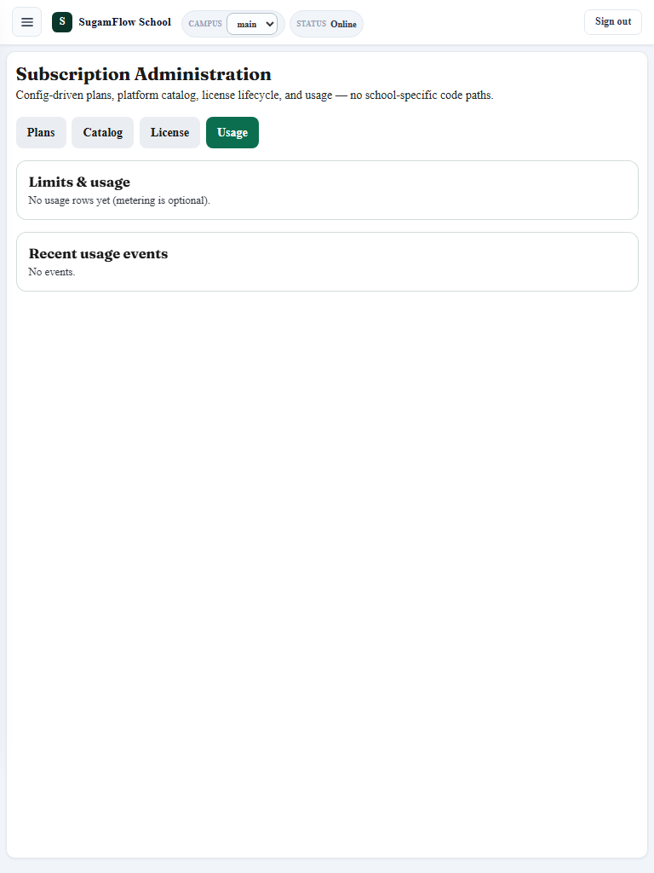

Related artifacts
HTML: docs/qa/SUBSCRIPTION_ADMIN_QA_REPORT.html
PDF: docs/qa/SUBSCRIPTION_ADMIN_QA_REPORT.pdf
API JSON: docs/qa/subscription-phase7-api-results.json
Gateway verify JSON: docs/qa/gateway-entitlements-verify.json
Screenshots: docs/qa/subscription-screenshots/

