**Final Progress Report**

**Name:** Nikhitha Sampelli

**Student ID:** 700713888

**Semester:** Spring 2022

**Instructor:** Dr.Xiaodong Yue

I am offered with an internship as a full stack developer at Eficens Systems LLC. My start date was on Jan 10th,2022, but due to delay in receiving the cpt i20 I pushed my start date to Jan 24th,2022. I have been assigned with a supervisor Sukadha.

**Name:** Sukhadha

**Email:** hr@eficensit.com

**Contact Number:** 6788929800

**Contact person**: Rajesh

**Email:** [rajeshv@eficenit.com](mailto:rajeshv@eficenit.com)

**Contact number:** 5135019534

I have been working as a developer with like working with Angular Framework, nodejs. In my first week I met all of my coworkers and the trainer. Later, I was presented to my HR, who informed me about the company's goals and vision. Then, as an intern, my trainer described the roles that will be assigned to me. I became acquainted with the workplace environment, after which they informed me of the training procedure and provided me with a list of tasks to complete.

These are the web technologies that I have used HTML,CSS,SASS,LESS, Bootstrap, Xml, Java script, Json and also we have used Angular js, Node js and other APIs as java script libraries. In our project we used Rally as our ticketing tool to track user stories.

Below is a small description of the technologies that we have used:

**HTML** (HyperText Markup Language) is the coding that organizes a web page's structure and content. Content could be organized using paragraphs, a list of bulleted points, or graphics and data tables, for example. Technologies such as Cascading Style Sheets (CSS) and programming languages like JavaScript can help.

A sample html document.

<!DOCTYPE html>  
<html>  
<head>  
<title>sample page title</title>  
</head>  
<body>  
  
<h1>Initial heading</h1>  
<p>This is chrome</p>  
  
</body>  
</html>

Cascading Style Sheets (**CSS**) is an abbreviated for Cascading Style Sheets.CSS specifies how HTML elements should appear on a screen, in print, or in other media.CSS helps you save time and effort. It has the ability to control the layout of numerous web pages at the same time.

CSS files contain external stylesheets.

Syntactically Awesome Stylesheet (**Sass**) is an acronym for Syntactically Awesome Stylesheet.Sass is a CSS extension.Sass is a pre-processor for CSS.Sass is perfectly compatible with all CSS versions.

Sass saves time by reducing the amount of CSS repetition.

Sass is an open source and use CSS framework.

Angular. bootstrap is a functional component in the core ng module that is used to manually launch an Angular application, giving you additional control over how your app is started.

**JavaScript** is defined as a text-based programming language that allows you to develop interactive web pages on both the client and server sides. Whereas HTML and CSS provide structure and aesthetic to web pages, JavaScript adds interactive components that keep users engaged. JavaScript is mostly utilized in web browsers and web-based applications. However, JavaScript is utilized in software, servers, and embedded hardware controls in addition to the Web. Javascript can also validate data.

Javascript variables can also be used as containers for the purpose of storing the values of the data.

Json is defined as JavaScript Object Notation is a text-based standard for the representation of structured data that is based on JavaScript object syntax. It is often used in web applications to convey data (for example; sending some of the data from the server side to the client side, so that it can be represented on a web page, or vice versa).

In other words, it can be simply said as Json can be used for the storage and transportation of the data. And Json is used mainly when the data is needed to be sent from the server side to the web page. Json is also portable irrespective of the language.

{  
"FamilyDetails":[  
  {"Name":"Sam", "lastName":"Athi"},  
  {"Gender":"Female", "Age":"25"},  
 ]  
}

**My Role and The project I worked on:**

Before I enter the firm on my first day, I am quite tense. First, I discussed with my manager about the project and learned about my responsibilities while working there. To begin, I received instruction in all of the technologies that will be utilized in my project. Later, I received some documentation that described the fundamental functionality of my program, on which the rest of the team is currently working. I received a desktop and system access using the company login ID after two days. Then I received some documents from my manager detailing how to configure the system with the project's software technologies.

I began working on it by configuring the visual studio code, which is where the coding is done, and then configuring the Keycloak Server in the VS vode. Prior to configuring the server we need to request the jdk from the organization portal where it took lots of time. Configuring the server took a long time because I needed the Global Security password to access the ESB services. In order to access the database, I also require the password. That's what my database administrator told me. Because our database is housed on LINUX, I used putty to update my database access password. My server configuration is complete now that I've completed all of these steps. I also installed SVN so that I could check in and out the code. My Dev setup is done with the help of team members.

After all the local setup and I cloned the code from the git to my local and without making any changes firstly I tested it in local to check whether the code is working correctly.

Then, for two days, I received a knowledge transfer from one of my teammates. Then I learned about the project on which I will be working on. My project is comprised of totally of five environments through which the code must pass, including DEV, INT testing, UAT testing, staging, and finally production. I only have access to the DEV environment because the rest of the environments are managed by the functional team.

For the project which we are developing is a team of 6 out of which 4 are Developers and 2 testers.

Angular Admin is a responsive Angular 9 template made with Sass and based on the CSS framework Bootstrap 4. The Sass compiler makes coding and customizing easy. All of the Bootstrap components have been adjusted to fit the Angular style and create a uniform look throughout the site. We have worked on the project that is already there but we have added some new features to the responsive web page like ToDo task features on the current application by using angular 13.

For this application development one of the developers in our team written

an algorithm so that the web page should work in such a way that it cannot skip its previous ToDo task before going to the next step.

These are some of the dependencies that I have worked on in angular. In order to get these dependencies install we have to run a command npm install and then ng serve.

"dependencies": {

"bcrypt": "^5.0.0",

"body-parser": "^1.19.0",

"bootstrap": "^4.5.2",

"chalk": "^4.1.0",

"cookie-parser": "^1.4.5",

"debug": "^4.1.1",

"ejs": "^3.1.5",

"express": "^4.17.1",

"express-session": "^1.17.1",

"jquery": "^3.5.1",

"morgan": "^1.10.0",

"mysql2": "^2.1.0",

"nodemon": "^2.0.4",

"passport": "^0.4.1",

"passport-local": "^1.0.0"

So for adding the ToDo features we have used bootstrap and angular material so I have included the bootsrap feature into the index file and the I have added the angular material.



After including the bootsrap and angular material I have written a small code for the design of navbar which acts as a header for the whole ToDo features.While designing these features we have to make sure whether the following modules are generated or not.Then I have added the toolbar.Then after adding the header module I have added the routing to header module. Further I have added the container in the html component for the segregation of rows and columns so that the ToDo features aligns in a perfect manner.Then I had a Doubt if I can add the mat card for the content organization and asked one of my teammates and I had a KT on that from manager. And I have added the card in the html component.

After enabling the routing I have added a text box where it includes task name and a button for the purpose of adding the selected task to ToDo features. After enabling the routing I have added a text box where it includes task name and a button for the purpose of adding the selected task to ToDo features.Then I have added the lists for our features where we have 3 lists; ToDo list, inprogress list and done list. Where I have added the drag and drop button for the tasks so that they can be dragged from one list to other.

To integrate all these tasks and lists ,I have created a model ‘task’ where I included the interface and then I exported the Interface where it include description of the task and done feature which tells us the status of the task. And finally I imported all these into ToDo component. Then I have added the function addTask in order to add the tasks from the ToDo form.

Below is the some code that I have worked on:



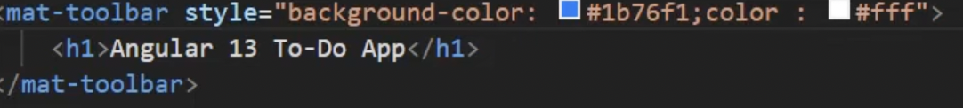

Added the routing component:

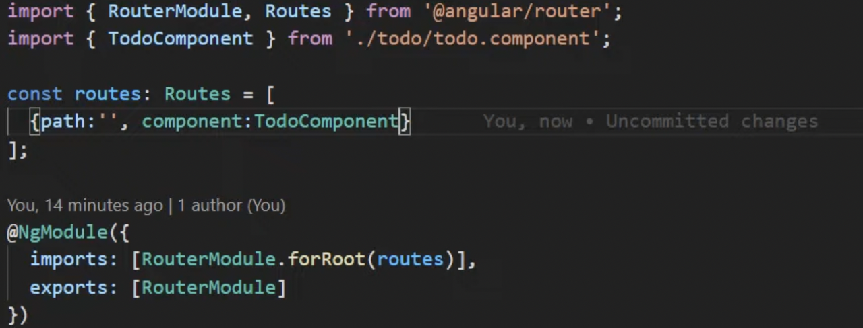

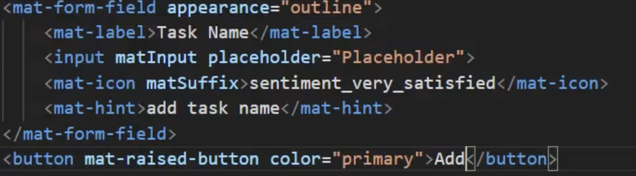

After enabling the routing I have added a text box where it includes task name and a button for the purpose of adding the selected task to ToDo features.

We use the Html generally for the purpose of designing webpages. However, HTML does not demonstrate any form of specialness to the webpage. We need to add some external coding to make the webpage more appealing, and we can do this with CSS (cascading style sheet). As long as the web page appears clean and basic, we apply the styling tags here. For this purpose we can do the styling either by internally on the HTML page or externally using CSS, and then the external CSS is linked to the HTML page so that all of the extra features are implemented.

.nav-link {  
 color: black;  
}  
  
.list-group-item {  
 padding: 1rem 0.9rem 0.95rem 0.9rem;  
}  
  
.ToDO {  
 line-height: 1.2rem;  
}  
  
.InProgress {  
 font-size: 1.5rem;  
}  
  
.Done{  
 margin-left: 0.09rem;  
 margin-bottom: 0;  
}  
  
.message {  
 font-size: 1.2rem;  
 font-weight: bold;  
}

**Problem statement and solution**

After writing the code in the routing module when I tried to run it in the browser I couldn’t see any content displayed in the browser.When I went through the documentation and after contacting my team lead I found out that I need to include an API in order to call these service so that it displays the content after writing and running the below code I was able to perform the routing operation and see the content in the browser.

.

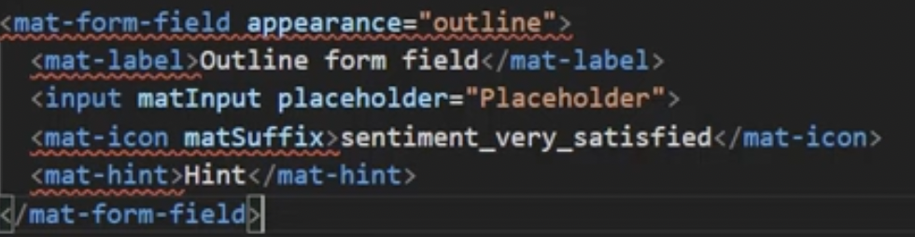

Also when I was performing the drag and drop operation I have created an event so that it can call all all the lists that I have implemented, initially I thought it imports explicitly but when I ran the application I got some error saying drag and drop list not found, then I tried to write it manually, eventhough it showed me the wrong output on the browser like cannot find the function name.Then I went through all the code that I wrote then I realized that I have not included the lists in the root component. After setting things done in the root component I ran the application and was able to see the the application running.

**Internship Experience:**

During my internship I have learned a lot of things. I have learned how the sprint is planned and generally how many days the sprint takes place and learned about PI planning which I never heard. Speaking about my project I was tensed and curious in my initial days. Later, I was slowly able to understand the things how they are getting done. My team lead helped me accessing the Rally and solving the tickets. And also I have learned many other things like integration, testing. During my bachelors I was not much exposed to real time work, this was a good opportunity for me to understand how the IT world is and what the computer world is.

Overall, I had a good opportunity in exploring the real time computer world and good experience in working with the peers.