Business Transactions

1. What is the ratio of game wins based on home, away, and neutral sites?

**SQL Query:**  
Our query aims to calculate the win ratio for the games based on the location where the game is played, which is the game type: home, neutral or away sites to identify the presence of a home game advantage for the Terps. The query retrieves the win ratio for each play type by counting the number of wins and calculating the ratio over the total number of plays. This is then grouped by the play type and years and ordered by years as well so that the obtained output can be interpreted over the years and trends can be analyzed.

**Tableau Output:**

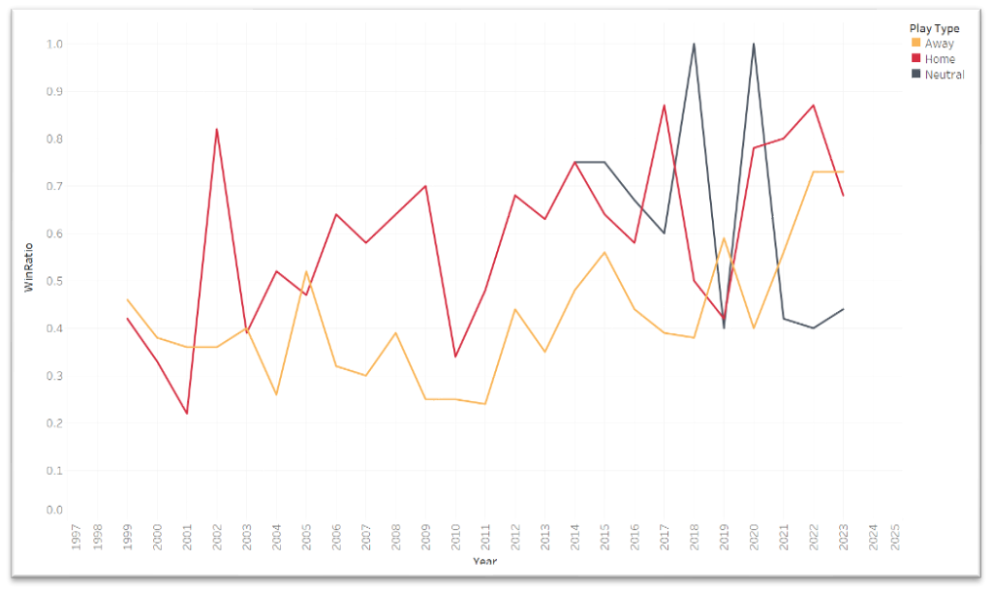  
**Home Playtype (overall average throughout the year 0.59):**

* The home-win ratio started at 0.42 in 1999, experiencing fluctuations in the early 2000s.
* A remarkable surge began in 2002, reaching a peak of 0.87 in 2017 and 2022.
* Notably, in 2014 and 2015, with home-win ratios of 0.75 and 0.64, the Terps achieved significant success, all while maintaining above-average away-win ratios.
* A consistently high home-win ratio showcases the team's formidable home-ground advantage.

**Away Playtype (overall average throughout the year 0.42):**

* Fluctuations over the years indicate less consistent away game performance.
* Notable improvement from 2011 onward, with strong performances in 2022 and 2023.
* In 2022, the Terps secured the Big Ten championship with the highest home and away win ratio. They maintained the same away win ratio in 2023, securing consecutive Big Ten championships.

**Neutral Playtype (overall average throughout the year 0.63):**

* Exhibiting high variability.
* Peaks in 2018 and 2020 showcase the potential for exceptional performance in neutral settings, winning all the games.
* Maintaining an overall average of 0.63 in neutral game sites.

**Conclusion:**

In conclusion, the Terps baseball team excels with a formidable home-ground advantage, shows consistent improvement in away games, and performs exceptionally in neutral settings during peak years. These insights offer a snapshot of the team's dynamic performance.

1. What is the team’s average margin of wins and losses in the previous years?