What is Jenkins?

Jenkins is an open-source automation server that helps automate parts of software development related to building, testing, and deploying applications. It supports continuous integration and continuous delivery (CI/CD).  
  
  
Install the JDK:

* Windows:
  + Run the downloaded .exe installer.
  + Follow the installation prompts.
  + Note the installation path (e.g., C:\Program Files\Java\jdk-17).
* macOS:
  + Open the downloaded .dmg file.
  + Follow the installation prompts.
* Linux:  
   For Ubuntu/Debian:  
   sudo apt update  
   sudo apt install openjdk-17-jdk

Then install jenkins for your computer:   
  
Jenkins Installation

Add Jenkins Repository (for Linux):

Debian/Ubuntu:  
sudo apt update  
sudo apt install openjdk-17-jdk  
wget -q -O - <https://pkg.jenkins.io/debian/jenkins.io.key>  
sudo apt-key add -  
echo deb http://pkg.jenkins.io/debian-stable binary/ | sudo tee /etc/apt/sources.list.d/jenkins.list  
sudo apt update

To Access the jenkins  
Open browser search as <https://localhost:8080>  
The 8080 is the port number of the jenkins.  
  
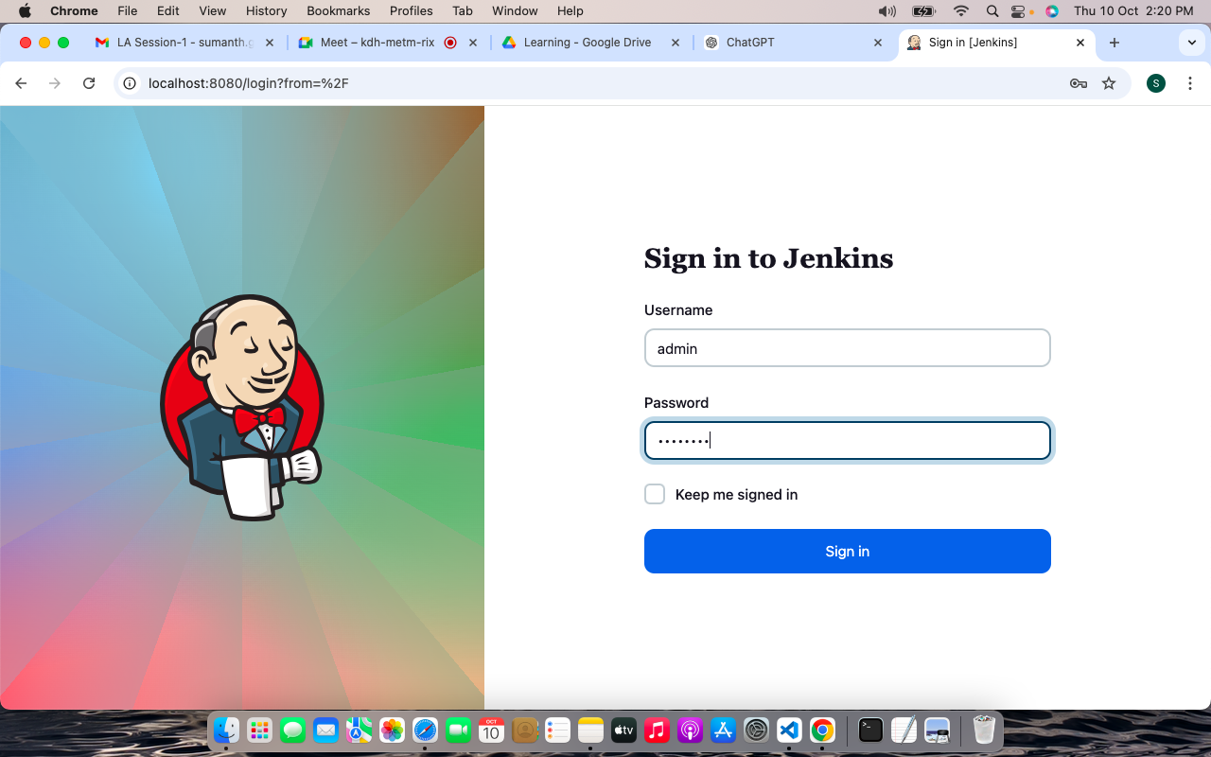

Key Components of Jenkins

1. Plugins

Functionality: Plugins can be used for various tasks, such as integrating with version control systems, configuring build environments, and reporting.

Types:

Build Tools: Maven, Gradle, Ant

Version Control: Git, Subversion, Mercurial

Testing: JUnit, Selenium, TestNG

Notifications: Email, Slack, HipChat

Cloud Integration: AWS, Azure, Google Cloud

Installation: Plugins can be installed from the Jenkins dashboard under "Manage Jenkins" > "Manage Plugins".

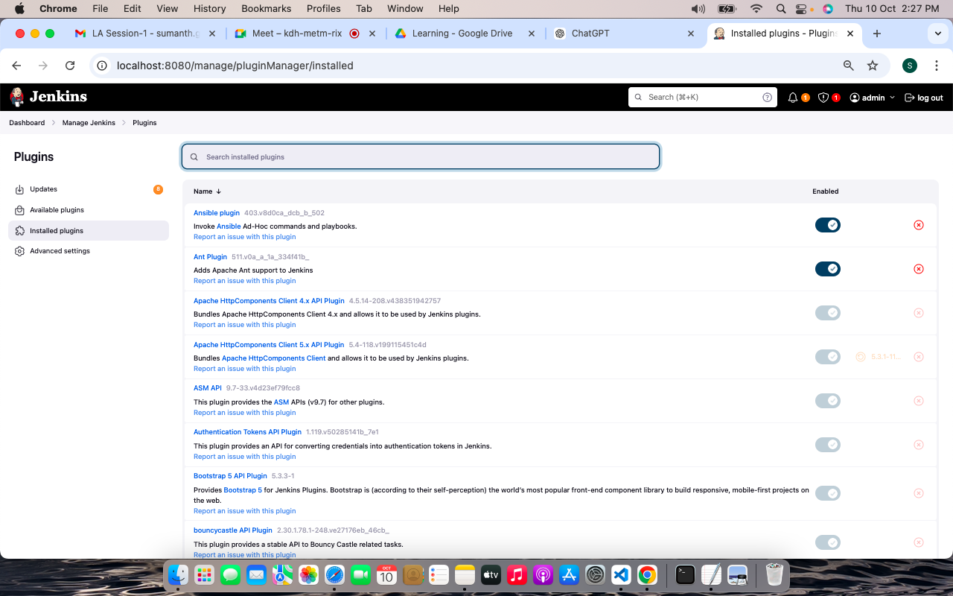

Projects:

* Definition: A job (or project) is a task that Jenkins executes. It can be a simple build, a complex pipeline, or a scheduled job.
* Types:
  + Freestyle Project: Basic job type for simple builds and tasks.
  + Pipeline: For complex workflows defined in a Jenkinsfile, allowing for continuous delivery and integration.
  + Multibranch Pipeline: Automatically manages branches in version control systems and creates a job for each branch.
  + Matrix Project: Supports running the same job across multiple configurations.
* Configuration: Jobs can be configured through the web UI, where you set parameters, triggers, and build steps.

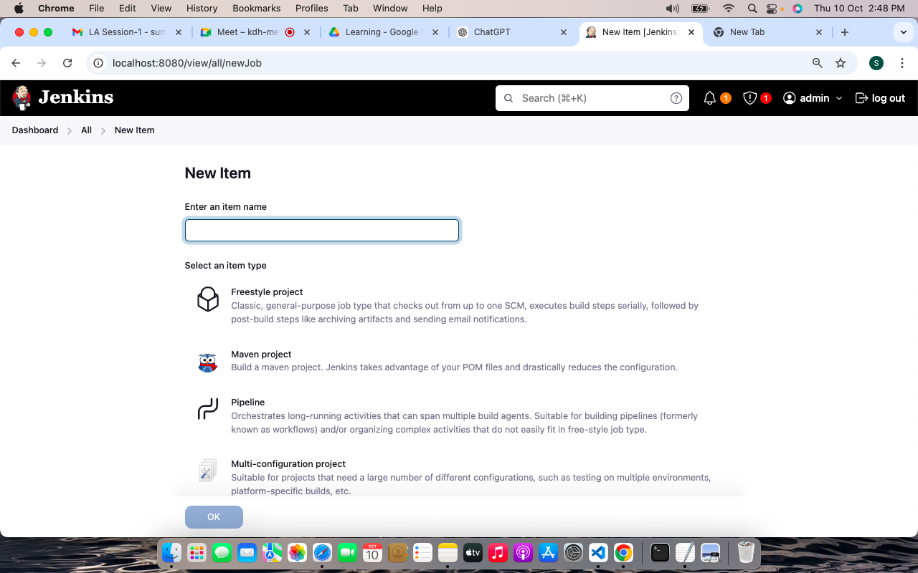

Freestyle project:  
  
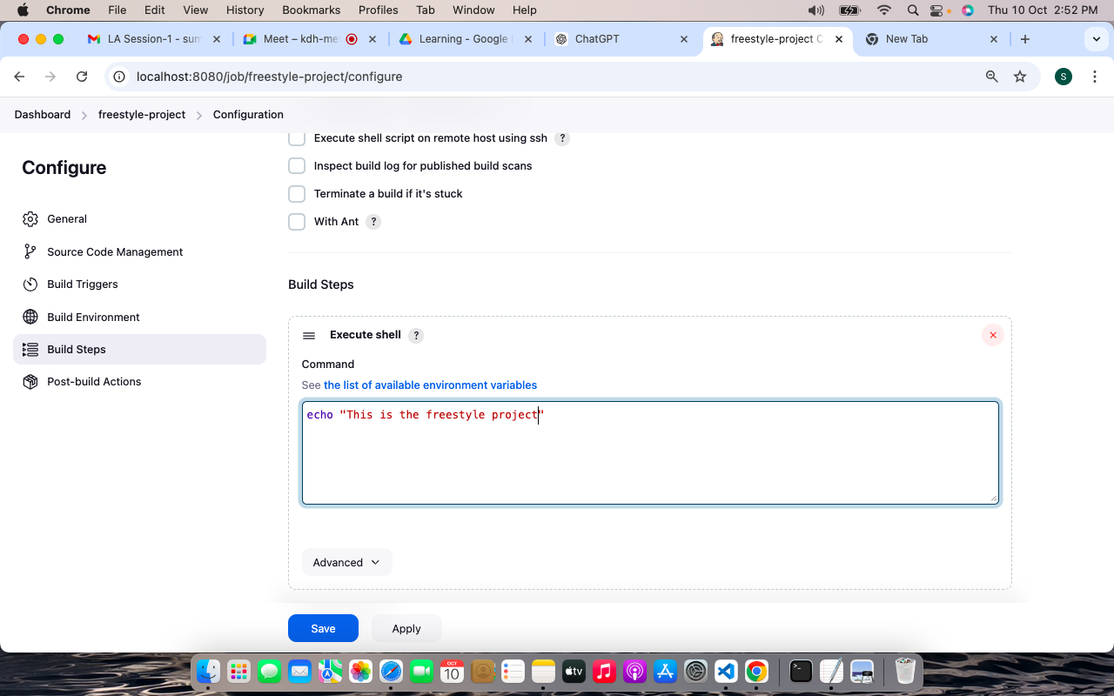  
  
Pipeline project:  
  
