**What is Jenkins?**

Jenkins is one open source tool to perform continuous integration. The basic functionality of Jenkins is to execute a predefined list of steps based on a certain trigger.

The trigger might for example be an change in a version control system or a time based trigger, e.g., a build every 20 minutes.

The list of steps can for example include:

* perform a software build with Apache Maven or Gradle
* Run a shell script
* Archive the build result
* Afterwards start the integration tests

Jenkins also monitors the execution of the steps and allows to stop the process if one of the steps fails. Jenkins allows to notify users about the build success or failure.

# Features

Jenkins offers the following features:

1. Easy installation
2. Easy configuration
3. Change set support
4. Permanent links
5. RSS/E-mail/IM Integration
6. After-the-fact tagging
7. JUnit/TestNG test reporting
8. Distributed builds
9. File fingerprinting
10. Plugin Support:

# Installation

Download the jenkins.war file from [**Jenkins Homepage**](http://jenkins-ci.org/).

You can start Jenkins in two ways :

1. Directly via the command line with

**java -jar jenkins.war**.

If you start it locally, you find it running under the following URL: <http://localhost:8080/>

1. To run it in your Tomcat server.

Install the Tomcat , put the  **jenkins.war** file into the webapps directory.

If you start Tomcat, your Jenkins installation will be available under

<http://localhost:8080/jenkins.war>

**Via Command Line**

Go to that path where jenkins.war is available then run the following command.

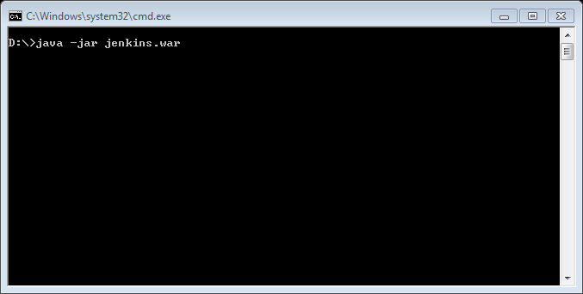

If we want to change the jenkin port number we can use following command

|  |
| --- |
| java -jar jenkins.war --ajp13Port=-1 --httpPort=8082 |
|  |

**Deploy in Tomcat**

* Placed Jenkins.war file in web-app folder
* Start the Tomcat server
  + Go to bin folder and run startup.bat file.
  + Tomcat started and deploy your Jenkins.war file in tomcat server.

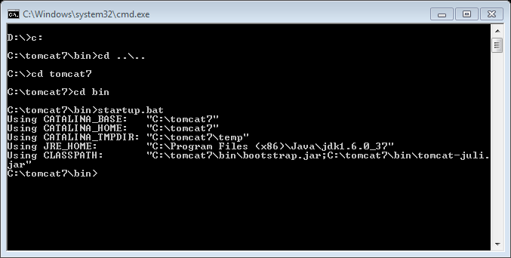

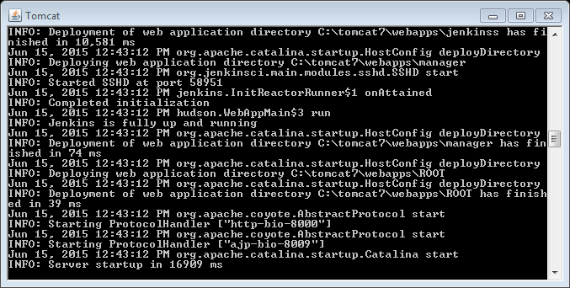

* Now your tomcat server is running and deployed Jenkins.war file successfully without any errors.
* Now open any browser and type the url : <http://localhost:8080/jenkins.war>
* You get the following screen.
* 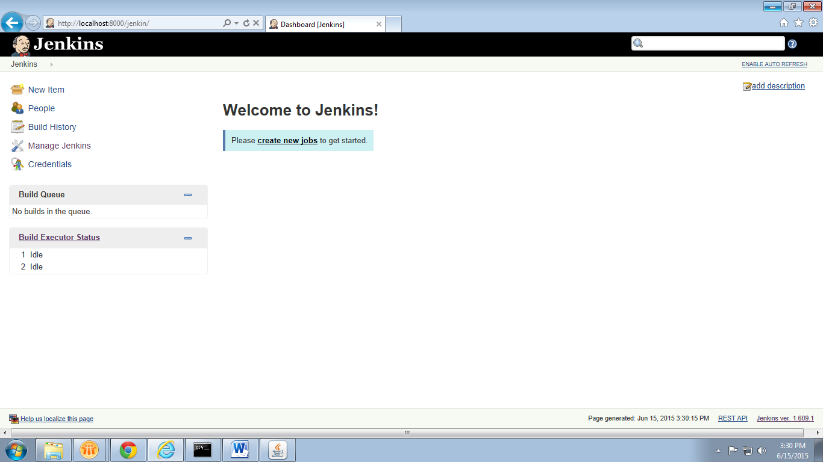
* Here we use 8000 as port number and we deploy jenkin.war file in tomcat. In your case it is 8080 and Jenkins.war.

**Configure Jenkins**

* We have Manage Jenkins option at left hand side. If we select that we have get the following screen.

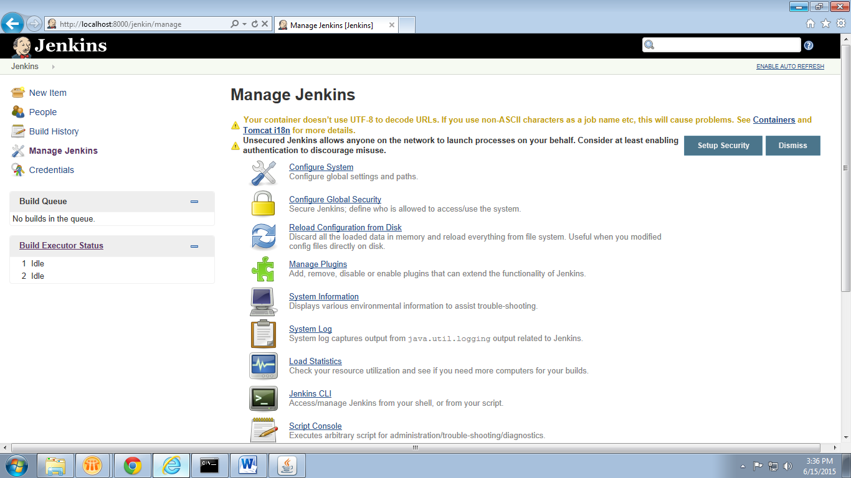

In this tab we can configure our system, Manage Plugins, Manage credentials etc..

**Creating Jobs**

* At the left hand side select the first option “New Item”.then you get the following screen.
* Give the Item Name and select Free style project radio button. Click on OK.

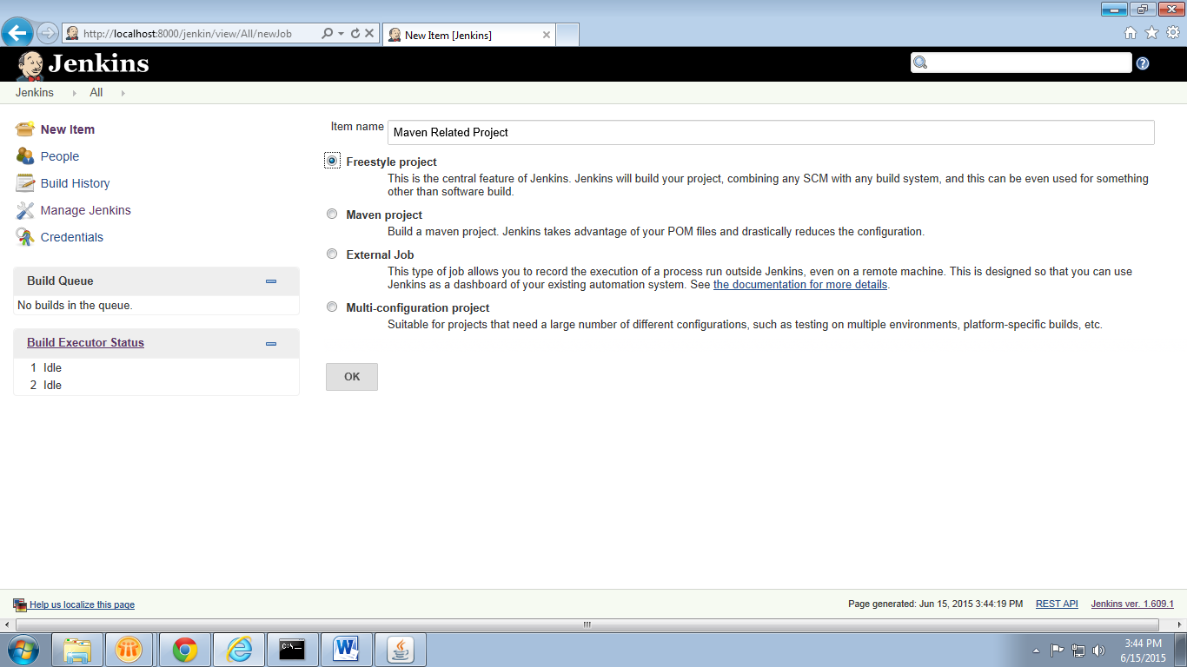

Then you get the job configuration screen. This configuration having various sections.

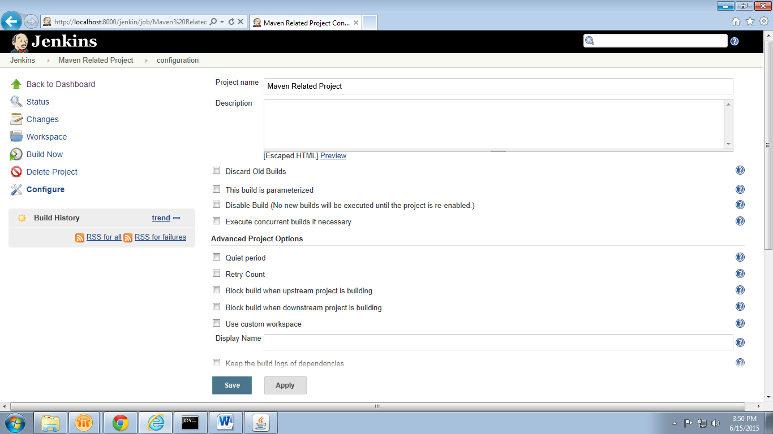

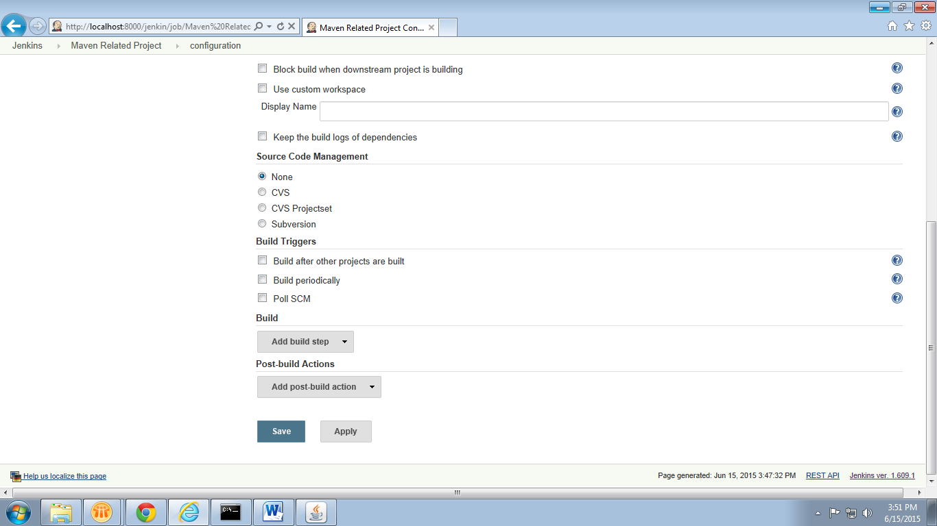

* **Source Code Management**
* We need to select any version control from given radio buttons and give the repository path where the complete code exist.
* Here we use sub version and its repository url. “https://CSCINDAE708195.asiapac.globalcsc.net/svn/ccsubv/cpm/trunk”

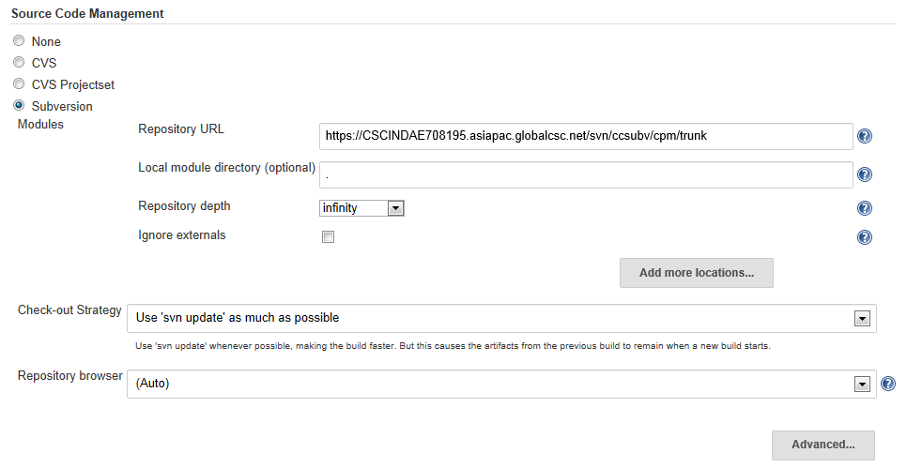

* **Build**
* In this section we can invoke Jenkins with Ant, Maven ,Sonar and execute Shell Scripts, Windows Batch Commands.
* **Example of Ant**

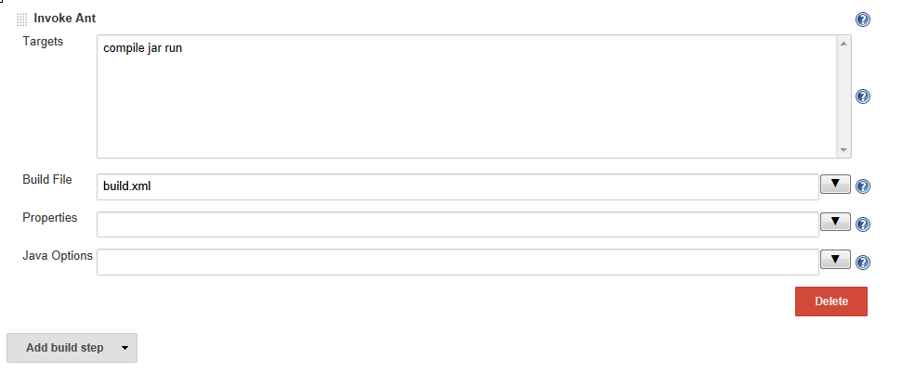

* **Example of Maven**

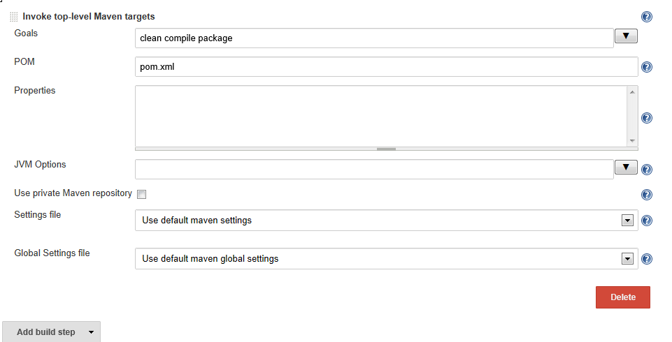

Press *Save* to finish the job definition.

**Build Jobs**

Press *Build Now*on the job page to validate the job works as expected

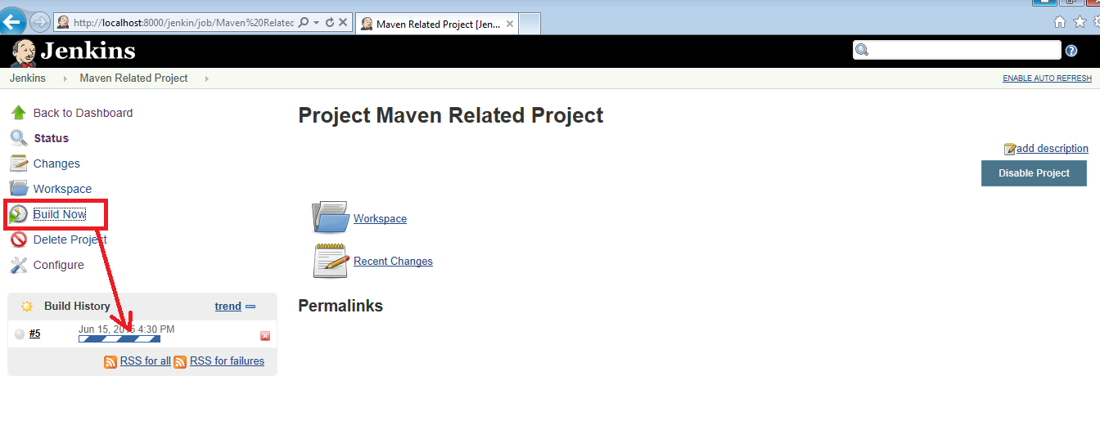

After a while the job should go to green or blue (depending on your configuration), if successful. Click on the job and afterwards on*Console Output* to see the log file in case of an error or to validate that log.

