An Internship Report

on

**Process Mining**

Submitted in partial fulfilment of the requirements

for the award of the degree of

**BACHELOR OF TECHNOLOGY**

in

**Computer Science and Engineering (Data Science)**

by

**Gurram Mekhala Sumanth (214G1A32A4)**

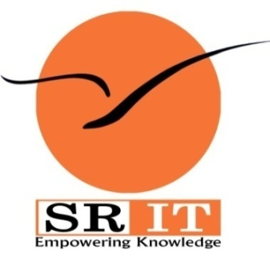

**DEPARTMENT OF COMPUTER SCIENCE AND ENGINEERING (DATA SCIENCE)**

**SRINIVASA RAMANUJAN INSTITUTE OF TECHNOLOGY**

**(AUTONOMOUS)**

**(Affiliated to JNTUA, accredited by NAAC with ‘A’ Grade, Approved by AICTE, New Delhi & Accredited by NBA (EEE, ECE & CSE))**

**Rotarypuram village, B K Samudram Mandal, Ananthapuramu-515701.**

**2023 – 2024**



**preface**

All India Council for Technical Education (AICTE) has initiated various activities for promoting industrial internship at the graduate level in technical institutes and Eduskills is a Non-profit organization which enables Industry 4.0 ready digital workforce in India. The vision of the organization is to fill the gap between Academic and Industry by ensuring world class curriculum access to the faculties and students. Formation of the All-India Council for Technical Education (AICTE) in 1945 by the Government of India.

**Purpose:** With a vision to create an industry-ready workforce who will eventually become leaders in emerging technologies, EduSkills & AICTE launches ‘Virtual Internship’ program on Process Mining. This field is one of the most in-demand, and this internship will serve as a primer.

**Company’s Mission Statement:** The main mission of these initiatives is enhancement of the employability skills of the students passing out from Technical Institutions.



**INDEX**

**LIST OF FIGURES**

**LIST OF TABLES**

**LIST OF ABBREVIATIONS**

**NoMENCLATURES**