Sumanth

Completed over 100 C-Language Programs

**SEQUENCE**

**Program 1 :**

/*

Program Name: 001(Sequence).c

Objective: Displays Personal Information

Author: Sumanth

Date: 6th June 2024

*/

# include <stdio.h>

main()

{

printf("\n Name: P.Sumanth Kumar Koti ");

printf("\n");

printf("\n DOB: May 19, 2007 ");

printf("\n");

printf("\n Moblie: +91-9848239269");

printf("\n");

}

**Output:**

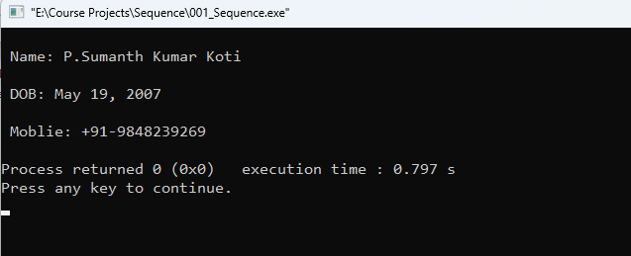

**Program 2 :**

//Program to calculate the total bill for iPhone & Covercase

# include <stdio.h>

int main()

{

//variable declaration

int p1,p2,amt;

//variable initialization

p1=0;

p2=0;

amt=0;

//input statements

printf("\n");

printf(" Enter the price of iPhone: ");

scanf("%d",&p1);

printf("\n");

printf(" Enter the price of Cover Case: ");

scanf("%d",&p2);

printf("\n");

//logic or process

amt = p1 + p2;

//output

printf(" Total Amount: Rs. %d",amt);

//Thank u message

printf("\n");

printf("\n");

printf("\t\t\t\t\t\t\tTHANK YOU , VISIT US AGAIN.");

printf("\n");

getch();

return 0;

}

**Output:**

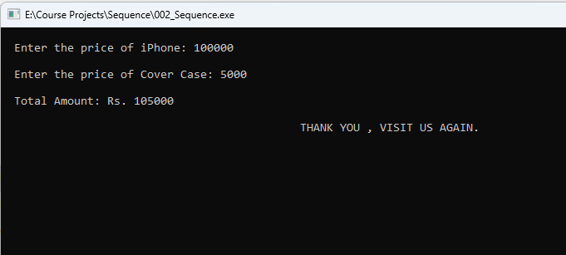

**Program 3 :**

//Program to calculate the amount to be given to the customer

# include <stdio.h>

int main()

{

//variable declaration

int p1,p2,amt;

//variable initialization

p1=0;

p2=0;

amt=0;

//input statements

printf("\n");

printf(" Enter the amount paid by the customer: ");

scanf("%d",&p2);

printf("\n");

printf(" Enter the Total Amount: ");

scanf("%d",&p1);

printf("\n");

//logic or process

amt = p2 - p1;

//output statements

printf(" Balance Amount to be return is: Rs.%d",amt);

printf("\n");

//Thank you message

printf("\n");

printf("\t\t\t\t\t\tTHANK YOU , VISIT US AGAIN.");

printf("\n");

printf("\n");

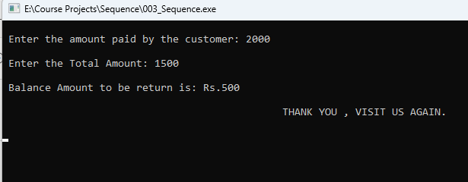

getch();

return 0;

}

**Output:**

**Program 4 :**

//Program to calculate the total & average

# include <stdio.h>

int main()

{

//variable declaration

int m1,m2,m3,m4,m5;

float total,avg;

//variable initialization

m1=0;

m2=0;

m3=0;

m4=0;

m5=0;

total=0;

avg=0;

//input statements

printf("\n");

printf(" \t\t\t\t\t\t Enter Your Marks");

printf("\n");

printf(" English: ");

scanf("%d",&m1);

printf("\n");

printf(" Sanskrit: ");

scanf("%d",&m2);

printf("\n");

printf(" Math's: ");

scanf("%d",&m3);

printf("\n");

printf(" Physics: ");

scanf("%d",&m4);

printf("\n");

printf(" Chemistry: ");

scanf("%d",&m5);

printf("\n") ;

//logic or process

total = m1 + m2 + m3 + m4 + m5;

avg = total/5;

//output statement

printf(" Total Marks: %.0f",total);

printf("\n");

printf("\n");

printf(" Average: %.2f %%",avg);

printf("\n");

getch();

return 0;

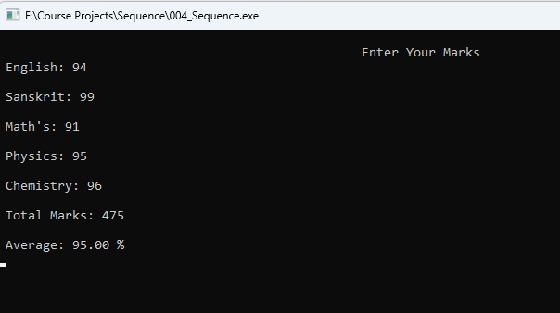}

**Output:**

**Program 5 :**

//Program to read Basic Salary of an Employee and display Gross Salary and Net Salary

# include <stdio.h>

main()

{

float bs,gs,ns,hra,da,pf;

bs=gs=ns=hra=da=pf=0;

printf("\n");

printf(" Enter Your Basic Salary : ");

scanf("%f",&bs);

hra= 0.2 * bs;

da= 0.1 * bs;

pf= 0.5 * bs;

gs= bs+hra+da;

ns= gs - pf;

printf(" Gross Salary: %f",gs);

printf("\n");

printf(" Net Salary: %f",ns);

printf("\n");

getch();

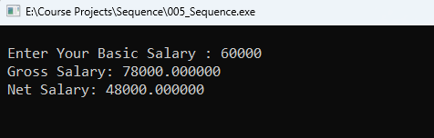

return 0;

}

**Output:**

**Program 6 :**

//Program to swap values of two variables A and B without using 3rd variable

# include <stdio.h>

main()

{

int a,b;

a=b=0;

printf("\n");

printf(" Enter the value of A: ");

scanf("%d",&a);

printf("\n");

printf(" Enter the value of B: ");

scanf("%d",&b);

printf("\n");

a = a + b;

b = a - b;

a = a - b;

printf(" A is : %d",a);

printf("\n");

printf("\n");

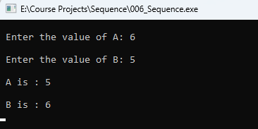 printf(" B is : %d",b);

printf("\n");

getch();

}

**Output:**

**Program 7 :**

//Program to read total Flying time in minutes and dislplay into hoursand minutes

# include <stdio.h>

int main()

{

int a,b,c;

a=b=c=0;

printf("\n");

printf(" Enter Flying time from Hyderabad to Singapore in minutes: ");

scanf("%d",&a);

b = a / 60;

c = a % 60;

printf("\n");

printf(" Flying time from Hyderbad to Singapore is %d hrs and %d minutes",b,c);

printf("\n");

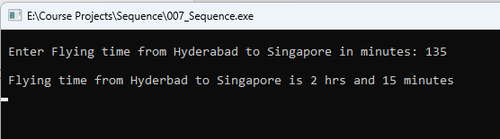

getch();

}

**Output:**

**Program 8 :**

//Program to read days and convert it into years,months,weeks and days\

# include <stdio.h>

int main()

{

int i,y,m,w,d;

i=y=m=w=d=0;

printf("\n");

printf(" Enter No of days: ");

scanf("%d",&i);

y = i / 365;

m = (i % 365) / 30;

w = ((i % 365) % 30) / 7;

d = (((i % 365) % 30)) % 7;

printf("\n");

printf(" Years: %d",y);

printf("\n");

printf(" Months: %d",m);

printf("\n");

printf(" Weeks: %d",w);

printf("\n");

printf(" Days: %d",d);

printf("\n");

getch();

}

**Output:**

}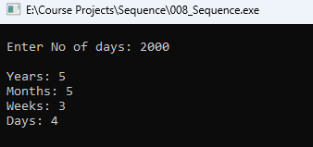

**Program 9 :**

//Program to read 3 characters and display them in reverse order

# include <stdio.h>

main()

{

char a,b,c,d;

a=b=c=d=0;

printf("\n");

printf(" Enter 3 characters of your choice: ");

scanf("%c %c %c",&a,&b,&c);

printf("\n");

d=a;

a=c;

c=d;

printf(" Reverse Order is %c %c %c",a,b,c);

printf("\n");

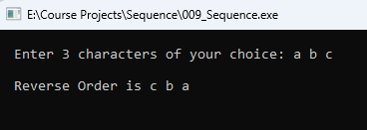 getch();

}

**Output:**

**Program 10 :**

// Program to read full name,gender,native place of a person and display

# include <stdio.h>

main()

{

char a[100],b,c[100];

printf("\n");

printf(" Enter your name: ");

scanf("%[^\n]",&a);

fflush(stdin);

printf("\n");

printf(" Enter your Gender(M/F) : ");

scanf("%c",&b);

fflush(stdin);

printf("\n");

printf(" Enter your Native Place : ");

scanf("%[^\n]",&c);

printf("\n");

printf(" %s - ",a);

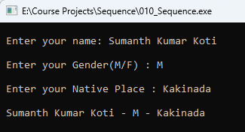 printf("%c - ",b);

printf("%s",c);

printf("\n");

getch();

}

**Output:**

**Program 11 :**

// Program to display how many bytes of memory each variable occupies

# include <stdio.h>

main()

{

int rn=0;

char gen,name[100];

float height;

printf("\n");

printf(" Enter Roll no. : ");

scanf("%d",&rn);

fflush(stdin);

printf("\n");

printf(" Enter Gender(M/F). : ");

scanf("%c",&gen);

fflush(stdin);

printf("\n");

printf(" Enter Name : ");

scanf("%s",&name);

fflush(stdin);

printf("\n");

printf(" Enter Height : ");

scanf("%f",&height);

printf("\n");

printf(" Roll no. occupies %d bytes of space",sizeof(rn));

printf("\n");

printf(" Gender occupies %d bytes of space",sizeof(gen));

printf("\n");

printf(" Name occupies %d bytes of space",sizeof(name));

printf("\n");

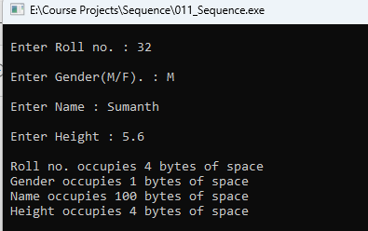 printf(" Height occupies %d bytes of space",sizeof(height));

printf("\n");

getch();

}

**Output:**

**Program 12 :**

// Program to read capital letters and display them in lower letters

# include <stdio.h>

main()

{

char a;

printf("\n");

printf(" Enter any Upper-case Alphabet (A - Z) : ");

scanf("%c",&a);

printf("\n");

printf(" Lower-case Letter is '%c'", a + 32);

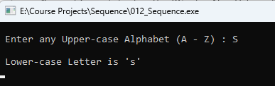 printf("\n");

getch();

}

**Output:**

**Program 13 :**

// Program to read the Tempareture in Fahrenheit and convert into Centigrade

# include <stdio.h>

main()

{

float f,c;

f=c=0;

printf("\n");

printf(" Enter the Temperature in Fahrenheit :");

scanf("%f",&f);

c = (f - 32) * 5/9;

printf("\n");

printf(" Temperature in Centigrade : %.2f",c);

printf("\n");

getch();

}

**Output:**

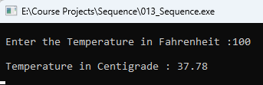

**Program 14 :**

// Program to read Rupees and convert into Paise

# include <stdio.h>

main()

{

float a,b;

a=b=0;

printf("\n");

printf(" Enter value in Rupees : ");

scanf("%f",&a);

b = a * 100;

printf("\n");

printf(" Value in Paise is %f",b);

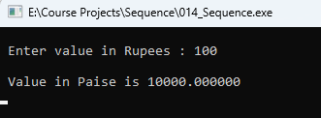 printf("\n");

getch();

}

**Output:**

**Program 15 :**

// Program to evaluate (a+b)2

# include <stdio.h>

main()

{

int a,b,c;

a=b=c=0;

printf("\n");

printf(" Enter value of a: ");

scanf("%d",&a);

printf("\n");

printf(" Enter value of b: ");

scanf("%d",&b);

c = (a*a) + (b*b) + 2*(a*b);

printf("\n");

printf(" The value of (%d + %d)^2 is %d",a,b,c);

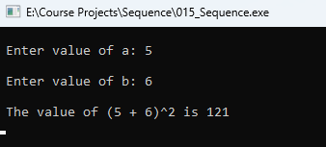

printf("\n");

getch();

}

**Output:**

**Program 16 :**

// Program to read radius of a circle and calclate area

# include <stdio.h>

main()

{

const float PI=3.14;

float a,b;

a=b=0;

printf("\n");

printf(" Enter the value of Radius of the Circle : ");

scanf("%f",&a);

printf("\n");

b = PI * a * a;

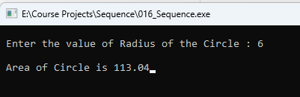 printf(" Area of Circle is %.2f",b);

getch();

}

**Output:**

**Program 17 :**

// Program to calculate Gross Salary and Net Salary from input Basic Salary,Allowances,Deductions

# include <stdio.h>

main()

{

int bs,al,ded;

float gs,ns;

bs=al=ded=gs=ns=0;

printf("\n");

printf(" Enter Basic Salary : ");

scanf("%d",&bs);

printf("\n");

printf(" Enter Allowance : ");

scanf("%d",&al);

printf("\n");

printf(" Enter Deduction : ");

scanf("%d",&ded);

gs = bs + al;

ns = gs - ded;

printf("\n");

printf(" Gross Salary : %.2f",gs);

printf("\n");

printf("\n");

printf(" Net Salary : %.2f",ns);

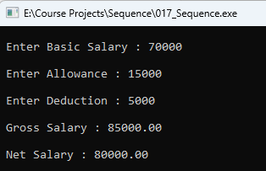 printf("\n");

getch();

}

**Output:**

**Program 18 :**

// Program to calculate Electricity from the inputted Present Month and Last Month readings

# include <stdio.h>

int main()

{

int pres,last,uc;

float amt;

const float RATE = 7.85;

printf("\n");

printf(" Enter Present Month Reading : ");

scanf("%d",&pres);

printf("\n");

printf(" Enter Last Month Reading : ");

scanf("%d",&last);

uc = pres - last;

amt = uc * RATE;

if(uc<0)

{

printf("\n");

printf(" \t\t\t\t\t\t\tERROR");

printf("\n");

printf("\n");

}

else

printf("\n");

printf(" Bill Amount : %.2f",amt);

printf("\n");

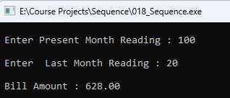

getch();

}

**Output:**

**Program 19 :**

// Program to display given matter in the Center of the screen

# include <stdio.h>

main()

{

printf("\n\t\t\t\t\t\tAH CAREER PVT LTD");

printf("\n");

printf("\n\t\t\t\t\t\t Danvaipeth");

printf("\n");

printf("\n\t\t\t\t\t\t Rajahmundry.");

printf("\n");

getch();

}

**Output:**

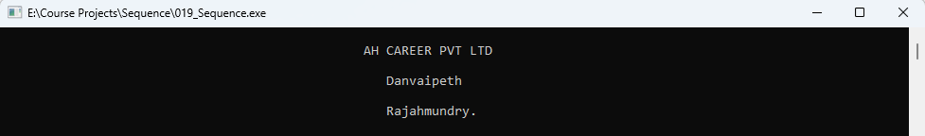

**Program 20 :**

//Program to read the total travelling distance in Kilo meters and display into meters

# include <stdio.h>

1. int main()

{

float a,b;

a=0;

printf("\n");

printf(" Enter Travelling Distance in Kilo Meters:");

scanf("%f",&a);

b = a * 1000;

printf("\n");

printf(" Travelling Distance in Meters :%.2f",b);

printf("\n");

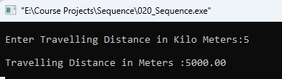 getch();

}

**Output:**

**Program 21 :**

//Program to split total bill amount along with tip among friends

# include <stdio.h>

main()

{

int a,c,e;

float b,d;

const float t1 = 10;

const float t2 = 5;

a=b=c=d=e=0;

printf("\n");

printf(" Enter Total Bill Amount :");

scanf("%d",&a);

printf("\n");

printf(" Enter the TIP (5%% or 10%%) :");

scanf("%f",&b);

printf("\n");

printf(" Enter Total Number of Friends :");

scanf("%d",&c);

if (b= 10)

{

e= (t1 * a) / 100;

d= (a + e) / c;

printf("\n");

printf(" Each one have to Pay Rs. %.2f",d);

printf("\n");

}

else if (b = 5)

{

e= (t2 * a) / 100;

d= (a + e) / c;

printf("\n");

printf(" Each one have to Pay Rs. %.2f",d);

printf("\n");

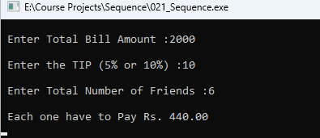 }

getch();

}

**Output:**

**Program 22 :**

// Program to calculate the total income of a house hold

# include <stdio.h>

main()

{

int a,b;

a=b=0;

printf("\n");

printf(" Enter Father's Income : Rs. ");

scanf("%d",&a);

printf("\n");

printf(" Enter Mother's Income : Rs. ");

scanf("%d",&b);

printf("\n");

printf(" Total Income is Rs. %d",(a+b));

printf("\n");

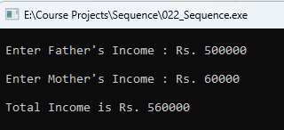 getch();

}

**Output:**

**Program 23 :**

// Program the total expenditure of a household

# include <stdio.h>

main()

{

int a,b,c,d,e;

a=b=c=d=e=0;

printf("\n");

printf(" Groceries : Rs. ");

scanf("%d",&a);

printf("\n");

printf(" Current Bill : Rs. ");

scanf("%d",&b);

printf("\n");

printf(" House Rent : Rs. ");

scanf("%d",&c);

printf("\n");

printf(" Gas Bill : Rs. ");

scanf("%d",&d);

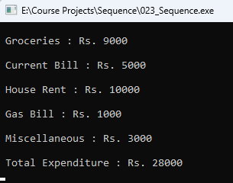 printf("\n");

printf(" Miscellaneous : Rs. ");

scanf("%d",&e);

printf("\n");

printf(" Total Expenditure : Rs. %d",(a+b+c+d+e));

printf("\n");

getch();

}

**Output:**

**Program 24 :**

// Program to calculate the cost of a cloth

# include <stdio.h>

main()

{

float a,b;

const int RATE=34;

a=b=0;

printf("\n");

printf(" Enter the length of cloth in meters :");

scanf("%f",&a);

printf("\n");

printf(" Rate per meter is Rs.34");

b = RATE * a;

printf("\n");

printf("\n");

printf(" Cost of Cloth is : Rs. %.2f",b);

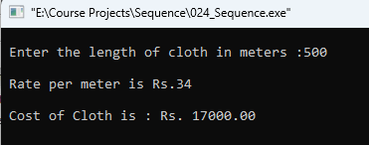 printf("\n");

getch();

}

**Output:**

**Program 25 :**

// Program to calculate the speed of a vehicle

# include <stdio.h>

main()

{

int a,b;

float c;

a=b=c=0;

printf("\n");

printf(" Enter Distance in meters: ");

scanf("%d",&a);

printf("\n");

printf(" Enter Time in seconds: ");

scanf("%d",&b);

c = a / b;

printf("\n");

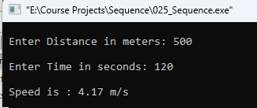 printf(" Speed is : %.2f m/s",c);

printf("\n");

getch();

}

**Output:**

**SELECTION**

**Program 1 :**

// Program to read the age of candidate & determine whether he/she is eligible to cast vote

# include <stdio.h>

int main()

{

int a;

a=0;

printf("\n");

printf(" Enter Your Age : ");

scanf("%d",&a);

printf("\n");

if(a>=18)

{

printf("\t\t\t\t Congratulations! 'You Are Eligible' to cast your vote.");

printf("\n");

}

else

{

printf("\t\t\t\t Oops! You are 'Too Young' to Vote.");

printf("\n");

}

getch();

}

**Output :**

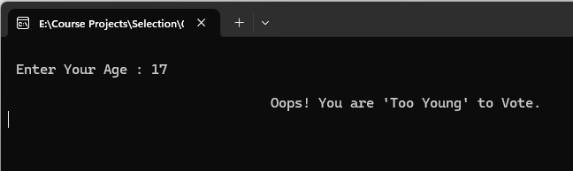

**Program 2 :**

// Program to raed the prices of two phones and displays the costlier one

# include <stdio.h>

main()

{

int a,b;

a=b=0;

printf("\n");

printf(" Price of SAMSUNG Mobile : Rs.");

scanf(" %d",&a);

printf("\n");

printf(" Price of VIVO Mobile : Rs.");

scanf(" %d",&b);

if (a>b)

{

printf("\n");

printf("\t\t\t\t\t\t $ SAMSUNG is Costlier $");

}

else if (a<b)

{

printf("\n");

printf("\t\t\t\t\t\t $ VIVO is Costlier $");

}

else

{

printf("\n");

printf("\t\t\t\t\t\t Both are at Same Price");

}

printf("\n");

getch();

}

**Output :**

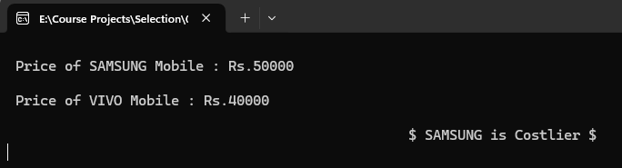

**Program 3 :**

// Program to calculate discount and display final ammount

# include <stdio.h>

main()

{

int a;

float b;

a=b=0;

printf("\n");

printf(" Enter Original Price : Rs.");

scanf("%d",&a);

if(a>=25000)

{

printf("\n");

printf("\t\t\t\t\t\t\t 'DISCOUNT is 10%%'");

printf("\n");

b = 0.1 * a;

printf(" Total Amount : Rs. %.2f",b);

}

else

{

printf("\n");

printf("\t\t\t\t\t\t 'DISCOUNT is 5%%'");

printf("\n");

b = 0.05 * a;

printf(" Total Amount : Rs. %.2f",b);

}

printf("\n");

getch();

}

**Output :**

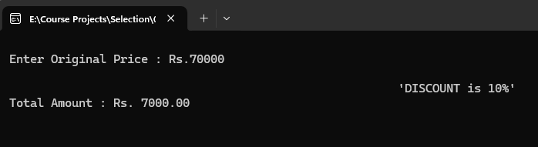

**Program 4 :**

// Program to display who is older than the other of two friends

# include <stdio.h>;

main()

{

int a,b;

char c[50];

char d[50];

a=b=0;

printf("\n");

printf(" Enter Name of Person 1 : ");

scanf("%s",&c);

printf("\n");

printf(" Enter Age of Person 1 : ");

scanf("%d",&a);

printf("\n");

printf(" Enter Name of Person 2 : ");

scanf("%s",&d);

printf("\n");

printf(" Enter Age of Person 2 : ");

scanf("%d",&b);

if (a>b)

{

printf("\n");

printf(" %s is older than %s",c,d);

}

else if (a<b)

{

printf("\n");

printf(" %s is younger than %s",c,d);

}

else

{

printf("\n");

printf(" %s and %s are Same Age",c,d);

}

printf("\n");

getch();

}

**Output :**

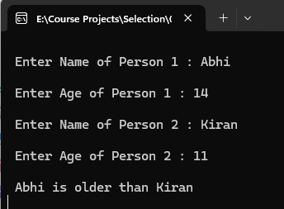

**Program 5 :**

// Program to check whether given number is positive or negative

# include <stdio.h>

int main()

{

int a;

a = 0;

printf("\n");

printf(" Enter a Number : ");

scanf("%d",&a);

if(a>0)

{

printf("\n");

printf(" %d is a positive number",a);

}

else

{

printf("\n");

printf(" %d is a negative number",a);

}

printf("\n");6

getch();

}

**Output :**

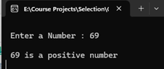

**Program 6 :**

// Program to find the biggest of 4 numbers

# include <stdio.h>

main()

{

float a,b,c,d;

a=b=c=d=0;

printf("\n");

printf(" Enter 'a' value : ");

scanf("%f",&a);

printf("\n");

printf(" Enter 'b' value : ");

scanf("%f",&b);

printf("\n");

printf(" Enter 'c' value : ");

scanf("%f",&c);

printf("\n");

printf(" Enter 'd' value : ");

scanf("%f",&d);

if (a>b && a>c && a>d)

{

printf("\n");

printf(" Biggest Number is %.2f",a);

}

if (b>a && b>c && b>d)

{

printf("\n");

printf(" Biggest Number is %.2f",b);

}

if (c>b && c>a && c>d)

{

printf("\n");

printf(" Biggest Number is %.2f",c);

}

if (d>b && d>c && d>a)

{

printf("\n");

printf(" Biggest Number is %.2f",d);

}

printf("\n");

getch();

}

**Output :**

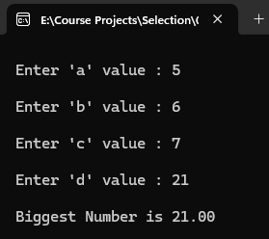

**Program 7 :**

// Program to check given input is divisible by 3 and 5

# include <stdio.h>

main()

{

int a=0;

printf("\n Enter Number : ");

scanf("%d",&a);

if (a%3==0 && a%5==0)

printf("\n Given Number is divisible by both 3 and 5.");

else

printf("\n Given Number is not divisible by both 3 and 5.");

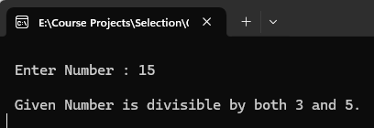

printf("\n");

getch();

}

**Output :**

**Program 8 :**

// Program to display the costliest pen

# include <stdio.h>

main()

{

int a,b,c;

a=b=c=0;

printf("\n");

printf(" Cost of Reynolds Pen : Rs. ");

scanf("%d",&a);

printf("\n");

printf(" Cost of Montex Pen : Rs. ");

scanf("%d",&b);

printf("\n");

printf(" Cost of Parker Pen : Rs. ");

scanf("%d",&c);

printf("\n");

if (a>b && a>c)

{

printf("\t\t\t\t\t\t $ Reynolds is Costliest $");

printf("\n");

}

else if (b>a && b>c)

{

printf("\t\t\t\t\t\t $ Montex is Costliest $");

printf("\n");

}

else if (c>a && c>b)

{

printf("\t\t\t\t\t\t $ Parker is Costliest $");

printf("\n");

}

getch();

}

**Output :**

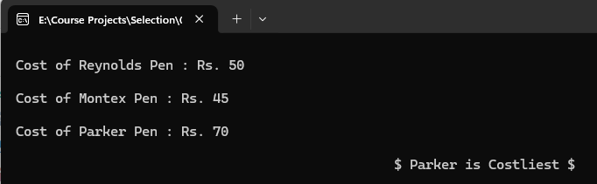

**Program 9 :**

// Program to read three values and display them in ascending order

# include <stdio.h>

main()

{

float a,b,c;

a=b=c=0;

printf("\n Enter Value of 'a' : ");

scanf("%f",&a);

printf("\n Enter Value of 'b' : ");

scanf("%f",&b);

printf("\n Enter Value of 'c' : ");

scanf("%f",&c);

if (a>b && a>c && b>c)

{

printf("\n Ascending Order is %.2f , %.2f , %.2f",a,b,c);

}

else if (a>b && a>c && c>b)

{

printf("\n Ascending Order is %.2f , %.2f , %.2f",a,c,b);

}

else if (b>a && b>c && a>c)

{

printf("\n Ascending Order is %.2f , %.2f , %.2f",b,a,c);

}

else if (b>a && b>c && c>a)

{

printf("\n Ascending Order is %.2f , %.2f , %.2f",b,c,a);

else if (c>a && c>b && a>b)

{

printf("\n Ascending Order is %.2f , %.2f , %.2f",c,a,b);

}

else if (c>a && c>b && b>c)

{

printf("\n Ascending Order is %.2f , %.2f , %.2f",c,b,a);

}

printf("\n");

getch();

}

**Output :**

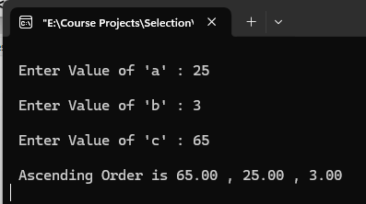

**Program 10 :**

// Program to calculate and display the absolute difference of 2 numbers

# include <stdio.h>

main()

{

int a,b,c;

a=b=c=0;

printf("\n");

printf(" Enter value of 'a' : ");

scanf("%d",&a);

printf("\n");

printf(" Enter value of 'b' : ");

scanf("%d",&b);

c=a - b;

if (c<0)

c = c * (-1);

printf("\n");

printf(" The absolute difference of (%d - %d) : %d",a,b,c);

printf("\n");

getch();

}

**Output :**

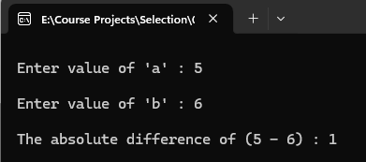

**Program 11 :**

// Program to calculate the profit or loss or no loss no profit

# include <stdio.h>

main()

{

int a,b;

a=b=0;

printf("\n");

printf(" Enter Cost Price : ");

scanf("%d",&a);

printf("\n");

printf(" Enter Selling Price : ");

scanf("%d",&b);

if (b-a>0)

{

printf("\n");

printf(" Heyy, You have made a profit of Rs . %d ",(b-a));

}

else if (b-a<0)

{

printf("\n");

printf(" Oops!! You made a loss of Rs . %d ",(b-a));

}

else

{

printf("\n");

printf(" Hmmm! No Profit ..... No Loss.....");

}

printf("\n");

getch();

}

**Output :**

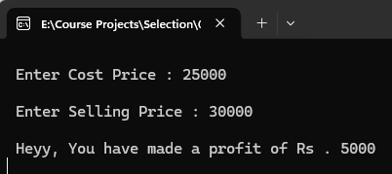

**Program 12 :**

// Program to read the rating of 3 movies and display the hit movie according to the input

# include <stdio.h>

main ()

{

int a,b,c;

a=b=c=0;

printf("\n");

printf(" Enter Rating of KALKI : ");

scanf("%d",&a);

printf("\n");

printf(" Enter Rating of PUSHPA : ");

scanf("%d",&b);

printf("\n");

printf(" Enter Rating of OG : ");

scanf("%d",&c);

if (a>b && a>c)

{

printf("\n");

printf(" KALKI is a Hit Movie.");

}

else if (b>a && b>c)

{

printf("\n");

printf(" PUSHPA is a Hit Movie.");

}

else if (c>b && c>a) 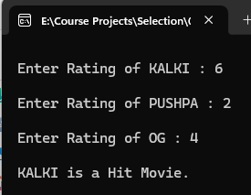

{

printf("\n");

printf(" OG is a Hit Movie.");

}

printf("\n");

getch();

}

**Output :**

**Program 13 :**

// Program to read the temperature and display suitable message

# include <stdio.h>

main()

{

float temp;

printf("\n");

printf(" Enter Temperature in Centigrade : ");

scanf("%f",&temp);

printf("\n Temperture is %.2f \n",temp);

if (temp<0)

{

printf("\n\t\t\t\t\t\t");

printf(" Ohhh! It's Freezing.");

}

else if (0<=temp && temp<=10)

{

printf("\n\t\t\t\t\t\t");

printf(" It's a too Cold out here!");

}

else if (10<temp && temp<=20)

{

printf("\n\t\t\t\t\t\t");

printf(" It's a little Cold out here!");

}

else if (20<temp && temp<=30)

{

printf("\n\t\t\t\t\t\t");

printf(" Hmmm! Looks like a good weather.");

}

else if (30<temp && temp<=40)

{

printf("\n\t\t\t\t\t\t");

printf(" It's getting a little hot out here.");

}

else if (temp>=40)

{

printf("\n\t\t\t\t\t\t");

printf(" Ohhh! It's freaking hot.");

}

printf("\n");

getch();

}

**Output :**

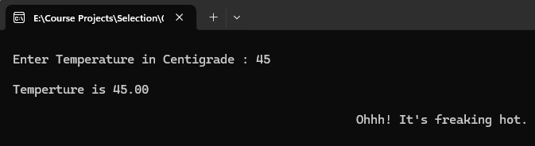

**Program 14 :**

// Program to display the view of each floor

# include <stdio.h>

main()

{

int a;

a=0;

printf("\n");

printf(" Enter Your Floor Number : ");

scanf("%d",&a);

if (a<0)

printf("\a\n\t\t\t\t That's an Restricted Area , Authorized Personal Only. ");

else

if (a>50)

printf("\a\n\t\t\t\t\t\t Sorry, We only have 50 Floors. ");

else

if (a%2 == 0)

printf("\n\t\t\t\t\t\t You have a Beach View. ");

else

printf("\n\t\t\t\t\t\t You have a Forest View. ");

printf("\n");

getch();

}

**Output :**

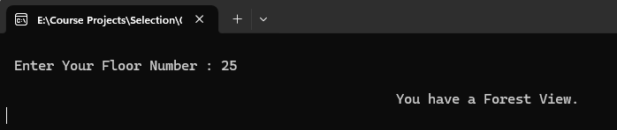

**Program 15 :**

// Program to read character and check whether if it is capital/smaller letter or special character

# include <stdio.h>

main()

{

char ch;

printf("\n");

printf(" Enter Character : ");

scanf("%c",&ch);

if (ch>=65 && ch<=90)

printf("\n %c is Capital Letter.",ch);

else

if (ch>=97 && ch<=122)

printf("\n %c is Lower-case Letter.",ch);

else

if (ch>=48 && ch<=57)

printf("\n %c is a Digit.",ch);

else

printf("\n %c is a Special Character.",ch);

printf("\n");

getch();

}

**Output :**

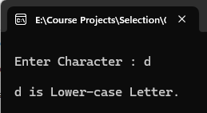

**Program 16 :**

// Program to read a character and check whether if character is vowel or consonants

# include <stdio.h>

main()

{

char ch;

printf("\n Enter character : ");

scanf("%c",&ch);

printf("\n");

if( (ch>=65 && ch<=90) || ( ch>=97 && ch<=122) )

{

if(ch=='a'||ch=='e'||ch=='i'||ch=='o'||ch=='u')

printf(" '%c' is a Vowel.",ch);

else

if (ch=='A'||ch=='E'||ch=='I'||ch=='O'||ch=='U')

printf(" '%c' is a Vowel.",ch);

else

printf(" '%c' is a Consonant.",ch);

}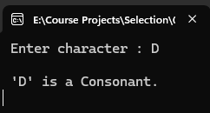

else

printf("\a\n\t\t\t\t\t\t \"INVALID INPUT\" ");

printf("\n");

getch();

}

**Output :**

**Program 17 :**

// Program to read date of birth and display whether if born in leap year

# include <stdio.h>

main ()

{

int a,b;

a=b=0;

printf("\n");

printf(" Enter Your Year of Birth : ");

scanf("%d",&a);

b = a%4;

if (b==0)

{

printf("\n");

printf(" You were born in a Leap year.");

printf("\n");

printf(" %d is a Leap year.",a);

}

else

{

printf("\n");

printf(" You were not born in a Leap year.");

printf("\n");

printf(" %d is a not Leap year.",a);

}

printf("\n");

getch();

}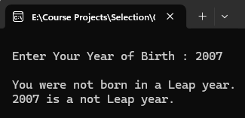

**Output :**

**Program 18 :**

// Program to calculate the current bill of a consumer

# include <stdio.h>

main()

{

int id,units;

char name[20];

float bill,net,sur,rate;

id=units=bill=net=sur=rate=0;

printf("\n Enter Customer ID : ");

fflush(stdin);

scanf("%d",&id);

printf("\n Enter Customer Name : ");

fflush(stdin);

scanf("%s",&name);

printf("\n Enter Units Consumed : ");

fflush(stdin);

scanf("%d",&units);

if (units<0)

{

printf("\a\n\t\t\t\t\t\t \"INVALID INPUT\" \n ");

return;

}

printf("\n Customer ID : %d",id);

printf("\n Customer Name : %s",name);

printf("\n Units Consumed : %d",units);

if (units<199)

{

rate = 1.20;

}

else if (units>=200 && units<400)

{

rate = 1.50;

}

else if (units>=400 && units<600)

{

rate = 1.80;

}

else if (units>=600)

{

rate = 2.00;

}

bill = rate * units;

if (bill<100)

{

printf("\a\n\t\t\t\t \"Bill Amount does not meet minimum requirements\" \n ");

return;

}

if (units<400)

printf("\n Bill Amount : Rs. %.2f",bill);

else

{

sur = 0.15 * bill;

net = sur + bill;

printf("\n Bill Amount : Rs. %.2f",bill);

printf("\n Surcharges : Rs. %.2f",sur);

printf("\n Net Amount : Rs. %.2f",net);

}

printf("\n");

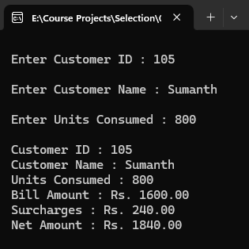 getch();

}

**Output :**

**Program 19 :**

// Program to read marks and display grades

# include <stdio.h>

main()

{

int m,p,c;

float total,avg;

m=p=c=0;

printf("\n Enter Marks of Maths : ");

scanf("%d",&m);

printf("\n Enter Marks of Physics : ");

scanf("%d",&p);

printf("\n Enter Marks of Chemistry : ");

scanf("%d",&c);

total = m + p + c;

avg = total / 3;

if (avg>90)

printf("\n\t\t\t\t\t\t \"Grade is 'A+'\" ");

else if (avg>80 && avg<90)

printf("\n\t\t\t\t\t\t \"Grade is 'A'\" ");

else if (avg>70 && avg<80)

printf("\n\t\t\t\t\t\t \"Grade is 'B+'\" ");

else if (avg>60 && avg<70)

printf("\n\t\t\t\t\t\t \"Grade is 'B'\" ");

else if (avg>50 && avg<60)

printf("\n\t\t\t\t\t\t \"Grade is 'C'\" ");

else if (avg<50)

printf("\a\n\t\t\t\t\t\t \"Grade is 'F'\" ");

printf("\n");

getch();

}

**Output :**

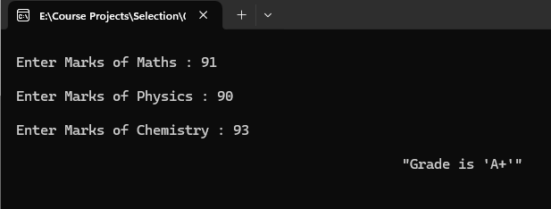

**Program 20 :**

// Program to read marks and display grades

# include <stdio.h>

main()

{

float sales,dis,amt;

sales=dis=amt=0;

printf("\n Enter Sales Amount : ");

scanf("%f",&sales);

if (sales>=25000)

dis = sales * 0.25;

else if (sales>20000 && sales<25000)

dis = sales * 0.20;

else if (sales>10000 && sales<20000)

dis = sales * 0.10;

else if (sales>5000 && sales<10000)

dis = sales * 0.5;

else if (sales<5000)

dis = 0;

amt = sales + dis;

printf("\n Discount : %.2f",dis);

printf("\n Actual Amount : %.2f",amt);

printf("\n");

getch();

}

**Output :**

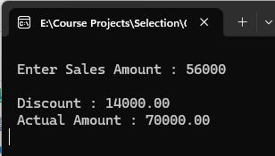

**Program 21 :**

// Program to calculate Gross Salary and Net Salary and bonus from input Basic Salary,Allowances,Deductions

# include <stdio.h>

main()

{

int bs,al,ded,exp;

float gs,ns,bon;

bs=al=ded=exp=gs=ns=0;

printf("\n Enter Basic Salary : ");

scanf("%d",&bs);

printf("\n Enter Allowance : ");

scanf("%d",&al);

printf("\n Enter Deduction : ");

scanf("%d",&ded);

printf("\n Experience : ");

scanf("%d",&exp);

gs = bs + al;

ns = gs - ded;

if (exp>5)

bon = ns * 3;

else if (exp>3)

bon = ns * 2;

else

bon = ns;

printf("\n Gross Salary : %.2f",gs);

printf("\n Net Salary : %.2f",ns);

printf("\n Bonus : %.2f",bon);

printf("\n");

getch();

}

**Output :**

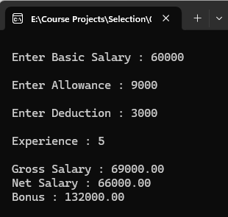

**Program 22 :**

// Program to read character and check whether if it is capital/smaller letter or special character

# include <stdio.h>

main()

{

char ch;

printf("\n");

printf(" Enter Character : ");

scanf("%c",&ch);

if (ch>=65 && ch<=90)

printf("\n %c is Capital Letter.",ch);

else

if (ch>=97 && ch<=122)

printf("\n %c is Lower-case Letter.",ch);

else

if (ch>=48 && ch<=57)

printf("\n %c is a Digit.",ch);

else

printf("\n %c is a Special Character.",ch);

printf("\n");

getch();

}

**Output :**

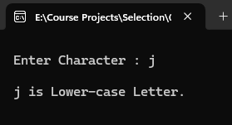

**Program 23 :**

// Program to check whether if is vowel or consonants

# include <stdio.h>

main()

{

char ch;

printf("\n Enter Character : ");

scanf("%c",&ch);

ch=tolower(ch);

if ( (ch>=97 && ch<=122) || (ch>=65 && ch<=90) )

if (ch=='a' || ch=='e' || ch=='i' || ch=='o' || ch=='u')

printf("\n '%c' is a Vowel.",ch);

else

printf("\n '%c' is a Consonant.",ch);

else

printf("\a\n\t\t\t\t\t\t \"INVALID INPUT\" ");

printf("\n");

getch();

}

**Output :**

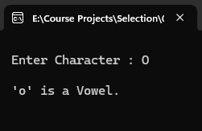

**Program 24 :**

// Program to check whether if the person is eligible for bonus or not (without using logic operators)

# include <stdio.h>

main()

{

int age=0;

char ms,gen;

printf("\n Enter Martial Status ( [M]arried/[U]nmarried ) : ");

scanf("%c",&ms);

ms=toupper(ms);

if (ms=='M')

{

printf("\n Enter Gender ( [M]ale/[F]emale ) : ");

fflush(stdin);

scanf("%c",&gen);

gen=toupper(gen);

if (gen=='M')

{

printf("\n Enter Age : ");

scanf("%d",&age);

if (age>30 )

printf("\n\t\t\t\t\t\t \"ELIGIBLE\" ");

else

printf("\n\t\t\t\t\t\t \"NOT ELIGIBLE\" ");

}

else if(gen=='F')

{

printf("\n Enter Age : ");

scanf("%d",&age);

if (age>25 )

printf("\n\t\t\t\t\t\t \"ELIGIBLE\" ");

else

printf("\n\t\t\t\t\t\t \"NOT ELIGIBLE\" ");

}

else

printf("\a\n\t\t\t\t\t\t \"INVALID GENDER\" ");

}

else

if (ms=='U')

printf("\n\t\t\t\t\t\t \"NOT ELIGIBLE\" ");

else

printf("\a\n\t\t\t\t\t\t \"INVLAID INPUT\" ");

printf("\n");

getch();

}

**Output :**

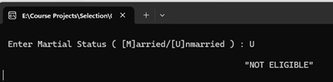

**Program 25 :**

// Program to check whether if the person is eligible for bonus or not (without using logic operators)

# include <stdio.h>

main()

{

int age=0;

char ms,gen;

printf("\n Enter Martial Status ( [M]arried/[U]nmarried ) : ");

scanf("%c",&ms);

if (ms=='M' || ms=='m')

{

printf("\n Enter Gender ( [M]ale/[F]emale ) : ");

fflush(stdin);

scanf("%c",&gen);

if ( (gen=='M') || (gen=='m') || (gen=='F') || (gen=='f') )

{

printf("\n Enter Age : ");

scanf("%d",&age);

if ( ( (gen=='M') || (gen=='m') && age>30 ) || ( (gen=='F') || (gen=='f') && age>25 ) )

printf("\n\t\t\t\t\t\t \"ELIGIBLE\" ");

else

printf("\n\t\t\t\t\t\t \"NOT ELIGIBLE\" ");

}

else

printf("\a\n\t\t\t\t\t\t \"INVALID GENDER\" ");

}

else

if (ms=='U' || ms=='u')

printf("\n\t\t\t\t\t\t \"NOT ELIGIBLE\" ");

else

printf("\a\n\t\t\t\t\t\t \"INVLAID INPUT\" ");

printf("\n");

getch();

}

**Output :**

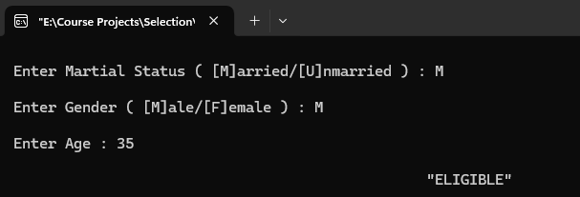

**Program 26 :**

// Program to check whether if passenger is eligible for consession or not

# include <stdio.h>

main()

{

int age=0;

char gen;

printf("\n Enter Age : ");

scanf("%d",&age);

if (age<0)

{

printf("\a\n\t\t\t\t\t\t \"INVALID AGE\" ");

return;

}

if (age<5)

printf("\n You have full consession.(No Ticket Required)");

else

{

printf("\n Enter Gender( [M]ale/[F]emale ): ");

fflush(stdin);

scanf("%c",&gen);

gen=toupper(gen);

if (gen=='M' || gen=='F')

{

if (gen=='M' && age>60)

printf("\n You have been allotted 50%% Consession.");

else

if (gen=='F' && age>50)

printf("\n You have been allotted 50%% Consession.");

else

printf("\n Sorry,no Consession.");

}

else

printf("\a\n\t\t\t\t\t\t Sorry,Only two Genders are allowed.");

}

printf("\n");

getch();

}

**Output :**

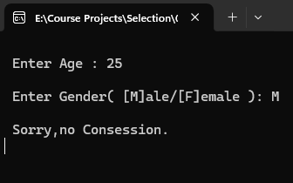

**Program 27 :**

// Program to generate final bill for customer based on discount

# include <stdio.h>

main()

{

int cost,dis,ext,days,billamt;

char mode;

cost=dis=ext=days=billamt=0;

printf("\n Enter Cost of the TV:");

scanf("%d",&cost);

printf("\n Are you Paying cash(y/n):");

fflush(stdin);

scanf("%c",&mode);

mode=toupper(mode);

if(mode=='Y')

{

dis=cost*25/100;

billamt=cost-dis;

}

else

if(mode=='N')

{

printf("\n In How many Days will you Pay? : ");

scanf("%d",&days);

if(days<7)

{

dis=cost*15/100;

billamt=cost-dis;

}

else

{

ext=cost*10/100;

billamt=cost+ext;

}

}

else

{

printf("\a\n\t\t\t\t\t\t \"INVALID MODE\" ");

return;

}

if(days<7)

printf("\n Discount is: Rs. %d",dis);

else

printf("\n Extra Amount is: Rs. %d",ext);

printf("\n Final Bill Amount : Rs. %d",billamt);

printf("\n\t\t\t\t\t\t \"THANK YOU\" ");

printf("\n");

getch();

}

**Output :**

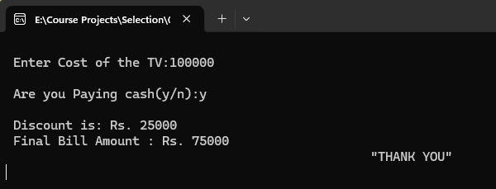

**Program 28 :**

// Program to accept marks and display whether if passed or failed

#include <stdio.h>

int main()

{

float total,avg;

int c,cpp,java;

printf("\n Enter the marks for C : ");

scanf("%d", &c);

printf("\n Enter the marks for CPP : ");

scanf("%d", &cpp);

printf("\n Enter the marks for JAVA : ");

scanf("%d", &java);

total = c+cpp+java;

avg = total/3;

if (c < 40 || cpp < 40 || java < 40)

{

printf("\n Failed in ");

if (c < 40) printf(" C ");

if (cpp < 40) printf(" CPP ");

if (java < 40) printf(" JAVA ");

return;

}

else

{

if (total>250)

printf("\n\t\t\t\t\t\t CONGRATS!! You passed in FIRST Class.");

else if (total>200)

printf("\n\t\t\t\t\t\t CONGRATS!! You passed in SECOND Class.");

else if (total>150)

printf("\n\t\t\t\t\t\t CONGRATS!! You passed in THIRD Class.");

}

printf("\n Total Marks : %.2f",total);

printf("\n Average Marks : %.2f",avg);

printf("\n");

getch();

}

**Output :**

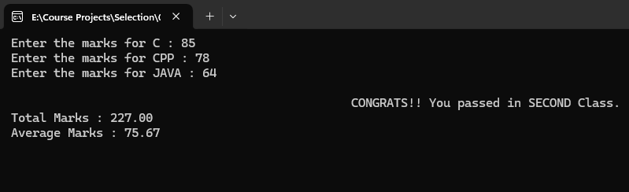

**Program 29 :**

// Program to prepare electricity bill

# include <stdio.h>

main()

{

int units=0;

float bill,rate;

char use;

printf("\n Enter Units Consumed : ");

scanf("%d",&units);

printf("\n For which use is electricity used( [D]omestic / [C]ommercial ) : ");

fflush(stdin);

scanf("%c",&use);

use=toupper(use);

if (units<0)

{

printf("\a\n\t\t\t\t\t\t \"INVALID INPUT\" ");

return;

}

if (use=='D' || use=='C')

{

if (use=='D')

if(units<100)

rate=100;

if (units>100 && units<200)

rate=1.50;

bill=rate * units;

if (units>200 && units<300)

rate=3.00;

bill=rate * units;

if(units>=300)

rate=5.00;

bill=rate * units;

if (use=='C')

if(units<100)

rate=150;

if (units>100 && units<200)

rate=2.50;

bill=rate * units;

if (units>200 && units<300)

rate=4.50;

bill=rate * units;

if(units>=300)

rate=7.50;

bill=rate * units;

}

else

{

printf("\a\n\t\t\t\t\t\t \"INVALID INPUT\" \n ");

return;

}

printf("\n Rate : Rs. %.2f",rate);

printf("\n Bill Amount : %.2f",bill);

printf("\n");

getch();

}

**Output 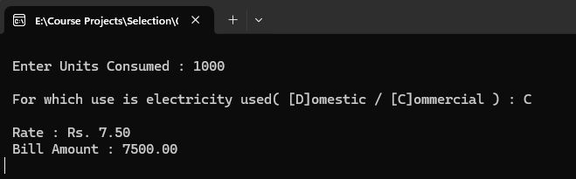:**

**Program 30 :**

// Program to check given input is divisible by 3 and 5

# include <stdio.h>

main()

{

int a=0;

printf("\n Enter Number : ");

scanf("%d",&a);

a%2==0 ? printf("\n %d is Even.",a) : printf("\n %d is Odd.",a);

printf("\n");

getch();

}

**Output :**

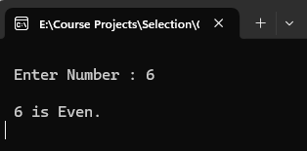

**Program 31 :**

// Program to differentiate persons based on height

# include <stdio.h>

main()

{

int a=0;

float b=0;

const float FEET=30.48;

printf("\n Enter Height in cm : ");

scanf("%d",&a);

b = a / FEET;

if (b>5.5)

printf("\n Your Height is %.2f feet and you are classified as 'Tall'. ",b);

else

if (b<4.5)

printf("\n Your Height is %.2f feet and you are classified as 'Dwarf'. ",b);

else

printf("\n Your height is %.2f feet and Your height is 'Average'. ",b);

printf("\n");

getch();

}

**Output :**

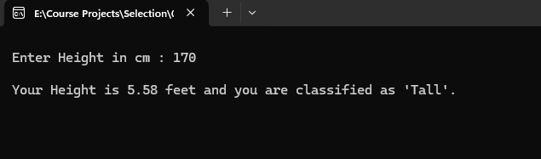

**Program 32 :**

// Program to display the bill amount in a restaurant

# include <stdio.h>

main()

{

int item,qty,bill;

item=qty=bill=0;

printf("\n\t\t\t\t\t\t Veg KHANA Restaurant ");

printf("\n\t\t\t\t\t\t ~~~~~~~~");

printf("\n\t\t\t\t\t\t Sno Items Price ");

printf("\n\t\t\t\t\t\t --- ----- ----- ");

printf("\n\t\t\t\t\t\t 1. Iddli Rs.25 ");

printf("\n\t\t\t\t\t\t 2. Dosa Rs.50 ");

printf("\n\t\t\t\t\t\t 3. Vada Rs.20 ");

printf("\n\t\t\t\t\t\t 4. Upma Rs.25 ");

printf("\n\t\t\t\t\t\t 5. Exit ");

printf("\n Which item to order : ");

scanf("%d",&item);

printf("\n How many plates : ");

scanf("%d",&qty);

switch(item)

{

case 1:bill = qty * 25 ; break ;

case 2:bill = qty * 50 ; break ;

case 3:bill = qty * 20 ; break ;

case 4:bill = qty * 25 ; break ;

default : printf("\a\n\t\t\t\t\t\t INVALID INPUT ");

}

printf("\n Bill Amount: Rs. %d",bill);

printf("\n");

getch();

}

**Output :**

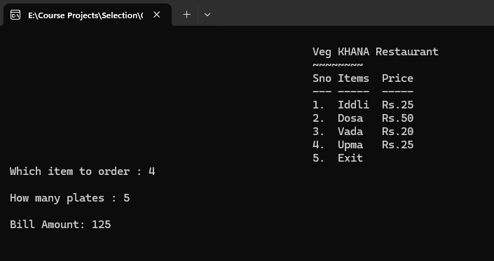

**Program 33 :**

// Program for arithematic operations

# include <stdio.h>

main ()

{

int a,b,c,opt;

a=b=c=opt=0;

printf("\n Enter a number : ");

scanf("%d",&a);

printf("\n Enter another number : ");

scanf("%d",&b);

printf("\n 1. Addition +");

printf("\n 2. Subtraction -");

printf("\n 3. Multiplication *");

printf("\n 4. Division /");

printf("\n 5. Exit ");

printf("\n Enter your option : ");

scanf("%d",&opt);

switch (opt)

{

case 1: c = a + b; break;

case 2: c = a - b; break;

case 3: c = a * b; break;

case 4: c = a / b; break;

case 5: break;

default : printf("\n \"INVALID INPUT\" ");

}

printf("\n Result is : %d ",c);

printf("\n");

getch();

}

**Output :**

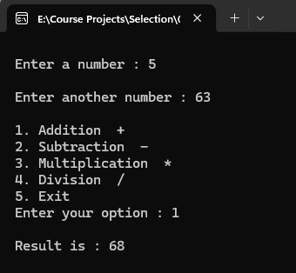

**Program 34 :**

// Program to read the grade of student and display corresponding message

# include <stdio.h>

main ()

{

char ch;

printf("\n Enter your grade : ");

scanf("%c",&ch);

ch = toupper(ch);

switch (ch)

{

case ‘S’: printf("\n SUPER"); break;

case ‘A’: printf("\n VERY GOOD"); break;

case ‘B’: printf("\n FAIR"); break;

case ‘Y’: printf("\n ABSENT"); break;

case ‘F’: printf("\n FAIL"); break;

default : printf("\n \"INVALID INPUT\" ");

}

printf("\n");

getch();

}

**Output :**

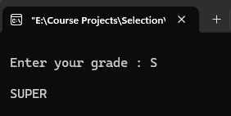

**Program 35 :**

// Program to check whether input is a digit or not

# include <stdio.h>

main()

{

char a=0;

printf("\n Enter a character : ");

scanf("%c",&a);

(a>=48 && a<=57) ? printf(" %c is a number",a) : printf(" %c is not a number",a);

printf("\n");

getch();

}

**Output :**

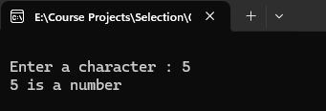

**Program 36 :**

// Program to check whether input is a digit or not

# include <stdio.h>

main()

{

int a,b;

a=b=0;

printf("\n Enter a number : ");

scanf("%d",&a);

printf("\n Enter another number : ");

scanf("%d",&b);

if (a<b)

printf("\n UP");

else if (a>b)

printf("\n DOWN");

else

printf("\n EQUAL");

printf("\n");

getch();

}

**Output :**

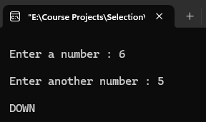

**Program 37 :**

// Program to read three values and display them in ascending order

# include <stdio.h>

main()

{

float a,b,c;

a=b=c=0;

printf("\n Enter Value of 'a' : ");

scanf("%f",&a);

printf("\n Enter Value of 'b' : ");

scanf("%f",&b);

printf("\n Enter Value of 'c' : ");

scanf("%f",&c);

if (a>b && a>c && b>c)

{

printf("\n Descending Order is %.2f , %.2f , %.2f",a,b,c);

printf("\n Ascending Order is %.2f , %.2f , %.2f",c,b,a);

}

else if (a>b && a>c && c>b)

{

printf("\n Descending Order is %.2f , %.2f , %.2f",a,c,b);

printf("\n Ascending Order is %.2f , %.2f , %.2f",b,c,a);

}

else if (b>a && b>c && a>c)

{

printf("\n Descending Order is %.2f , %.2f , %.2f",b,a,c);

printf("\n Ascending Order is %.2f , %.2f , %.2f",c,a,b);

}

else if (b>a && b>c && c>a)

{

printf("\n Descending Order is %.2f , %.2f , %.2f",b,c,a);

printf("\n Ascending Order is %.2f , %.2f , %.2f",a,c,b);

}

else if (c>a && c>b && a>b)

{

printf("\n Descending Order is %.2f , %.2f , %.2f",c,a,b);

printf("\n Ascending Order is %.2f , %.2f , %.2f",b,a,c);

}

else if (c>a && c>b && b>c)

{

printf("\n Descending Order is %.2f , %.2f , %.2f",c,b,a);

printf("\n Ascending Order is %.2f , %.2f , %.2f",a,b,c);

}

printf("\n");

getch();

}

**Output :**

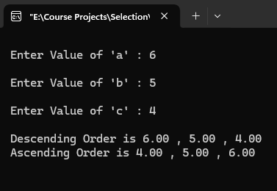

**Program 38 :**

// Program to convert given input into date format

# include <stdio.h>

main()

{

int a,b,c,d;

a=b=c=d=0;

printf("\n Enter three integers : ");

scanf("%d %d %d",&a,&b,&c);

d=a+1;

printf("\n Date following %d : %d : %d is %d : %d : %d",a,b,c,d,b,c);

printf("\n");

getch();

}

**Output :**

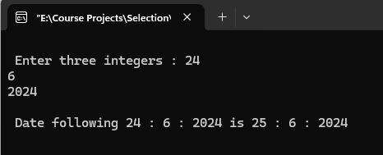

**Program 39 :**

// Program to read the grade of student and display corresponding message

# include <stdio.h>

main ()

{

char ch;

printf("\n Enter colour of traffic signal : ");

scanf("%c",&ch);

ch = toupper(ch);

switch (ch)

{

case 'R': printf("\n \"RED Light Please STOP\" "); break;

case 'Y': printf("\n \"YELLOW Light Please Check and Go\" "); break;

case 'G': printf("\n \"GREEN Light Please GO\" "); break;

default : printf("\n \"THERE IS NO SIGNAL POINT\" ");

}

printf("\n");

getch();

}

**Output :**

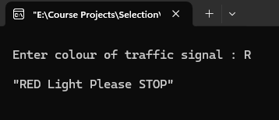

**Program 40 :**

// Program to read the grade of student and display corresponding message

# include <stdio.h>

main ()

{

char ch;

printf("\n Enter your grade : ");

scanf("%c",&ch);

ch = toupper(ch);

switch (ch)

{

case 'E': printf("\n Excellent"); break;

case 'V': printf("\n Very Good"); break;

case 'G': printf("\n Good"); break;

case 'A': printf("\n Average"); break;

case 'F': printf("\n Fail"); break;

default : printf("\n \"INVALID INPUT\" ");

}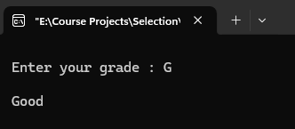

printf("\n");

getch();

}

**Output :**

**LOOPS**

**Program 1 :**

// Program to print numbers from n to 1

# include <stdio.h>

main()

{

int c;

printf("\n Enter Value of 'N' : ");

scanf("%d",&c);

do

{

printf(" %d ",c);

c--;

}while (c>=1);

printf("\n");

getch();

}

**Output :**

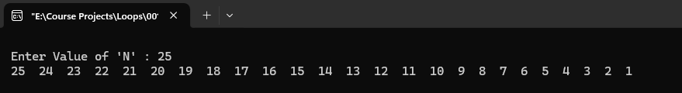

**Program 2 :**

// Program to read a name and display it the no. of letters times along with serial no.

# include <stdio.h>

main()

{

int a=0,c=1;

char name[100];

printf("\n Enter Name : ");

scanf("%s",&name);

a=strlen(name);

do

{

printf(" %d.%s\n",c,name);

c++;

}while(c<=a);

printf("\n");

getch();

}

**Output :**

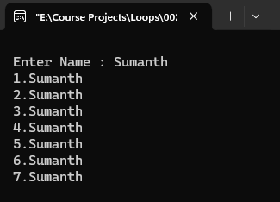

**Program 3 :**

// Program to read 10 numbers and display the sum of even numbers and odd numbers

# include <stdio.h>

main()

{

int a,c,sum1,sum2;

sum1=sum2=0;

for(c=1;c<=10;c++)

{

printf("\n Enter Number %d : ",c);

scanf("%d",&a);

if(a%2==0)

sum1=sum1+a;

else

sum2=sum2+a;

}

printf("\n Sum of Even Numbers is %d.",sum1);

printf("\n Sum of Odd Numbers is %d.",sum2);

printf("\n");

getch();

}

**Output :**

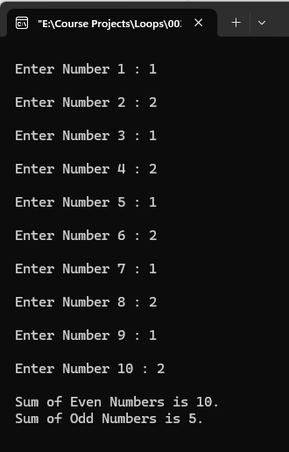

**Program 4 :**

// Program to display upper case letters (A to Z)

# include <stdio.h>

main()

{

int c;

for(c=65;c<=90;c++)

{

printf(" %c ",c);

}

printf("\n");

getch();

}

**Output :**

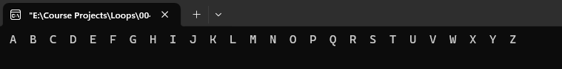

**Program 5 :**

// Program to print the sum of first and last numbers of inputted number

# include <stdio.h>

main()

{

int no,ld,fd,sum,temp;

no=ld=fd=sum=temp=0;

printf("\n Enter a Number : ");

scanf("%d",&no);

temp=no;

ld=no%10;

no=no/10;

while (no>=10)

{

fd=no%10;

no=no/10;

}

fd=no;

sum=fd+ld;

no=temp;

printf("\n The Sum of First and Last Digits of %d is %d.",no,sum);

printf("\n");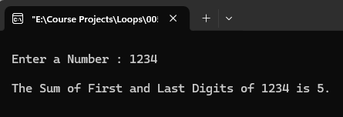

getch();

}

**Output :**

**Program 6 :**

// Program to print result for the input based and power

# include <stdio.h>

# include <math.h>

main()

{

int b,p,result;

b=p=result=0;

printf("\n Enter Base Number : ");

scanf("%d",&b);

printf("\n Enter Power Number : ");

scanf("%d",&p);

result=pow(b,p);

printf("\n Result is %d.",result);

printf("\n");

getch();

}

**Output :**

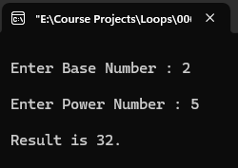

**Program 7 :**

// Program to read name and aadhar number and display messages for valid and invalid aadhar numbers

# include <stdio.h>

main()

{

long long no,temp;

int c=0;

char name[100];

printf("\n Enter Name : ");

scanf("%[^\n]",&name);

printf("\n Enter Aadhar number : ");

fflush(stdin);

scanf("%lld",&no);

temp=no;

while (no!=0)

{

no=no/10;

c++;

}

no=temp;

if (c==12)

printf("\n Heyy! %s, Your Aadhar number is %lld is verified successfully.",name,no);

else

printf("\n Heyy! %s, Your Aadhar number is %lld is invalid,kindly recheck.",name,no);

printf("\n");

getch();

}

**Output :**

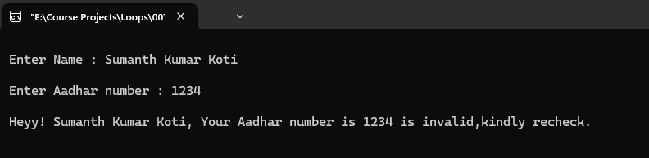

**Program 8 :**

// Program to check whether if inputted number is perfect or not

# include <stdio.h>

main()

{

int f,no,sum,temp;

f=1;

no=sum=temp=0;

printf("\n Enter a number : ");

scanf("%d",&no);

temp=no;

do

{

if (no%f==0)

{

printf(" %d ",f);

sum=sum+f;

f++;

}

else

f++;

}while (f<no);

printf("\n Sum is %d",sum);

no=temp;

if (sum==no)

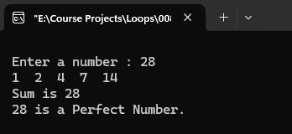 printf("\n %d is a Perfect Number.",no);

else

printf("\n %d is not a Perfect Number.",no);

printf("\n");

getch();

}

**Output :**

**Program 9 :**

// Program to check whether if given number is strong number or not

# include <stdio.h>

main()

{

long f,no,temp;

int sum,a;

a=no=sum=0;

printf("\n Enter a Non-Negative Number : ");

scanf("%d",&no);

temp=no;

while(no>0)

{

f=1;

a=no%10;

while (a>=1)

{

f=f*a;

a--;

}

sum=sum+f;

no=no/10;

}

no=temp;

if (sum==no)

printf("\n %d is a Strong Number.",no);

else

printf("\n %d is not a Strong Number.",no);

printf("\n");

getch();

}

**Output :**

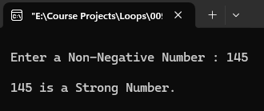

**Program 10 :**

// Program to print the given number that many times

# include <stdio.h>

main()

{

int c=1,no;

no=0;

printf("\n Enter a number : ");

scanf("%d",&no);

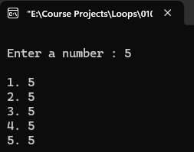 while(c<=no)

{

printf("\n %d. %d",c,no);

c++;

}

printf("\n");

getch();

}

**Output :**

**Program 11 :**

// Program to print the table of given number

# include <stdio.h>

main()

{

int no,sv,ev;

no=sv=ev=0;

printf("\n Enter a number : ");

scanf("%d",&no);

printf("\n Enter Starting Value : ");

scanf("%d",&sv);

printf("\n Enter Ending Value : ");

scanf("%d",&ev);

if(no>0 && sv<ev && sv>0 && ev >0)

{

while(sv<=ev)

{

printf("\n %d * %d = %d",no,sv,no*sv);

sv++;

}

}

else

printf("\a\n\t\t\t\t\t\t \"INVALID INPUT\" ");

printf("\n");

getch();

}

**Output :**

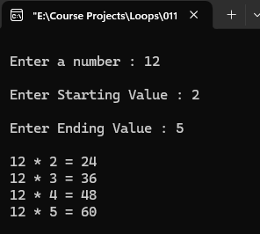

**Program 12 :**

// Program to check whether if inputted number is prime or not

# include <stdio.h>

# include <math.h>

main()

{

int f,i,no,sum;

char isprime='y';

f=2;

i=no=sum=0;

printf("\n Enter a number : ");

scanf("%d",&no);

while(f<= sqrt(no))

{

i++;

if (no%f==0)

{

isprime='n';

break;

}

else

f++;

}

printf("\n Number of Iterations : %d",i);

if (isprime=='y')

printf("\n %d is a Prime Number.",no);

else

printf("\n %d is not a Prime Number.",no);

printf("\n");

getch();

}

**Output :**

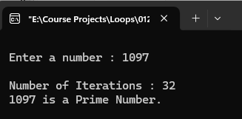

**Program 13 :**

// Program to print fibonacci series from 1 to 100

# include <stdio.h>

main()

{

int a,b,c;

a=1;

b=c=0;

while (c<100)

{

c=a+b;

printf(" %d",b);

a=b;

b=c;

}

printf("\n");

getch();

}

**Output :**

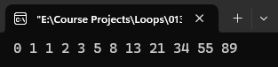

**Program 14 :**

// Program to check whether if inputted number is prime or not

# include <stdio.h>

# include <math.h>

main()

{

int f,no1,no2,i;

char isprime='y';

f=1;

no1=no2=i=0;

printf("\n Enter a number : ");

scanf("%d",&no1);

printf("\n Enter another number : ");

scanf("%d",&no2);

if (no1>no2)

{

printf("\a\n\t\t\t\t\t\t \"INVALID RANGE\" ");

return;

}

while (no1<=no2)

{

while (f<=no1)

{

if (no1%f==0 && f<=no1)

{

i++;

}

f++;

}

if (i==2)

printf(" %d",no1);

no1++;

f=1;

i=0;

}

printf("\n");

getch();

}

**Output :**

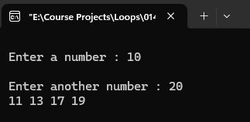

**Program 15 :**

// Program to check whether if given number is armstrong number or not

# include <stdio.h>

main()

{

int no,r,sum,temp;

temp=r=sum=0;

printf("\n Enter a Number : ");

scanf("%d",&no);

temp=no;

while (no>0)

{

r=no%10;

sum=sum+(r*r*r);

no=no/10;

}

no=temp;

if (no==sum)

printf("\n %d is an Armstrong Number.",no);

else

printf("\n %d is not an Armstrong Number",no);

printf("\n");

getch();

}

**Output :**

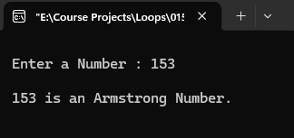

**Program 16 :**

// Program to find if given number is palindrome or not

# include <stdio.h>

main()

{

int on,rn,no,rem;

on=rn=no=rem=0;

printf("\n Enter a Number : ");

scanf("%d",&no);

on=no;

while (no!=0)

{

rem=no%10;

rn=rn*10+rem;

no=no/10;

}

no=on;

if (on==rn)

printf("\n %d is a Palindrome Number.",no);

else

printf("\n %d is not a Palindrome Number.",no);

printf("\n");

getch();

}

**Output :**

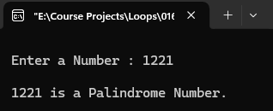

**Program 17 :**

// Program to date of birth and display lucky number and suitable gemstone

# include <stdio.h>

main()

{

int a,no,sum;

char Emerald,Ruby,Sapphire,Opal,Onyx,Amber,Moonstone,Topaz,Garnet,Aquamarine;

a=no=sum=0;

printf("\n Enter Date of Birth ( \"DDMMYYYY\" ): ");

scanf("%d",&no);

while (no!=0)

{

a=no%10;

sum=sum+a;

no=no/10;

}

if (sum>=10)

{

no=sum;

sum=0;

while (no!=0)

{

a=no%10;

sum=sum+a;

no=no/10;

}

}

printf("\n Your Lucky Number is %d.",sum);

switch (sum)

{

case 1:printf("\n Your Gemstone is Emerald."); break;

case 2:printf("\n Your Gemstone is Ruby."); break;

case 3:printf("\n Your Gemstone is Sapphire."); break;

case 4:printf("\n Your Gemstone is Opal."); break;

case 5:printf("\n Your Gemstone is Onyx."); break;

case 6:printf("\n Your Gemstone is Amber."); break;

case 7:printf("\n Your Gemstone is Moonstone."); break;

case 8:printf("\n Your Gemstone is Topaz."); break;

case 9:printf("\n Your Gemstone is Garnet."); break;

default :printf("\n Your Gemstone is Aquamarine.");

}

printf("\n");

getch();

}

**Output :**

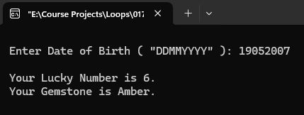

**Program 18 :**

// Program to read numbers until user enters 0 and display the sum of even numbers and odd numbers

# include <stdio.h>

main()

{

int a,c,e,o,sum1,sum2;

c=1;

e=o=sum1=sum2=0;

do

{

printf("\n Enter Number %d : ",c);

scanf("%d",&a);

c++;

if (a==0)

break;

if(a%2==0)

{

e++;

sum1=sum1+a;

}

else

{

o++;

sum2=sum2+a;

}

}while(a!=0);

printf("\n No of Even Numbers is %d.",e);

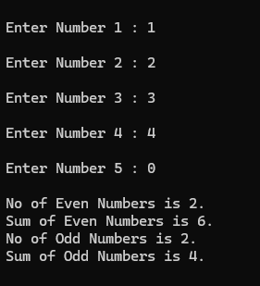 printf("\n Sum of Even Numbers is %d.",sum1);

printf("\n No of Odd Numbers is %d.",o);

printf("\n Sum of Odd Numbers is %d.",sum2);

printf("\n");

getch();

}

**Output :**

**Program 19 :**

// Program to print the factorial of a positive number

# include <stdio.h>

main()

{

long f,no,temp;

f=no=1;

printf("\n Enter a Non-Negative Number : ");

scanf("%ld",&no);

temp=no;

while(no>=1)

{

f=f*no;

no--;

}

no=temp;

if (no=0)

printf("\n Factorial of %d is 1.",no);

else

if (no>0)

printf("\n Factorial of %d is %d.",no,f);

else

if (no<0)

printf("\n\a\t\t\t\t\t\t \"INVALID INPUT\" ");

printf("\n");

getch();

}

**Output :**

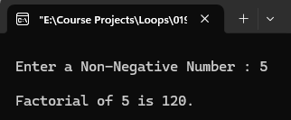

**Program 20 :**

// Program to print 10 random numbers and find the biggest number

# include <stdio.h>

# include <stdlib.h>

# include <time.h>

main()

{

int i,r,big=0;

srand(time(0));

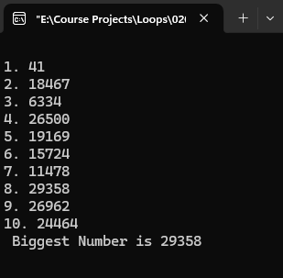 for (i=1;i<=10;i++)

{

r=rand();

printf("\n%d. %d",i,r);

if (r>big)

big=r;

}

printf("\n Biggest Number is %d",big);

printf("\n");

getch();

}

**Output :**

**Program 21 :**

//Program to find hcf of to numbers

# include <stdio.h>

main()

{

int f,hcf,no1,no2;

hcf=no1=no2=0;

f=1;

printf("\n Enter Number 1 : ");

scanf("%d",&no1);

printf("\n Enter Number 2 : ");

scanf("%d",&no2);

if (no1<no2)

{

while (f<=no1)

{

if(no1%f==0 && no2%f==0)

{

hcf=f;

f++;

}

else

f++;

}

}

else

{

while (f<=no2)

{

f=1;

if(no1%f==0 && no2%f==0)

{

hcf=f;

f++;

}

else

f++;

}

}

printf("\n The HCF of %d and %d is %d.",no1,no2,hcf);

printf("\n");

getch();

}

**Output :** 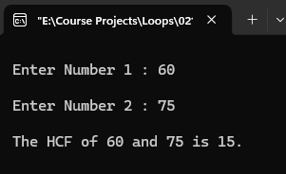

**Program 22 :**

//Program to find lcm of to numbers

# include <stdio.h>

main()

{

int f,lcm,no1,no2,m1,m2;

lcm=no1=no2=0;

m1=m2=f=1;

printf("\n Enter Number 1 : ");

scanf("%d",&no1);

printf("\n Enter Number 2 : ");

scanf("%d",&no2);

for (f=1;f<=no1;f++)

{

if (no1%f==0)

while (no1>=1 && f!=no1)

{

m1=m1*f;

break;

}

}

for (f=1;f<=no2;f++)

{

if (no2%f==0)

while (no2>=1 && f!=no2)

{

m2=m2*f;

break;

}

}

if (no1==1)

for (f=1;f<=no2;f++)

{

if (no2%f==0)

while (no2>=1)

{

m2=m2*f;

break;

}

}

lcm=m1*m2;

printf("\n The LCM of %d and %d is %d.",no1,no2,lcm);

printf("\n");

getch();

}

**Output :**

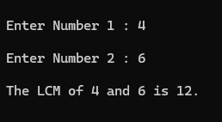

**Program 23 :**

// Program to print ASCII chart

# include <stdio.h>

main()

{

int c;

for (c=1;c<=256;c++)

printf(" [ %d - %c ]",c,c);

printf("\n");

getch();

}

**Output :** 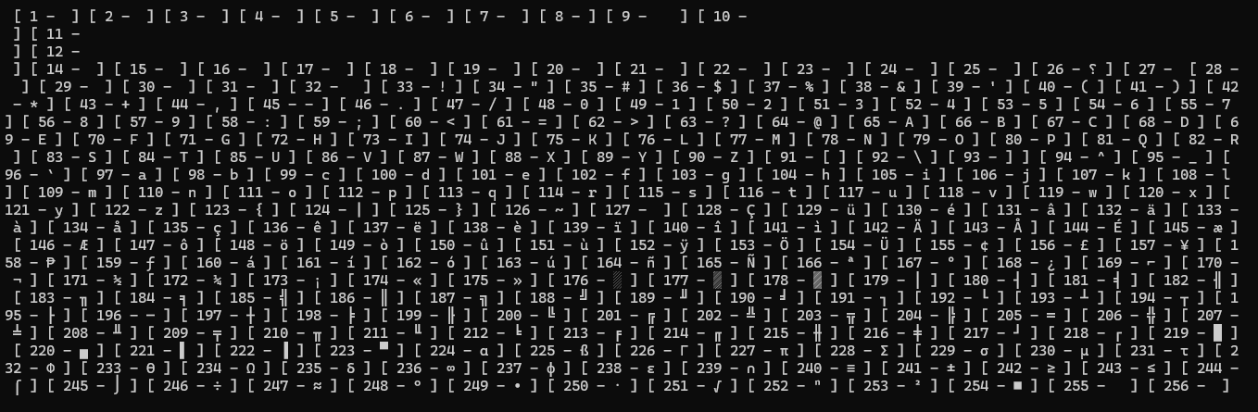

**Program 24 :**

// Program to print factors of given numbers

# include <stdio.h>

main()

{

int f,no;

f=1;

no=0;

printf("\n Enter a number : ");

scanf("%d",&no);

if (no>=0)

{

while(f<=no)

{

if (no%f==0)

{

printf(" %d ",f);

f++;

}

else

f++;

}

}

else

printf("\n\a\t\t\t\t\t\t \"INVALID INPUT\" ");

printf(" are the factors of %d.",no);

printf("\n");

getch();

}

**Output :**

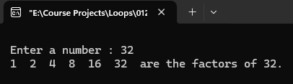

**Program 25 :**

// Program to read name of user and stop after user enters 'N'

# include <stdio.h>

# include <string.h>

main()

{

int i=1,len=0;

char name[100],opt;

while (1)

{

printf("\n Enter Name : ");

scanf("%s",&name);

len=strlen(name);

printf("\n Length of \"%s\" is %d.",name,len);

printf("\n\n Do you wish to continue? (Y/N) : ");

fflush(stdin);

scanf("%c",&opt);

opt=toupper(opt); 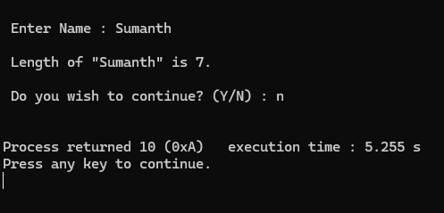

if (opt=='N')

{

printf("\n");

return;

}

}

}

**Output :**

**ARRAYS**

**Program 1 :**

// Program to read an array of 'N' elements and print average and total

# include <stdio.h>

main()

{

int i,n,a[1000]={0};

float total,avg;

total=avg=0;

printf("\n Enter Value of 'N' : ");

scanf("%d",&n);

for (i=0;i<n;i++)

{

printf("\n Enter Number %d : ",i+1);

scanf("%d",&a[i]);

if(a[i]=='=')

{

break;

}

}

for (i=0;i<n;i++)

{

total+=a[i];

}

avg=total/n;

printf("\n Total : %.2f",total);

printf("\n Average : %.2f",avg);

printf("\n");

getch();

}

**Output :**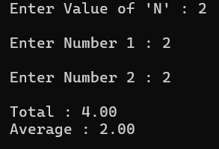

**Program 2 :**

// Program to store even numbers in odd index and odd numbers in even index

# include <stdio.h>

# include <stdlib.h>

# include <time.h>

main()

{

int arr[10]={0};

int i,j,r,a,b;

char found='n';

i=r=0;

srand(time(0));

while (i<10)

{

r=rand()%10;

if (r!=0)

{

if (r%2==0)

{

if(i%2==0)

{

arr[i]=r;

i++;

}

}

else

if (i%2!=0)

{

arr[i]=r;

i++;

}

}

}

for (i=0;i<10;i++)

printf("\t%d",arr[i]);

printf("\n");

getch();

}

**Output :** 

**Program 3 :**

// Program to fill an array of 10 elements with random numbers

# include <stdio.h>

# include <stdlib.h>

# include <time.h>

main()

{

int i,arr[10];

srand(time(0));

for (i=0;i<10;i++)

{

arr[i]=rand()%1000;

printf("\t%d",arr[i]);

}

printf("\n");

}

**Output :**



**Program 4 :**

// Program to fill an array of 10 elements with random numbers

# include <stdio.h>

# include <stdlib.h>

# include <time.h>

# define SIZE 10

main()

{

int i=1,j,r,temp=0;

int arr[SIZE]={0},a[SIZE]={0},d[SIZE]={0};

char found='n';

srand(time(0));

while (i<=SIZE)

{

r=rand()%1000;

for (j=0;j<SIZE;j++)

{

if (arr[j]==r)

{

found='y';

break;

}

}

if (found=='n')

{

arr[i]=r;

printf("\t%d",arr[i]);

i++;

}

}

// For Ascending Order

for (i=0;i<SIZE;i++)

{

a[i]=arr[i+1];

}

// Logic

for (i=0;i<SIZE;i++)

{

for (j=0;j<SIZE;j++)

{

if(a[i]>a[j])

{

temp=a[j];

a[j]=a[i];

a[i]=temp;

}

}

}

printf("\n Ascending Order :\n");

for (i=9;i>=0;i--)

printf("\t%d",a[i]);

// For Descending Order

for (i=0;i<SIZE;i++)

{

d[i]=arr[i+1];

}

// Logic

for (i=0;i<SIZE;i++)

{

for (j=0;j<SIZE;j++)

{

if(d[i]>d[j])

{

temp=d[j];

d[j]=d[i];

d[i]=temp;

}

}

}

printf("\n Descending Order :\n");

for (i=0;i<SIZE;i++)

printf("\t%d",d[i]);

printf("\n");

}

**Output :**

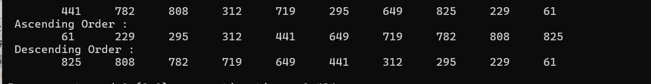

**Program 5 :**

// Program to fill an array of n elements with multiples of 5 and copy them to another array and print it

# include <stdio.h>

main()

{

int i,n,arr1[1000]={0},arr2[1000]={0};

printf("\n Enter value of 'N' : ");

scanf("%d",&n);

for (i=0;i<n;i++)

{

arr1[i]=arr1[i-1]+5;

}

for (i=0;i<n;i++)

{

arr2[i]=arr1[i];

}

for (i=0;i<n;i++)

{

printf("\t%d",arr2[i]);

}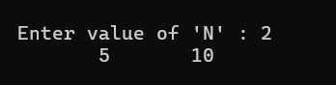

printf("\n");

}

**Output :**

**Program 6 :**

// Program to build a housie app

# include <stdio.h>

# include <string.h>

# include <time.h>

main()

{

int i,j,r,arr[9][10];

char found='n';

srand(time(0));

for(i=0;i<9;i++)

{

for(j=0;j<10;j++)

arr[i][j]=rand()%90;

}

for(i=0;i<9;i++)

{

for(j=0;j<10;j++)

{

printf("\t%d",arr[i][j]);

}

printf("\n");

}

printf("\n") ;

}

**Output :**

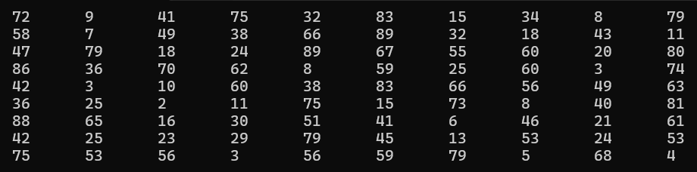

**Program 7 :**

// Program to read and print max and min numbers

# include <stdio.h>

main()

{

int no[10],max,min,i;

for (i=0;i<10;i++)

{

printf("\n Enter %d Number : ",i+1);

scanf("%d",&no[i]);

}

max=min=no[0];

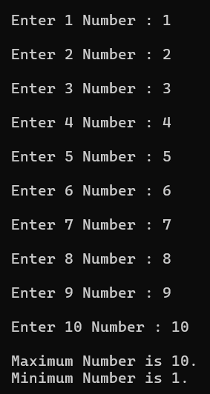 for (i=0;i<10;i++)

{

if (no[i]>max)

max=no[i];

else

if (no[i]<min)

{

min=no[i];

}

}

printf("\n Maximum Number is %d.",max);

printf("\n Minimum Number is %d.",min);

printf("\n");

}

**Output :**

**Program 9 :**

// Program to fill an array of 10 elements with random numbers and print no of digits

# include <stdio.h>

# include <stdlib.h>

# include <time.h>

main()

{

int i,len,arr[10],no;

srand(time(0));

for (i=0;i<10;i++)

{

arr[i]=rand();

}

for (i=0;i<10;i++)

{

no=arr[i];

len=0;

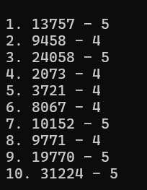 while (no!=0)

{

no=no/10;

len++;

}

printf("\n %d. %d - %d",i+1,arr[i],len);

}

printf("\n");

}

**Output :**

**Program 10 :**

// Program to insert an element in an array of n elements

# include <stdio.h>

main()

{

int n,i,pos,element,arr[n+1];

printf("\n Enter the number of elements in the array : ");

scanf("%d",&n);

for (i=0;i<n;i++)

{

printf("\n Enter Element %d : ",i+1);

scanf("%d",&arr[i]);

}

printf("\n Array Before Insertion : \n");

for (i=0;i<n;i++)

{

printf("\t%d",arr[i]);

}

printf("\n Enter the position to insert the element (1 to %d) : ",n+1);

scanf("%d",&pos);

if (pos<1 || pos>n+1)

{

printf("\a\n\t\t\t\t\t\tInvalid position!\n");

return;

}

printf("\n Enter the element to be inserted : ");

scanf("%d",&element);

for (i=n;i>=pos;i--)

{

arr[i]=arr[i-1];

}

arr[pos-1]=element;

printf("\n Array After Insertion :\n");

for (i=0;i<=n;i++)

{

printf("\t%d",arr[i]);

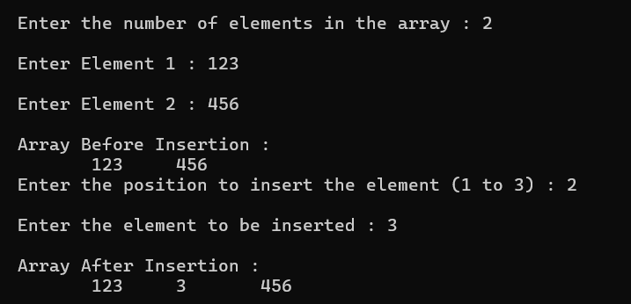 }

printf("\n");

}

**Output :**

**Program 11 :**

// Program to delete an element from an array of n elements

#include <stdio.h>

main()

{

int i,n,pos,arr[n+1];

printf("\n Enter the number of elements in the array : ");

scanf("%d",&n);

for (i=0;i<n;i++)

{

printf("\n Enter Element %d : ",i+1);

scanf("%d",&arr[i]);

}

printf("\n Array Before Deletion : \n");

for (i=0;i<n;i++)

{

printf("\t%d",arr[i]);

}

printf("\n Enter the position of the element to be deleted (1 to %d) : ", n);

scanf("%d",&pos);

if (pos<1 || pos>n)

{

printf("\a\n\t\t\t\t\t\tInvalid position!\n");

}

else

{

for (int i=pos-1;i<n-1;i++)

{

arr[i]=arr[i+1];

}

n--;

printf("\n Array after deletion :\n");

for (int i=0;i<n;i++)

{

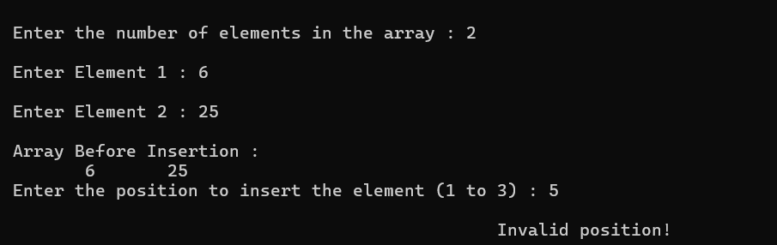 printf("\t%d",arr[i]);

}

}

printf("\n");

}

**Output :**

**Program 12 :**

// Program to perform matrix multiplication

# include <stdio.h>

# include <stdlib.h>

# include <time.h>

main ()

{

int a[3][3],b[3][3],c[3][3],i,j;

srand(time(0));

for (i=0;i<3;i++)

{

for (j=0;j<3;j++)

a[i][j]=rand()%10;

}

for (i=0;i<3;i++)

{

for (j=0;j<3;j++)

b[i][j]=rand()%10;

}

for (i=0;i<3;i++)

{

for (j=0;j<3;j++)

c[i][j]=( a[i][0]*b[0][j] ) + ( a[i][1]*b[1][j] ) + ( a[i][2]*b[2][j] );

}

for (i=0;i<3;i++)

{

for (j=0;j<3;j++)

printf("\t%d",a[i][j]);

printf("\n");

}

printf("\n\n");

for (i=0;i<3;i++)

{

for (j=0;j<3;j++)

printf("\t%d",b[i][j]);

printf("\n");

}

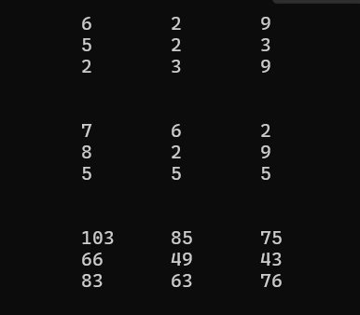 printf("\n\n");

for (i=0;i<3;i++)

{

for (j=0;j<3;j++)

printf("\t%d",c[i][j]);

printf("\n");

}

printf("\n");

}

**Output :**

**Program 13 :**

// Program to print upper and lower triangle 5*5 array

# include <stdio.h>

# include <stdlib.h>

# include <time.h>

main ()

{

int i,j,a[5][5];

srand(time(0));

for (i=0;i<5;i++)

{

for (j=0;j<5;j++)

{

if (i>j)

a[i][j]=0;

else

if(i<j)

a[i][j]=0;

else

a[i][j]=rand()%50;

}

}

for (i=0;i<5;i++)

{

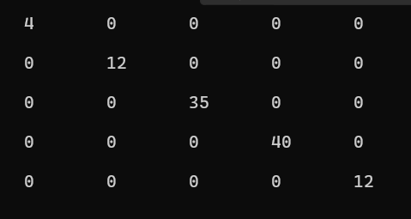 for (j=0;j<5;j++)

printf("\t%d",a[i][j]);

printf("\n\n");

}

printf("\n");

}

**Output :**

**Program 14 :**

// Program to print upper and lower triangle 5*5 array

# include <stdio.h>

# include <stdlib.h>

# include <time.h>

main ()

{

int i,j,a[5][5],b[5][5];

srand(time(0));

for (i=0;i<5;i++)

{

for (j=0;j<5;j++)

{

if (i>j)

a[i][j]=0;

else

a[i][j]=rand()%50;

}

}

for (i=0;i<5;i++)

{

for (j=0;j<5;j++)

{

if (i<j)

b[i][j]=0;

else

b[i][j]=rand()%50;

}

}

printf("\n\tUpper Triangle\n");

for (i=0;i<5;i++)

{

for (j=0;j<5;j++)

{

printf("\t%d",a[i][j]); 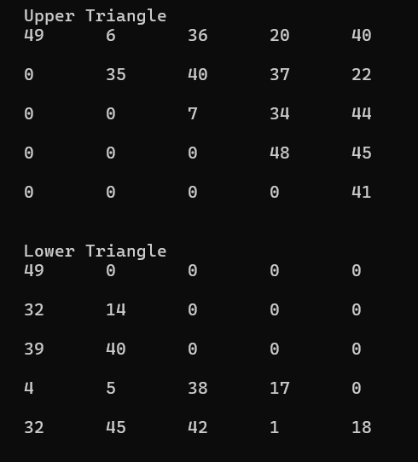

}

printf("\n\n");

}

printf("\n\tLower Triangle\n");

for (i=0;i<5;i++)

{

for (j=0;j<5;j++)

{

printf("\t%d",b[i][j]);

}

printf("\n\n");

}

printf("\n");

}

**Output :**

**Program 15 :**

// Program to search an element in 5*5 matrix

# include <stdio.h>

# include <stdlib.h>

# include <time.h>

main ()

{

int a[5][5],no,i,j;

char found='n';

srand(time(0));

for (i=0;i<5;i++)

{

for (j=0;j<5;j++)

a[i][j]=rand()%1000;

}

for (i=0;i<5;i++)

{

for (j=0;j<5;j++)

{

printf("\t%d",a[i][j]);

}

printf("\n");

}

printf("\n Enter a Number to search : ");

scanf("%d",&no);

for (i=0;i<5;i++)

{

for (j=0;j<5;j++)

{

if (no==a[i][j])

{

found='y';

break;

}

}

if (found=='y')

break;

}

if (found=='y')

printf("\n %d is found at %d,%d.",no,i+1,j+1);

else

printf("\n %d is not found.",no);

printf("\n");

}

**Output :**

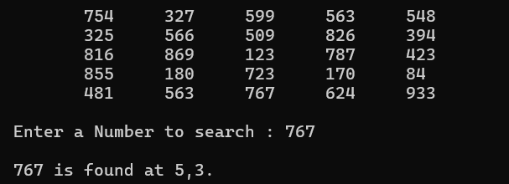

**STRINGS**

**Program 1 :**

// Program to read a string and display it length many times

# include <stdio.h>

# include <string.h>

main()

{

char str[100];

int i,len=0;

printf("\n Enter Your String : ");

scanf("%s",str);

len=strlen(str);

for (i=0;i<len;i++)

printf("\n %d.%s",i+1,str);

printf("\n");

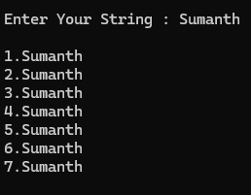}

**Output :**

**Program 2 :**

// Program to read a string and convert into proper case

# include <stdio.h>

# include <string.h>

main()

{

int i,len;

char str[100];

printf("\n Enter String : ");

scanf("%[^\n]",&str);

len=strlen(str);

for (i=0;i<len;i++)

{

if (str[i]>=65 && str[i]<=97)

str[i]=tolower(str[i]);

else

if (str[i]==' ')

{

i++;

if (str[i]>=97 && str[i]<=122)

str[i]=toupper(str[i]);

}

}

str[0]=toupper(str[0]);

for (i=0;i<len;i++)

printf("%c",str[i]);

printf("\n");

}

**Output :**



**Program 3 :**

// Program to check whether if inputted string is palindrome or not

# include <stdio.h>

# include <string.h>

main ()

{

int i,len=0;

char str[100],palindrome='y',temp;

printf("\n Enter Sting : ");

scanf("%s",&str);

temp=str;

len=strlen(str);

len--;

if (tolower(str[0])==tolower(str[len]))

{

len--;

for (i=1;i<(len/2);i++)

{

if (tolower(str[i])==tolower(str[len]))

palindrome='y';

else

palindrome='n';

}

}

else

{

printf("\n %s is not a Palindrome.\n",str);

return;

}

if (palindrome=='y')

printf("\n %s is a Palindrome.",str);

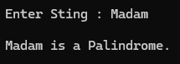

printf("\n");

}

**Output :**

**Program 4 :**

// Program to read username and password(password input is displayed in stars *)

# include <stdio.h>

# define max 100

main()

{

char username[max];

char password[max];

void read_password(char *password);

printf("\n Enter username : ");

scanf("%s",&username);

printf("\n Enter password : ");

read_password(password);

printf("\n");

}

void read_password(char *password)

{

int i=0;

char ch;

while (1)

{

ch=getch();

if (ch==13)

{

password[i] = '\0';

break;

}

else if (ch==8)

{

if (i>0)

{

i--;

printf("\b \b");

}

} else if (i<max-1)

{

password[i]=ch;

i++;

printf("*");

}

}

return ;

}

**Output :**

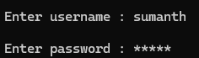

**Program 5 :**

// Program to read password and check strength

#include <stdio.h>

#include <string.h>

#include <ctype.h>

#define MIN_LENGTH 8

main()

{

const char* check_password_strength(const char *password);

char password[100];

printf("\n Enter the password : ");

scanf("%99s",password);

const char* strength=check_password_strength(password);

printf("\n Password strength : %s",strength);

pritnf("\n");

}

const char* check_password_strength(const char *password)

{

if (strlen(password) < MIN_LENGTH)

return "Password is too short. It must be at least 8 characters long.";

int has_lower=contains_lower(password);

int has_upper=contains_upper(password);

int has_digit=contains_digit(password);

int has_symbol=contains_symbol(password);

if (has_lower && has_upper && has_digit && has_symbol)

return "Very Strong";

else if (has_lower && has_upper && (has_digit || has_symbol))

return "Strong";

else if (has_lower && (has_upper || has_digit || has_symbol))

return "Medium";

else if (has_lower && !has_upper && !has_digit && !has_symbol)

return "Weak";

else

return "Password does not meet the required criteria.";

}

int contains_lower(const char *password)

{

while (*password)

{

if (islower(*password))

return 1;

password++;

}

return 0;

}

int contains_upper(const char *password)

{

while (*password)

{

if (isupper(*password))

return 1;

password++;

}

return 0;

}

int contains_digit(const char *password)

{

while (*password)

{

if (isdigit(*password))

return 1;

password++;

}

return 0;

}

int contains_symbol(const char *password)

{

while (*password)

{

if (!isalnum(*password))

return 1;

password++;

}

return 0;

}

**Output :**

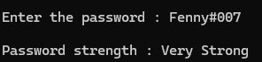

**Program 6 :**

// Program to read to passwords and check similiarities

# include <stdio.h>

# include <string.h>

main ()

{

int i,len1,len2;

char p1[100],p2[100],match;

printf("\n Enter Password 1 : ");

scanf("%s",&p1);

printf("\n Enter Password 2 : ");

scanf("%s",&p2);

len1=strlen(p1);

len2=strlen(p2);

if (len1==len2)

{

for (i=0;i<len1;i++)

{

if (p1[i]==p2[i])

{

match='y';

}

else

{

match='n';

break ;

}

}

if (match=='y')

printf("\n\t\t\t\t\t\tPasswords Match.");

else

printf("\a\n\t\t\t\t\t\tPasswords Do Not Match.");

}

else

printf("\a\n\t\t\t\t\t\tPasswords Do Not Match.");

printf("\n");

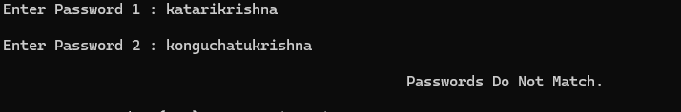}

**Ouput :**

**Program 7 :**

// Program to read a string and display smallest and biggest words

#include <stdio.h>

#include <string.h>

#define max 1000

main()

{

void find_largest_and_smallest_words(char *str, char *largest, char *smallest);

char str[max],largest[max],smallest[max];

printf("\n Enter a string : ");

scanf("%[^\n]",&str);

find_largest_and_smallest_words(str,largest,smallest);

printf("\n Largest word : %s",largest);

printf("\n Smallest word : %s",smallest);

printf("\n");

}

void find_largest_and_smallest_words(char *str, char *largest, char *smallest)

{

char *word=strtok(str," ");

if (word!=NULL)

{

strcpy(largest,word);

strcpy(smallest,word);

}

while (word!=NULL)

{

if (strlen(word)>strlen(largest))

strcpy(largest,word);

if (strlen(word)<strlen(smallest))

strcpy(smallest,word);

word = strtok(NULL," ");

}

}

**Output :**

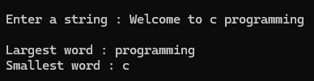

**Program 8 :**

// Program to reverse the inputted string

# include <stdio.h>

# include <string.h>

main()

{

int i,len=0;

char str[100];

printf("\n Enter String : ");

scanf("%[^\n]",&str);

printf("\n ");

len=strlen(str);

for (i=len;i>=0;i--)

putchar( str[i]);

printf("\n");

}

**Output :**

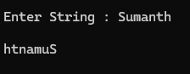

**Program 9 :**

// Program to print second word from inputted string

# include <stdio.h>

main()

{

int i;

char str[100];

printf("\n Enter String : ");

scanf("%[^\n]",&str);

printf("\n ");

for (i=0;str[i]!=0;i++)

{

if (str[i]==' ')

{

i++;

while (str[i]!=' ')

{

putchar(str[i]);

i++;

}

}

}

printf("\n");

}

**Output :**

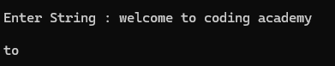

**Program 10 :**

// Program to generate username from inputted mail id

# include <stdio.h>

main()

{

int i;

char mail[100],un[100];

printf("\n Enter Mail ID : ");

scanf("%[^\n]",&mail);

for (i=0;mail[i]!='@';i++)

{

if (mail[i]==' ')

{

printf("\a\n\t\t\t\t\t\tSpaces are not allowed.\n");

return;

}

}

for (i=0;mail[i]!='\0' && mail[i]!='@';i++)

un[i] = mail[i];

un[i]='\0';

if (mail[i]!='@')

{

printf("\n\t\t\t\t\tInvalid email ID. '@' symbol is missing.\n");

return ;

}

printf("\n Username : %s",un);

printf("\n");

}

**Output :**

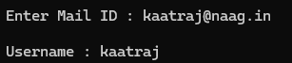

**Program 11 :**

// Program to read name and copy all vowels in one string and all consonants in another string

# include <stdio.h>

# include <string.h>

main()

{

int i,vindex=0,cindex=0;

char name[100],v[100]={0},c[100]={0};

printf("\n Enter Name : ");

scanf("%[^\n]",&name);

for (i=0;name[i]!='\0';i++)

{

if ( (name[i]=='A') || (name[i]=='a') || (name[i]=='E') || (name[i]=='e') || (name[i]=='I') || (name[i]=='i') || (name[i]=='O') || (name[i]=='o') || (name[i]=='U') || (name[i]=='u') )

v[vindex++]=name[i];

else if ( (name[i]>='A' && name[i]<='Z') || (name[i]>='a' && name[i]<='z') )

c[cindex++]=name[i];

}

printf("\n Vowels : %s",v);

printf("\n Consonants : %s",c);

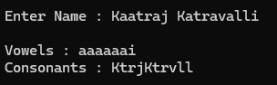 printf("\n");

}

**Output :**

**Program 12 :**

// Program to check given word is present in main string

# include <stdio.h>

# include <string.h>

main()

{

char str[100],word[50],*result;

printf("\n Enter Main String : ");

scanf("%[^\n]",&str);

printf("\n Enter Word to search : ");

fflush(stdin);

scanf("%s",&word);

result=strstr(str,word);

if (result)

printf("\n Word exists.");

else

printf("\n Word does not exists.");

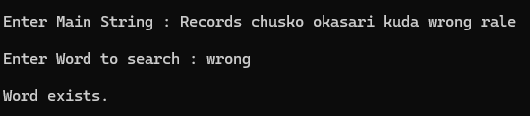 printf("\n");

}

**Output :**

**Program 13 :**

// Program to read name and display it in specific pattern

# include <stdio.h>

# include <String.h>

main ()

{

int i,j;

char name[100];

printf("\n Enter Name : ");

gets(name);

for (i=0;i<strlen(name);i++)

{

for (j=0;j<=i;j++)

printf("%c ",name[j]);

printf("\n");

}

printf("\n");

}

**Output :**

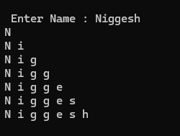

**Program 14 :**

// Program to read 10 names and display the longest name

# include <stdio.h>

# include <string.h>

main()

{

int i,len,l,max=0;

char name[10][100];

for(i=0;i<10;i++)

{

printf("\n Enter Name : ");

scanf("%s",&name[i]);

}

for (i=0;i<10;i++)

{

len=strlen(name[i]);

if (len>max)

{

max=len;

l=i;

}

}

printf("\n Longest Name is %s,length is %d.",name[l],max);

printf("\n");

}

**Output :**

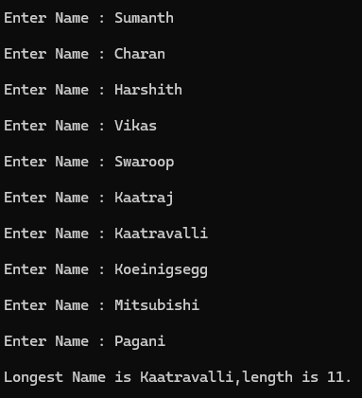

**Program 15 :**

// Program to name and display success message

# include <stdio.h>

# include <string.h>

main()

{

int i,len;

char name[100];

printf("\n Enter Name : ");

scanf("%s",&name);

len=strlen(name);

if (len<5)

printf("\n Name must contain more than 5 characters.");

else

printf("\n Name has been stored successfully.");

printf("\n");

}

**Output :**

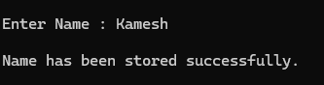

**Program 16 :**

// Program to read mail id and validate it

# include <stdio.h>

# include <string.h>

main()

{

int i,len;

char mail[100],at='n',dot='n';

printf("\n Enter Mail ID : ");

scanf("%s",&mail);

len=strlen(mail);

for (i=0;i<len;i++)

{

if (mail[i]=='@')

{

at='y';

break ;

}

}

if (at=='y')

{

for (i=i+1;i<len;i++)

{

if (mail[i]=='.')

{

dot='y';

break ;

}

}

if (dot=='n')

{

printf("\a\n\t\t\t\t\t\tMail ID should contain '.'\n");

return ;

}

}

else

{

printf("\a\n\t\t\t\t\t\tMail ID should contain '@'\n");

return ;

}

printf("\n\t\t\t\t\t\tMail ID Verified Successfully.");

printf("\n");

}

**Output :**

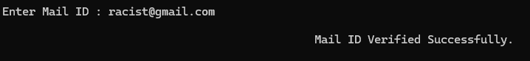

**Program 17 :**

// Program to read a string and count the first character occurrence

# include <stdio.h>

# include <string.h>

main ()

{

int i,c=0;

char str[100],fc;

printf("\n Enter String : ");

scanf("%[^\n]",&str);

for (i=0;i<strlen(str);i++)

str[i]=toupper(str[i]);

fc=str[0];

for (i=0;i<strlen(str);i++)

{

if (str[i]==fc)

c++;

}

printf("\n The Character '%c' or '%c' is repeated %d times.",fc,fc+32,c);

printf("\n");

}

**Output :**

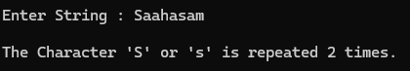

**Program 18 :**

// Program to read a string and print vowels in capitals and rest in lowwer

# include <stdio.h>

# include <string.h>

main ()

{

int i;

char str[100];

printf("\n Enter String : ");

scanf("%[^\n]",&str);

for (i=0;i<strlen(str);i++)

str[i]=tolower(str[i]);

for (i=0;i<strlen(str);i++)

{

if (str[i]=='a' || str[i]=='e' || str[i]=='i' || str[i]=='o' || str[i]=='u')

putchar(toupper(str[i]));

else

putchar(str[i]);

}

printf("\n");

}

**Output :**



**Program 19 :**

// Program to read two strings and check whether if they are anagrams

# include <stdio.h>

# include <string.h>

main()

{

int i,j,len1,len2;

char s1[100],s2[100],anagram;

printf("\n Enter String 1 : ");

scanf("%s",&s1);

printf("\n Enter String 2 : ");

scanf("%s",&s2);

len1=strlen(s1);

len2=strlen(s2);

if (len1==len2)

{

anagram='y';

for (i=0;i<len1;i++)

{

for (j=0;j<len2;j++)

{

if (s1[i]==s2[j])

{

anagram='y';

break ;

}

else

{

anagram='n';

}

}

if (anagram=='n')

break ;

}

}

else

printf("\n %s and %s are not anagrams.",s1,s2);

if (anagram=='y')

printf("\n %s and %s are anagrams.",s1,s2);

else

printf("\n %s and %s are not anagrams.",s1,s2);

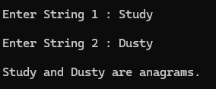 printf("\n");

}

**Output :**

**Program 20 :**

// Program to read a string and print in zigzag case

# include <stdio.h>

# include <string.h>

main()

{

int i,len;

char str[100];

printf("\n Enter String : ");

gets(str);

printf("\n ");

len=strlen(str);

for (i=0;i<len;i++)

{

if (str[i]==' ')

putchar(str[i]);

if (i%2==0)

putchar(toupper(str[i]));

else

putchar(tolower(str[i]));

}

printf("\n");

}

**Output :**

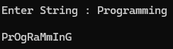

**FUNCTIONS**

**Program 1.1 :**

// Program to calculate mean of 3 numbers

# include <stdio.h>

# include "myfunctions.h"

main ()

{

float no1,no2,no3,mean;

printf("\n Enter Number 1 : ");

scanf("%f",&no1);

printf("\n Enter Number 2 : ");

scanf("%f",&no2);

printf("\n Enter Number 3 : ");

scanf("%f",&no3);

mean=mean3(no1,no2,no3);

printf("\n Mean of %.2f,%.2f,%.2f is %.2f",no1,no2,no3,mean);

printf("\n");

}

**Output :**

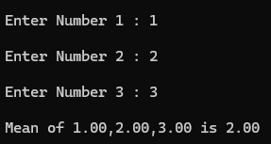

**Program 1.2 :**

// Program to check positivity or negativity of a number

# include <stdio.h>

# include "myfunctions.h"

main ()

{

float no;

char check;

printf("\n Enter Number : ");

scanf("%f",&no);

check=checkno(no);

if (check=='p')

printf("\n %.2f is a Positive Number.",no);

else if (check=='n')

printf("\n %.2f is a Negative Number.",no);

else if (check=='z')

printf("\n %.2f is Zero.",no);

printf("\n");

}

**Output :**

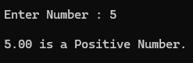

**Program 1.3 :**

// Program to count words in inputted strings

# include <stdio.h>

# include <string.h>

# include "myfunctions.h"

main ()

{

int len,w=1;

char str[100];

printf("\n Enter String : ");

scanf("%[^\n]",&str);

w=wcount(str);

printf("\n Number of words in inputted string are %d.",w);

printf("\n");

}

**Output :**

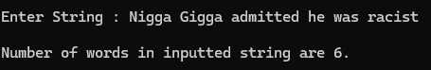

**Program 1.4 :**

// Program to convert inputted string into proper case

# include <stdio.h>

# include <string.h>

# include "myfunctions.h"

main ()

{

int i;

char str[100];

printf("\n Enter String : ");

scanf("%[^\n]",&str);

propercase(str);

for (i=0;i<strlen(str);i++)

printf("%c",str[i]);

printf("\n");

}

**Output :**



**Myfunctions.h :**

// Functions Declaration

float mean3(float,float,float);

char checkno(float);

int wcount(char []);

char propercase(char []);

// Function Definiton

//Mean Function

float mean3(float x,float y,float z)

{

float mean3,sum=0;

sum=x+y+z;

mean3=sum/3.0;

return mean3;

}

//Check number function

char checkno(float x)

{

if (x>0)

return 'p';

else if (x<0)

return 'n';

else if (x==0)

return 'z';

}

//Word count

int wcount(char str[])

{

int i,w=1;

for (i=0;i<strlen(str);i++)

{

if (str[i]==' ')

w++;

}

return w;

}

// Proper case

char propercase(char str[])

{

int i;

for (i=0;i<strlen(str);i++)

{

if (str[i]>=65 && str[i]<=97)

str[i]=tolower(str[i]);

else

if (str[i]==' ')

{

i++;

if (str[i]>=97 && str[i]<=122)

str[i]=toupper(str[i]);

}

}

str[0]=toupper(str[0]);

}

**Program 2 :**

// Program to swap two numbers using functions

# include <stdio.h>

main ()

{

void swap (int *a,int *b);

int a,b;

printf("\n Enter 'A' Value : ");

scanf("%d",&a);

printf("\n Enter 'B' Value : ");

scanf("%d",&b);

printf("\n Numbers before calling swap function : %d,%d",a,b);

swap(&a,&b);

printf("\n Numbers after calling swap function : %d,%d",a,b);

printf("\n");

}

void swap (int *a,int *b)

{

int temp;

temp=*a;

*a=*b;

*b=temp;

return ;

}

**Output :**

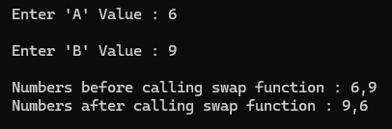

**Program 3 :**

// Program to calculate area of circle using functions

# include <stdio.h>

# define PI 3.14

main ()

{

float area(float );

float a,r=0;

printf("\n Enter the Value of 'R' : ");

scanf("%f",&r);

a=area(r);

printf("\n Area is %.2f",a);

printf("\n");

}

float area(float r)

{

float a;

a=r*PI;

return a;

}

**Output :**

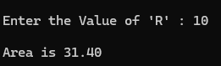

**Program 4 :**

// Program to display number of visitors of a website

#include <stdio.h>

main()

{

int i;

for (i=0;i<10;i++)

countVisitors();

printf("\n");

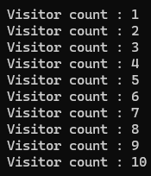}

void countVisitors()

{

static int visitorCount=0;

visitorCount++;

printf("\n Visitor count : %d",visitorCount);

}

**Output :**

**Program 5 :**

// Program to read a string and display character along with address

# include <stdio.h>

main ()

{

int i,*p;

char str[100];

printf("\n Enter String : ");

scanf("%[^\n]",&str);

p=&str;

for (i=0;str[i]!='\0';i++)

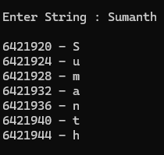 {

printf("\n %u - %c",p,str[i]);

p++;

}

printf("\n");

}

**Output :**

**STRUCTURES**

**Program 1 :**

// Program to maintain a catalog of books and add new books,display them and search specific book

# include <stdio.h>

# include <string.h>

# define max 100

int i;

struct book

{

int bookID;

char title[100];

char author[100];

int noofpages;

float price;

int publicationYear;

};

void addBook(struct book books[], int *n);

void displayBooks(struct book books[], int n);

void searchBook(struct book books[], int n);

void updateBook(struct book books[], int n);

main()

{

struct book books[max];

int n=0;

int choice;

while (1)

{

printf("\n----------------------------------------------\n");

printf("\n Book Catalog Management System");

printf("\n 1. Add Book");

printf("\n 2. Display All Books");

printf("\n 3. Search Book");

printf("\n 4. Update Book");

printf("\n 5. Exit");

printf("\n Enter your choice : ");

scanf("%d",&choice);

switch (choice)

{

case 1:

addBook(books,&n);

break;

case 2:

displayBooks(books,n);

break;

case 3:

searchBook(books,n);

break;

case 4:

updateBook(books,n);

break;

case 5:

printf("\n Exiting.\n");

return 0;

default:

printf("\a\n\t\t\t\t\t\tInvalid choice. Please try again.");

}

}

printf("\n");

}

void addBook(struct book books[], int *n)

{

if (*n>=max)

{

printf("\n Catalog is full. Cannot add more books.\n");

return;

}

printf("\n----------------------------------------------\n");

printf("\n Enter book details : ");

printf("\n Book ID: ");

scanf("%d",&books[*n].bookID);

printf(" Title: ");

scanf(" %[^\n]",books[*n].title);

printf(" Author : ");

scanf(" %[^\n]",books[*n].author);

printf(" Number of Pages : ");

scanf("%d",&books[*n].noofpages);

printf(" Price : ");

scanf("%f",&books[*n].price);

printf(" Publication Year : ");

scanf("%d",&books[*n].publicationYear);

(*n)++;

printf("\n Book added successfully.");

printf("\n----------------------------------------------\n");

}

void displayBooks(struct book books[], int n)

{

if (n==0)

{

printf("\n No books in the catalog.");

return;

}

printf("\n**********************************************\n");

printf("\n Book Catalog :");

for (int i=0;i<n;i++)

{

printf("\n Book ID : %d",books[i].bookID);

printf("\n Title : %s",books[i].title);

printf("\n Author : %s",books[i].author);

printf("\n Number of Pages : %d",books[i].noofpages);

printf("\n Price : %.2f",books[i].price);

printf("\n Publication Year : %d",books[i].publicationYear);

printf("\n");

}

printf("\n**********************************************\n");

}

void searchBook(struct book books[], int n)

{

int choice, bookID;

char searchStr[100];

printf("\n----------------------------------------------\n");

printf("\n Search by :");

printf("\n 1. Book ID");

printf("\n 2. Author");

printf("\n 3. Title");

printf("\n Enter your choice : ");

scanf("%d",&choice);

printf("\n----------------------------------------------\n");

switch (choice)

{

case 1:

printf("\n Enter Book ID : ");

scanf("%d",&bookID);

for (int i=0;i<n;i++)

{

if (books[i].bookID==bookID)

{

printf("\n----------------------------------------------\n");

printf("\n Book found :");

printf("\n Book ID : %d",books[i].bookID);

printf("\n Title : %s",books[i].title);

printf("\nAuthor : %s",books[i].author);

printf("\n Number of Pages : %d",books[i].noofpages);

printf("\n Price : %.2f",books[i].price);

printf("\n Publication Year : %d",books[i].publicationYear);

printf("\n----------------------------------------------\n");

return;

}

}

printf("\n Book with ID %d not found.",bookID);

break;

case 2:

printf("\n Enter Author : ");

scanf("%[^\n]",searchStr);

for (int i=0;i<n;i++)

{

if (strcmp(books[i].author, searchStr)==0)

{

printf("\n----------------------------------------------\n");

printf("\n Book found :");

printf("\n Book ID : %d",books[i].bookID);

printf("\n Title : %s",books[i].title);

printf("\n Author : %s",books[i].author);

printf("\n Number of Pages : %d",books[i].noofpages);

printf("\n Price : %.2f",books[i].price);

printf("\n Publication Year : %d",books[i].publicationYear);

printf("\n----------------------------------------------\n");

}

}

break;

case 3:

printf("\n Enter Title : ");

scanf("%[^\n]",searchStr);

for (int i=0;i<n;i++)

{

if (strcmp(books[i].title, searchStr)==0)

{

printf("\n----------------------------------------------\n");

printf("\n Book found :");

printf("\n Book ID : %d",books[i].bookID);

printf("\n Title : %s",books[i].title);

printf("\n Author : %s",books[i].author);

printf("\n Number of Pages : %d",books[i].noofpages);

printf("\n Price : %.2f",books[i].price);

printf("\n Publication Year : %d",books[i].publicationYear);

printf("\n----------------------------------------------\n");

}

}

break;

default:

printf("\n\a\t\t\t\t\t\tInvalid choice. Please try again.");

}

}

void updateBook(struct book books[], int n)

{

int bookID;

printf("\n Enter Book ID to update : ");

scanf("%d",&bookID);

for (int i=0;i<n;i++)

{

if (books[i].bookID==bookID)

{

printf("\n----------------------------------------------\n");

printf("\n Book found :");

printf("\n Current details :");

printf("\n Book ID : %d",books[i].bookID);

printf("\n Title : %s",books[i].title);

printf("\n Author : %s",books[i].author);

printf("\n Number of Pages : %d",books[i].noofpages);

printf("\n Price : %.2f",books[i].price);

printf("\n Publication Year : %d",books[i].publicationYear);

printf("\n Enter new price : ");

scanf("%f",&books[i].price);

printf("\n Price updated successfully.");

printf("\n----------------------------------------------\n");

return;

}

}

printf("\n Book with ID %d not found.",bookID);

}

**Output :**

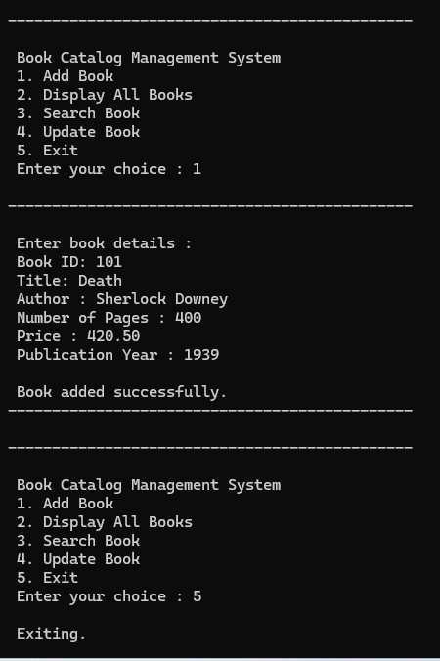

**Program 2 :**

// Program to read and display average salary,employees with highest and lowest salaries

# include <stdio.h>

# define max 100

struct employee

{

int id;

float salary;

char name[50],designation[50];

}e;

int i;

void read (struct employee e[],int *n);

void display (struct employee e[],int n);

main ()

{

struct employee e[max];

int n;

read(e,&n);

display(e,n);

printf("\n");

}

void read (struct employee e[],int *n)

{

printf("\n Enter the number of employees : ");

scanf("%d",n);

for (i=0;i<*n;i++)

{

printf("\n Enter details for employee %d\n",i+1);

printf(" ID : ");

scanf("%d",&e[i].id);

printf(" Name : ");

fflush(stdin);

scanf("%[^\n]",&e[i].name);

printf(" Designation : ");

fflush(stdin);

scanf("%[^\n]",&e[i].designation);

printf(" Salary : ");

scanf("%f",&e[i].salary);

}

}

void display(struct employee e[], int n)

{

if (n==0)

{

printf("\a\n\t\t\t\t\t\tNo employee data available.\n");

return;

}

float total=0;

struct employee highest=e[0];

struct employee lowest=e[0];

for (i=0;i<n;i++)

{

total+=e[i].salary;

if (e[i].salary>highest.salary)

highest=e[i];

if (e[i].salary<lowest.salary)

lowest=e[i];

}

float average=total/n;

printf("\n--------------------------------------------------\n");

printf("\n Average Salary : %.2f\n",average);

printf("\n--------------------------------------------------\n");

printf("\n Employee with the highest salary :");

printf("\n ID : %d",highest.id);

printf("\n Name: %s",highest.name);

printf("\n Designation: %s",highest.designation);

printf("\n Salary: %.2f",highest.salary);

printf("\n--------------------------------------------------\n");

printf("\n Employee with the lowest salary :");

printf("\n ID : %d",lowest.id);

printf("\n Name: %s",lowest.name);

printf("\n Designation: %s",lowest.designation);

printf("\n Salary : %.2f",lowest.salary);

}

**Output :**

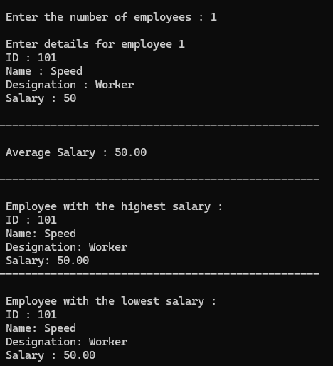

**Program 3 :**

// Program to read student name and any id proof

# include <stdio.h>

# pragma pack(1)

int no,i;

struct student

{

char name[50];

union

{

long long aadharno;

long long pp;

char panno[10];

char dlno[12];

}id;

int idtype;

};

void read (struct student s[] , int no);

void search (struct student s[] , int no);

main ()

{

printf("\n Enter number of students : ");

scanf("%d",&no);

struct student s[no];

read (s,no);

search (s,no);

printf("\n");

}

void read(struct student s[], int no)

{

for (int i=0;i<no;i++)

{

printf("\n Enter Details of Student %d :",i+1);

printf("\n Enter Student Name : ");

scanf(" %[^\n]",s[i].name);

printf("\n\n\t1. Aadhar Number");

printf("\n\t2. Passport Number");

printf("\n\t3. PAN Number");

printf("\n\t4. Driving License Number");

printf("\n\n Enter ID Proof Type: ");

scanf("%d",&s[i].idtype);

switch (s[i].idtype)

{

case 1:

printf("\n Enter Aadhar Number: ");

scanf("%lld",&s[i].id.aadharno);

break;

case 2:

printf("\n Enter Passport Number: ");

scanf("%lld",&s[i].id.pp);

break;

case 3:

printf("\n Enter PAN Number: ");

scanf("%s",s[i].id.panno);

break;

case 4:

printf("\n Enter Driving License Number: ");

scanf("%s",s[i].id.dlno);

break;

default:

printf("\a\n\t\t\t\t\t\tInvalid Choice");

i--;

break;

}

}

return ;

}

void search(struct student s[], int no)

{

char found='n';

printf("\n Details of Students using Aadhar Number :\n");

for (int i=0;i<no;i++)

{

if (s[i].idtype==1)

{

printf("\n Name : %s",s[i].name);

printf("\n Aadhar Number : %lld",s[i].id.aadharno);

found='y';

}

}

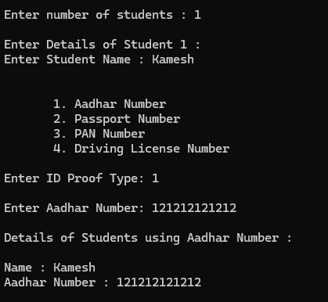 if (found=='n')

printf("\n NIL");

return ;

}

**Output :**

**Program 4 :**

// Program to recreate ren command

// Question 134

#include <stdio.h>

#include <stdlib.h>

main(int argc, char *argv[])

{

char ch;

char new_name[100];

if (argc!=3)

{

printf("\n Usage : %s <old_filename> <new_filename>\n\n", argv[0]);

exit(0);

}

FILE *fp = fopen(argv[1],"r");

if (fp == NULL)

{

printf("\a\nFile '%s' does not exist.\n\n", argv[1]);

exit(0);

}

fclose(fp);

printf(" Do you want to rename '%s' to '%s'? (Y/N) : ",argv[1],argv[2]);

fflush(stdin);

scanf("%c",&ch);

ch=tolower(ch);

if (ch=='n')

{

printf("\n File renaming cancelled.\n\n");

exit(0);

}

else if (ch=='y')

{

if (rename(argv[1],argv[2])==0)

printf("\nFile renamed successfully.\n\n");

else

perror("Error renaming file");

}

else

printf("\nInvalid input. File renaming cancelled.\n\n");

}

**Output :**

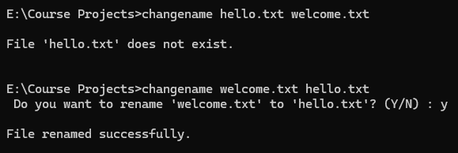

**Program 5 :**

// Program to read employee id,name and salary and store into employee.dat file

#include <stdio.h>

#include <stdlib.h>

struct employee

{

char name[50];

int id;

float salary;

};

main()

{

FILE *fp;

struct employee *e = NULL;

int num=0,capacity=1,i=0;

char choice;

e=(struct employee *)malloc(capacity * sizeof(struct employee));

if (e==NULL)

{

printf("\a\n\t\t\t\t\t\tUnable to Allocate Memory.\n");

exit(0);

}

fp=fopen("employee.dat","at");

if (fp==NULL)

{

printf("\a\n\t\t\t\t\t\tUnable to open file.\n");

free(e);

exit(0);

}

do

{

if (num>=capacity)

{

capacity++;

e=(struct employee *)realloc(e, capacity * sizeof(struct employee));

if (e==NULL)

{

printf("\a\n\t\t\t\t\t\tUnable to reallocate memory.\n");

fclose(fp);

exit(0);

}

}

printf("\nEnter Details For Employee %d :\n",num+1);

printf("\n ID : ");

scanf("%d",&e[num].id);

printf(" Name : ");

scanf(" %[^\n]",e[num].name);

printf(" Salary : ");

scanf("%f",&e[num].salary);

fwrite(&e[num],sizeof(struct employee),1,fp);

num++;

printf("\n Do You Want to Continue (Y/N): ");

fflush(stdin);

scanf("%c",&choice);

choice=tolower(choice);

}while (choice=='y');

fclose(fp);

free(e);

printf("\n Employee details have been saved to employee.dat");

printf("\n\n Do You Wish to Display Details : ");

fflush(stdin);

scanf("%c",&choice);

if (choice=='y')

{

fp = fopen("employee.dat","rb");

if (fp==NULL)

{

printf("\a\n\t\t\t\t\t\tUnable to open file.\n");

exit(0);

}

struct employee e;

printf("\n Employee Details : ");

printf("\n----------------------------------------------------\n");

printf("%-10s %-30s %-10s", "ID", "Name", "Salary");

printf("\n---------------------------------------------------\n");

while (fread(&e,sizeof(struct employee),1,fp)==1)

{

printf(" %-10d %-30s %-10.2f\n",e.id,e.name,e.salary);

i++;

}

printf("\n---------------------------------------------------\n");

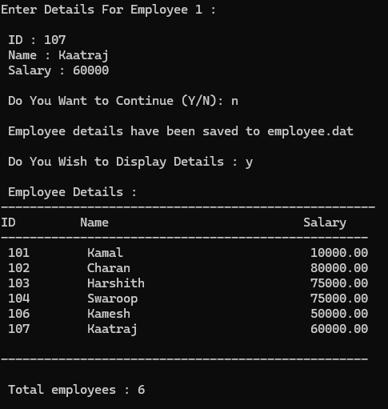 printf("\n Total employees : %d",i);

fclose(fp);

}

printf("\n");

}

**Output :**