When it comes to data science problems, neural networks are one of the fastest growing class of algorithms in terms of popularity. In my last post, I spoke about the role of activation functions in neural networks. Today, we will talk a specific type of neural network for unsupervised feature learning - the autoencoders

What are autoencoders ?

Autoencoders are neural networks that use the input variables to do the training instead of having a separate class of labels for training. In other words, the output of the neural network is same as the input. Mathematically speaking, it is a neural network trying to learn the identity function. Following is a sample autoencoder

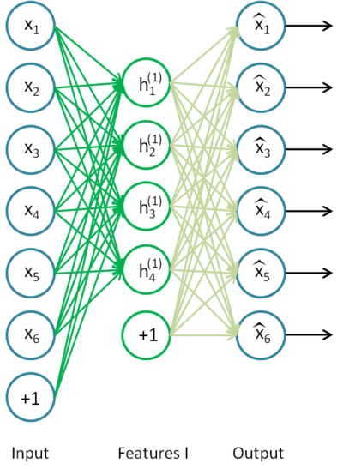

Why learn the identity function ?

Well, there are lots of applications for an autoencoder. The most popular application currently is pre-training deep neural networks. The idea behind this is to start the training with a more meaningful set of weights learned by the autoencoder instead of random initial weights.

Another common application is dimensionality reduction. For the purpose of the post, we will stick to dimensionality reduction. Majority of the machine learning tasks demand that you generate a compressed representation of the data in order to be able to build your model with a reasonable time complexity and space complexity. The process of extracting this compressed representation is called dimensionality reduction. Dimensionality reduction always involves a certain amount of loss in information. The idea is to balance out this loss with the gain in computational effort.

So how do we reduce the number of dimensions ?

We already spoke about how autoencoders basically try to reconstruct the input. If the hidden units were same in number as the input dimension, we would ideally have zero error in reconstruction. What we do is we restrict the number of hidden units and train the autoencoder to reconstruct the input with minimal error.

Ok, what’s so special about autoencoders in comparison to other dimensionality reduction techniques like PCA ?

Principal Component Analysis a.k.a PCA projects the input onto a lower dimensional surface. But it works on the assumption that the data has linearly correlated features. Let’s understand what that means. The following figures shows the result of applying PCA

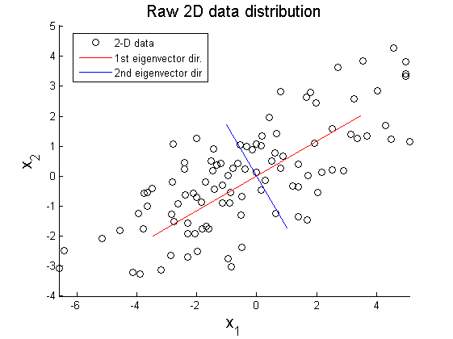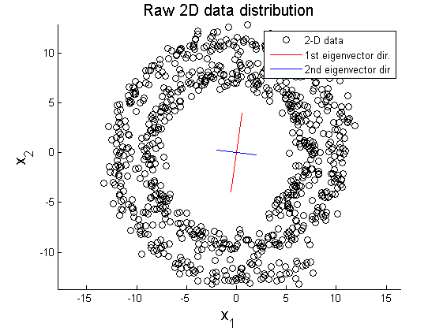

Image courtesy –

https://www.projectrhea.org/rhea/index.php/PCA_Theory_Examples

On linearly correlated data , PCA does a nice job of reducing the dimensions while on non linearly correlated data, PCA fails.

Autoencoders are much more powerful than techniques like PCA in terms of being able to generate non linear encodings. In my previous [post](https://sumanthprabhu.github.io/posts/2016-25-NN-why-activation-functions/), I have explained how activation functions introduce non linearity in neural networks.

Practical comparison of PCA and Autoencoders

To compare PCA and autoencoders, let’s see how each of them perform on the MNIST digit dataset. We generate 2d representations and project them on to a plane with each class represented by a different colour. The following figure shows how PCA performs.

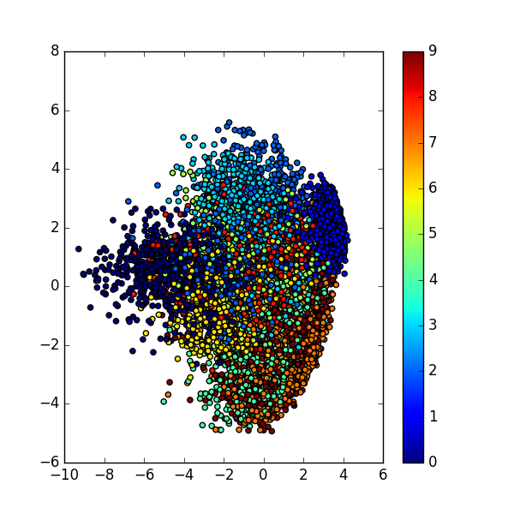The following figure shows how the autoencoders perform.

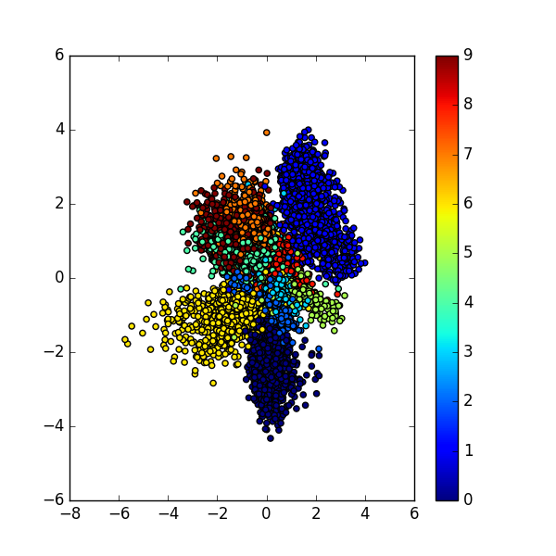

We see that the representation given by autoencoders turn out to be more separable than what PCAs would give.

In conclusion, autoencoders are an interesting approach to unsupervised learning. They find a lot of applications in machine learning and we saw how they can be used in dimensionality reduction.