Using given cooccurrence details,

1) Calculate Dicecoefficient to determine the strength of co-occurrence
between any two words w and w' as below.
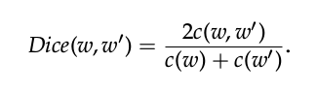

The rationale behind the use of the Dice coefficient instead of simple co-occurrence count such as c(w, w ), is dividing c(w,w') by the average of the total counts of the two words to drastically decreases the ranking of words that tend to co-occur
frequently with many other words.

2)For all w which are highest-ranking words co-occurring with query q in the given co-occurrence graph and satisfying below equation.
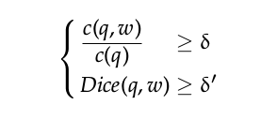

Where δ and δ' are experimental tuned thresholds.
All such w will become vertices of query gaph Gq.

References :
Clustering and Diversifying Web Search
Results with Graph-Based Word
Sense Induction – Di Macro & Navigli

