MERN FULL STACK LAB MANUAL

PROGRAM ONE:
FILE NAME:simple.html
<html>
<head>
<title>simple.com</title>
</head>
<body>
<h1>this is my first web page</h1>
<p>aditya </p>
</body>
</html>

Output:
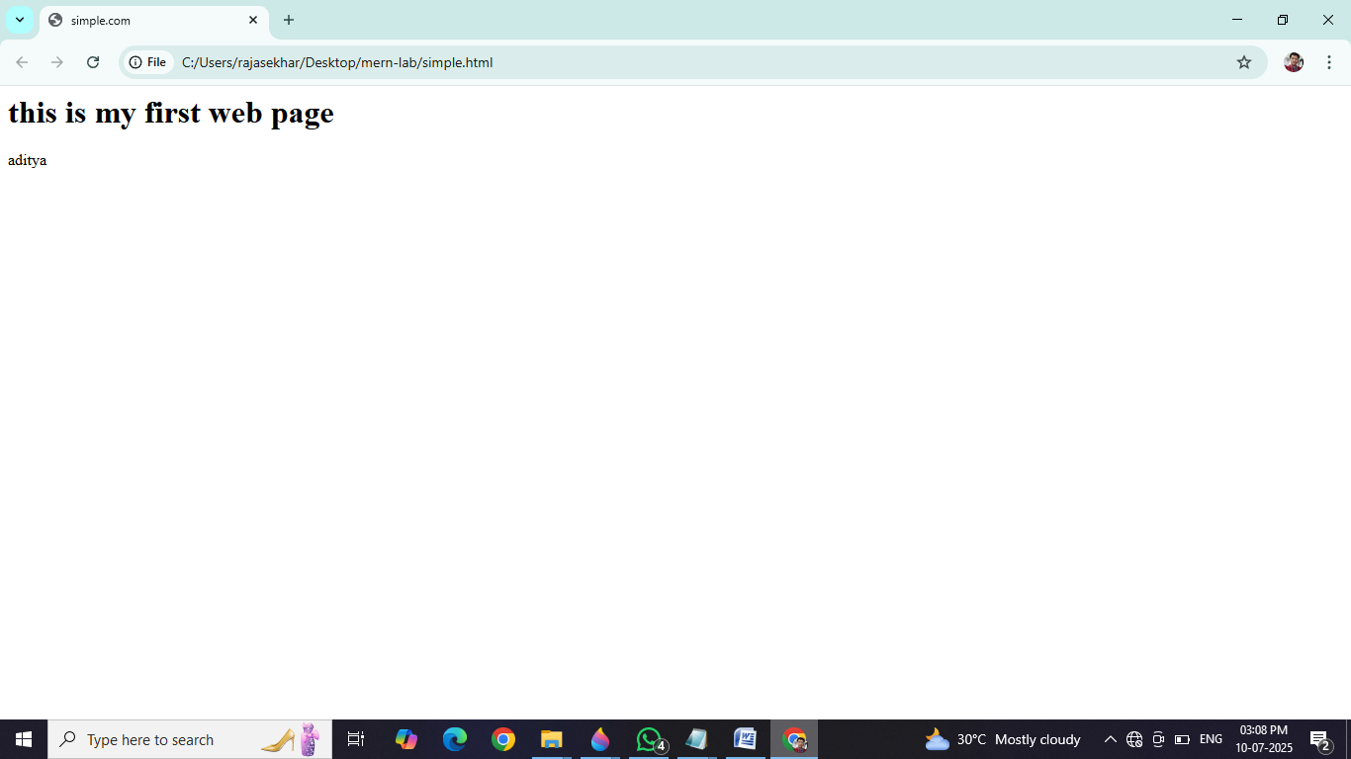

PROGRAM TWO:
FILE NAME:list tags.html
<html>
<head>
<title> branches</title>
</head>
<body>
<h2>order list</h2>
<ol type="i">
<li>cse</li>
<li>it</li>
<li>ece</il>
<li>aiml</li>
</ol>
<h2>unorder list</h2>
<ul type="disc">
<li>pen</li>
<li>boll pen</li>
<li>ink pen</li>
</ul>
<h2>definition list</h2>
<dl>
<dt>html</dt>
<dd>hyper text markup language</dd>
<dt>js</dt>
<dd>java script</dd>
</dl>
</body>
</html>

Output: