**VISVESVARAYA TECHNOLOGICAL UNIVERSITY BELGAUM - 590014**



**A DBMS Mini-Project Report**

**On**

***“RESUME BUILDER”***

*A Mini-project report submitted in partial fulfillment of the requirements for the award of the degree of* ***Bachelor of Engineering in Computer Science and Engineering***

*of Visvesvaraya Technological University, Belgaum.*

Submitted by:

**SUMANTH S (1DT18CS104)**

**AND**

**THOTA LOKESWARNATH (1DT18CS108)**

Under the Guidance of:

**Mr. Manjunath D R (Assoc. Prof. Dept of CSE)**



**Department of Computer Science and Engineering**

**DAYANANDA SAGAR ACADEMY OF TECHNOLOGY AND MANAGEMENT**

Kanakapura Road, Udayapura, Bangalore

2019-2020

(Accredited by NBA, New Delhi for 3 years validity: 26-07-2018 to 30-06-2021)

**DAYANANDA SAGAR ACADEMY OF TECHNOLOGY AND MANAGEMENT,**

Kanakapura Road, Udayapura, Bangalore

**DEPARTMENT OF COMPUTER SCIENCE & ENGINEERING**



**CERTIFICATE**

This is to certify that the Mini-Project on Database Management System (DBMS) entitled **“BANK MANAGEMENT”** has been successfully carried out by **SUMANTH S (1DT18CS104) and THOTA LOKESWARNATH (1DT18CS108)** a bonafide students of **Dayananda sagar academy of technology and management** in partial fulfillment of the requirements for the award of degree in **Bachelor of Engineering in Computer Science and Engineering** of **Visvesvaraya Technological University, Belgaum** during academic year 2019-20. It is certified that all corrections/suggestionsindicated for Internal Assessment have been incorporated in the report deposited in the departmental library. The mini project report has been approved as it satisfies the academic requirements in respect of project work for the said degree.

**GUIDES:**

**Mr. Manjunath D R (Assoc. Prof. Dept of CSE)**

**Dr. C. NANDINI**

**(Vice Principal & HOD, Dept. of CSE)**

**Examiners:** **Signature with Date**

**1:**

**2:**

**ACKNOWLEDGEMENT**

It gives us immense pleasure to present before you our project titled **“RESUME BUILDER USING HTML and PHP”.** The joy and satisfaction that accompany thesuccessful completion of any task would be incomplete without the mention of those who made it possible. We are glad to express our gratitude towards our prestigious institution **DAYANANDA** **SAGAR ACADEMY OF TECHNOLOGY AND MANAGEMENT** for providing us with utmostknowledge, encouragement and the maximum facilities in undertaking this project.

We wish to express a sincere thanks to our respected principal **Dr. B. R. Lakshmikantha** for all their support.

We express our deepest gratitude and special thanks to **Dr.C.Nandini, Vice Principal & H.O.D, Dept.**

**Of Computer Science Engineering**, for all her guidance and encouragement.

We sincerely acknowledge the guidance and constant encouragement of our mini- project guides, **Dr.** **Sandhya N (Assoc. Prof. Dept of CSE) and Mr. Manjunath D R (Asst. Prof. Dept of CSE)**

**SUMANTH S (1DT18CS037)**

**AND**

**THOTA LOKESWARNATH (1DT18CS047)**

i

**ABSTRACT**

Our Project “RESUME BUILDER” is a computerized system used to store information about the applicant and the applicant can view,edit or download information in the form of a resume.

The system allows the user to maintain his or her information from matriculation to skills and work experience . The system provides the applicant with various options like social media, internships and all the related information about their education.. Once the applicant completes filling information in all the related fields and submits , now the applicant can view or edit or download the final resume.

The user needs to sign up or log in . After registering or logging in the user can start to build his/her resume by providing their information. The user at the end will get a finished product that is resume to submit for his or her job applications.

We have the database where we could see the resumes of all the applicants. The admin can also view or edit or update those resumes as all the resumes along with their information is stored in the database.

|  |  |  |
| --- | --- | --- |
| **TABLE OF CONTENTS** |  |  |
| **Chapter #** | **Chapter Name** | **Page #** |
| **1** | **INTRODUCTION** | **1** |
| **1.1** | **Background** | **1** |
| **1.2** | **Problem Definition** | **1** |
| **1.3** | **Motivation** | **1** |
| **1.4** | **Objective** | **2** |
| **1.5** | **Scope of the project** | **2** |
| **2** | **REQUIREMENTS** | **3** |
| **2.1** | **Hardware Requirements** | **3** |
| **2.2** | **Software Requirements** | **3** |
| **3** | **DESIGN** | **4** |
| **3.1** | **Database Design** | **4** |
| 3.1.1 | E-R Diagram | 4 |
| 3.1.2 | Database Schema | 5 |
| 3.1.3 | Relational Schema | 8 |
| **3.2** | **Database Normalization** | **9** |
| 3.2.1 | First Normal Form | 9 |
| 3.2.2 | Second Normal Form | 9 |
| 3.2.3 | Third Normal Form | 9 |
| **3.3** | **User Interface** | **9** |
| 3.3.1 | User Registration Module | 10 |
| 3.3.2 | User Operations Module | 11 |
| 3.3.3 | Admin Operations Module | 12 |
| 3.3.4 | Additional Operations Module | 13 |
|  | **SOURCE CODE** | **20** |
|  |
|  |
|  |
|  | **BIBLIOGRAPHY** | **27** |

**CHAPTER 1**

**INTRODUCTION**

**1.1 Background**

A resume is the summary of your background,skills and qualifications, which are sent to potential host organizations (companies) for review. In the early stages the resumes were simple and boring. The evolution of resumes was rapid and is still in the process of evolution . Some of the major changes which took place are as follows −

Resume builders have arrived with new templates that is with new designs.The resumes are now made more professional and more appealing than before.

**1.2 Problem Definition**

This project is aimed to allow users to build more professional and appealing resumes for free of cost which led to “RESUME BUILDER”. This project is developed mainly to simplify the manual work and provide easy user interface and satisfy the applicant needs. The effective purpose of the project is to computerize the operation of a user for free of cost and to make the user reach his/her requirements faster and without any interruptions.

**1.3 Motivation**

**Manual System:** The existing system is very time consuming and requires a lot of effort.

**Technical System:** With the invention of latest technology, we should update our systems whichare very fast, accurate, user-friendly and reliable.

**1.4 Objective**

* To provide resume builder application for free of cost.
* Editing, adding and updating of records is improved which results in proper resource management of resume data.
* Only the administrator is guaranteed the access
* Resumes were evolved from scraps of papers to digital format with the introduction of computers
* Provides instant resume to individuals
* Online Resume Builders came into existence with development of internet

**1.5 Scope of the project**

The project provides a very simple application which modernizes the process for free of cost for Resume Builder. Individuals **need resumes and resume builder** services that allows them to look more professional and appealing. This application saves the data of users in the database. Allows users to edit , add or update information.

**CHAPTER 2**

**REQUIREMENTS**

The requirements can be broken down into 2 major categories namely hardware and software requirements. The former specifies the minimal hardware facilities expected in a system in which the project has to be run. The latter specifies the essential software needed to build and run the project.

**2.1 Hardware Requirements**

The Hardware requirements are very minimal and the program can be run on most of the machines.

|  |  |  |
| --- | --- | --- |
| • | Processor | - Intel 486/Pentium processor or better |
| • | Processor Speed | - 500 MHz or above |
| • | Hard Disk | - 20GB(approx) |
| • | RAM | - 64MB or above |
| • | Storage Space | - Approx. 2MB |

**2.2 Software Requirements**

|  |  |  |
| --- | --- | --- |
| • | Technology Implemented | : Postgres Server |
| • | Language Used | : PYTHON , SQL |
| • | Database | : Postgres SQL |
| • | User Interface Design | : HTML, CSS |
| • | Web Browser | : Google Chrome |

**CHAPTER 3**

**DATABASE DESIGN**

**3.1.1 E-R Diagram**

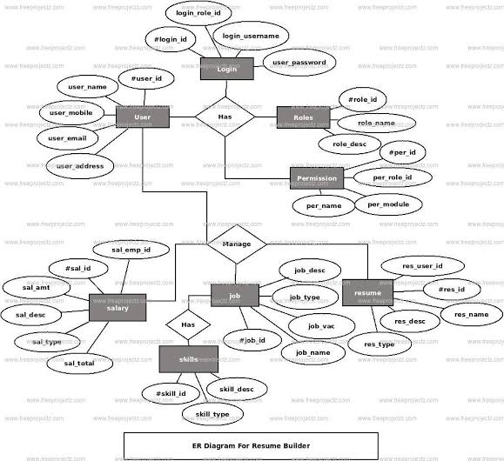

**3.1.2 Database Schema**

***Database:***

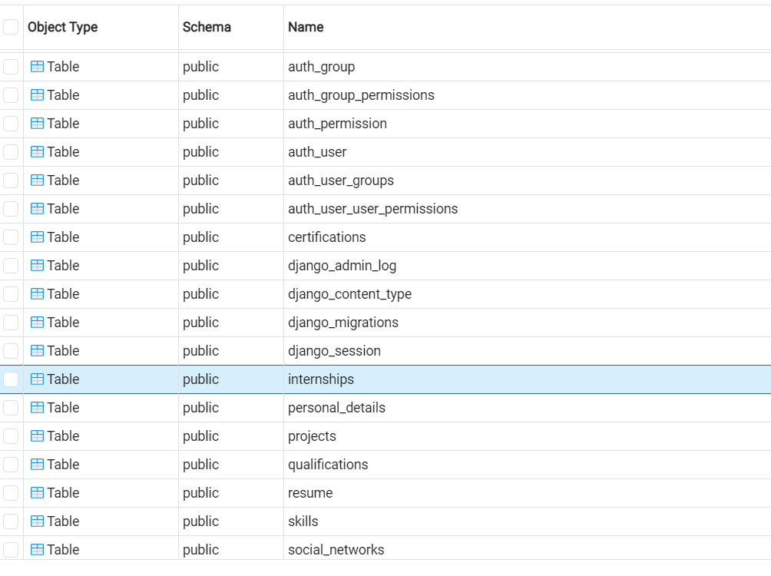

***Table:Resume***

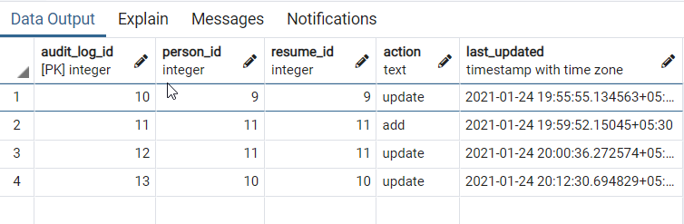

***Table:***

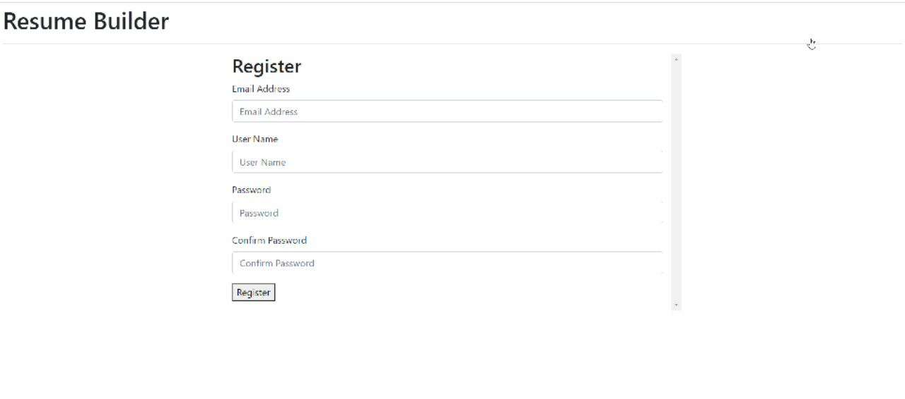

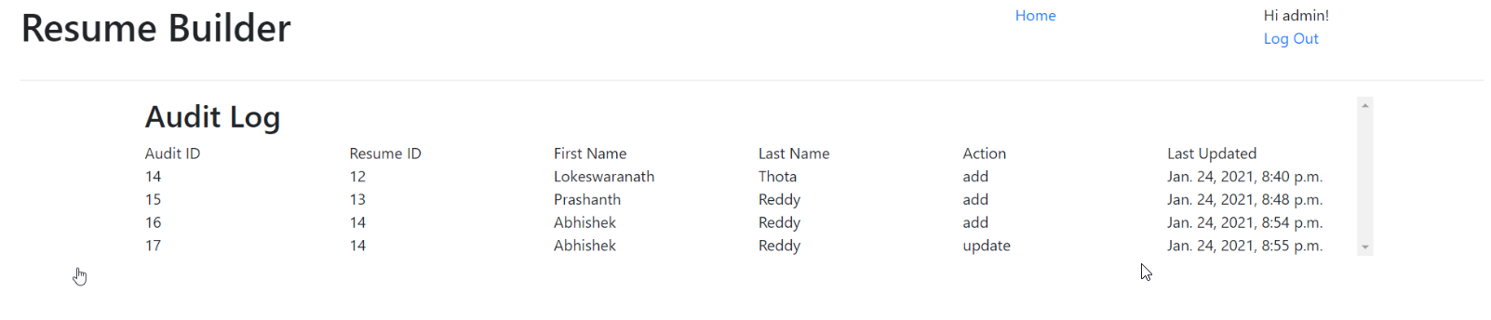

**3.1.3 Relational Schema**

***Database:***

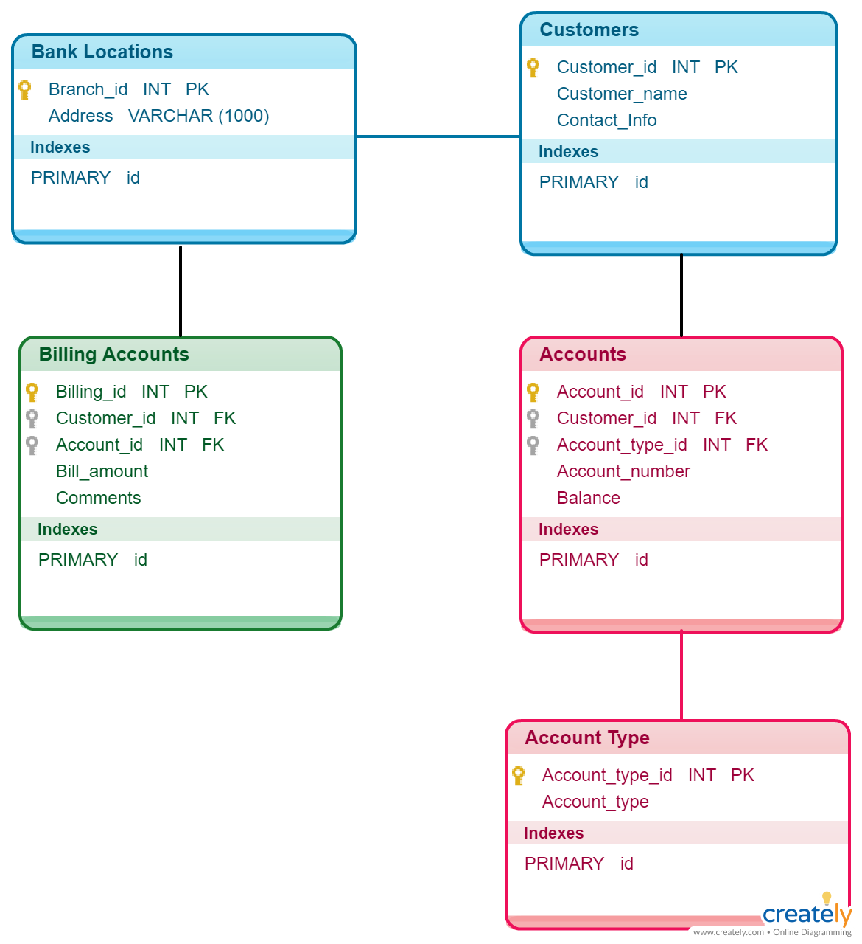

**3.2 Database Normalization**

**3.2.1 First Normal Form**

All the Relations are designed in such a way that it has no repeating groups. Hence all tables are in 1st Normal Form.

**3.2.2 Second Normal Form**

A relation is said to be in second normal form if it is already in first normal form and it has no partial dependency. All the tables in the database are designed in such a way that there is no partial dependency. Hence all tables are in 2nd Normal Form.

**3.2.3 Third Normal Form**

A relation is said to be in third normal form if it is already in 1st and 2nd Normal Form and has no transitive dependency. All the tables in the database are designed in such a way that there is no transitive dependency. Hence all tables are in 3rd Normal Norm.

**3.3 User Interface**

The User Interface of the Complaint Management System (Post Complaint Freely) is divided into User Module - For the users registered to post complaints Admin Module – For the admin/owner(users) of the CMS

**3.3.1 USER REGISTRATION MODULE User Registration**

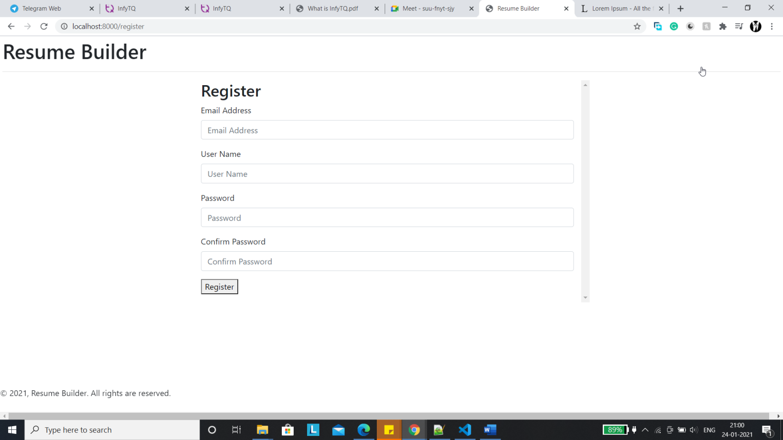

Figure 3.1: User registration module

**User Login**

Figure 3.2: User Signup

**3.3.2 USER OPERATIONS MODULE**

**Transaction History**

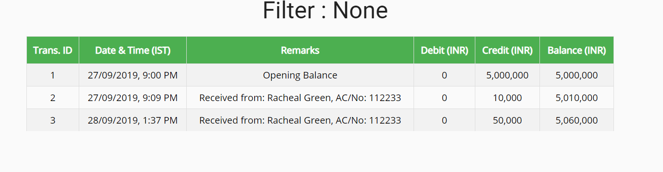 Figure 3.3: Menu Page

**Secured Transaction**

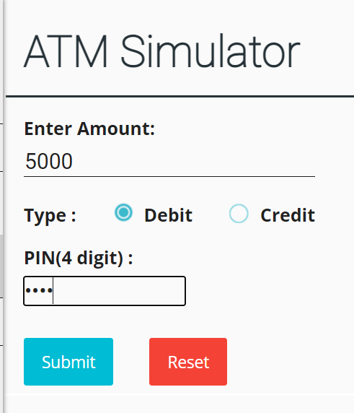

**3.3.3ADMIN OPERATION MODULE**

**Admin Registration**

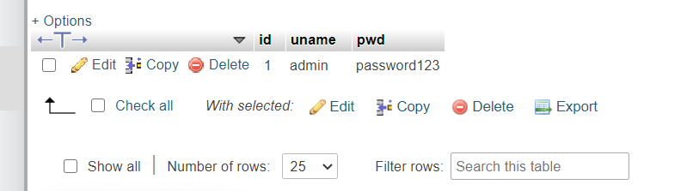

Figure 3.5: Admin registration module

**Admin login**

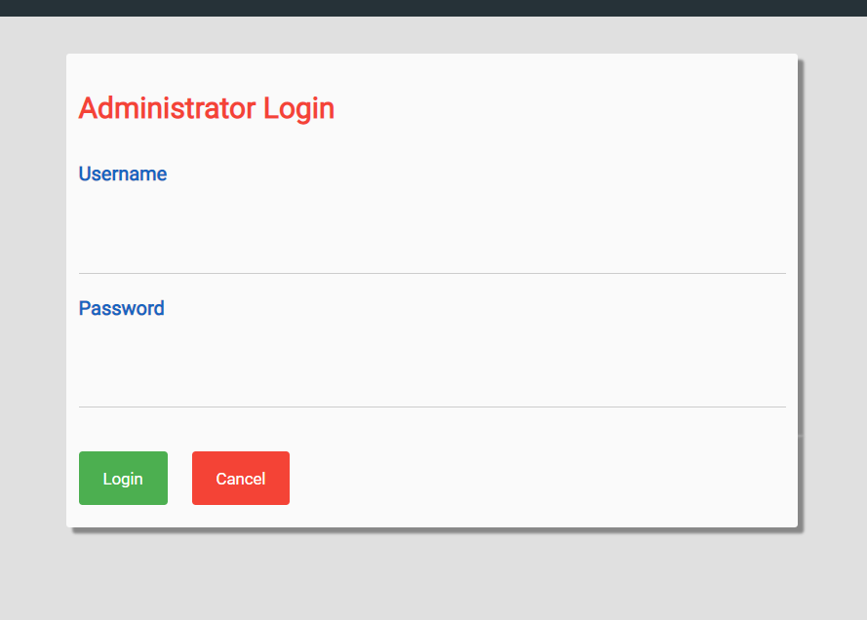

Figure 3.6: Admin Signup

**3.3.4 ADDITIONAL OPERATION MODULE**

**Manager CUSTOMERS**

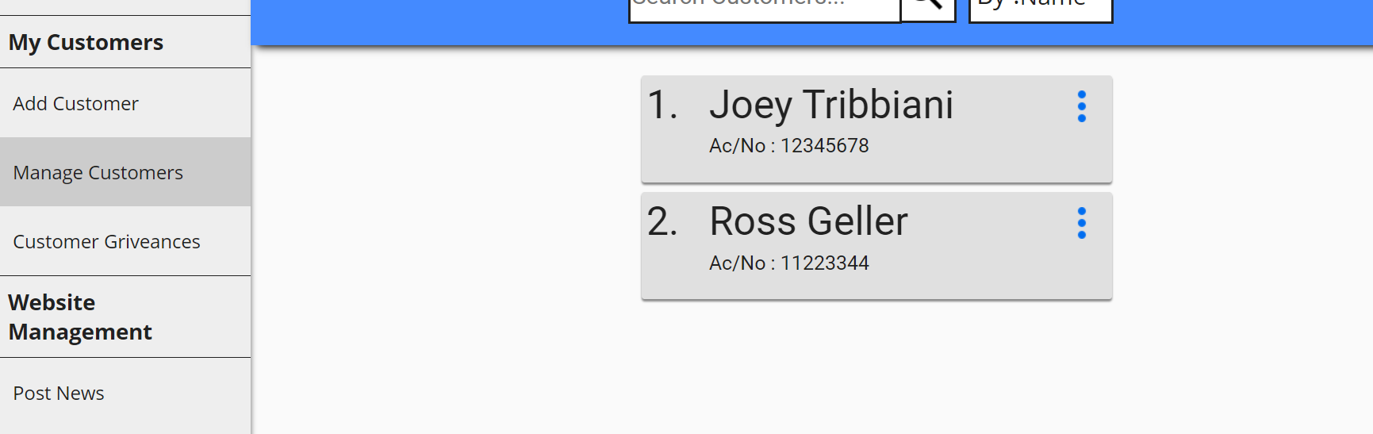

Figure 3.7: Manager Dashboard

**POST NEWS**

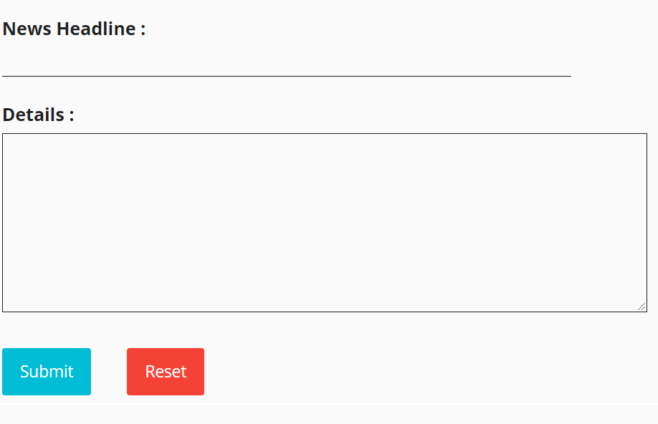

Figure 3.8: Add Food_Items

**STORED PROCEDURES :**

The stored procedure del implemented in project is for displaying the deleted orders of the users which shows all the information about the order like the order_date, number of items added to the order, the items added to the order etc.

**TRIGGERS :**

The trigger is implemented for inserting all details in the order table to a backup table order_ele which helps in having a backup of all the deleted orders by users.

Before:

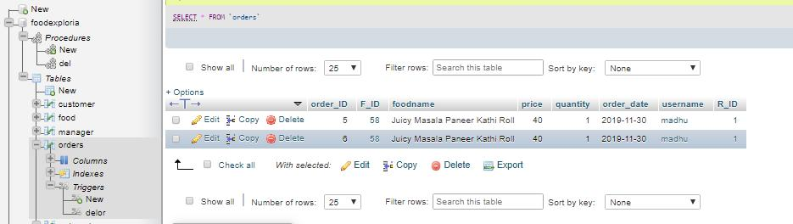

After:

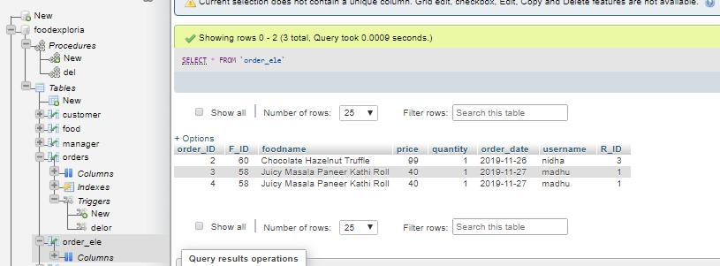

**SOURCE CODE**

-- phpMyAdmin SQL Dump

-- version 4.8.4

-- https://www.phpmyadmin.net/

--

-- Host: 127.0.0.1

-- Generation Time: Sep 28, 2019 at 10:00 AM

-- Server version: 10.1.37-MariaDB

-- PHP Version: 7.3.1

SET SQL_MODE = "NO_AUTO_VALUE_ON_ZERO";

SET AUTOCOMMIT = 0;

START TRANSACTION;

SET time_zone = "+00:00";

/*!40101 SET @OLD_CHARACTER_SET_CLIENT=@@CHARACTER_SET_CLIENT */;

/*!40101 SET @OLD_CHARACTER_SET_RESULTS=@@CHARACTER_SET_RESULTS */;

/*!40101 SET @OLD_COLLATION_CONNECTION=@@COLLATION_CONNECTION */;

/*!40101 SET NAMES utf8mb4 */;

--

-- Database: `net_banking`

--

-- --------------------------------------------------------

--

-- Table structure for table `admin`

--

CREATE TABLE `admin` (

`id` int(11) NOT NULL,

`uname` char(25) DEFAULT NULL,

`pwd` char(25) DEFAULT NULL

) ENGINE=InnoDB DEFAULT CHARSET=latin1;

--

-- Dumping data for table `admin`

--

INSERT INTO `admin` (`id`, `uname`, `pwd`) VALUES

(1, 'admin', 'password123');

-- --------------------------------------------------------

--

-- Table structure for table `beneficiary1`

--

CREATE TABLE `beneficiary1` (

`benef_id` int(11) NOT NULL,

`benef_cust_id` int(11) DEFAULT NULL,

`email` varchar(30) DEFAULT NULL,

`phone_no` varchar(20) DEFAULT NULL,

`account_no` int(11) DEFAULT NULL

) ENGINE=InnoDB DEFAULT CHARSET=latin1;

-- --------------------------------------------------------

--

-- Table structure for table `beneficiary2`

--

CREATE TABLE `beneficiary2` (

`benef_id` int(11) NOT NULL,

`benef_cust_id` int(11) DEFAULT NULL,

`email` varchar(30) DEFAULT NULL,

`phone_no` varchar(20) DEFAULT NULL,

`account_no` int(11) DEFAULT NULL

) ENGINE=InnoDB DEFAULT CHARSET=latin1;

--

-- Dumping data for table `beneficiary2`

--

INSERT INTO `beneficiary2` (`benef_id`, `benef_cust_id`, `email`, `phone_no`, `account_no`) VALUES

(1, 1, 'joey@gmail.com', '984141', 12345678),

(2, 3, 'ross@gmail.com', '98989898', 11223344);

-- --------------------------------------------------------

--

-- Table structure for table `beneficiary3`

--

CREATE TABLE `beneficiary3` (

`benef_id` int(11) NOT NULL,

`benef_cust_id` int(11) DEFAULT NULL,

`email` varchar(30) DEFAULT NULL,

`phone_no` varchar(20) DEFAULT NULL,

`account_no` int(11) DEFAULT NULL

) ENGINE=InnoDB DEFAULT CHARSET=latin1;

-- --------------------------------------------------------

--

-- Table structure for table `customer`

--

CREATE TABLE `customer` (

`cust_id` int(11) NOT NULL,

`first_name` varchar(30) DEFAULT NULL,

`last_name` varchar(30) DEFAULT NULL,

`gender` varchar(10) DEFAULT NULL,

`dob` date DEFAULT NULL,

`aadhar_no` int(11) DEFAULT NULL,

`email` varchar(30) DEFAULT NULL,

`phone_no` varchar(20) DEFAULT NULL,

`address` varchar(255) DEFAULT NULL,

`branch` varchar(30) DEFAULT NULL,

`account_no` int(11) DEFAULT NULL,

`pin` int(4) DEFAULT NULL,

`uname` varchar(30) DEFAULT NULL,

`pwd` varchar(30) DEFAULT NULL

) ENGINE=InnoDB DEFAULT CHARSET=latin1;

--

-- Dumping data for table `customer`

--

INSERT INTO `customer` (`cust_id`, `first_name`, `last_name`, `gender`, `dob`, `aadhar_no`, `email`, `phone_no`, `address`, `branch`, `account_no`, `pin`, `uname`, `pwd`) VALUES

(1, 'Joey', 'Tribbiani', 'male', '1970-05-18', 12345, 'joey@gmail.com', '984141', 'Newyork', 'newyork', 12345678, 1234, 'joey', 'password'),

(2, 'Racheal', 'Green', 'female', '1985-12-28', 5555, 'racheal@gmail.com', '9841414', 'Central Perk', 'newyork', 112233, 1234, 'racheal', 'password'),

(3, 'Ross', 'Geller', 'male', '2001-01-12', 11223344, 'ross@gmail.com', '98989898', 'Newyork', 'newyork', 11223344, 1111, 'ross', 'password');

-- --------------------------------------------------------

--

-- Table structure for table `news`

--

CREATE TABLE `news` (

`id` int(10) UNSIGNED NOT NULL,

`title` varchar(40) DEFAULT NULL,

`created` datetime DEFAULT NULL

) ENGINE=InnoDB DEFAULT CHARSET=latin1;

--

-- Dumping data for table `news`

--

INSERT INTO `news` (`id`, `title`, `created`) VALUES

(1, 'Hello World !', '2017-09-06 15:45:25'),

(2, 'The First News !', '2017-09-06 15:45:55'),

(3, 'Increasing Interest Rates !', '2017-09-06 15:46:21'),

(4, 'GST on banking', '2017-11-19 16:39:35'),

(5, 'RBI allows PMC Bank customers to withdra', '2019-09-27 21:07:12'),

(6, 'New Post', '2019-09-28 13:35:58');

-- --------------------------------------------------------

--

-- Table structure for table `news_body`

--

CREATE TABLE `news_body` (

`id` int(10) UNSIGNED NOT NULL,

`body` text

) ENGINE=InnoDB DEFAULT CHARSET=latin1;

--

-- Dumping data for table `news_body`

--

INSERT INTO `news_body` (`id`, `body`) VALUES

(1, '\"Lorem ipsum dolor sit amet, consectetur adipiscing elit, sed do eiusmod tempor incididunt ut labore et dolore magna aliqua. Ut enim ad minim veniam, quis nostrud exercitation ullamco laboris nisi ut aliquip ex ea commodo consequat. Duis aute irure dolor in reprehenderit in voluptate velit esse cillum dolore eu fugiat nulla pariatur. Excepteur sint occaecat cupidatat non proident, sunt in culpa qui officia deserunt mollit anim id est laborum.\"'),

(2, 'What is Lorem Ipsum? Lorem Ipsum is simply dummy text of the printing and typesetting industry. Lorem Ipsum has been the industry\'s standard dummy text ever since the 1500s, when an unknown printer took a galley of type and scrambled it to make a type specimen book. It has survived not only five centuries, but also the leap into electronic typesetting, remaining essentially unchanged. It was popularised in the 1960s with the release of Letraset sheets containing Lorem Ipsum passages, and more recently with desktop publishing software like Aldus PageMaker including versions of Lorem Ipsum. Why do we use it? It is a long established fact that a reader will be distracted by the readable content of a page when looking at its layout. The point of using Lorem Ipsum is that it has a more-or-less normal distribution of letters, as opposed to using \'Content here, content here\', making it look like readable English. Many desktop publishing packages and web page editors now use Lorem Ipsum as their default model text, and a search for \'lorem ipsum\' will uncover many web sites still in their infancy. Various versions have evolved over the years, sometimes by accident, sometimes on purpose (injected humour and the like). Where does it come from? Contrary to popular belief, Lorem Ipsum is not simply random text. It has roots in a piece of classical Latin literature from 45 BC, making it over 2000 years old. Richard McClintock, a Latin professor at Hampden-Sydney College in Virginia, looked up one of the more obscure Latin words, consectetur, from a Lorem Ipsum passage, and going through the cites of the word in classical literature, discovered the undoubtable source. Lorem Ipsum comes from sections 1.10.32 and 1.10.33 of \"de Finibus Bonorum et Malorum\" (The Extremes of Good and Evil) by Cicero, written in 45 BC. This book is a treatise on the theory of ethics, very popular during the Renaissance. The first line of Lorem Ipsum, \"Lorem ipsum dolor sit amet..\", comes from a line in section 1.10.32. The standard chunk of Lorem Ipsum used since the 1500s is reproduced below for those interested. Sections 1.10.32 and 1.10.33 from \"de Finibus Bonorum et Malorum\" by Cicero are also reproduced in their exact original form, accompanied by English versions from the 1914 translation by H. Rackham. Where can I get some? There are many variations of passages of Lorem Ipsum available, but the majority have suffered alteration in some form, by injected humour, or randomised words which don\'t look even slightly believable. If you are going to use a passage of Lorem Ipsum, you need to be sure there isn\'t anything embarrassing hidden in the middle of text. All the Lorem Ipsum generators on the Internet tend to repeat predefined chunks as necessary, making this the first true generator on the Internet. It uses a dictionary of over 200 Latin words, combined with a handful of model sentence structures, to generate Lorem Ipsum which looks reasonable. The generated Lorem Ipsum is therefore always free from repetition, injected humour, or non-characteristic words etc.'),

(3, 'This is to inform that as of today interest rates will increase by 4.6% on loans and decrease by 5.8% on deposits. Effective immediately. '),

(4, 'This is to inform that GST shall be applied on all usages of :\r\n1. Credit Cards\r\n2. Debit Cards\r\n3. Internet Banking\r\nat a nominal (nationally applied) rate of 18%.\r\n'),

(5, 'Mumbai: The Reserve Bank of India (RBI) has eased the restrictions on depositors of Punjab & Maharashtra Cooperative Bank (PMC Bank), two days after it put a Rs 1,000 cap on the money a saver could withdraw, triggering protests.\r\n\r\nA depositor in the Mumbaibased bank can withdraw up to Rs 10,000, the RBI said in a press release on Thursday.\r\n\r\nThis will allow more than 60% of the depositors withdraw their entire account balance, according to the central bankâ€™s calculation.\r\n\r\nThe Rs 1,000 cap was set on September 24. The RBI said it hiked the limit after an initial assessment of the bankâ€™s liquidity position by an administrator appointed by it.\r\n\r\nThe RBI said it had identified â€œmajor financial irregularities, failure of internal control and systems of the bank and wrong/under-reporting of its exposures under various off-site surveillanceâ€ that it conducted.'),

(6, 'Write the content here!');

-- --------------------------------------------------------

--

-- Table structure for table `passbook1`

--

CREATE TABLE `passbook1` (

`trans_id` int(11) NOT NULL,

`trans_date` datetime DEFAULT NULL,

`remarks` varchar(255) DEFAULT NULL,

`debit` int(11) DEFAULT NULL,

`credit` int(11) DEFAULT NULL,

`balance` int(11) DEFAULT NULL

) ENGINE=InnoDB DEFAULT CHARSET=latin1;

--

-- Dumping data for table `passbook1`

--

INSERT INTO `passbook1` (`trans_id`, `trans_date`, `remarks`, `debit`, `credit`, `balance`) VALUES

(1, '2019-09-27 21:00:06', 'Opening Balance', 0, 5000000, 5000000),

(2, '2019-09-27 21:09:38', 'Received from: Racheal Green, AC/No: 112233', 0, 10000, 5010000),

(3, '2019-09-28 13:37:08', 'Received from: Racheal Green, AC/No: 112233', 0, 50000, 5060000);

-- --------------------------------------------------------

--

-- Table structure for table `passbook2`

--

CREATE TABLE `passbook2` (

`trans_id` int(11) NOT NULL,

`trans_date` datetime DEFAULT NULL,

`remarks` varchar(255) DEFAULT NULL,

`debit` int(11) DEFAULT NULL,

`credit` int(11) DEFAULT NULL,

`balance` int(11) DEFAULT NULL

) ENGINE=InnoDB DEFAULT CHARSET=latin1;

--

-- Dumping data for table `passbook2`

--

INSERT INTO `passbook2` (`trans_id`, `trans_date`, `remarks`, `debit`, `credit`, `balance`) VALUES

(1, '2019-09-27 21:05:28', 'Opening Balance', 0, 150000, 150000),

(2, '2019-09-27 21:09:38', 'Sent to: Joey Tribbiani, AC/No: 12345678', 10000, 0, 140000),

(3, '2019-09-28 13:37:08', 'Sent to: Joey Tribbiani, AC/No: 12345678', 50000, 0, 90000),

(4, '2019-09-28 13:37:25', 'Cash to Self', 10000, 0, 80000);

-- --------------------------------------------------------

--

-- Table structure for table `passbook3`

--

CREATE TABLE `passbook3` (

`trans_id` int(11) NOT NULL,

`trans_date` datetime DEFAULT NULL,

`remarks` varchar(255) DEFAULT NULL,

`debit` int(11) DEFAULT NULL,

`credit` int(11) DEFAULT NULL,

`balance` int(11) DEFAULT NULL

) ENGINE=InnoDB DEFAULT CHARSET=latin1;

--

-- Dumping data for table `passbook3`

--

INSERT INTO `passbook3` (`trans_id`, `trans_date`, `remarks`, `debit`, `credit`, `balance`) VALUES

(1, '2019-09-28 13:35:27', 'Opening Balance', 0, 800000, 800000);

--

-- Indexes for dumped tables

--

--

-- Indexes for table `admin`

--

ALTER TABLE `admin`

ADD PRIMARY KEY (`id`);

--

-- Indexes for table `beneficiary1`

--

ALTER TABLE `beneficiary1`

ADD PRIMARY KEY (`benef_id`),

ADD UNIQUE KEY `benef_cust_id` (`benef_cust_id`),

ADD UNIQUE KEY `email` (`email`),

ADD UNIQUE KEY `phone_no` (`phone_no`),

ADD UNIQUE KEY `account_no` (`account_no`);

--

-- Indexes for table `beneficiary2`

--

ALTER TABLE `beneficiary2`

ADD PRIMARY KEY (`benef_id`),

ADD UNIQUE KEY `benef_cust_id` (`benef_cust_id`),

ADD UNIQUE KEY `email` (`email`),

ADD UNIQUE KEY `phone_no` (`phone_no`),

ADD UNIQUE KEY `account_no` (`account_no`);

--

-- Indexes for table `beneficiary3`

--

ALTER TABLE `beneficiary3`

ADD PRIMARY KEY (`benef_id`),

ADD UNIQUE KEY `benef_cust_id` (`benef_cust_id`),

ADD UNIQUE KEY `email` (`email`),

ADD UNIQUE KEY `phone_no` (`phone_no`),

ADD UNIQUE KEY `account_no` (`account_no`);

--

-- Indexes for table `customer`

--

ALTER TABLE `customer`

ADD PRIMARY KEY (`cust_id`),

ADD UNIQUE KEY `aadhar_no` (`aadhar_no`),

ADD UNIQUE KEY `email` (`email`),

ADD UNIQUE KEY `phone_no` (`phone_no`),

ADD UNIQUE KEY `account_no` (`account_no`),

ADD UNIQUE KEY `uname` (`uname`);

--

-- Indexes for table `news`

--

ALTER TABLE `news`

ADD PRIMARY KEY (`id`);

--

-- Indexes for table `news_body`

--

ALTER TABLE `news_body`

ADD PRIMARY KEY (`id`);

--

-- Indexes for table `passbook1`

--

ALTER TABLE `passbook1`

ADD PRIMARY KEY (`trans_id`);

--

-- Indexes for table `passbook2`

--

ALTER TABLE `passbook2`

ADD PRIMARY KEY (`trans_id`);

--

-- Indexes for table `passbook3`

--

ALTER TABLE `passbook3`

ADD PRIMARY KEY (`trans_id`);

--

-- AUTO_INCREMENT for dumped tables

--

--

-- AUTO_INCREMENT for table `admin`

--

ALTER TABLE `admin`

MODIFY `id` int(11) NOT NULL AUTO_INCREMENT, AUTO_INCREMENT=2;

--

-- AUTO_INCREMENT for table `beneficiary1`

--

ALTER TABLE `beneficiary1`

MODIFY `benef_id` int(11) NOT NULL AUTO_INCREMENT;

--

-- AUTO_INCREMENT for table `beneficiary2`

--

ALTER TABLE `beneficiary2`

MODIFY `benef_id` int(11) NOT NULL AUTO_INCREMENT, AUTO_INCREMENT=3;

--

-- AUTO_INCREMENT for table `beneficiary3`

--

ALTER TABLE `beneficiary3`

MODIFY `benef_id` int(11) NOT NULL AUTO_INCREMENT;

--

-- AUTO_INCREMENT for table `customer`

--

ALTER TABLE `customer`

MODIFY `cust_id` int(11) NOT NULL AUTO_INCREMENT, AUTO_INCREMENT=4;

--

-- AUTO_INCREMENT for table `news`

--

ALTER TABLE `news`

MODIFY `id` int(10) UNSIGNED NOT NULL AUTO_INCREMENT, AUTO_INCREMENT=7;

--

-- AUTO_INCREMENT for table `news_body`

--

ALTER TABLE `news_body`

MODIFY `id` int(10) UNSIGNED NOT NULL AUTO_INCREMENT, AUTO_INCREMENT=7;

--

-- AUTO_INCREMENT for table `passbook1`

--

ALTER TABLE `passbook1`

MODIFY `trans_id` int(11) NOT NULL AUTO_INCREMENT, AUTO_INCREMENT=4;

--

-- AUTO_INCREMENT for table `passbook2`

--

ALTER TABLE `passbook2`

MODIFY `trans_id` int(11) NOT NULL AUTO_INCREMENT, AUTO_INCREMENT=5;

--

-- AUTO_INCREMENT for table `passbook3`

--

ALTER TABLE `passbook3`

MODIFY `trans_id` int(11) NOT NULL AUTO_INCREMENT, AUTO_INCREMENT=2;

COMMIT;

/*!40101 SET CHARACTER_SET_CLIENT=@OLD_CHARACTER_SET_CLIENT */;

/*!40101 SET CHARACTER_SET_RESULTS=@OLD_CHARACTER_SET_RESULTS */;

/*!40101 SET COLLATION_CONNECTION=@OLD_COLLATION_CONNECTION */;

**BIBLIOGRAPHY**

**BOOK REFERENCES:**

1. Learn to Code HTML and CSS: Develop and Style Websites (Web Design Courses) 1st,       Kindle Edition by Shay Howe  

1. *PHP 6 and MySQL 5* - Larry Ullman

**WEBSITE REFERENCES:**

**HTML Learning:**

* 1. <https://www.codecademy.com/>
  2. <https://dash.generalassemb.ly/>
* 3. <https://www.w3schools.com/>

 

**PHP Learning:**

* 1. [http://www.tutorialspoint.com/php/](https://www.php.net/)
  2. [https://killerphp.com](https://killerphp.com/)
* 3. <https://www.w3schools.com/>

 

 

**Contact Details :**

Name : FRANK E M DANNIE , USN (1DT18CS037)

EMAIL : [frank.dannie@gmail.com](mailto:frank.dannie@gmail.com)

Name : JAYA POOJARY, USN (1DT18CS047)

EMAIL : jayapoojary862[@gmail.com](mailto:madhumitha71999@gmail.com)