AIMLCZG546
Software Engineering for Machine Learning
Assignment I - E-commerce Product Recommendation
GR4ML | Collaborative filtering | Interest cold start | Microservices + CQRS | Streamlit
Group: G049
Submission data: 6 July 2026

Group Details and Submission Note
Sl. | BITS ID | Name | Contribution | %
1 | 2025aa05877 | VIVEK KUMAR AGARWAL | Problem statement, requirements, measurable goals, and quality requirements | 100
2 | 2025aa05974 | RAVI RAJ LADHA | GR4ML Business, Analytics Design, and Data Preparation views | 100
3 | 2025aa05544 | SUMANTH T P | Microservices and CQRS architecture design, justification and implementation | 100
4 | 2025aa05013 | NISHAT CHOUDARY | ML implementation, tests, execution evidence, and report integration | 100

How This Report Answers the Seven Questions
Question | Requirement | Evidence in this submission
1 | Domain and ML problem statement | Section 1
2 | Requirements and measurable goals using GR4ML | Section 2
3 | Business, Analytics Design, Data Preparation views | Section 3; Figures 1-3
4 | Top three quality requirements with justification | Section 4
5 | Architecture with ML and non-ML components | Section 5; Figure 4
6 | Select and apply two relevant patterns | Section 6
7 | Implement patterns with code and screenshots | Sections 7-9; Appendix A

Objective 1 - Requirements Formulation

Question 1 - Domain and Problem Statement
Chosen domain. We selected e-commerce and online retail. A storefront must decide which small set of products to show each shopper while catalogue size, user intent, and inventory change continuously.
Problem statement. We use timestamped implicit feedback - view, click, cart, and purchase events - to build an ML system that learns product affinity and returns a personalized top-5 list of unseen products for a known user. We use item-based collaborative filtering because it is explainable, inexpensive to train at assignment scale, and fast at query time.
ML formulation. We map each action to preference strength (1, 2, 3, or 5), aggregate it into a user-item matrix, and transform it into an item-item cosine-similarity model. A user vector multiplied by this similarity matrix produces scores; previously seen products are masked before ranking.
Why ML is appropriate. User preference is not governed by a stable set of deterministic rules. It depends on sparse historical behavior and changes over time. The requirement therefore covers data quality, uncertainty in model output, repeatable retraining, and continuous evaluation - not only an API response.
Following the lecture, we aligned goals at four levels so that model performance is traceable to user and business value.
Goal level | Goal for this application | Measure
Organizational | Increase revenue per shopping session. | CTR uplift and average order value
Product | Show a useful personalized product block. | Recommendation usage and response latency
User | Find interesting products quickly. | Top-5 hit rate and user feedback
Model | Rank relevant unseen products. | Precision@5, Recall@5, Coverage@5

Question 2 - Requirement Specifications and Measurable Goals
Unlike a deterministic application, an ML system depends on both software behavior and the training data. We therefore specify functional, data, model, and quality requirements.
ID | Requirement specification | Verification
FR1 | Load a schema-valid interaction dataset. | CSV loader rejects missing columns.
FR2 | Deduplicate events and apply action weights. | Unit tests inspect event counts and matrix.
FR3 | Train and persist an item-based CF model. | NPZ artifact and metadata are version matched.
FR4 | Evaluate without train-test leakage. | Leave-2-out Precision/Recall/Hit Rate@5.
FR5 | Accept interactions and training as commands. | Command Service returns 202/200.
FR6 | Serve top-k unseen products as queries. | Query Service returns five ranked products.
FR7 | Create named users with a primary catalogue interest. | User command persists a validated profile.
FR8 | Recommend useful products before a new user has interaction history. | Cold-start query ranks products from the selected interest.
DR1 | Accept only complete IDs, valid actions, and ISO timestamps; ignore duplicate event IDs. | Validation and deduplication unit tests.
MR1 | Make training reproducible and version every persisted model. | Fixed seeds and model/metadata version check.
NFR1 | Keep training writes separate from low-latency reads. | Independent Command and Query services.

The first three measures can be calculated from the held-out interaction data. Serving latency and business uplift need live traffic, so we keep them as deployment targets rather than presenting them as results from this prototype.
Goal | Target | Result from this run | Status
Recommendation relevance | Precision@5 >= 0.30 | 0.307 | Passed
Held-out recovery | Recall@5 >= 0.70 | 0.769 | Passed
Catalogue reach | Coverage@5 >= 0.80 | 1.000 | Passed
Serving latency | p95 < 200 ms | Requires load test | Production validation
Business impact | CTR uplift >= 8% | Requires A/B test | Production validation

Question 3 - GR4ML Views
We use one visual style across all three GR4ML views: the title treatment, type scale, line weight, spacing, and footer key remain consistent. The shapes retain their GR4ML meaning: goals are ovals, algorithms are hexagons, softgoals are clouds, indicators use a traffic-light symbol, entities use structured boxes, operators use rectangles, and notes have a folded corner.
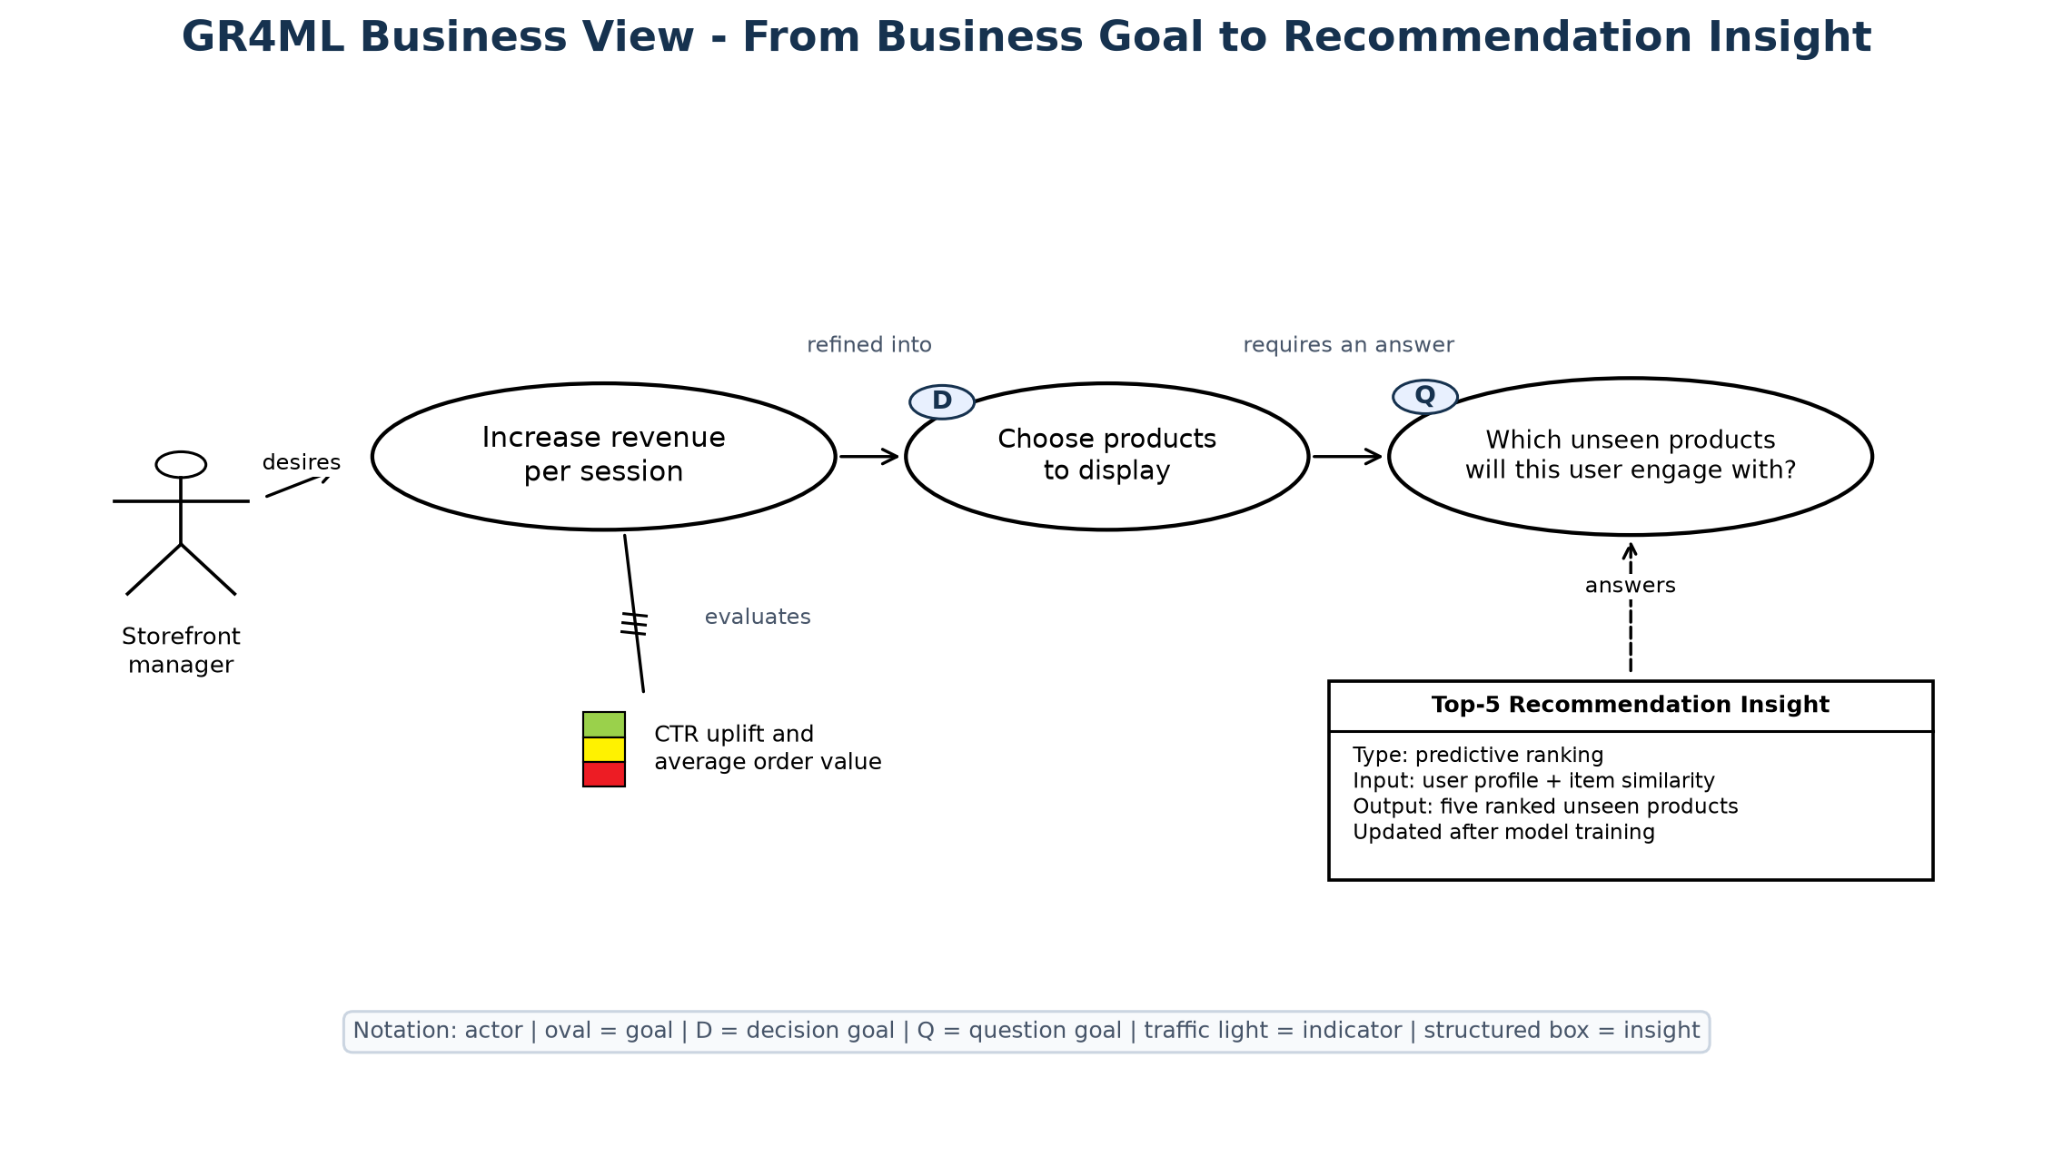
Figure 1. GR4ML Business View using Actor, Business Goal, Decision Goal, Question Goal, Indicator, and Insight notation.
Business interpretation. The Storefront Manager wants to increase revenue per session. That business goal leads to a recurring product decision: which items should occupy the limited recommendation space? The Top-5 Recommendation Insight answers the related question about unseen products. CTR and average order value are the indicators used to judge whether the decision helps the business goal.
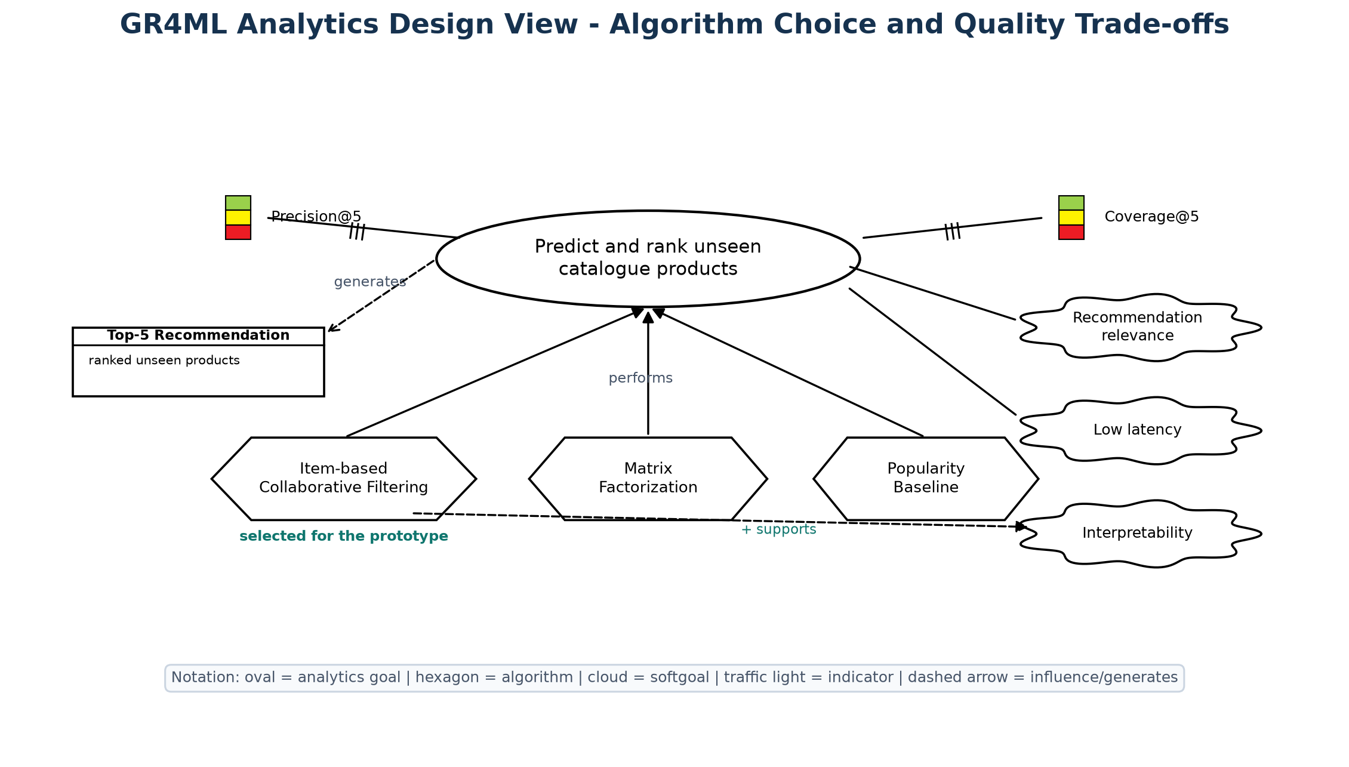
Figure 2. GR4ML Analytics Design View using Analytics Goal, Algorithm, Softgoal, Indicator, Performs, Influence, Evaluates, and Generates notation.
Analytics interpretation. The analytics goal is to estimate preferences for products a user has not seen. We considered item-based collaborative filtering, matrix factorization, and a popularity baseline. Item-based CF fits this prototype because its similarity scores are easy to inspect and inexpensive to serve. Precision@5 checks relevance, while Coverage@5 checks whether recommendations extend beyond a small part of the catalogue.
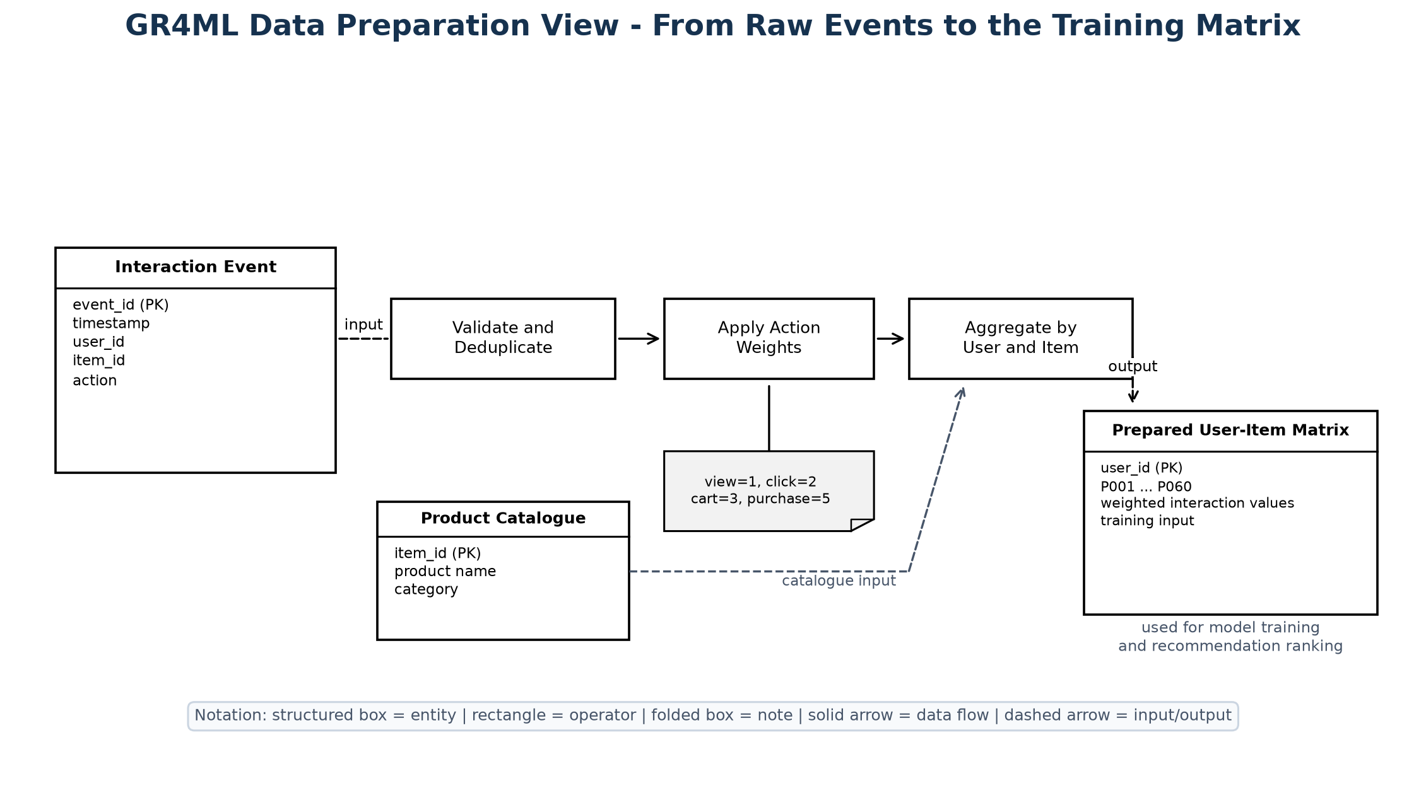
Figure 3. GR4ML Data Preparation View using Entities, Operators, Note, Data Flow, Input/Output, and Relationship notation.
Data interpretation. Interaction Event and Product Catalogue are the two source entities. The pipeline validates events, removes duplicate event IDs, maps actions to weights, and aggregates values for each user-item pair. The result is the matrix used for evaluation, training, and ranking. The folded note records the exact weights so the transformation can be reproduced.
Cross-view traceability: Prepared User-Item Matrix is required for the Prediction and Ranking Analytics Goal; that goal generates the Top-5 Recommendation Insight; the insight answers the Question Goal; the answer supports the product-display Decision Goal; and the decision contributes to the revenue-per-session Business Goal.

Question 4 - Top Three Quality Requirements
Quality requirement | Why it is critical | Design response
Recommendation relevance | Irrelevant products waste scarce storefront space and reduce user trust. | Weighted feedback, unseen-item masking, Precision/Recall/Hit Rate@5 gates.
Low query latency | Recommendations are requested on the page-render path. | Precomputed similarity and a read-only Query Service; p95 target < 200 ms.
Scalability and change isolation | Training is compute-heavy while reads are frequent and latency-sensitive. | Command and Query microservices can deploy and scale independently.

The Analytics Design View shows relevance and latency as softgoals and includes interpretability because it influenced the algorithm choice. Scalability is addressed in the architecture by separating training commands from recommendation reads. Together, the two views keep model quality and software quality in the same design discussion.

Objective 2 - System Architecture

Question 5 - Architecture and Responsibilities
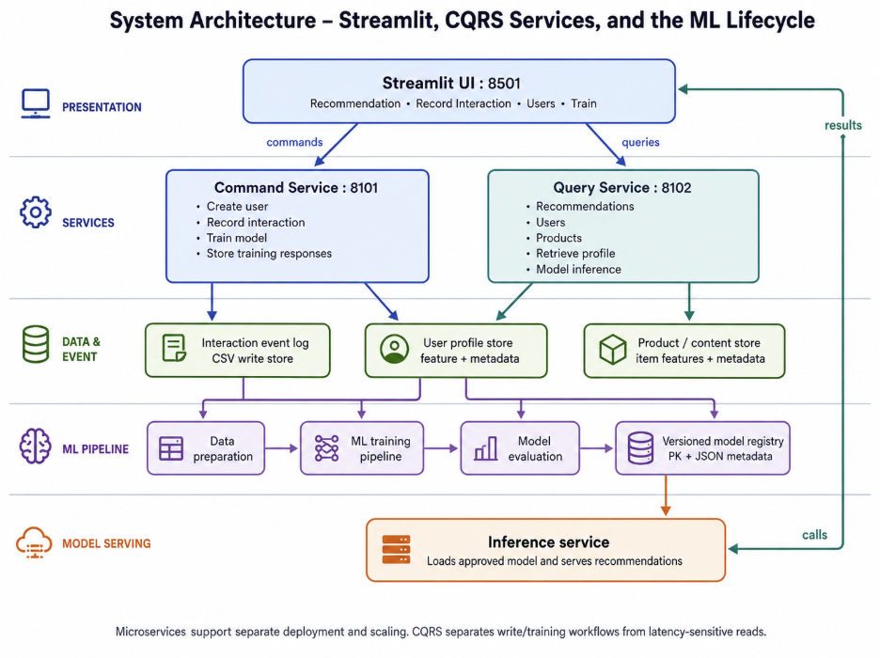
Figure 4. System architecture separating ML, data, command/write, and query/read concerns.
Component | Type | Responsibility
Streamlit UI :8501 | Presentation | Runs user, interaction, training, and recommendation flows.
Command Service :8101 | Non-ML service | Owns writes and invokes training.
Training pipeline | ML component | Loads, prepares, evaluates, fits, and persists.
Raw event log | Data store | Authoritative command-side interaction history.
User profile store | Data store | Named users and primary cold-start interests.
Versioned read model | ML artifact | Similarity matrix, user features, metadata.
Query Service :8102 | ML serving | Serves collaborative or interest-based recommendations and recent actions.

Read path. A recommendation request goes from Streamlit to the Query Service. The service reads the user profile and current model artifact, masks products already seen by the user, and returns ranked catalogue records. This path does not modify the event log or trigger training.
Write and training path. User creation, interaction recording, and retraining go through the Command Service. Interactions are appended to the event log; training reads that log, builds a fresh model, and publishes a new artifact version. The Query Service detects the new version and reloads it for later requests.

Question 6 - Two Selected Architectural Patterns

Pattern 1 - Microservices
Application. Command and Query responsibilities are separate FastAPI applications on ports 8101 and 8102. Each has its own entry point, API contract, health endpoint, tests, and Docker Compose process. This keeps model training away from the request path used to fetch recommendations and allows the two workloads to be scaled separately.
Trade-off. Distributed deployment increases operational complexity. The local setup uses a shared artifact directory for reproducibility; a production design would publish to a model registry or object store and add authentication, tracing, retries, and rollback.

Pattern 2 - CQRS
Application. POST /commands/interactions, POST /commands/users, and POST /commands/train mutate the write side. Product, user, recent-action, model-info, and recommendation endpoints remain read-only. The query process atomically reloads a new model version; a profile with no trained history receives an interest-based cold-start ranking.
Trade-off. CQRS introduces eventual consistency: an accepted interaction affects queries only after training and publication. For recommendations this is acceptable when freshness is monitored and the previous valid model remains available during retraining.

Question 7 - Implementation, Code, and Output

7.1 ML Training and Evaluation
The pipeline reports five stages: LOAD, PREPARE, EVALUATE, TRAIN, and PERSIST. The seed creates 80 users, 60 items, and 960 interaction events. The model artifact used for this report records 994 events and stores arrays in NPZ with metadata in JSON; it does not rely on an executable pickle file.
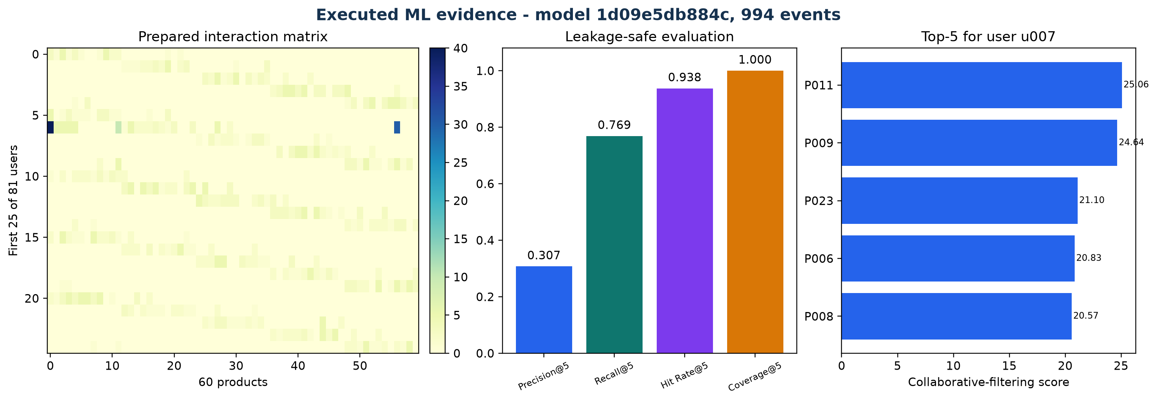
Figure 5. Prepared interaction matrix, offline metrics, and the top-5 scores from the saved model.
Offline evaluation result: Precision@5=0.307, Recall@5=0.769, Hit Rate@5=0.938, and Coverage@5=1.000 across 80 users.
How to read the measures. Precision@5 is the fraction of five returned products that were held out as relevant. Recall@5 measures how many held-out products were recovered. Hit Rate@5 asks whether at least one held-out product appeared for a user. Coverage@5 reports the fraction of catalogue items that appeared in any top-5 list. These values check the offline pipeline on synthetic data; they are not a substitute for an online business experiment.

7.2 Pattern Implementation and API Evidence
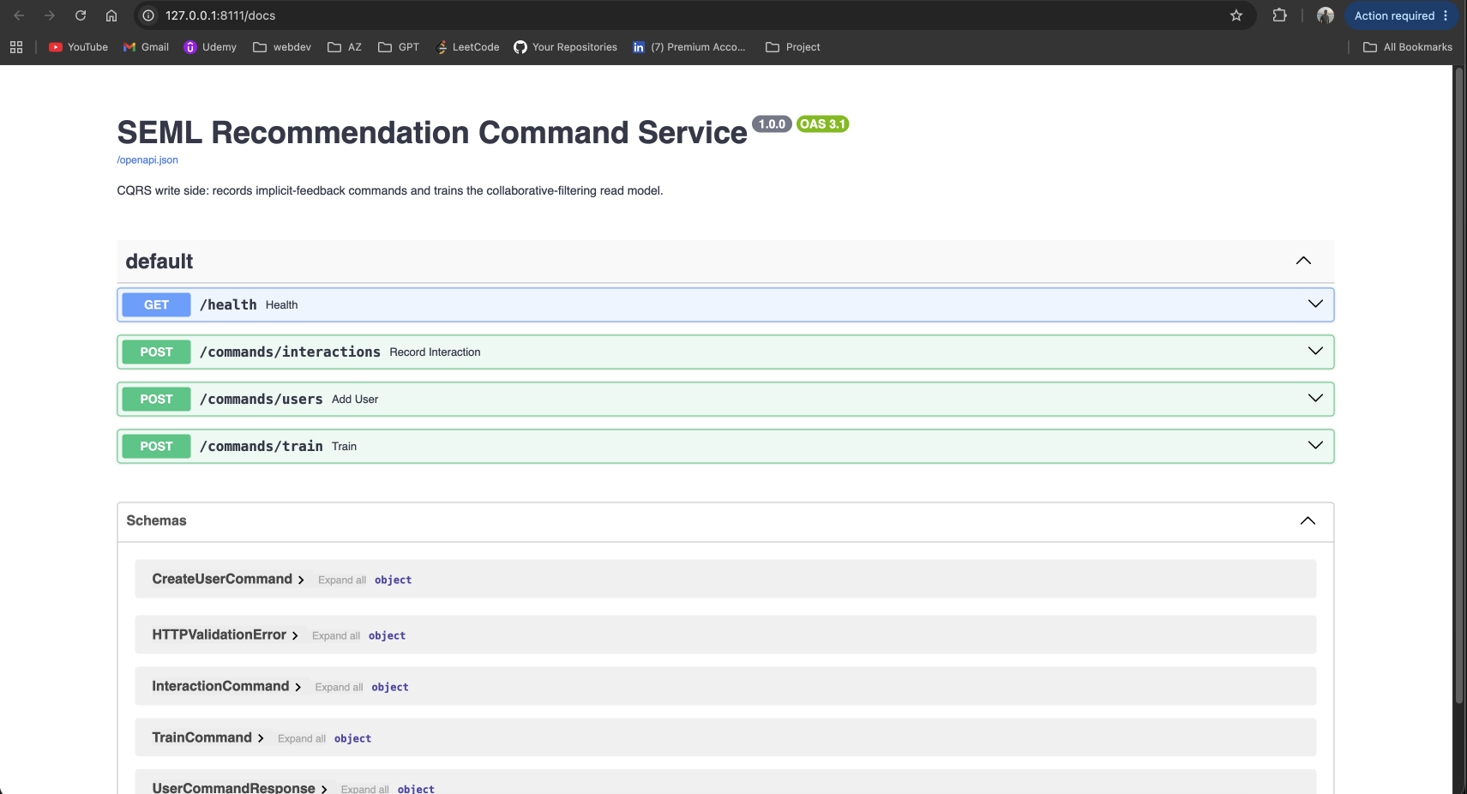
Figure 6. Command Service contract shown in Swagger UI.
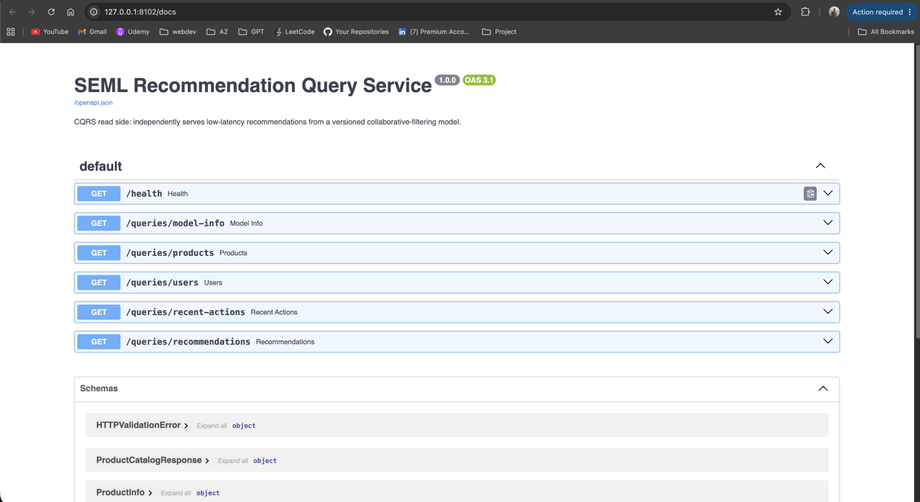
Figure 7. Query Service contract shown in Swagger UI.
API interpretation. The Swagger pages make the CQRS split visible in the running application. The Command Service owns profile, interaction, and training changes. The Query Service exposes model metadata, products, named users, recent actions, and recommendations, but no command routes.
Browser capture context: The screenshots record an isolated demonstration run. The Command Service was bound to port 8111 for that run so its clean interaction file could remain separate from another local process; the Makefile and architecture retain 8101 as the normal command port. Model version identifiers change whenever training publishes a new artifact.

7.3 UI Flows Captured in the Browser
Flow 1 - Personalized recommendation and recent activity. The user selects a named customer and top-k value, then submits a read-only query. The UI displays realistic product names, categories, scores, model strategy, and the three most recent actions beneath the ranking.
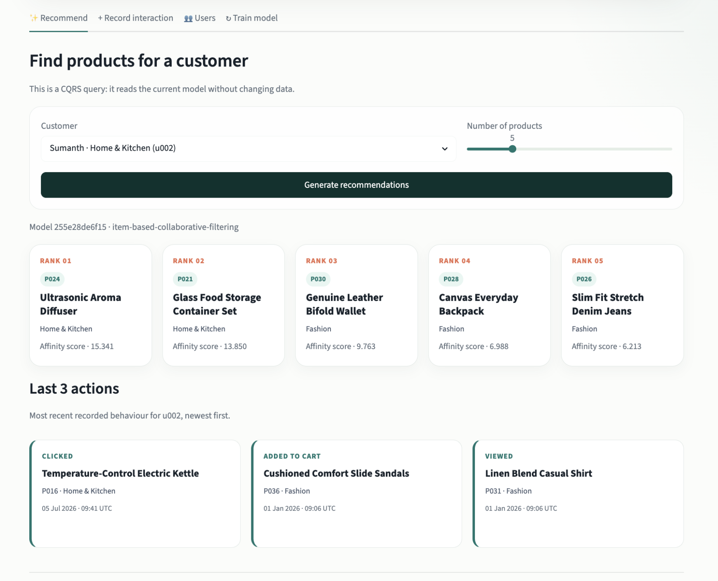
Figure 8. Collaborative recommendations with the three latest actions.
Flow 2 - Record interaction. A named customer, product, and action type are selected. Submitting the form sends POST /commands/interactions and appends a validated implicit-feedback event; the UI explains that retraining is required before it changes collaborative rankings.
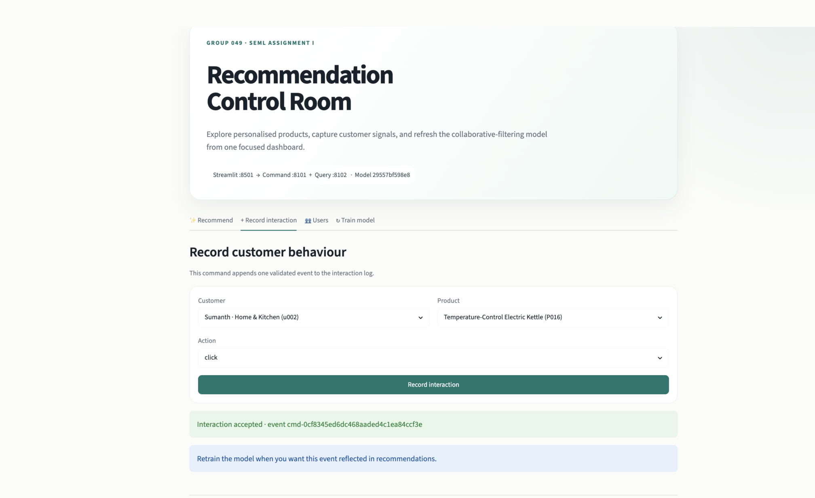
Figure 9. Interaction form after recording an implicit-feedback event.
Flow 3 - User management. The Users tab lists the five default named profiles and their interests. The add-user form validates a name and primary-interest dropdown before POST /commands/users persists a new profile.
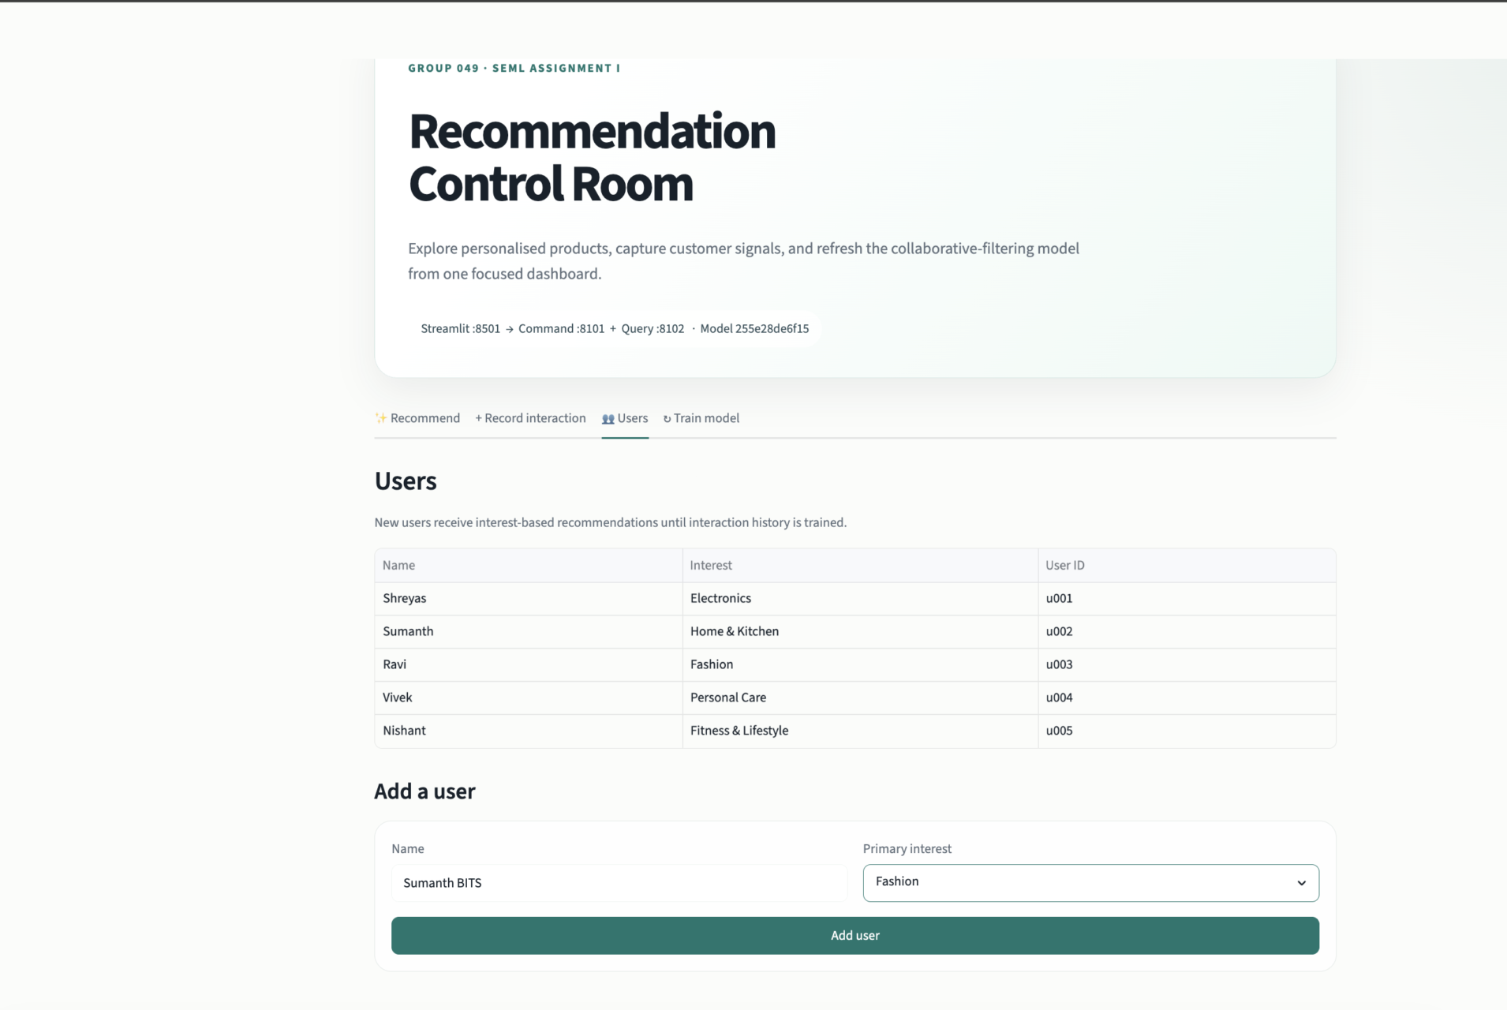
Figure 10. Five default user profiles and the add-user form.
Flow 4 - Interest-based cold start. A newly created user has no interaction history in the trained matrix. The Query Service therefore returns products from that profile's selected interest and labels the strategy interest-based-cold-start. After the user records actions and the model is retrained, the same request can move to collaborative recommendations; the saved interest remains available as a fallback.
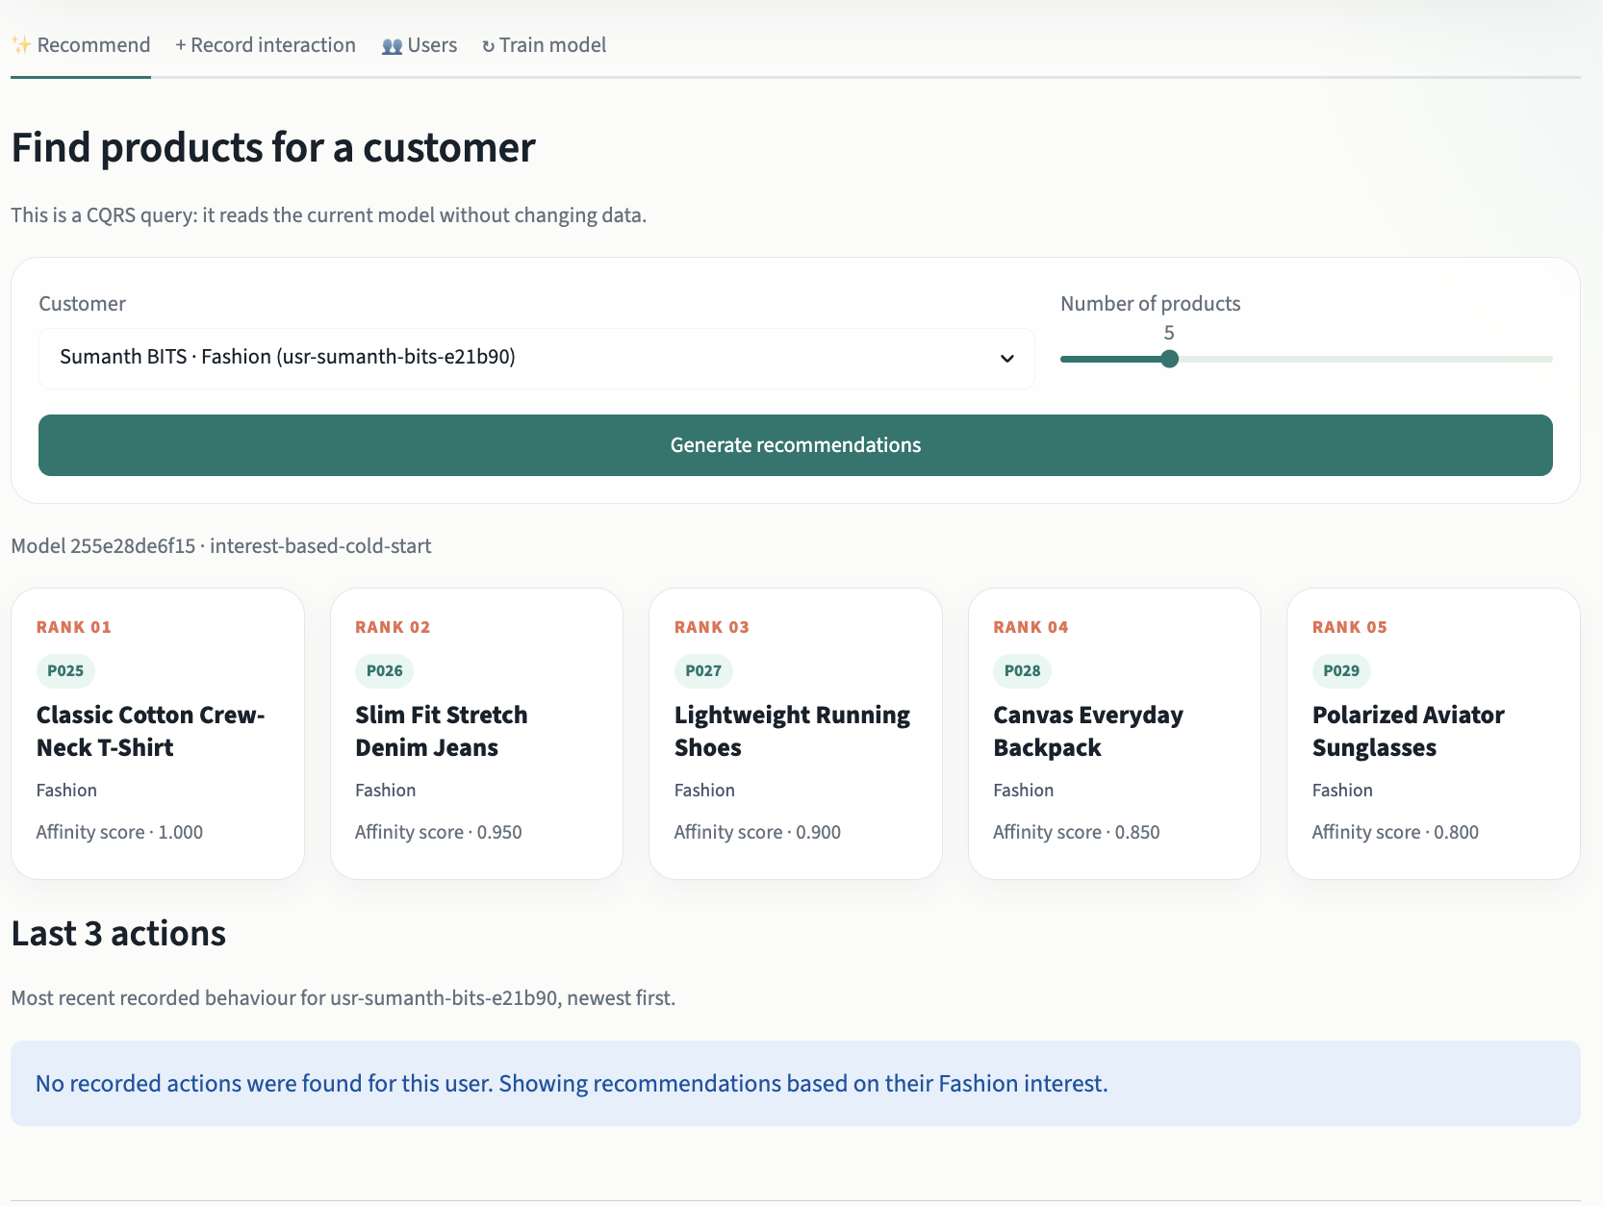
Figure 11. Interest-based recommendations for a newly created user.
Flow 5 - Model training. The operator selects evaluation K and holdout events, then submits POST /commands/train. The five-stage pipeline loads, prepares, evaluates, trains, and persists the read model; the Query Service reloads it without exposing a write route.
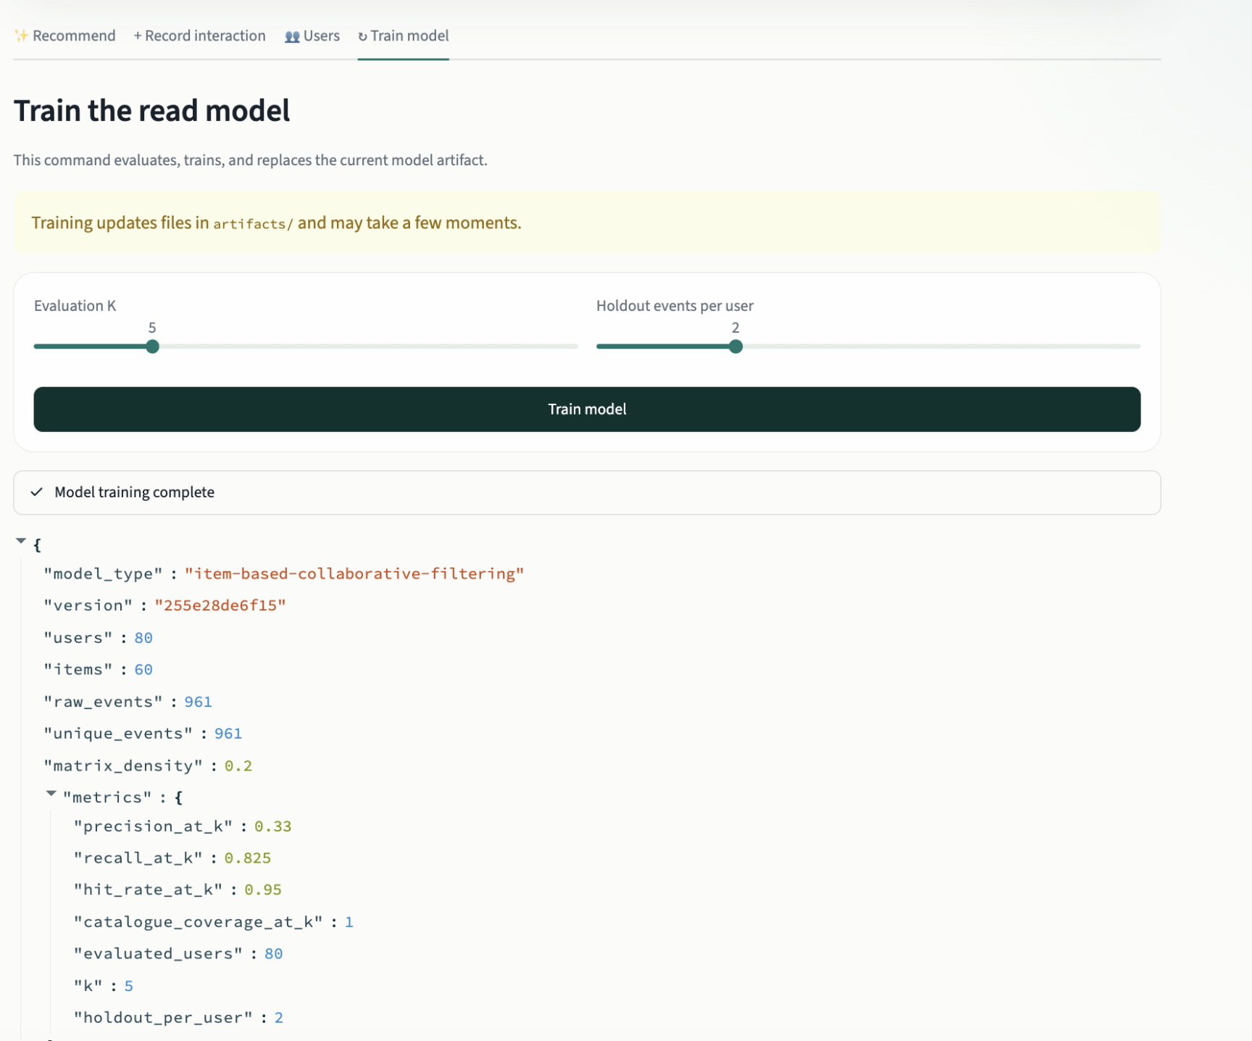
Figure 12. Training controls and the completed pipeline summary.
Training result shown in Figure 12. The clean browser dataset started with 960 events. The interaction flow added one click before training, so the captured summary reports 961 raw and unique events, 80 users, 60 products, Precision@5 of 0.330, Recall@5 of 0.825, Hit Rate@5 of 0.950, and full catalogue coverage. Later local runs may have a different event count and version while following the same pipeline.

7.4 Verification and Reproducibility
Check | Result
Ruff lint | Passed
Ruff formatting | Passed
Mypy static typing | 20 source files passed
Pytest | 8 tests passed
Coverage | 88% total
Browser flows | Five UI flows and two Swagger pages captured
Notebook | All code cells executed; outputs and browser evidence saved

Reproduction commands
uv venv --python 3.12 .venv
source .venv/bin/activate
uv pip install -r requirements.txt -e ".[dev,report]"
python scripts/seed_data.py
python scripts/train_and_evaluate.py
# Run in separate terminals
uvicorn ecom_ml.command_service.main:app --port 8101
uvicorn ecom_ml.query_service.main:app --port 8102
streamlit run frontend/app.py --server.port 8501
# Quality gates
make check
python scripts/verify_live.py

7.5 Limitations and Future Improvements
This prototype uses deterministic synthetic interactions, a CSV command store, and a shared local artifact directory. It does not include online experiment data, authentication, privacy controls, or drift alerts. Cold start uses one declared interest, which is useful for showing the flow but much simpler than a production hybrid recommender.
As future work, we would use an event broker and durable warehouse, a feature store, a model registry with approval and rollback, content/popularity fallbacks, distributed tracing, load tests, drift and bias monitoring, and an A/B experiment measuring CTR and revenue per session.

Appendix A - Key Code Excerpts
The notebook runs the ML path and embeds the relevant service modules. The main excerpts are repeated below so the implementation can be reviewed alongside the design discussion.
A.1 Data validation, deduplication, weighting, and matrix construction
def prepare_interactions(rows: list[Interaction]) -> PreparedInteractions:
"""Deduplicate, validate, weight, and aggregate raw events into a matrix."""
unique: dict[str, Interaction] = {}
for row in rows:
validate_interaction(row)
unique.setdefault(row.event_id, row)
users = tuple(sorted({row.user_id for row in unique.values()}))
items = tuple(sorted({row.item_id for row in unique.values()}))
if not users or not items:
raise ValueError("at least one user and item are required")
user_index = {user_id: index for index, user_id in enumerate(users)}
item_index = {item_id: index for index, item_id in enumerate(items)}
matrix = np.zeros((len(users), len(items)), dtype=np.float64)
for row in unique.values():
matrix[user_index[row.user_id], item_index[row.item_id]] += ACTION_WEIGHTS[row.action]
return PreparedInteractions(
users=users,
items=items,
matrix=matrix,
raw_event_count=len(rows),
unique_event_count=len(unique),
)
A.2 Model training
@classmethod
def fit(cls, prepared: PreparedInteractions) -> CollaborativeFilteringModel:
"""Fit item-item cosine similarity from a prepared interaction matrix."""
matrix = prepared.matrix.astype(np.float64, copy=True)
similarity = cosine_similarity(matrix.T).astype(np.float64, copy=False)
np.fill_diagonal(similarity, 0.0)
version_input = (
matrix.tobytes() + "|".join(prepared.users).encode() + "|".join(prepared.items).encode()
)
version = hashlib.sha256(version_input).hexdigest()[:12]
return cls(
users=prepared.users,
items=prepared.items,
interaction_matrix=matrix,
item_similarity=similarity,
version=version,
)
A.3 Recommendation inference
def recommend(self, user_id: str, k: int = 5) -> list[Recommendation]:
"""Score and rank unseen items for a known user."""
if k < 1 or k > 20:
raise ValueError("k must be between 1 and 20")
try:
user_index = self.users.index(user_id)
except ValueError as exc:
raise KeyError(f"unknown user_id: {user_id}") from exc
user_vector = self.interaction_matrix[user_index]
scores = (user_vector @ self.item_similarity).astype(np.float64, copy=True)
seen = user_vector > 0
scores[seen] = -np.inf
ordered = np.argsort(np.nan_to_num(scores, neginf=_NEGATIVE_FILL))[::-1]
recommendations: list[Recommendation] = []
for item_index in ordered:
if len(recommendations) == k:
break
if seen[item_index]:
continue
score = scores[item_index]
recommendations.append(
Recommendation(
item_id=self.items[int(item_index)],
score=round(float(score if np.isfinite(score) else 0.0), 4),
)
)
return recommendations
A.4 Leakage-safe evaluation
def evaluate_leave_n_out(
prepared: PreparedInteractions,
*,
k: int = 5,
holdout_per_user: int = 2,
seed: int = 1546,
) -> EvaluationMetrics:
"""Hide interactions, fit on the remainder, and evaluate top-k recovery."""
if k < 1:
raise ValueError("k must be positive")
if holdout_per_user < 1:
raise ValueError("holdout_per_user must be positive")
rng = np.random.default_rng(seed)
train_matrix = prepared.matrix.copy()
held_out: dict[int, set[int]] = {}
for user_index in range(train_matrix.shape[0]):
positives = np.flatnonzero(train_matrix[user_index] > 0)
if len(positives) <= holdout_per_user:
continue
selected = rng.choice(positives, size=holdout_per_user, replace=False)
train_matrix[user_index, selected] = 0.0
held_out[user_index] = {int(index) for index in selected}
train_data = PreparedInteractions(
users=prepared.users,
items=prepared.items,
matrix=train_matrix,
raw_event_count=prepared.raw_event_count,
unique_event_count=prepared.unique_event_count,
)
model = CollaborativeFilteringModel.fit(train_data)
precisions: list[float] = []
recalls: list[float] = []
hit_users = 0
recommended_items: set[str] = set()
for user_index, relevant in held_out.items():
recommendations = model.recommend(prepared.users[user_index], k=k)
predicted_ids = {recommendation.item_id for recommendation in recommendations}
predicted_indices = {prepared.items.index(item_id) for item_id in predicted_ids}
hits = len(predicted_indices & relevant)
precisions.append(hits / k)
recalls.append(hits / len(relevant))
hit_users += int(hits > 0)
recommended_items.update(predicted_ids)
user_count = len(precisions)
return EvaluationMetrics(
precision_at_k=round(float(np.mean(precisions)) if precisions else 0.0, 4),
recall_at_k=round(float(np.mean(recalls)) if recalls else 0.0, 4),
hit_rate_at_k=round(hit_users / user_count if user_count else 0.0, 4),
catalogue_coverage_at_k=round(
len(recommended_items) / len(prepared.items) if prepared.items else 0.0,
4,
),
evaluated_users=user_count,
k=k,
holdout_per_user=holdout_per_user,
)
A.5 End-to-end ML pipeline
def train_pipeline(
data_path: Path,
artifact_dir: Path,
*,
k: int = 5,
holdout_per_user: int = 2,
) -> TrainingSummary:
"""Execute and log every stage of the ML lifecycle."""
print(f"[1/5] LOAD {data_path}", flush=True)
rows = load_interactions(data_path)
print("[2/5] PREPARE validate, deduplicate, weight, aggregate", flush=True)
prepared = prepare_interactions(rows)
print(f"[3/5] EVALUATE leave-{holdout_per_user}-out Precision@{k}", flush=True)
evaluation = evaluate_leave_n_out(
prepared,
k=k,
holdout_per_user=holdout_per_user,
)
print("[4/5] TRAIN fit item-item cosine similarity on all events", flush=True)
model = CollaborativeFilteringModel.fit(prepared)
print(f"[5/5] PERSIST {artifact_dir}", flush=True)
saved = save_artifact(
model,
artifact_dir,
metrics=evaluation.as_dict(),
training_event_count=prepared.unique_event_count,
)
density = float((prepared.matrix > 0).sum() / prepared.matrix.size)
summary = TrainingSummary(
model_type="item-based-collaborative-filtering",
version=model.version,
users=len(prepared.users),
items=len(prepared.items),
raw_events=prepared.raw_event_count,
unique_events=prepared.unique_event_count,
matrix_density=round(density, 4),
metrics=evaluation.as_dict(),
model_path=str(saved.model_path),
)
print(
f"DONE version={summary.version} "
f"precision@{k}={evaluation.precision_at_k:.4f} "
f"coverage@{k}={evaluation.catalogue_coverage_at_k:.4f}",
flush=True,
)
return summary

References
R1. Nalchigar, S. and Yu, E. (2020). Designing Business Analytics Solutions: A Model-Driven Approach. Business & Information Systems Engineering, 62, 61-75. https://doi.org/10.1007/s12599-018-0555-z
R2. Sarwar, B., Karypis, G., Konstan, J., and Riedl, J. (2001). Item-based collaborative filtering recommendation algorithms. WWW '01, 285-295. https://doi.org/10.1145/371920.372071
R3. Microsoft Azure Architecture Center. CQRS pattern. https://learn.microsoft.com/en-us/azure/architecture/patterns/cqrs
R4. Microsoft Azure Architecture Center. Architecture styles - Microservices. https://learn.microsoft.com/en-us/azure/architecture/guide/architecture-styles/
R5. scikit-learn documentation. sklearn.metrics.pairwise.cosine_similarity. https://scikit-learn.org/stable/modules/generated/sklearn.metrics.pairwise.cosine_similarity.html
R6. FastAPI documentation. Automatic interactive API documentation. https://fastapi.tiangolo.com/features/#automatic-docs

