1. What are escape characters, and how do you use them?

**Answer** :An escape sequence charcxter always follows a back slash i.e., \ There are escape sequences like \n which means new line ,\t mwhich means tab

Ex:print('\n krishna') -->leaves a line then prints it

And also escape sequences can be used when we want to use a illegal character Illegal charcter means inserting a double quotes inside a string surroundeed by double quote marks

Ex: "This is krishna's book'" -🡪This will work well without any issues if we use an escape sequences

2. What do the escape characters n and t stand for?

**Answer**: \n which means new line , \t means tab space

3. What is the way to include backslash characters in a string?

**Answer** : "This is krishna\'s book'"

4. The string "Howl's Moving Castle" is a correct value. Why isn't the single quote character in the word Howl's not escaped a problem?

**Answer** : Because it’s an illegal character .In order to solve this problem we are using the escape sequence characters

5. How do you write a string of newlines if you don't want to use the n character?

**Answer**: This can happen by writing multiples lines in a triple quotes

print('''Lets learn one

new thing everyday ''')

6. What are the values of the given expressions?

'Hello, world!'[1] 🡪**Answer** is e

'Hello, world!'[0:5]🡪**Answer** is Hello

'Hello, world!'[:5]🡪**Answer** is Hello

'Hello, world!'[3:] 🡪 **Answer** is lo, world!

7. What are the values of the following expressions?

'Hello'.upper() 🡪**Answer** is HELLO

'Hello'.upper().isupper() --->**Answer** is True

'Hello'.upper().lower()-🡪**Answer** is False

8. What are the values of the following expressions?

'Remember, remember, the fifth of July.'.split()

'-'.join('There can only one.'.split())

**Answer 1**: split happens w.r.t to the space between the words . And it returns the list with all the words along with commas in the sentence as shown below

['Remember,', 'remember,', 'the', 'fifth', 'of', 'July.']

**Answer 2**:

Each string inside join will be concatenated

'ThereRemember, remember, the fifth of July.canRemember, remember, the fifth of July.onlyRemember, remember, the fifth of July.one.'

9. What are the methods for right-justifying, left-justifying, and centering a string?

**Answer** :

We have three methods such as ljust,rjust,center methods .inorder to observe the output of these methods pass the same width to all the three as show below

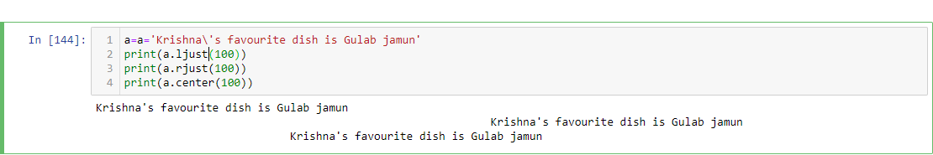

10. What is the best way to remove whitespace characters from the start or end?

**Answer** :We can remove whitespaces by using the strip methods lstrip and rstrip are the two ones

By default they will remove whitespaces .If needed we can pass the characters also

