**Module 1 Activity 1: Installation of Tools**

Naga Sumanth Vema

IFT 554: Middleware Programming & Database Security

Dinesh Sthapit

January 21st, 2024

**Module 1 Activity 1: Installation of Tools**

Task 1 - Visual Studio Code Installation Proof

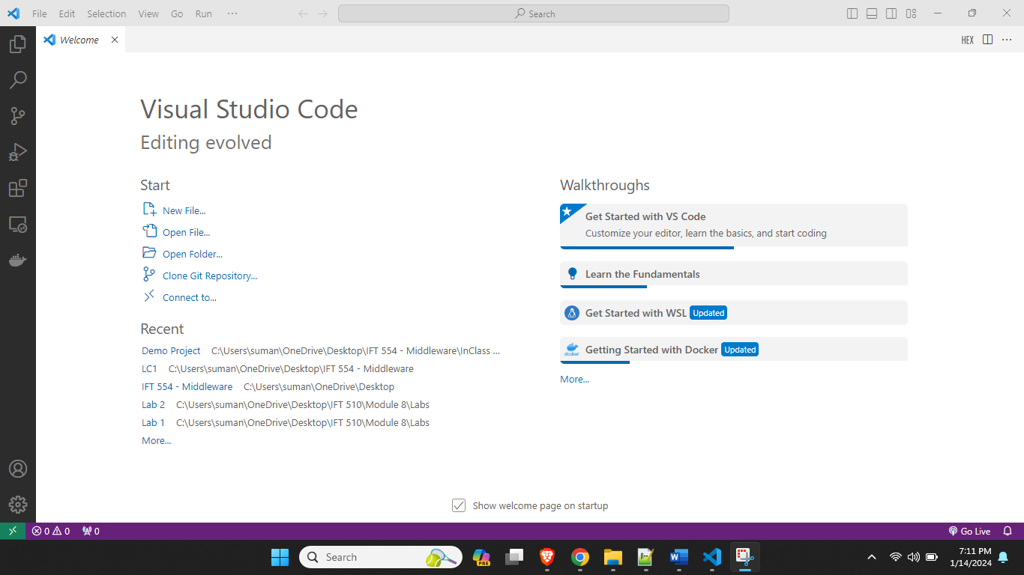

Task 2 - Node.js Installation Proof

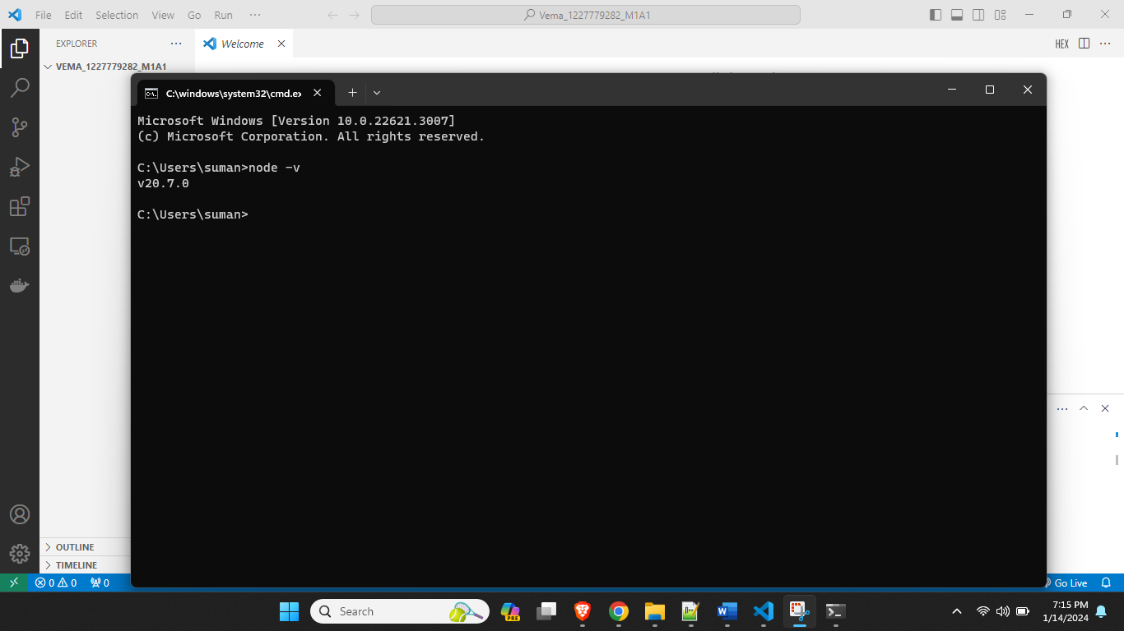

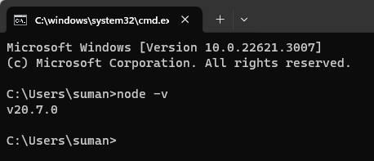

NPM Version –

