**Module 1 Activity 2: Project Setup**

Naga Sumanth Vema

IFT 554: Middleware Programming & Database Security

Dinesh Sthapit

January 21st, 2024

**Module 1 Activity 2: Project Setup**

Screenshot 1 - Visual Studio Code application running on the desktop.

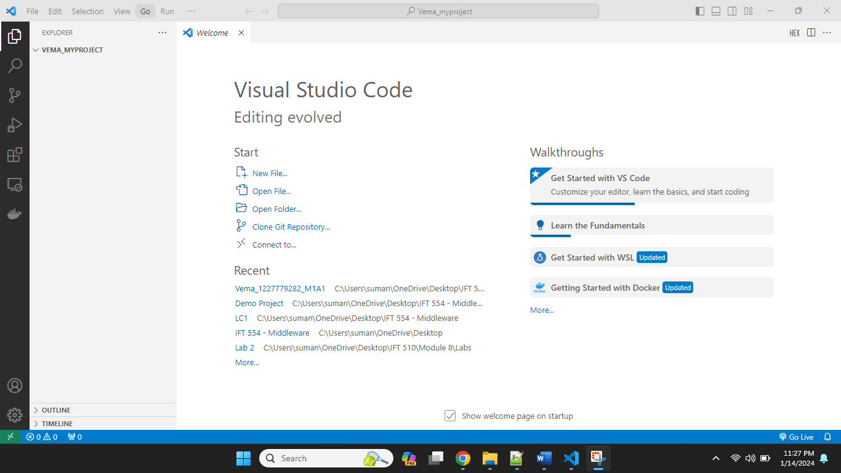

Screenshot 2: Terminal window opened in Visual Studio Code.

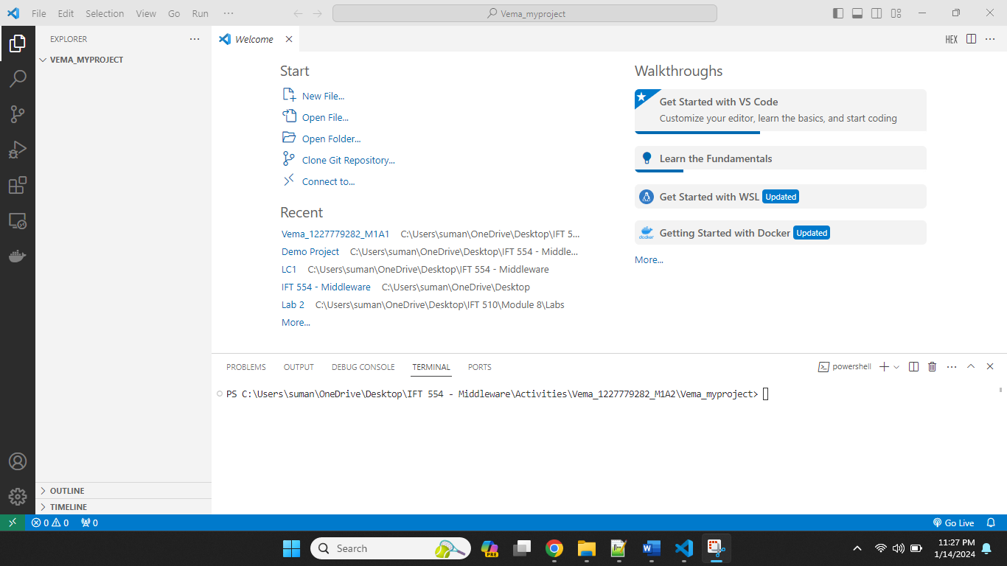

Screenshot 3: Execution of the command node -v displaying the Node.js version.

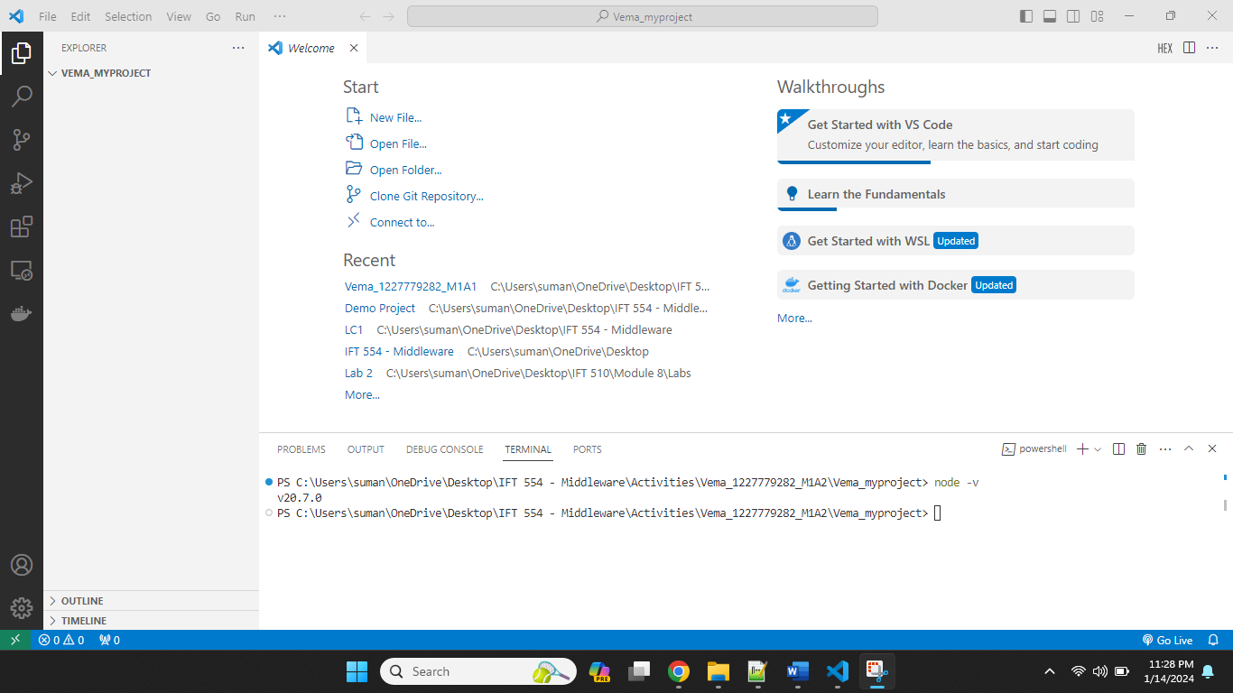

Screenshot 4: Execution of the command npm -v displaying the npm version.

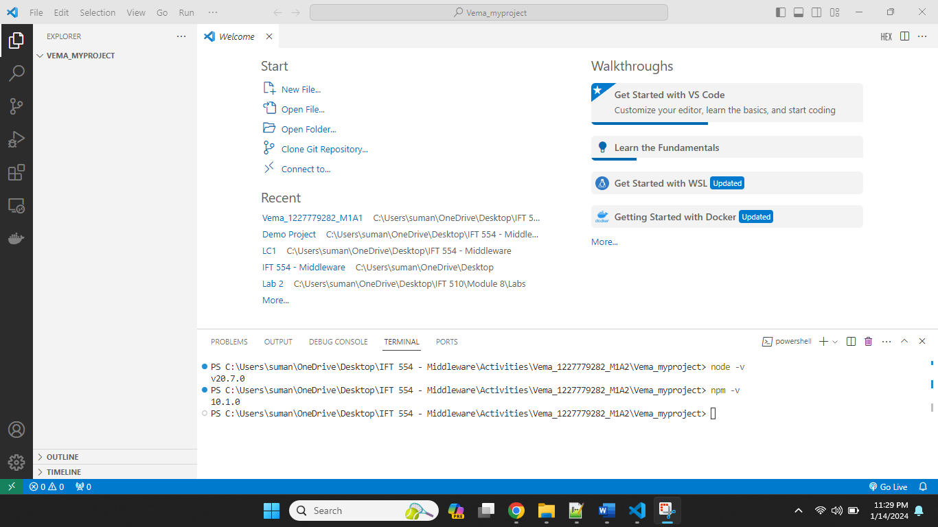

Screenshot 5: Visual Studio Code interface displaying the creation of a new folder named "Lastname_myproject" using the File > Open Folder option.

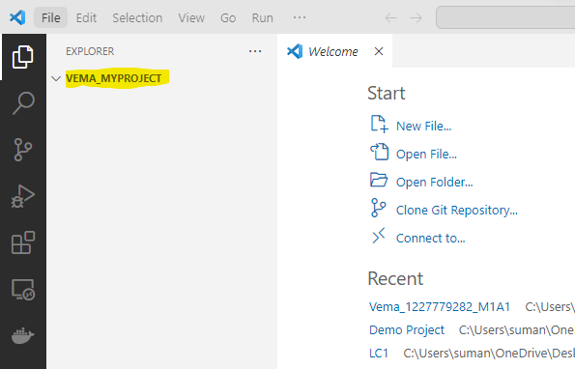

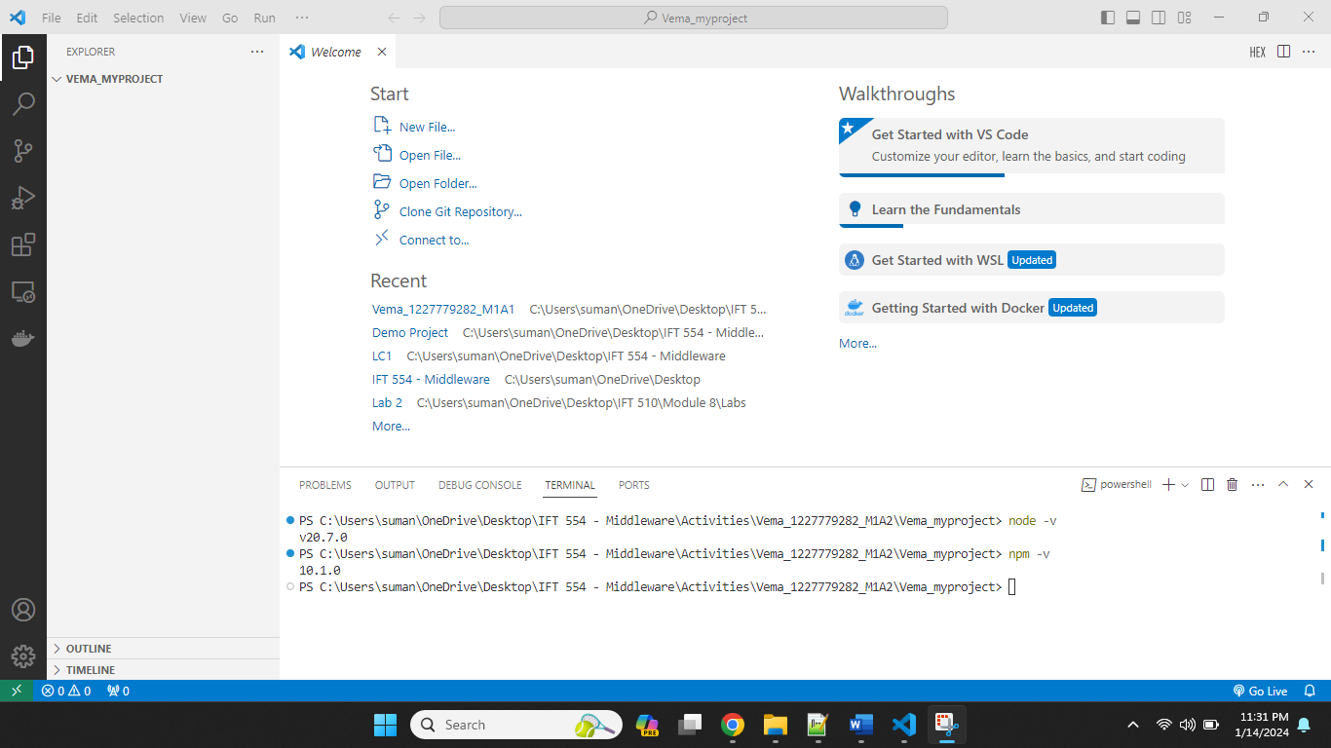

Screenshot 6: Terminal window in Visual Studio Code showing the execution of the command npm init -y to initialize a Node.js project and generate the package.json file.

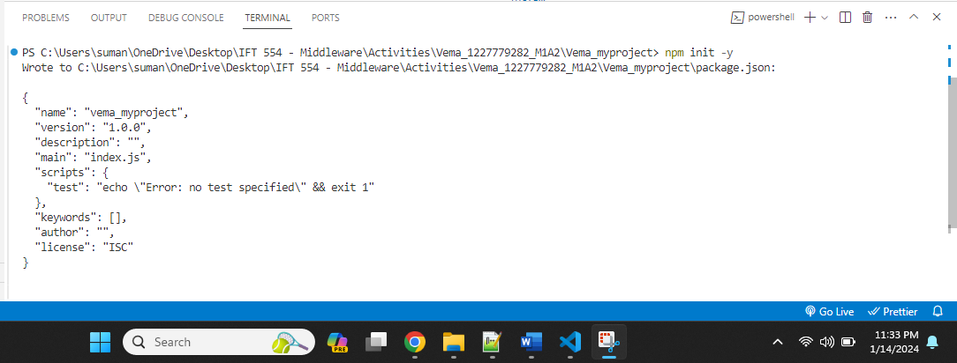

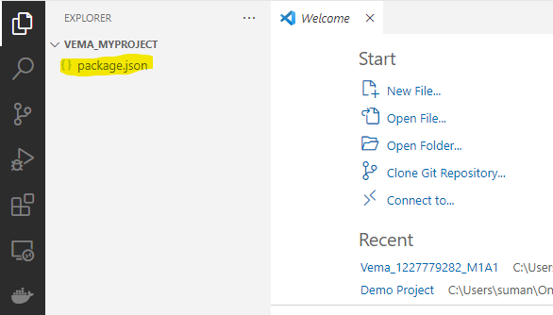

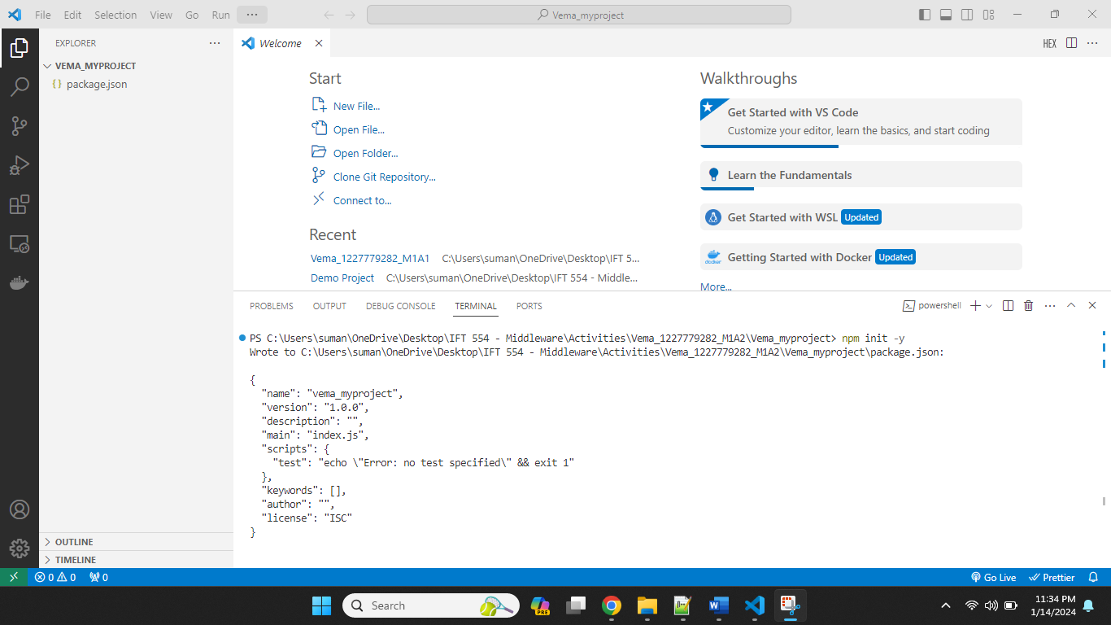

Screenshot 7: Visual Studio Code explorer displaying the creation of a new file named "index.js" within the project folder.

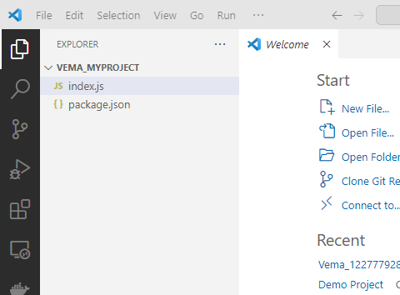

Screenshot 8: Editor view in Visual Studio Code showing the opened "index.js" file.

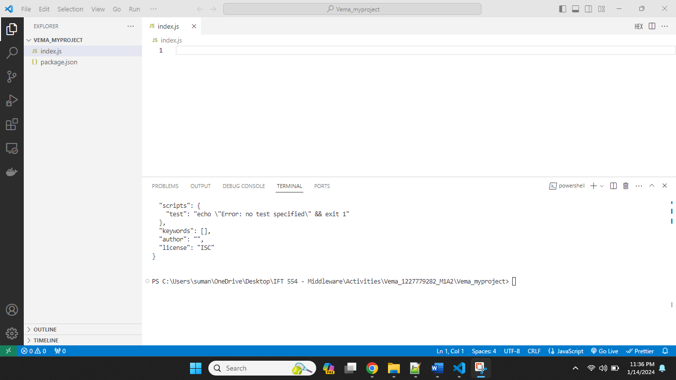

Screenshot 9: Terminal window demonstrating the installation of Express.js using the command npm install express.

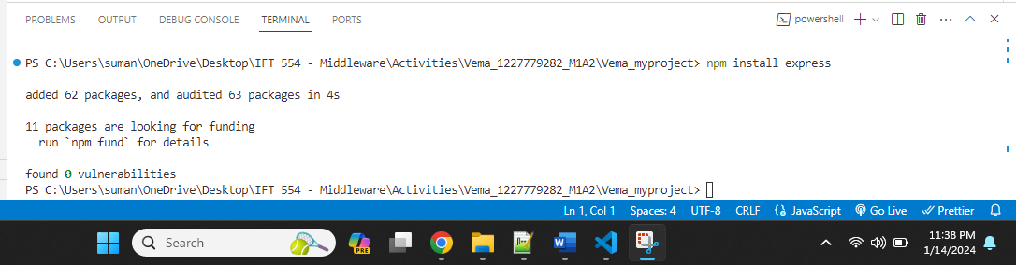

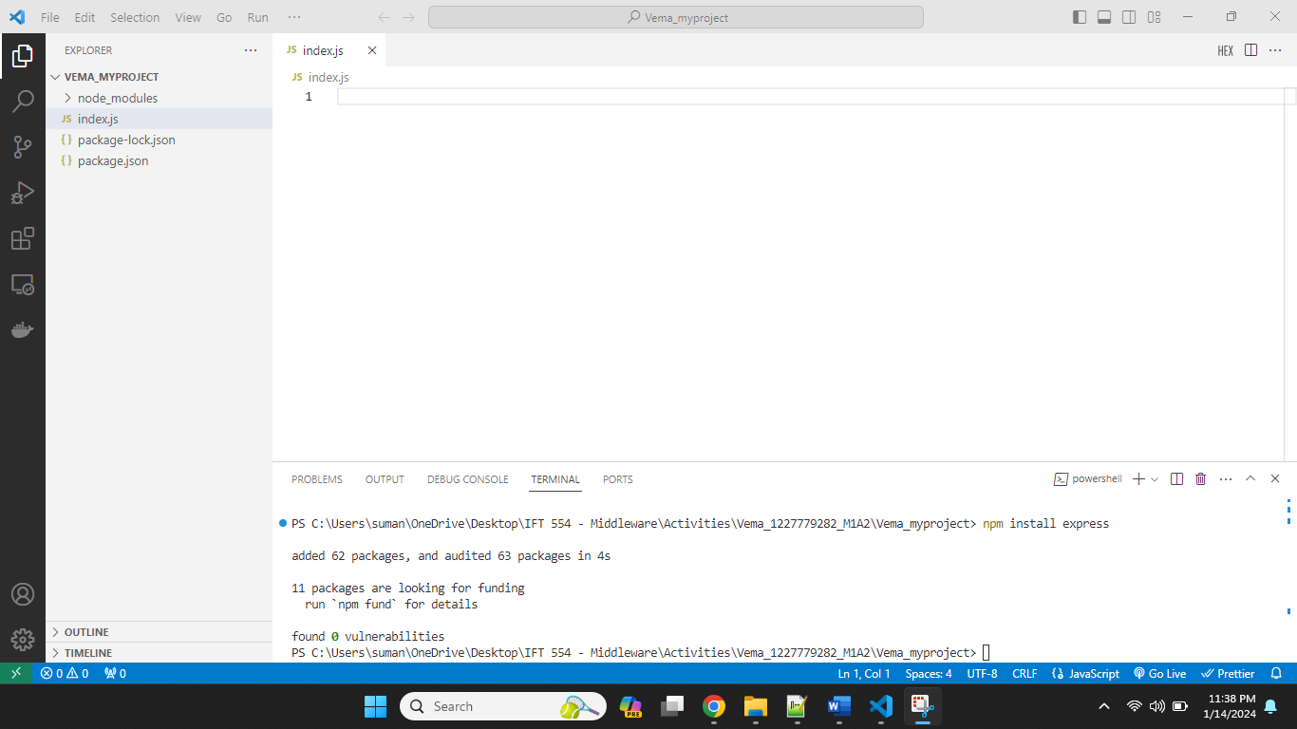

Screenshot 10: Code snippet in the "index.js" file displaying the command console.log('Welcome to IFT 458').

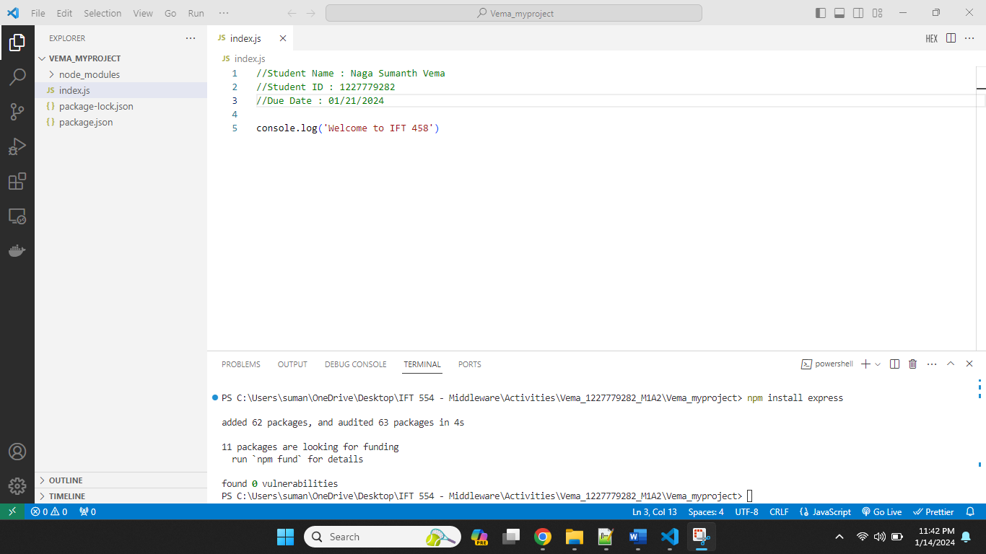

Screenshot 11: Visual Studio Code interface showcasing the auto-save feature being enabled from the File menu.

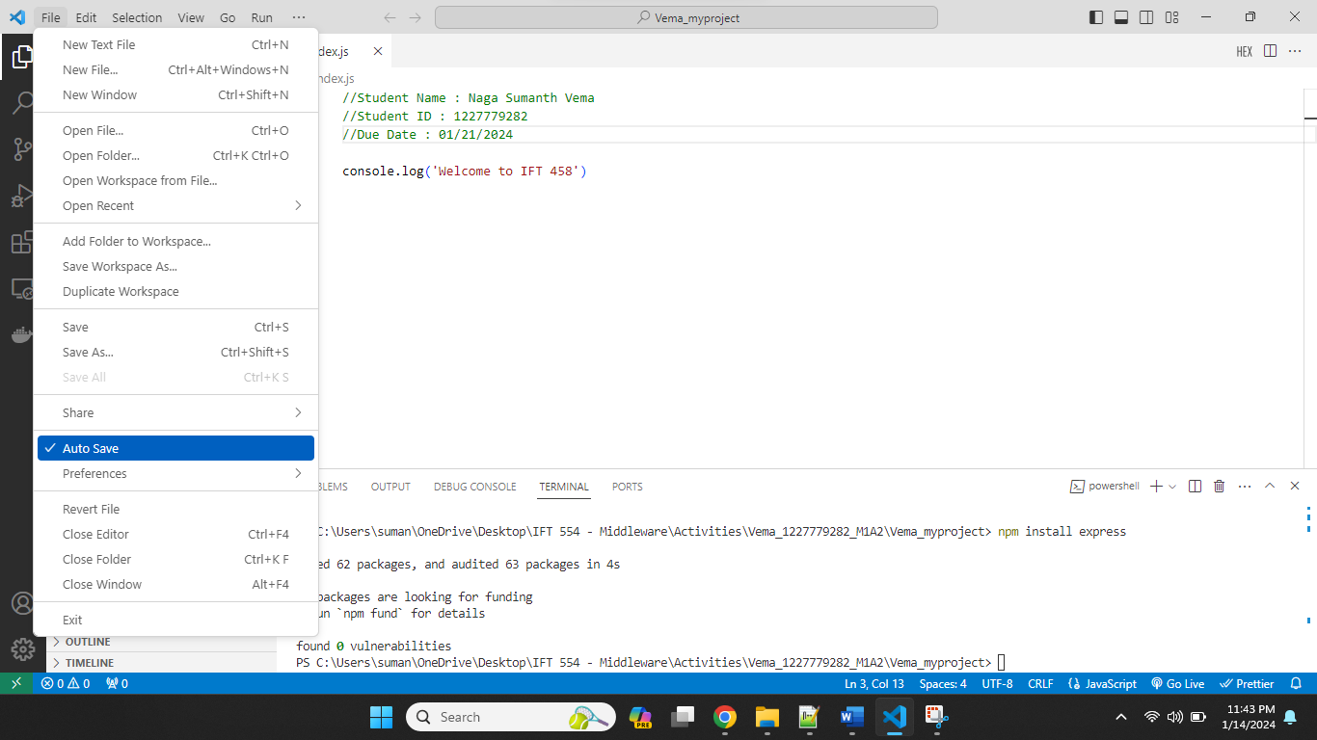

Screenshot 12: Terminal window executing the command node index.js to run the Node.js application.

