OUTLINE OF PROJECT

Introduction
Objective
Purpose
Module
Screen Short
Conclusion

INTRODUCTION
Submitted By:
Sumant Vyas
Tarun Tailor
Geetesh Kashyap
Nitin Bagdi

Hello We Are From Techno India NJR Institute Of Technology, Udaipur.
We are doing summers internship from Sanjay rathore Sir who works for Grass Institute, Jaipur. We have Chosen fullstack Development Course.
We have learned so many technology from Sanjay Sir mentioned below:

HTML
CSS
JavaScript
Node JS
TypeScript
Angular
Mongo DataBase
MongoDb Atals
Git
GitHub
We have also used above all technologies in our Project.

Our Project is freelancing Website In this developer can register themselves and create their profile and clients can visit our website and find developers and see developers profile ad their skills and many more and if client interested can contact via Email.

In our Website Web developers often work for clients who are trying to get their product or service onto the web. The work is typically very project focused and involves collaborating with a team that helps to coordinate the client’s needs into the end product. The client could be a tech company, an organization, or a government. The work could involve front-end, back-end, or full-stack web development.

Web development could be a good profession for you if you like solving logical problems, building useful things, and experimenting with new technologies. Web developers are in high demand, generally have a good work/life balance, and command comfortable salaries. Google your specific location to get a better sense of your local web development job opportunities.

OBJECTIVE

This Project is going to be developed with main objects behind this.

* The main objective of Freelancing is that to provide the all developers to
Clients.
* In this website Developer can register themselves and create their
profile so Clients easily find any developers by searching their category
on Search Bar.

Other Objective
* Database Security.
*Effective database management.
* Transaction managements.
* Maintain addition or deletion in any category.

Web base system
* Easy and fast response.
* Flexible to access.
* Provides details efficiently.

System should be user friendly

* User friendly interface.
* Availability of multiple categorized Developers at one place at same time.
* Any time any news related to different fields will be available.

PURPOSE

* This website is open to public and user or developer can come here and
use.
* Developers can easily create their profile here.
* Clients can easily search any developer.
* Any time any developer related to different category will be available.

SOFTWARE REQUIREMENT

AT Developer End

* Front-end : JavaScript, HTML5, CSS.
* Back-end : Angular, Node, Express, MongoDb Atlas.
* OS : Window 10 , Linux or any other .
* Other tools : Visual Studio code.

AT End User

* Any Latest Web Enabled Browser.
* Window 10 , Linux or any other .

MODULE

* Developer Module

* Dashboard Module

* Contact us Module

* Search Module
SCREEN LAYOUT

# Freelancing Home Page:-

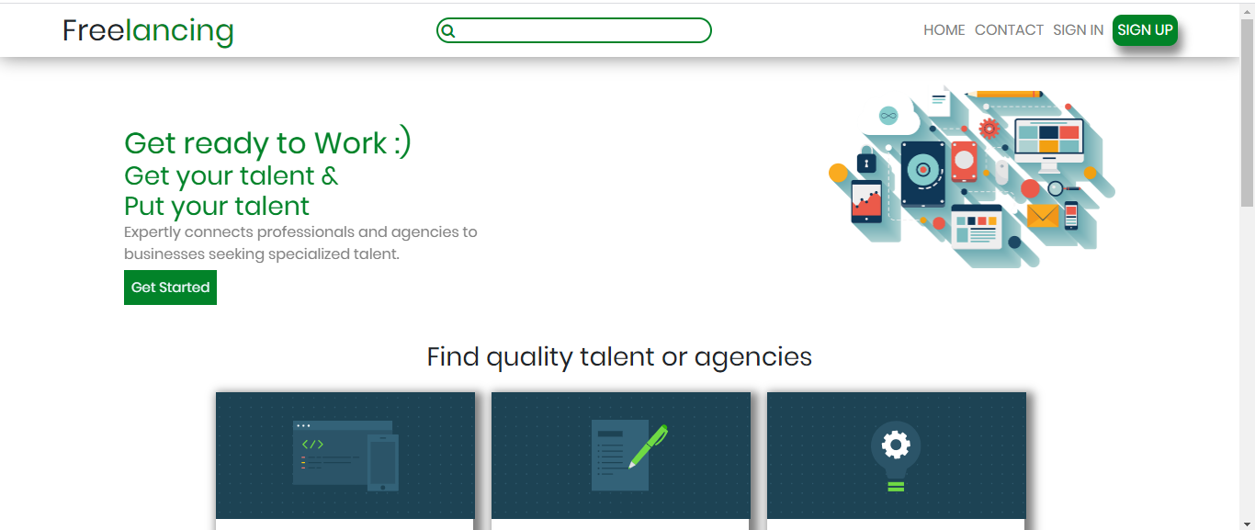
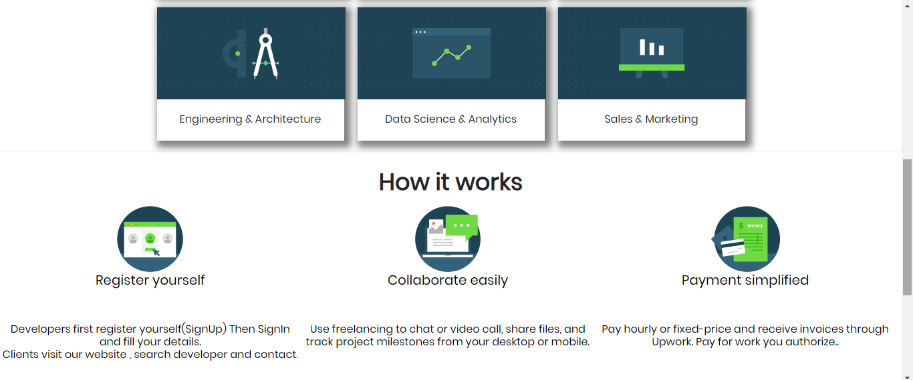
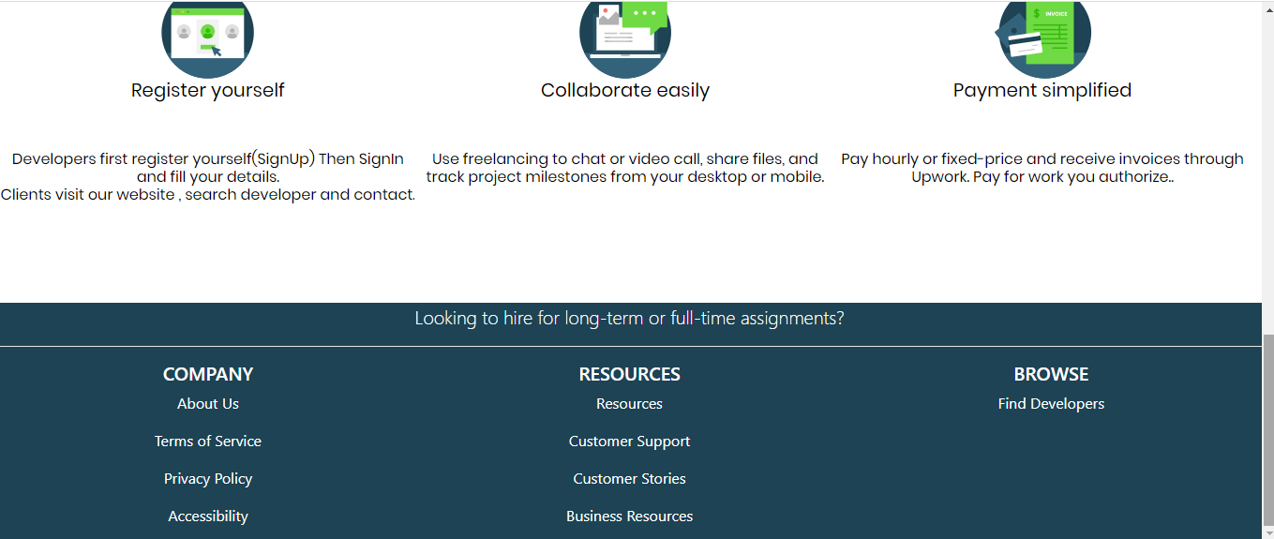

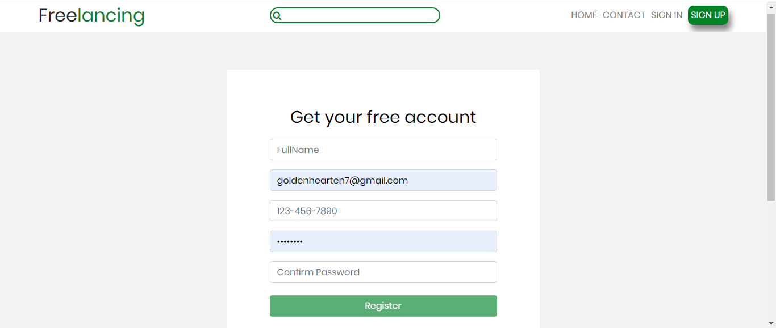

# Developer SignUp form:-

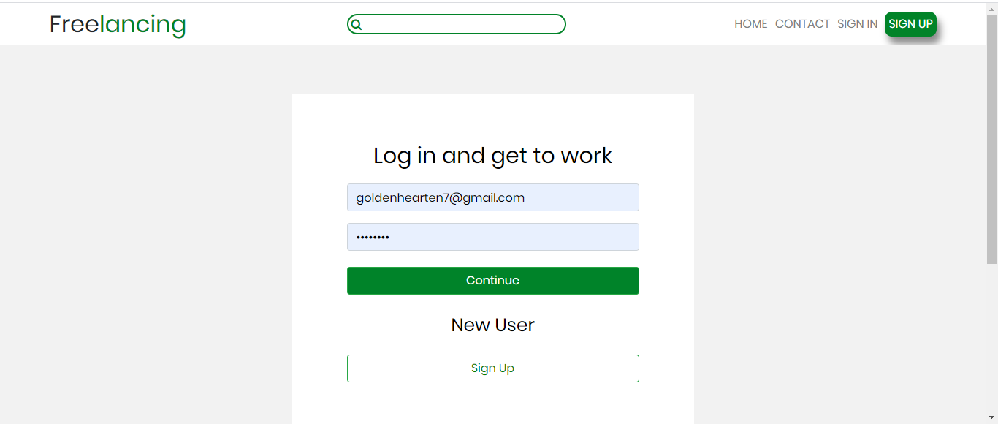

# Developer SignIn form:-

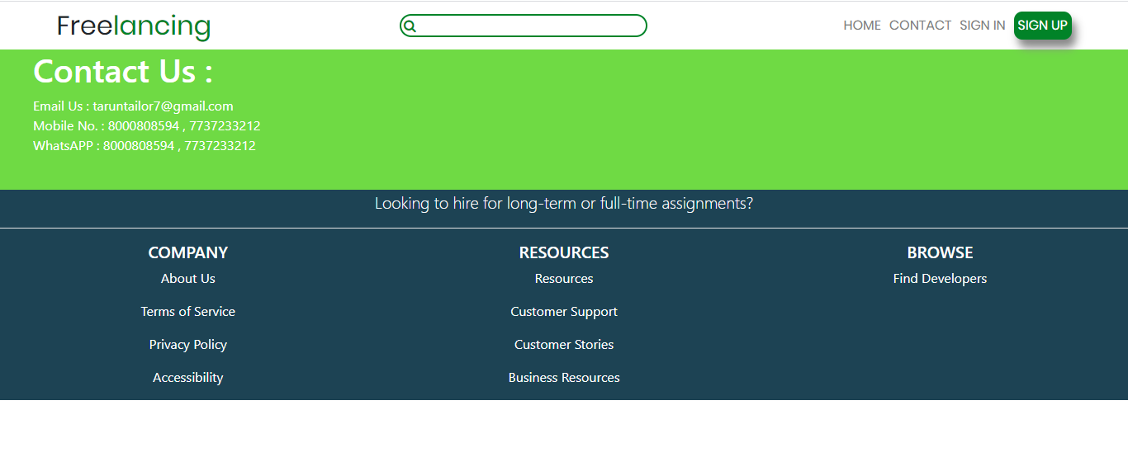
#Contact Us:-

#Developer’s Details Dashboard:-

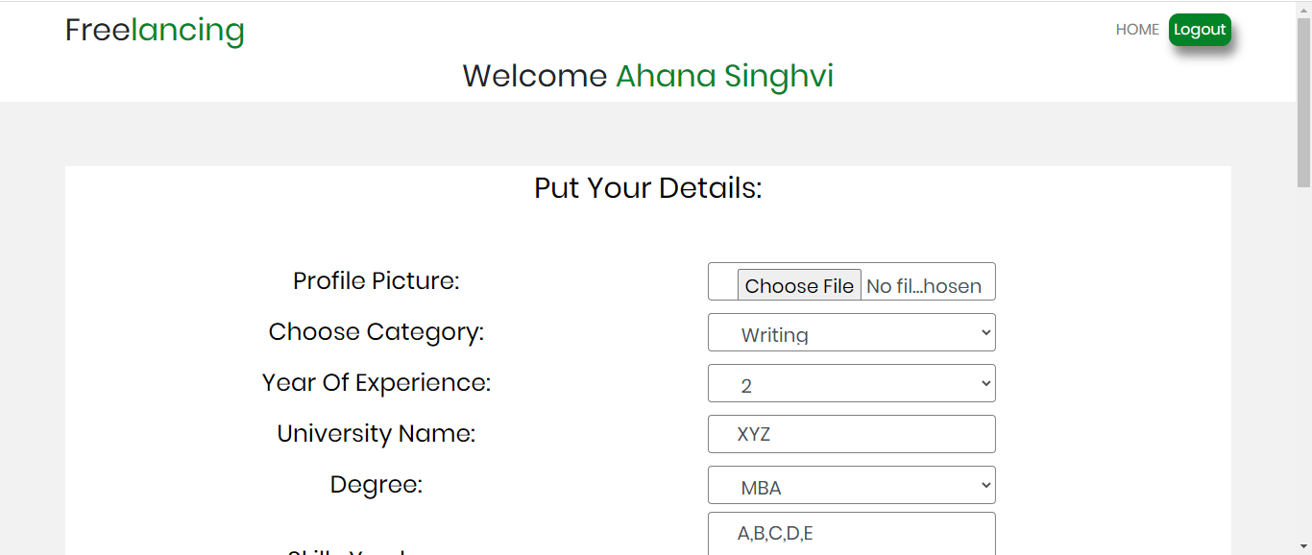
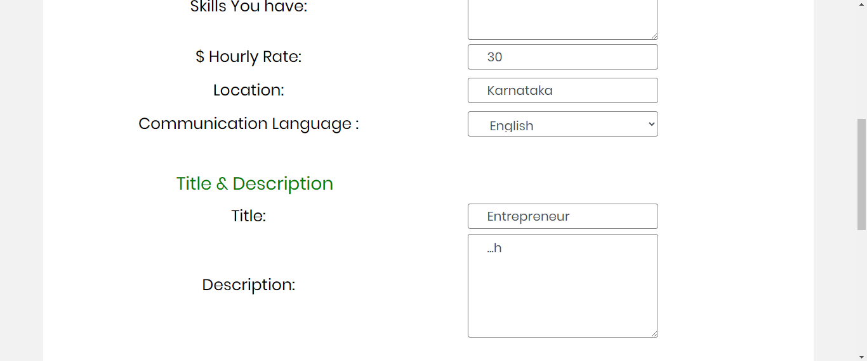
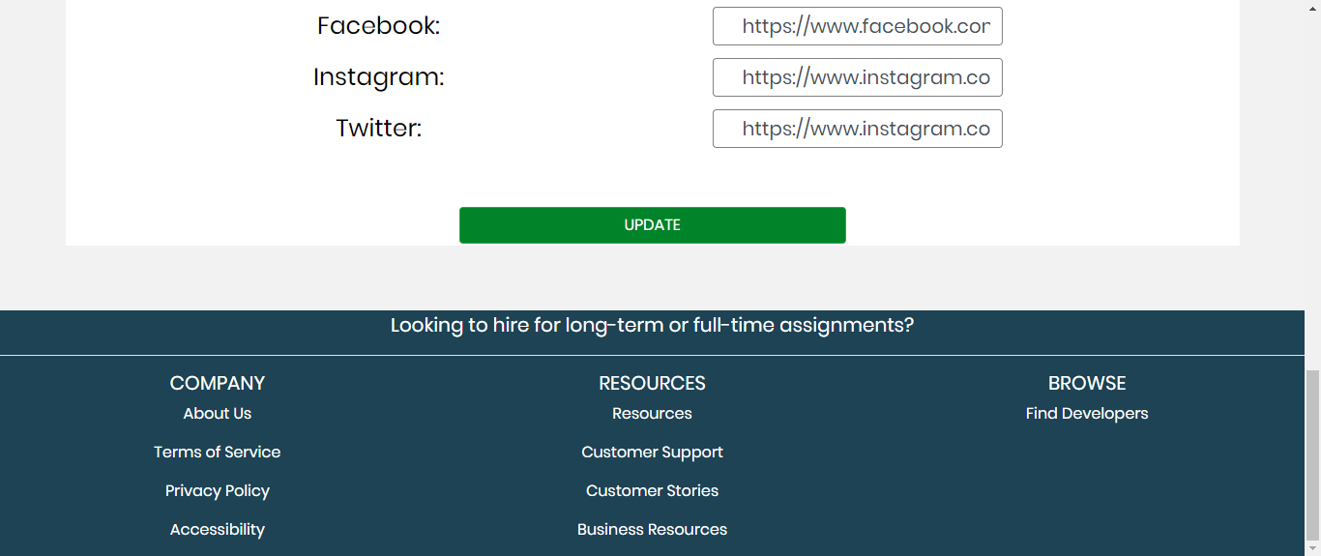

#Developer Profile:-

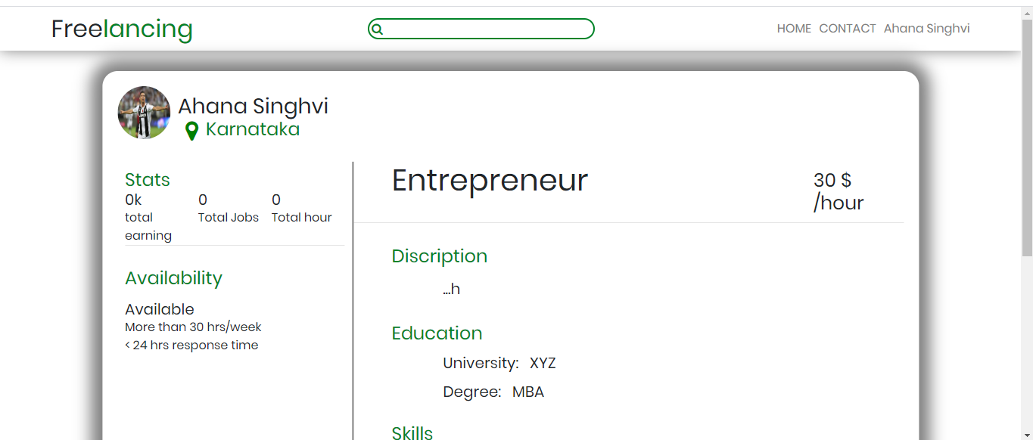
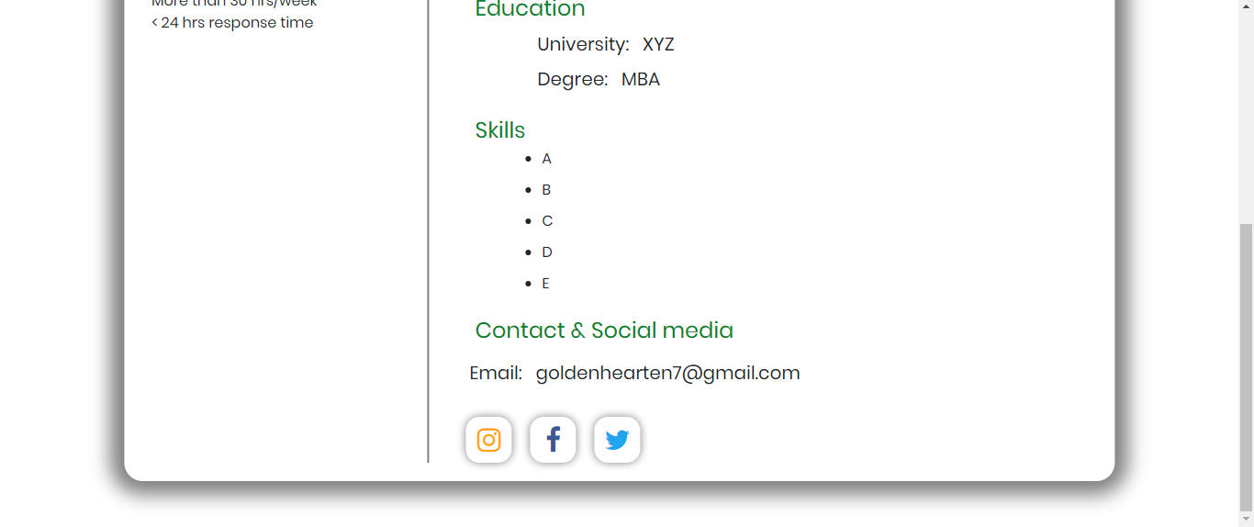
CONCLUSION

In our project work, an attempt has been made to develop a Freelancing Website. We develop this project that helps the people and people can find any developer. To establish this website we use various methodologies. To develop this project we have faced many problem but we hardly tried to develop this project. Our supervisor helps us by giving his valuable opinion, decision and time.

THANK YOU

