OBJECTIVE QUESTIONS

Question 1

Question:

What is the distribution of account balances across different regions?

Solution:

Final Answer

The analysis indicates that Germany has the highest average account balance, with an average balance of approximately 120K, whereas France and Spain have similar average balances of around 62K each.
This suggests that customers in Germany maintain significantly higher account balances than customers in the other two regions. Such insights can help the bank identify high-value markets and design region-specific financial products and customer retention strategies.

Charts & Tables

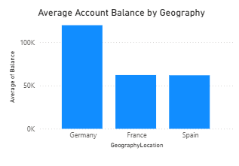

Approach
- Used the Balance field from the Bank_Churn table.
- Used Geography Location from the Geography table.
- Calculated the Average Balance for each geographic region.
- Visualized the comparison using a Clustered Column Chart.
- Compared the average balances to identify regional trends.

Business Insight
- Germany has the highest average customer balance, indicating a higher concentration of customers with larger deposits.
- France and Spain exhibit nearly identical average balances, suggesting similar customer deposit behavior in these regions.
- The bank may consider targeted premium banking services or investment products for customers in Germany while exploring strategies to increase deposits in France and Spain.
Question 2

Question:

Identify the top 5 customers with the highest Estimated Salary in the last quarter of the year. (SQL)

Solution:

SQL Code

select CustomerID, Surname, EstimatedSalary, BankDOJ from customerinfo
where quarter(bankdoj) = 4
order by estimatedsalary desc
limit 5;

Output Image of SQL Result

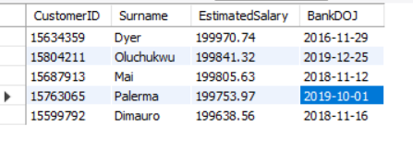

Brief Explanation

The query filters customers whose BankDOJ falls in the fourth quarter (October to December) using the QUARTER() function. The results are then sorted in descending order based on EstimatedSalary, and the top five customers with the highest salaries are returned using the LIMIT clause.

Result Summary

The query identified the following customers as having the highest estimated salaries among those who joined the bank during the last quarter of the year:
- Dyer – 199,970.74
- Oluchukwu – 199,841.32
- Mai – 199,805.63
- Palerma – 199,753.97
- Dimauro – 199,638.56
This query helps the bank identify high-income customers who joined during Q4, which can be useful for targeted marketing campaigns, premium banking services, or customer relationship management initiatives.

Question 3

Question:

Calculate the average number of products used by customers who have a credit card. (SQL)

Solution:

SQL Code

select avg(Numofproducts) as Avg_Products
from bank_churn
where hascrCard = 1;

Output Image of SQL Result

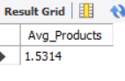

Brief Answer Explanation

The query filters customers who have a credit card (HasCrCard = 1) and calculates the average number of products they use by applying the AVG() aggregate function on the NumOfProducts column.
The result shows that customers with a credit card use an average of approximately 1.53 bank products. This indicates that credit card holders typically use between one and two banking products, suggesting an opportunity for the bank to increase product adoption through cross-selling and personalized product recommendations.

Question 4

Question:

Determine the churn rate by gender for the most recent year in the dataset.

Solution:

Final Answer

The analysis indicates that female customers experienced a higher churn rate than male customers in the most recent year of the dataset.
- Female Churn Rate: Approximately 25%
- Male Churn Rate: Approximately 15%
This suggests that female customers were more likely to leave the bank during the latest year, highlighting a customer segment that may require focused retention strategies.

Charts & Tables

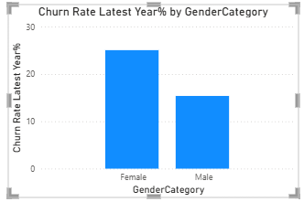

Approach
- Identified the most recent year in the dataset using the MAX() function on the Bank DOJ year.
- Created a DAX measure to calculate the churn rate by dividing the number of exited customers by the total number of customers for that year.
- Multiplied the result by 100 to express the value as a percentage.
- Used GenderCategory as the comparison dimension.
- Visualized the results using a Clustered Column Chart.

DAX Code:

Churn Rate Latest Year% =
VAR LatestYear =
MAX(CustomerInfo[Bank DOJ].[Year])
RETURN
CALCULATE(
DIVIDE(
CALCULATE(
COUNT(Bank_Churn[CustomerId]),
Bank_Churn[Exited] = 1
) * 100,
COUNT(Bank_Churn[CustomerId])
),
YEAR(CustomerInfo[Bank DOJ]) = LatestYear
)

Business Insight
- Female customers exhibit a noticeably higher churn rate than male customers.
- This may indicate differences in customer satisfaction, engagement, or product usage between the two groups.
- The bank should investigate the factors contributing to higher churn among female customers and consider personalized retention campaigns, loyalty programs, or customer engagement initiatives to improve retention.

Question 5

Question:

Compare the average credit score of customers who have exited and those who remain. (SQL)

Solution:

SQL Code

select
case
when exited = 1 then "Exited"
else "Retained"
end
as CustomerStatus, round(avg(creditscore),2) as AvgCreditScore
from bank_churn
group by exited;

Output Image of SQL Result

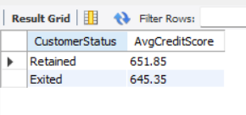

Visualization

Brief Answer Explanation

The query groups customers based on their churn status (Exited) and calculates the average credit score for each group using the AVG() aggregate function.
The results show:
- Customers who remained with the bank have an average credit score of 651.85.
- Customers who exited the bank have an average credit score of 645.35.
Although retained customers have a slightly higher average credit score, the difference is relatively small (approximately 6.5 points). This suggests that credit score alone is unlikely to be a strong predictor of customer churn, and other factors such as customer activity, product usage, account balance, and tenure should also be considered when analyzing churn behavior.

Result Summary
- Average Credit Score (Retained Customers): 651.85
- Average Credit Score (Exited Customers): 645.35
- Difference: 6.50 points
Business Insight: Customers who stayed with the bank have a marginally higher average credit score than those who churned. However, the small difference indicates that customer churn is influenced by multiple factors rather than credit score alone.

Question 6

Question:
Which gender has a higher average estimated salary, and how does it relate to the number of active accounts? (SQL)

Solution:

SQL Code

select g.GenderCategory,
sum(case when b.isActivemember = 1 then 1 else 0 end) as ActiveCustomer,
round(avg(c.EstimatedSalary),2) as AvgEstimatedSalary
from bank_churn b join customerinfo c on b.customerid = c.customerid
join gender g on g.genderid = c.genderid
group by g.gendercategory;

Output Image of SQL Result

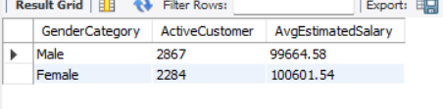

Visualization

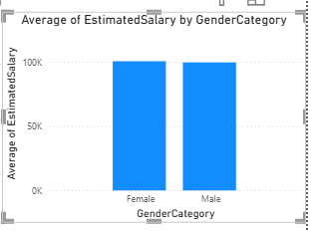

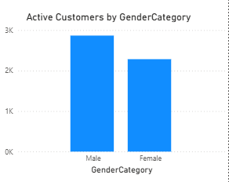

Brief Answer Explanation

The query joins the Bank_Churn, CustomerInfo, and Gender tables using CustomerID and GenderID. It then:
- Counts the number of active customers (IsActiveMember = 1) for each gender.
- Calculates the average estimated salary using the AVG() function.
- Groups the results by GenderCategory.

Result Summary

- Females have the higher average estimated salary.
- Males have the higher number of active accounts.
- This suggests that while female customers in the dataset earn slightly more on average, male customers are more actively engaged with the bank.

Question 7

Question:
Segment the customers based on their credit score and identify the segment with the highest exit rate. (SQL)

Solution:

SQL Code

with cte1 as
(
select *,
case
when creditscore >= 800 then "Excellent"
when creditscore >= 740 then "Very Good"
when creditscore >= 670 then "Good"
when creditscore >= 580 then "Fair"
else "Poor"
end as CreditCategory
from bank_churn
)
select CreditCategory, count(*) as TotalCustomers,
sum(case when exited = 1 then 1 else 0 end)as ExitedCustomers,
round((sum(case when exited = 1 then 1 else 0 end)*100/count(*)),2) as ExitRate
from cte1
group by CreditCategory
order by exitrate desc;

Output Image of SQL Result

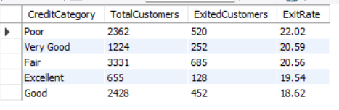

Visualization

Brief Answer Explanation

The query first uses a Common Table Expression (CTE) to classify customers into five credit score categories: Excellent, Very Good, Good, Fair, and Poor.
It then:
- Counts the total number of customers in each category.
- Counts the number of customers who exited.
- Calculates the exit rate as:
Exit Rate= (Exited Customers/Total Customers)*100
Finally, the results are sorted in descending order of exit rate to identify the segment with the highest customer churn.

Result Summary

- Customers with Poor credit scores exhibit the highest likelihood of churning.
- The Good credit score segment has the lowest exit rate, indicating comparatively better customer retention.
- Although the differences are not extremely large, the bank should monitor customers with lower credit scores and consider targeted retention initiatives, personalized financial guidance, or suitable banking products to improve customer loyalty.

Question 8

Question:
Find out which geographic region has the highest number of active customers with a tenure greater than 5 years. (SQL)

Solution:

SQL Code

select GeographyLocation, count(*) as ActiveCustomers
from customerinfo c join bank_churn b on c.customerid = b.customerid
join geography g on g.geographyid = c.geographyid
where b.isactivemember = 1 and b.tenure > 5
group by g.geographylocation
order by ActiveCustomers desc;

Output Image of SQL Result

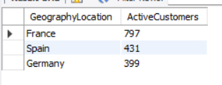

Visualization

Brief Answer Explanation

The query joins the CustomerInfo, Bank_Churn, and Geography tables to associate each customer with their geographic region.
It then:
- Filters customers who are active members (IsActiveMember = 1).
- Includes only customers with a tenure greater than five years.
- Groups the data by geographic region.
- Counts the number of qualifying customers in each region.
- Sorts the results in descending order to identify the region with the highest count.

Result Summary

- France has the largest number of long-tenure active customers, indicating stronger long-term customer engagement and retention in that region.
- Spain ranks second, while Germany has the lowest count among the three regions.
- The bank can study the factors contributing to customer retention in France and consider implementing similar engagement strategies in other regions to improve long-term customer loyalty.

Question 9

Question:
What is the impact of having a credit card on customer churn, based on the available data?

Solution:

Final Answer

The analysis shows that customers without a credit card have a slightly higher churn rate than customers who own a credit card. However, the difference between the two groups is minimal, indicating that credit card ownership alone does not have a significant impact on customer churn.
This suggests that customer churn is likely influenced by multiple rather than solely by whether a customer owns a credit card.

Charts & Tables

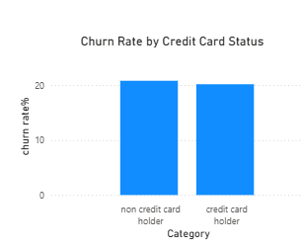

Approach
- Created a Churn Rate % measure using DAX by dividing the number of exited customers by the total number of customers.
- Categorized customers based on Credit Card Status (Credit Card Holder / Non Credit Card Holder).
- Visualized the churn rate for each category using a Clustered Column Chart.
- Compared the churn rates to evaluate the relationship between credit card ownership and customer churn.

DAX Code:

Churn Rate % =
DIVIDE(
CALCULATE(
COUNT(Bank_Churn[CustomerId]),
Bank_Churn[Exited] = 1
),
COUNT(Bank_Churn[CustomerId])
) * 100

Business Insight

- Non-credit card holders exhibit a marginally higher churn rate than credit card holders.
- The difference is very small, suggesting that credit card ownership is not a strong standalone predictor of customer churn.
- The bank should focus on additional factors such as customer activity, tenure, product usage, account balance, and service quality when designing customer retention strategies.
- If the bank wishes to evaluate the effectiveness of credit card reward programs, additional data related to reward participation, cashback usage, or loyalty benefits would be required, as this information is not available in the current dataset.

Question 10

Question:
For customers who have exited, what is the most common number of products they have used?

Solution:

Final Answer

The analysis shows that customers who exited the bank most commonly had only one banking product.
Among exited customers:
- 1 Product → Highest number of exited customers
- 2 Products → Second highest
- 3 Products → Significantly fewer
- 4 Products → Very few exited customers
This indicates that customers with only one product are more likely to leave the bank than customers who use multiple banking products.

Charts & Tables

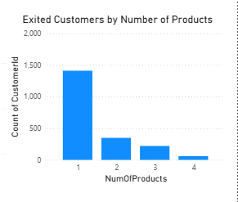

Approach

- Filtered the dataset to include only customers with Exited = 1.
- Used NumOfProducts as the X-axis.
- Used Count of CustomerID as the Y-axis.
- Created a Clustered Column Chart to visualize the distribution of exited customers by the number of products they used.
- Compared the counts to identify the most common product usage among exited customers.

Business Insight

- Customers with only one banking product account for the highest number of exits.
- Customers using multiple banking products exhibit comparatively lower churn, suggesting stronger engagement with the bank.
- This indicates that increasing product adoption through cross-selling, may improve customer retention and reduce churn.

Question 11

Question:
Examine the trend of customers joining over time and identify any seasonal patterns (yearly or monthly). Prepare the data through SQL and then visualize it.

Solution:

SQL Code

select year(Bankdoj) as Year, count(*) as CustomersCount from customerinfo
group by year(Bankdoj)
order by Year;

select month(Bankdoj) as Month, count(*) as CustomersCount from customerinfo
group by month(Bankdoj)
order by Month;

select quarter(Bankdoj) as Quarter,count(*) as CustomersCount from customerinfo
group by Quarter(Bankdoj)
order by Quarter;

Output Image of SQL Result

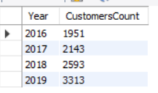

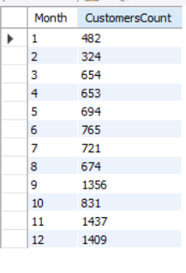

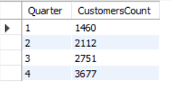

Visualization
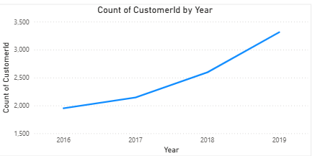

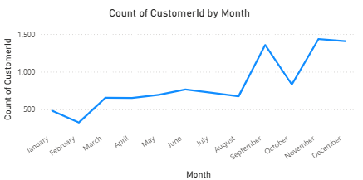

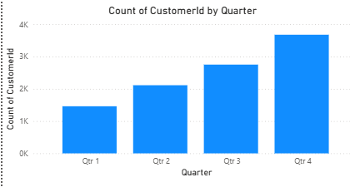

Brief Answer Explanation

The analysis reveals a steady increase in customer acquisition over the years, with the highest number of new customers joining in 2019 (3,313 customers).
Monthly analysis shows that customer acquisition is not evenly distributed throughout the year. The highest number of customer registrations occurred in:
- November (1,437 customers)
- December (1,409 customers)
- September (1,356 customers)
Quarterly analysis further confirms this trend:
- Q4 recorded the highest number of customer registrations (3,677 customers), followed by Q3 (2,751 customers).
These results indicate a clear seasonal pattern, with customer acquisition peaking during the third and fourth quarters, particularly in the final months of the year.

Result Summary

- Customer acquisition increased consistently from 2016 to 2019, indicating business growth.
- The bank experienced significantly higher customer registrations during Q3 and Q4, especially in September, November, and December.
- These seasonal peaks may be driven by year-end promotional campaigns, holiday offers, salary cycles, or increased financial planning activities.
- The bank can leverage these insights by scheduling major marketing campaigns, promotional offers, and onboarding initiatives during the months with historically higher customer acquisition to maximize growth.

Question 12

Question:
Analyze the relationship between the number of products and the account balance for customers who have exited.

Solution:

Final Answer

The analysis shows that the average account balance remains relatively consistent across customers with different numbers of products.
- Customers with 4 products have the highest average balance (approximately 94K).
- Customers with 3 products have the lowest average balance (approximately 86K).
- Customers with 1 and 2 products maintain average balances of around 90K–92K.
Overall, there is no strong relationship between the number of products owned and the average account balance among customers who have exited. The differences are relatively small, indicating that account balance alone does not explain why customers with different product holdings choose to leave the bank.

Charts & Tables

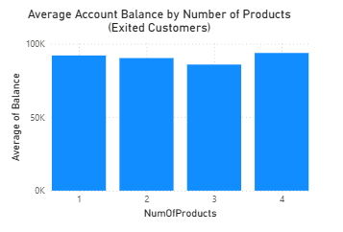

Approach

- Filtered the dataset to include only Exited = 1.
- Used NumOfProducts as the X-axis.
- Used Average of Balance as the Y-axis.
- Created a Clustered Column Chart to compare average balances across product categories.
- Compared the average balances to identify any noticeable relationship between product ownership and account balance.

Business Insight

- The average account balance is fairly similar across all product categories, indicating that exited customers maintained comparable balances regardless of the number of products they owned.
- Customers with four products have a slightly higher average balance, but the difference is not substantial.
- Since balance does not vary significantly by product count, the bank should investigate other factors—such as customer engagement, service experience, pricing, or product satisfaction—to better understand the reasons for customer churn.

Question 13

Question:
Identify any potential outliers in terms of balance among customers who have remained with the bank.

Solution:

Final Answer

The majority of retained customers fall within the 0–50K and 100K–150K balance groups.

Very few retained customers have balances in the 200K–250K range, making these customers potential high-balance outliers within the retained customer population.

Although a statistical outlier detection method (such as a Box & Whisker plot) was not available, the grouped balance analysis indicates that customers with balances above 200K are relatively uncommon.

Charts & Tables

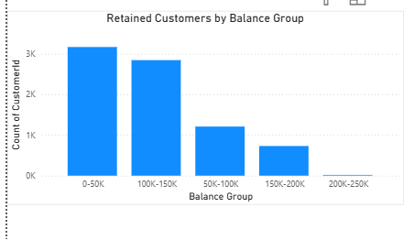

Approach

- Created balance ranges using a DAX calculated column.
- Filtered the data to include only retained customers (Exited = 0).
- Used Balance Group on the X-axis.
- Used Count of CustomerID on the Y-axis.
- Compared the customer distribution across balance groups to identify unusually rare balance ranges.

DAX Calculated Column

Balance Group =
SWITCH(
TRUE(),
Bank_Churn[Balance] < 50000, "0-50K",
Bank_Churn[Balance] < 100000, "50K-100K",
Bank_Churn[Balance] < 150000, "100K-150K",
Bank_Churn[Balance] < 200000, "150K-200K",
Bank_Churn[Balance] < 250000, "200K-250K",
"250K+"
)

Business Insight

- Most retained customers maintain balances below 150K.
- The 200K–250K balance group contains only a small number of customers, indicating these are potential high-value customers.
- Since these customers represent a small but valuable segment, the bank may consider offering premium banking services, personalized relationship management, and exclusive financial products to strengthen their loyalty.
- Note: This analysis identifies potential outliers based on grouped balance ranges. A statistical method such as a Box & Whisker plot or IQR analysis would provide a more rigorous identification of outliers if available.

Question 14

Question:
How many different tables are given in the dataset, out of these tables which table only consists of categorical variables?

Solution:

Final Answer

The dataset consists of 7 tables, which can be classified as follows:

Table Name | Contains Only Categorical Variables?
ActiveCustomer | Yes
CreditCard | Yes
ExitCustomer | Yes
Gender | Yes
Geography | Yes
CustomerInfo | No
Bank_Churn | No

Out of these, 5 tables consist only of categorical variables:
- ActiveCustomer
- CreditCard
- ExitCustomer
- Gender
- Geography
These tables are lookup (dimension) tables that store category identifiers and descriptive labels.

Question 15

Question:
Using SQL, write a query to find out the gender-wise average income of males and females in each geography id. Also, rank the gender according to the average value. (SQL)

Solution:

SQL Code

with cte1 as
(
select g.GenderCategory, go.GeographyLocation, round(avg(estimatedSalary),2) as AvgSalary
from customerinfo c
join gender g on g.genderid = c.genderid
join geography go on go.geographyid = c.geographyid
group by g.GenderCategory, go.GeographyLocation
)

select * ,
rank() over(partition by GeographyLocation order by AvgSalary desc) as Rnk
from cte1;

Output Image of SQL Result

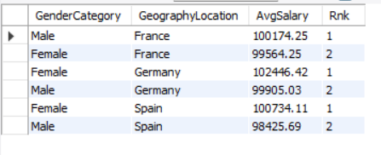

Visualization

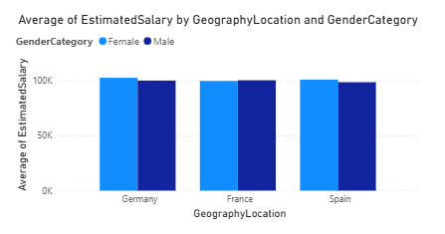

Brief Answer Explanation

The query first uses a Common Table Expression (CTE) to calculate the average estimated salary for each combination of Gender and Geography.
The RANK() window function is then applied by partitioning the data based on GeographyLocation and ordering the average salary in descending order. This assigns Rank 1 to the gender with the highest average salary in each geographic region.

Result Summary

- Female customers have the highest average estimated salary in Germany and Spain, while male customers lead in France.
- The differences in average salaries across genders are relatively small, indicating a fairly balanced income distribution within each region.
- These insights can help the bank design region-specific marketing campaigns, premium banking services, and personalized financial products based on the dominant customer income segment in each geography.

Question 16

Question:
Using SQL, write a query to find out the average tenure of the people who have exited in each age bracket (18-30, 30-50, 50+).

Solution:

SQL Code

with cte1 as
(
select customerid,
case
when age between 18 and 30 then "18-30"
when age between 31 and 50 then "31-50"
else "50+"
end as AgeBracket
from customerinfo
)

select c.AgeBracket, round(avg(b.Tenure),2) as AvgTenure
from bank_churn b
join cte1 c on c.customerid = b.customerid
where b.exited = 1
group by c.AgeBracket
order by c.AgeBracket;

Output Image of SQL Result

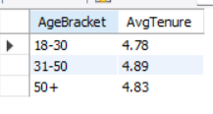

Visualization

Brief Answer Explanation

The query first creates a Common Table Expression (CTE) to classify customers into three age brackets:
- 18–30
- 31–50
- 50+
It then joins the CTE with the Bank_Churn table, filters only customers who have exited (Exited = 1), and calculates the average tenure for each age group using the AVG() aggregate function.

Result Summary

- Customers across all age groups tend to leave the bank after approximately five years of tenure.
- The similarity in average tenure suggests that tenure alone is not a strong differentiator of churn across age segments.

Question 17

Question:
Is there any direct correlation between salary and the balance of the customers? And is it different for people who have exited or not?

Solution:

Final Answer

The scatter plots show no strong direct correlation between Estimated Salary and Account Balance.
For retained customers (Exited = 0):
- The points are widely scattered across the salary range.
- The trend line is nearly flat, indicating a very weak relationship between salary and balance.
For exited customers (Exited = 1):
- The pattern is similar, with balances spread across all salary levels.
- The trend line is also almost flat, showing little to no correlation.
Conclusion: Salary does not appear to be a strong predictor of account balance, and the relationship is not significantly different between customers who exited and those who remained.

Charts & Tables

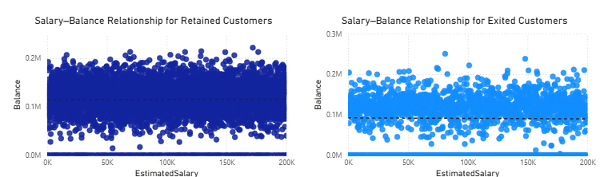

Approach

- Used EstimatedSalary on the X-axis and Balance on the Y-axis.
- Created separate scatter plots for Exited = 0 and Exited = 1.
- Enabled trend lines to observe the direction and strength of the relationship.
- Compared the spread of points and the slope of the trend lines across both customer groups.

Business Insight

- Customers with high salaries do not necessarily maintain high balances, and customers with lower salaries can also have substantial balances.
- The similarity of the two scatter plots suggests that salary is not a major factor distinguishing exited customers from retained customers.
Question 18

Question:
Is there any correlation between the salary and the Credit score of customers?

Solution:

Final Answer

The scatter plots indicate no significant correlation between Credit Score and Estimated Salary.
- For retained customers, the data points are widely dispersed across all salary and credit score values, and the trend line is almost horizontal, indicating virtually no relationship.
- For exited customers, the data follows a similar pattern. The trend line shows only a slight downward slope, suggesting a very weak negative relationship, but the effect is minimal.
Overall, Estimated Salary does not appear to influence a customer's Credit Score, regardless of whether the customer exited or remained with the bank

Charts & Tables

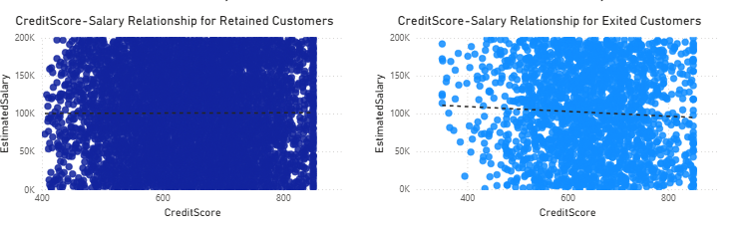

Approach

- Created two scatter plots by separating customers based on their Exited status.
- Used CreditScore on the X-axis.
- Used EstimatedSalary on the Y-axis.
- Enabled trend lines to evaluate the direction and strength of the relationship.
- Compared the distribution and trend between retained and exited customers.

Business Insight

- Estimated Salary and Credit Score are largely independent variables in this dataset.
- Customers with both high and low salaries are distributed across the entire range of credit scores.
- The similarity between retained and exited customers indicates that salary is not a meaningful predictor of creditworthiness or customer churn.
Question 19

Question:
Rank each bucket of credit score as per the number of customers who have churned the bank.

Solution:

Final Answer

Rank | Credit Score Bucket | Churned Customers (Approx.)
1 | Fair | ~685
2 | Poor | ~520
3 | Good | ~452
4 | Very Good | ~252
5 | Excellent | ~128

Charts & Tables

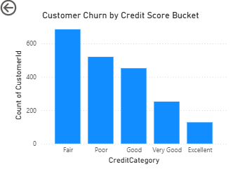

Approach

Categorized customers into credit score buckets:
- Poor (<580)
- Fair (<670)
- Good (<740)
- Very Good (<800)
- Excellent (>=800)
Filtered the dataset to include only Exited = 1.
Used CreditCategory on the X-axis.
Used Count of CustomerID on the Y-axis.
Sorted the chart in descending order of customer count to rank the buckets.

Dax code:
CreditCategory = IF(Bank_Churn[CreditScore] >= 800, "Excellent", IF(Bank_Churn[CreditScore] >= 740, "Very Good", IF(Bank_Churn[CreditScore] >= 670, "Good", if(Bank_Churn[CreditScore] >= 580, "Fair","Poor"))))
Business Insight

- The Fair credit score segment contributes the largest number of customer exits, followed by the Poor segment.
- Customers with Very Good and Excellent credit scores account for comparatively fewer churned customers.
- Since this analysis is based on churn counts rather than churn rates, it should be interpreted alongside the size of each credit score bucket. Evaluating the churn rate for each bucket provides a more accurate measure of churn risk, whereas the churn count highlights which segments contribute the greatest volume of customer loss.

Question 20

Question:
According to the age buckets find the number of customers who have a credit card. Also retrieve those buckets that have lesser than average number of credit cards per bucket.

Solution:

Final Answer

Age Bucket | Credit Card Customers | Average per Bucket | Category
18–30 | 1,400 | 2,351.67 | Below Average
31–50 | 4,781 | 2,351.67 | Above Average/Equal
50+ | 874 | 2,351.67 | Below Average

Charts & Tables

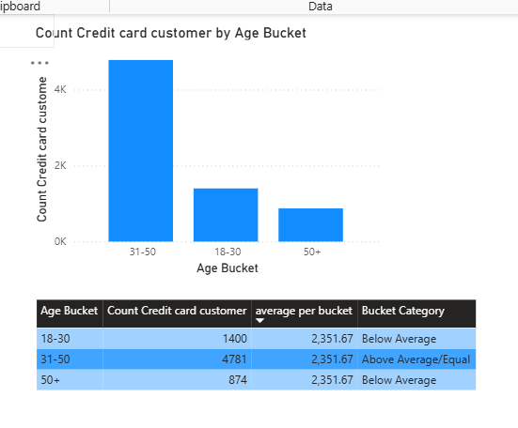

Approach

- Created an Age Bucket calculated column to group customers into three age ranges:
18–30
31–50
50+
- Calculated the number of customers who own a credit card using the HasCrCard field.
- Computed the overall average number of credit card customers across all age buckets using AVERAGEX.
- Compared each bucket's count against the overall average and classified it as Below Average or Above Average/Equal.
- Displayed the results using a column chart and a summary table.

DAX Calculated Column:

Age Bucket =
SWITCH(
TRUE(),
CustomerInfo[Age] >= 18 && CustomerInfo[Age] <= 30, "18-30",
CustomerInfo[Age] >= 31 && CustomerInfo[Age] <= 50, "31-50",
"50+"
)

DAX Measure:

Count Credit card customer =
CALCULATE(
COUNT(CustomerInfo[CustomerId]),
Bank_Churn[HasCrCard] = 1
)

Average per Bucket =
AVERAGEX(
ALL(CustomerInfo[Age Bucket]),
[Count Credit card customer]
)

Bucket Category =
IF(
[Count Credit card customer] < [Average per Bucket],
"Below Average",
"Above Average/Equal"
)

Business Insight

- The 31–50 age group represents the largest segment of credit card holders, accounting for significantly more customers than the overall average.
- Both the 18–30 and 50+ age groups have lower-than-average credit card adoption.
- The bank could improve credit card penetration by introducing student/young professional cards for younger customers and premium or senior-focused card benefits for older customers, helping increase adoption in these underrepresented age segments.

Question 21

Question:
Rank the Locations as per the number of people who have churned the bank and average balance of the customers.

Solution:

Final Answer

Rank | Location | Churned Customers | Average Bank Balance
1 | Germany | 814 | 119,730.12
2 | France | 810 | 62,092.64
3 | Spain | 413 | 61,818.15

Charts & Tables

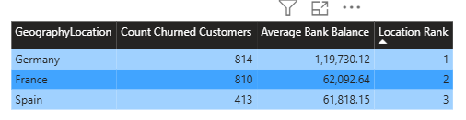

Approach

- Calculated the total number of churned customers for each geography.
- Calculated the average account balance for each geography.
- Used RANKX() to rank locations.
- Multiplied the churn count by 1,000,000 before adding the average balance so that churn count remains the primary ranking criterion and average balance acts as a tie-breaker.
- Applied Dense Ranking to avoid gaps in rank values.

DAX Measure:

Average Bank Balance =
AVERAGE(Bank_Churn[Balance])

Count Churned Customers =
CALCULATE(
COUNT(CustomerInfo[CustomerId]),
Bank_Churn[Exited] = 1
)

Location Rank =
RANKX(
ALL(Geography[GeographyLocation]),
[Count Churned Customers] * 1000000 + [Average Bank Balance],
,
DESC,
DENSE
)

Business Insight

- Germany should be the bank's highest-priority region for churn reduction initiatives because it represents both:
The largest number of churned customers.
The highest-value customer base in terms of account balances.
- Although France has a churn volume nearly equal to Germany, the financial impact per customer is lower due to the smaller average balance.
- Spain currently presents the lowest churn risk among the three regions.
- The bank should focus retention campaigns, loyalty programs, and customer engagement efforts first in Germany, as reducing churn there would likely yield the greatest financial benefit.

Question 22

Question:
As we can see that the “CustomerInfo” table has the CustomerID and Surname, now if we have to join it with a table where the primary key is also a combination of CustomerID and Surname, come up with a column where the format is “CustomerID_Surname”.

Solution:

SQL Code

select concat(customerid, "_", surname) as CustomerKey
from customerinfo;

Output Image of SQL Result

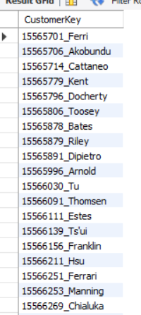

Brief Answer Explanation

The query uses the CONCAT() function to merge the CustomerID and Surname, separated by an underscore (_), into a single column named CustomerKey.
This composite key uniquely identifies each customer and can be used to join the CustomerInfo table with another table whose primary key is also a combination of CustomerID and Surname.

Result Summary

Composite keys are commonly used when a single column is not sufficient to uniquely identify a record. Creating a combined key such as CustomerID_Surname enables reliable joins between tables, helps maintain data integrity, and simplifies integration with external datasets that use composite primary keys.

Question 23

Question:
Without using “Join”, can we get the “ExitCategory” from ExitCustomers table to Bank_Churn table? If yes do this using SQL.

Solution:

SQL Code

select *,
(select exitcategory from exitcustomer e where e.exitid = b.exited )
as ExitCategory
from bank_churn b;

Output Image of SQL Result

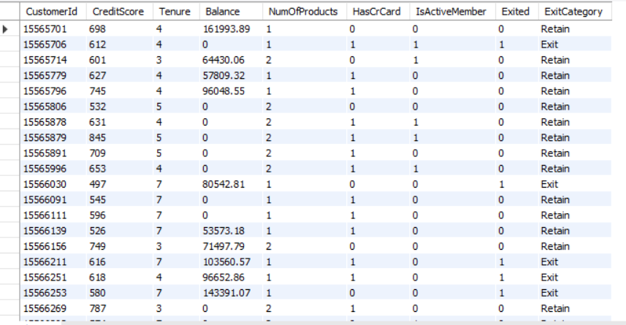

Brief Answer Explanation

Instead of using a JOIN, the query uses a correlated subquery to fetch the corresponding ExitCategory from the ExitCustomer table.
For each row in the Bank_Churn table:
- If Exited = 0, the subquery returns Retain.
- If Exited = 1, the subquery returns Exit.
The subquery is executed for every row, matching ExitID with the Exited column.

Business Insight

Using a correlated subquery is an alternative to a JOIN for retrieving related data from another table. While it works well for small lookup tables like ExitCustomer, JOINs are generally preferred in production environments because they are typically more efficient and scalable when working with large datasets.

Question 24

Question:
Were there any missing values in the data, using which tool did you replace them and what are the ways to handle them?

Solution:

Final Answer

There were no missing values in the dataset. Since the data was complete, no data cleaning or replacement techniques were applied.

Approach
- Inspected the dataset after importing it into SQL and Power BI.
- Checked each table for NULL or blank values.
- Confirmed that all required fields contained valid data.
- As no missing values were present, the dataset was used directly for analysis.

Brief Answer Explanation

Since the dataset contained no missing values, no preprocessing techniques such as imputation or row removal were necessary.
If missing values had been present, they could have been handled using tools like Power Query Editor in Power BI or SQL queries.
Common methods for handling missing values include:
- Removing rows containing missing values (when only a few records are affected).
- Replacing numerical missing values with the mean, median, or mode.
- Replacing categorical missing values with the most frequent category.
- Filling missing values using a default value such as "Unknown" or 0, depending on the business context.
- Using interpolation or predictive models for advanced imputation when appropriate.

Business Insight

Ensuring that the dataset contains no missing values improves data quality and increases the reliability of SQL queries, Power BI dashboards, and business insights. A complete dataset minimizes preprocessing effort and helps produce more accurate analytical results.

Question 25

Question:
Write the query to get the customer IDs, their last name, and whether they are active or not for the customers whose surname ends with “on”.

Solution:

SQL Code

select c.Customerid, c.Surname,
case
when b.isActivemember = 1 then "Active"
else "Inactive"
end as ActiveStatus
from customerinfo c
join bank_churn b on b.customerid = c.customerId
where c.surname like "%on";

Output Image of SQL Result

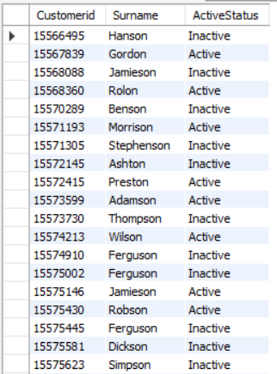

Brief Answer Explanation

The query joins the CustomerInfo and Bank_Churn tables using the CustomerID field. It then filters customers whose Surname ends with "on" using the LIKE '%on' pattern.
A CASE statement converts the IsActiveMember flag into a readable Active or Inactive status.

Business Insight

Pattern-based filtering using LIKE is useful for searching customer records based on naming conventions or partial text matches. Combining this with customer activity status enables targeted customer analysis and can support tasks such as customer verification, segmentation, or personalized marketing campaigns.

Question 26

Question:
Can you observe any data disrupency in the Customer’s data? As a hint it’s present in the IsActiveMember and Exited columns. One more point to consider is that the data in the Exited Column is absolutely correct and accurate.

Solution:

Final Answer

Exit Category | Active Members | Inactive Members
Exit | 735 | 1302
Retain | 4416 | 3547

Since the Exited column is assumed to be accurate:
- 735 customers are marked as Active Members despite having Exited the bank.
- Logically, customers who have exited should no longer be classified as active members.
- Therefore, the inconsistency exists in the IsActiveMember field rather than the Exited field.

Charts & Tables

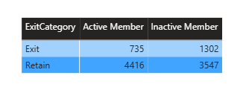

Approach

- Compared the ExitCategory (Exit/Retain) against the Active Member Status (Active/Inactive).
- Displayed the counts in a matrix visual.
- Evaluated whether the combinations were logically consistent.
- Since the problem statement confirms that Exited is correct, treated IsActiveMember as the inconsistent field.

Brief Answer Explanation

The expected business logic is:
- Exited = 1 → Customer should be Inactive.
- Exited = 0 → Customer may be Active or Inactive.
However, the dataset contains 735 customers who are labeled as Active Members even though they have exited the bank. Since the Exited column is confirmed to be accurate, the inconsistency lies in the IsActiveMember column.

Business Insight

This inconsistency can affect churn analysis, customer segmentation, and predictive modeling. Before building machine learning models or business dashboards, the bank should investigate and correct the IsActiveMember values for exited customers to ensure accurate reporting and decision-making.

SUBJECTIVE QUESTIONS

Question 1

Question:
Customer Behavior Analysis: What patterns can be observed in the spending habits of long-term customers compared to new customers, and what might these patterns suggest about customer loyalty?

Solution:

Approach:

The analysis segments customers based on their tenure into three groups:
- New Customers (0–3 years)
- Mid Tenure Customers (4–5 years)
- Long-Term Customers (6+ years)

The following KPIs were analyzed for each segment:
- Average Account Balance
- Average Number of Products
- Active Customer Percentage
- Credit Card Usage Percentage
- Churn Rate Percentage

The comparison helps understand whether customer behavior changes with tenure and whether longer relationships indicate stronger loyalty.

DAX CODE:

Customer Tenure Segment = SWITCH(true(),
Bank_Churn[Tenure] <=3, "New Customers (0-3 yrs)",
Bank_Churn[Tenure] <= 5, "Mid Tenure Customers (4-5 yrs)",
"Long Term Customers (6+ yrs)"
)

Average Bank Balance = AVERAGE(Bank_Churn[Balance])

Active% = divide(CALCULATE(count(Bank_Churn[CustomerId]),Bank_Churn[IsActiveMember] = 1), count(Bank_Churn[CustomerId]))*100

Credit Card Usage% = divide(CALCULATE(count(Bank_Churn[CustomerId]),Bank_Churn[HasCrCard] = 1),count(Bank_Churn[CustomerId]))*100

churn rate% = divide(CALCULATE(COUNT(Bank_Churn[CustomerId]), Bank_Churn[Exited] = 1),COUNT(Bank_Churn[CustomerId]))*100

Charts & Tables:

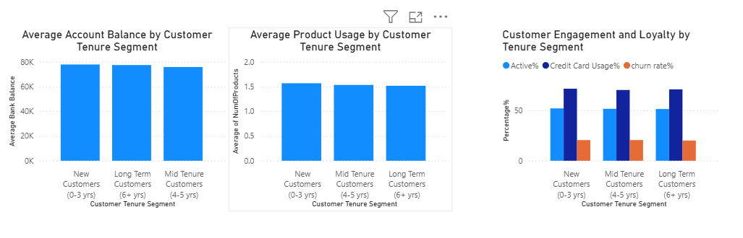

Insights:

- The average account balance remains fairly consistent across all tenure segments, indicating that customers maintain similar balances regardless of how long they have been with the bank.
- The average number of products is also nearly identical (around 1.5 products per customer) across all groups, suggesting that product adoption does not significantly increase with customer tenure.
- Approximately half of the customers are active members in each tenure segment, indicating similar engagement levels among new and long-term customers.
- Credit card usage remains consistently high (around 70%) across all tenure groups, showing that credit cards are widely adopted irrespective of customer tenure.
- The churn rate is nearly the same across New, Mid-Tenure, and Long-Term customers (around 20%), indicating that longer tenure alone does not guarantee stronger customer loyalty.

Recommendations:

- Since customer behavior is similar across all tenure groups, the bank should not rely solely on tenure when designing retention strategies.
- Introduce personalized loyalty programs for long-term customers to strengthen engagement and reward continued relationships.
- Encourage customers to adopt additional banking products through targeted cross-selling campaigns, as product usage remains relatively low across all segments.
- Focus retention efforts on other factors such as customer activity, service quality, product mix, and customer satisfaction, which are likely to have a greater impact on loyalty than tenure alone.
- Monitor customer engagement regularly and identify at-risk customers using multiple indicators rather than tenure by itself.

Conclusion

The analysis indicates that customer tenure alone is not a strong indicator of spending behavior or loyalty. Customers across all tenure segments maintain similar balances, use a similar number of products, exhibit comparable credit card usage, and experience nearly identical churn rates. This suggests that the bank should adopt behavior-based and personalized retention strategies instead of relying solely on the length of the customer relationship.

Question 2

Question:
Product Affinity Study: Which bank products or services are most commonly used together, and how might this influence cross-selling strategies?

Solution:

Approach:

The analysis uses Number of Products as the primary dimension to understand how customers interact with the bank's products. Three visualizations were created to compare product ownership with:
- Active Membership Status
- Customer Churn Status
- Credit Card Ownership
This helps identify common product combinations and understand how product usage relates to customer engagement, retention, and credit card adoption.

Charts & Tables:

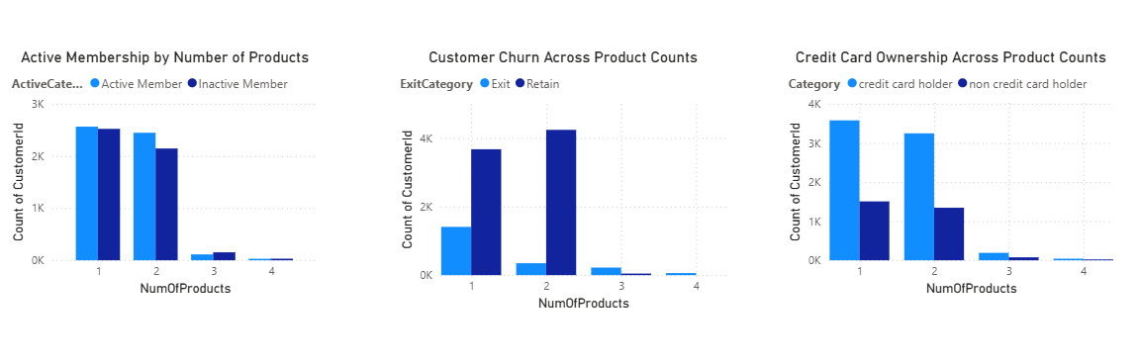

Insights:

- Most customers use one or two banking products, while very few customers use three or four products.
- Customers with one and two products form the largest customer segments and therefore account for the highest number of retained as well as churned customers.
- Credit card ownership is significantly higher among customers with one or two products, suggesting that credit cards are one of the most commonly adopted banking services.
- The number of customers decreases sharply for three and four products, indicating relatively low adoption of multiple banking products.
- Active membership is also concentrated among customers with one and two products, reflecting the overall customer distribution.

Recommendations:

- Target customers with one product through personalized cross-selling campaigns to encourage adoption of a second product, such as a credit card, savings account, loan, or investment product.
- Develop bundled banking packages that combine complementary products to increase customer engagement and product adoption.
- Analyze the characteristics of customers who successfully use multiple products and use these insights to identify similar customers for cross-selling opportunities.
- Since credit cards have high adoption among customers with one and two products, leverage them as an entry point to promote additional financial services.
- Monitor customers with only one product, as increasing product usage can strengthen customer relationships and potentially improve long-term retention.

Conclusion

The analysis shows that customers most commonly use one or two banking products, with credit cards being one of the most frequently adopted services. Product adoption drops considerably beyond two products, highlighting an opportunity for the bank to implement targeted cross-selling and bundled product strategies. Expanding customers' product portfolios can improve engagement, deepen customer relationships, and increase overall customer lifetime value.

Question 3

Question:
Geographic Market Trends: How do economic indicators in different geographic regions correlate with the number of active accounts and customer churn rates?

Solution:

Approach:

The analysis compares customer behavior across different geographic regions (France, Germany, and Spain) using the following metrics:
- Number of Active Customers
- Average Account Balance
- Customer Churn Rate
- Average Estimated Salary

These metrics help understand whether financial indicators such as account balance and salary are associated with customer engagement and churn across regions.

DAX CODE:

Active Customers =CALCULATE(count(Bank_Churn[CustomerId]),Bank_Churn[IsActiveMember] = 1)

Average Bank Balance = AVERAGE(Bank_Churn[Balance])

churn rate% = divide(CALCULATE(COUNT(Bank_Churn[CustomerId]), Bank_Churn[Exited] = 1),COUNT(Bank_Churn[CustomerId]))*100

Charts & Tables:
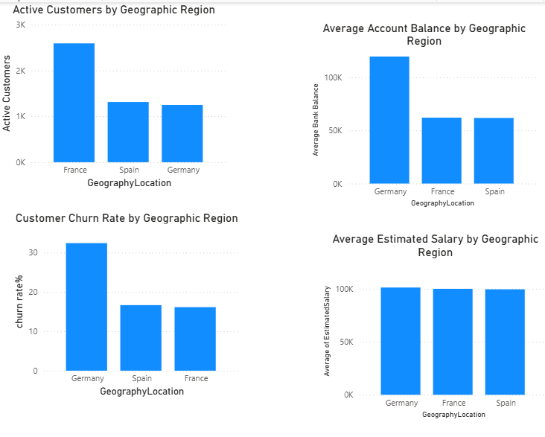

Insights:

- France has the highest number of active customers, indicating stronger customer engagement compared to Germany and Spain.
- Germany has the highest average account balance, suggesting that customers in this region maintain larger deposits.
- Despite having the highest average balances, Germany also records the highest churn rate (approximately 32%), indicating that higher-value customers are more likely to leave the bank.
- France and Spain have similar average account balances and significantly lower churn rates (around 16–17%) than Germany.
- The average estimated salary is nearly identical across all three regions, suggesting that salary alone does not explain the differences in churn or customer activity.

Recommendations:

- Prioritize customer retention initiatives in Germany, as it has both the highest customer balances and the highest churn rate, making customer loss more financially significant.
- Conduct further analysis in Germany to identify additional churn drivers, such as customer satisfaction, product usage, service quality, or competitor activity.
- Continue engagement programs in France to maintain its high active customer base.
- Since salary levels are similar across all regions, focus on behavioral and relationship-based factors rather than income when developing regional retention strategies.
- Implement region-specific marketing campaigns instead of adopting a uniform approach across all geographic markets.

Conclusion

The analysis indicates that geographic location has a stronger relationship with customer activity and churn than estimated salary. Germany stands out as a high-value yet high-risk market, with customers maintaining the highest account balances but also exhibiting the highest churn rate. France demonstrates the strongest customer engagement with the largest active customer base, while Spain remains relatively stable. These findings suggest that the bank should adopt region-specific retention and customer engagement strategies to maximize customer value and reduce churn.

Question 4

Question:
Risk Management Assessment: Based on customer profiles, which demographic segments appear to pose the highest financial risk to the bank, and why?

Solution:

Approach:

To identify high-risk customer segments, the analysis was performed using four key business indicators:
- Customer Churn Rate by Age Group
- Average Account Balance by Customer Status (Exited vs Retained)
- Customer Churn Rate by Geographic Region
- Average Credit Score by Customer Status

These metrics help determine which customer segments are more likely to leave the bank and the potential financial impact associated with their departure.

DAX CODE:

Age Bucket = switch(TRUE(),
CustomerInfo[Age] >= 18 && CustomerInfo[Age] <= 30, "18-30",
CustomerInfo[Age] >= 31 && CustomerInfo[Age] <= 50, "31-50",
"50+")

churn rate% = divide(CALCULATE(COUNT(Bank_Churn[CustomerId]), Bank_Churn[Exited] = 1),COUNT(Bank_Churn[CustomerId]))*100

Average Bank Balance = AVERAGE(Bank_Churn[Balance])

Charts & Tables:

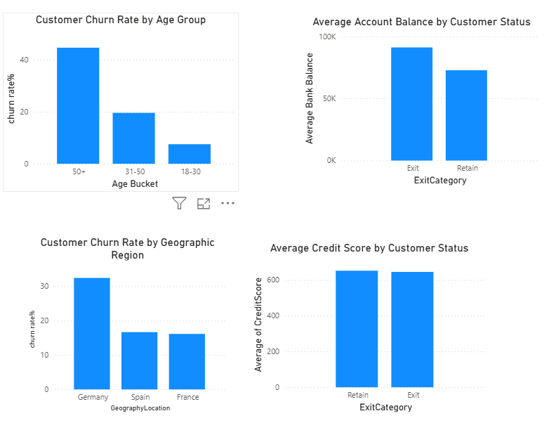

Insights:

- The 50+ age group has the highest churn rate (approximately 45%), making older customers the highest-risk demographic segment.
- Germany records the highest regional churn rate (around 32%), indicating a greater concentration of customer attrition compared to France and Spain.
- Customers who exit the bank maintain a higher average account balance than retained customers, suggesting that the bank is losing relatively higher-value customers.
- The average credit score is nearly the same for retained and exited customers, indicating that credit score alone is not a strong indicator of churn risk.
- The combination of high churn rates and higher account balances among exited customers represents a significant financial risk for the bank.

Recommendations:

- Prioritize retention initiatives for customers aged 50 years and above, as they exhibit the highest likelihood of churn.
- Implement targeted retention programs in Germany, where customer attrition is significantly higher than in other regions.
- Focus on retaining customers with high account balances through personalized relationship management, loyalty benefits, and premium banking services.
- Since credit score shows minimal variation between retained and exited customers, incorporate additional behavioral factors such as customer activity, tenure, product usage, and engagement into risk assessment models.
- Develop an early warning system to identify high-value customers at risk of leaving before churn occurs.

Conclusion

The analysis indicates that the highest financial risk comes from customers aged 50 and above and customers located in Germany, as these segments exhibit the highest churn rates. Additionally, customers who leave the bank tend to maintain higher average account balances, increasing the financial impact of churn. In contrast, credit score does not significantly differentiate churn behavior, suggesting that demographic and behavioral characteristics should be prioritized when developing customer risk management and retention strategies.

Question 5

Question:
Customer Tenure Value Forecast: How would you use the available data to model and predict the lifetime (tenure) value in the bank of different customer segments?
and why?

Solution:

Approach:

To estimate customer lifetime value (LTV), a Lifetime Value Score was created using key customer attributes available in the dataset:
- Customer Tenure
- Number of Products
- Active Membership Status
- Credit Card Ownership

Based on the calculated score, customers were classified into three Lifetime Value Segments:
- High Value
- Medium Value
- Low Value

The analysis was further supported by comparing:
- Average Account Balance by Tenure Segment
- Average Product Usage by Tenure Segment
- Customer Engagement (Active vs. Inactive)
- Customer Churn Rate by Tenure Segment
- Distribution of Customers across Lifetime Value Segments
This approach provides a simple scoring model for estimating future customer value using the available data.

DAX CODE:

Lifetime Value Score =
Bank_Churn[Tenure] * 2 +
Bank_Churn[NumOfProducts] * 3 +
IF(Bank_Churn[IsActiveMember] = 1, 5, 0) +
IF(Bank_Churn[HasCrCard] = 1, 2, 0)

Lifetime Value Segment =
SWITCH(
TRUE(),
[Lifetime Value Score] >= 25, "High Value",
[Lifetime Value Score] >= 15, "Medium Value",
"Low Value"
)
Customer Tenure Segment = SWITCH(true(),
Bank_Churn[Tenure] <=3, "New Customers (0-3 yrs)",
Bank_Churn[Tenure] <= 5, "Mid Tenure Customers (4-5 yrs)",
"Long Term Customers (6+ yrs)"
)

churn rate% = divide(CALCULATE(COUNT(Bank_Churn[CustomerId]), Bank_Churn[Exited] = 1),COUNT(Bank_Churn[CustomerId]))*100

Charts & Tables:

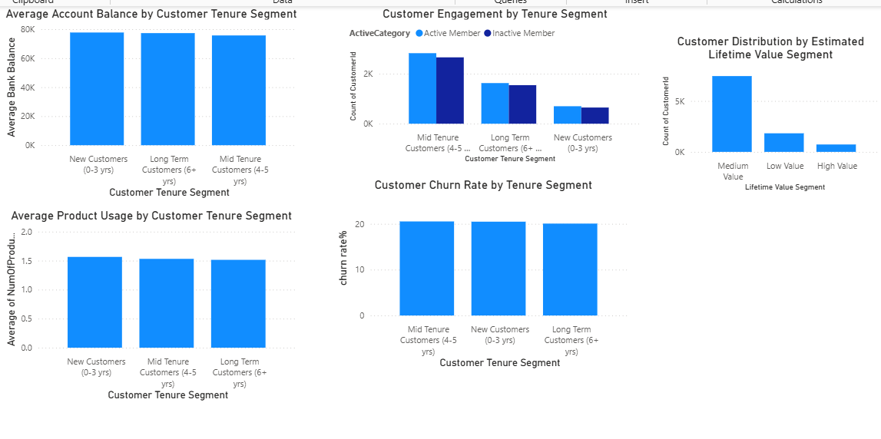

Insights:

- The average account balance remains relatively consistent across all tenure segments, indicating that balance alone does not differentiate customer value.
- Customers across all tenure groups use approximately 1.5 banking products on average, suggesting similar product adoption regardless of tenure.
- Customer engagement is highest among Mid-Tenure customers, who have the largest number of active members.
- The churn rate remains close to 20% across all tenure segments, indicating that tenure alone does not strongly influence customer retention.
- The majority of customers fall into the Medium Value segment, while relatively few customers qualify as High Value, making them an important group for targeted retention efforts.

Recommendations:

- Prioritize retention programs for High Value customers, as they contribute the greatest long-term business value.
- Encourage Medium Value customers to increase their value by promoting additional banking products and improving customer engagement.
- Focus on increasing product adoption among Low Value customers through personalized cross-selling and loyalty campaigns.
- Enhance customer engagement initiatives, especially for inactive customers, to improve their Lifetime Value Score over time.
- Expand the Lifetime Value model by incorporating additional variables such as transaction frequency, loan utilization, digital banking activity, and customer profitability for more accurate forecasting.

Conclusion

The Lifetime Value model indicates that most customers belong to the Medium Value segment, while High Value customers form a relatively small but strategically important group. Although account balances, product usage, and churn rates remain fairly consistent across tenure segments, combining tenure, product ownership, active membership, and credit card usage provides a practical method for estimating customer lifetime value. This segmentation enables the bank to prioritize retention efforts, design targeted marketing campaigns, and allocate resources toward customers with the highest long-term potential.

Question 6

Question:
Marketing Campaign Effectiveness: How could you assess the impact of marketing campaigns on customer retention and acquisition within the dataset? What extra information would you need to solve this?

Solution:

Approach:

The current dataset contains customer demographics, account information, balances, product usage, and churn status. However, it does not include any marketing campaign data, making it impossible to directly measure the effectiveness of marketing campaigns on customer acquisition or retention.
To evaluate campaign performance, the dataset would need to be enriched with marketing-related information that links customers to specific campaigns and their responses.

Additional Information Required:

Field | Purpose
Campaign ID | Identify each marketing campaign
Customer ID | Link customers to campaigns
Campaign Date | Compare customer behavior before and after campaigns
Campaign Type | Identify channels (Email, SMS, Phone, Social Media, etc.)
Campaign Cost | Measure campaign profitability (ROI)
Campaign Response | Track opens, clicks, or responses
Offer Type | Identify offers such as cashback, loans, or discounts
Campaign Conversion | Determine whether the customer accepted the offer
Acquisition Source | Identify how new customers joined the bank

How Campaign Effectiveness Could Be Measured:

1. Customer Retention Rate
Measure:
- Churn rate before vs. after the campaign

2. Customer Acquisition
Measure:
- Number of new customers acquired through each campaign

3. Campaign Conversion Rate
Formula:
Conversion Rate= (customers accepted offer / customers contacted)*100

4. Return on Investment (ROI)
Formula:
ROI = (Revenue Generated – Campagin Cost)/Campagin Cost

5. Customer Lifetime Value (LTV) After Campaign
Compare customer value before and after the campaign using metrics such as:
- Average Account Balance
- Number of Products
- Customer Churn Rate
- Lifetime Value Score

Insights:

- The current dataset cannot measure marketing campaign effectiveness because no campaign-related information is available.
- Customer acquisition, customer response, and campaign performance cannot be evaluated without campaign history.
- Existing customer and churn data can serve as baseline metrics but cannot be directly attributed to marketing activities.

Recommendations:

- Create a dedicated Marketing Campaign table linked to customers through Customer ID.
- Record campaign details such as campaign type, date, cost, response, and conversion.
- Track KPIs including Retention Rate, Acquisition Rate, Conversion Rate, Customer Lifetime Value, and Return on Investment (ROI).
- Use these metrics to evaluate campaign performance and optimize future marketing strategies based on customer behavior.

Conclusion

The current dataset does not contain marketing campaign information, making it impossible to directly assess the impact of campaigns on customer acquisition or retention. To perform this analysis, additional data such as campaign details, customer responses, conversion outcomes, campaign costs, and acquisition channels would be required. With this information, the bank could effectively measure campaign success using KPIs such as retention rate, acquisition rate, conversion rate, lifetime value, and ROI, enabling data-driven marketing decisions.

Question 7

Question:
Customer Exit Reasons Exploration: Can you identify common characteristics or trends among customers who have exited that could explain their reasons for leaving?

Solution:

Approach:

To identify common characteristics among customers who have exited, the analysis focused on four key dimensions:
- Age Group
- Number of Bank Products Used
- Geographic Region
- Average Account Balance
Only customers with Exited = 1 were considered in this analysis. These dimensions help identify customer segments that contribute most to churn and provide possible explanations for customer attrition.

DAX CODE:

Age Bucket = switch(TRUE(),
CustomerInfo[Age] >= 18 && CustomerInfo[Age] <= 30, "18-30",
CustomerInfo[Age] >= 31 && CustomerInfo[Age] <= 50, "31-50",
"50+")

Exited Customers = CALCULATE(count(Bank_Churn[CustomerId]),Bank_Churn[Exited] = 1)

Average Bank Balance = AVERAGE(Bank_Churn[Balance])

Charts & Tables:
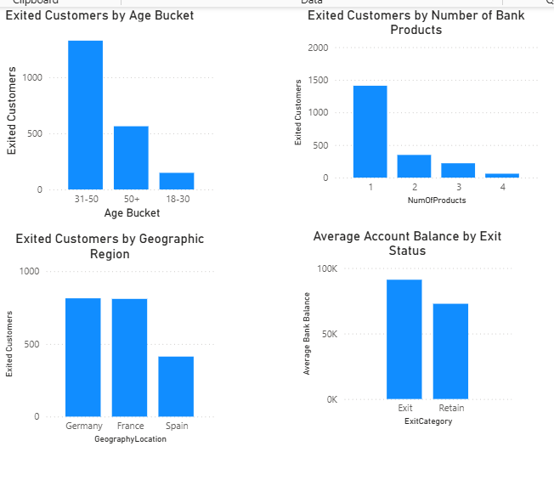
Insights:

- The 31–50 age group accounts for the largest number of exited customers, indicating that middle-aged customers contribute the most to customer attrition.
- Most exited customers owned only one banking product, suggesting that customers with limited product engagement are more likely to leave the bank.
- Germany and France have the highest number of exited customers, while Spain has noticeably fewer customer exits.
- Customers who exited maintained a higher average account balance than retained customers, indicating that the bank is losing relatively high-value customers.
- The results suggest that low product adoption, combined with certain demographic and regional characteristics, may contribute to higher churn.

Recommendations:

- Increase product engagement by encouraging customers with only one product to adopt additional banking services through personalized cross-selling.
- Develop targeted retention programs for customers in the 31–50 age group, as they represent the largest proportion of customer exits.
- Conduct deeper analysis in Germany and France to identify regional factors contributing to higher customer attrition.
- Prioritize retention efforts for customers with high account balances, as losing these customers has a greater financial impact on the bank.
- Implement proactive customer engagement strategies, such as personalized offers and relationship management, to reduce churn among valuable customer segments.
Conclusion

The analysis shows that customers who leave the bank commonly belong to the 31–50 age group, typically use only one banking product, and are more concentrated in Germany and France. Additionally, exited customers tend to have higher average account balances, making their departure more costly for the bank. These findings suggest that improving product adoption, strengthening customer relationships, and focusing retention efforts on high-value customers could significantly reduce customer churn.

Question 8

Question:
Are 'Tenure', 'NumOfProducts', 'IsActiveMember', and 'EstimatedSalary' important for predicting if a customer will leave the bank?

Solution:

Approach:

To evaluate whether these variables influence customer churn, the following analyses were performed:
- Customer Churn Rate by Tenure
- Customer Churn Rate by Number of Products
- Customer Churn Rate by Active Membership
- Average Estimated Salary by Exit Status
- Average Account Balance by Exit Status
These visualizations compare customer behavior between retained and exited customers to determine which variables are useful predictors of churn.

DAX CODE:

churn rate% = divide(CALCULATE(COUNT(Bank_Churn[CustomerId]), Bank_Churn[Exited] = 1),COUNT(Bank_Churn[CustomerId]))*100

Charts & Tables:

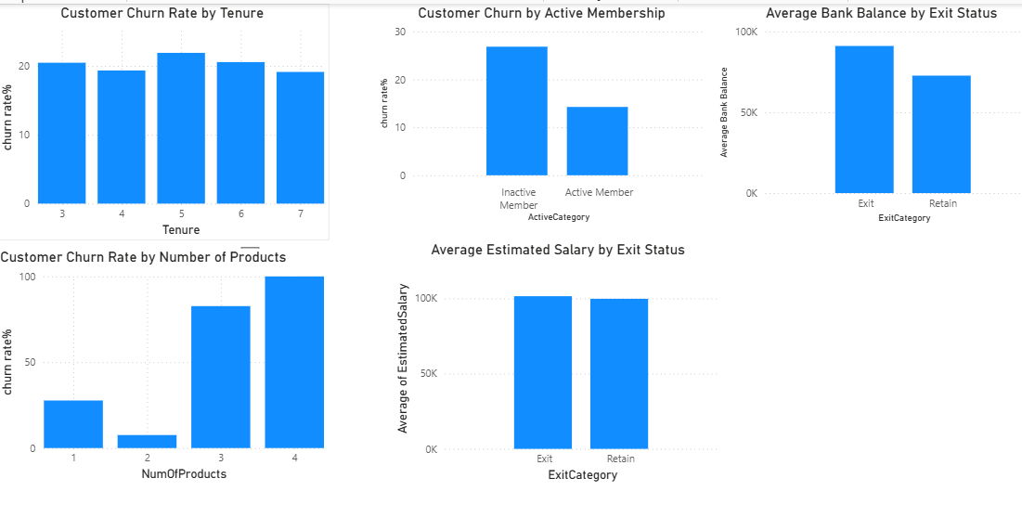

Insights:

- Tenure has only a small impact on customer churn. Churn rates remain relatively stable across different tenure values, indicating that tenure alone is not a strong predictor.
- Number of Products is one of the strongest predictors of churn. Customers with three or four products exhibit significantly higher churn rates, while customers with two products have the lowest churn rate.
- Active Membership strongly influences customer retention. Inactive members have nearly double the churn rate compared to active members, making customer activity an important predictor.
- Estimated Salary shows very little difference between retained and exited customers, suggesting that salary alone is not a significant factor in predicting churn.
- Customers who exited maintain a higher average account balance, indicating that high-value customers are also at risk of leaving the bank.

Recommendations:

- Use Number of Products and Active Membership as key variables when developing churn prediction models.
- Implement proactive engagement programs for inactive customers to reduce their likelihood of churn.
- Investigate why customers with three or more products exhibit higher churn despite greater product adoption, as this may indicate service or satisfaction issues.
- Do not rely heavily on Estimated Salary as a standalone predictor; instead, combine it with behavioral and engagement metrics.
- Prioritize retention efforts for customers with high account balances, as their departure has a greater financial impact.

Conclusion

The analysis indicates that Number of Products and Active Membership are the most important predictors of customer churn within the available dataset. Tenure has only a modest influence, while Estimated Salary provides little predictive value. Additionally, customers with higher account balances are more likely to leave, highlighting the importance of combining demographic, behavioral, and financial variables when building an effective churn prediction model.

Question 9

Question:
Utilize SQL queries to segment customers based on demographics and account details.

Solution:

SQL Code

SELECT
c.CustomerID,
g.GenderCategory AS Gender,
geo.GeographyLocation AS Geography,
CASE
WHEN c.Age BETWEEN 18 AND 30 THEN 'Young'
WHEN c.Age BETWEEN 31 AND 50 THEN 'Middle Aged'
ELSE 'Senior'
END AS Age_Group,

CASE
WHEN b.CreditScore >= 800 THEN 'Excellent'
WHEN b.CreditScore >= 740 THEN 'Very Good'
WHEN b.CreditScore >= 670 THEN 'Good'
WHEN b.CreditScore >= 580 THEN 'Fair'
ELSE 'Poor'
END AS Credit_Segment,

CASE
WHEN b.Balance >= 100000 THEN 'High Balance'
WHEN b.Balance >= 50000 THEN 'Medium Balance'
ELSE 'Low Balance'
END AS Balance_Segment,

CASE
WHEN b.NumOfProducts = 1 THEN 'Single Product'
WHEN b.NumOfProducts = 2 THEN 'Two Products'
ELSE 'Multiple Products'
END AS Product_Segment,

CASE
WHEN b.IsActiveMember = 1 THEN 'Active'
ELSE 'Inactive'
END AS Membership_Status,

case
when b.hascrcard = 1 then 'Credit Card Holder'
else 'Non Credit Card Holder'
end as Credit_Card_Status,
CASE
WHEN b.Tenure <= 3 THEN 'New Customer'
WHEN b.Tenure <= 5 THEN 'Mid-Tenure Customer'
ELSE 'Long-Term Customer'
END AS Tenure_Segment

FROM CustomerInfo c
JOIN Bank_Churn b
ON c.CustomerID = b.CustomerID
JOIN Gender g
ON c.GenderID = g.GenderID
JOIN Geography geo
ON c.GeographyID = geo.GeographyID;

Output Image of SQL Result

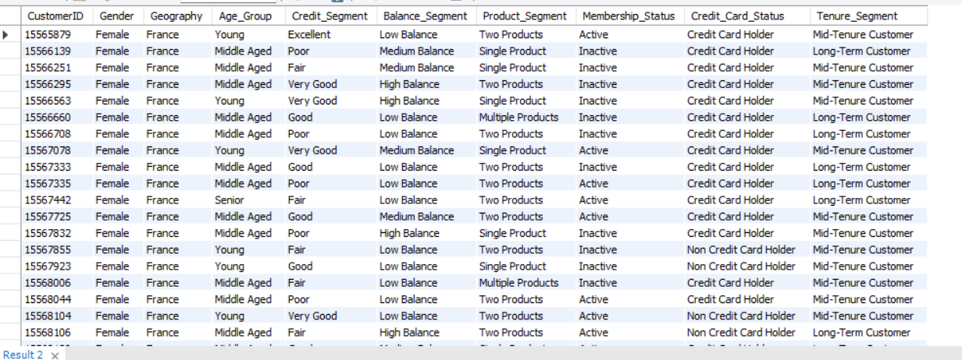

Approach

The customer segmentation was performed by combining information from multiple tables using SQL joins:
- CustomerInfo provided demographic details such as Customer ID and Age.
- Bank_Churn provided banking-related information including Credit Score, Balance, Number of Products, Active Membership, Credit Card Ownership, and Tenure.
- Gender and Geography lookup tables were joined to retrieve descriptive category names.
Using SQL CASE statements, customers were grouped into business-friendly segments instead of raw numerical values:
- Age Group: Young, Middle Aged, Senior
- Credit Segment: Poor, Fair, Good, Very Good, Excellent
- Balance Segment: Low, Medium, High Balance
- Product Segment: Single Product, Two Products, Multiple Products
- Membership Status: Active or Inactive
- Credit Card Status: Credit Card Holder or Non-Credit Card Holder
- Tenure Segment: New Customer, Mid-Tenure Customer, Long-Term Customer
The resulting dataset provides a comprehensive customer profile that can be used for reporting, customer analytics, marketing campaigns, churn prediction, and cross-selling strategies.

Insights

- The segmentation creates a 360-degree customer profile by combining demographic and account-related information into a single dataset.
- Customers are grouped into meaningful business categories, making analysis easier than working with raw numerical values.
- The segmented data can quickly identify customer groups such as:
  - Young customers with high credit scores.
  - Long-term active customers.
  - Customers with high balances but only one banking product.
  - Inactive customers with excellent credit scores.
- This structured segmentation enables the bank to compare customer behavior across multiple dimensions without repeatedly writing complex SQL queries.
- The resulting dataset can also serve as a foundation for dashboards, predictive models, and business intelligence reporting.

Recommendations

- Use these customer segments to design targeted marketing campaigns for different customer groups.
- Focus cross-selling efforts on customers with high balances but few banking products.
- Develop retention strategies for inactive customers and customers identified as high churn risk.
- Use tenure and product segments to identify loyal customers who may be eligible for premium banking services.
- Integrate these segments into Power BI dashboards to enable business users to filter and analyze customer behavior efficiently.
- Periodically review and refine the segmentation thresholds (such as balance and credit score ranges) to align with evolving business objectives.

Conclusion

The SQL query successfully segments customers using both demographic attributes (age, gender, geography) and account characteristics (credit score, balance, products, membership, credit card ownership, and tenure). This consolidated customer segmentation provides a strong analytical foundation for customer profiling, churn analysis, personalized marketing, cross-selling opportunities, and strategic decision-making.

Question 10

Question:
How can we create a conditional formatting setup to visually highlight customers at risk of churn and to evaluate the impact of credit card rewards on customer retention?

Solution:

Approach:

The objective was to make customers at different levels of churn risk easily identifiable while simultaneously evaluating whether credit card ownership influences customer retention.
A Power BI Table visual was created containing key customer attributes including Customer ID, Geography, Credit Score, Balance, Number of Products, Active Membership, Credit Card Status, and a calculated Churn Risk category.
Conditional formatting was then applied to the Churn Risk column using background colors:
- High Risk → Red
- Medium Risk → Yellow
- Low Risk → Green
This allows business users to quickly identify customers requiring immediate retention efforts.
To evaluate the impact of credit card rewards, a Clustered Column Chart was created comparing retained and exited customers based on Credit Card Status.
This combination provides both detailed customer-level risk identification and an overall comparison of customer retention among credit card holders and non-credit card holders.

Charts & Tables:

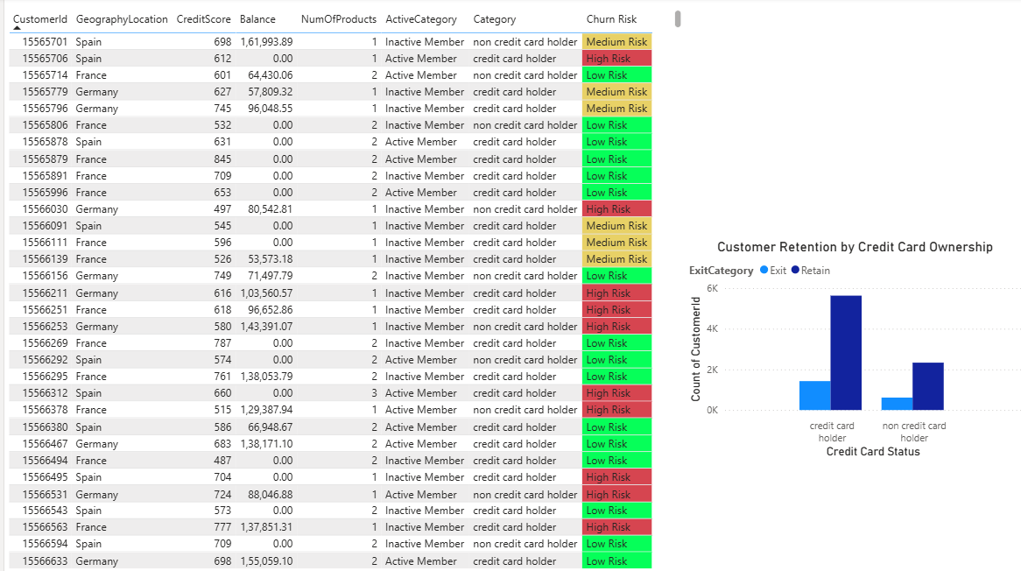

DAX CODE:

Churn Risk =
SWITCH(
TRUE(),
Bank_Churn[Exited] = 1, "High Risk",
Bank_Churn[IsActiveMember] = 0 && Bank_Churn[NumOfProducts] = 1, "Medium Risk",
"Low Risk"
)

Insights:

- Conditional formatting makes high-risk customers immediately visible, allowing managers to prioritize retention efforts without manually reviewing customer records.
- The majority of customers are classified as Low Risk, while a smaller group falls into the High Risk category and requires immediate attention.
- The retention chart shows that credit card holders represent a larger retained customer base than non-credit card holders.
- Credit card ownership appears to be associated with stronger customer engagement and improved retention, although additional behavioral data would be needed to establish causation.
- Combining customer-level risk classification with credit card ownership provides a practical framework for identifying customers who are most likely to benefit from targeted loyalty programs.

Recommendations:

- Use conditional formatting as part of a customer monitoring dashboard so relationship managers can quickly identify high-risk customers.
- Prioritize proactive engagement with customers classified as High Risk through personalized offers, financial advice, or loyalty incentives.
- Continue promoting credit card reward programs to increase customer engagement and strengthen retention.
- Regularly review and update the churn risk classification model as customer behavior changes over time.
- Combine churn risk with additional metrics such as customer balance, product usage, and activity level to create more accurate retention strategies.

Conclusion

By applying conditional formatting to the Churn Risk column, the bank can instantly identify customers requiring retention efforts. The accompanying analysis of credit card ownership and customer retention provides additional insight into customer engagement. Together, these visualizations support faster decision-making, improved customer monitoring, and more effective retention strategies.

Question 11

Question:
What is the current churn rate per year and overall as well in the bank? Can you suggest some insights to the bank about which kind of customers are more likely to churn and what different strategies can be used to decrease the churn rate?

Solution:

Approach:

To understand customer churn behavior, the overall churn rate was further analyzed across multiple dimensions:
- Year (trend over time)
- Age Group
- Geographic Region
- Number of Products
- Active Membership Status
These analyses help identify customer segments with the highest churn risk and support targeted retention strategies.

DAX Code:

churn rate% = divide(CALCULATE(COUNT(Bank_Churn[CustomerId]), Bank_Churn[Exited] = 1),COUNT(Bank_Churn[CustomerId]))*100

Charts & Tables:

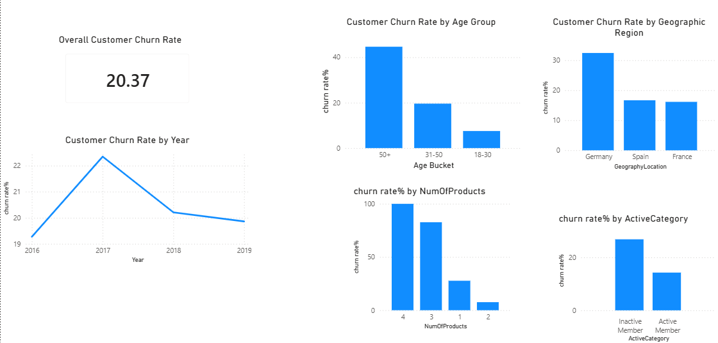

Insights:

- The bank's overall customer churn rate is 20.37%, indicating that approximately one out of every five customers has left the bank.
- The yearly trend shows that churn peaked around 2017 before gradually declining in subsequent years, suggesting some improvement in customer retention.
- Customers aged 50 years and above have the highest churn rate, making them the most vulnerable demographic segment.
- Germany has the highest customer churn rate among all geographic regions, while France and Spain experience comparatively lower churn.
- Customers owning three or four products exhibit significantly higher churn rates than customers with one or two products, suggesting possible dissatisfaction among highly engaged customers.
- Inactive members are substantially more likely to leave the bank than active members, highlighting customer engagement as an important driver of retention.

Recommendations:

- Develop targeted retention programs for customers aged 50+, including personalized financial advice and loyalty benefits.
- Conduct detailed regional analysis in Germany to identify local factors contributing to higher customer attrition.
- Investigate why customers with multiple banking products are leaving despite greater product adoption, and improve service quality for these high-value customers.
- Increase customer engagement through personalized communication, digital banking features, and reward programs to encourage inactive members to become active.
- Monitor churn trends regularly using Power BI dashboards and implement predictive analytics to identify customers at high risk before they leave.
- Introduce proactive retention campaigns based on customer behavior, account activity, and product usage.

Conclusion

The analysis reveals an overall churn rate of 20.37%, with the highest churn observed among customers aged 50+, inactive members, customers owning three or more products, and customers located in Germany. Although the yearly trend indicates a slight improvement after 2017, targeted retention strategies focused on these high-risk customer segments can further reduce churn and improve long-term customer loyalty.

Question 12

Question:
Create a dashboard incorporating all the KPIs and visualization-related metrics. Use a slicer in order to assist in selection in the dashboard.

Solution:

Approach:

An interactive Power BI dashboard was developed to provide a comprehensive overview of customer churn, customer demographics, and key banking performance indicators. The dashboard combines KPI cards, charts, and slicers to enable users to monitor business performance and explore customer behavior dynamically.
The dashboard includes the following KPIs:
- Total Customers
- Overall Churn Rate
- Exited Customers
- Average Account Balance
- Average Credit Score
To support detailed analysis, several visualizations were added to identify churn trends across customer segments, demographics, geography, and customer lifetime value.
Interactive slicers were also incorporated, allowing users to filter the entire dashboard by:
- Exit Status
- Active Membership
- Geography
- Gender
This enables business users to perform self-service analysis without modifying the underlying reports.

DAX Code:

churn rate% = divide(CALCULATE(COUNT(Bank_Churn[CustomerId]), Bank_Churn[Exited] = 1),COUNT(Bank_Churn[CustomerId]))*100

Lifetime Value Segment =
SWITCH(
TRUE(),
[Lifetime Value Score] >= 25, "High Value",
[Lifetime Value Score] >= 15, "Medium Value",
"Low Value"
)

Exited Customers = CALCULATE(count(Bank_Churn[CustomerId]),Bank_Churn[Exited] = 1)

Charts & Tables:

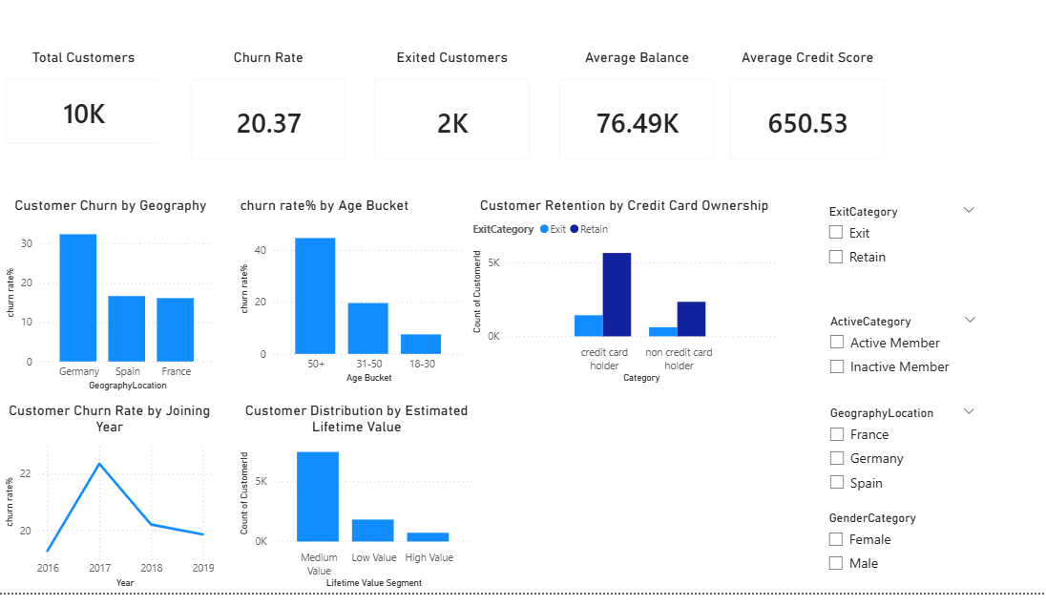

Insights:

- The dashboard reports 10,000 total customers, with an overall churn rate of 20.37% and approximately 2,000 exited customers.
- Germany records the highest customer churn among the three geographic regions.
- Customers aged 50 years and above exhibit the highest churn rate.
- Credit card holders represent a larger retained customer base compared to non-credit card holders.
- Most customers fall into the Medium Lifetime Value segment, while High Lifetime Value customers form the smallest group.
- The yearly churn trend indicates that churn peaked in 2017 before declining slightly in later years.
- Interactive slicers enable users to quickly identify trends within specific customer segments without creating multiple reports.

Recommendations:

- Use this dashboard as a management reporting tool to monitor customer churn and customer engagement regularly.
- Focus retention initiatives on high-risk groups such as older customers, customers in Germany, and customers identified through slicer-based analysis.
- Monitor KPIs periodically to evaluate the effectiveness of customer retention programs.
- Expand the dashboard by incorporating additional business metrics such as campaign performance, customer complaints, transaction activity, and profitability.
- Enable scheduled data refreshes so decision-makers always have access to the latest customer insights.

Conclusion

The Power BI dashboard provides a centralized and interactive view of the bank's customer base by combining key performance indicators, churn analysis, demographic insights, and customer value metrics. The inclusion of slicers allows users to perform flexible, real-time analysis across different customer segments, making the dashboard an effective decision-support tool for monitoring performance and developing customer retention strategies.

Question 13

Question:
How would you approach this problem, if the objective and subjective questions weren't given?

Solution:

Approach:

If no predefined questions were provided, I would follow a structured data analysis process to identify business problems, explore the data, and derive actionable insights.

Step 1: Understand the Business Problem

- Understand the banking domain and business objectives.
- Identify the available datasets and relationships between tables.
- Define potential KPIs such as customer churn rate, customer retention, customer demographics, average balance, credit score, and customer activity.

Step 2: Explore the Dataset
- Review all tables and understand primary and foreign key relationships.
- Check data types, missing values, duplicates, and data consistency.
- Perform basic descriptive statistics for numerical columns.

Step 3: Perform Data Cleaning
- Handle missing values if present.
- Remove duplicate records.
- Validate relationships between tables.
- Create calculated columns or categories such as Age Bucket, Credit Score Bucket, Balance Segment, and Tenure Segment.

Step 4: Perform Exploratory Data Analysis (EDA)
Analyze important business questions such as:
- Overall churn rate
- Churn by geography
- Churn by age group
- Churn by gender
- Credit score distribution
- Product usage
- Customer activity
- Balance distribution
- Customer tenure
- Salary analysis

Step 5: Create KPIs
Develop important business measures including:
- Total Customers
- Churn Rate
- Retained Customers
- Exited Customers
- Average Balance
- Average Credit Score
- Average Salary
- Active Member Percentage

Step 6: Build Visualizations
Create interactive dashboards using:
- Bar Charts
- Line Charts
- Pie/Donut Charts
- Cards
- Tables
- Slicers for filtering

Step 7: Generate Business Insights
Identify:
- High-risk customer segments
- Customer behavior patterns
- Geographic differences
- Product usage trends
- Retention opportunities

Step 8: Provide Recommendations
Suggest business actions to:
- Reduce customer churn
- Improve customer engagement
- Increase cross-selling opportunities
- Enhance customer retention strategies

Insights:

Following a structured analytical approach helps uncover hidden patterns in customer behavior without relying on predefined questions. By exploring demographics, customer activity, balances, products, and geography, meaningful business insights can be identified and converted into actionable recommendations.

Recommendations:

- Begin every project with data understanding and quality assessment.
- Create reusable KPIs before building visualizations.
- Perform exploratory data analysis to discover trends instead of assuming them.
- Build interactive dashboards that allow stakeholders to filter data by geography, age, gender, tenure, and customer status.
- Use insights from the analysis to support data-driven business decisions for customer retention, risk management, and marketing strategies.

Question 14

Question:
In the Bank_Churn table, how can you modify the name of the HasCrCard column to Has_creditcard?

Solution:

SQL Code

ALTER TABLE Bank_Churn
RENAME COLUMN HasCrCard TO Has_creditcard;

Approach

The objective of this task is to rename an existing column in the Bank_Churn table without affecting the stored data.
The ALTER TABLE statement is used to modify the structure of an existing table. The RENAME COLUMN clause changes only the column name while preserving all records, data types, constraints, indexes, and relationships associated with that column.
In this case:
- Existing column name: HasCrCard
- New column name: Has_creditcard
This operation improves readability and naming consistency by replacing the abbreviated column name with a clearer and more descriptive one.

Insights

- Renaming a column does not modify or delete any data stored in the table.
- The column values (0 or 1) remain unchanged after renaming.
- Existing relationships, constraints, and indexes continue to work unless external queries or applications explicitly reference the old column name.
- Using meaningful and standardized column names improves database maintainability and makes SQL queries easier to understand.

Recommendations

- Follow a consistent naming convention across the entire database (for example, using descriptive names with underscores such as Has_creditcard).
- Update all SQL queries, stored procedures, views, reports, and Power BI models that reference the old column name to avoid errors.
- Test dependent applications after renaming to ensure compatibility.
- Maintain proper database documentation whenever schema changes are made so future developers and analysts can easily understand the data model.Periodically review and refine the segmentation thresholds (such as balance and credit score ranges) to align with evolving business objectives.

