**1.For given JSON iterate in for loop**

Code :

var person = '{"name":"Jack", "age":25, "vehicel":["bike","car","cycle"]}';

var Obj = JSON.parse(person);

for (let k = 0; k < Obj.vehicel.length; k++) {

console.log(Obj.vehicel[k]);

}

Output:

bike

car

cycle

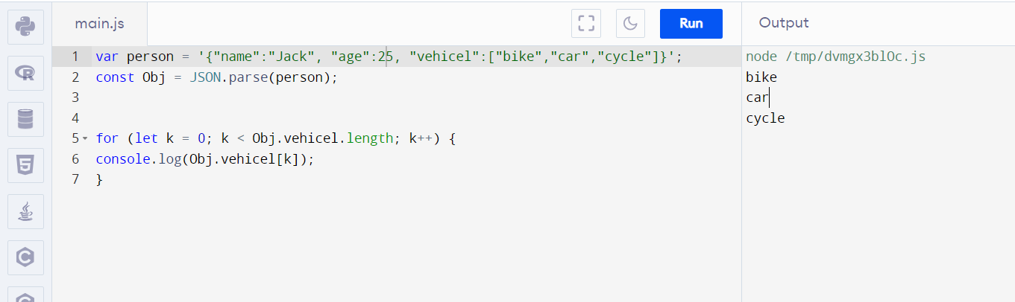

**2.Create your own resume data in JSON format**

Code:

var myresume = { "name":"Sumanya selvi R",

"Qualification":"B.sc computer science",

"Skills":"Web Designing",

"Known Language":"Tamil,English"

}

console.log(myresume);

Output:

{

name: 'Sumanya selvi R',

Qualification: 'B.sc computer science',

Skills: 'Web Designing',

'Known Language': 'Tamil,English'

}

