Web3 and Blockchain Basics: Wallet Setup and DApp Exploration
Submitted by: Satti Suma Date: November 28, 2025 Testnet Used: Sepolia Section 1: Documentation

MetaMask Installation:
Initially, I installed the MetaMask extension in my browser. After installation, I created a new wallet account and set a strong password. A 12-word secret recovery phrase was generated, which I saved securely. Once set up, my public wallet address became visible, allowing me to receive tokens or test ETH.
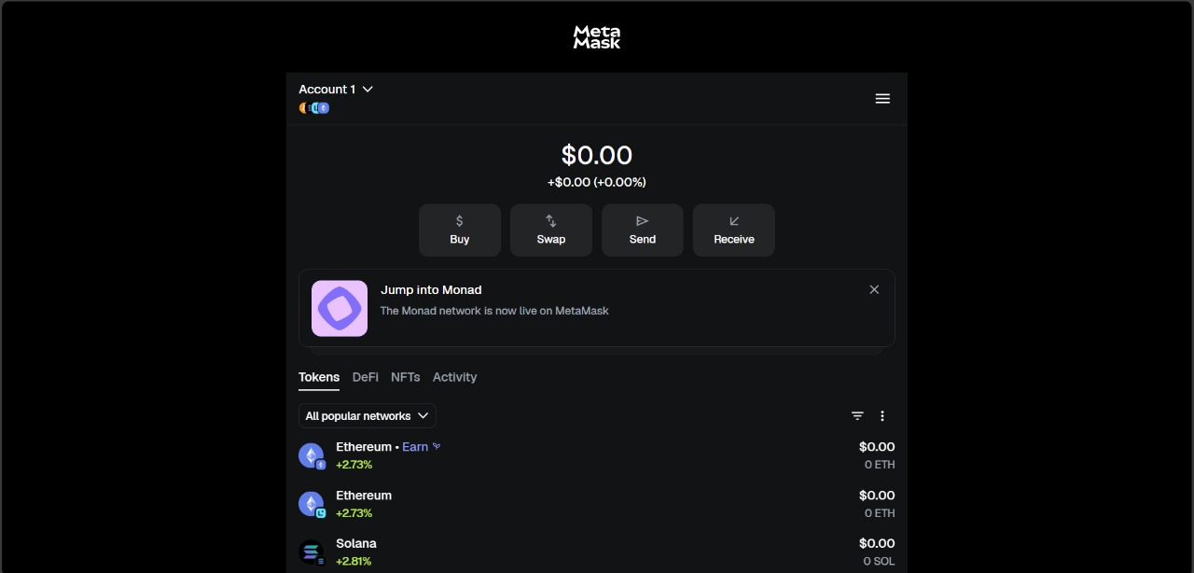

Network Configuration(Sepolia Testnet):
After installation, I enabled the Show Test Networks option in MetaMask settings and selected the Sepolia Test Network. This allows me to interact with blockchain applications without using real ETH. After that I visited the Sepolia Faucet site https://cloud.google.com/application/web3/faucet/ethereum/sepolia and entered my wallet address to request test ETH for testing transactions.

After a while, the ETH was credited to my wallet successfully.
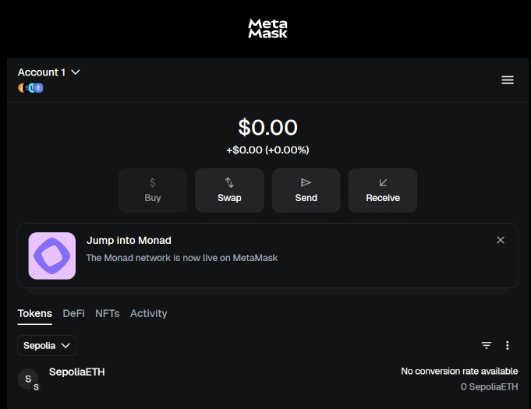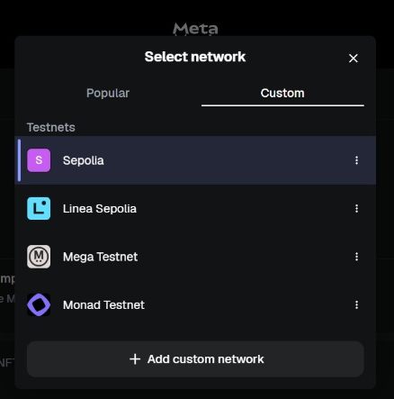

Testnet Balance:
After claiming ETH from the faucet, I verified the transaction on Sepolia Etherscan site TESTNET Sepolia (ETH) Blockchain Explorer to confirm the transfer was successful or not. The balance reflected in MetaMask as 0.05 SepoliaETH, which is sufficient to perform token swaps or interact with DApps.
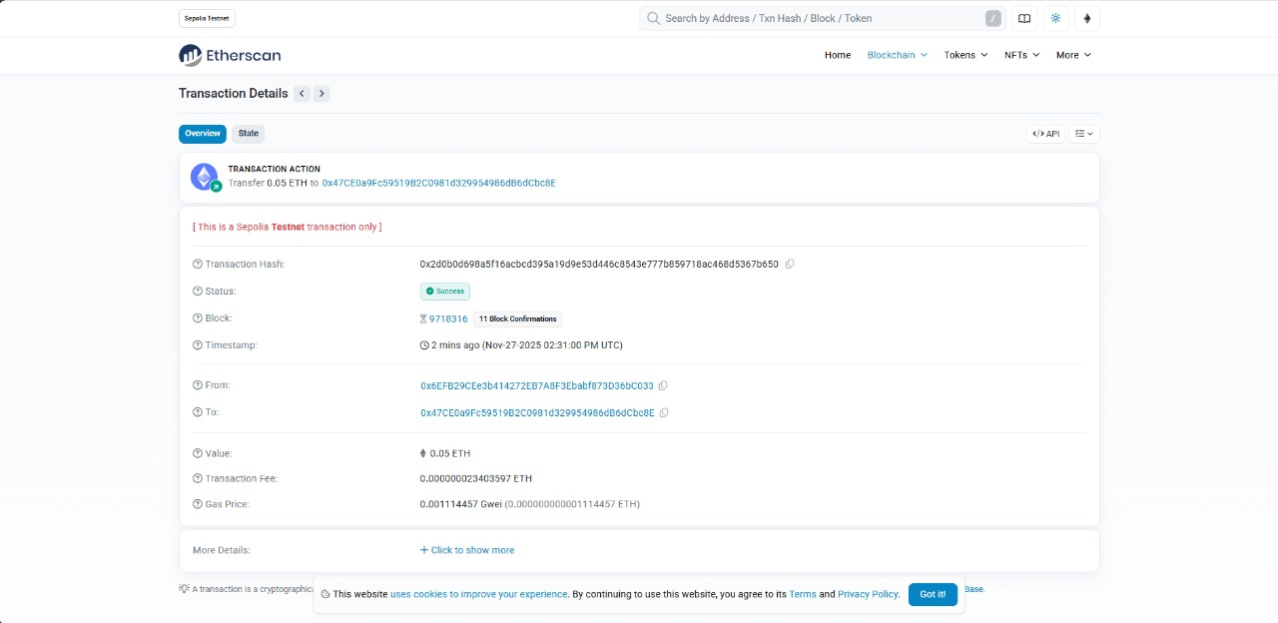

DApp Connection(Uniswap Testnet):
Next, I opened the Uniswap testnet site https://app.uniswap.org and connected my MetaMask wallet to the Sepolia Test Network. A MetaMask popup appeared

asking for approval to connect.After I got approval, my wallet address appeared at the top right corner of the page, which confirms the connection is done.
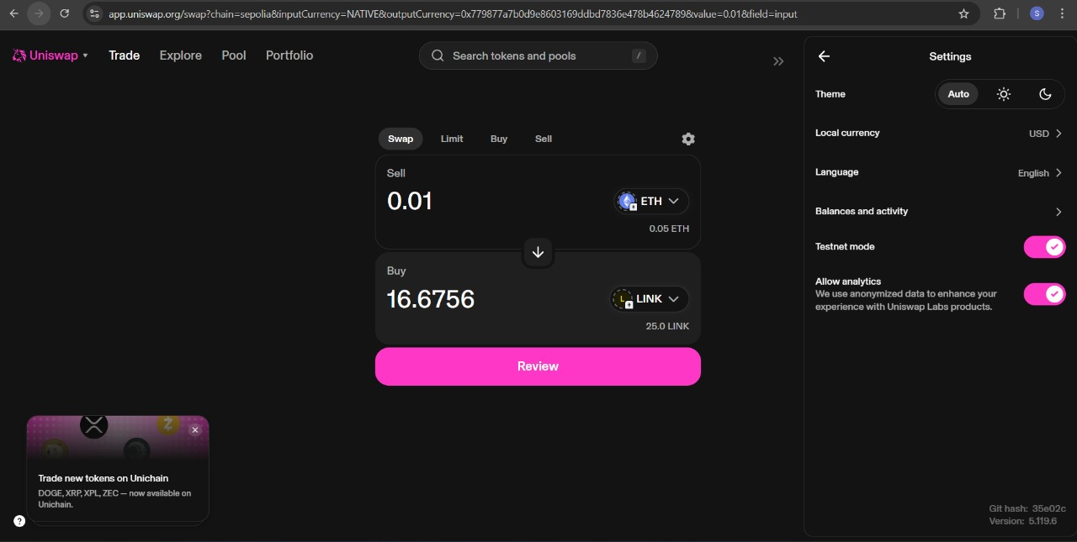

Completed Transaction(Token Swap):
I did a token swap on Uniswap, exchanging a small amount of SepoliaETH for a test token such as LINK. MetaMask automatically calculated the gas fees and displayed a confirmation window.
After submitting the transaction, it was successfully processed and confirmed on the Sepolia testnet.

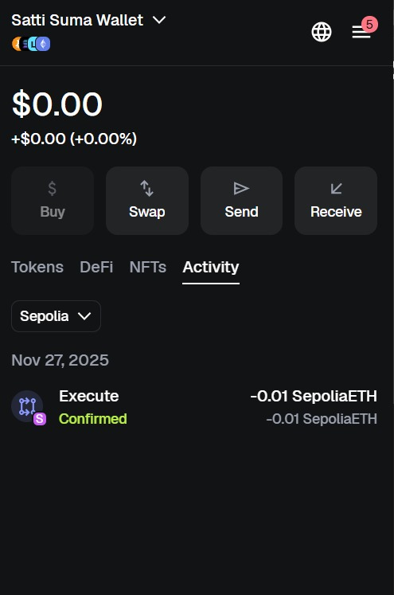

Summary
●◯ Wallet Used: MetaMask
●◯ Test Network : Sepolia Testnet
●◯ DApp Used: Uniswap (Testnet)
◯● Action Performed: Token swap (ETH -> LINK)
●◯ Trashaction Hashes : (Faucet + Swap)
●◯ Blockchain Explorer: Sepolia Etherscan

Section 2: Written Reflection

Introduction
Through this activity, I gained a clear and practical understanding of how blockchain technology, Web3 concepts, and decentralized applications (DApps) function in the real world. Before starting this project, I only had a vague idea about blockchain, but by setting up my wallet, obtaining testnet ETH, and interacting with DApps and also I understood how these systems work together to create a decentralized digital environment.

Key Blockchain Concepts
One of the key blockchain concepts I learned is that a blockchain is a distributed and immutable ledger. Unlike a traditional database managed by a single authority, a blockchain is maintained by thousands of computers (nodes) across the world. Every transaction is verified through a consensus mechanism like Proof of Work (PoW) or Proof of Stake (PoS), ensuring that no one can alter the data
once it’s recorded. I also understood how each block contains a cryptographic hash of the previous block, linking them securely and preventing tampering. This architecture creates transparency and trust among users without relying on a central authority.

Centralized vs. Decentralized Applications
Another major takeaway was understanding the difference between centralized and decentralized applications. Centralized apps, like social media or banking platforms, depend on a company or organization to manage user data and transactions. In contrast, decentralized applications run on blockchain networks where users maintain control over their data and assets through wallets. This gives users sovereignty — meaning they own their funds and identities instead of depending on intermediaries. For example, when I connected my MetaMask wallet to Uniswap, I didn’t need to create an account or give personal information, yet I could still make a transaction directly from my wallet.

Understanding Smart Contracts
Smart contracts were another fascinating concept. I learned that these are self-executing codes stored on the blockchain that automatically perform actions when specific conditions are met. For instance, in the Uniswap

DApp, the smart contract handled the entire swap process between tokens — verifying the input, calculating the exchange rate, and finalizing the transaction — without any human involvement. This automation reduces errors, increases efficiency, and removes the need for middlemen.

Wallet Security and Best Practices
While using MetaMask, I also learned important security practices. I realized how critical it is to protect the seed phrase and private keys, as losing them means losing access to the wallet permanently. I also learned to identify phishing attempts, always verify official URLs, and understand that no one should ever ask for your seed phrase.
This step helped me develop awareness about digital security and safe wallet management.

Challenges Faced and Solutions
Finally, I faced a few challenges during the process — such as configuring the test network, finding a working faucet, and connecting MetaMask with DApps.
Initially, I didn’t see the Sepolia network and had to enable test networks manually. Some faucets also took time to send test ETH, but I learned to verify each transaction on Etherscan to confirm it was completed. These challenges helped me build problem-solving skills and confidence in exploring decentralized tools.

Conclusion
This experience gave me a strong foundation in blockchain and Web3 concepts. I am able to understand how blockchain ensures transparency, how smart contracts enable trustless automation, and how wallets empower users to participate in a decentralized economy.
This hands-on learning helped me bridge the gap between theory and practical things, and now I feel confident in exploring emerging technologies like NFTs, DeFi, and decentralized identity systems.

Section 3: Technical Summary

Testnet Used:
I used the Sepolia Testnet for all blockchain interactions. This network was selected because it is one of the officially supported Ethereum testnets and works seamlessly with MetaMask and most DApps. It provides test Ether through reliable faucet services for conducting mock transactions without real financial risk.

DApp(s) Interacted With:
I interacted with the Uniswap DApp (Testnet version) to explore decentralized exchanges (DEXs) and understand how token swapping works on the blockchain. Additionally, I visited the OpenSea Testnet to learn about NFT transactions and listing processes, though some features were unavailable due to network restrictions.

Types of Transactions Performed:
- Faucet Transaction: Requested and received test Ether into my MetaMask wallet from the Sepolia faucet.
- Swap Transaction: Used Uniswap to perform a test token swap between ETH and a test token on the Sepolia network.
- Approval and Confirmation: Approved the transaction on MetaMask, observed gas estimation, and reviewed the transaction confirmation on the Sepolia Etherscan explorer.

Errors Encountered and Troubleshooting Steps:
Initially, the OpenSea testnet site did not load correctly, which was resolved by switching browsers and clearing cache data. I also faced a MetaMask connection issue that prevented the DApp from detecting my wallet; this was fixed by manually switching the network to Sepolia and reconnecting the wallet.
Additionally, slow transaction confirmation was observed due to high network activity, so I increased the gas fee slightly to ensure faster processing.

