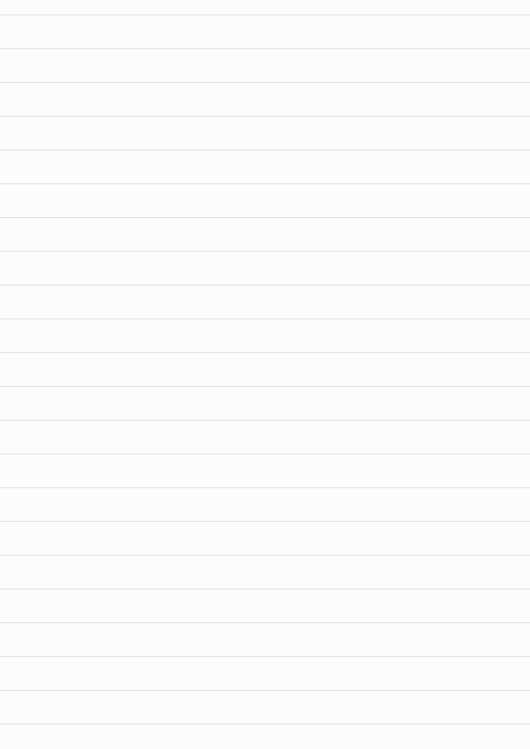

<!DOCTYPE html>

<html lang="en">

<head>

<meta charset="UTF-8">

<meta name="viewport" content="width=device-width, initial-scale=1">

<title>Suma Public School - Bengaluru</title>

<link href="https://fonts.googleapis.com/css2?family=Poppins:wght@400;600&display=swap" rel="stylesheet">

<style>

\* {

box-sizing: border-box;

margin: 0;

padding: 0;

}

body {

font-family: 'Poppins', sans-serif;



background: #f8f9fa;

color: #333;

line-height: 1.6;

}

header {

background: #004aad;

padding: 1rem 2rem;

color: white;

position: sticky;

top: 0;

z-index: 1000;

}

header h1 {

font-size: 1.8rem;

}

nav {

margin-top: 0.5rem;

}

nav a {

color: white;

margin: 0 1rem;



text-decoration: none;

font-weight: 500;

}

nav a:hover {

text-decoration: underline;

}

.hero {

background: url('https://images.unsplash.com/photo-1607083204528-7830d5b2f26f?auto=format&fit=crop&w=1470&q=80') no-repeat center center/cover;

height: 50vh;

display: flex;

justify-content: center;

align-items: center;

color: white;

text-shadow: 2px 2px 5px rgba(0,0,0,0.7);

text-align: center;

padding: 2rem;



}

.hero h2 {

font-size: 2.5rem;

animation: fadeInDown 1.5s ease;

}

@keyframes fadeInDown {

from {opacity: 0; transform: translateY(-50px);}

to {opacity: 1; transform: translateY(0);}

}

section {

padding: 2rem 5%;

}

.info {

background: white;

margin-bottom: 2rem;

padding: 2rem;

border-radius: 10px;

box-shadow: 0 4px 8px rgba(0,0,0,0.1);

transition: transform 0.3s;

}



.info:hover {

transform: translateY(-5px);

}

h2 {

color: #004aad;

margin-bottom: 1rem;

}

ul {

margin-left: 1.2rem;

}

.contact, .admissions {

background: #e9f2ff;

padding: 2rem;

border-radius: 10px;

}

footer {

text-align: center;

padding: 1.5rem;

background: #004aad;

color: white;

font-size: 0.9rem;



margin-top: 2rem;

}

@media (max-width: 768px) {

nav a {

display: block;

margin: 0.5rem 0;

}

.hero {

height: 30vh;

}

.hero h2 {

font-size: 1.8rem;

}

}

</style>

</head>

<body>

<header>

<h1>Suma Public School</h1>

<nav>



<a href="#location">Location</a>

<a href="#academics">Academics</a>

<a href="#facilities">Facilities</a>

<a href="#feedback">Feedback</a>

<a href="#contact">Contact</a>

<a href="#admissions">Admissions</a>

</nav>

</header>

<section class="hero">

<h2>Welcome to Suma Public School</h2>

</section>

<section id="location" class="info">

<h2>📍 Location</h2>

<p>1st Cross Road, G Narayanappa Layout, Hebbal Kempapura, Bengaluru, Karnataka 560024</p>

</section>

<section id="academics" class="info">



<h2>🏫 Academic Details</h2>

<ul>

<li><strong>Board:</strong> State Board (Karnataka)</li>

<li><strong>Grades Offered:</strong> Pre-Nursery to Class 10</li>

<li><strong>Medium of Instruction:</strong> English</li>

<li><strong>Class Strength:</strong> Approximately 40 students per class</li>

<li><strong>Annual Fee:</strong> ₹55,000</li>

</ul>

</section>

<section id="facilities" class="info">

<h2>🏢 Infrastructure & Facilities</h2>

<ul>

<li>Spacious classrooms</li>

<li>Library available</li>

<li>Digital boards and internet



connectivity</li>

<li>Indoor and outdoor sports facilities</li>

<li>School transport services</li>

<li>Basic safety measures in place</li>

</ul>

</section>

<section id="feedback" class="info">

<h2>🌟 Parent & Community Feedback</h2>

<p><strong>Overall Rating:</strong> 4.5/5</p>

<ul>

<li>Positive feedback on teaching quality and co-curricular activities</li>

<li>Praised for academic focus and timely completion of activities</li>

</ul>

</section>



<section id="contact" class="contact">

<h2>📞 Contact Information</h2>

<p><strong>Phone:</strong> +91 9538382711, 8884411233, 9448018191</p>

</section>

<section id="admissions" class="admissions">

<h2>🗓️ Admission Details</h2>

<ul>

<li><strong>Admission Start Month:</strong> Second week of December</li>

<li><strong>Minimum Age for Admission:</strong> 3.6 years</li>

</ul>

</section>

<footer>



<p>&copy; 2025 Suma Public School. All rights reserved.</p>

</footer>

</body>

</html>