Website

EngageMe is a Mobile App designed for colleges and their students. It can be used to communicate with both current and prospective students focusing on the courses, events, pictures, fees and latest updates. <http://engagedapp.com.au/>

**My Role:** UX/UI, Concept development, Wireframes, Visual Design, Web Optimised images

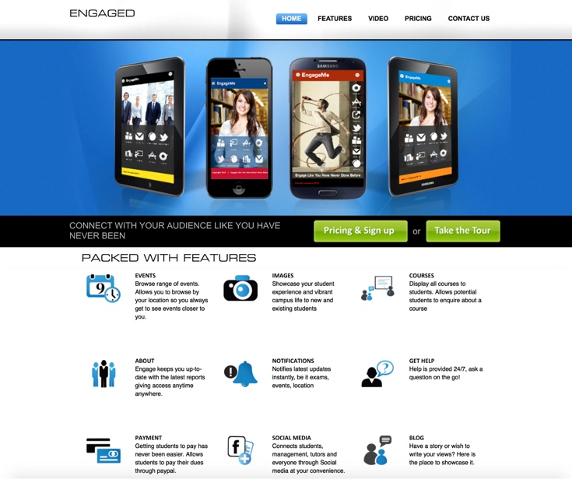

Inoa Fashions Australia, an online shopping for apparels for Retail stockists

<http://inoafashions.com/>

**My Role:** UX/UI, Concept development, Wireframes, Visual Design, Web Optimised images

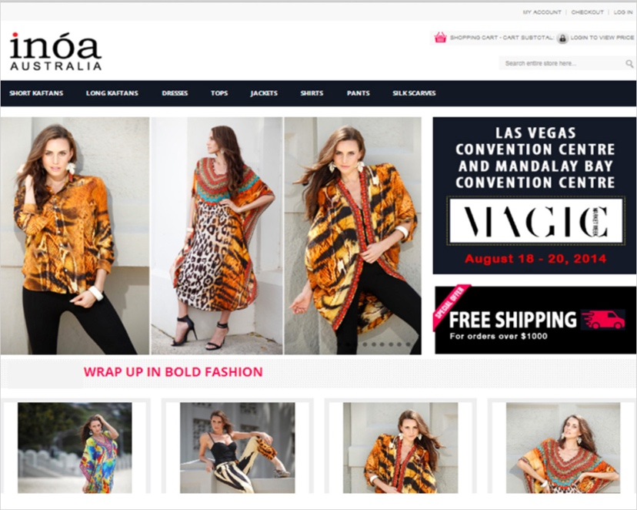

Capital Careers, Training Institute <http://www.capitalcareers.com.au/>

**My Role:** UX/UI, Concept development, Wireframes, Visual Design



Together Let’s- <http://togetherlets.com.au/>

**My Role:** Website redesign,Concept development, Visual Design, Web optimised images, icon creation

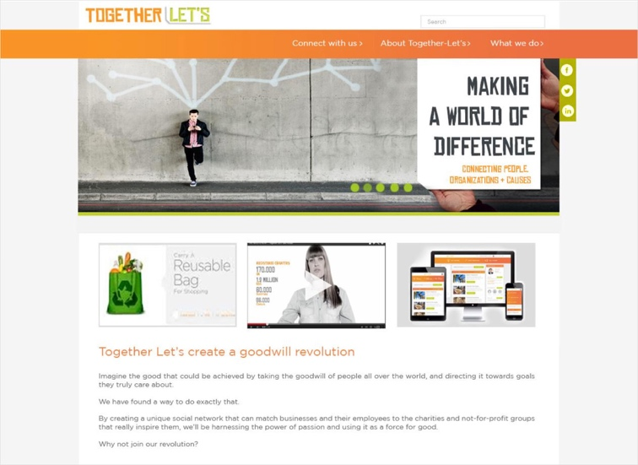

**Accenture India,** Web portal for client visits

**My Role:** Concept design, Paper prototypes, Wireframes, Visual Design, Design Specs, Web optimised images



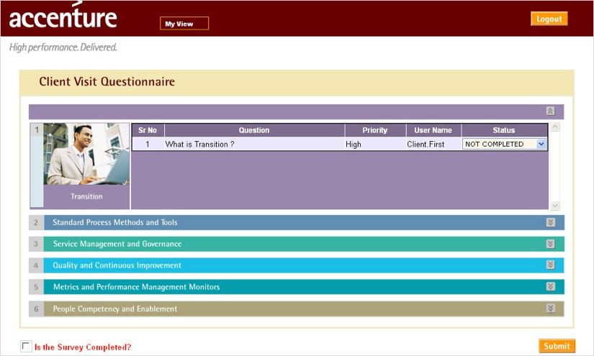

**Caricme** is a startup company which is into micro personalised gifting in India. <https://www.caricme.com/>

**My Role:** Concept development, UI, Visual Design, Photography

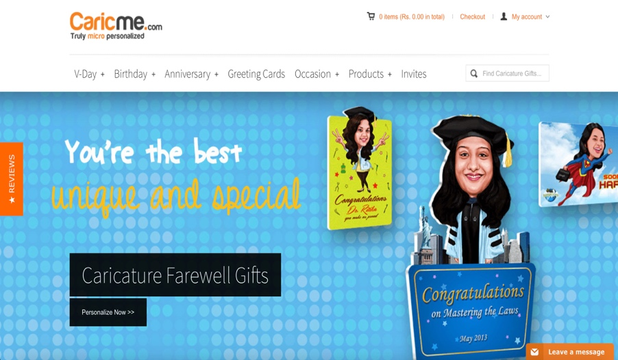

**The Chocolate Room** <http://thechocolateroom.com.au/>

**My Role:** Concept development, Wireframes, UI, Visual Design, Image retouching

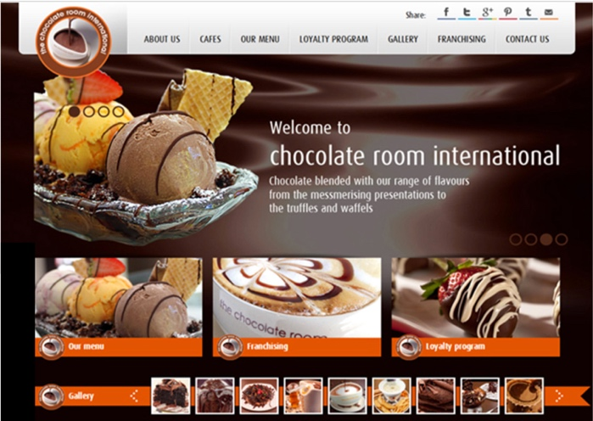

**Serve n Eat Homewares**, online shopping for household items <http://www.serveneat.com.au/>

**My Role:** UI design, Concept development, Typography

