**Software Requirements**

**Specification**

**for**

**Library Management System**

**Version 1.0 approved**

**Prepared by**

**K.Suma Smitha(15IT123)**

**8th January 2018**

# Table of Contents

Table of Contents 2

Revision History 2

1. Introduction 1

1.1 Purpose 1

1.2 Document Conventions 1

1.3 Intended Audience and Reading Suggestions 1

1.4 Product Scope 1

1.5 References 1

2. Overall Description 2

2.1 Product Perspective 2

2.2 Product Functions 2

2.3 User Classes and Characteristics 2

2.4 Operating Environment 2

2.5 Design and Implementation Constraints 2

2.6 User Documentation 2

2.7 Assumptions and Dependencies 3

3. External Interface Requirements 4

3.1 User Interfaces 4

3.2 Hardware Interfaces 4

3.3 Software Interfaces 4

3.4 Communications Interfaces 4

4. System Features 5

5. Other Nonfunctional Requirements 5

5.1 Performance Requirements 5

5.2 Safety Requirements 5

5.3 Security Requirements 5

5.4 Software Quality Attributes 5

5.5 Business Rules 5

6. Other Requirements 6

Appendix A: Glossary 6

Appendix B: Analysis Models 6

Appendix C: To Be Determined List 6

# Revision History

|  |  |  |  |
| --- | --- | --- | --- |
| **Name** | **Date** | **Reason For Changes** | **Version** |
|  |  |  |  |
|  |  |  |  |

# Introduction

## Purpose

This web application provides facility to manage a library. It saves time and strain to administrator of a library. Also it helps users finding and borrowing books easier. It also helps in maintaining the records of who borrowed a particular book and returned it, when the transactions happened. It also gives the users a chance to lodge complaints regarding library to the management.

## Document Conventions

This document was prepared using the IEEE recommended practice for Software Requirements Specification.

## Intended Audience and Reading Suggestions

The different types of reader that this document is intended for are developers, project managers, marketing stuff, users, testers and documentation writers. The rest of this SRS contains overall description, external interface, requirements, system features, non-functional requirements and other requirements. Suggested Sequence for this document- begin with the overview and proceed through the sections that are most pertinent to each reader type.

## Product Scope

Scope of this project is very broad compared to manually maintaining the records of a library. They are:

* This can be used in educational institutions’ as well as public libraries.
* User’s location doesn’t matter if he wants information about certain book, as it is a web application.
* No restriction on who can use the website for information about the library (or books).
* No manual work of preparing and storing the library records.
* Less time consumption for finding a book, as the registered number and o.ther details of the books are available on the website and are easily attainable
* For administrator it is useful because it reduces the amount of strain he should undergo for maintaining the records.

## References

## <https://en.wikipedia.org/wiki/Integrated_library_system>

## [http://dspace.cusat.ac.in/jspui/bitstream/123456789/8218/1/library%20management%20system.pdf](http://dspace.cusat.ac.in/jspui/bitstream/123456789/8218/1/library management system.pdf)

## http://www.iisjaipur.org/iiim-current-08/MCA_IV_Sem_Pro_Eva/11.Project-online%20library%20management%20system.pdf

# Overall Description

## Product Perspective

This is an online library management system which can be accessible via internet 24 hours a day, 7 days a week. The objective of this is to reach and connect the members of a library, people who want to use books in a library and the administrator. This application will allow only the registered users to borrow and view details of a borrowed book. Others can only see the author name and registered number of the book.

## Product Functions

The functions are divided according to the user types such as

* The administrator can add/delete the details of a book in the records.
* The administrator can only view all the details of all the books
* The users can view the details and borrowing status of a book.
* A non-registered user can only see limited details of a book.

## User Classes and Characteristics

The various users of this applications are classified into two types

* Administrator
* User

The application requires the user to have characteristics such as the user should be able to communicate and write in English. If not, the student should be instructed about the basics usage of the application.

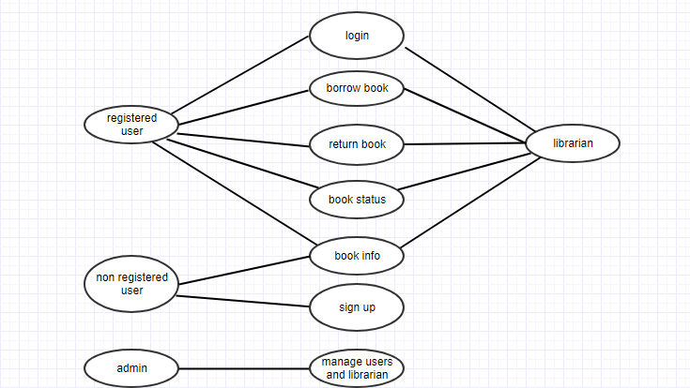

Figure 1: Use Case Diagram for library management system

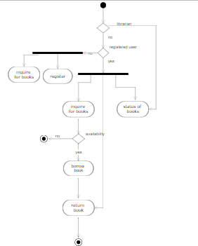 Figure 2: Activity Diagram for library management system

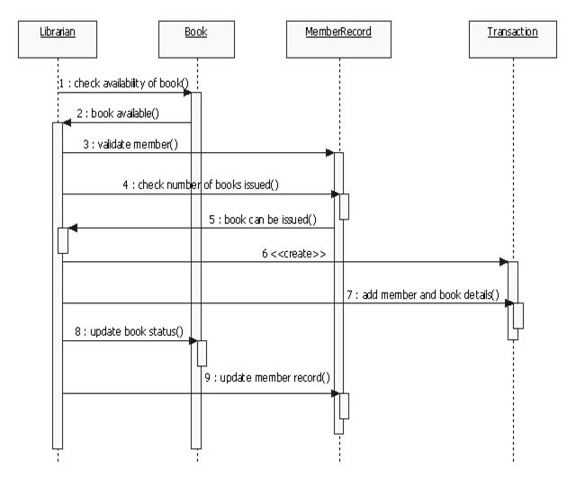 Figure 3: Sequence Diagram for library management system

## Operating Environment

This application runs with the environment of a web browser and internet connection is required if it is made online.

## Design and Implementation Constraints

This web application is usable for maintain only a single library. It cannot be used to maintain inter-connected libraries or different branches of a library.

## User Documentation

This product will include a user manual which includes the product overview, complete configuration of the required software and the hardware, technical details and contact details which will include the email address.

## Assumptions and Dependencies

There are some assumptions regarding this product.

* It is assumed that the user has basic knowledge of the system as any action by the user is considered valid when he is accessing the information.
* It is assumed that the data entered by the user while the registration is true.
* It is assumed that a user searches for information of valid and available books.

# External Interface Requirements

## User Interfaces

**Registration Screen:**

Various fields available on this screen will be:

Login name.

Email Id.

Password.

**Login Screen:**

Fields available on this screen will be:

Login name.

Password.

**Inquiry about books Screen:**

Various fields are:

Book name.

Optional fields:

Author name.

Book registered number.

**Result Displaying Screen:**

Various fields are:

Book name.

Author name.

Registered number of the book.

If the user is registered, then borrowing status.

## Hardware Interfaces

Screen Resolution of at least 800X600 is required for proper and complete viewing of screens. Higher Resolution can also be accepted.

## Software Interfaces

Any windows based operating system.

Mysql Server Database.

PHP and JavaScript.

## Communications Interfaces

None

# System Features

Some Performance requirements identified is listed below:

The database shall be able to accommodate a minimum of 1,000 records of Users.

The database shall also be able to accommodate information of a minimum of 1500 books

There are no other specific performance requirements that will affect development

# Other Nonfunctional Requirements

## Performance Requirements

The system must be interactive and the delays involved must be less .So in every action-response of the system, there are no immediate delays. In case of opening windows forms, of popping error messages and saving the settings or sessions there is delay much below 2 seconds, In case of opening databases, sorting questions and evaluation there are no delays and the operation is performed in less than 2 seconds for opening ,sorting, computing, posting > 90% of the files. Also when connecting to the server the delay is based on editing the distance of the 2 systems and the configuration between them so there is high probability that there will be or not a successful connection in less than 25 seconds for sake of good communication.

## Safety Requirements

The database may get crashed at any certain time due to virus or operating system failure. Therefore it is required to take the database backup.

## Security Requirements

Some of the factors that are identified to protect the software from accidental of malicious access, use, modification below. Keep specific log or history datasets.

## Software Quality Attributes

The quality of the system is maintained in such a way so that it can be very user friendly to all the users. The software quality attributes are assumed as under:

* Accurate and hence reliable.
* Secured.
* Fast speed.
* Compatibility.

## Business Rules

* Registered users can search for the information of a book.
* Registered users can borrow, return a book.
* Librarian can maintain the records in the library, approve the issue of books.
* Administrator can manage all the accounts and functions of the system.

# Other Requirements

A database is maintained to store all the information about all books and also the information about users and the admins.

# Appendix A: Glossary

# Appendix B: Analysis Models

# Appendix C: To Be Determined List