d1 = read.csv('Q9_a.csv',header=TRUE, sep=",")

####Top 10 rows and last 10 rows

head(d1,10)

tail(d1,10)

summary(d1)

d1$speed

###########Summary of the data#########

summary(d1$speed)

summary(d1$dist)

#####################

plot(d1$speed)

plot(d1$speed,d1$dist)

# points and lines

plot(d1$speed, type= "b") # p: points, l: lines,b: both

plot(d1$speed, xlab = 'index',

ylab = 'speed', main = 'speed vs distance',

col = 'blue')

# Horizontal bar plot

barplot(d1$speed, main = 'speed vs distance',

ylab = 'speed', col= 'red',horiz = T)

#Histogram

hist(d1$dist)

hist(d1$speed)

hist(d1$dist,

main = 'distance in metres',

xlab = 'distance.', col='blue')

hist(d1$speed,

main = 'speed in km',

xlab = 'speed.', col='red')

#Single box plot

boxplot(d1$speed,main="Boxplot")

# Multiple box plots

boxplot(d1[,1:3],main='Multiple')

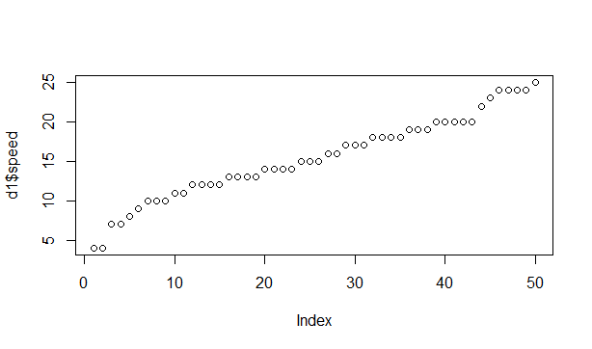

Linear growth of speed

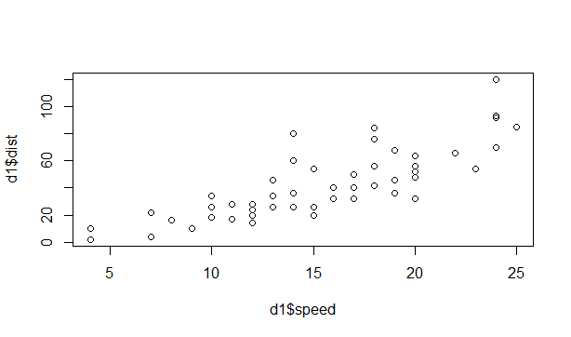

Speed vs distance

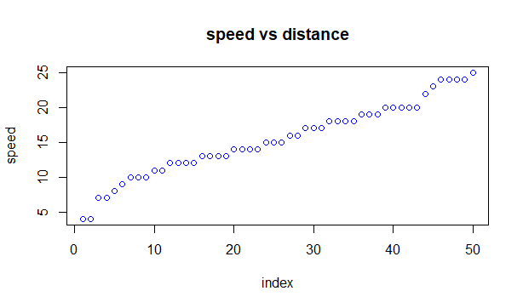

Histogram of speed shows that the speed shows left skewed.

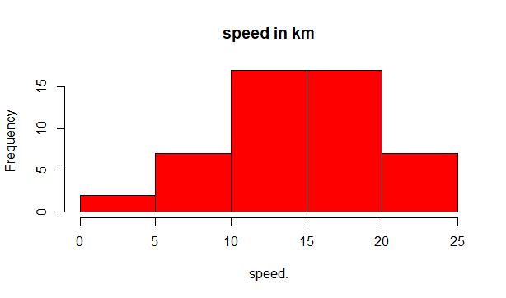

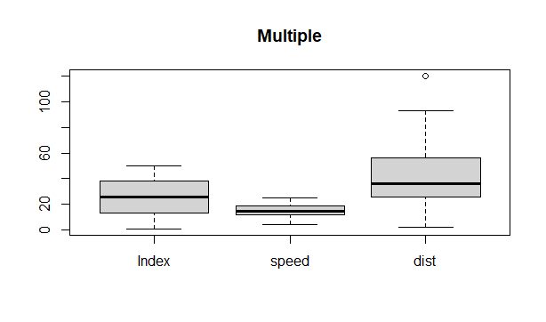

Distance is right skewed and speed is also right skewed.

