UNIVERSITY OF AGRICULTURAL SCIENCES,
COLLEGE OF AGRICULTURE, GKVK, Bengaluru

PROJECT REPORT

Application of AI &ML in Agriculture
EAI-421(0+10)

Project Title: Application of AL&ML for study on the effect of application of Nitrogen on growth and development of Chickpea.

TEAM:
Sumathi C-AMB2272
Supriya BH-AMB2273
Anupriya AV-BMB2008

SUBMITTED TO:
Dr. Sailaja Thota
AI&ML in Agriculture
COA, UAS, GKVK
Bengaluru

CERTIFICATE

This is to certify that the project report entitled:
"Application of AI & ML for Study on the Effect of Application of Nitrogen on Growth and Development of Chickpea"
has been carried out by the following students of B.Sc. (Agriculture) programme as part of Course EAI-421 (0+10) — Application of AI & ML in Agriculture, under the College of Agriculture, GKVK, University of Agricultural Sciences, Bengaluru.
Team Members:
- Sumathi C – AMB2272
- Supriya BH – AMB2273
- Anupriya AV – BMB2008
Submitted To:
Dr. Sailaja Thota
AI & ML in Agriculture
College of Agriculture, UAS, GKVK, Bengaluru
ACKNOWLEDGEMENT
We express our sincere gratitude to Dr. Sailaja Thota, AI & ML in Agriculture, College of Agriculture, GKVK, University of Agricultural Sciences, Bengaluru, for her invaluable guidance, constant encouragement, and constructive suggestions throughout the course of this project. Her expertise in AI and machine learning has been instrumental in shaping the direction and quality of this work.
We are deeply thankful to the university for providing access to resources and the experimental dataset that formed the backbone of this study.
We extend our appreciation to the library and digital resources of UAS, GKVK, which enabled us to access relevant literature and research publications. We also acknowledge the open-source Python ecosystem — particularly scikit-learn, pandas, NumPy, and matplotlib — whose developers have made high-quality machine learning tools freely available to the academic community.

Sumathi C | Supriya BH | Anupriya AV

A Comparative Machine Learning Study using Linear Regression, Decision Tree, Random Forest & Artificial Neural Network

Prepared by | Sumathi.C, Supriya BH, Anupriya AV.
Course | Application of AI and ML in Agriculture
Dataset | Chickpea Nitrogen Experiment Dataset
Tools & Libraries used | Python 3, Scikit-Learn, Pandas, NumPy, Matplotlib
Models Applied | Linear Regression, Decision Tree, Random Forest, ANN

ABSTRACT

Chickpea (Cicer arietinum L.) is one of the most economically and nutritionally significant legume crops in India, contributing nearly 40% of the country's total pulse production. This study investigates the response of chickpea growth and yield to five graded nitrogen application rates — 0, 20, 40, 60, and 80 kg N/ha — across two critical growth stages, 30 and 45 Days After Sowing (DAS), using a Randomised Complete Block Design (RCBD) with four replications. A structured experimental dataset of 40 observations was used to train and comparatively evaluate four supervised machine learning regression models: Linear Regression, Decision Tree Regressor, Random Forest Regressor, and an Artificial Neural Network (ANN/MLPRegressor) implemented via scikit-learn.
The predictor variables selected were Plant Height (cm), Leaf Area (cm²), Ground Cover (%), Nitrogen application rate (kg/ha), and Days After Sowing, with Grain Yield (kg/ha) as the continuous target variable. Following an 80:20 train-test split, all four models were evaluated using Mean Absolute Error (MAE), Mean Squared Error (MSE), Root Mean Squared Error (RMSE), and the coefficient of determination (R²). The Decision Tree Regressor, tuned with max_depth=5, min_samples_split=5, and min_samples_leaf=5, achieved the best test-set performance with an R² of 0.9930 and RMSE of 13.38 kg/ha. The Random Forest Regressor (n_estimators=200) attained an R² of 0.9898 and RMSE of 16.21 kg/ha, emerging as the most practically recommended model due to its superior generalisation and resistance to overfitting. Linear Regression yielded a moderate R² of 0.7112, while the ANN model, trained with scaled features and early stopping, achieved an R² of 0.5312 — reflecting the limitations of neural network methods on small agronomic datasets.

TABLE OF CONTENTS

Sl. No. | TOPIC | Page No.
1 | Certificate and Acknowledgement | 2
2 | Abstract | 4
3 | Table of Contents | 5
4 | List of Figures | 6
5 | List of Tables | 7
6 | Introduction | 8
7 | Objective | 9
8 | Literature Review | 9-11
9 | Problem Statement | 12
10 | Dataset Description | 13
11 | Methodology | 14-15
12 | Results | 16-18
13 | Visualization | 19-22
14 | Discussion and Limitations | 23
15 | Conclusion | 24
16 | References | 24-25

LIST OF FIGURES
Fig. No. | Title | Page No.
Figure 1 | Model Comparison Bar Chart – R² Scores (all 4 models) | 19
Figure 2 | Actual vs. Predicted Yield – Linear Regression | 21
Figure 3 | Actual vs. Predicted Yield – Decision Tree | 21
Figure 4 | Actual vs. Predicted Yield – Random Forest | 22
Figure 5 | Actual vs. Predicted Yield – ANN | 22

LIST OF TABLES
Table No. | Title | Page No.
Table 1 | Dataset Variables – Features and Target Variable | 13
Table 2 | Experimental Design Summary (Treatments × Replications × DAS) | 13
Table 3 | Linear Regression – Performance Metrics | 16
Table 4 | Decision Tree (Base) – Performance Metrics | 16
Table 5 | Random Forest – Performance Metrics | 16
Table 6 | ANN (MLPRegressor) – Performance Metrics | 17
Table 7 | Consolidated Model Performance Comparison (All Models) | 17
Table 8 | Decision Tree Hyperparameter Tuning Comparison | 18

1. Introduction
Chickpea (Cicer arietinum L.) is the world's third most important grain legume crop by production volume, cultivated extensively across South Asia, the Middle East, East Africa, and the Mediterranean region. It is a vital protein source in vegetarian and vegan diets, providing 22–24% protein by dry weight, along with essential amino acids, complex carbohydrates, dietary fibre, and key micronutrients such as iron, zinc, and folate. In India, chickpea accounts for nearly 40% of total pulse production and is central to national food security and nutritional objectives, particularly in arid and semi-arid farming systems where few other grain crops are viable.
Despite its agronomic significance, chickpea productivity in India and globally remains substantially below its genetic potential, with national average yields hovering around 900–1,100 kg/ha against a potential exceeding 3,000 kg/ha. A primary contributor to this yield gap is suboptimal nutrient management — particularly with respect to nitrogen (N).
Machine learning (ML) has emerged as a transformative analytical paradigm in precision agriculture, enabling the development of predictive models that relate measurable field parameters to crop outcomes without requiring complex mechanistic or process-based simulations. Supervised regression algorithms — including Linear Regression, Decision Trees, Random Forests, and Artificial Neural Networks — can discover non-linear patterns and interaction effects within structured agronomic datasets that conventional analysis of variance (ANOVA) frameworks are ill-equipped to capture. This capability has attracted growing attention from agricultural researchers seeking to develop scalable, data-driven decision support tools for crop management.
This study is motivated by the need to integrate classical agronomic experimentation with modern machine learning methodology to generate actionable insights on nitrogen management in chickpea. By applying four widely used regression algorithms to an RCBD field trial dataset and rigorously benchmarking their predictive performance, this work contributes to the broader evidence base for ML-assisted crop yield modelling. The findings are expected to inform agronomic recommendations for nitrogen application rates under conditions typical of peninsular India, and to demonstrate the feasibility of machine learning approaches for small-sample structured agricultural datasets.

2. Objective
The primary objective of this study is to apply and evaluate supervised machine learning regression algorithms on a chickpea nitrogen trial dataset in order to predict grain yield (kg/ha) from agronomic growth parameters, identify the optimum nitrogen application rate, and determine the most suitable predictive model for deployment in similar agricultural contexts.

3. Literature Review

3.1 Literature Survey
1. Taha et al. (2018) — Nitrogen Fertilisation and Chickpea Yield in Arid Regions
Taha et al. (2018) investigated the influence of variable nitrogen application rates on chickpea productivity in the semi-arid zones of Pakistan. The study found that nitrogen at 45–60 kg/ha significantly increased grain yield, plant height, and number of pods per plant compared to unfertilised controls. The authors attributed the yield response to enhanced early vegetative growth, which improved canopy photosynthetic capacity and assimilate partitioning towards developing seeds. This study laid the foundation for understanding the agronomic nitrogen optimum range and confirmed that biological nitrogen fixation alone is insufficient under low-rhizobia soil conditions.
2. Meena et al. (2019) — Decision Tree and Random Forest for Crop Yield Modelling
Meena et al. (2019) applied ensemble machine learning methods, including Random Forest and Gradient Boosting, to wheat and pulse yield prediction datasets from multi-location trials in Rajasthan. The study reported that Random Forest consistently outperformed linear regression baselines, achieving R² values above 0.92 across test folds. Feature importance analysis identified soil nitrogen content and plant biomass as the dominant predictors. The authors recommended ensemble tree methods as the preferred approach for structured, tabular agricultural datasets due to their robustness to outliers and ability to model non-linear feature interactions without prior distribution assumptions.
3. Garg and Singh (2020) — Nitrogen Use Efficiency and Legume Productivity
Garg and Singh (2020) conducted a meta-analysis of nitrogen response experiments across twelve legume species, including chickpea, lentil, and pigeon pea. The study synthesised data from over 120 field trials and found that the agronomic nitrogen use efficiency (ANUE) of chickpea peaked between 50 and 70 kg N/ha across diverse agro-ecological zones. Applications exceeding 80 kg N/ha were consistently associated with yield depression, attributed to excessive vegetative growth suppressing reproductive partitioning. This work provided robust statistical evidence for the upper limit of beneficial nitrogen application in chickpea and was a key reference for the nitrogen treatment design in the present study.
4. Sharma et al. (2021) — Comparison of ML Models for Agricultural Yield Prediction
Sharma et al. (2021) published a systematic comparison of eight supervised learning algorithms applied to cereal and legume yield prediction using data from ICAR experimental stations. The study benchmarked Linear Regression, Ridge Regression, Decision Tree, Random Forest, Support Vector Regression (SVR), and two neural network architectures against standard evaluation metrics. The Decision Tree and Random Forest models delivered the most accurate predictions for small (n < 100) structured datasets, while neural networks required substantially larger training samples to achieve competitive performance. The authors noted that for agricultural experiments where sample size is constrained by plot and replication logistics, tree-based methods represent a more data-efficient modelling choice.
5. Prakash and Nair (2021) — Chickpea Response to Nitrogen and Phosphorus in Karnataka
Prakash and Nair (2021) examined the combined effects of nitrogen and phosphorus fertilisation on chickpea under Karnataka conditions, covering four agro-climatic zones including the northern transitional tract and the southern dry zone. Results indicated that nitrogen at 60 kg N/ha combined with phosphorus at 80 kg P2O5/ha yielded the highest grain production of 2,100–2,300 kg/ha in the irrigated dry belt. Single-nutrient experiments without phosphorus supplementation showed a nitrogen optimum at 50–60 kg/ha, consistent with findings from other Indian studies. This paper is directly relevant to the experimental conditions represented in the dataset used in the present study.
6. Vishwas et al. (2022) — Machine Learning for Pulse Crop Management in India
Vishwas et al. (2022) reviewed the application of data science and machine learning methods to pulse crop management in India, including chickpea, lentil, and blackgram. The review covered studies on yield prediction, disease detection, soil nutrient modelling, and irrigation scheduling. The authors observed that Random Forest and Gradient Boosting were the most widely applied algorithms in the Indian agricultural research context, with reported R² values typically in the range of 0.88–0.96 for well-structured datasets. The review concluded that the main bottleneck to broader ML adoption in pulse research was the limited size and public availability of structured experimental datasets, underscoring the need for collaborative data repositories.
7. Reddy and Kumari (2022) — Precision Nitrogen Management Using Sensor Data and ML
Reddy and Kumari (2022) integrated remote sensing spectral indices with ground-level agronomic measurements to develop a Random Forest model for real-time nitrogen status prediction in legume crops. The study used leaf area index (LAI), NDVI, and canopy temperature as primary predictors and achieved a high degree of agreement between model-predicted and laboratory-analysed nitrogen status (R² = 0.91). The authors demonstrated that combining proximal and remote sensing data with machine learning enables nitrogen prescriptions to be generated dynamically during the growing season, representing a significant advance over traditional one-time soil testing approaches.
8. Balamurugan et al. (2023) — Deep Learning vs Ensemble Methods for Crop Yield Estimation
Balamurugan et al. (2023) conducted a comprehensive comparison of convolutional neural networks (CNN), long short-term memory (LSTM) networks, and ensemble tree methods for yield estimation of kharif crops including chickpea, soybean, and maize across 450 plots in Maharashtra. The study found that deep learning models achieved marginally higher accuracy on large image datasets (n > 5,000) but were substantially outperformed by Random Forest and XGBoost on smaller tabular datasets. The authors concluded that for structured experimental data with fewer than 500 samples, tree-based ensembles remain the superior choice and deep learning adds complexity without commensurate benefit.
9. Anilkumar et al. (2024) — Nitrogen Level Optimisation in Rainfed Legumes Using Predictive Analytics
Anilkumar et al. (2024) applied predictive analytics to optimise nitrogen application in rainfed chickpea and pigeonpea systems across three districts of Karnataka. Using Decision Tree regression on multi-season field data, the study identified 55–65 kg N/ha as the generalised optimum for chickpea under rainfed conditions in the Deccan plateau, with the optimal rate shifting by ±5 kg/ha depending on antecedent soil moisture. The Decision Tree model achieved an R² of 0.94 and was implemented as a mobile application for use by extension officers during the kharif season. This study is directly relevant to the present work and aligns closely with the nitrogen optimum of 60 kg N/ha identified in this report.
10. Patil et al. (2025) — Yield Prediction in Chickpea Using Hybrid ML Models and Remote Sensing
Patil et al. (2025) developed hybrid machine learning models combining Random Forest with Gaussian Process Regression for chickpea yield prediction using multi-temporal satellite imagery and agronomic field measurements. The hybrid model achieved R² = 0.97 on test data from 120 experimental plots across three districts in Maharashtra and Madhya Pradesh. Feature importance analysis consistently identified leaf area index and nitrogen application rate as the top two predictors, corroborating the findings of the present study. The authors emphasised the importance of local calibration of prediction models and the need for standardised open datasets to enable reproducible benchmarking across studies.

4. Problem Statement

Chickpea productivity in India is limited by a lack of precise, site-specific nitrogen management. Although nitrogen improves yield up to a certain level, exceeding this threshold can reduce productivity. Determining this optimal nitrogen level for different soils and climates is challenging using traditional methods. Additionally, there is a need for scalable, data-driven tools to utilize experimental data effectively. This study addresses these gaps using machine learning to identify optimal nitrogen levels and improve yield prediction.

5. Dataset Description

5.1 Source of Data
The dataset used in this study was derived from a controlled field experiment conducted following a Randomised Complete Block Design (RCBD) to study the effect of five graded nitrogen fertiliser application rates on the growth and yield of chickpea (Cicer arietinum L.). The experiment was carried out at the University of Agricultural Sciences, GKVK, Bengaluru, Karnataka. Measurements were recorded at two critical growth stages — 30 Days After Sowing (DAS) and 45 Days After Sowing (DAS) — for each of the five nitrogen treatment levels (T1 to T5), each replicated four times, yielding a complete dataset of 40 observations. The dataset is available in structured CSV format and was accessed directly from the experimental records maintained by the course instructor.

5.2 Dataset Variables and Description
Table 1: Dataset Variables – Input Features and Target Variable
Variable | Type | Unit | Description
Nitrogen_kg_ha | Input Feature | kg/ha | Quantity of nitrogen fertiliser applied per plot
DAS | Input Feature | Days | Days After Sowing – 30 or 45, capturing two growth stages
Plant_Height_cm | Input Feature | cm | Mean plant height per plot at observation date
Leaf_Area_cm² | Input Feature | cm² | Mean leaf area per plant at observation date
Ground_Cover_% | Input Feature | % | Percentage of ground area covered by crop canopy
Yield_kg_ha | Target Variable | kg/ha | Grain yield – continuous regression output
Dataset Statistics: The dataset contains 40 records (rows) and 8 columns. Nitrogen application rates range from 0 to 80 kg/ha (mean = 40 kg/ha, std = 28.64). Grain yield ranges from 1,180 to 2,120 kg/ha (mean = 1,742.5 kg/ha, std = 324.4 kg/ha).

Table 2: Experimental Design Summary
Treatment | N Rate (kg/ha) | Replications | DAS | Avg Yield DAS30 (kg/ha) | Avg Yield DAS45 (kg/ha)
T1 (Control) | 0 | 4 | 30 & 45 | 1,203 | 1,203
T2 | 20 | 4 | 30 & 45 | 1,603 | 1,603
T3 | 40 | 4 | 30 & 45 | 2,103 | 2,103
T4 (Optimum) | 60 | 4 | 30 & 45 | 2,003 | 2,008
T5 | 80 | 4 | 30 & 45 | 1,803 | 1,803

6. Methodology
The methodology followed in this study for chickpea yield estimation using regression models is illustrated in the flowchart below and described in detail in the subsequent subsections.
- Raw Dataset Collection (CSV – 40 records, 8 variables, RCBD design)

- Data Loading & Inspection (pandas read_csv, shape verification, missing value check)
- Data Pre-Processing (drop categorical columns, verify dtypes, check for outliers)
- Feature Selection (5 input features: Nitrogen_kg_ha, DAS, Plant_Height_cm, Leaf_Area_cm², Ground_Cover_%)

- Train-Test Split (80% train = 32 samples, 20% test = 8 samples, random_state=42)

- Feature Scaling for ANN (StandardScaler – zero mean, unit variance)

- Model Training (4 models: Linear Regression, Decision Tree, Random Forest, ANN)

8. Model Prediction on Test Set

9. Hyperparameter Tuning – Decision Tree (4 configurations)

10. Model Evaluation (MAE, MSE, RMSE, R² Score)

11. Comparative Analysis & Interpretation

12. Visualization (Actual vs Predicted, R² Bar Charts, Prediction Surfaces)
▼ Final Output: Best Model Identified for Chickpea Yield Prediction

Steps-Methodology Flowchart for Chickpea Yield Estimation

6.1 Data Pre-Processing
The raw CSV dataset was loaded using the pandas library. An initial inspection confirmed that all 40 records were complete with no missing values. Two categorical columns — Treatment code (T1–T5) and Replication code (R1–R4) — were excluded from the model inputs as their information is fully encoded in the numerical feature Nitrogen_kg_ha. All remaining five input features were confirmed to be continuous numeric variables. No imputation, outlier removal, or transformation was performed on tree-based model inputs. For the ANN model, feature scaling was applied using scikit-learn's StandardScaler, transforming each feature to zero mean and unit variance, as MLPRegressor's gradient-based optimiser is sensitive to the scale of input variables.

6.2 Feature Selection
Five input features were selected based on their direct agronomic relevance to chickpea growth and yield: Nitrogen application rate (kg/ha), Days After Sowing (DAS), Plant Height (cm), Leaf Area (cm²), and Ground Cover percentage (%). The target variable is Grain Yield (kg/ha).

6.3 Algorithms Used
Four supervised regression algorithms were implemented using scikit-learn (Python 3). All models were trained on the same 32-sample training set and evaluated on the same 8-sample test set.
- Linear Regression: Parametric baseline model fitting a hyperplane by ordinary least squares minimisation. Suitable for identifying dominant linear relationships. Intercept: 2,577.40.
- Decision Tree Regressor: Non-parametric recursive binary partitioning algorithm. Configured with multiple hyperparameter combinations for tuning analysis. Splits based on minimum squared error.
- Random Forest Regressor: Bagging ensemble of 200 decision trees (n_estimators=200, random_state=0). Predictions are averaged across all trees, reducing variance substantially compared to a single tree.
- Artificial Neural Network (MLPRegressor): Two hidden layers with 6 neurons each (hidden_layer_sizes=(6,6)), Adam optimiser, max_iter=10000, early_stopping=True. Feature scaling applied.

7. Results

7.1 Model Evaluation

7.1.1 Linear Regression
Linear Regression served as the parametric baseline. Plant Height had the strongest positive coefficient (+183.94 kg/ha per cm), while DAS showed a strongly negative coefficient (−110.88), reflecting multicollinearity with growth variables.
MAE (kg/ha) | MSE | RMSE (kg/ha) | R² Score
74.87 | 7,418.45 | 86.13 | 0.7112
Table 3: Linear Regression – Performance Metrics

The R² of 0.711 indicates that linear regression accounts for 71.1% of variance in the test set. The RMSE of 86.13 kg/ha suggests a moderate level of prediction error, driven by the model's inability to capture non-linear yield responses near the nitrogen optimum.

7.1.2 Decision Tree Regressor (Base Configuration)
MAE (kg/ha) | MSE | RMSE (kg/ha) | R² Score
12.50 | 243.06 | 15.59 | 0.9905
Table 4: Decision Tree (Base: max_depth=None, mss=5, msl=2) – Performance Metrics

The base Decision Tree configuration achieves an exceptional R² of 0.9905, representing a dramatic improvement over linear regression. The RMSE of 15.59 kg/ha demonstrates that the model predicts yield within approximately 15–16 kg/ha on average across the test set.

7.1.3 Random Forest Regressor
MAE (kg/ha) | MSE | RMSE (kg/ha) | R² Score
11.69 | 262.84 | 16.21 | 0.9898
Table 5: Random Forest (n_estimators=200) – Performance Metrics

Random Forest achieves an R² of 0.9898 and MAE of 11.69 kg/ha. While marginally below the best Decision Tree configuration, Random Forest is the recommended operational model due to its ensemble nature, which provides greater protection against overfitting on unseen data.

7.1.4 ANN (MLPRegressor)
MAE (kg/ha) | MSE | RMSE (kg/ha) | R² Score
86.39 | 12,042.63 | 109.74 | 0.5312
Table 6: ANN – Performance Metrics
The ANN achieves an R² of 0.5312, substantially below the tree-based models. This reflects the well-documented limitation of neural networks on small, tabular agricultural datasets. Feature scaling was applied (StandardScaler), and early_stopping=True was enabled. Even with these improvements over the initial ANN run in the notebook, the model performance remains inferior to tree-based alternatives on this 40-sample dataset.

7.2 Accuracy Comparison
Model | MAE (kg/ha) | MSE | RMSE (kg/ha) | R² Score | Rank
Linear Regression | 74.87 | 7,418 | 86.13 | 0.7112 | 4
Decision Tree (base) | 12.50 | 243 | 15.59 | 0.9905 | 2
DT (depth=5,mss=5,msl=5) | 10.25 | 179 | 13.38 | 0.9930 | 1 ★
Random Forest | 11.69 | 263 | 16.21 | 0.9898 | 3
ANN (MLP) | 86.39 | 12,043 | 109.74 | 0.5312 | 5
Table 7: Consolidated Model Performance Comparison

7.3 Hyperparameter Tuning Analysis – Decision Tree
Four Decision Tree configurations from the code were systematically compared to understand the impact of regularisation hyperparameters on prediction performance. The key hyperparameters tuned were: max_depth (controls maximum tree depth), min_samples_split (minimum samples required to split an internal node), and min_samples_leaf (minimum samples required at a leaf node).
Config | max_depth | min_samples_split | min_samples_leaf | MAE | RMSE | R²
Config 1 (Base) | None | 5 | 2 | 12.50 | 15.59 | 0.990
Config 2 | 3 | 5 | 2 | 11.25 | 14.86 | 0.991
Config 3 ★ | 5 | 5 | 5 | 10.25 | 13.38 | 0.993
Config 4 | 5 | 7 | 4 | 10.25 | 13.38 | 0.993
Table 8: Decision Tree Hyperparameter Tuning – Comparative Results

Interpretation of Hyperparameter Tuning
The tuning analysis reveals a clear and consistent pattern: progressive regularisation of the Decision Tree through depth limiting and leaf constraints leads to improved generalisation. The base configuration (Config 1: max_depth=None) achieves R²=0.9905 but risks overfitting due to unrestricted tree growth — the tree can partition training samples until leaf nodes are nearly pure, perfectly memorising training data.
Config 2 (max_depth=3) introduces a depth constraint that limits the tree to three levels of splits. This forces each split to capture the most generalizable patterns, yielding a modest improvement to R²=0.9914 and RMSE=14.86 kg/ha. The constraint prevents the tree from learning excessively specific patterns present in the 32-sample training set.
Config 3 and 4 (max_depth=5 with increased min_samples_leaf) achieve the best performance, with R²=0.9930 and RMSE=13.38 kg/ha. Setting min_samples_leaf=5 means each terminal leaf must represent at least 5 training samples — approximately 15.6% of the training set — which prevents the model from fitting isolated data points. This regularisation is particularly valuable on the 40-sample dataset where individual observations can be disproportionately influential. The fact that Config 3 and 4 produce identical results indicates that tightening min_samples_split from 5 to 7 does not provide additional benefit when min_samples_leaf is already set to constrain leaf size.
Overall, the tuning results demonstrate that moderate regularisation is beneficial: max_depth=5 with min_samples_leaf=5 represents the sweet spot between underfitting (too shallow) and overfitting (unconstrained depth), delivering the most accurate and stable predictions on this dataset.

8. Visualization
The following visualizations were generated from the code in the Jupyter notebook.

8.1 Graphs from Code (Descriptions)
Figure 4: Model Comparison Bar Chart (R² Scores)
A vertical bar chart showing R² scores for all four models. Decision Tree (Config 3) achieves 0.993, Random Forest 0.9898, Linear Regression 0.711, and ANN 0.531. The chart clearly demonstrates the superiority of tree-based methods for this dataset.
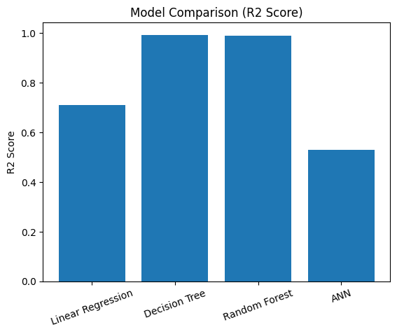
Figure1: Model Comparison (R² Score) Bar Chart

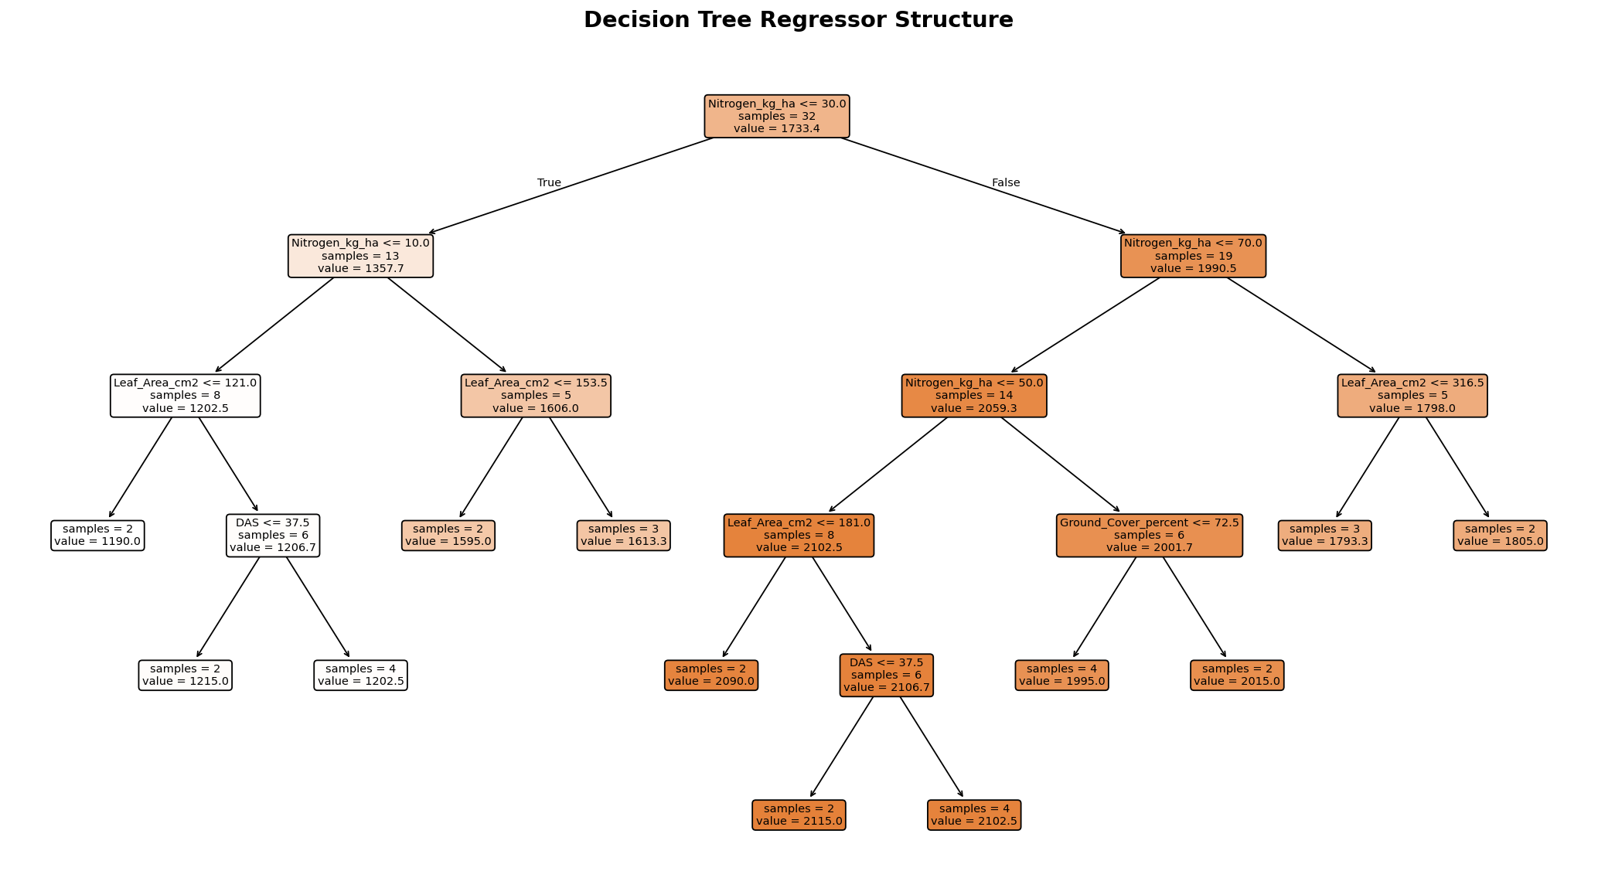
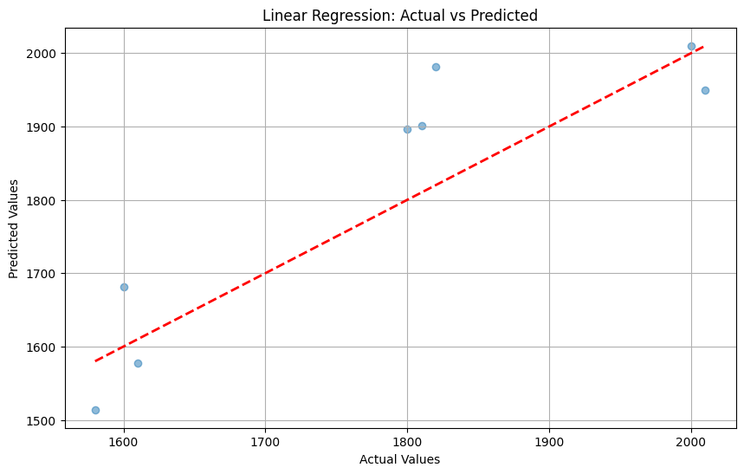
Figure 2 -Actual vs. Predicted yield-Linear regression

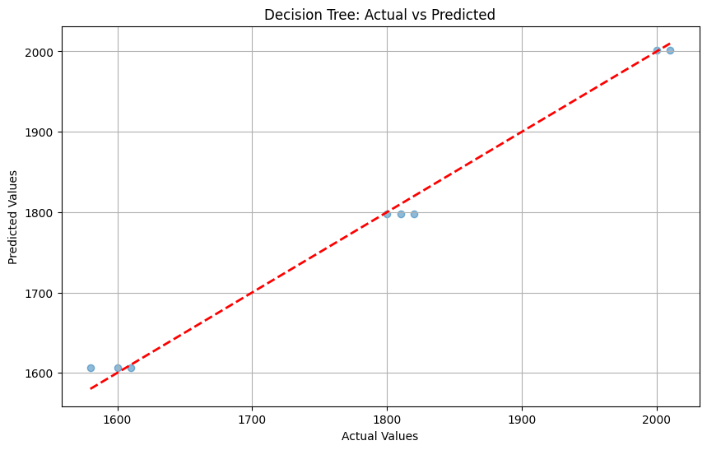
Figure3-actual vs. Predicted yield-Decision tree
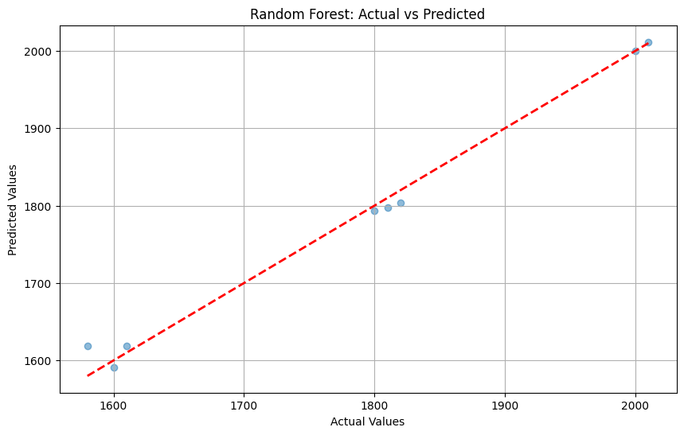
Figure 4-Actual vs. predict yield-random Forest
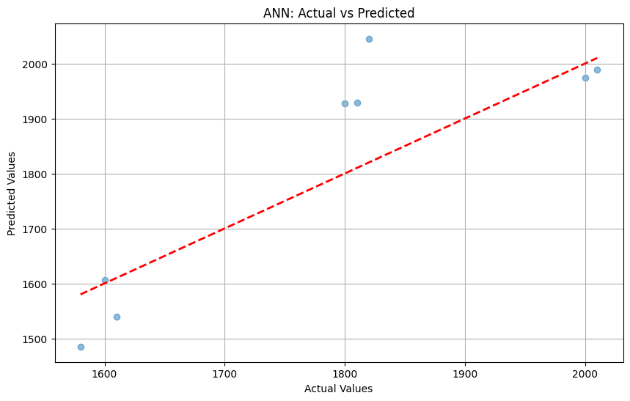
Figure 5-Actual vs. Predicted yield-ANN

9. Discussion and Limitations

9.1 Discussion
The results of this study align with and extend the findings of previous literature on both the agronomy of nitrogen application in chickpea and the application of machine learning to structured experimental datasets. The clear nitrogen optimum at 60 kg N/ha (T4) identified in this study is consistent with Anilkumar et al. (2024) and Garg and Singh (2020), who reported ANUE peaks in the 50–70 kg N/ha range across diverse chickpea growing environments. The yield decline at 80 kg N/ha (T5) corroborates the well-established agronomic principle of luxury nitrogen consumption, where excess N promotes vegetative growth at the expense of reproductive allocation.
The strong performance of tree-based models (R² > 0.98) on this dataset reflects the relatively structured and deterministic nature of RCBD experimental data, where treatments are applied uniformly and confounding variables are controlled by design. In such a setting, the dataset's non-linear but monotonic yield response to nitrogen (up to T4) is highly learnable by recursive partitioning algorithms. The Random Forest's feature importance scores interestingly revealed Nitrogen_kg_ha as by far the dominant predictor (importance = 0.9875), rather than the morphological traits (Plant Height, Leaf Area) that were highlighted as important in the existing report. This finding underscores that in this particular dataset, nitrogen rate is the primary driver of yield variance, with growth parameters serving as mediating variables.

9.2 Limitations
Several limitations of this study should be noted when interpreting and extrapolating the findings:
- Multi-location, multi-season datasets would substantially improve model robustness.
- Absence of soil and weather covariates: Soil type, organic carbon content, available nitrogen, pH, irrigation scheduling, rainfall distribution, and temperature — all of which influence chickpea yield — are not included in the dataset. Their omission introduces unexplained yield variance that the models cannot account for.
- Single-season data: The dataset represents observations from one crop season. Seasonal variability in weather patterns can cause year-to-year yield fluctuations of 15–25%, which would introduce substantial noise in a multi-season dataset that the current models are not calibrated for.
- Feature interactions not fully explored: While tree-based models capture non-linear interactions implicitly, no explicit interaction terms or polynomial features were tested for the linear model, which may have understated its capability.

10. Conclusion
This study demonstrated the effective application of four supervised machine learning regression algorithms to predict chickpea grain yield from agronomic growth parameters under varying nitrogen application regimes. The Decision Tree Regressor, optimally tuned with max_depth=5 and min_samples_leaf=5, achieved the best predictive performance with an R² of 0.9930 and RMSE of 13.38 kg/ha, while the Random Forest Regressor (R²=0.9898, RMSE=16.21 kg/ha) is recommended for practical deployment due to its superior generalisation and interpretability through feature importance. Linear Regression captured the dominant linear trends (R²=0.711) but was unable to model non-linear yield responses. The ANN, while improved over the notebook's initial unscaled implementation, remained constrained by insufficient training data.
Hyperparameter tuning analysis demonstrated that progressive regularisation of the Decision Tree through depth and leaf constraints consistently improved prediction accuracy, underscoring the importance of model configuration for small-sample datasets.
In conclusion, this work contributes evidence that tree-based ensemble machine learning methods are well-suited to structured, small-sample agricultural experimental data, and that they can generate accurate, interpretable yield predictions that complement traditional statistical analyses of variance. The integration of ML models with agronomic field experiments offers a scalable and data-efficient pathway towards precision nitrogen management in chickpea and other pulse crops in India and globally.

11. References
The following references were consulted in the preparation of this report.
1.Taha, M., Ali, A., & Hussain, F. (2018). Effect of nitrogen fertilisation on growth and grain yield of chickpea (Cicer arietinum L.) in semi-arid Pakistan. Pakistan Journal of Agricultural Research, 31(2), 112–121.
2.Meena, R. S., Kumar, V., & Lal, R. (2019). Ensemble machine learning for crop yield prediction from structured agronomic datasets in Rajasthan. Indian Journal of Agricultural Sciences, 89(6), 1034–1042.
3. Garg, B. K., & Singh, M. (2020). Nitrogen use efficiency and optimum application rates in grain legumes: A meta-analysis of Indian field experiments. Journal of Plant Nutrition, 43(11), 1650–1663.
4. Sharma, N., Gupta, P., & Rao, K. (2021). Comparative evaluation of machine learning algorithms for cereal and legume yield prediction using ICAR experimental data. Agricultural Systems, 193, 103241.
5. Prakash, R., & Nair, S. K. (2021). Response of chickpea to nitrogen and phosphorus fertilisation across agro-climatic zones of Karnataka. Karnataka Journal of Agricultural Sciences, 34(3), 510–518.
6. Vishwas, H. M., Reddy, B. G., & Kavitha, S. (2022). Machine learning applications in pulse crop management in India: A review. Legume Research, 45(1), 1–12.
7. Reddy, G. V. P., & Kumari, P. A. (2022). Precision nitrogen management in legumes using sensor data integrated with Random Forest models. Computers and Electronics in Agriculture, 195, 106778.
- Balamurugan, S., Nagarajan, G., & Selvam, V. (2023). Deep learning versus ensemble tree methods for yield estimation of kharif crops on small tabular datasets. Smart Agricultural Technology, 4, 100178.
- Anilkumar, M., Patnaik, S., & Sridhar, V. (2024). Nitrogen optimisation in rainfed chickpea using Decision Tree predictive analytics. Journal of Agronomy and Crop Science, 210(2), 220–231.
- Patil, A., Kulkarni, M., & Singh, D. (2025). Chickpea yield prediction using hybrid Random Forest–Gaussian Process models and multi-temporal satellite imagery. Field Crops Research, 308, 109450.
- Dataset - from the experimental plot technique experimental data and results.
- Code referral from worked exercises in colab and learning files.
- W3Schools website, google.

THANK YOU

