Build And Deploy a grid for Chrome and Firefox based testing
Step 1: Launch AWS EC2 Instance:-
Go to AWS EC2 Console.
Launch a new instance with the following settings:
-Name: SeleniumGridServer
- Amazon Machine Image: Ubuntu Server 22.04 LTS (Free Tier)
- Instance Type: t2.micro
- Key Pair: Create New Key Pair or select one
- Add Security Group Rule:
1)SSH (default)
2)Custom TCP (port:4444,Sourcetype:Anywhere)
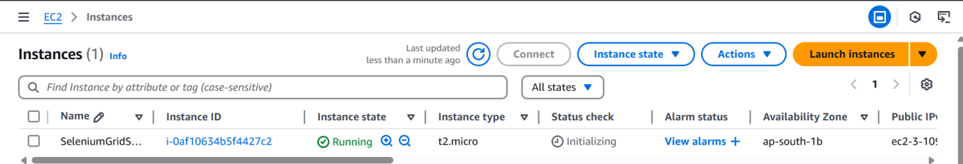
Step 2: Connect to EC2 Instance via Mobaxtream:-
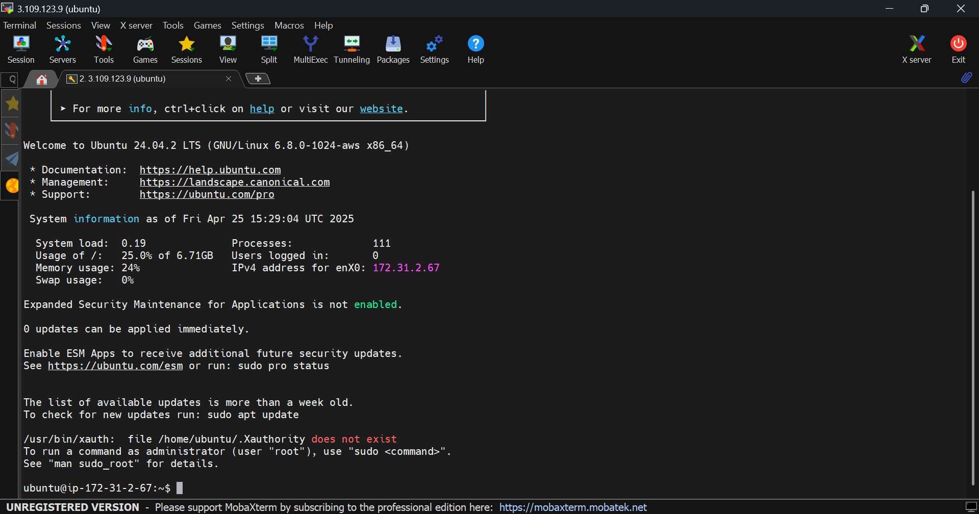
Step 3: Install Docker and Docker Compose:-
- sudo apt update
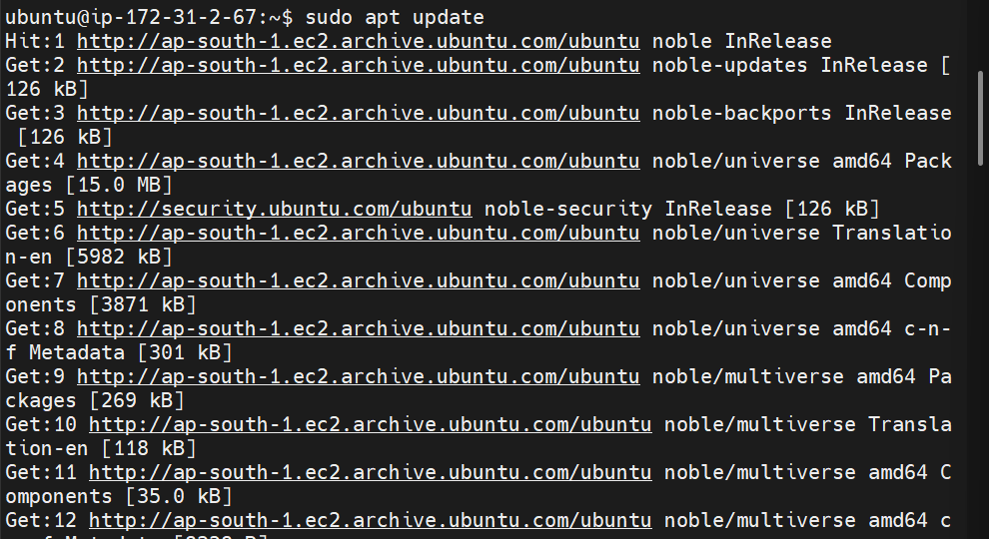
To Install Docker
- sudo apt install -y docker.io
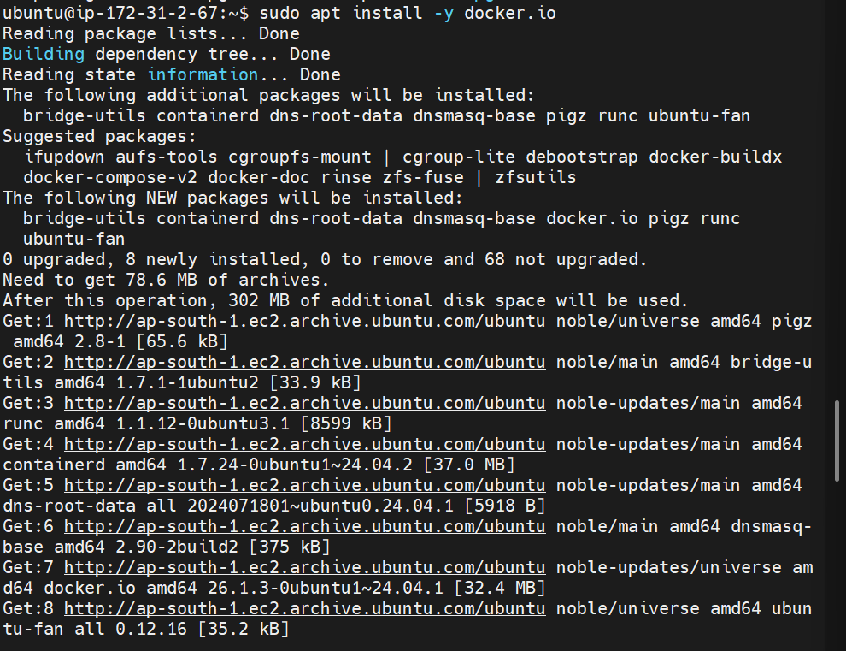
To start and enable Docker
- sudo systemctl start docker
- sudo systemctl enable docker
To Install Docker Compose
- sudo curl -L "https://github.com/docker/compose/releases/download/v2.17.3/docker-compose-$(uname -s)-$(uname -m)" -o /usr/local/bin/docker-compose
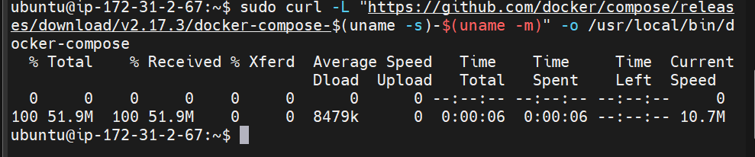
- sudo chmod +x /usr/local/bin/docker-compose
To Check versions
- docker –version
- docker-compose –version
Step 4: Create Selenium Grid with Docker Compose:-
- mkdir selenium-grid && cd selenium-grid
- nano docker-compose.yml
Paste this code:

Save (Ctrl + O, Enter), then exit (Ctrl + X)
Step 5: Start the Selenium Grid:-
To Run the grid:
sudo docker-compose up -d
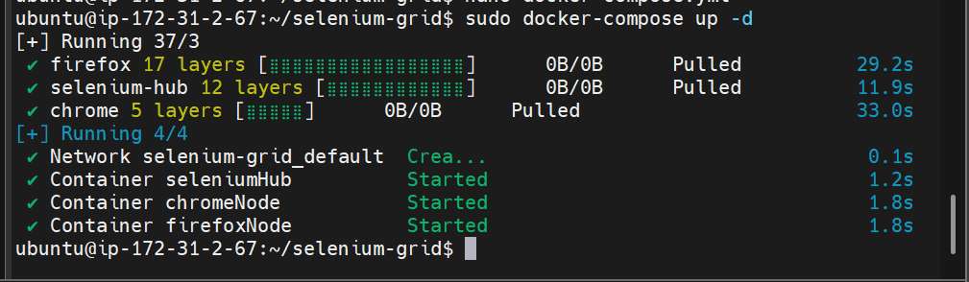
To Check containers:
sudo docker ps
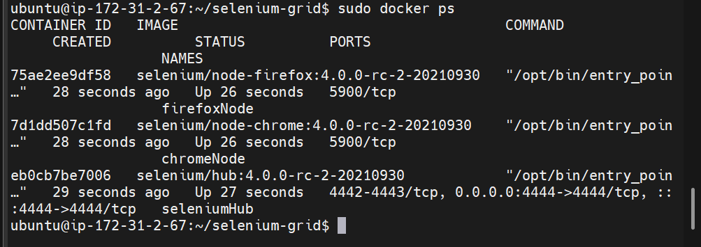
Step 6: Access Selenium Grid UI:-
Open in your browser:
http://<Your-EC2-Public-IP>:4444/ui
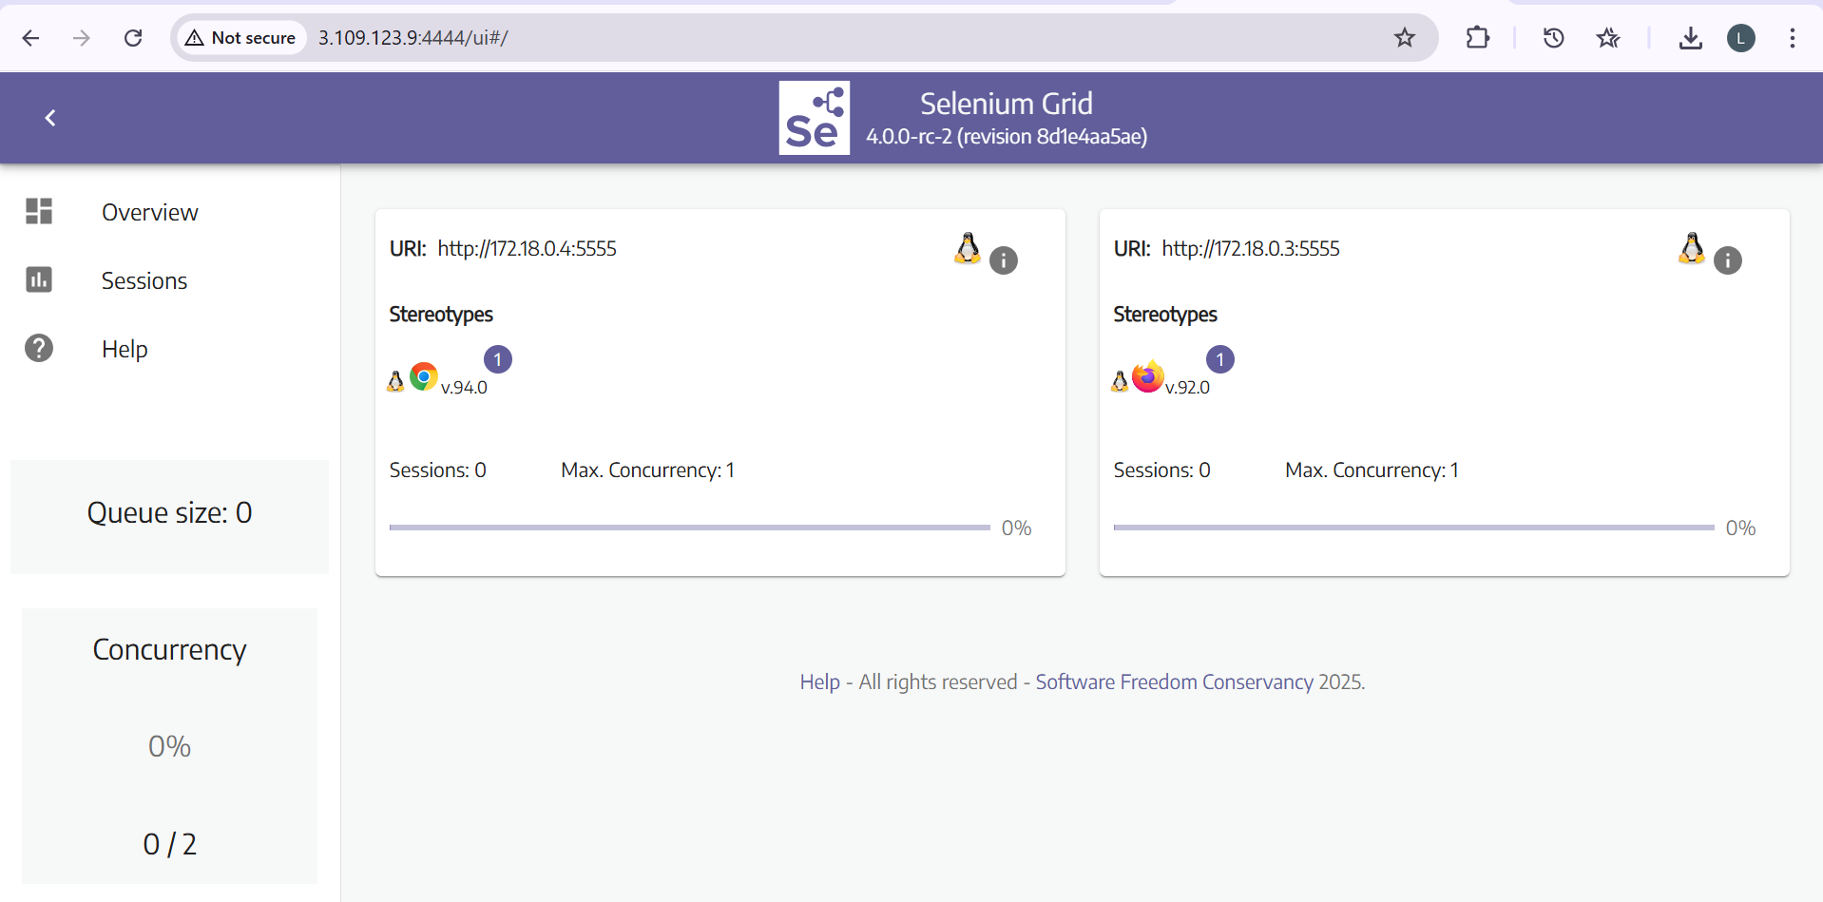
Step 7: Run a Sample Python Test:-
Create a Virtual Environment:
Install Python and Selenium:
sudo apt install python3-venv python3-full -y
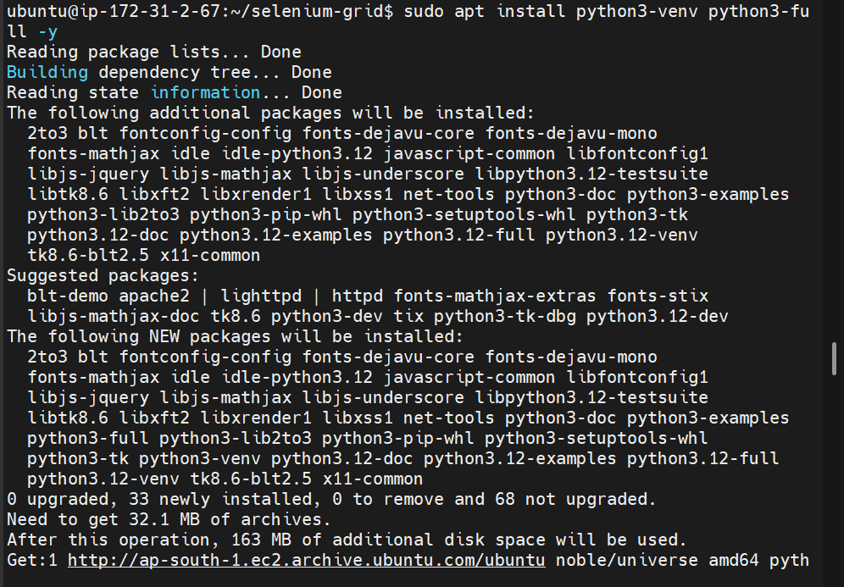
python3 -m venv venv
source venv/bin/activate
pip install selenium
nano test_grid.py
Paste below code:
from selenium import webdriver
from selenium.webdriver.common.by import By
browser = "chrome"
GRID_URL = "http://localhost:4444/wd/hub"
options = None
if browser == "chrome":
options = webdriver.ChromeOptions()
elif browser == "firefox":
options = webdriver.FirefoxOptions()
else:
raise Exception("Unsupported browser!")
driver = webdriver.Remote(
command_executor=GRID_URL,
options=options
)
driver.get("https://www.google.com")
print("Title:", driver.title)
driver.quit()
Save (Ctrl + O, Enter), then exit (Ctrl + X)
python3 test_grid.py
