SCertify
Seed Certification Using Block Chain Technology

Submitted to
Gov-TechThon 2020 Hackathon

Team Members:
1. S. Sumathi – Team Leader
2. G. Lathaselvi
3. M. Esther Hannah
4. L. Sherly Puspha Annabel
5. R. Deepa
St. Joseph’s College of Engineering, Chennai

Seed Certification Using Block Chain Technology
Team Name :SCertify

- Motivation
The agriculture industry lacks a proper mechanism that can validate and track the distribution of good seeds so the farmers don’t get much information about the origin of the seeds they would be sowing which leads the loss of productivity by 10% of overall cotton crop production in India, to name a few.
The government has set protocols for seed development like the certified foundations which cultivates varieties of seeds under a controlled environment, keeping in view the physical and physiological parameters, before it is sent to the seed aggregators but the process in the seed supply chain is itself not transparent with substantial human errors reducing its accountability.
Seed Certification is needed
- To maintain and make available to the farmers, high quality seeds and propagating materials of notified kind and varieties.
- To ensure the acceptable standards of seed viability, vigour, purity and seed health.
- To ensure genetic identity and genetic purity.

- Problem Statement
Generally seed producing companies apply QR Code on their seed bags, helpful in tracking its distribution from the point of aggregators and distributors until it reaches the retailers. But, by the time the seed reaches to the farmers, many unsought practices happen in between the current supply chain. First the GPS tracking of the land is done and the information is put in a distributed ledger as a ‘First Block’. The quality of seeds are also checked, adding pesticides, etc., and photographs are taken to authenticate whether it’s good or bad seeds. In every process, the name of the person would be mentioned who would be evaluating the quality of seeds, whether it’s good or bad. Once the process of filtering spurious seeds is complete, the distributor creates another block in this chain upon receiving the seeds and the QR Code is applied atop the package as tracking method until it reaches the retailers. Besides the QR Code mode of tracking, the distributor also puts a unique verification code inside the package for the farmers to send it via SMS or verify it through the app which marks the process as complete. Blockchain technology usesa decentralised ledger, where there is no chance of human mischief and if those particular seeds were incorrectly evaluated a person evaluating would be held accountable.
- Current Status of Farmers in India
Farmers are the backbone of India’s economy. Farmers constantly incur loss due to poor quality seeds that had failed to germinate. Our government has taken great initiatives to provide farmers high quality seeds through various certification agencies. An article is published in The Hindu dated June 28, 2020 serious action will be taken against seed companies, if they fail to provide compensation to farmers for supplying poor quality seed.

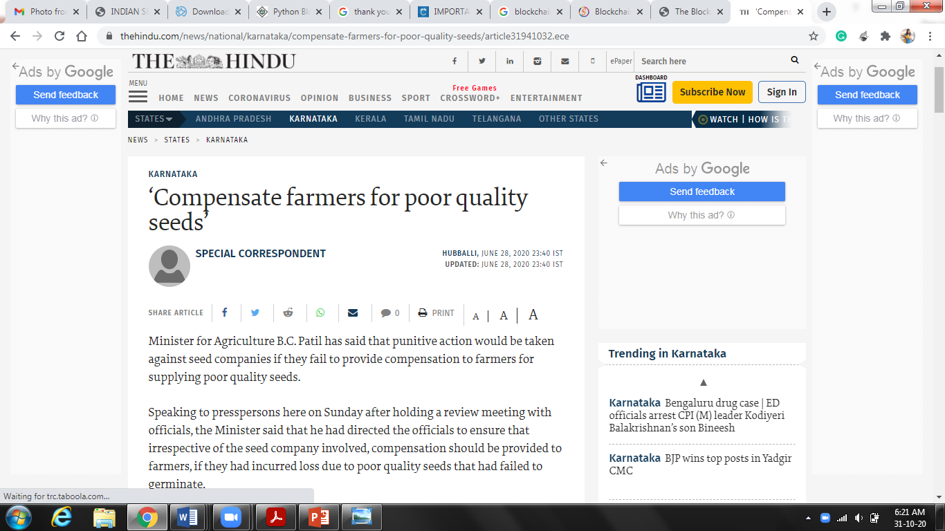

- Drawbacks of the existing supply chain system
The existing seed certification process that assess and certify the quality of the seeds has the following disadvantages.
- Lack of transparency
- Lack of Trust
- Lack of traceability
- Lack of Decentralization
Hence, it is essential to implement a supply chain system which maintains the data about the quality of the seeds public so that it could not be tampered and thereby increasing the production of crops.

- Objective of the proposed system - SCertify
The proposed system helps in providing the farmers continuous supply of high quality seeds. It also help in systematically increase the production of the superior varieties of cash crops. The proposed system incorporates the Block-chain technology which is a great tool with very practical applications that will make a difference in the lives of farmers. This system is the first mile of the journey to see how block-chain will fit into the Seed supply chain. Information related to crop origin, expiry, validity, etc will be stored in an immutable manner.

  - BlockChain Technology
As per the NASSCOM 2019, nearly 50% of the states are involved in significant initiatives driving block chain technology. The number of projects built by block-chain development services providers have crossed the $20 billion across multiple industries. It is deployed in the system for tracking, tracing, and supporting quality of seeds in supply chains. Traceability information regarding seed quality will be stored in a secured manner. It also Adds value to the end product i.e quality Seeds. It also gives the stakeholders a chance to know the farm to farmer route of seeds.
The proposed system that includes blockchain technology provides the following
- Transparency —system is able to highlight the status of each item whether is certified as high quality or not due to blockchain architecture
- Immutability — the open ledger ensures the records cannot be altered and the destination of each item can be tracked
- Legitimity — the codes cannot be forged, as scanning a forged code will reveal the fact of coun-terfeit at once.
- Feasibility — replacing the expensive (and forgeable) excise stamps with inexpensive (yet unforgeable) blockchain based QR-codes
- In order to avoid duplication of data, Blockchain Technology is applied.
- Man in the middle attack is eliminated.
- It is a trusted execution environment.
- Every stakeholder in the system can ensure and validate its predecessor cryptographically.
- Blockchain based QRCode Technology is applied instead of QRCode technology in order to provide transparency.

- Advantages of the proposed System
50% of the states in India are involved in significant initiatives driving the blockchain technology adoption.
- The proposed system can positively investigate the impact of electronic linkages upon all types of food producers and food products
- It enhances the decision making ability of the farmers to know about the quality of the seeds
- The proposed architecture that incorporates blockchain provides security using Hashing, transparency, traceability and immutability using block chain are achieved
- Seed Growers and other certification agencies can be added into the system.
- End to End communication is maintained
- Difficult to modify the data once it is transmitted
- Application is adaptable to accommodate large number of stakeholders
- Highly Scalable
- Seed Grower’ Data is encrypted and Hash key is generated and sent to the Seed Producing Plant which.
- Even Large Data will be compressed and sent through blockchain by using secure hash algorithm SHA-512 algorithm
- As Digital Signature is provided by the seed certification agency, authentication is maintained.
- A single change in a block will affect the entire block chain. Hence SHA-1 algorithm is applied in every block
- Public Key Encryption -Rivest Schmir Adlemen algorithm is used

- Software Requirements
Front End Tools
- React
- Python 3.0
Back End Tools
- Mongo DB

- System Architecture
The following figure Fig. 1.1 clearly depicts the system architecture of the proposed seed certification system . It involves the stake holders like Seed Grower (SG) in the level 1 who will complete the one time registration and create the first block. The Seed Produing Agency (SPA), Seed Testing Lab (STL) and Seed Certification Agency (SCA) who is the second level is responsible for Processing, post-processing and data upload –using block chain, and updating the seed test reports and generating the certificates and tag based on quality of seeds.
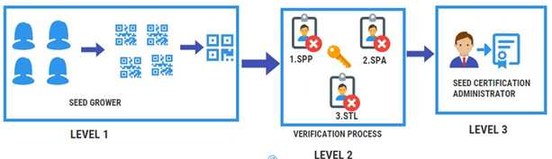
Fig 1.1 System architecture of proposed system

  - Steps in seed Certification Process
- Authorization of Seed Growers (SG)
- Verification of seed source, class, etc. and field inspections to verify conformity to the prescribed field standards by Seed Processing Plant (SPP)
- Supervision at post harvest stages including processing & packing by Seed Producing Agency (SPA) and Seed sample Testing and analysis by Seed Testing Lab (STL)
- Grant of certificate, tagging and sealing by Seed Certification Agency (SCA)
- The system is designed such that various Reports can be downloaded

  - UML Diagram
The various stakeholders like SG,SPP, STL, SCA are the actors and registration, verification, inspection, raw seed intake and stock verification, processing and sampling, testing , issue of certificate, tagging, MIS and reporting are the various usecases are depicted in the figure 1.2
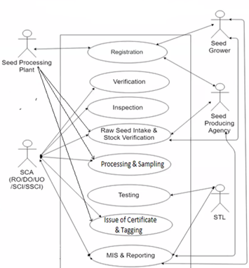

Fig 1.2 UML Diagram for the proposed system

- Module Description
The following are the various listed modules that are to be implemented
- Data Acquisition and Registration
- Inspection and Secure Storage
- Seed Testing and Updation
- Seed Certification and Tagging
- BlockChain Based QR Generation

  - Data Acquisition and Registration
Each SG in the group will be assigned with unique code which is generated using hashing algorithm that takes timestamp, transaction id, sgid.

  - Inspection and secure storage
  - Every member in the SG group will be combined together based on the sgId, landRecordArea, cropRegCode. Every group will be assigned with unique hash code using hashing algorithm that takes cropRegCode, landRecordArea.
  - SPP will be given with the lotNo. of the SeedGrower whose seed is to be certified. After physical verification, the genuinity of the seed will be updated in the respective sgID.
  - The second process of verification which involves processing and packing will be done by SPA who will be giving the further genuinity of the seed along with the hash code of respective sgId and sppID.

  - Seed Testing and Updation
- The third process of verification will be done by STL who will test the further genuinity of the seed by testing the sample seeds in the lab.
- After successful verification, it produces sample secret code along with the information about which class the seed belongs to.
- This information will be updated with hash code along with the respective STL details.

  - Seed Certifcation and Tagging
- The final process of certification will be done by the SCA. After seed processing and test, SCA fetches the information like total quantity of seed that are processed, date of processing and verification, sample secret code using the lot number of the respective seed grower.
- In addition, SCA also produces seed certificate and tag certificate which includes tag details and certificate details. These details are updated and a new hash code will be generated.

  - BlockChain Based QRCode generation
- BlockChain based QRcode will be generated finally. The farmers can scan the seed bag QRcodes to ensure their validity.
- Once the QRcode is scanned, the counterfeit seed bags will be identified due to the immutable nature of blockchain ledger.
- Once the seed bag is sold, the respective block will be closed.

- Sytem Design
Table Name : spadata_upload
S.No | Field Name | Datatype
1 | lotNumber | Varchar
2 | owner | Varchar
3 | crop | Varchar
4 | variety | Varchar
5 | sourceTagNo | Number
6 | sourceClass | Varchar
7 | destinationClass | Varchar
8 | sourceQuantity | Varchar
9 | sourceDateOfIssue | date
10 | growerName | Varchar
11 | spaName | Varchar
12 | dateOfIssue | date
13 | destiStorehouse | Varchar
14 | sourceStore House | Varchar
15 | sgName | Varchar
16 | sgId | Varchar
17 | finYear | Varchar
18 | season | Varchar
19 | landRecordsKhatano | Number
20 | landRecordsPlotno | Number
21 | landRecordsArea | Number
22 | cropRegCode | Varchar
23 | sppId | Number
24 | SppName | Varchar

Table Name : spadata_process
S.No | Field Name | Datatype
1 | processingDate | Date
2 | verificationDate | Date
3 | samplesecretCode | Varchar
4 | samplePassed | Varchar
5 | sampleTestDate | Date
6 | certificateNo | Number
7 | certifcateDate | Date
8 | tagSeries | Number
9 | tagIssuedRangeFrom | Varchar
10 | tagissuedRangeTo | Varchar
11 | noOfTagsIssued | Number
12 | certificateValidateInmonth | Number
Table Name : stldata_upload
S.No | Field Name | Datatype
1 | samplesecretCode | Varchar
2 | samplePassed | Varchar
3 | sampleTestDate | Date

Table Name : scadata_upload
S.No | Field Name | Datatype
1 | totalQuantityProcessed | Number
2 | processingDate | Date
3 | verificationDate | Date
4 | samplesecretCode | Varchar
5 | samplePassed | Varchar
6 | sampleTestDate | Date
7 | certificateNo | Number
8 | certifcateDate | Date
9 | tagSeries | Number
10 | tagIssuedRangeFrom | Varchar
11 | tagissuedRangeTo | Varchar
12 | noOfTagsIssued | Number
- Screenshots
11.1 Data Acquisition and Registration
a. Seed Grower Page
Activities Performed:
- Registration
- Raw seed Intake &stock verification
- MIS & Reporting
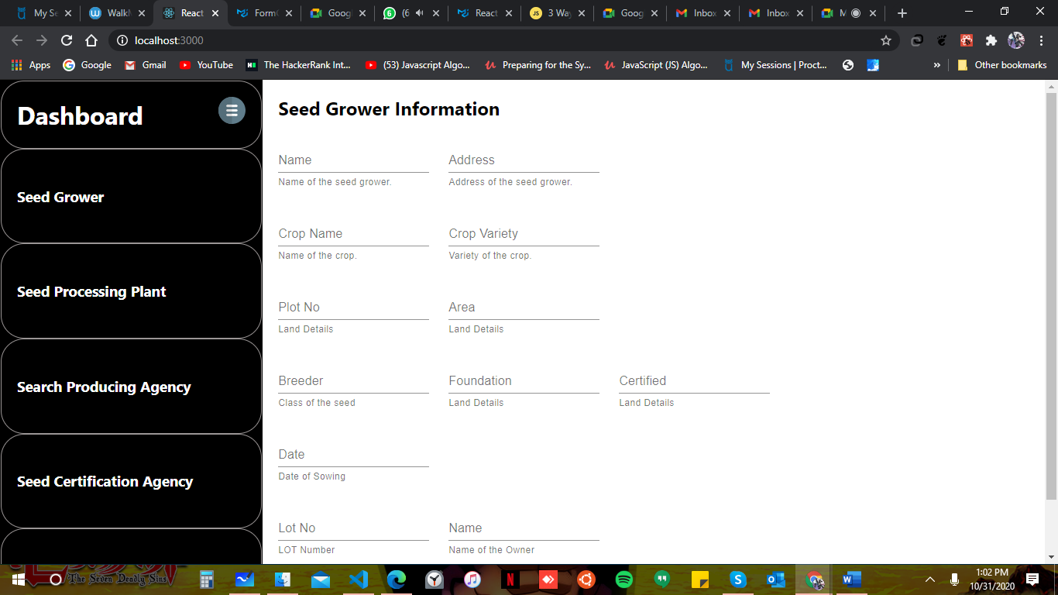

- Seed Processing Plant (SPP)
Activities Performed
- Raw seed Intake &stock verification
- Processing & Sampling
- Issue of Certificates and Tagging
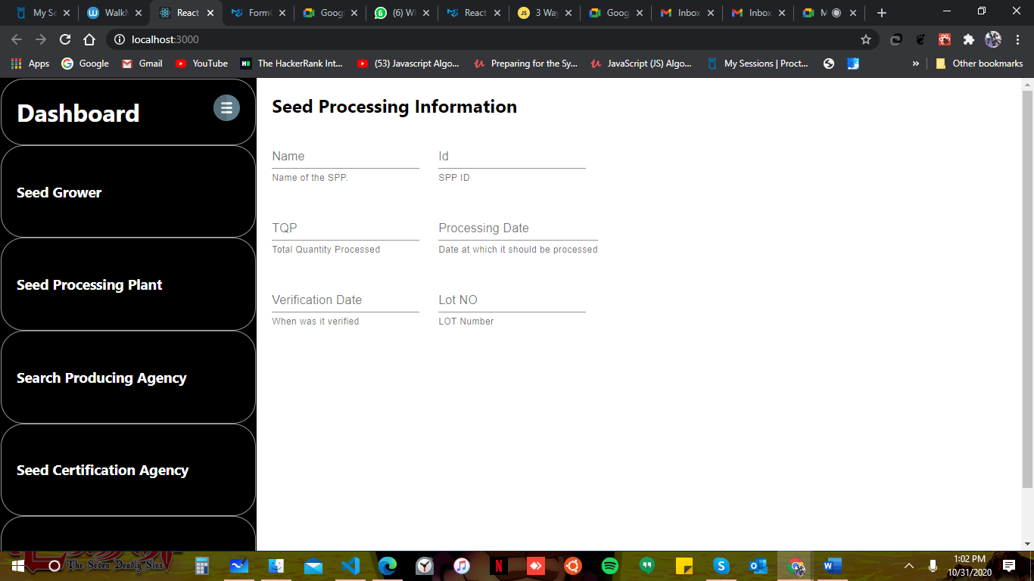

- Seed Producing Agency (SPC)
Activities Performed
- Registration
- Raw seed Intake & stock verification

- Seed Testing Agency (STA)
Activities Performed
- Testing
- MIS & Reporting
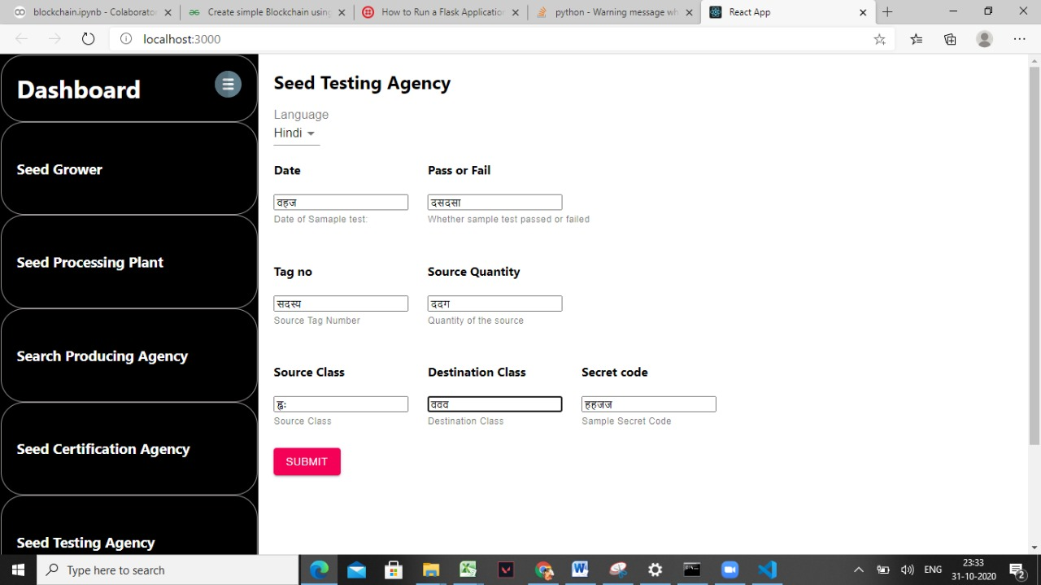

- Seed Certification Agency (SCA)
Activities Performed
- Verification
- Inspection
- Processing & Sampling
- Certificate Issue & Tagging
- MIS & Reporting
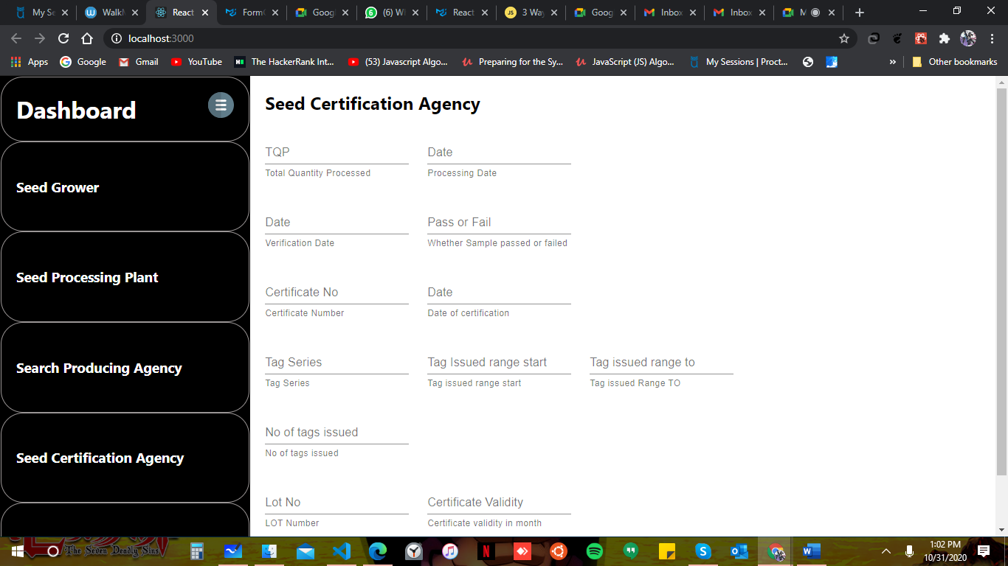

Additional Screenshots
Lot Number Generation
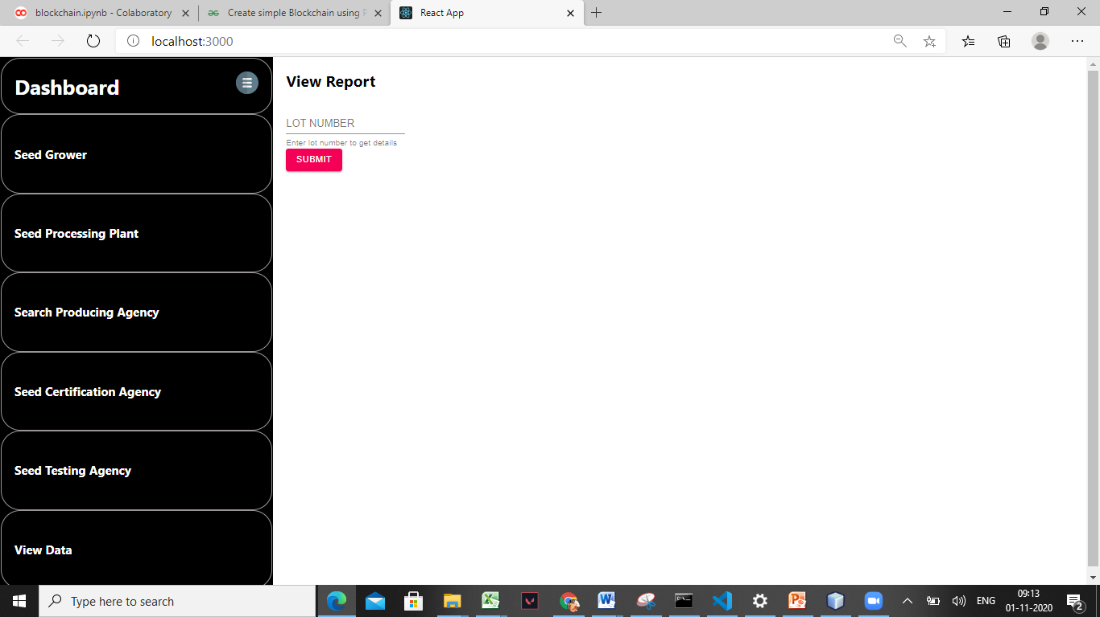

Hash Code Generation

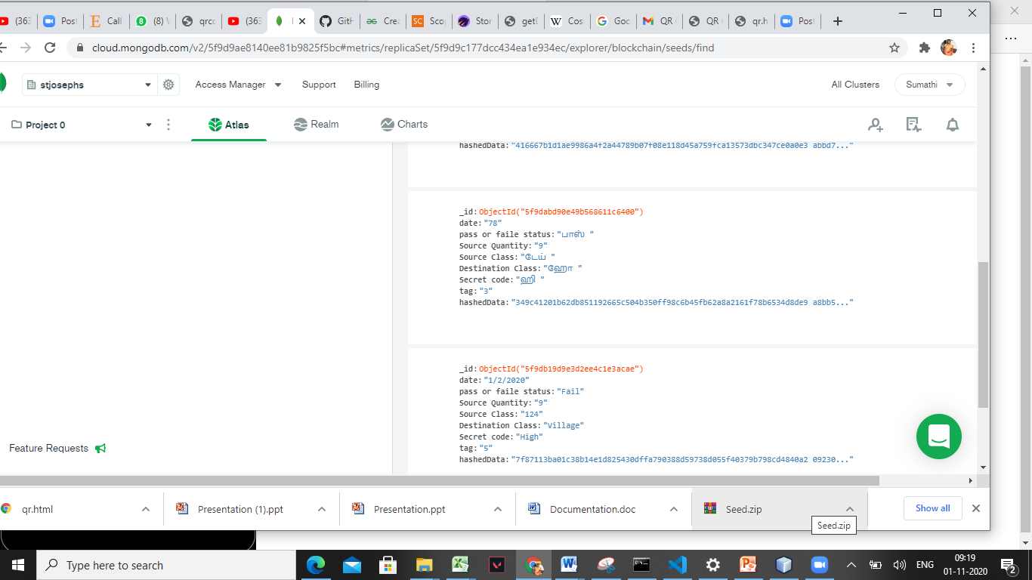

Report Generation
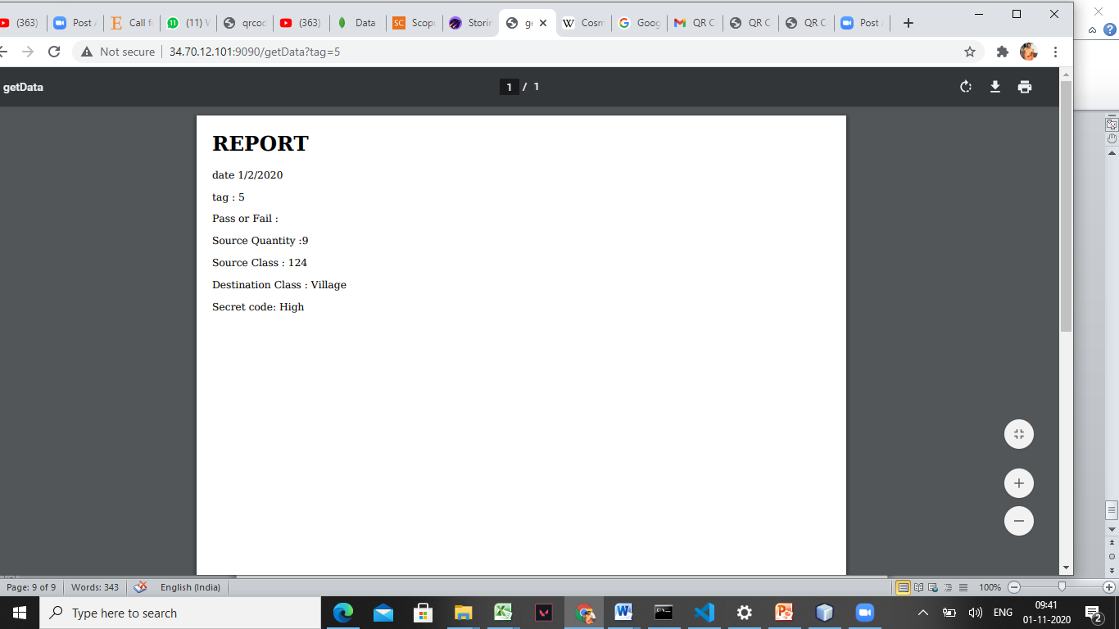

QR Code Generation

Conclusion

The proposed system using blockchain achieves transparency, traceability, authentication of QR code that is generated. The system is a tamperroof system as man in the middle attack is eliminated. The system is also highly scalable as it acommodates large number of stakeholders who wish to join the blockchain. Cryptographic distributed blockchain on seed certification is focused and achieved. This also creates a trusted executed and multilingual environment where the farmers are provided with high quality seed.

