SONY(索尼)——EVI-D30/D30P/D70/D70P/D100/D100P (RS-232/422指令集)
波特率：9600/38400-N-8-1 (请注意设备底部设置拨位开关)
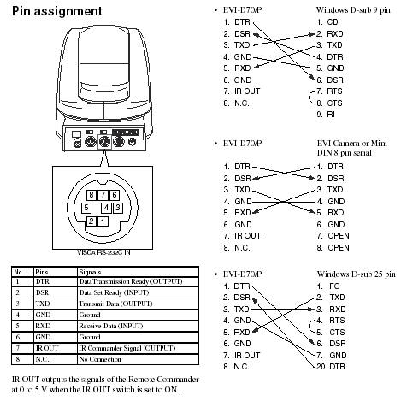

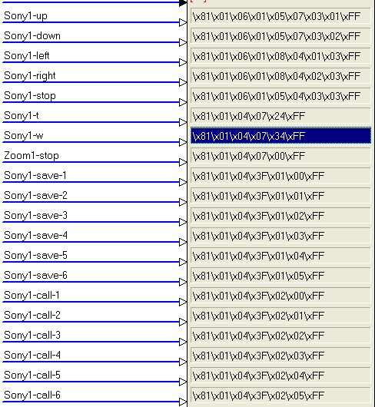
主要功能控制代码一览表：
类别 功能 代码 说明
Power(电源) On(开) 8x 01 04 00 02 FF
Off(待机) 8x 01 04 00 03 FF
Zoom(缩放)
Stop 8x 01 04 07 00 FF
Tele (Standard) 8x 01 04 07 02 FF
Wide (Standard) 8x 01 04 07 03 FF
Tele (Variable) 8x 01 04 07 2p FF p = 0 (Low) to 7 (High), 8 steps
Wide (Variable) 8x 01 04 07 3p FF
Focus(焦距)
Stop 8x 01 04 08 00 FF
Far (Standard) 8x 01 04 08 02 FF
Near (Standard) 8x 01 04 08 03 FF
Far (Variable) 8x 01 04 08 2p FF p = 0 (Low) to 7 (High), 8 steps
Near (Variable) 8x 01 04 08 3p FF
Pan-tiltDrive
Left (左) 8x 01 06 01 VV WW 01 03 FF
Right (右) 8x 01 06 01 VV WW 02 03 FF
UpLeft(左上) 8x 01 06 01 VV WW 01 01 FF
UpRight(右上) 8x 01 06 01 VV WW 02 01 FF
DownLeft(左下) 8x 01 06 01 VV WW 01 02 FF
DownRight(右下) 8x 01 06 01 VV WW 02 02 FF
Stop(停止) 8x 01 06 01 VV WW 03 03 FF
AbsolutePosition
(绝对定位) 8x 01 06 02 VV WW
0Y 0Y 0Y 0Y 0Z 0Z 0Z 0Z FF
RelativePosition
(相对定位) 8x 01 06 03 VV WW
0Y 0Y 0Y 0Y 0Z 0Z 0Z 0Z FF
Home(初始) 8x 01 06 04 FF
Reset(复位) 8x 01 06 05 FF
前8个功能需发停止代码方可停止转动
Down (下) 8x 01 06 01 VV WW 03 02 FF
Up (上) 8x 01 06 01 VV WW 03 01 FF
VV: Pan speed 01 to 18
WW: Tilt Speed 01 to 14
YYYY: Pan Position FA60 to 05A0 (center 0000)
ZZZZ: Tilt Position FE98 to 0168 (center 0000)

