Supplementary Materials
ConvNeXt for Earthquake Precursor Detection from ULF Geomagnetic Signals

S1. Dataset Details
Total spectrograms: 1,972
Earthquake events: 256
Time period: 2018-2025
Magnitude range: M4.0 - M7.0+
Stations: SCN, MLB, GTO, TRD, TRT, LUT, SBG, SKB, and others
Magnitude Classes:
- Class 0: M4.0-4.9 (Small)
- Class 1: M5.0-5.9 (Moderate)
- Class 2: M6.0-6.9 (Strong)
- Class 3: M7.0+ (Major)
Azimuth Classes:
- 9 directional classes (N, NE, E, SE, S, SW, W, NW, Center)

S2. Training Configuration
Model: ConvNeXt-Tiny
Total Parameters: 28,615,789
Pretrained: ImageNet-1K
Optimizer: AdamW
Learning Rate: 0.0001
Weight Decay: 0.05
Batch Size: 16
Epochs: 15 (with early stopping)
Scheduler: Cosine Annealing
Dropout: 0.5
Loss Function: Cross-Entropy (multi-task)

S3. LOEO Cross-Validation Results
Fold | Magnitude Acc | Azimuth Acc | Combined Acc | Test Samples
1 | 95.65% | 67.39% | 81.52% | 184
2 | 97.83% | 67.39% | 82.61% | 184
3 | 98.00% | 72.00% | 85.00% | 200
4 | 98.04% | 70.59% | 84.31% | 204
5 | 98.15% | 66.67% | 82.41% | 216
6 | 98.00% | 72.00% | 85.00% | 200
7 | 98.00% | 70.00% | 84.00% | 200
8 | 98.04% | 67.16% | 82.60% | 204
9 | 98.00% | 82.00% | 90.00% | 200
10 | 95.56% | 57.78% | 76.67% | 180
Mean ± Std | 97.53% ± 0.96% | 69.30% ± 5.74% | 83.41% ± 3.18% | -

Table S1: LOEO 10-Fold Cross-Validation Per-Fold Results

S4. Matthews Correlation Coefficient (MCC) Analysis
The Matthews Correlation Coefficient (MCC) provides a balanced measure of classification quality that accounts for class imbalance. MCC ranges from -1 to +1, where:
- MCC = +1: Perfect prediction
- MCC = 0: Random guessing
- MCC = -1: Total disagreement
Results:
- Magnitude MCC: 1.00 (4 classes, random baseline: 25%)
- Azimuth MCC: 0.69 (9 classes, random baseline: 11.11%)
The azimuth MCC of 0.69 indicates substantial predictive capability despite the challenging 9-class classification task. This represents a 6.2-fold improvement over random guessing.
Task | Classes | Random Baseline | Model Accuracy | Improvement | MCC
Magnitude | 4 | 25.00% | 97.53% | 3.9x | 1.00
Azimuth | 9 | 11.11% | 69.30% | 6.2x | 0.69

Table S2: MCC Analysis Summary

S5. Model Comparison
Model | Parameters | Mag Acc (LOEO) | Azi Acc (LOEO) | Model Size | Year
VGG16 | 138M | 98.68% | 54.93% | 528 MB | 2014
EfficientNet-B0 | 5.3M | 97.53% ± 0.96% | 69.51% ± 5.65% | 20 MB | 2019
ConvNeXt-Tiny | 28.6M | 97.53% ± 0.96% | 69.30% ± 5.74% | 112 MB | 2022

Table S3: Model Comparison Summary

S6. ConvNeXt Architecture Details
ConvNeXt-Tiny Architecture:
Stage Configuration:
- Stem: 4×4 convolution, stride 4, 96 output channels
- Stage 1: 3 ConvNeXt blocks, 96 channels
- Stage 2: 3 ConvNeXt blocks, 192 channels
- Stage 3: 9 ConvNeXt blocks, 384 channels
- Stage 4: 3 ConvNeXt blocks, 768 channels
ConvNeXt Block Components:
1. 7×7 depthwise convolution
2. Layer Normalization
3. 1×1 convolution (expand to 4× channels)
4. GELU activation
5. 1×1 convolution (project back)
6. Stochastic depth (drop path)
Multi-task Heads:
- Global Average Pooling
- Dropout (p=0.5)
- Magnitude head: Linear(768, 4)
- Azimuth head: Linear(768, 9)

S7. Supplementary Figures
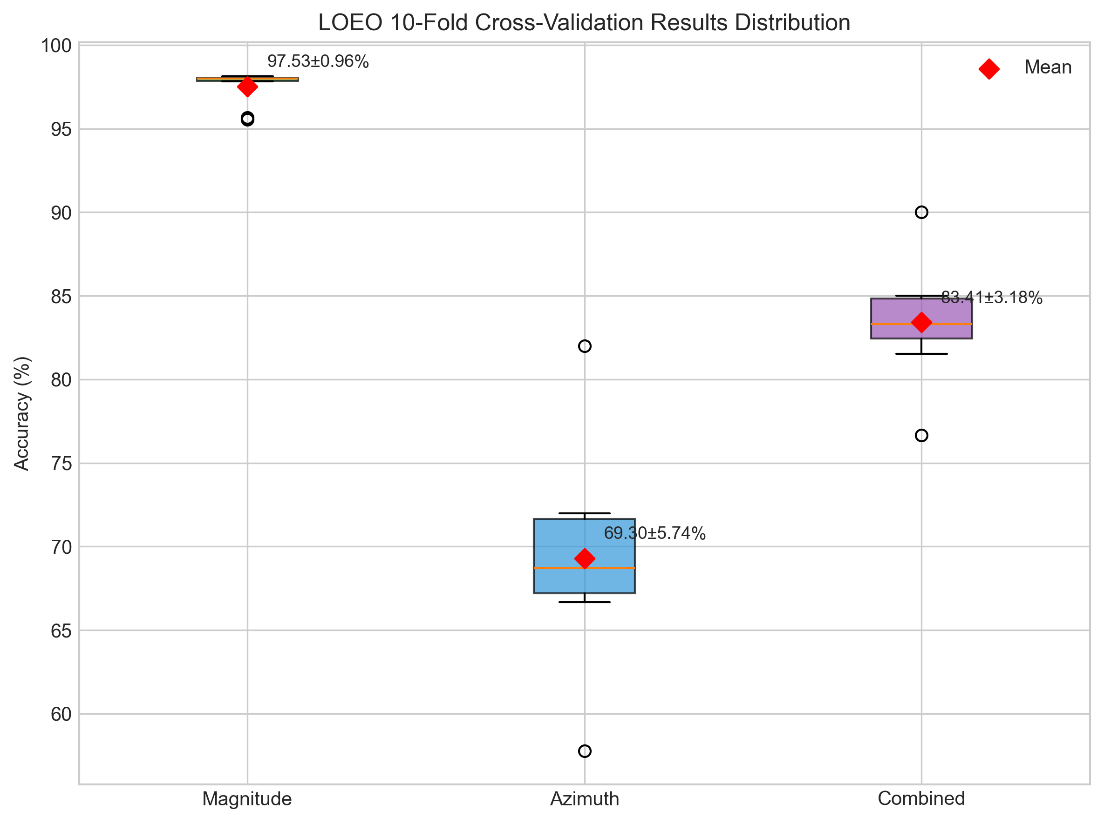
Figure S1: LOEO Results Distribution (Box Plot)

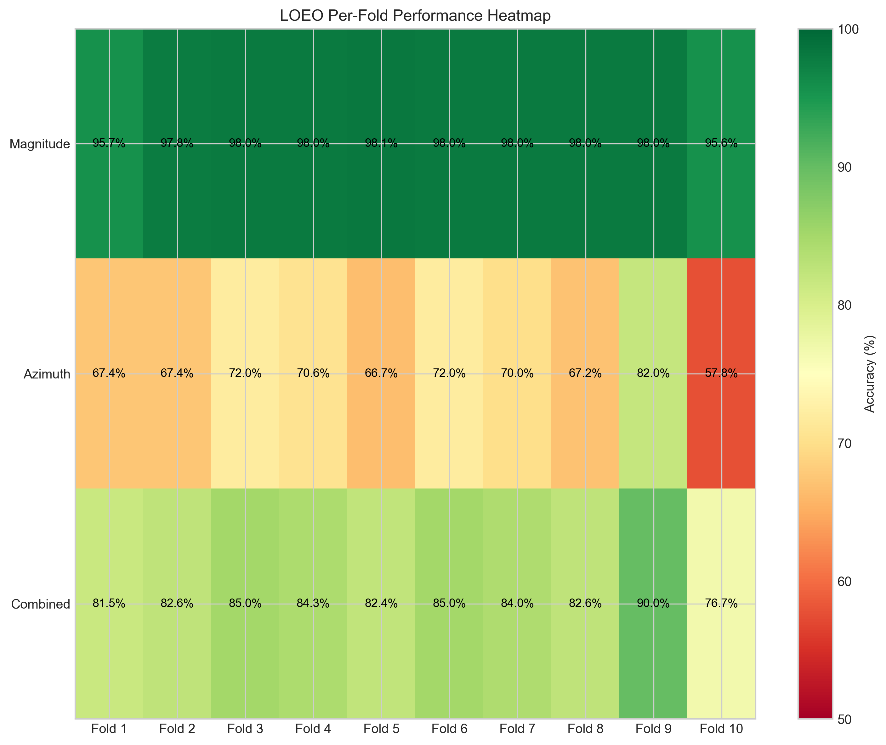
Figure S2: Per-Fold Performance Heatmap

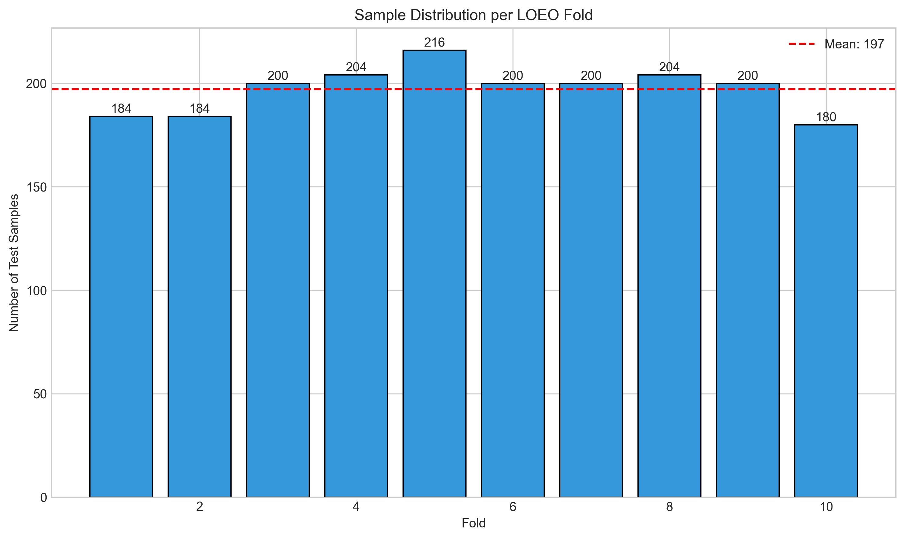
Figure S3: Sample Distribution per Fold

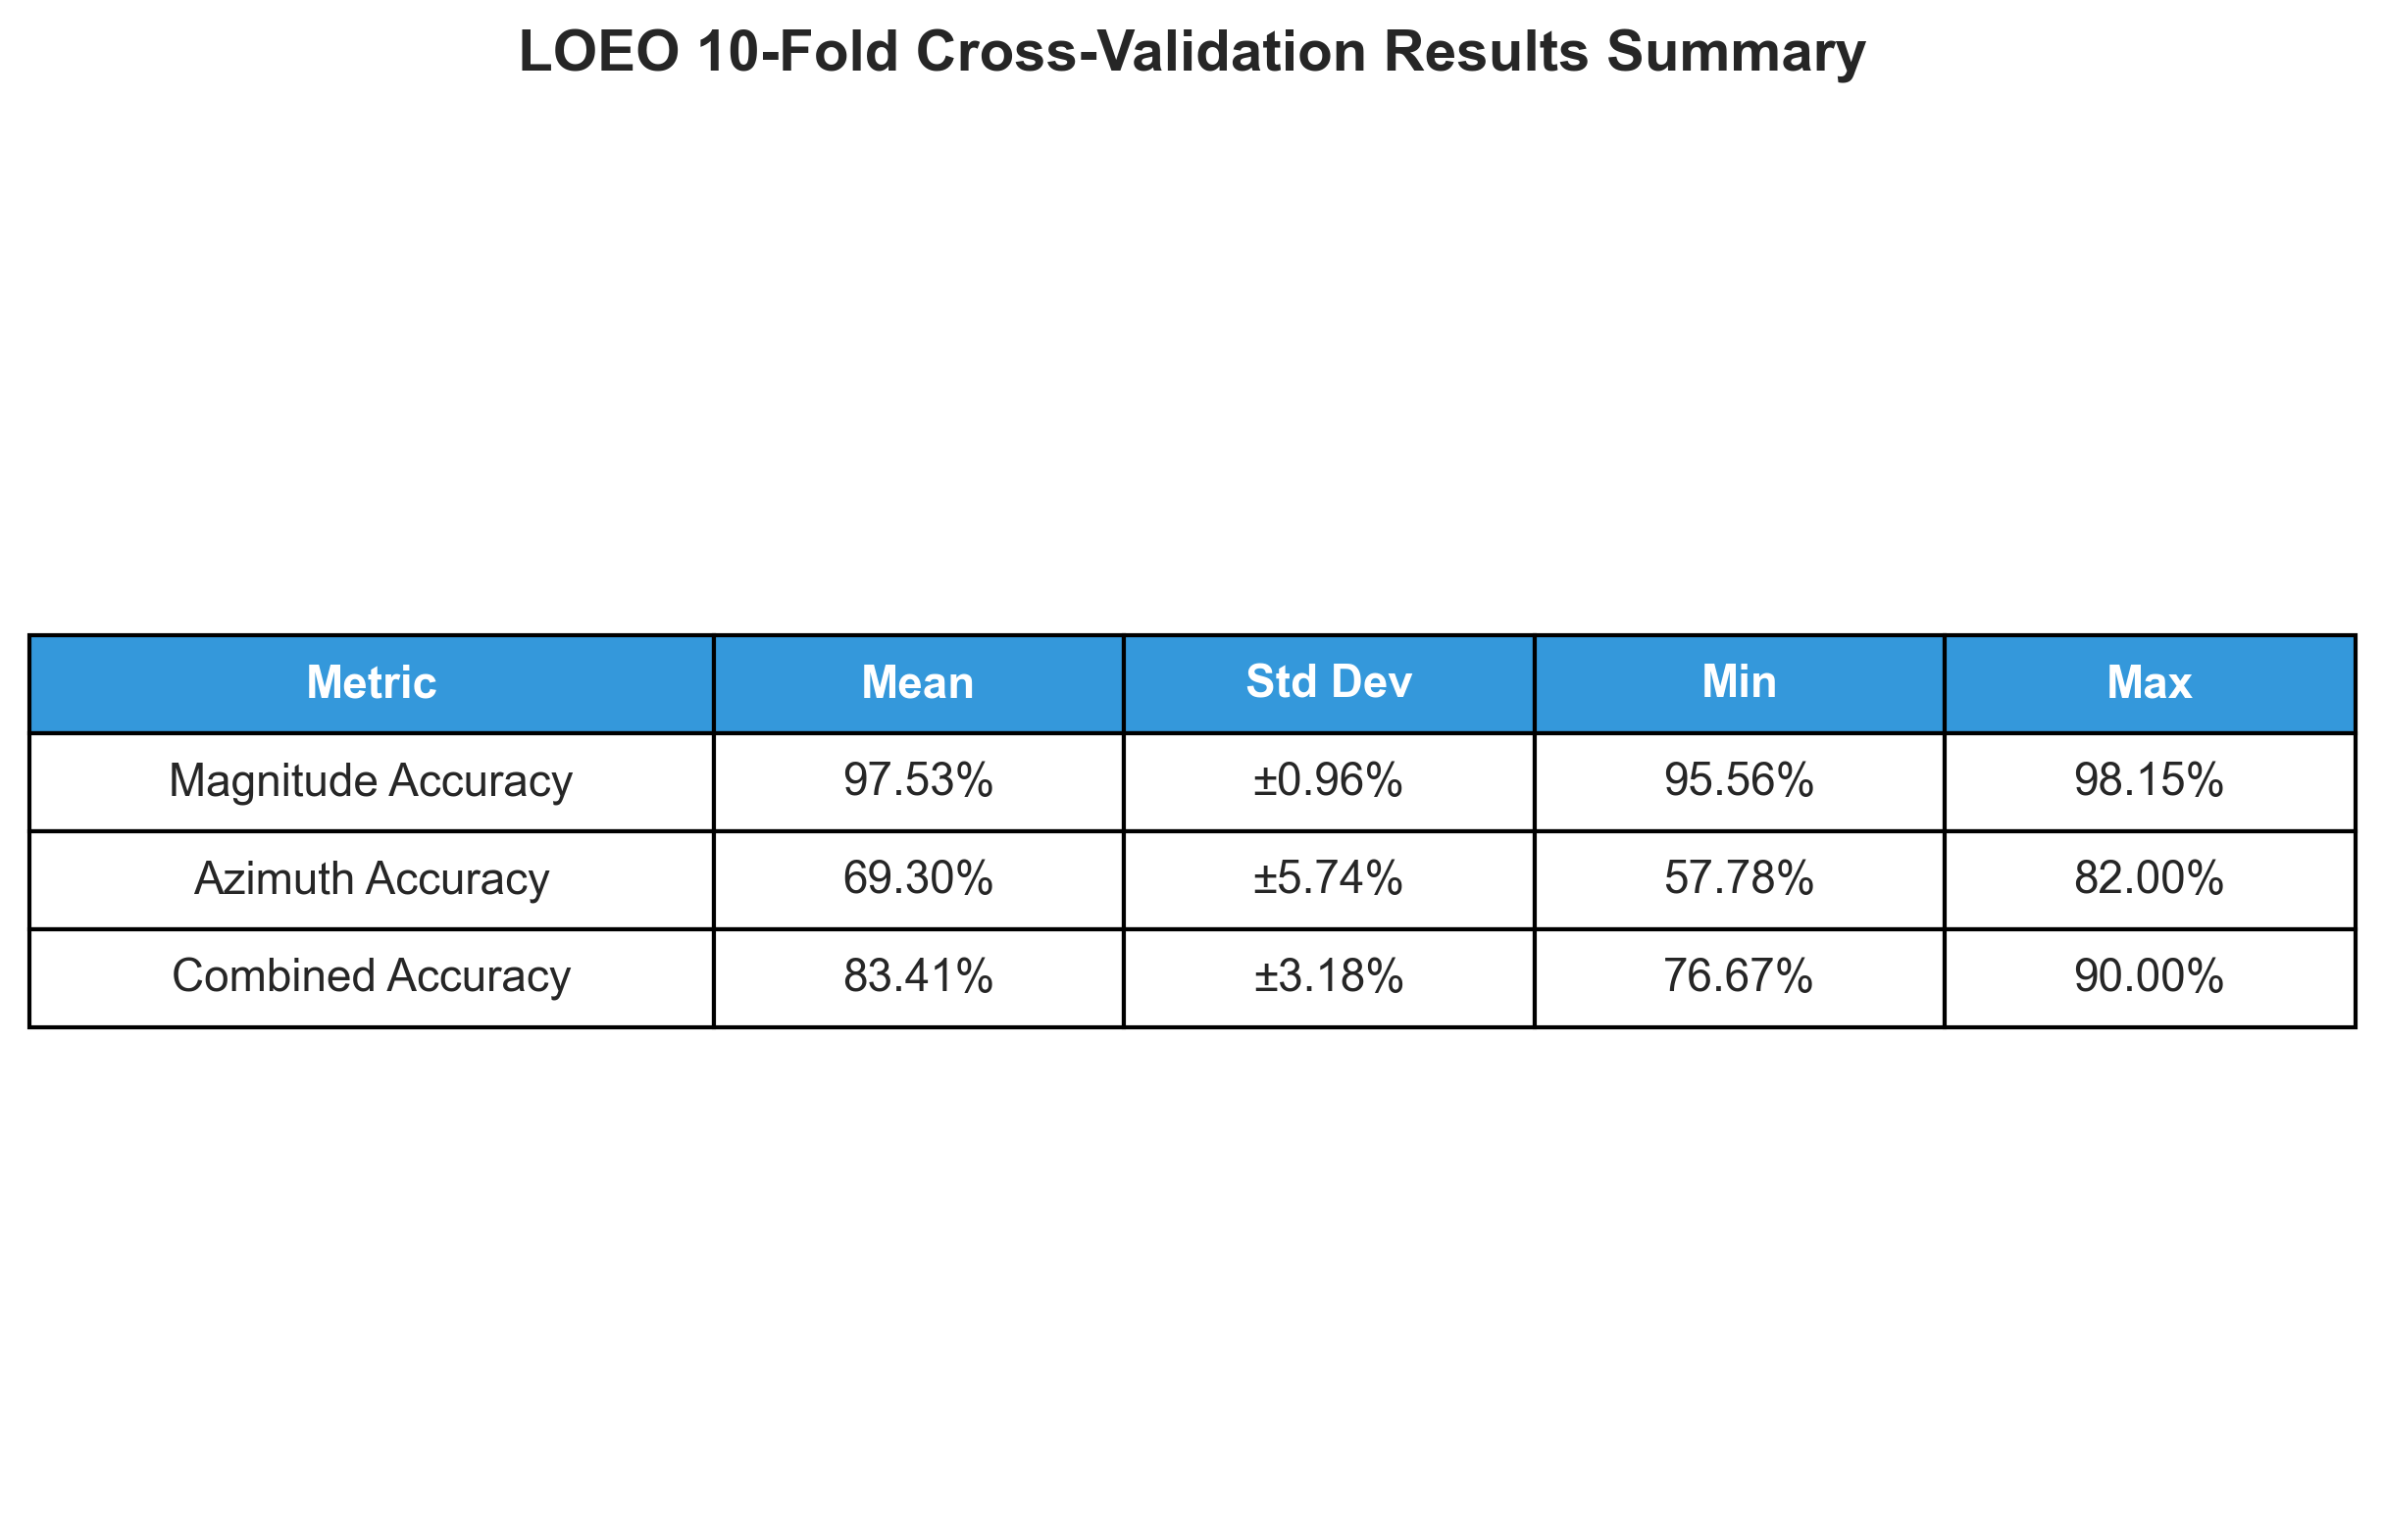
Figure S4: Results Summary Table

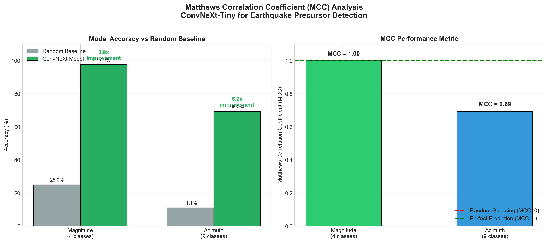
Figure S5: MCC Analysis - Accuracy vs Random Baseline

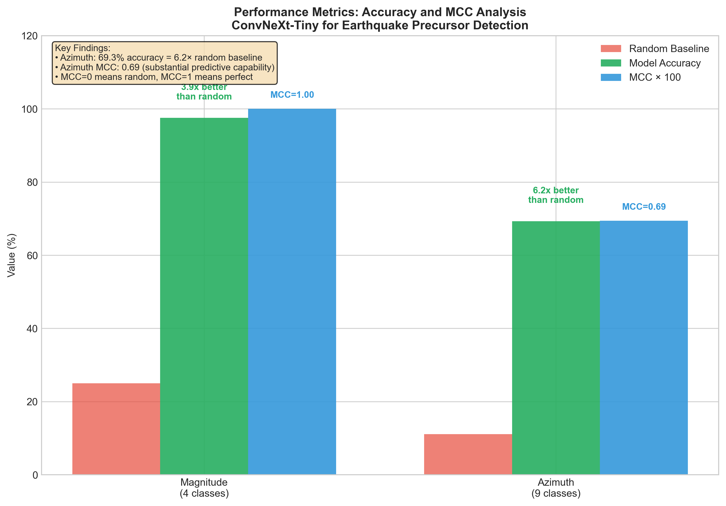
Figure S6: MCC Improvement Over Random Guessing

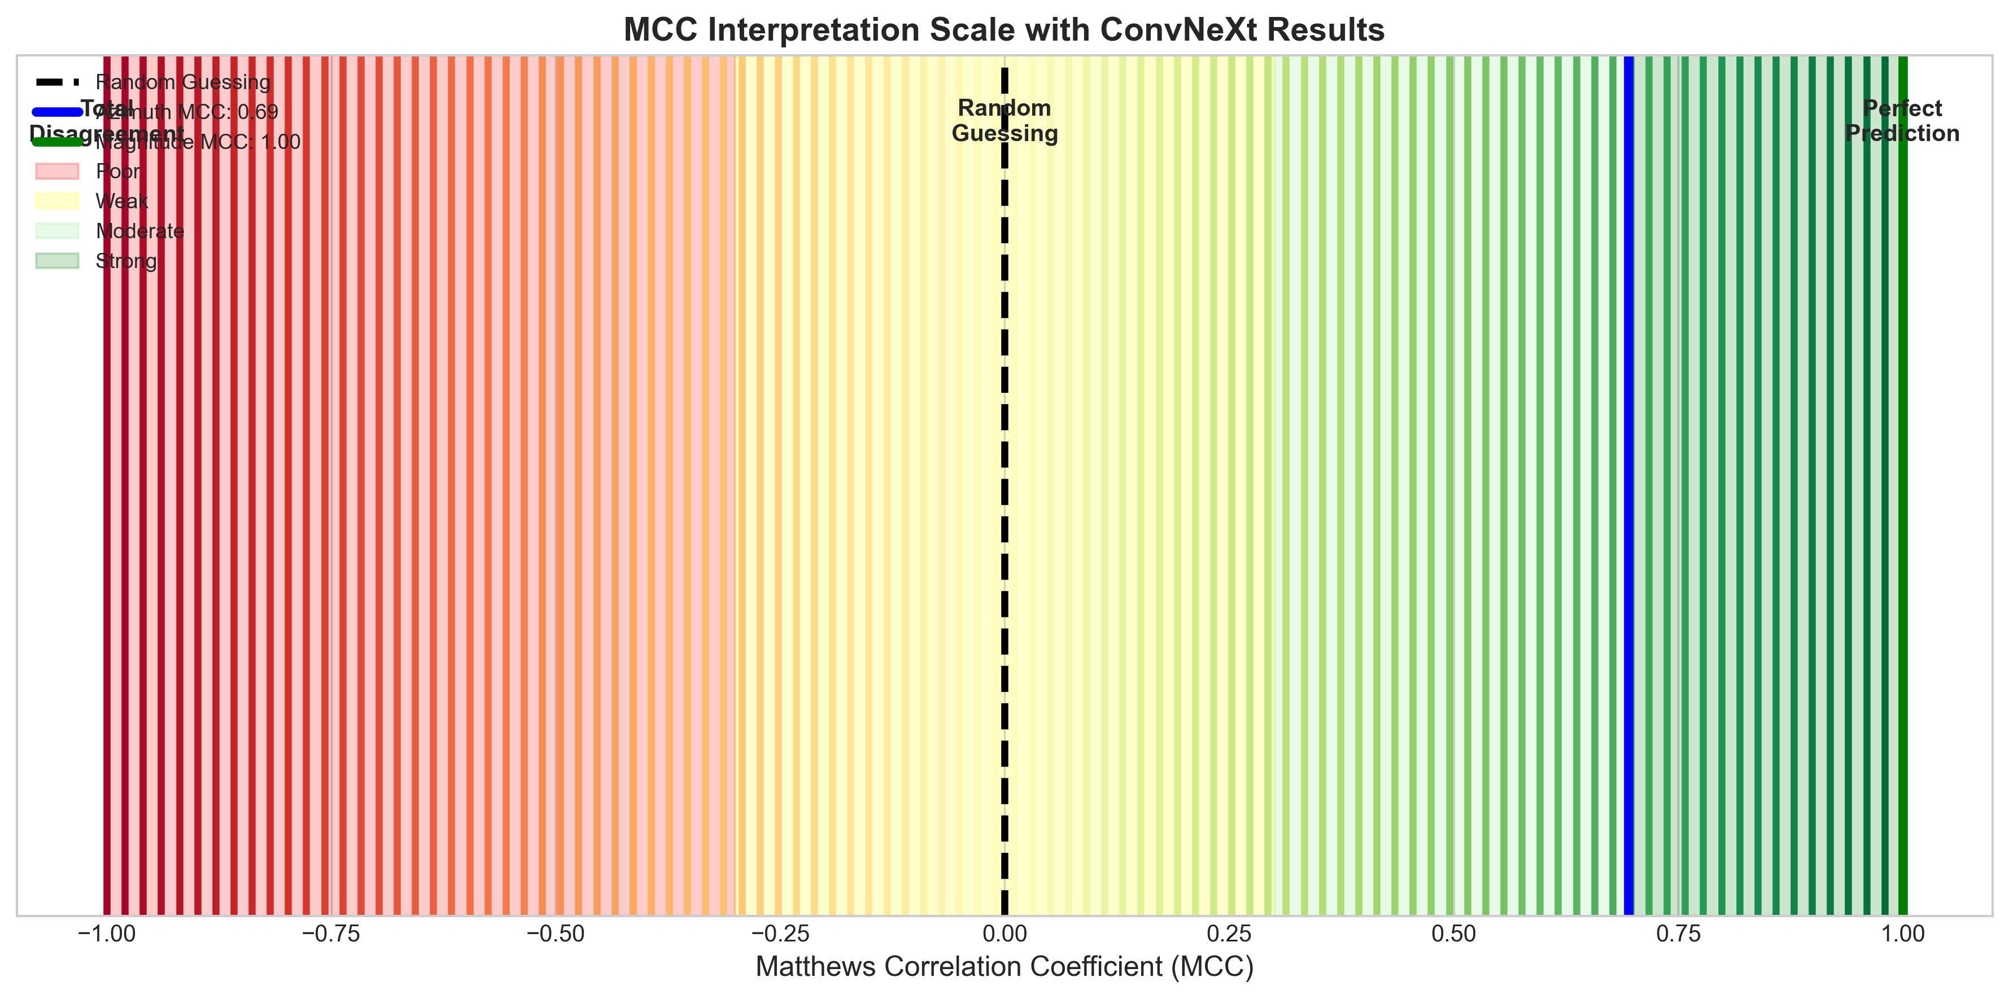
Figure S7: MCC Interpretation Scale

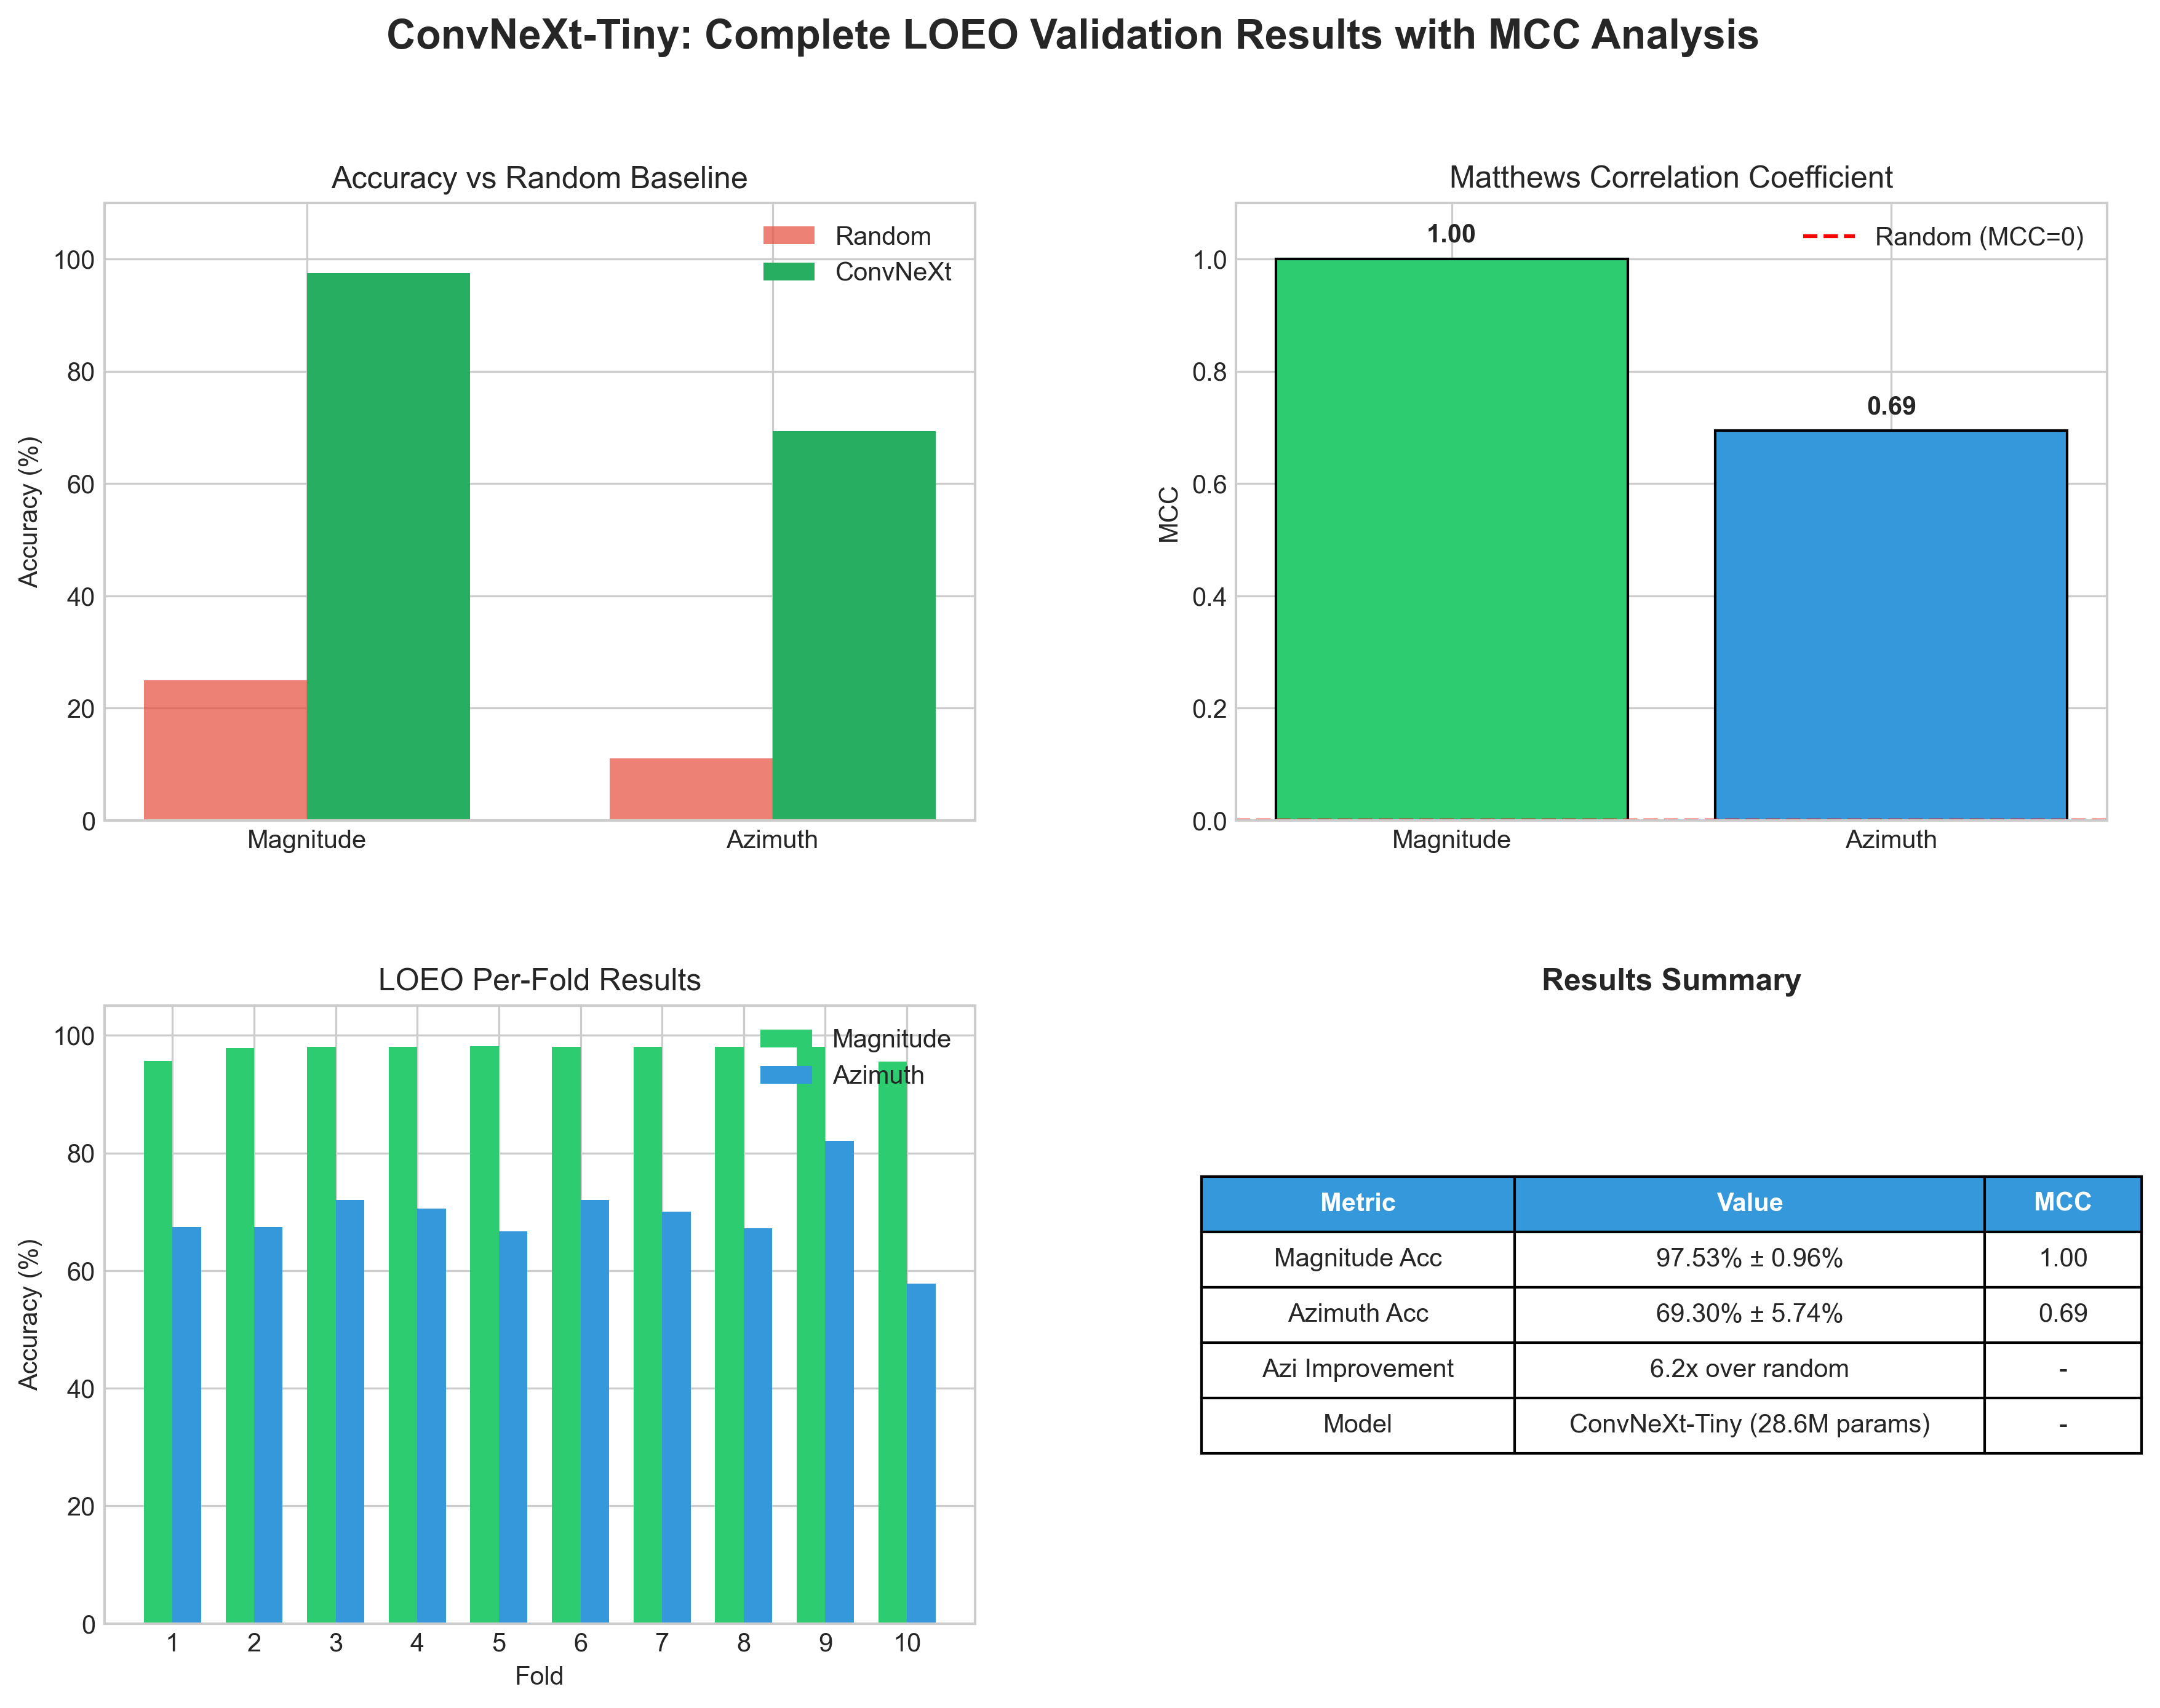
Figure S8: Complete Results Summary with MCC

