Declaration of Competing Interest
Manuscript Title: Hierarchical EfficientNet for Earthquake Precursor Detection from Geomagnetic Spectrograms: A Multi-Task Deep Learning Approach

Authors:
- Sumawan Sumawan, Sepuluh Nopember Institute of Technology, Surabaya, Indonesia
- Bambang L. Widjiantoro, Sepuluh Nopember Institute of Technology, Surabaya, Indonesia
- Katherin Indriawati, Sepuluh Nopember Institute of Technology, Surabaya, Indonesia
- Muhamad Syirojudin, Meteorological, Climatological and Geophysical Agency, Jakarta, Indonesia

Declaration
The authors declare that they have no known competing financial interests or personal relationships that could have appeared to influence the work reported in this paper.

Financial Interests
The authors declare no financial interests related to this work. This research did not receive any specific grant from funding agencies in the public, commercial, or not-for-profit sectors.

Personal Relationships
The authors declare no personal relationships with other people or organizations that could inappropriately influence this work.

Research Data
All data used in this study were obtained from publicly available sources (BMKG geomagnetic observatories) and earthquake catalogs (USGS, BMKG). No proprietary data were used.

Intellectual Property
The authors declare no patents, trademarks, or other intellectual property related to this work that could constitute a competing interest.

Date: February 14, 2026
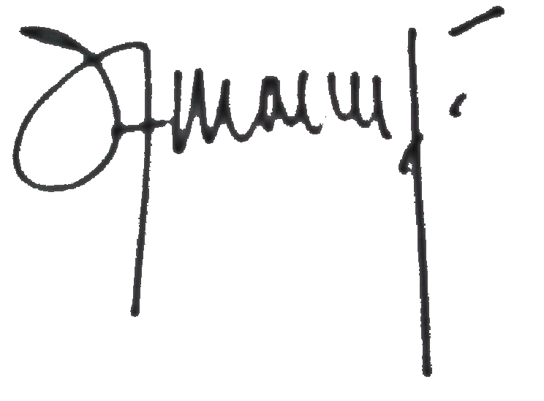
Corresponding Author Signature: _________________________

Corresponding Author Name: Sumawan Sumawan
Corresponding Author Email: sumawanbmkg@gmail.com

