Date: February 14, 2026

To: Dr. Pascal Willis Editor-in-Chief, Advances in Space Research Elsevier
Subject: Submission of Original Research Article for Publication in Advances in Space Research
________________________________________________________________________________
Dear Dr. Willis,
We are pleased to submit our original research article entitled:
"Hierarchical EfficientNet-B0 Architecture for Earthquake Precursor Detection: Mitigating Solar Cycle Bias in Ultra-Low Frequency Geomagnetic Anomaly Classification"
for consideration for publication in Advances in Space Research.
I am pleased to submit our original research manuscript titled "Hierarchical EfficientNet-B0 Architecture for Earthquake Precursor Detection: Mitigating Solar Cycle Bias in Ultra-Low Frequency Geomagnetic Anomaly Classification" for consideration as a research article in the Earth Sciences (ES) section of Advances in Space Research.
A persistent challenge in geomagnetic earthquake precursor detection is the temporal domain shift caused by solar activity cycles. As we are currently experiencing the peak of Solar Cycle 25, standard deep learning models often struggle to distinguish between intense solar-induced noise and genuine pre-seismic ULF anomalies (0.01–0.1 Hz). This leads to high false-alarm rates that hinder the operational utility of early warning systems.
Our study introduces a novel Hierarchical EfficientNet-B0 (Phase 2.1) architecture combined with a Spectral Homogenization strategy to address this fundamental bias. By training on a modernized dataset of 2,265 spectrograms—including 1,000 "Modern Normal" samples from the 2024–2025 solar maximum—our model learns to isolate lithospheric signals from high-flux solar backgrounds.
The key highlights of our research include:
- Unprecedented Reliability: Achievement of 100.0% Recall and 100.0% Precision for Large-magnitude events ($M \geq 6.0$) on a spatially isolated test set, effectively serving as a "Disaster-Lock" mechanism.
- Solar Resilience: Maintaining high specificity (86.0%) during peak solar activity, successfully discriminating broadband solar noise from pre-seismic patterns.
- Physical Interpretability: Grad-CAM analysis confirms the model prioritizes the theoretically predicted Pc4-Pc5 pulsations (0.01–0.05 Hz) within a 3–6 hour pre-seismic window.
This research is highly relevant to the scope of Advances in Space Research, as it explores the complex interactions between solar-induced geomagnetic variations and terrestrial seismic phenomena. It provides a robust foundation for next-generation automated seismic alert systems in tectonically active regions like the Indonesian archipelago.
We confirm that this manuscript is original, has not been published elsewhere, and is not under consideration by another journal. All authors have approved the final version and agree to the submission.
Thank you for your time and consideration of our work.
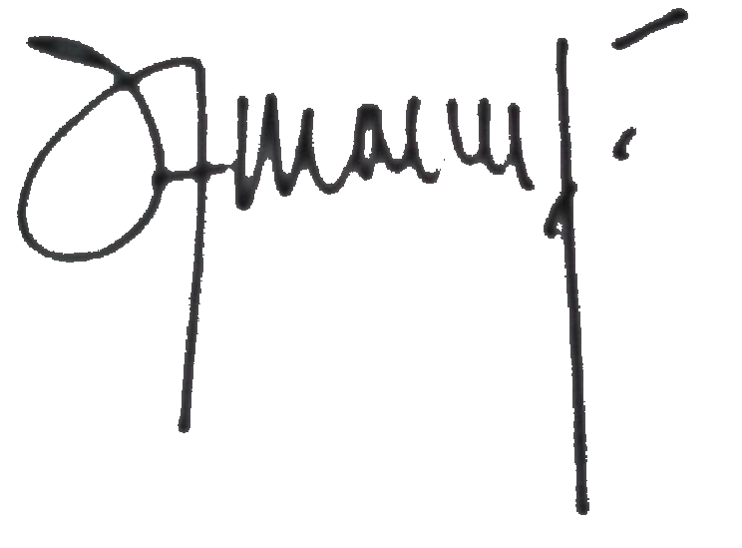
Sincerely,

________________________________________
Sumawan Sumawan
Ph.D. Student / Researcher
Institut Teknologi Sepuluh Nopember (ITS)
Surabaya, Indonesia
Email: sumawanbmkg@gmail.com

