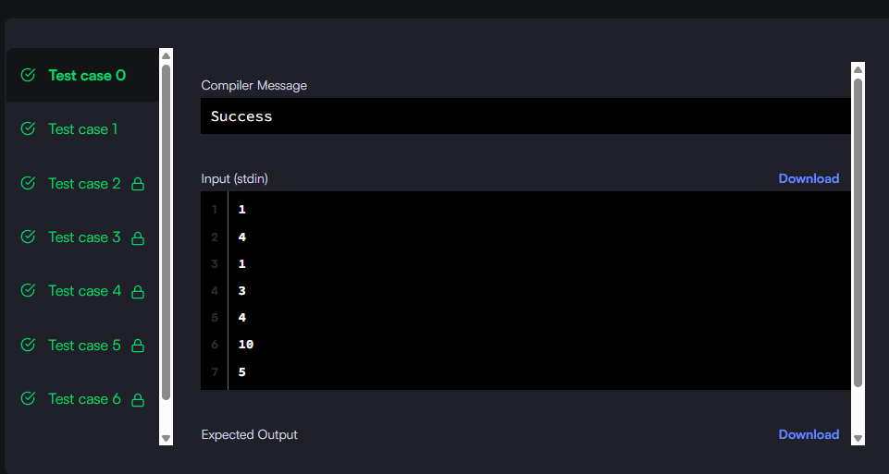

#!/bin/python3

import math

import os

import random

import re

import sys

class DoublyLinkedListNode:

    def __init__(self, node_data):

        self.data = node_data

        self.next = None

        self.prev = None

class DoublyLinkedList:

    def __init__(self):

        self.head = None

        self.tail = None

    def insert_node(self, node_data):

        node = DoublyLinkedListNode(node_data)

        if not self.head:

            self.head = node

        else:

            self.tail.next = node

            node.prev = self.tail

        self.tail = node

def print_doubly_linked_list(node, sep, fptr):

    while node:

        fptr.write(str(node.data))

        node = node.next

        if node:

            fptr.write(sep)

#

# Complete the 'sortedInsert' function below.

#

# The function is expected to return an INTEGER_DOUBLY_LINKED_LIST.

# The function accepts following parameters:

#  1. INTEGER_DOUBLY_LINKED_LIST llist

#  2. INTEGER data

#

#

# For your reference:

#

# DoublyLinkedListNode:

#     int data

#     DoublyLinkedListNode next

#     DoublyLinkedListNode prev

#

#

def sortedInsert(llist, data):

    new_node = DoublyLinkedListNode(data)

    # Case 1: Empty list

    if llist is None:

        return new_node

    # Case 2: Insert at the beginning

    if data < llist.data:

        new_node.next = llist

        llist.prev = new_node

        return new_node

    # Case 3: Traverse to find the position

    current = llist

    while current.next and current.data < data:

        current = current.next

    if current.data >= data:

        # Insert before current

        prev_node = current.prev

        prev_node.next = new_node

        new_node.prev = prev_node

        new_node.next = current

        current.prev = new_node

    else:

        # Insert after current (end of list)

        current.next = new_node

        new_node.prev = current

    return llist

if __name__ == '__main__':

    fptr = open(os.environ['OUTPUT_PATH'], 'w')

    t = int(input())

    for t_itr in range(t):

        llist_count = int(input())

        llist = DoublyLinkedList()

        for _ in range(llist_count):

            llist_item = int(input())

            llist.insert_node(llist_item)

        data = int(input())

        llist1 = sortedInsert(llist.head, data)

        print_doubly_linked_list(llist1, ' ', fptr)

        fptr.write('\n')

    fptr.close()

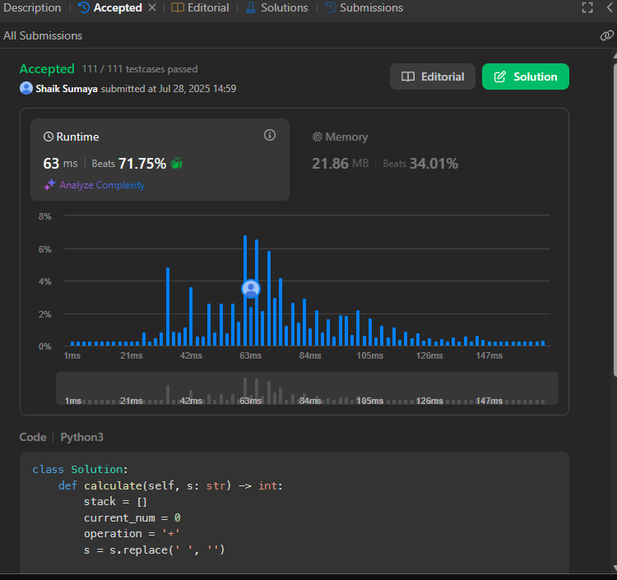

class Solution:

def calculate(self, s: str) -> int:

stack = []

current_num = 0

operation = '+'

s = s.replace(' ', '')

for i in range(len(s)):

char = s[i]

if char.isdigit():

current_num = current_num * 10 + int(char)

# If we reach an operator or end of string

if char in '+-*/' or i == len(s) - 1:

if operation == '+':

stack.append(current_num)

elif operation == '-':

stack.append(-current_num)

elif operation == '*':

stack.append(stack.pop() * current_num)

elif operation == '/':

prev = stack.pop()

# Division that truncates towards zero

stack.append(int(prev / current_num))

operation = char

current_num = 0

return sum(stack)

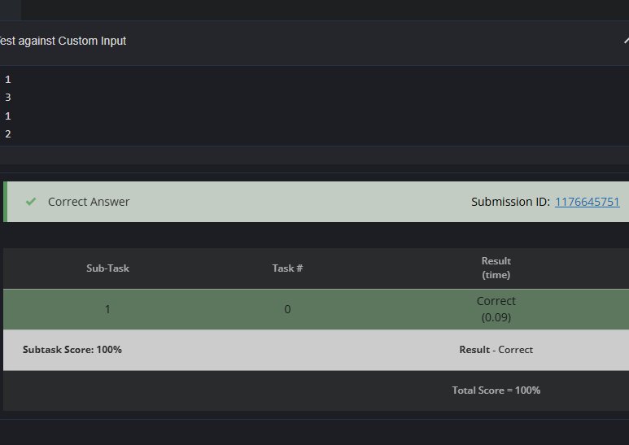

# cook your dish here

def find_missing_doll(dolls):

result = 0

for doll in dolls:

result ^= doll

return result

# Read input

T = int(input())

for _ in range(T):

N = int(input())

dolls = []

for _ in range(N):

doll_type = int(input())

dolls.append(doll_type)

print(find_missing_doll(dolls))