Hackerrank:

#!/bin/python3

import math

import os

import random

import re

import sys

from collections import defaultdict

#

# Complete the 'sherlockAndAnagrams' function below.

#

# The function is expected to return an INTEGER.

# The function accepts STRING s as parameter.

#

def sherlockAndAnagrams(s):

    # Write your code here

    substr_count = defaultdict(int)

    for i in range(len(s)):

        freq = [0] * 26

        for j in range(i, len(s)):

            freq[ord(s[j]) - ord('a')] += 1

            key = tuple(freq)

            substr_count[key] += 1

    count = 0

    for key in substr_count:

        n = substr_count[key]

        count += n * (n - 1) // 2

    return count

if __name__ == '__main__':

    fptr = open(os.environ['OUTPUT_PATH'], 'w')

    q = int(input().strip())

    for q_itr in range(q):

        s = input()

        result = sherlockAndAnagrams(s)

        fptr.write(str(result) + '\n')

    fptr.close()

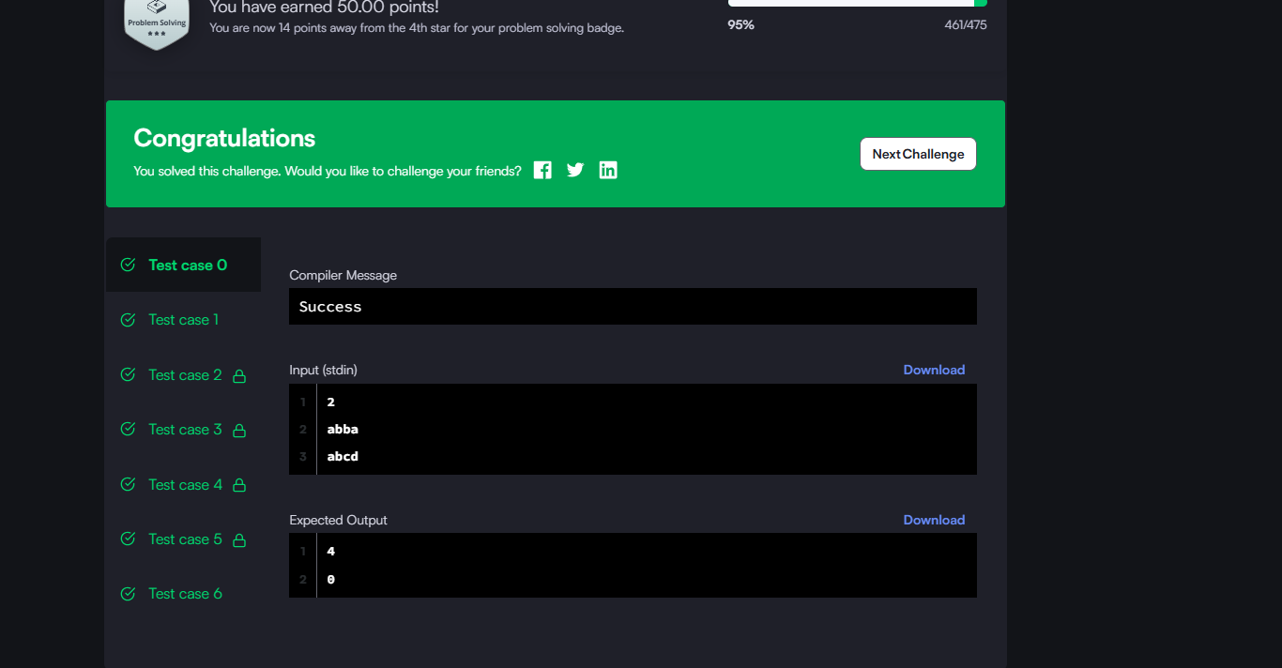

Leetcode:

class Solution(object):

def minWindow(self, s, t):

"""

:type s: str

:type t: str

:rtype: str

"""

if not s or not t:

return ""

dict_t = Counter(t)

required = len(dict_t)

# Pointers for the window

l, r = 0, 0

formed = 0

window_counts = defaultdict(int)

# (window length, left, right)

ans = float("inf"), None, None

while r < len(s):

character = s[r]

window_counts[character] += 1

if character in dict_t and window_counts[character] == dict_t[character]:

formed += 1

while l <= r and formed == required:

if (r - l + 1) < ans[0]:

ans = (r - l + 1, l, r)

window_counts[s[l]] -= 1

if s[l] in dict_t and window_counts[s[l]] < dict_t[s[l]]:

formed -= 1

l += 1

r += 1

return "" if ans[0] == float("inf") else s[ans[1]:ans[2] + 1]

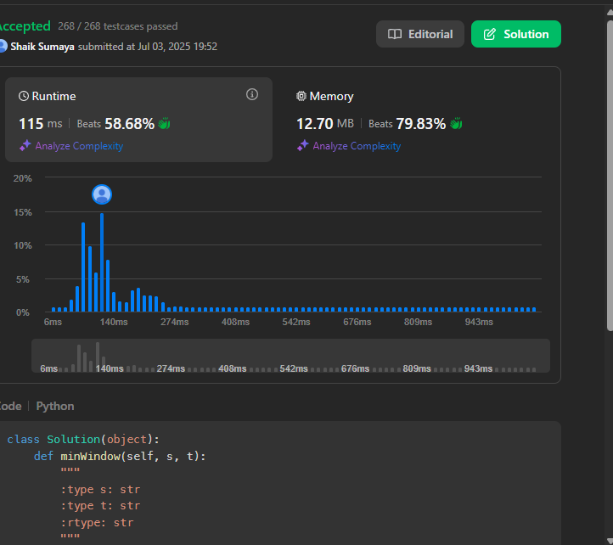

Codechef:

t = int(input())

while t > 0:

s = input()

# Your code goes here

vowels = set('aeiou')

count = 0

happy = False

for ch in s:

if ch in vowels:

count += 1

if count > 2:

happy = True

break

else:

count = 0

if happy:

print("HAPPY")

else:

print("SAD")

t -= 1

