Data Analysis and Visualization

# Look for the Type of dog_stage that has highest rating.

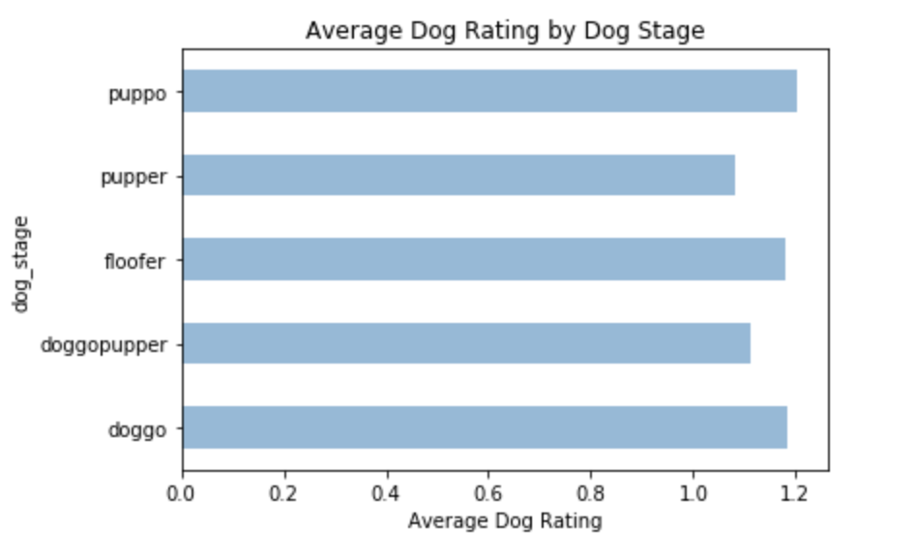

### **Insight 1**

From the Average Dog Rating by Dog Stage bar chart, we can see Puppo has the highest average rating among all stages. Puppy is given a good score, while Pupper has the least average rating.

# Find the most factor contributes to high retweet_count and favorite_count

### **Insight 2**

Rating group between 10/10 to 15 /10 have highest average retweet_count and favorite_count, this is not surprising since most of tweets' rating are within this range. However, there are some outliers that can be spotted on, such as 0/10,5/10,6/10 tweets actually have really high retweet_count and favorite_count, especially 6/10 rating's tweet. This shows low rating intrigue people's tweeting passion more than extreme high rating,for example 666/10 and 182/10.

Additionally, average Retweet Count and Favorite Count are increasing from 201702 to 201708, but the overall summary of Retweet Count and Favorite Count are increasing 201706, then decreasing.

### 

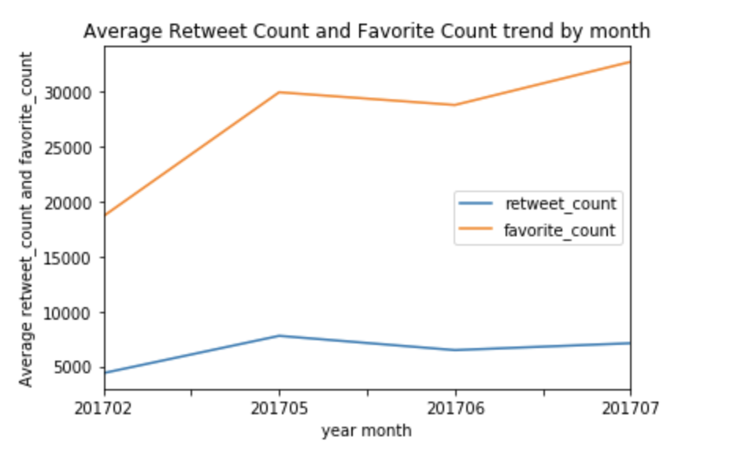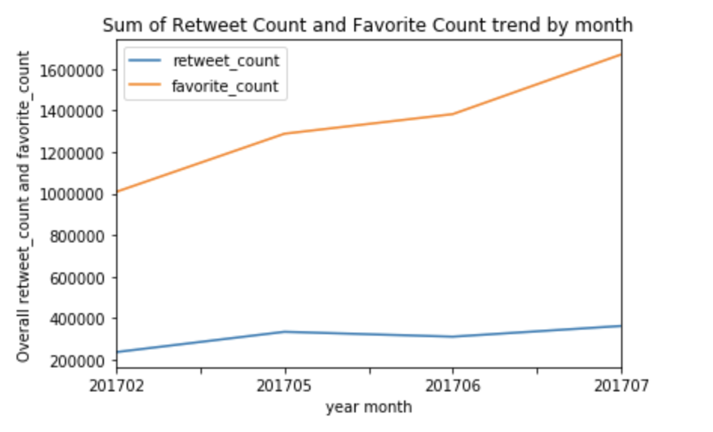

**Insight 3**

There is interesting pattern in the above graphs. In Average Rating trend over months line chart, there is two peaks, one is around 201607 and another is around 201704. 201607 has average rating 2.77 and 201704 has 3.0, there must be some outlier rating which makes average rating so high.

The prediction ratte for 3 dog breed are from 71.5% to 73.3%. Among 3 prediction of dog breed column, dogbreed_indicator2 has the highest dog breed prediction rate.

**Insight 4**

These three lists below show the preference of weRateDog tweeter. we can see clumber is undoubtly his favorate dog breed, then pomeranian, saluki shows up in both predictions, so are tibetan_mastiff and standard_schnauzer.

