**CHAPTER 1**

**INTRODUCTION**

**1.1 Introduction**

Vision is the most important part of human physiology. But unfortunately loss of vision is becoming common now days. Blind people face everyday challenge in moving one place to another. Complete blind people face so many difficulties self-navigating outside well-known environments. In fact, biggest challenges are the movement in physically for blind people. A crowed street may create difficulties for blind people.

According to World Health Organization (WHO) reports in 2015, there were 940 million people with some degree of vision loss. Low vision is faced by 240 million and 39 million were blind. Over the age of 50 years, most people have this poor vision problem. This thing is mostly common in the developing countries.

Blind people use stick as a tool for directing them when they move or walk. The problem of this tool, it’s completely manual. It is difficult for blind people to move or live without help. So they need a smart stick that can help them for guiding the proper way. Not only that but also help to guide all the necessary thing that a blind man need when he is alone or moving. Smart stick provides a complete guideline so a blind man can easily avoid the obstacles and other things that may cause harm. This application will provide some function that may ease the path of a blind man moving or walking.

**1.2 Project objective**

The aim of this project is to design and construct a smart stick that can detect obstacle switch may appear in the path of walking, using microcontroller, sensors, Bluetooth module(HC-05) and android application, through which user will be able to communicate with the system by sound and voice command. The unites able to take sensor reading from the sensors attached to it and depending on the sensor value it can warn the user about obstacle.

**1.3 Methodology**

In this system, I’m using Arduino Uno R3 which is manufactured based on the Atmel ATmega328. The Arduino will host all the sensors and Bluetooth module. There will be two mode of this device.

* Walking mode
* Voice command mode

User can switch to any of this mode using a switch that will be attach to the stick. In the walking mode the Arduino will read sensors data. Then the Arduino will analyze the data and send some warning text to the android application using Bluetooth module. Then the android app will convert that text to speech to warn the user.

The other mode, voice command mode can also be called query mode. If the user want know some information , it can be used. In this mode, user will give some predefined command to the android application. Then the application will send this query command to the Arduino, and after getting the result of the query the android application will convert that result to speech.

**1.4 Organization of the report**

This report is organized as follow: Chapter 2 describes about the block diagram of the complete system and also the diagram of the other module and components. It also narrates about the implementation of the hardware section of the system. Chapter 3 contains the user application (android app) design and implementation of the application. Chapter 4 contains system deployment and testing result. Finally Chapter 5 concludes the report with recommendation for future expansion provisions of the work.

**1.5 Project justification**

This project is of contributory knowledge to the development and implementation of a smart stick for blind in such developing country like Bangladesh using available components like microcontroller, Bluetooth module, sensors etc. Beside that this system provides some extend of advance features are listed below

* Controlling of your stick through android app.
* Controlling of your stick through voice command thus provides exact time, current location and also temperature sensor update.
* Getting Real-time status of the electrical appliances of the sensors.
* Real-time temperature and sensor reading like object detection, flame detection.
* Using the calling option a blind man can call an emergency number when they need.
* Automatic lights on/off depending on the ambient light sensor status. (Outer side)
* Voice command feature will greatly help the blind people from all types of problem as they face in their day to day life.

**CHAPTER 2:**

**HARDWARE DESIGN**

**2.1 Introduction**

Hardware design is one of the most crucial parts of this work. But before getting into the technical details block diagram of complete system and its connection should be studied. Then the circuit diagram and working principle will be discussed. In this chapter, hardware description of the system is provided. Then the design cost analyzed to study its feasibility of application in the real life.

**2.2 Block diagram of the system**

Fig 2.1 shows the simple block diagram of the system. The diagram depicts basic connection and data flow across the system. In my system the Arduino which contains a microcontroller (ATmega328) that has 14digital input and output pins. Here is 6 pin that is used as PWM output. Also 6 analog pin. A USB connection, a 16 MHZ quartz crystal, power jack and also reset button. There are Temperature sensor, ultrasonic sensor and flame sensor, light dependent register in that system. The microcontroller which controls these components, like the sensors and reading the values from the sensors. Now the Arduino is connected to the android application via Bluetooth module (HC-05). All sensor reading is analyzed and then warns the user through the voice. Using the sound waves, the obstacles can be detected. This ultrasonic sensor measures the distance. It sends the out a sound wave at a specific frequency. Then it listens the sound wave to bounce back. Four ultrasonic sensors are used in this system. One is right, one is left and front one is also in front of the system box. Then one ultrasonic sensor is in the down that detect the hole come to the path of blind people.

Here the flame sensor is interfaced to the arduino to detect flame and also give result of the value. There is used 3 flame sensor. One which is front gives the analog value and other two give the digital value. Temperature sensor is able to measure the heat energy of the weather .In this system, There is one temperature sensor (LM35) in that system. HC-05module is designed for transparent wireless serial connection setup. All the sensors reading is taking in the walking mode when the switch is Off. The switch in off mode means walking mode give the sensor value. The value of flame sensor, ultrasonic sensor, the light dependent resistor can get in that mode.

Now next mode is the command mood. Bluetooth creates communication among them. The On of switch provides the information of other things. That part helps a blind man to know all the necessary thing of a daily life. Suppose that blind person need to know about time. This system will provide the exact time. Also provides the calling option, giving temperature of the environment where that person is in.

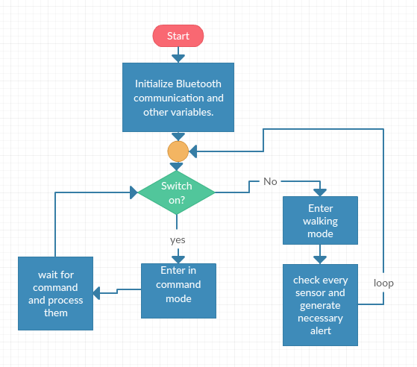Fig 2.1:Block Diagram of The Complete System

**2.2.1 Circuit diagram of complete system**

Now we will go little deep into the system’s hardware configuration with all the major and minor components it consists of. Fig 2.2 shows the circuitry diagram of the system.

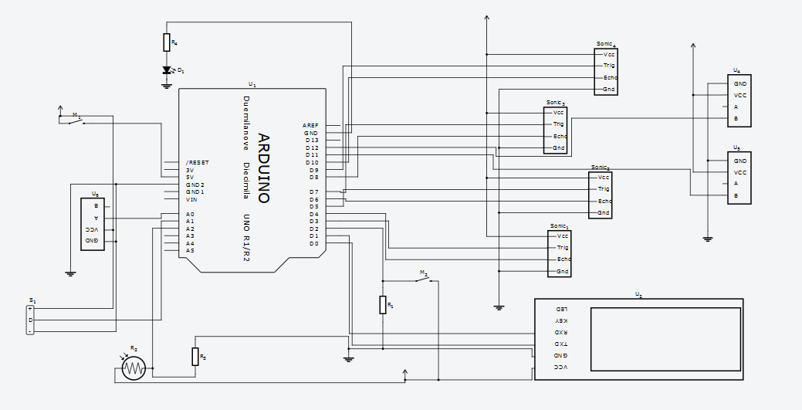

Fig 2.2:Circuit Diagram of Complete System

In my system the Arduino which contains a microcontroller (ATmega328) that has 14digital input and output pins. Here is 6 pin that is used as PWM output. Also 6 analog pin. A USB connection, a 16 MHZ quartz crystal, power jack and also reset button. There are Temperature sensor, ultrasonic sensor and flame sensor, light dependent register in that system. The microcontroller which controls these components, like the sensors and reading the values from the sensors

By doing this sensors communication, user can switch to any of this mode using a switch that will be attach to the stick. In the walking mode the Arduino will read sensors data. Then the Arduino will analyze the data and send some warning text to the android application using Bluetooth module. Then the android app will convert that text to speech to warn the user.

The other mode, voice command mode can also be called query mode. If the user want know some information, it can be used. In this mode, user will give some predefined command to the android application. Then the application will send this query command to the Arduino and after getting the result of the query the android application will convert that result to speech.

**2.2.1 Circuit diagram of sensor module**

In this sub section discussion over the sensor module will be made. There are 4 sensors in this sensor module. First one is Ambient Light sensor which is a Light Dependent Resistor (LDR), second one is temperature sensor LM35, and third one is flame sensor based on infrared radiation detection. The Flame Sensor can be used to detect fire. The flame sensor sources or other light sources of the wavelength in the range of 760nm - 1100 nm. The fourth one is ultrasonic sensor. HCSR04 is an Ultrasonic ranging module. This sensor consists of a transmitter, receiver and control circuit. It has four pins for VCC, GND, Trigger and Echo. You can easily interface it with microcontrollers and Arduino boards .Basic principle of works are given below-

(1) That module sends eight 40 kHz.

(2) Then it detects whether there is pulse signal back.

(3) Now the signal back through the high level and the time of high level output is

Test distance = (high level time *velocity of sound (340M/S)/2

These sensors are powered from the Arduino’s 5v output pin. The ground reference is 0v which is taken from Arduino board. All the sensors in the sensor module are sharing the same voltage supply line and ground reference in the system. Here is the 14 digital input or output pin .6 analog outputs and 6 PWM pin. Here is the digital input and analog input of circuit.

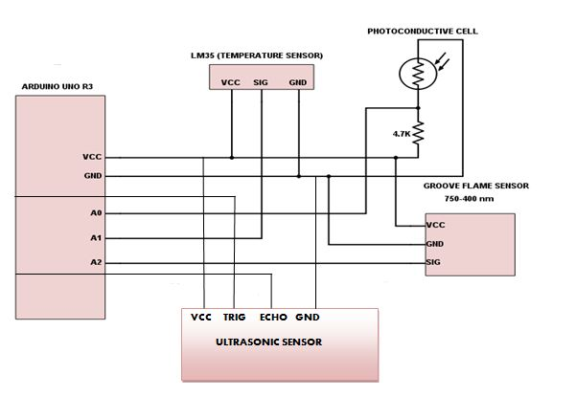 Fig. 2.3: Sensor Module (Light, Temperature, Flame, Ultrasonic sensor)

**LM35 integrated-circuit**

The LM35 is integrated circuit temperature that output voltage is linearly proportional to the Centigrade temperature. That LM35 device has an advantage. The advantage is over the temperature sensors calibrated in Kelvin. The user is not required to subtract a large constant voltage. The voltage from the output to obtain convenient Centigrade scaling.

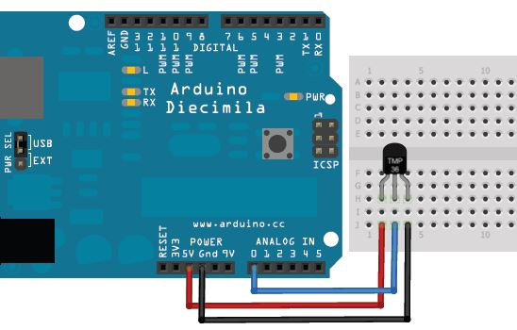

Fig. 2.3 : LM35 Circuit

The LM35 device does not require any typical accuracies in a room temperature. Over a full −55°C to 150°C temperature range for the device. That LM35 is rated to the −55°C to 150°C temperature range. LM35 draws only 60 µA from the supply. That

device is used for single power supply or the plus and minus supplies. LM35 control the circuitry easy. It has also low self-heating of less than supply. The wafer level is assured by the timing . The device is used with single power supplies, or with plus and minus supplies. , it has very low self-heating of less than 0.1°C in the air.

**Flame sensor**

The Grove - Flame Sensor is used to detect fire source .That also detect other light sources like the range is 760nm – 1100nm. Flame sensor is based on YG1006 which is high in speed and also high sensitive. That sensor is sensitive to infrared radiation. For an example, in the fighting game, that sensor plays a very important role .That may be used as a robot eyes to find the fire source. That flame sensor is also playing an important role in that system. Here is using three flame sensor in that whole system. The front flame sensor gives the analog value of the flame in the side. Other two sensors give the value in digital. The analog sensors give the pin (A0,D0,Gnd,Vcc) and the another one is (D0,Gnd,Vcc). They can easily interface with the arduino and the arduino board.

The detection point is about 60 degree. When I use that flame sensor in the system, I just make a condition for the analog sensor. By giving a condition of flame sensor ,it get all the value . But according to the condition, it only give a certain value that is checked by the condition. And I also use the digital flame sensor where it gives a reading of 1 and 0. If the sensor detects fire give 1, otherwise the value is 0.

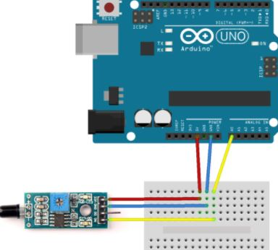

Fig. 2.4: Flame Sensor circuit

**Light dependent resistor**

Light dependent resistor is a light-controlled variable [resistor](https://en.wikipedia.org/wiki/Resistor). The photoresistor decreases with the increasing value of light intensity. We can say in other words, it exhibits [photoconductivity](https://en.wikipedia.org/wiki/Photoconductivity). A photoresistor can be applied in light-sensitive detector circuits. It is also applied in light- and dark-activated switching circuits.

A photoresistor is made of a high resistance [semiconductor](https://en.wikipedia.org/wiki/Semiconductor). For this reason, in the high as several mega ohms when it is dark. Few hundred ohms is given in light. In that system a light dependent resistor is used so that a blind person can move in night and other people can easily notice it. That light dependent resistor gives high mega ohm at night. So in my project a led is connected with that light dependent resistor. According to the condition when the resistor get night, it turns on the led. It becomes off at the day mood. So that becomes easy to use for a blind person.

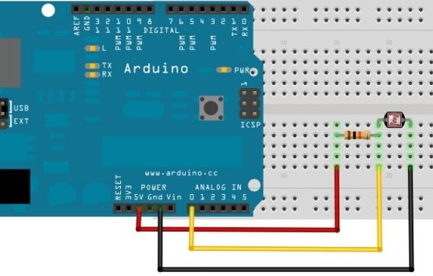

Fig. 2.5 : Light Dependent Resistor circuit

**Ultrasonic Sensor**

This is the HC-SR04 ultrasonic ranging Sensor. This sensor provides 2cm to 400cm which is a ranging accuracy that can reach up to 3 mm. Each HC_SR04 module includes an ultrasonic transmitter, a receiver and a control circuit. There are only four pins on the HC-SR04: VCC (Power), Trig (Trigger), Echo (Receive) and GND (Ground) . Using the sound waves, the obstacles can be detected. This ultrasonic sensor measures the distance. It sends the out a sound wave at a specific frequency. Then it listens the sound wave to bounce back.

Now according to the system work, four ultrasonic sensors are used in this system. One is right, one is left and front one is also in front of the system box. Then one ultrasonic sensor is in the down that detect the hole come to the path of blind people.

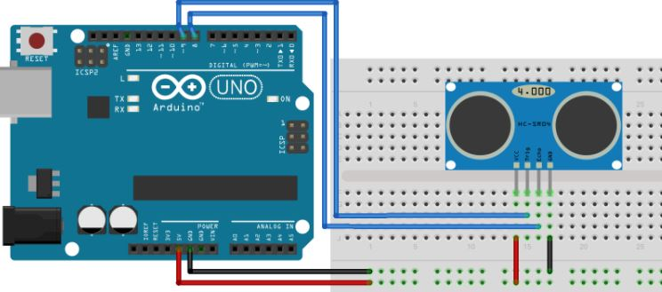

Fig. 2.6 : Ultrasonic sensor circuit

**2.3 Bluetooth Module (HC-05)**

The Bluetooth Module is the latest Bluetooth wireless serial cable. This version of the popular Bluetooth uses the HC-05 module. (RX/TX) work as serial pipe. To get the target of the stream of 9600 to 115200bps can be passed from computer to computer.

That can be powered from 3.3V up to 6V from battery. All the signal pins are on 3V-6V tolerant. Level shifting is not required. We do not need to attach the device directly to a serial port. We just need an RS232 to the TTL converter. Individual or the a 6 pin header can be solder.

In that system Bluetooth Module (HC -05) is the main communication device to communicate the sensors value with the android application. By using this Bluetooth module, a blind person can easily run the application and get the proper information of all the sensors along with the other feature. That module run on both walking and command mode. According to the switch on and off, the device is connected by the Bluetooth. First a blind need to turn on Bluetooth on his or her phone. Then the Bluetooth module will help to communicate with the device and the android application .

By turning on the system switch, the Bluetooth module is on. So now all are set, a blind man just turn on or turn off to get the proper direction. Here Bluetooth module plays an important role in this system. If somehow the Bluetooth module is disconnected, that system cannot read the sensor value to give as a command for blind person.

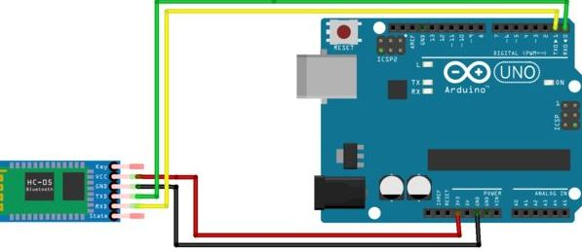

Fig. 2.7: Bluetooth Module circuit

**2.4 Switch**

A switch must have at least two terminals, they are-

1. Current to go in (potentially)
2. Another to come out (potentially)

Switch has two modes. One is on and another is off. That two describes the simplest version of switch through. The one is for the current go and another to come out.

We need to know how many separate circuit a switch can control based on the number of pole. A switch which has one pole can only influence one single circuit. Four different circuits can be controlled by four switches

A switch’s throwcount defines how many positions each of the switch’s poles can be connected to. For example, if a switch has two throws, two terminals can be connected by the circuit.

A switch can be defined as the name of the following below-

1. “Single-pole, Single-throw
2. “Single-pole ,double-throw
3. “Double-pole , double throw”

The poles and the throws can be help to know a switch to be classified. Switch that defines as the above description. That may be abbreviated to SPST, SPDT, SPST and DPDT, respectively.

SPST gets one output and one input. For that reason the switch is either on or off. In that system SPST switch is used. One switch is used to turn on the whole system. Another one is used to control the box of the stick (combination of sensors) with the android application

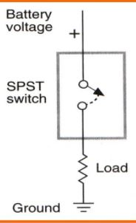

Fig. 2.8: Switch (SPST)

Switch has two modes. One is on and another is off. That two describes the simplest version of switch through. The one is for the current go and another to come out.

We need to know how many separate circuit a switch can control based on the number of pole. A switch which has one pole can only influence one single circuit. Four different circuits can be controlled by four switches

**2.5 Arduino Uno R3**

The Arduino Uno is a microcontroller board based which is the best board to start any kind of electronics and the coding.

In my system, the Arduino which contains a microcontroller (ATmega328) that has 14digital input and output pins. Here is 6 pin that is used as PWM output. Also 6 analog pin. A USB connection, a 16 MHZ quartz crystal, power jack and also reset bottom.

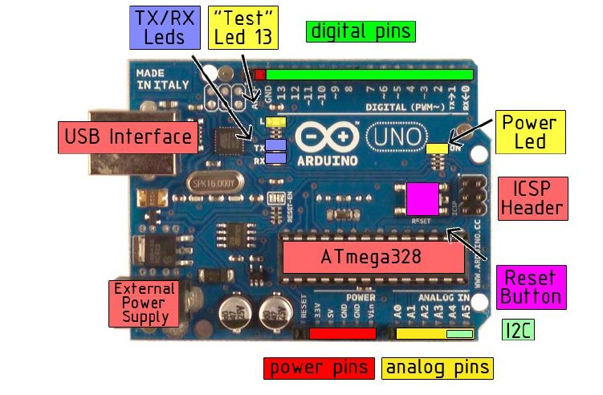

Fig. 2.7: Arduino UNO R3

**Technical specification**

Microcontroller ATmega328

Operating Voltage 5V

Input Voltage (recommended) 7-12V

Input Voltage (limits) 6-20V

Digital I/O Pins 14 (of which 6 provide PWM output)

Analog Input Pins 6

DC Current per I/O Pin 40 mA

DC Current for 3.3V Pin 50 mA

Flash Memory 32 KB of which 0.5 KB used by

boot loader

SRAM 2 KB

EEPROM 1 KB

Clock Speed 16 MHz

**Power**

USB connection is used to supply power in Arduino Uno. And also with an external power supply. The power source automatically is selected. Connecting the adapter by doing plugging. AC-to-DC adapter can provides External power. The Leads is inserted to GND and also the Vin pin to the POWER connector. The volt of 6 to 2o can operate the board. 5V pin may supply less than five volt. But using more than 12V may destroy or overheat the board. The power play a vital role in system.

In developing that system the power supply becomes the most import part of the project .As there are 4 ultrasonic sensor,3 flame sensor,1 temperature and 1 light dependent resistor, the power supply cannot distributing same in all the same time. So I just keep a good care about of the issue. After getting knowledge about it, I find a recommended range 7 to 12 volts. The power pins are as follows:

* **VIN**. This is the input voltage. The Arduiono board gets it when it uses the external power. You can supply voltage through this pin, or, if supplying voltage via the power jack, access it through this pin.
* **5V**. this is used to supply the power in microcontroller. This also gives power to the other component of the board. In my system 5V is used for the power supp;y to the microcontroller and other component.
* **3V3**. A 3.3 volt supply generated by the on-board regulator. 50 mA is maximum current
* **GND** .pins of Ground

**Memory**

32 KB of flash memory for storing code is used in the Atmega328. To read and write from the EEPROM library, it has 2KB of SRAM and 1KB of EEPROM.

**Input and output**

14 digital pins are used in Uno. That is on the input or the output value. There is function for this and that are below-

1. pinMode()
2. digitalWrite()
3. digitalRead()

40 mA is providing in every pin and pull up resistor which resistor is 20-50 kohms. The function of pinMode() helps to declare a pin that may be used as input or the output. Next digitalRead() is declared when we just need one digital pin to set as value. The digitalWrite() function is for the digital pin output.

* **External Interrupts**: On a low voltage pin is configured .It can be also a rising or the change of value. To know ab0ut it, the function Interrupt () can be used.
* **Serial**: Receiving the RX and transmit the serial data. That pins are also connected to the ATmega8U2 USB –to-TTL serial chip.
* **PWM**: PWM pins are 3, 5, 6, 9, 10, and 11. analogWrite() is provided with 8-bit PWM output.
* **SPI**: 13(SCK), 10(SS), 11(MOSI), 12(MISO). That pins support SPI communication. It is provided through the hardware.
* **I2C:** hardware. Using the wire library, support I2C communicates.
* **LED:** .Digital pin 13 is built in LED . When the pin is HIGH value, then the LED is on. Again the LED pin is LOW, it’s off. 6 analog pin that is (A0 to A5) .Every inputs provide 10 bits of resolution. By using the AREF and analogReference () function is possible to change upper end range.

Here we can see another couple pin in the board:

* AREF: Bring This is for the reference voltage of analog inputs. The function is used called analogReference()
* Reset: Bring Now bring the LOW to reset the microcontroller .Here is added a reset button that may block one on the board.

In my system, the Arduino which contains a microcontroller (ATmega328) that has 14digital input and output pins. Here is 6 pin that is used as PWM output. Also 6 analog pin. A USB connection, a 16 MHZ quartz crystal, power jack and also reset bottom.

**Communication**

the Arduino which contains a microcontroller (ATmega328) that has 14digital input and output pins. Here is 6 pin that is used as PWM output. Also 6 analog pin. A USB connection, a 16 MHZ quartz crystal, power jack and also reset button. There are Temperature sensor, ultrasonic sensor and flame sensor, light dependent register in that system. The microcontroller which controls these components, like the sensors and reading the values from the sensors.

Arduino has the facilities to communicate with the computer. Another Arduino or the microcontroller. The ATmega328 provides UART TTL in serial communication .Digital pin 0 and 1. The 0 is RX and 1 is TX. Now the serial communication over the USB use as a virtual port to the computer. The standard USB COM drives and no external drive is needed.

These pins can be configured to trigger an interrupt on a low value, a rising or falling edge, or a change in value. See the attach Interrupt () function for details. 10 (SS), 11 (MOSI), 12 (MISO), 13 (SCK). These pins support SPI communication, which, although provided by the underlying hardware, is not currently included in the Arduino language. The Arduino software includes a serial monitor. That allows to send the data. The RX and TX LEDs on the board will flash when that data is being taransmitted.That thing is happened through the USB to serial chip and the USB connection to computer.

In that system Bluetooth Module (HC -05) is the main communication device to communicate the sensors value with the android application. By using this Bluetooth module, a blind person can easily run the application and get the proper information of all the sensors along with the other feature. That module runs on both walking and command mode. According to the switch on and off, the device is connected by the Bluetooth. First a blind need to turn on Bluetooth on his or her phone. Then the Bluetooth module will help to communicate with the device and the android application. By turning on the system switch, the Bluetooth module is on. So now all are set, a blind man just turn on or turn off to get the proper direction. Here Bluetooth module plays an important role in this system.

These sensors are powered from the Arduino’s 5v output pin. The ground reference is 0v which is taken from Arduino board. All the sensors in the sensor module are sharing the same voltage supply line and ground reference in the system. Here is the 14 digital input or output pin .6 analog outputs and 6 PWM pin. Here is the digital input and analog input of circuit

In that system, Bluetooth creates communication among them. The On of switch provides the information of other things. That part helps a blind man to know all the necessary thing of a daily life. Suppose that blind person need to know about time. This system will provide the exact time. Also provides the calling option, giving temperature of the environment where that person is in.

**2.5 Cost Analysis of The Hardware**

To design the hardware, the following components are required:

* Arduino UNO R3

Quantity: 1 pc

Cost: 600.00

* Light Dependent Resistor(LDR)

Quantity:1 pc

Cost: 10.00

* Grove Flame Sensor

Quantity: 3 pc

Cost: 2721.00

* Temperature Sensor(LM35)

Quantity: 1 pc

Cost: 70.00

* Ultrasonic sensor(HC-SR04)

Quantity: 4 pc

Cost: 600.00

* Bluetooth module(HC-05)

Quantity: 1pc

Cost: 510.00

* Blind stick

Quantity: 1pc

Cost: 900.00

So, Total cost is 5,411 (Five thousand four hundred eleven taka only). This cost is very reasonable

**CHAPTER 3**

**SOFTWARE DESIGN AND IMPLEMENTATION**

**3.1 Introduction**

In the software part of this project there are two block of program/code are running in two different devices across the entire system. An Arduino sketch (see APPENDIX E) on the Arduino UNO R3 which based on C/C++ language and another is an android application which is based on App Inventor web application

**3.2 Overall description**

In this Sub section I will discuss about the overall description of the application software.

App Inventor is maintained by the Massachusetts Institute of Technology (MIT). This is an open source web application. App Inventor is originally provided by Google.

It gives opportunity to create something new in the platform of Android operating system. Its graphical user interface allows user to create easily an application. Creating new thing may add new research in educational computing. The application for the system is made in app inventor. Where it provides the basic logic of the program. One just needs to understand the basic logic. After knowing about the basic logic about coding, one can make an application in app inventor. In my system there is a GUI for all separate part of system that the application provides

**3.2.1 Product perspective**

The perspective of the application is to provide a user friendly graphical user interface through which user can give different command. This application provide the command of call home, time, temperature and location. This piece of software will also facilitate the communication of Arduino and give the accurate result of ultrasonic sensor and flame sensor through voice.

## 

## 3.2.2 Product functions

There is few basic functionality which will be handled by the application. Some of them listed below

* Provide Graphical user interface for home, temperature, time, location..
* Monitoring facility of sensor values
* Control the devices in other words control the specific digital pin status
* Facilitate the communication between Arduino and Bluetooth module(HC-05)
* Facilitate Voice recognition system

## 3.3 User interface

User interface is an interface through which user will communicate with the system. In general we have 5 different user interfaces in this application. The home screen, setting interface for the overall setting of the application .

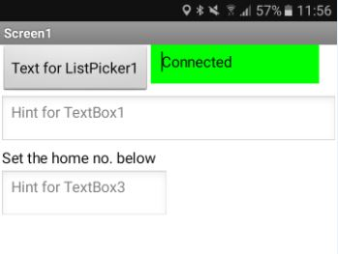

Fig. 3.1: Home screen Interface

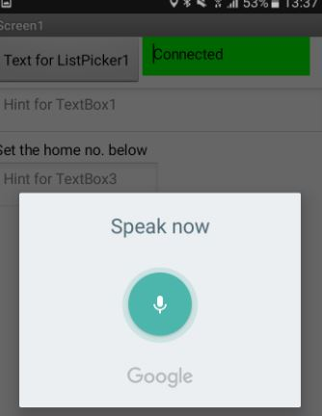

Fig .3.2. Command mode interface

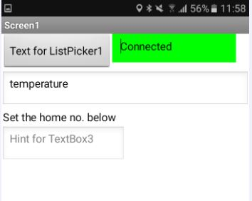

Fig.3.3. tempreture option in command mode

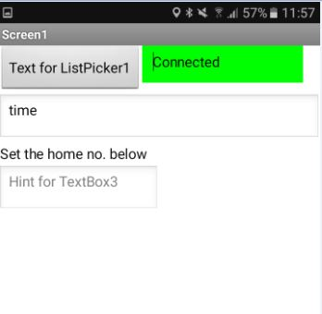

Fig 3.4. time option in command mode

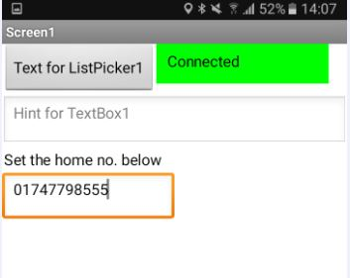

Fig.3.5. Call home option in command mode

## 

## 3.3.2 Hardware interface

While this application will be running the arduino will give the sensors value. The value according to the condition will give as an output in voice through the android application.

## 3.3.3 Software interfaces

This application was developed in App inventor .App Inventor is maintained by the Massachusetts Institute of Technology (MIT). This is an open source web application. App Inventor is originally provided by Google.

**CHAPTER 4**

**SYSTEM DEPLOYMENT AND TEST RESULT**

**4.1 Introduction**

In this chapter we will discuss about the deployment of the system and the test results that generated in the system testing phase of the whole system in different case scenario.

**4.2 Deployment of the system**

I have installed Arduino, Bluetooth module (HC-05) and other components as described in the chapter 2 . The main power supply board will power up all the components. Then these components are placed into box and then fix the box with the stick. I am using an android phone as a prototype with the stick. After Complete deployment the I will push the system through test.

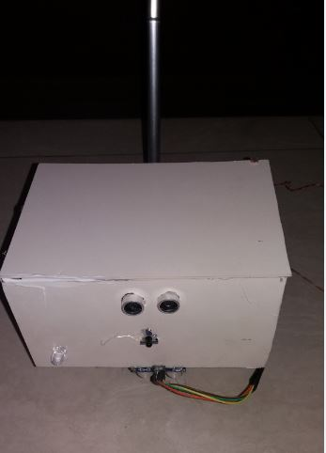

Figure. 4.1: Original system photograph

**4.3 Testing of the system**

For the test purpose we have bind the box with a stick and started walking in a room where there are many obstacles.

Table. 4.1: Test result of the system

|  |  |  |  |  |  |  |
| --- | --- | --- | --- | --- | --- | --- |
| **Serial Number** | **Input Method** | **User Action** | **Input** | **Sensor Reading** | **Action** | **Android action** |
| 1 | Room obstacle | Walking with the stick | Room wall to the ultrasonic(Front) | Front Ultrasonic  Distance less than 20 cm. | Arduino sends warning message to the android device | Android device speaks up the warnin message “Obstacle Front” |
| 2 | Room obstacle | Walking with the stick | Room wall to the ultrasonic(Left) | Left Ultrasonic  Distance less than 15 cm. | Arduino sends warning message to the android device | Android device speaks up the warnin message “Obstacle Left” |
| 3 | Room obstacle | Walking with the stick | Room wall to the ultrasonic(Right) | Right Ultrasonic  Distance less than 15 cm. | Arduino sends warning message to the android device | Android device speaks up the warnin message “Obstacle Right” |
| 4 | Room obstacle(fire) | Walking with the stick | Fire source to the front of the box | Fire detected by the front flame sensor | Arduino sends warning message to the android device | Android device speaks up the warnin message “Alert, Fire detected” |
| 5 | Room obstacle(fire) | Walking with the stick | Fire source to the left of the box | Fire detected by the left flame sensor | Arduino sends warning message to the android device | Android device speaks up the warnin message “Fire detected left” |
| 6 | Room obstacle(fire) | Walking with the stick | Fire source to the right of the box | Fire detected by the eight flame sensor | Arduino sends warning message to the android device | Android device speaks up the warnin message “Fire detected right” |
| 7 | Room hole | Walking with the stick | Room hole to the ultrasonic(down) | Hole detected by ultrasonic sensor | Arduino sends warning message to the android deveice | Android deveice speaks up the warning message “Stop” |
| 8 | Voice command | Switching to command mode. Voice command to android device (Time) | “Time” | - | - | Android device speaks up with current time. |
| 9 | Voice command | Switching to command mode. Voice command to android device (Location) | “Location” | - | - | Android device speaks up with current location. |
| 10 | Voice command | Switching to command mode. Voice command to android device (Call home) | “Call Home” | - | - | Android application will make a call to an emergency number which is predefined. |
| 11 | Voice command | Switching to command mode. Voice command to android device (Temperature) | “Temperature” | Temperature sensor analog reading | Andorid device will request temperature reading from arduino. Arduino then send the current temperature to the android device. | Android device speaks up with current temperature. |
| 12 | Room | Dark light |  | LDR will detect low light. | Arduino will detect low light and turn on the led light. | - |

**4.4 Summary**

In this chapter I have described how the hardware is implementation is done and the testing result of the system. Test results are summarized in tabular form also. The tabular data shows that the system is working as indented from both medium of input and the system output was relevant.

**CHAPTER 5:**

**CONCLUSION**

**5.1 Conclusion**

In this work I have developed a smart stick that can be used for detecting the obstacle, flame and also voice command. Voice command feature will greatly help the blind people by giving the information of the current location, time, the temperature and also provide the calling function. So a blind man can use this smart stick and easily can move according to wish

**5.2 Limitation of the proposed system**

The smart stick for blind is a system that gives a blind lot of information about the environment where he or she is moving or walking . The system is capable for blind to walk or moving and also give necessary information needed. But there is some limitation of that system. Some limitations are given below.

* The components of the system may become useless if there is any problem of power.
* That system is connected through a Bluetooth module to interact the sensor and android application. So any problem of the Bluetooth may stop the voice command of the system.

**5.3 Recommendation for future work**

The possibilities of the smart stick for blind are endless. We can integrate almost everything of our daily life to this system to work them more efficiently and to make them intelligent to carry out their task by own. Some possible enhancement of the system listed below

* Updated Things like crossing road, staircase detection can be added to this system to control them through this device.
* To have more decision taking capabilities by employing varied type of sensors and get all other necessary information for blind people.
* Add a complete system that may guide to walk for a location. A user may fixed a location and get stopped when the location has arrived.
* Make the stick more active so that it can ensure safety issues.
* Add some other feature like AI (artificial intelligent) feature can be added. The stick give own decision when the obstacles come and give a decision according to the environment.

F