Computer Forensics Case Studies
Case Study 3 Investigating Memory Evidence

Name: Badmus Sumayyah
Reg., Number: 2025/FWSD/1142

Practical roadmap
Part 1 — Prepare the forensic workspace
Find the memory image and Volatility 2, check Python 2, create folders, and capture the initial screenshot.
Part 2 — Preserve and verify evidence
Record the image's size, calculate its SHA-256 hash, and preserve an unchanged original. Part 3 — Identify the Windows memory profile
Run Volatility's image information command and choose a profile supported by the output. Part 4 — Investigate processes and command history
Examine process listings, scanned processes, command history, and console artefacts. Part 5 — Examine USB and registry artefact
Inspect the relevant registry hives and USB storage, mounted-device, and shell-folder records. Part 6 — Correlate evidence and build the timeline
Compare the memory artefacts, document timestamps in UTC where supported, and distinguish facts from inference.
Part 7 — Complete the report and evidence pack
Organise command outputs, screenshots, evidence hashes, findings, limitations, and conclusions.

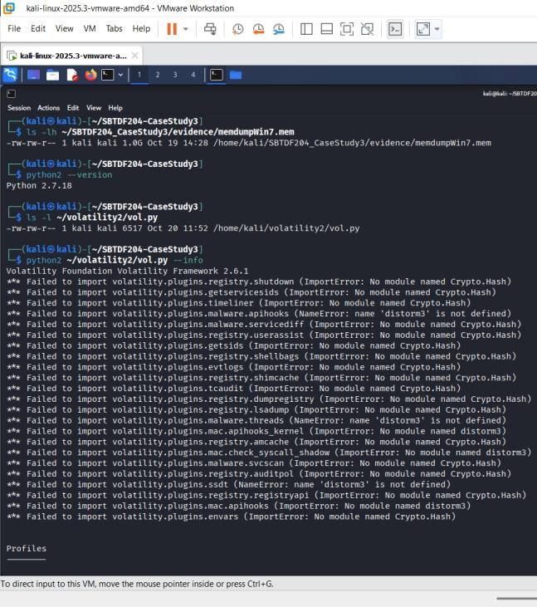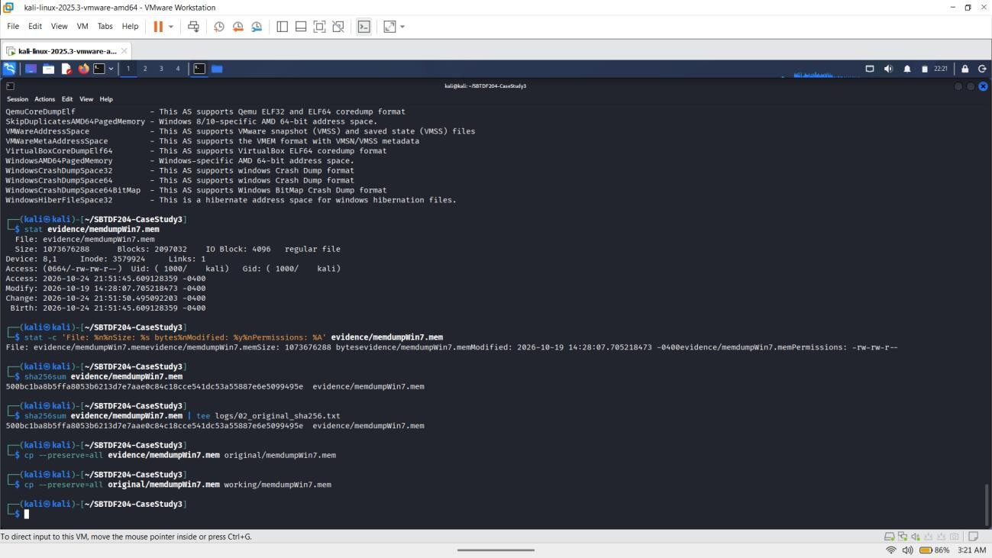

Completed evidence log — E01

Field | Recorded value
Evidence ID | E01
Original filename | memdumpWin7.mem

Supplied source path | evidence/memdumpWin7.mem
Preserved original | original/memdumpWin7.mem
Working copy | working/memdumpWin7.mem
File size | 1,073,676,288 bytes
Original SHA-256 | 500bc1ba8b5ffa8053b6213d7e7aae0c84c18cce541dc53a55887e6e5099495e
Working-copy SHA-256 | Not yet shown in the supplied output
Original-to-working comparison | PASS — cmp returned success
Verification record | logs/02_evidence_integrity.txt
Source file modified time | 2026-10-19 14:28:07.705218473 -0400

Part 1 and Part 2: Investigation Preparation and Evidence Preservation

- Introduction
The first two parts of this practical involved preparing the investigation workspace and preserving the memory image for forensic examination. The aim was to organise the case files, confirm that the required tools were available, record the memory image details and make copies for analysis without changing the supplied evidence.

Investigation Workspace Preparation
The investigation was carried out in Kali Linux using the case-study directory ~/SBTDF204-CaseStudy3. The memory image supplied for the investigation was named memdumpWin7.mem and was located in the evidence folder.
The file details were checked using the Linux stat command. The memory image had a size of 1,073,676,288 bytes. Its recorded modification time was 19 October 2026 at 14:28:07, with the displayed time zone offset of -0400.
Python 2.7.18 was available on the system. The Volatility 2 script was also located at
/home/kali/volatility2/vol.py. These checks confirmed that the required Python version and the Volatility 2 script were present for the next stage of the investigation.

Evidence Preservation and Integrity Verification

The original memory image was retained in the evidence folder. A preserved copy was created in the original folder, and a separate working copy was created in the working folder. The working copy was intended for subsequent forensic analysis.
The SHA-256 hash of the supplied memory image was calculated using sha256sum. The recorded hash was:
500bc1ba8b5ffa8053b6213d7e7aae0c84c18cce541dc53a55887e6e5099495e
The comparison between original/memdumpWin7.mem and working/memdumpWin7.mem was performed using the Linux cmp command. The terminal returned PASS, confirming that these two files were byte-for-byte identical at the time of comparison.
The SHA-256 hashes of all three files still need to be compared and recorded together to complete the full integrity verification. The original file hash alone does not establish that every copy has the same hash.

Evidence Records
The evidence was assigned the identifier E01 for documentation purposes. The evidence paths were recorded as follows:
  - Supplied memory image: evidence/memdumpWin7.mem
  - Preserved original: original/memdumpWin7.mem
  - Working copy: working/memdumpWin7.mem
The hash record was saved as logs/02_original_sha256.txt. The evidence-integrity record was intended to be saved as logs/02_evidence_integrity.txt.

Operating-system profile and image time are supported
The imageinfo output suggested several Windows 7 profiles, including Win7SP1x86_23418, Win7SP0x86, Win7SP1x86_24000, and Win7SP1x86. The selected profile for the initial examination was Win7SP1x86.
The image timestamp reported by Volatility was 6 January 2019, 15:09:06 UTC. The kdbgscan output included a valid KDBG owner-tag check, and pslist and pstree returned process information under the selected profile. These results support using Win7SP1x86 provisionally, but they do not establish that it is the only possible profile.
Volatility 2.6.1 was used with Python 2.7.18. Warnings about missing Crypto.Hash and distorm3 affected some plugins. The profile validation and plugin limitations should be included in the report.

Part 3: Memory Image Identification and Initial Process Analysis
  - Objective
The was to identify the operating system represented in the memory image, select a suitable Volatility profile, and perform initial process analysis. The examination was conducted using Volatility Framework 2.6.1

Memory Image Identification
The imageinfo plugin suggested several possible profiles, including Win7SP1x86_23418, Win7SP0x86, Win7SP1x86_24000, and Win7SP1x86. The output identified the image as Service Pack 1 and indicated a PAE-enabled 32-bit memory environment.
The kdbgscan results provided additional support for the Windows 7 profile family. The Win7SP1x86 profile was selected provisionally for the initial process examination because the pslist and pstree commands returned process information using this profile.
The memory image timestamp reported by Volatility was 6 January 2019 at 15:09:06 UTC.

Process Analysis Findings
The pslist and pstree plugins returned information about processes present in the memory image. The process tree showed explorer.exe (PID 2524) as the parent of cmd.exe (PID 3996), chrome.exe (PID 2388), and FTK Imager.exe (PID 2596).
The command prompt process had a recorded start time of 15:06:11 UTC. Chrome had a recorded start time of 15:04:30 UTC, while FTK Imager had a recorded start time of 15:07:15 UTC. These processes were identified for further examination because they may be relevant to the investigation of suspected file transfer activity.
Several Chrome child processes were also listed. Their presence is consistent with a multi-process browser, but the process list alone does not establish which websites were visited or what files were transferred.
The psscan plugin returned no process records. This result differed from the output of pslist and pstree, so it was treated as inconclusive rather than proof that no hidden or terminated processes existed.

Technical Limitations
During execution, Volatility displayed import errors for the Python modules Crypto.Hash and distorm3. These errors prevented several plugins, including shellbags and timeliner, from loading. The missing dependencies must be addressed before relying on those plugins for further analysis.

Although the initial process commands returned results, the profile selection remains provisional until supported by additional validation. The psscan result also requires further investigation.

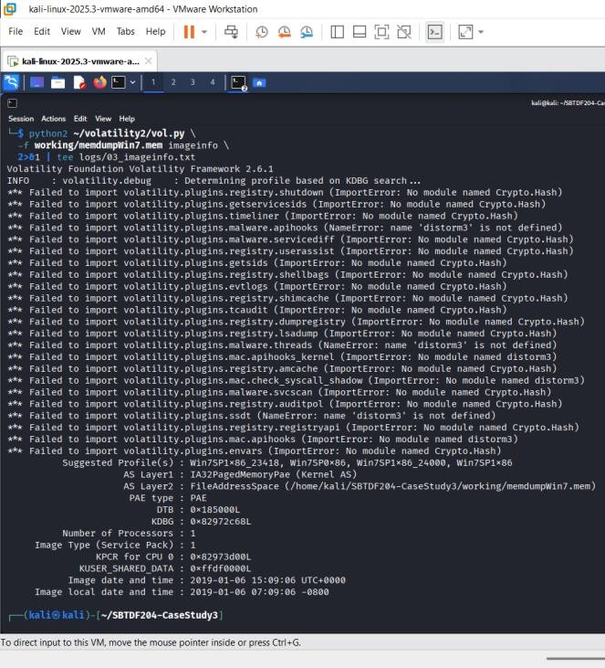
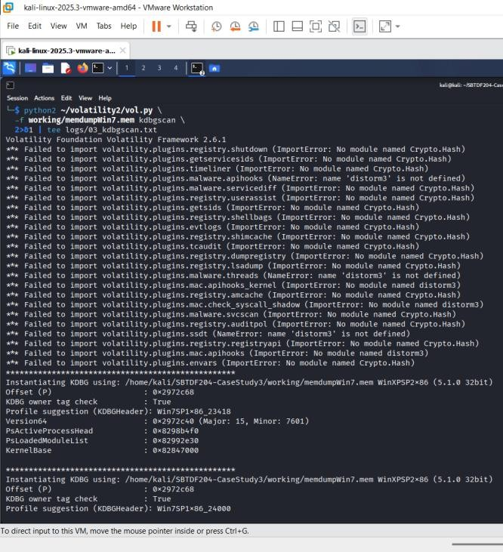

Results so far

Check | Actual result
Volatility version | 2.6.1
Suggested profiles | Win7SP1x86_23418, Win7SP0x86, Win7SP1x86_24000, Win7SP1x86
Image type | Service Pack 1
Memory architecture | 32-bit (IA-32)
PAE | PAE
Image timestamp | 2019-01-06 15:09:06 UTC
KDBG validation | KDBG owner tag check: True
KDBG profile  suggestions | Includes Win7SP1x86_23418, Win7SP1x86_24000, and Win7SP1x86

pslist test | Returned Windows processes using Win7SP1x86
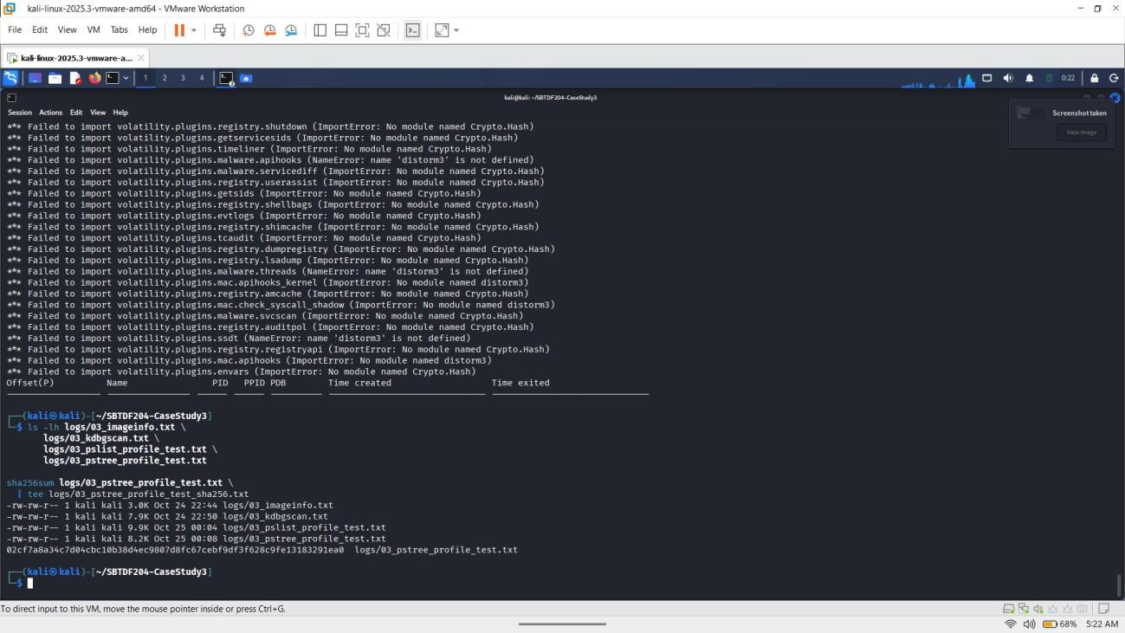
Important limitation: The output contains warnings about missing Python modules Crypto.Hash and distorm3. Some Volatility plugins therefore failed to load. Although imageinfo, kdbgscan, and pslist produced useful output, these warnings must be addressed before relying on plugins that require the missing dependencies.

Process tree analysis

Item | Actual observation
Volatility version | 2.6.1
Profile used | Win7SP1x86
Memory image timestamp | 2019-01-06 15:09:06 UTC
explorer.exe | PID 2524
cmd.exe | PID 3996, parent PID 2524
chrome.exe | PID 2388, parent PID 2524
Chrome child processes | PIDs 1280, 976, 2380 and 2912

FTK Imager.exe | PID 2596, parent PID 2524
Dependency warnings | Crypto.Hash and distorm3 are missing
The process tree supports using Win7SP1x86 provisionally. The image profile should still be validated using additional evidence.

Record the psscan finding

Field | Result
Plugin | psscan
Profile | Win7SP1x86
Volatility version | 2.6.1
Process records returned | 0
Command error | No explicit psscan error shown
Interpretation | Inconclusive; no process records were returned
The earlier pslist and pstree commands returned processes, while psscan returned none. That difference needs further investigation. The dependency warnings do not necessarily explain the empty psscan output because psscan itself is not one of the listed plugins that failed to import.

command outputs is in the logs folder and include screenshots of imageinfo, kdbgscan, pstree, and psscan.

Conclusion
This established a preliminary Windows 7 Service Pack 1, 32-bit profile selection and produced an initial process tree from the memory image. The presence of cmd.exe, Chrome, and FTK Imager provides useful leads for the next stage of the investigation.

Part 4: Process, Command History, and Network Artefact Analysis Evidence Limitations
Several limitations were identified during the memory forensics investigation. These limitations were considered when interpreting the results to avoid making conclusions that were not fully supported by the recovered evidence.

Limitations of the memory image
The investigation was conducted using the available memory image, memdumpWin7.mem. Memory analysis provides information about processes, commands, and network artefacts present in the captured image, but it does not necessarily contain every activity performed on the computer. The findings therefore represent the artefacts recovered from the available memory image.

Missing Volatility dependencies
Some Volatility plugins reported errors because the Crypto.Hash and distorm3 modules were unavailable in the Python 2 environment. These errors prevented certain plugins from loading, limiting the investigation of some registry, process, and malware-related artefacts. The affected plugins would need to be made operational before their results could be included in the analysis.

Process scanning limitations
The psscan plugin returned no process records. This result was inconclusive and does not prove that hidden or terminated processes were absent. The process findings were therefore based primarily on the successful output from pslist and pstree, with the limitations of the available scan recorded.

Command history limitations
The cmdscan and consoles plugins recovered the commands ipconfig, cd Downloads, and copy secret_file.docx F:. The console screen also displayed 1 file(s) copied. This supports the finding that the console recorded a reported successful copy operation. However, the command history does not independently establish the identity of drive F:, whether it was removable storage, or whether the file remained on the destination after the operation.

Network artefact limitations
The netscan output identified two TCP connection artefacts between 192.168.56.8 and 192.168.56.5 on port 80. Both were marked CLOSED, and neither was associated with a process ID in the output. These entries do not establish that a file was transferred over the network,

identify the data exchanged, or demonstrate a connection between the network activity and the recovered copy command.

Attribution and timeline limitations
The recovered process information provides process identifiers and start times, but it does not establish who was physically operating the computer. The available command history also does not provide reliable individual timestamps for each command. Consequently, the exact time of the copy operation and the identity of the person responsible could not be established from these artefacts alone.

Limitations of the conclusion
Although the recovered console records provide evidence of a reported file-copy operation involving secret_file.docx, the available results do not independently prove that the operation was unauthorised or that the file was transferred to a particular removable device or over a network. Additional evidence, such as disk artefacts, removable-device records, file metadata, or corroborating logs, would be required to strengthen these conclusions.

Overall Assessment
The investigation recovered relevant process, command-history, console, and network artefacts. The principal finding was the console record of the secret_file.docx copy command accompanied by the message 1 file(s) copied. The findings should be treated as evidence of recorded system activity rather than conclusive proof of the identity of the operator, the destination device, or the circumstances of an alleged unauthorised transfer.

Important network findings

Finding | Evidence from your output | Interpretation
System IP address | 192.168.56.8 | Consistent with the IP address recovered from the ipconfig console output.
Connection to port 80 | 192.168.56.8:49177 →  192.168.56.5:80, state CLOSED | A TCP connection artefact involving a remote endpoint on HTTP port 80. It does not prove a successful file transfer.
Second port 80 artefact | 192.168.56.8:49178 →  192.168.56.5:80, state CLOSED | A second recorded connection artefact to the same endpoint.

SSH service | 0.0.0.0:22, PID 2016, sshd.exe | An SSH service was listening on port 22. This alone does not prove a remote login occurred.
Windows file-sharing ports | Ports 139 and 445, owned by System | NetBIOS/SMB-related ports were listening; this does not establish that files were transferred over them.
Chrome UDP artefact | 192.168.56.8:56647, PID  2388, chrome.exe | Chrome was associated with a UDP endpoint. The output does not identify the remote destination for this entry.

process and network evidence relates to a potential download or transfer
The process listing recorded the following relevant processes:

Process | PID | Recorded start time (UTC)
explorer.exe | 2524 | 2019-01-06 15:02:54
chrome.exe | 2388 | 2019-01-06 15:04:30
cmd.exe | 3996 | 2019-01-06 15:06:11
conhost.exe | 3988 | 2019-01-06 15:06:11
FTK Imager.exe | 2596 | 2019-01-06 15:07:15
The network scan recorded two closed TCP connection artefacts:
- 192.168.56.8:49177 - 192.168.56.5:80, state CLOSED, PID -1.
- 192.168.56.8:49178 - 192.168.56.5:80, state CLOSED, PID -1.
The console's ipconfig output also showed the local IPv4 address 192.168.56.8.
These artefacts establish that the memory image contained the listed processes and connection records. They do not establish that Chrome downloaded the file, that either TCP connection transferred it, or that a remote endpoint should be contacted. No endpoint was contacted as part of this analysis.

Part 5: USB and Registry Artefact Examination
The registry artefacts recovered from the Windows memory image were examined using Volatility 2.6.1. The hivelist output identified the SYSTEM hive and the user registry hive belonging to IEUser.
The USB storage examination identified the registry subkey Disk&Ven_General&Prod_UDisk&Rev_5.00 under USBSTOR. The MountedDevices output contained a \DosDevices\F: mapping whose binary data identified a device path containing the same USBSTOR device identifier. This provides evidence that drive F: was associated with the identified USB storage device in the recovered registry state.
The finding is consistent with the command history recovered in Part 4, which contained copy secret_file.docx F: and the console message 1 file(s) copied. The user shell-folder records also identified the Downloads directory as C:\Users\IEUser\Downloads, consistent with the source location displayed in the recovered console.
These findings provide a connection between the reported copy command and a USB storage device associated with drive F:. However, the registry evidence alone does not establish that secret_file.docx was present on the USB device after the operation, nor does it establish who performed the copy or whether the transfer was authorised. The recorded registry update times should not be treated as exact timestamps for the copy operation.
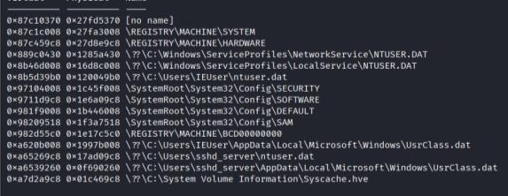
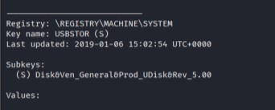

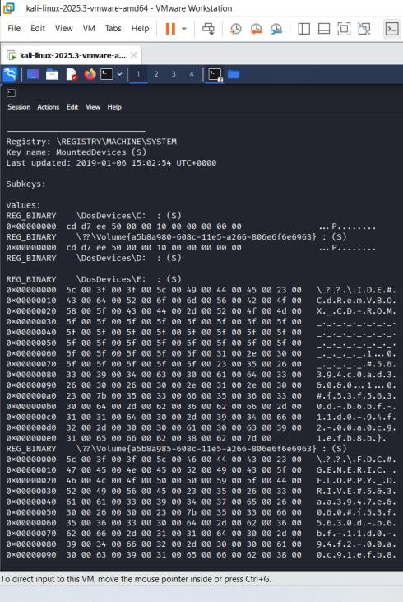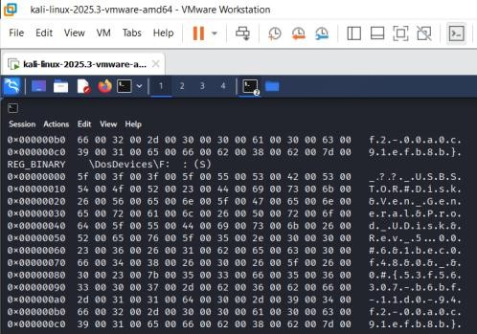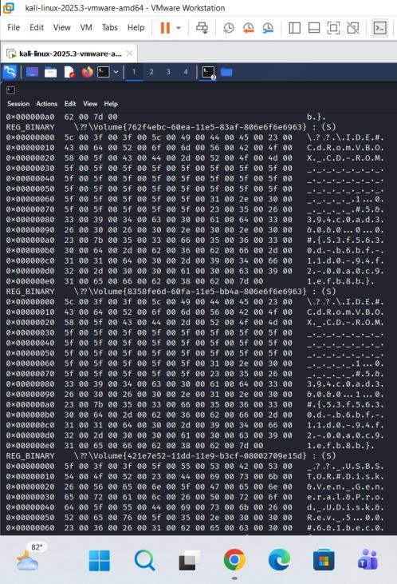

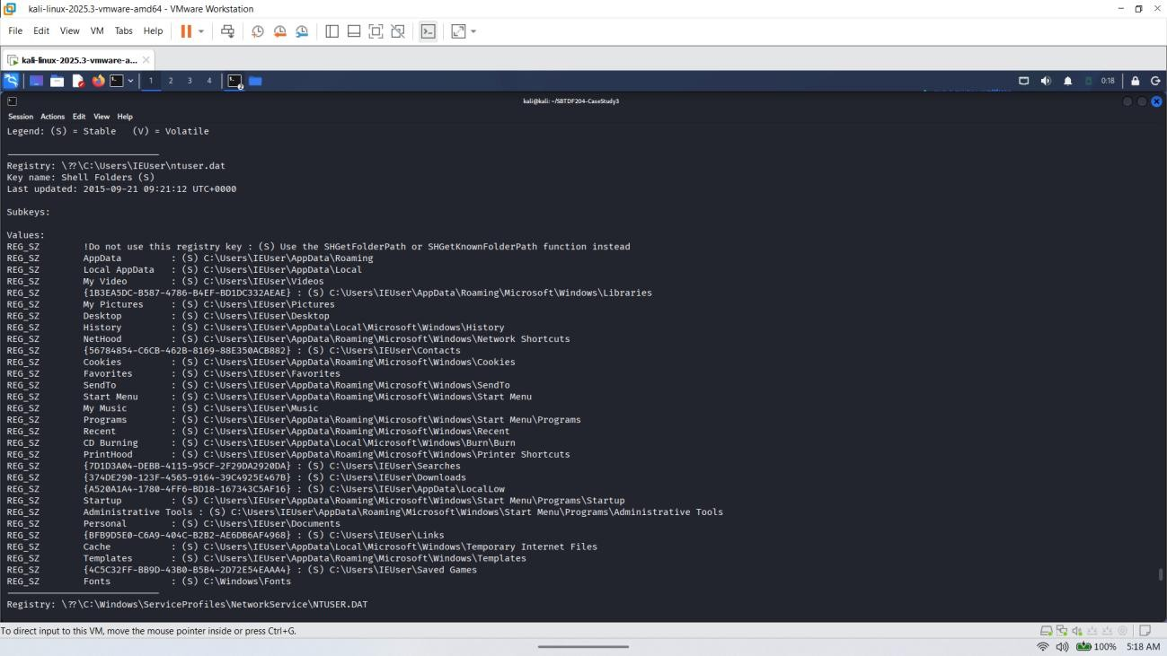
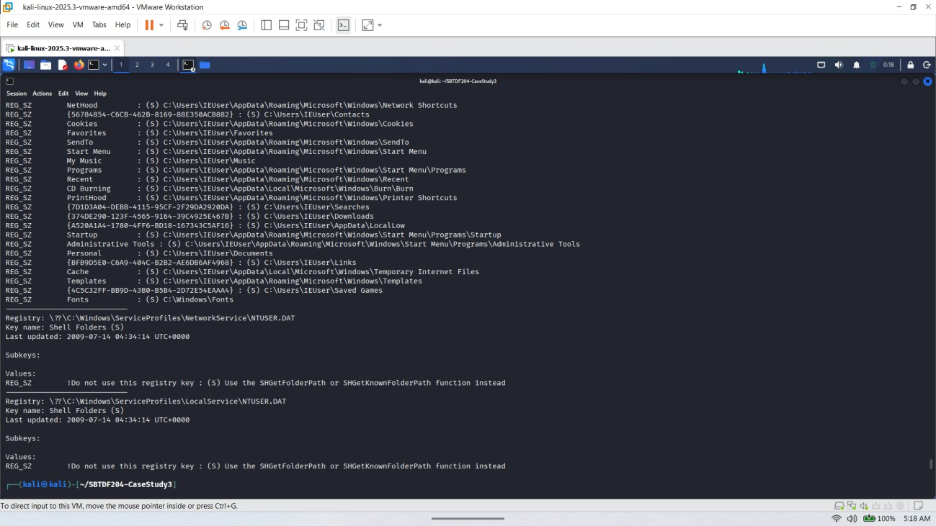

Interpretation of the evidence, user and account artefacts are relevant

Artefact | Observed result | Forensic significance

SYSTEM\Enum\ USBSTOR | Disk&Ven_General&Prod_UDisk& Rev_5.00 | Windows registry contains a USB mass-storage device entry identified as General UDisk.
SYSTEM\Mounte dDevices | \DosDevices\F: maps to a device path containing  USBSTOR#Disk&Ven_General&Pro d_UDisk&Rev_5.00 | Strong evidence that drive letter F: was associated with this USB storage device in the recovered registry state.
USBSTOR volume record | Volume GUID {421e7e52-11dd-11e9-b3cf-08002709e15d} maps to the same USBSTOR device path | Provides an additional volume-to-device correlation.
IEUser shell folders | Downloads resolves to C:\Users\IEUser\Downloads | Consistent with the source directory in the recovered command history.
Registry last-updated time | USBSTOR and MountedDevices report 2019-01-06 15:02:54 UTC | Indicates the reported last-update time of those registry keys, not necessarily the exact time the file was copied.

Part 6: Correlation of Evidence and Timeline
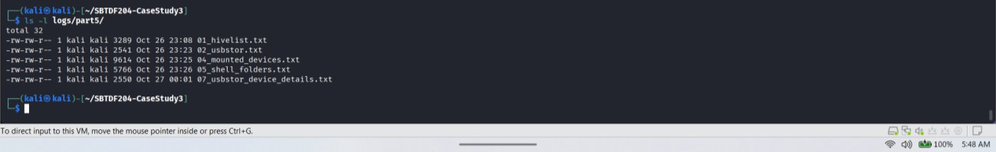

Purpose
The purpose of this section is to compare the process information, command history, network artefacts and registry records recovered from the Windows memory image. The findings are arranged chronologically where timestamps are available. Direct observations are separated from interpretations so that the conclusion remains supported by the evidence.

Evidence correlation
The recovered command history contains the following sequence:
  - ipconfig
  - cd Downloads

  - copy secret_file.docx F:
The console output also contains the message 1 file(s) copied. This is direct evidence that the recovered console history recorded a successful copy operation.
The registry examination identified Disk&Ven_General&Prod_UDisk&Rev_5.00 under the SYSTEM hive. The MountedDevices output associated drive F: with a device path containing the same USBSTOR identifier. These records connect the drive letter used in the copy command with a registered USB storage device.
The user registry records identify the Downloads folder as C:\Users\IEUser\Downloads. This is consistent with the console command cd Downloads and the displayed prompt C:\Users\IEUser\Downloads>.
The process information shows that cmd.exe was running as part of the user session, while explorer.exe and Chrome were also present. FTK Imager was recorded as a running process. Their presence provides context about the system at the time represented by the memory image, but does not independently establish involvement in the suspected file copy.
The network scan identified closed TCP connections from 192.168.56.8 to 192.168.56.5 on port
80. These records do not establish that the file was transferred over the network or that these connections were related to the copy command.

Timeline of relevant artefacts
All timestamps below are expressed in UTC where the recovered output explicitly provides UTC timestamps.

Timestamp (UTC) | Observed artefact | Interpretation and limitation
2019-01-06  15:02:54 | explorer.exe process start; USBSTOR and MountedDevices registry update times | The process and registry records are consistent with the system state. These timestamps do not establish when the copy occurred.
2019-01-06  15:04:30 | chrome.exe, PID 2388, started | Browser activity was represented in the memory image; a download is not established.
2019-01-06  15:06:11 | cmd.exe, PID 3996, and conhost.exe, PID 3988, started | The command-line environment was running. The individual command execution time is unknown.

Time not established | copy secret_file.docx F: and 1 file(s) copied. | The console recorded a copy command and success message.
2019-01-06  15:07:15 | FTK Imager.exe, PID 2596, started | The process was present; its role in the suspected copy is not established.
2019-01-06  15:09:06 | Volatility-reported memory image timestamp | Timestamp reported by the tool for the memory image; it is not the copy-command timestamp.
Timeline limitation: The process start times and registry update times are not exact timestamps for the individual commands. The command sequence can be established from the recovered history, but it cannot be assigned an exact time using the available output.

Facts and inferences Directly observed facts
- The memory image contains command history associated with cmd.exe, PID 3996.
- The recovered command sequence includes ipconfig, cd Downloads, and copy secret_file.docx F:.
- The recovered console output displays 1 file(s) copied.
- The SYSTEM registry contains a USBSTOR entry identifying a General UDisk, revision 5.00.
- The MountedDevices output associates drive F: with a device path containing the same USBSTOR identifier.
- The IEUser registry hive identifies the Downloads directory as C:\Users\IEUser\Downloads.
- The network artefacts include two closed TCP entries involving 192.168.56.8 and 192.168.56.5 on port 80.

Reasonable inferences
- The recovered command history is consistent with an attempt to copy secret_file.docx from the Downloads directory to drive F:.
- The console message indicates that Windows reported one file copied.
- The matching drive-letter and USBSTOR records support the interpretation that the destination drive was associated with the identified USB storage device.

- The combined artefacts support a suspected USB file-copy scenario more strongly than the command history alone.

Matters not established
- The exact time the copy command was executed.
- Whether secret_file.docx remained on the USB device after the operation.
- The actual contents or hash of the destination file.
- The identity of the person who entered the command.
- Whether the copy was authorised.
- Whether the network connections were related to the suspected file copy.

Part 7: Complete the Report and Evidence Pack
The memory image, command outputs, screenshots, hashes, findings and limitations are been kept together.

Evidence folder and file organisation
    - evidence/ — supplied evidence image; leave unchanged.
    - original/ — preserved copy of the supplied memory image.
    - working/ — copy used for analysis.
    - logs/ — command output, integrity checks and tool records.
    - logs/part5/ — USB and registry examination outputs.
    - screenshots/ — screenshots showing important commands and results.
    - report/ — final report and evidence log, if stored separately.

Evidence register

Evidence  ID | Item | Location / filename | Purpose | Status / note
E01 | Windows memory  image | evidence/memdumpWin7.mem | Primary memory  evidence | SHA-256  recorded in the evidence log.

E02 | Preserved memory  copy | original/memdumpWin7.mem | Preservation copy | Compare hash with E01.
E03 | Working memory copy | working/memdumpWin7.mem | Volatility examination | cmp comparison recorded as PASS; record its SHA-256.
E04 | Image identification | logs/03_imageinfo.txt; logs/03_kdbgscan.txt | Profile selection | Win7SP1x86 used  provisionally.
E05 | Process outputs | logs/03_pstree_profile_test.txt; logs/03_psscan.txt;  logs/04_pslist.txt | Process context | psscan returned no records;  inconclusive.
E06 | Command history and  console | logs/04_cmdscan.txt; logs/04_consoles.txt | Recovered command  sequence | Includes copy command and '1  file(s) copied.'
E07 | Network scan | logs/04_netscan.txt | Network artefacts | Two closed TCP entries to 192.168.56.5:80;  no proven file  transfer.
E08 | USB and registry records | logs/part5/ — confirm exact filenames | Correlate F: with USBSTOR  device | General UDisk, revision 5.00.

Verify and record evidence hashes
I run the following commands from the case-study directory, then the SHA-256 for all three memory-image files output were saved..
cd ~/SBTDF204-CaseStudy3
sha256sum evidence/memdumpWin7.mem original/memdumpWin7.mem working/memdumpWin7.mem \
| tee logs/07_memory_image_sha256.txt

cmp -s evidence/memdumpWin7.mem original/memdumpWin7.mem && echo "evidence vs original: PASS" || echo "evidence vs original: FAIL"
cmp -s original/memdumpWin7.mem working/memdumpWin7.mem && echo "original vs working: PASS" || echo "original vs working: FAIL"

The recorded SHA-256 for the supplied image is 500bc1ba8b5ffa8053b6213d7e7aae0c84c18cce541dc53a55887e6e5099495e.

Save a reproducible command record
The following commands collect the main outputs used in the investigation.
cd ~/SBTDF204-CaseStudy3 mkdir -p logs/final

python2 ~/volatility2/vol.py -f working/memdumpWin7.mem --profile=Win7SP1x86 pslist 2>&1 | tee logs/final/pslist.txt python2 ~/volatility2/vol.py -f working/memdumpWin7.mem --profile=Win7SP1x86 pstree 2>&1 | tee logs/final/pstree.txt python2 ~/volatility2/vol.py -f working/memdumpWin7.mem --profile=Win7SP1x86 cmdscan 2>&1 | tee logs/final/cmdscan.txt python2 ~/volatility2/vol.py -f working/memdumpWin7.mem --profile=Win7SP1x86 consoles 2>&1 | tee logs/final/consoles.txt python2 ~/volatility2/vol.py -f working/memdumpWin7.mem --profile=Win7SP1x86 netscan 2>&1 | tee logs/final/netscan.txt

Conclusion
The memory artefacts provide a consistent sequence of evidence for a suspected file copy to USB storage. The command history records copy secret_file.docx F: and displays the message 1 file(s) copied. The registry evidence independently associates drive F: with a USB storage device identified as General UDisk, revision 5.00. The Downloads folder path is also consistent with the recovered command sequence.
Taken together, these findings support the conclusion that the recovered Windows environment recorded a file-copy operation directed at a drive associated with the identified USB device. However, the memory evidence examined so far does not independently confirm the destination file's continued existence, the identity or authorisation of the operator, or the exact time of the operation. The closed TCP entries do not provide sufficient evidence to attribute the suspected copy to a network transfer.

