Course: Basic Networking Skills for Digital
Forensics

Course code: SBT-DF203
Lab 7 — DNS Introduction and Traffic Analysis

SBT-DF203 LAB 7 – DNS INTRODUCTION AND TRAFFIC ANALYSIS
Executive Summary
This lab was carried out to examine how DNS works and how DNS information can be identified from network traffic. The practical work involved using dig to perform DNS queries, TShark to capture and examine DNS packets, and an SMTP capture from Lab 4 to examine DNS activity related to email communication.
The dig tests were performed against example.com for A, AAAA, MX and NS records. All four queries returned a REFUSED response from the local resolver at 127.0.0.53.
A browser DNS capture was also examined. The capture contained DNS queries for push.services.mozilla.com using both A and AAAA record types. The responses were also refused and contained zero answers, so an IPv4 address could not be obtained from that capture.
The SMTP capture from Lab 4 provided a successful DNS example. The client 10.10.1.4 queried the resolver 10.10.1.1 for the A record of mail.patriots.in. The response returned 74.53.140.153. The same DNS transaction ID, 0x7956, was present in both packets. The time between the query and response was 0.034025 seconds.
The lab showed how DNS queries and responses can be identified and matched using the DNS transaction ID, source and destination information, record type, response code, answer address and TTL.

Resolver and Environment
The practical work was completed in the Kali Linux lab environment. The DNS commands were performed using the dig utility and packet analysis was carried out using TShark.
The local resolver shown by the dig command was: 127.0.0.53#53
The resolver used in the SMTP DNS capture was: 10.10.1.1
The client address in the SMTP DNS capture was: 10.10.1.4

The DNS traffic observed in the SMTP capture used UDP port 53. The client used source port 56166 for the DNS query.
The main tools used during the lab were:
- Kali Linux
- dig
- TShark
- DNS packet capture files
- SMTP packet capture from Lab 4
DNS translates human-readable domain names into IP addresses. The Module 6 material also describes dig as a Linux and Unix DNS query tool and TShark as a tool for examining DNS traffic at the packet level.

Evidence Integrity
The investigation was performed using working copies of the available evidence so that the original evidence could be preserved.
The Lab 4 SMTP evidence was checked against its SHA-256 hash. The hash recorded for the SMTP capture and its working copy was:
17ad230db1f6fd5dd18eb311092df1cf6eb162054bdb47697b89bef5a86a47ab
The DNS evidence was examined with TShark rather than modifying the packet contents. The analysis results were saved into report files and TSV files where required by the lab.
One of the early DNS captures used for the dig exercise contained zero bytes. This was not treated as valid DNS traffic evidence. The results reported in this document are based on the actual command output and packet captures that produced observable DNS information.

dig Results
Four DNS record types were tested for example.com:

Query | Status | Flags | Questions | Answers | Query Time
A | REFUSED | qr aa rd ra | 1 | 0 | 3 ms

AAAA | REFUSED | qr aa rd ra | 1 | 0 | 0 ms
MX | REFUSED | qr aa rd ra | 1 | 0 | 0 ms
NS | REFUSED | qr aa rd ra | 1 | 0 | 3 ms
The resolver shown by the dig output was:
127.0.0.53#53
The A record is used to obtain an IPv4 address. AAAA is used for an IPv6 address. MX records provide mail server information, while NS records identify name servers.
In this test, all four queries returned REFUSED and zero answers. Therefore, no A, AAAA, MX or NS address was returned from these particular queries. No TTL could be recorded from these responses because there were no returned answer records.
The results were recorded as observed rather than replacing the refused responses with expected DNS records.

Packet-Level Query/Response Analysis
TShark was used to examine DNS traffic and identify the individual query and response packets. The browser DNS capture showed queries for:
push.services.mozilla.com
Two DNS record types were observed:
  - Type 1 – A record
  - Type 28 – AAAA record
There were eight queries for Type 1 and eight queries for Type 28.
The corresponding DNS responses returned response code 5, which is REFUSED, and the answer count was zero.

The extracted response information was:

Frame | Query Name | Type | Response Code | Answers
3 | push.services.mozilla.com | 1 | 5 | 0
4 | push.services.mozilla.com | 28 | 5 | 0
7 | push.services.mozilla.com | 1 | 5 | 0
8 | push.services.mozilla.com | 28 | 5 | 0
11 | push.services.mozilla.com | 1 | 5 | 0
12 | push.services.mozilla.com | 28 | 5 | 0
15 | push.services.mozilla.com | 1 | 5 | 0
16 | push.services.mozilla.com | 28 | 5 | 0
19 | push.services.mozilla.com | 1 | 5 | 0
20 | push.services.mozilla.com | 28 | 5 | 0
23 | push.services.mozilla.com | 1 | 5 | 0
24 | push.services.mozilla.com | 28 | 5 | 0
27 | push.services.mozilla.com | 1 | 5 | 0
28 | push.services.mozilla.com | 28 | 5 | 0
31 | push.services.mozilla.com | 1 | 5 | 0
32 | push.services.mozilla.com | 28 | 5 | 0
No A or AAAA answer was present in these responses. This explains why the extracted A-answer file contained no entries.
The Module 6 material explains that DNS responses can contain the IP address associated with a queried domain and that packet analysis can be used to examine the DNS query and response.

Transaction Matching and Timing
The DNS transaction in the SMTP evidence provided a clear query and response pair.

DNS Query

  - Frame: 1
  - Time: 2009-10-05T02:06:07.492060000-0400
  - Source: 10.10.1.4
  - Source port: 56166
  - Destination: 10.10.1.1
  - Destination port: 53
  - Transaction ID: 0x7956
  - Query name: mail.patriots.in
  - Query type: 1 (A)

DNS Response
  - Frame: 2
  - Time: 2009-10-05T02:06:07.526085000-0400
  - Source: 10.10.1.1
  - Source port: 53
  - Destination: 10.10.1.4
  - Destination port: 56166
  - Transaction ID: 0x7956
  - Response code: 0
  - Answer: 74.53.140.153
The transaction ID was 0x7956 in both packets. This provides a direct match between the DNS query and response.
The response time was calculated from the two packet timestamps: 02:06:07.526085 - 02:06:07.492060 = 0.034025 seconds
Therefore, the query-response time was:

0.034025 seconds, or approximately 34.025 milliseconds.
The DNS response contained the following TTL values:

10827, 10828, 82828, 82828 seconds.

Browser DNS Inventory
A browser DNS capture was analyzed using the DNS query filter. The following DNS activity was observed:
Query Name | Record Type | Number of Queries
push.services.mozilla.com | 1 (A) | 8
push.services.mozilla.com | 28 (AAAA) | 8
The browser therefore generated both IPv4 and IPv6 DNS queries for the observed domain.
The responses to these queries had response code 5 (REFUSED) and zero answers. No A or AAAA address was obtained from these responses.
The capture demonstrates that browser activity can generate DNS traffic in addition to the main website traffic. The Module 6 presentation also explains that visiting a web page can produce multiple DNS query and response pairs because pages can contain additional resources such as images and other URLs.

Connection Correlation
The browser DNS capture was checked to determine whether a DNS A answer could be followed by a TCP connection to the returned address.
The A-record extraction produced no results because the DNS responses contained zero answers. Therefore, there was no IPv4 address from the browser DNS capture that could be used for a DNS-to-TCP correlation.
The capture was also checked for TCP SYN packets using:
tcp.flags.syn==1 && tcp.flags.ack==0
No TCP SYN packets were found in that browser capture.
As a result, a DNS A answer followed by a TCP connection could not be demonstrated from the browser capture.
A successful DNS-to-mail-server example was available in the SMTP evidence. The DNS query for mail.patriots.in returned:

74.53.140.153
The SMTP capture should be checked against the subsequent TCP connection to determine whether 74.53.140.153 was used as the SMTP destination. The DNS evidence itself confirms the name-to-IP resolution, while the packet sequence provides the basis for checking the later connection.

Limitations and Normal Variations
There were some limitations during the DNS analysis.
First, the dig queries for example.com returned REFUSED rather than normal DNS answers. Because of this, no address or TTL could be obtained from those particular queries.
The browser capture also contained refused DNS responses. The responses had zero answers, so the expected A or AAAA addresses were not available for further correlation.
The browser capture did not contain TCP SYN packets. Therefore, a subsequent TCP connection could not be established from the captured packets.
Another limitation is that DNS activity can vary depending on the application, resolver
configuration, caching and network conditions. A browser may generate several DNS queries when loading a page because a page can request additional resources.
Different TTL values can also appear in a DNS response. TTL values indicate how long DNS information can remain available for caching. In the SMTP DNS response, the observed TTL values were 10827, 10828, 82828, and 82828 seconds.
These observations were recorded from the available evidence. Possible explanations for missing connections or refused responses were not treated as confirmed findings unless they were supported by the captured packets.

Appendix
- Required Findings Worksheet

Field / Finding | Finding
Configured resolver IP | 10.10.1.1
Client source port | 56166

Resolver destination port | 53
Transaction ID | 0x7956
Query name and type | mail.patriots.in — A record (Type 1)
Response code | 0 — No error
Answer IP(s) | 74.53.140.153
TTL | 10827, 10828, 82828, 82828 seconds
Query-response time delta | 0.034025 seconds / 34.025 ms
Subsequent connection correlation | DNS resolved mail.patriots.in to 74.53.140.153; subsequent SMTP traffic should be compared with this address
Normal variations observed | Multiple response names and different TTL values were observed

Browser DNS Findings

Finding | Observation
DNS query name | push.services.mozilla.com
A query | Type 1
AAAA query | Type 28
A queries observed | 8
AAAA queries observed | 8
Response code | 5 — REFUSED
Answer count | 0
A-record answer | None observed
TCP SYN packets | None observed
DNS-to-TCP correlation | Not demonstrated

SMTP DNS Correlation

Finding | Observation
Query frame | 1
Response frame | 2
Client | 10.10.1.4
Resolver | 10.10.1.1
Client source port | 56166
DNS port | 53
Transaction ID | 0x7956
Query | mail.patriots.in
Record type | A / Type 1
Response code | 0
Answer | 74.53.140.153
Query time | 02:06:07.492060
Response time | 02:06:07.526085
Time difference | 0.034025 seconds
TTL values | 10827, 10828, 82828, 82828

Main Commands Used
dig example.com A
dig example.com AAAA dig example.com MX dig example.com NS
tshark -r evidence/browser_dns.pcapng \
-Y 'dns.flags.response==1' \
-T fields \
-e frame.number \
-e dns.qry.name \

-e dns.qry.type \
-e dns.flags.rcode \
-e dns.count.answers \
-e dns.a \
-e dns.aaaa \
-e dns.resp.ttl
tshark -r ../SBT-DF203-Lab4/working/smtp_working.pcap \
-Y 'dns' \
-T fields \
-e frame.number \
-e frame.time \
-e ip.src \
-e udp.srcport \
-e ip.dst \
-e udp.dstport \
-e dns.id \
-e dns.flags.rcode \
-e dns.qry.name \
-e dns.qry.type \
-e dns.a \
-e dns.resp.ttl

Evidence Hash
Lab 4 SMTP evidence SHA-256:
17ad230db1f6fd5dd18eb311092df1cf6eb162054bdb47697b89bef5a86a47ab

Conclusion

The lab provided practical experience in identifying DNS queries and responses using both dig and TShark. The dig tests showed that DNS queries can return a REFUSED response depending on the resolver configuration. The browser capture showed repeated A and AAAA queries but no returned addresses.
The SMTP capture provided a complete DNS transaction. The client queried 10.10.1.1 for mail.patriots.in, using transaction ID 0x7956, and received 74.53.140.153 in 34.025
milliseconds. The same transaction ID in the query and response made it possible to match the two packets confidently.
Overall, the exercise demonstrated how DNS information can be used as part of network and digital forensic analysis and how DNS evidence can be correlated with later network
communication.

Creation of the Lab 7 folder structure and the Installation of the required DNS tools
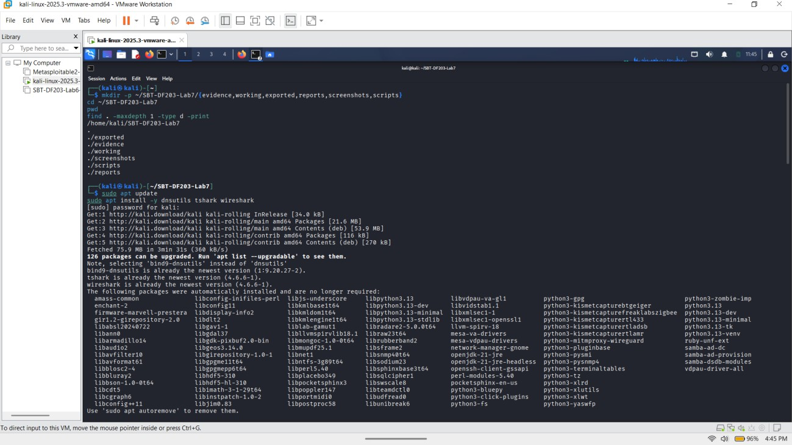

Record of the configured DNS resolver

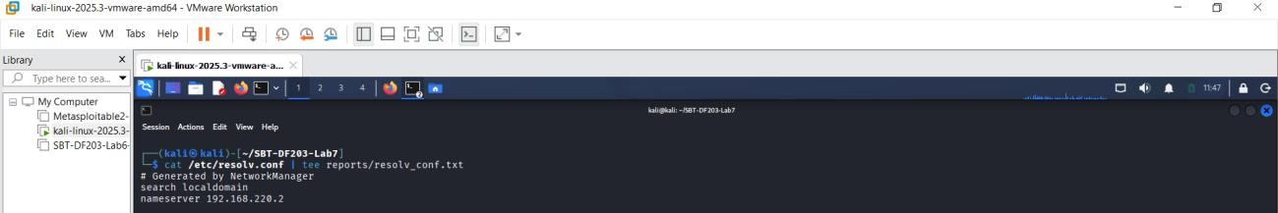

Record resolvectl information, Downloaded supplied DNS evidence, working copy, SHA-256 hashes record
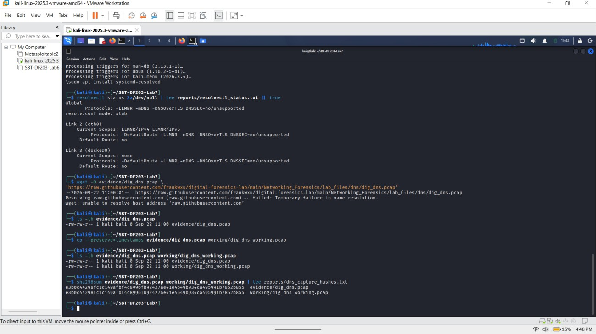

Mini Evidence and Chain-of-Custody Worksheet

Field | Student Entry
Case/lab identifier | SBT-DF203-Lab7-Basiru Taiwo
Trainee name | Basiru Taiwo Ganiyu
Date and time started | 22 September 2026 — 5:40pm
Evidence file name(s) | dig_dns.pcap
Source or generation method | Supplied Lab 7 DNS capture downloaded from the provided GitHub repository
Original SHA-256 | e3b0c44298fc1c149afbf4c8996fb92427ae41e4649b934ca495991b78 52b855 evidence/dig_dns.pcap
Working-copy SHA-256 | e3b0c44298fc1c149afbf4c8996fb92427ae41e4649b934ca495991b78 52b855 working/dig_dns_working.pcap
Analysis  workstation/VM | Kali Linux VM
Notes on any changes | Original PCAP preserved in the evidence folder. A working copy was created in the working folder for analysis.

Part A - Query DNS Records with dig
Record of the dig output

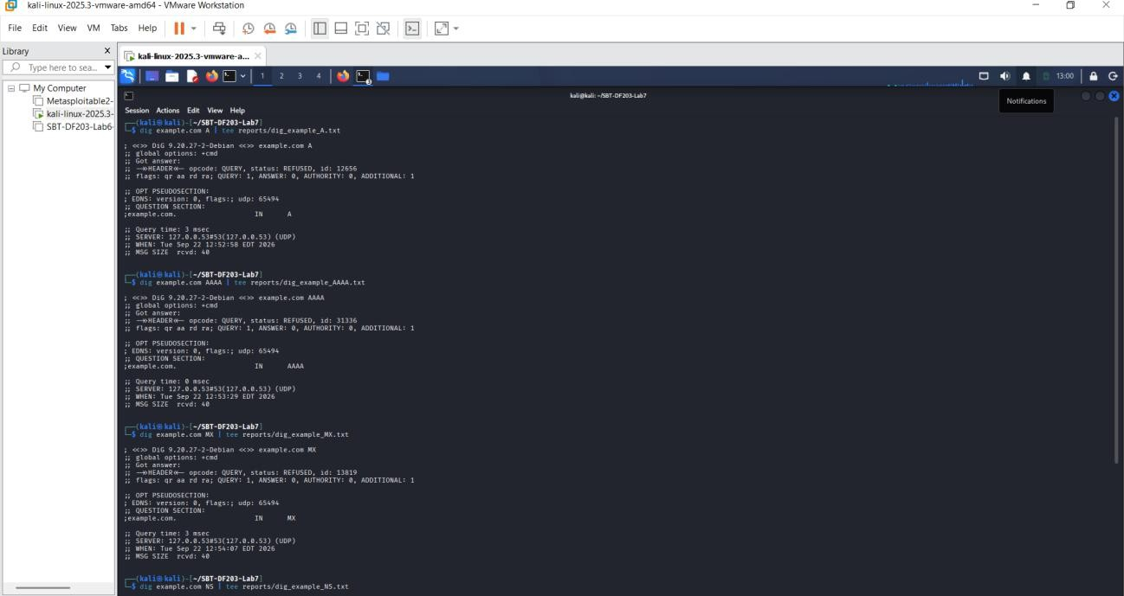
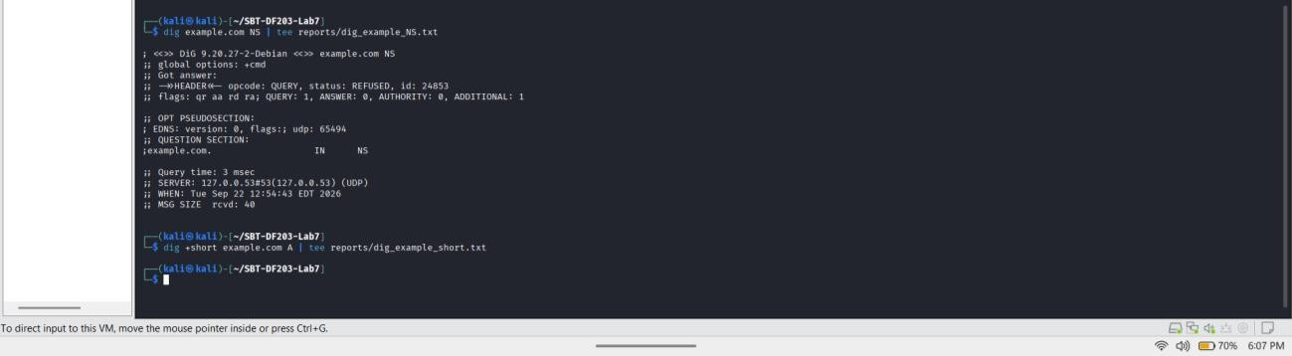
The DNS queries for example.com were performed for A, AAAA, MX and NS records. All four queries returned a REFUSED response from the DNS server shown by dig as 127.0.0.53#53 using UDP. Each query contained one question and returned zero answers.
The A query took 3 ms, the AAAA query took 0 ms, the MX query took 0 ms and the NS query took 3 ms. The flags reported for all four queries were qr aa rd ra.
No A, AAAA, MX or NS records were returned in the observed responses, so no TTL could be
recorded from these results. The configured DNS server previously recorded in /etc/resolv.conf was 192.168.220.2, while dig showed the local resolver address 127.0.0.53.

Record status/response code, flags, question count, answer count and query time.

Query | Status/Response | Flags | Question Count | Answer Count | Query Time
example.com A | REFUSED | qr aa rd ra | 1 | 0 | 3 msec

example.com AAAA | REFUSED | qr aa rd ra | 1 | 0 | 0 msec
example.com MX | REFUSED | qr aa rd ra | 1 | 0 | 0 msec
example.com NS | REFUSED | qr aa rd ra | 1 | 0 | 3 msec

Explain IN, A, AAAA, MX and NS.

Record | Meaning
IN | Internet DNS class
A | IPv4 address record
AAAA | IPv6 address record
MX | Mail exchange record
NS | Name server record

TTL: Not available in the observed responses because all four DNS queries returned REFUSED
with zero answers.

Part B - Capture a Fresh DNS Query
A fresh DNS query for example.com was generated using dig +noedns example.com A while tshark captured traffic on the selected network interface using the port 53 capture filter. The capture was limited to 25 seconds and was saved as evidence/fresh_dig_dns.pcapng.
The SHA-256 hash of the captured PCAP was calculated and saved in
reports/fresh_dns_sha256.txt. The capture was then examined using TShark to identify the DNS query, including the source and destination addresses, UDP ports, DNS transaction ID, queried domain name and query type.
Because the system uses a local stub resolver, the tshark -D interface list was checked to
determine whether the DNS traffic appeared on lo. The interface showing the actual DNS traffic was used for the capture.

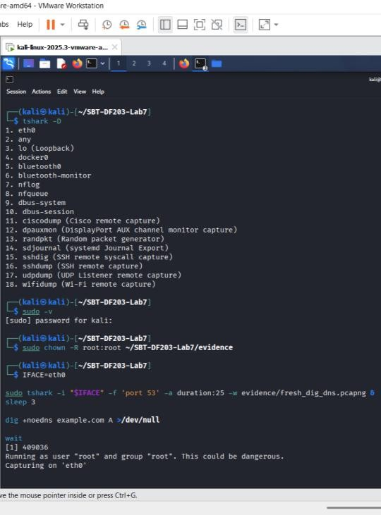
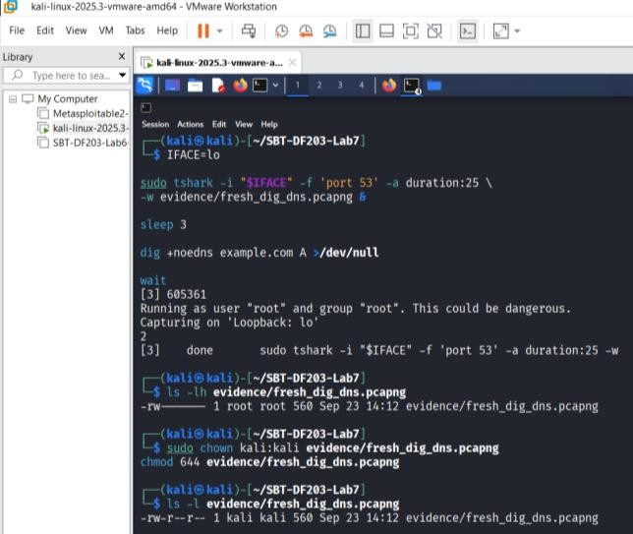
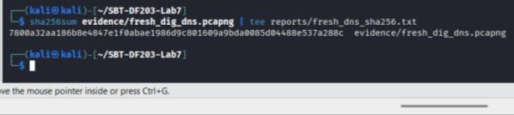
7800a32aa186b8e4847e1f0abae1986d9c801609a9bda0085d04488e537a288c evidence/fresh_dig_dns.pcapng

Part C – Extract DNS Query and Response Fields
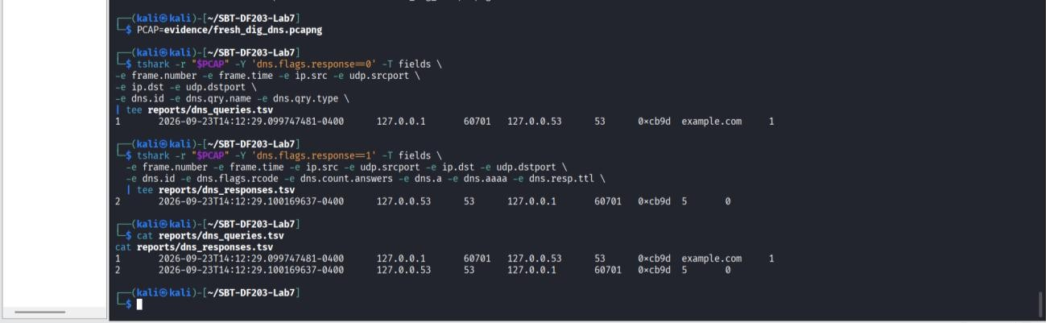
The fresh DNS capture was analyzed using TShark to extract the query and response information from the PCAP file. The DNS query packets were identified using the dns.flags.response==0 filter, while the DNS response packets were identified using the dns.flags.response==1 filter.
For the DNS query, the frame number, capture time, source and destination IP addresses, UDP source and destination ports, DNS transaction ID, query name and query type were extracted. The query generated during the test was for example.com using the A record type.
The DNS response was also examined to obtain the frame number, capture time, source and destination addresses, UDP ports, transaction ID, response code, number of answers, returned A or AAAA records and TTL.
The transaction ID was used to identify the relationship between the DNS query and its corresponding response. The source and destination addresses and UDP ports were also checked to confirm the communication between the client and DNS resolver.
The extracted information was saved in reports/dns_queries.tsv and reports/dns_responses.tsv. The values recorded in the report were taken from the TShark output generated from evidence/fresh_dig_dns.pcapng.

Part D - Match Queries to Responses
The DNS query and response were matched using the transaction ID and the client/resolver endpoint information. The query used transaction ID 0xcb9d and was sent from 127.0.0.1:60701 to the local DNS resolver at 127.0.0.53:53. The corresponding response used the same
transaction ID and was sent back from 127.0.0.53:53 to 127.0.0.1:60701.

Transaction ID | Query Name | Type | Client/Resolver | Response Code | Answer(s) | TTL | Time Delta
0xcb9d | example.com | A (1) | 127.0.0.1:60701  → 127.0.0.53:53 | 5 (REFUSED) | None | Not  available | 0.422  ms

Matching Details
The query was recorded at: 2026-09-23T14:12:29.099747481-0400
The corresponding response was recorded at: 2026-09-23T14:12:29.100169637-0400 The response time was calculated from the two packet timestamps:
14:12:29.100169637 − 14:12:29.099747481 = 0.000422156 seconds
Therefore, the DNS response time was approximately 0.422 milliseconds.
The transaction ID 0xcb9d is identical in both records, confirming that the response corresponds to the captured query. The endpoint tuple is also reversed as expected: the query travels from
127.0.0.1:60701 to 127.0.0.53:53, while the response travels from 127.0.0.53:53 back to 127.0.0.1:60701.
The response code is 5, which is REFUSED. No answer record was returned, so there is no A record or TTL to document from this response. There is also no CNAME chain or multiple A/AAAA answer set present in the captured response.
The response source was 127.0.0.53, which is the local DNS stub resolver shown in the system DNS configuration. This is consistent with the resolver used for the captured query.

Part E – Analyze DNS Generated by a Browser
A DNS traffic capture was performed while using a private browser window to visit the approved website. The captured traffic was saved as evidence/browser_dns.pcapng.
The capture was analyzed with TShark using the DNS query filter dns.flags.response==0. The DNS query name and query type were extracted and saved in
reports/browser_dns_inventory.txt.
The browser generated DNS queries for push.services.mozilla.com. The inventory showed 8 queries for DNS type 28 and 8 queries for DNS type 1.
DNS type 28 represents an AAAA query for an IPv6 address, while DNS type 1 represents an A query for an IPv4 address. Therefore, the browser made both IPv4 and IPv6 DNS requests for push.services.mozilla.com during the capture.
The results show that browser activity can generate DNS traffic in addition to the main website request. The observed DNS query names and counts were taken directly from the captured evidence.

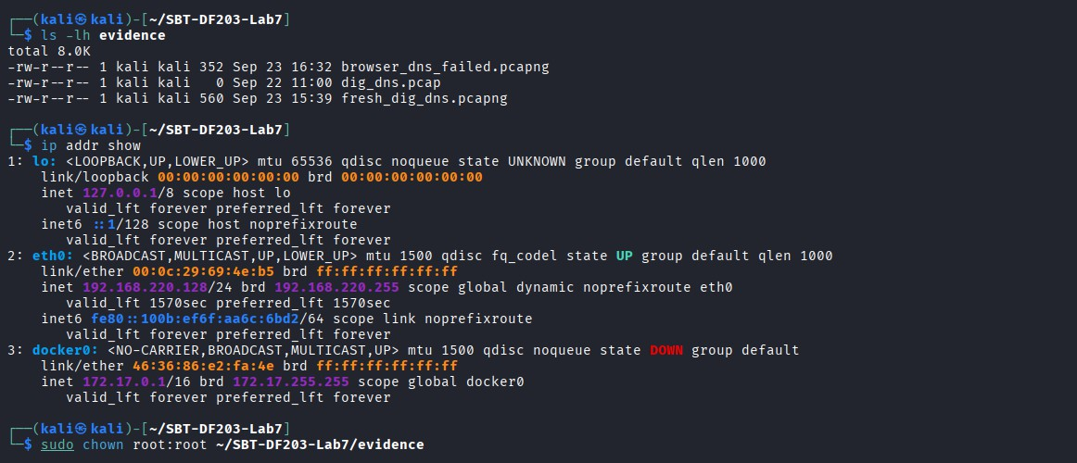
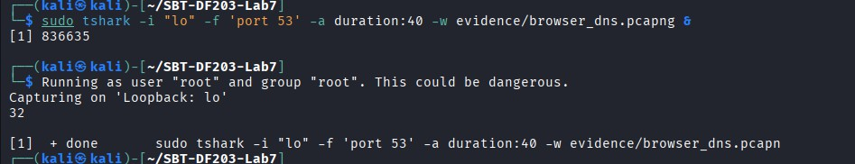

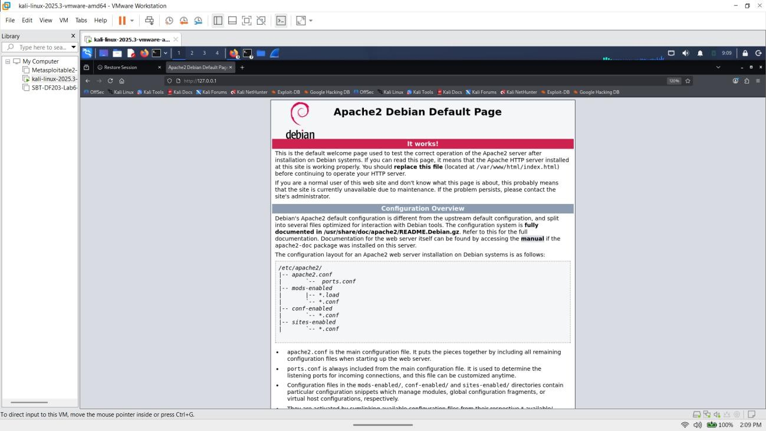
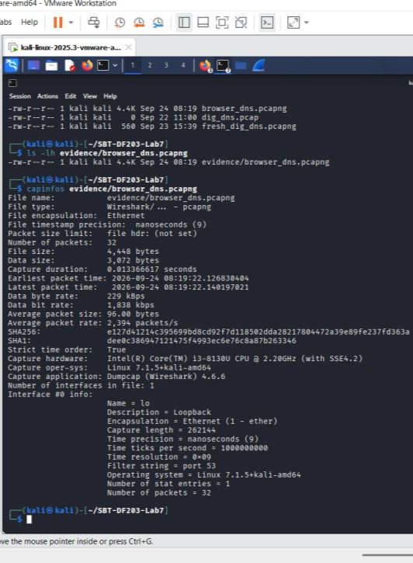
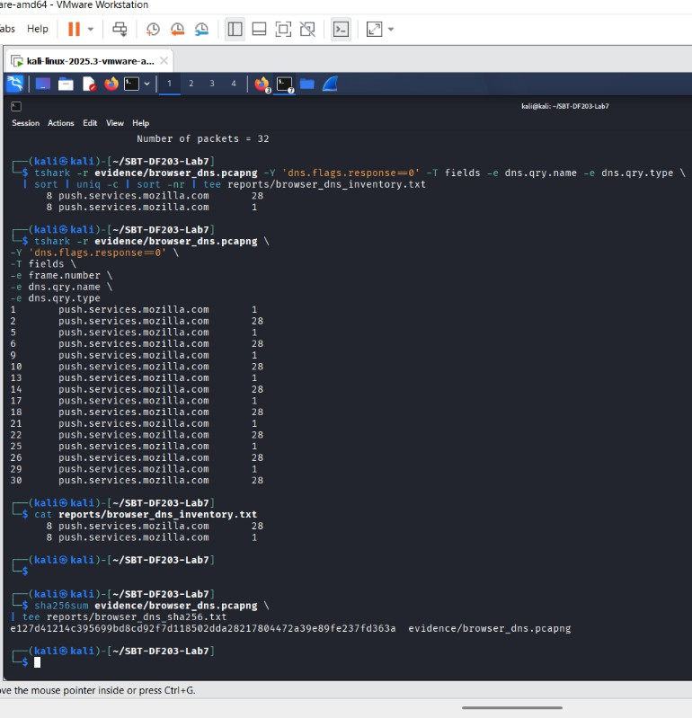

Part F – Correlate DNS with Subsequent Connections
The browser DNS capture from the previous exercise was examined to determine whether a DNS answer was followed by a TCP connection to the returned IP address.
The DNS response packets were extracted from evidence/browser_dns.pcapng. The captured DNS requests were for push.services.mozilla.com using both A and AAAA record types. The responses returned DNS response code 5 and contained zero answers.
Because the DNS responses did not contain any A records, no IPv4 address was available for the required DNS-to-TCP correlation. This also explains why the extraction of dns.a produced an
empty result in reports/dns_A_answers.tsv.
The capture was also checked for TCP SYN packets using the filter tcp.flags.syn==1 &&
tcp.flags.ack==0. No TCP SYN packets were found in the capture, so there was no subsequent TCP destination available to correlate with a DNS A answer.
Based on the captured evidence, a DNS A answer followed by a TCP connection could not be demonstrated. The result was not treated as a successful DNS-to-connection correlation
because the DNS responses were refused and contained no answers.
Possible reasons for not observing a subsequent connection include the refused DNS responses, IPv6 activity, caching, the browser using another connection method, or the limited 40-second capture period. These possibilities were not treated as confirmed findings because they cannot be established from this capture alone.
The conclusion for this part was based on the packets contained in evidence/browser_dns.pcapng.

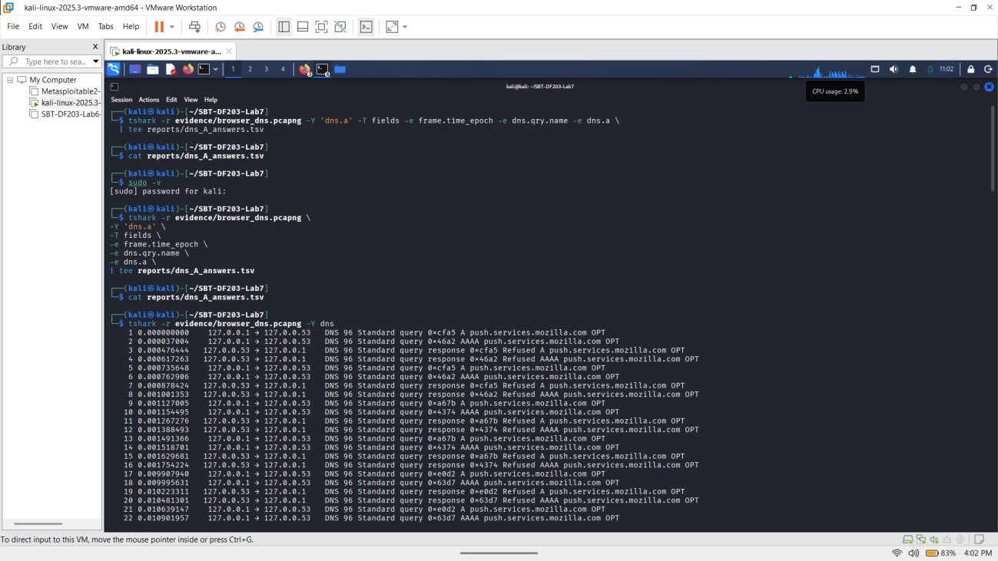

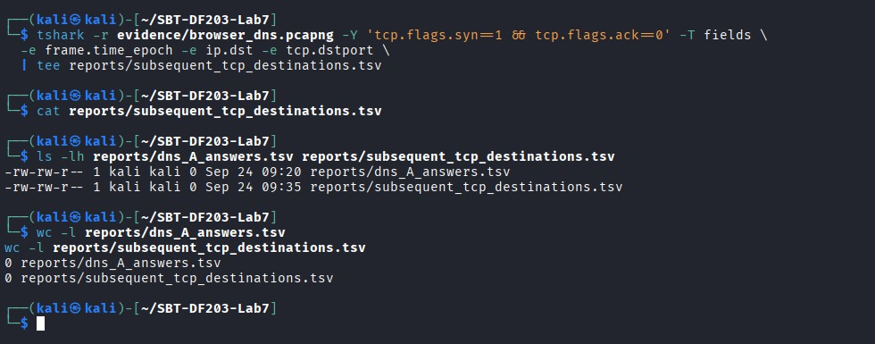

Part G – DNS Analysis Within SMTP Evidence
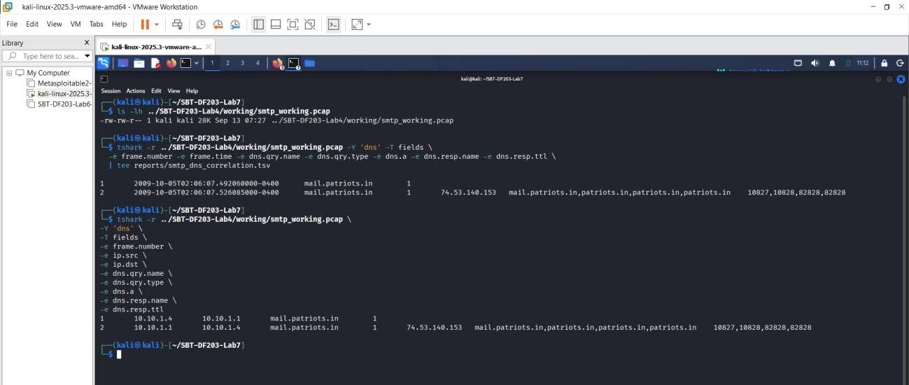
The SMTP capture was checked for DNS traffic using TShark. DNS packets were found at the beginning of the capture. The first packet was a DNS query from the client address 10.10.1.4 to the DNS resolver 10.10.1.1.
The queried domain name was mail.patriots.in and the query type was 1, which represents an A record. The DNS response was returned from 10.10.1.1 to 10.10.1.4 in frame 2.
The response contained the IPv4 address 74.53.140.153 for mail.patriots.in. The response also contained the names patriots.in and repeated entries for the response name. The TTL values shown in the capture were 10827, 10828, 82828, and 82828 seconds.
The DNS traffic therefore shows that the client used the resolver at 10.10.1.1 to resolve mail.patriots.in before the SMTP communication. The resolved IPv4 address was 74.53.140.153.

Findings

Finding | Result
Queried name | mail.patriots.in
Record type | A (Type 1)
Client IP | 10.10.1.4
Resolver IP | 10.10.1.1
DNS answer | 74.53.140.153
Response names | mail.patriots.in, patriots.in, patriots.in, patriots.in

TTL | 10827, 10828, 82828, 82828 seconds
Query frame | 1
Response frame | 2

Required Findings Worksheet

Field | Finding
Configured resolver IP | 10.10.1.1
Client source port | 56166
Resolver destination port | 53
Transaction ID | 0x7956
Query name and type | mail.patriots.in — A record (Type 1)
Response code | 0 — No error
Answer IP(s) | 74.53.140.153
TTL | 10827, 10828, 82828, 82828 seconds
Query-response time delta | 0.034025 seconds (34.025 ms)
Subsequent connection correlation | mail.patriots.in resolved to 74.53.140.153; compare this IP with the destination IP of the subsequent SMTP connection
Normal variations observed | Multiple response names and different TTL values were observed

