Reconstructing Suspected Drug Trafficking From Chrome Web History
Case Study 2 Individual browser history investigation

Case reference and student identification

Student full name | Sumayyah Badmus
Registration number | 2025/FWSD/11425
Course code | SBT-DF204 Computer Forensics Case Studies
Case title | Reconstructing Suspected Drug Trafficking From Chrome Web History
Evidence examined | Google Chrome History SQLite database, supplied as Chrome_History_Cryptocurrency_Lab.db  (profile of Windows user FSCS_User)
Examination date | 11 October 2026
Submission file name | SBTDF204_CaseStudy2_2025FWSD11202.docx

Executive conclusion
The History database (supplied as Chrome_History_Cryptocurrency_Lab.db) records 74 visits to 57 URLs, all between 13:54:18 and 15:02:56 UTC on 19 April 2022, plus one completed download. The records form a coherent, time-ordered sequence that is consistent with the case hypothesis: a Craigslist account log-in and a multi-step posting workflow producing a listing titled "cheaper than Rx supplements" (13:54–13:58 UTC); access to a Gmail account and an email thread with the same subject followed by "order" (14:04 UTC); a later thread whose subject contains a 64-character Bitcoin-style transaction ID (14:56 UTC); an Imgur page reached from that email and a download named proof_of_payment.png (14:56–14:57 UTC); lookup of the same transaction ID in two blockchain explorers and a Kraken exchange session (14:58–15:02 UTC).
The history proves that this Chrome profile requested these URLs in this order. It does not prove the content of any page or email, that a drug was offered or sold, that the payment was real or received, or who was at the keyboard. The only drug-related text in the database is the listing title "Rx supplements" in the "health and beauty" category; no record shows a controlled substance. Confidence: moderate-to-high that the profile performed the posting-to-payment-verification sequence; low-to-moderate that it amounts to drug trafficking; low that it identifies a named individual (Section 7).

Evidence acquisition and integrity
The case file is a Google Chrome history database. The assessment brief calls it History and states that it is "added in study material section"; it was supplied through the course study material and saved to the Downloads folder of the examiner's Kali Linux workstation on 11 October 2026 under the file name Chrome_History_Cryptocurrency_Lab.db.

Original file name | Chrome_History_Cryptocurrency_Lab.db (the brief's History file)
Source | Course study material for SBT-DF204 Case Study 2 (downloaded to ~/Downloads)
File size | 196,608 bytes
SHA-256 (original) | b991b0fa69662c44caf599e468c8088576ebd9cebbf46d02c89cf51bcde3fd19
SHA-256 (working copy) | b991b0fa69662c44caf599e468c8088576ebd9cebbf46d02c89cf51bcde3fd19 (identical)
Read-only original | ~/SBTDF204_CaseStudy2/01_original_evidence/Chrome_History_Cryptocurrency_Lab.db (mode 444)
Working copy | ~/SBTDF204_CaseStudy2/02_working_copy/Chrome_History_Cryptocurrency_Lab.db
Tools | Kali Linux; cp, chmod, stat, sha256sum; sqlite3 command-line shell

Working-copy method. An assignment folder was created first, with separate folders for the original evidence, working copy, SQL, screenshots, notes and submission (Figure 1). The file was copied with cp -p into 01_original_evidence/ and made read-only with chmod 444. Its size was read with stat and its SHA-256 with sha256sum. A second copy was placed in 02_working_copy/ and hashed; the two hashes are identical (Figure 2). Every query was run only against the working copy with sqlite3 -readonly, so the evidence could not be modified. Each action was recorded with a UTC timestamp in a case log (05_notes/case_log.txt).

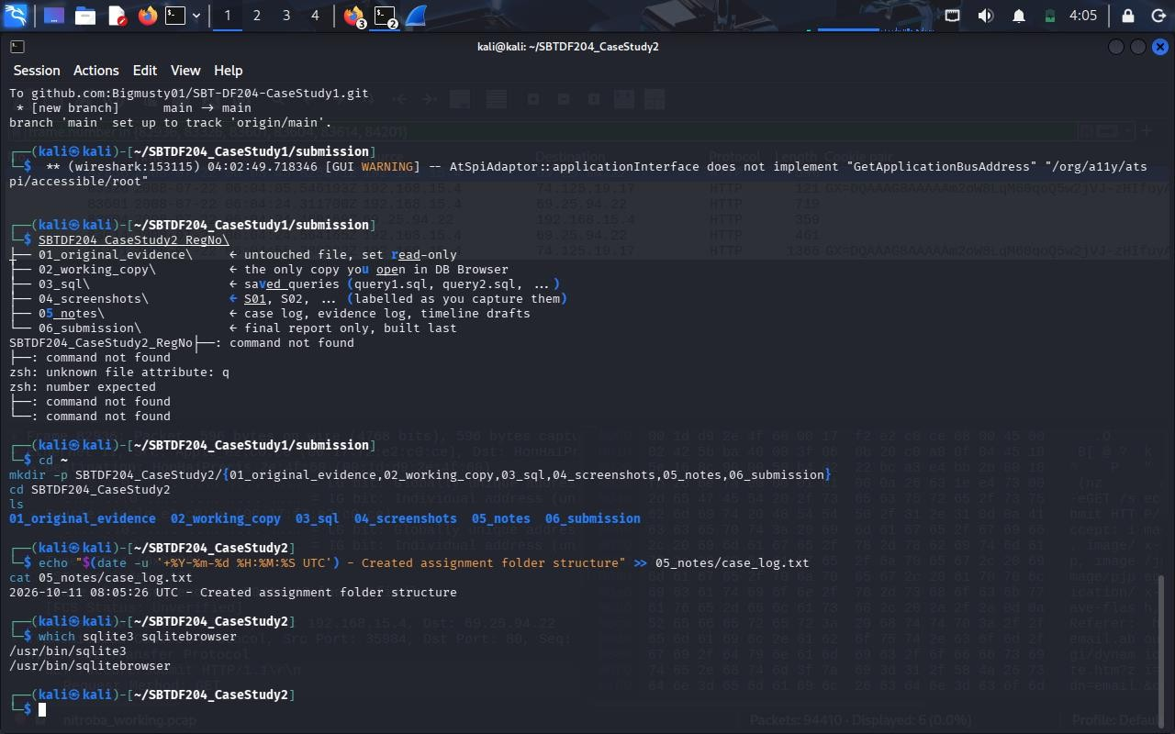
Figure 1 Assignment folder structure created, first case-log entry, and sqlite3 and sqlitebrowser confirmed installed.
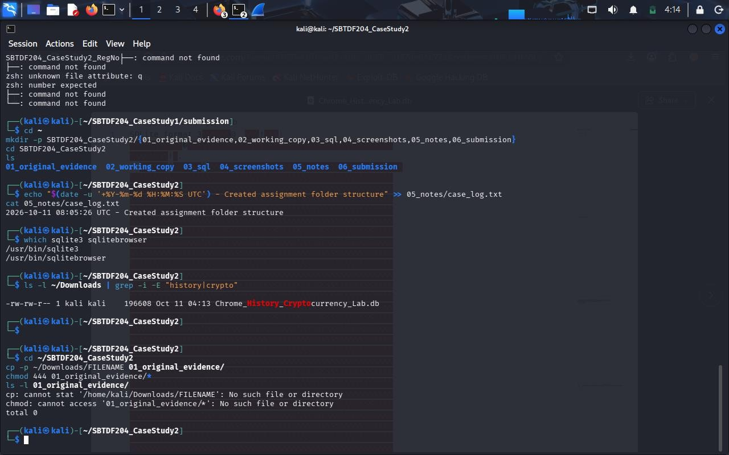
Figure 1a Source file located in ~/Downloads (196,608 bytes), followed by a first copy attempt that failed because a placeholder file name (FILENAME) was typed; no file was created or altered (total 0). The correct copy is shown in Figure 2.

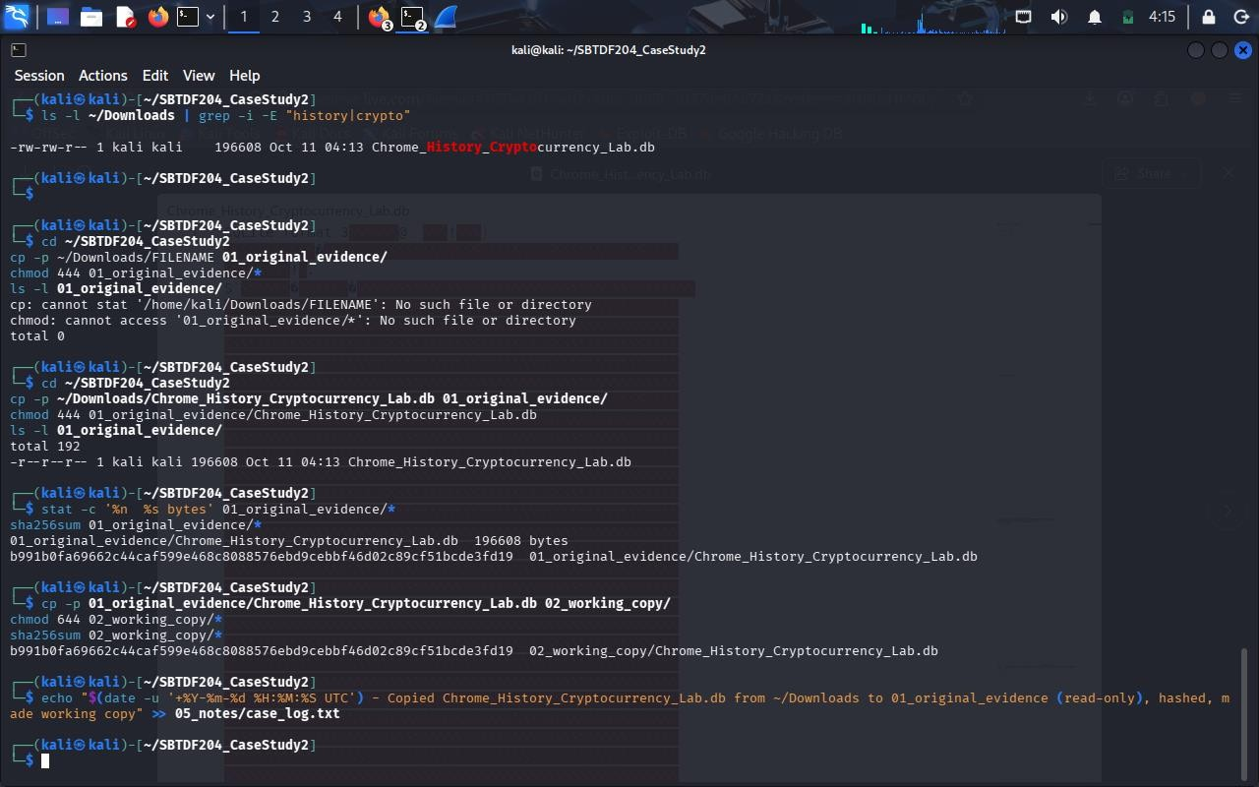
Figure 2 Original copied to 01_original_evidence (read-only, 196,608 bytes); SHA-256 of the original and the working copy are identical; case-log entry written (E01).
Precautions. No live site, account, e-mail, exchange, wallet or transaction ID referenced in the history was visited or queried. The Chrome meta table reports history schema version 53 (last compatible version 16).

Database method

Tables reviewed
The schema was listed first (sqlite_master). Tables holding data were: urls (57 rows), visits (74), downloads (1), downloads_url_chains (1), keyword_search_terms (4), content_annotations (47) and context_annotations (45). visit_source, segments, segment_usage, clusters, clusters_and_visits, downloads_slices, downloads_reroute_info and typed_url_sync_metadata were empty.
Table / field | Role in this case
urls | One row per distinct URL: id, url, title, visit_count, typed_count, last_visit_time, hidden. Titles supply the page names relied on (e.g. "posting confirmation", "Inbox (12) - …", "Transaction: …"). typed_count is 0 for every URL.
visits | One row per page load: id, url (→ urls.id), visit_time (WebKit µs), from_visit (the visit that led here), transition  (type + qualifier bits), visit_duration (µs), opener_visit (visit that opened this one in a new tab/window).
downloads | File-save record: target path, start/end time, bytes received/total, state, referrer, tab_url, etag, last_modified, MIME type.
downloads_url_chains | The URL(s) actually fetched for a download, in order (chain_index); here the direct image URL on i.imgur.com.
keyword_search_terms | Search terms entered through the omnibox/search box (four terms: craigslist, gmail, blockchain explorer, kraken), tied to urls.id.

Timestamp conversion
Chrome stores visit_time, start_time and end_time as microseconds since 1 January 1601 00:00:00 UTC. They were converted with datetime(t/1000000 + strftime('%s','1601-01-01'), 'unixepoch'), which yields UTC; all times in this report are UTC. Example: visit 1, visit_time 13294850058231547 → 2022-04-19 13:54:18 UTC. Durations in visit_duration are microseconds, shown here in seconds. If the device clock was set to US Eastern time (EDT, UTC−4 on that date an assumption suggested by the Baltimore Craigslist site and the en-US search parameter rlz=…enUS989US989, not proven), local times would read four hours earlier (e.g. 09:54:18). No local-time conversion is used in the tables.

Joins and transition interpretation
Visits were joined to URLs on visits.url = urls.id and ordered by visit_time (Appendix A, query4_timeline.sql). The base transition is transition & 0xFF; qualifier bits are read from the high bits of the unsigned 32-bit value (SQLite returns some as negative integers, e.g. −2147483648 = 0x80000000). The values present in this database are:
Stored value | Hex | Base type | Qualifiers | Count | Visit IDs
805306373 | 0x30000005 | 5 = GENERATED | start of a navigation chain; end of a chain | 1 | 1
805306368 | 0x30000000 | 0 = LINK | start of a navigation chain; end of a chain | 21 | 2, 20, 21, 23, 34, 35, 36, 47, …
268435456 | 0x10000000 | 0 = LINK | start of a navigation chain | 12 | 3, 6, 9, 11, 24, 31, 37, 43, …
-2147483648 | 0x80000000 | 0 = LINK | HTTP server redirect | 13 | 4, 12, 25, 26, 27, 28, 29, 32, …
-1610612736 | 0xa0000000 | 0 = LINK | end of a chain; HTTP server redirect | 9 | 5, 7, 10, 13, 30, 33, 50, 56, …
805306375 | 0x30000007 | 7 = FORM_SUBMIT | start of a navigation chain; end of a chain | 7 | 8, 14, 15, 16, 17, 18, 19
838860805 | 0x32000005 | 5 = GENERATED | initiated from the address bar; start of a navigation chain; end of a chain | 3 | 22, 51, 59
1610612736 | 0x60000000 | 0 = LINK | end of a chain; client (script/meta) redirect | 3 | 42, 46, 74
1073741824 | 0x40000000 | 0 = LINK | client (script/meta) redirect | 5 | 44, 45, 68, 72, 73

Reading rules applied: (a) base 5 (GENERATED) with FROM_ADDRESS_BAR = a search entered in the address bar (visits 22, 51, 59; visit 1 lacks the address-bar bit, so it came from another omnibox/search-box path); (b) base 7 (FORM_SUBMIT) = a form was submitted to reach the page (visits 8, 14–19); (c) from_visit was followed to rebuild chains, and opener_visit to identify pages opened in a new tab or window; (d) redirect qualifiers were treated as automatic hops, not user actions. There are no base-1 (TYPED) transitions and every typed_count is 0, so no URL was recorded as typed in full; the user-initiated entry points are the four omnibox searches.

Findings

Q1 Evidence file and preservation
History, 196,608 bytes, SHA-256 b991b0fa…cde3fd19, supplied as Chrome_History_Cryptocurrency_Lab.db and preserved as described in Section 3 (evidence log E01, Figures 1–2). The integrity check passed (E02, Figure 3).

Q2 Relevant tables and fields
See Section 4.1. The urls ↔ visits join provides what was visited, when and how; downloads + downloads_url_chains
document the single file saved (E02, E12; Figures 3 and 10).

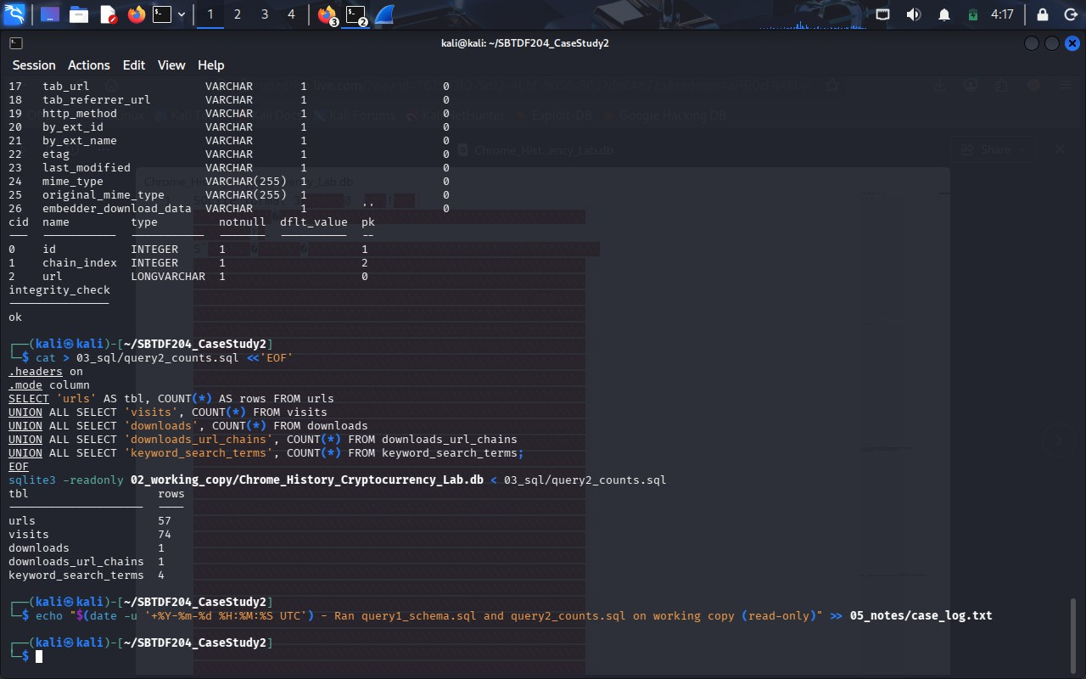
Figure 3 End of the schema listing (downloads_url_chains fields), PRAGMA integrity_check = ok, and row counts: urls 57, visits 74, downloads 1, downloads_url_chains 1, keyword_search_terms 4 (E02).
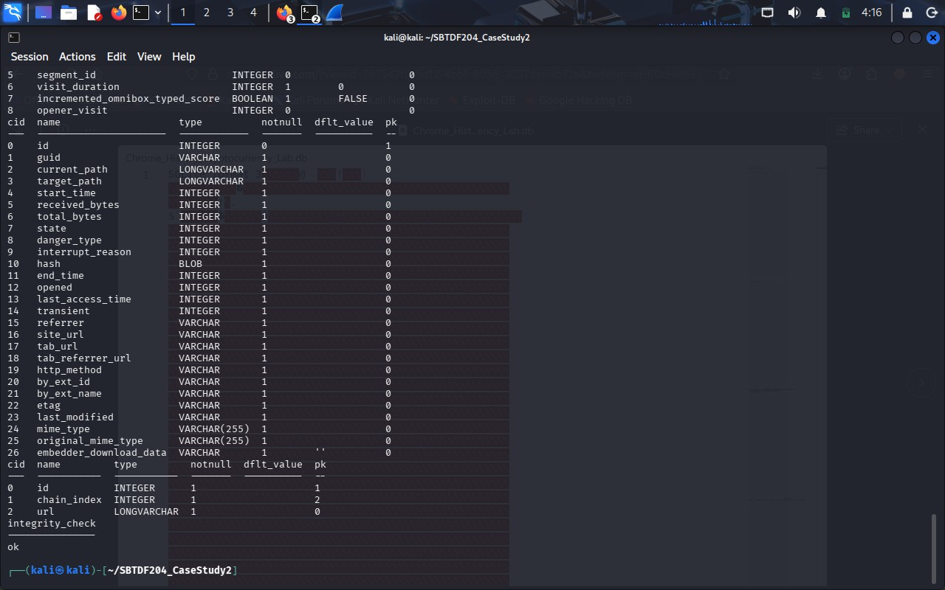
Figure 3a Earlier part of the query1_schema.sql output: PRAGMA table_info fields of visits (including from_visit, visit_duration, opener_visit) and all 27 fields of downloads, then downloads_url_chains and the integrity check (E02).

Q3 When the activity occurred
First visit: visit 1, 2022-04-19 13:54:18 UTC. Last visit: visit 74, 15:02:56 UTC. Total span 1 h 08 min 38 s, with one long gap (visit 47 at 14:05:59 → visit 48 at 14:56:47, about 50.8 minutes) between the "order" email thread and the

transaction-ID thread. The download ran 14:56:58 → 14:57:10 UTC (11.8 s). Method: Section 4.2 with
query3_timerange.sql and query4_timeline.sql (E03; first visit visible in Figure 4, last visit in Figure 11).
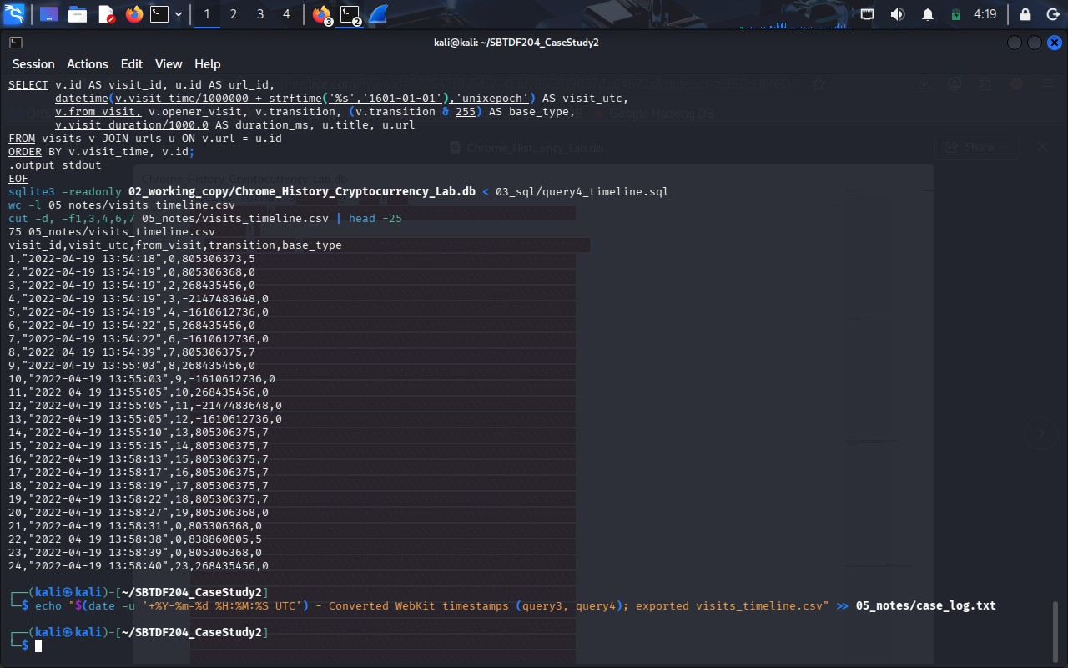
Figure 4 query4_timeline.sql: timeline exported to visits_timeline.csv (75 lines = 74 visits + header). Visit 1 is at 2022-04-19 13:54:18 UTC (E03).

Q4 How the browser reached the material URLs
- Search entry. Visits 1, 22, 51 and 59 are base-5 omnibox searches for "craigslist", "gmail", "blockchain explorer" and "kraken"; visits 22, 51 and 59 carry the address-bar qualifier. Each is followed by a second visit to the same results URL recorded as a link with opener = the search visit (V2, V23, V52, V60), and then by a link to the destination whose from_visit is that second visit (V3, V24, V53, V61).
- Redirect chains. Visits 3→5 (craigslist.org → geo → baltimore.craigslist.org), 6→7 (account home → log-in page), 9→10 (www → baltimore), 11→13 (post → draft key → ?s=type), 24→30 (Gmail entry → Gmail about page), 31→33 (account chooser), 37→42 (CheckCookie → SetOSID → SetSID → mail → #inbox), 43→46 and 72→74 (Gmail ?compose= fragments), 49→50 (Gmail link wrapper → Imgur), 55→56 (explorer search → /btc/tx/) and 67→70 (Kraken redirect → mempool.space) are redirect chains, identified by the qualifier bits and from_visit links.
- Form submissions. Visit 8 (Craigslist log-in), visits 14–19 (posting wizard steps: category, edit, map, image, preview, confirmation). Each has from_visit = the preceding wizard step.
- Openers. Visit 21 (live listing) has from_visit 0 and opener_visit 20 (the manage-posting page), so it was opened from that page rather than navigated to in place. Visits 43, 47 and 48 (Gmail) and 62–63, 65–66, 67 and 71 (Kraken) likewise carry opener_visit values pointing to earlier visits.
Evidence: E04–E16; full per-visit values in Appendix C.

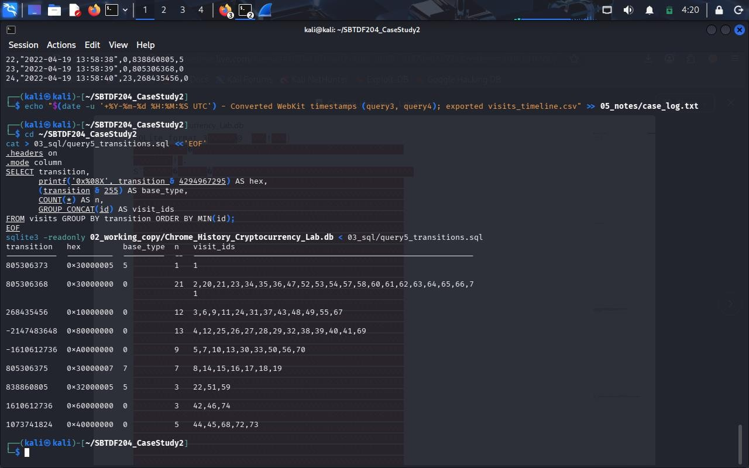
Figure 5 query5_transitions.sql: the nine distinct transition values with hex, base type, counts and visit IDs (E04).
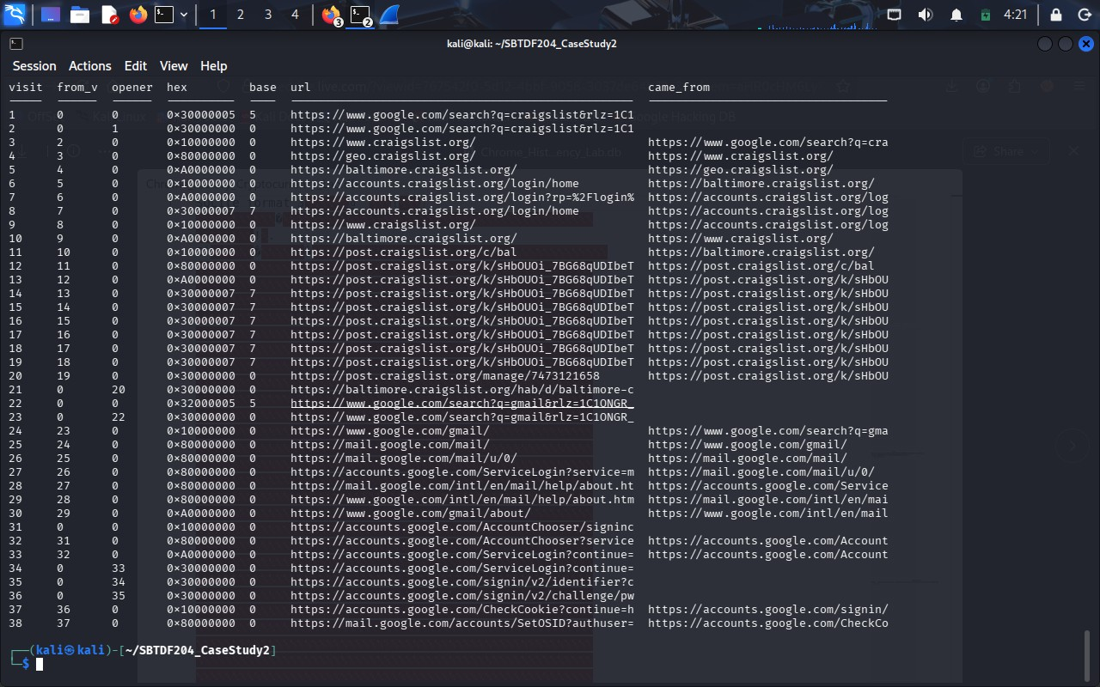
Figure 6 query6_chains.sql: each visit with from_visit, opener_visit, hex transition, base type, URL and the URL it came from (visits 1–38) (E04–E06).

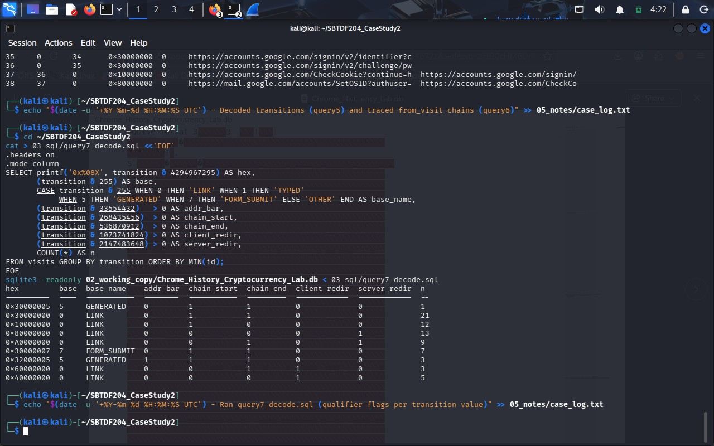
Figure 7 query7_decode.sql: qualifier flags (address bar, chain start, chain end, client redirect, server redirect) for each transition value (E04).

Q5 Evidence relating to the suspected posting
At 13:54:19 the profile reached craigslist.org (visits 3–5) and at 13:54:22 was sent to an account log-in page (visit 7, 17.5 s on page). Visit 8 at 13:54:39 is a base-7 form submission to accounts.craigslist.org/login/home titled "craigslist account", from_visit 7 (23.4 s on the log-in page): consistent with a log-in, though credentials and outcome are not recorded (E05). At 13:55:05 the posting flow began at post.craigslist.org/c/bal ("choose type"), redirecting to a draft URL carrying a session key (visits 11–13). Form-submit visits then step through "choose category" (14, 13:55:10), "create posting" (15, 13:55:15 177.7 s on page, matching the 13:58:13 start of the next step), "add map" (16), "create posting"/image step (17, 13:58:17), preview (18, 13:58:19) and "posting confirmation" (19, 13:58:22) the same URL (url_id 8) first seen as a redirect stop at 13:55:05, so the title alone at visit 12 does not show publication. Visit 20 at 13:58:27 is post.craigslist.org/manage/7473121658 ("manage posting") and visit 21 at 13:58:31 is the public listing baltimore.craigslist.org/hab/d/baltimore-cheaper-than-rx-supplements/7473121658.html, titled "cheaper than Rx supplements - health and beauty - by owner", opened from visit 20 (E06, E07).
Challenging evidence: the listing category is "health and beauty", the title says "supplements", and the browser history stores no ad text, price, images or location. The records support that an advertisement was created and reached its manage and public pages; they do not show what was offered.

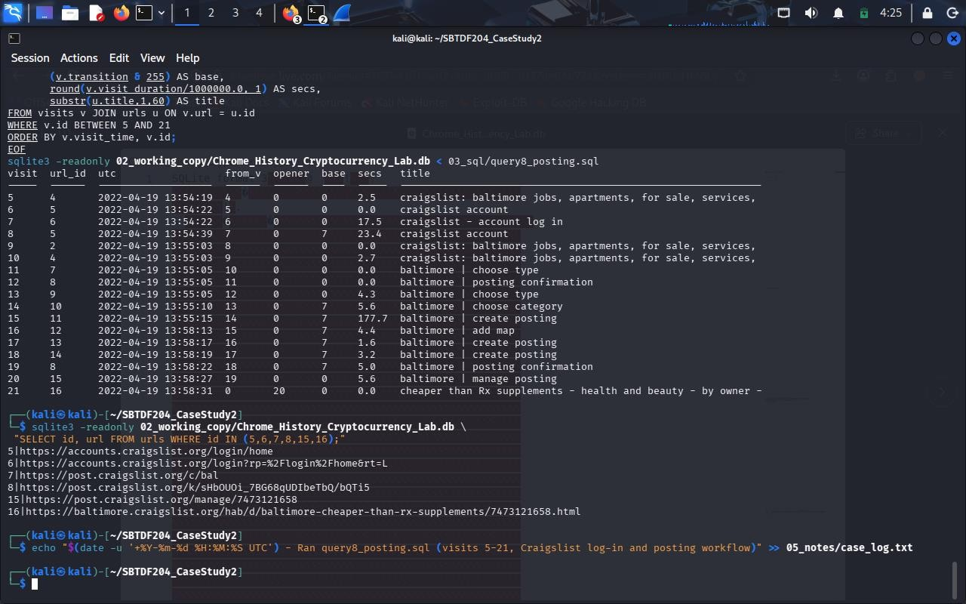
Figure 8 query8_posting.sql: Craigslist log-in and posting workflow, visits 5–21, with time on page, and the full URLs of the posting pages (E05–E07).

Q6 Communications and payment activity
- Gmail access (13:58:38–13:59:31). Visit 22 searches "gmail"; visits 24–30 form a redirect chain that passes through mail.google.com/mail/ and ends on the public Gmail about page; account chooser, sign-in and password-challenge pages follow (31–36, visit 36 at 13:59:26); visit 37 at 13:59:29 is titled "Inbox (12) - unsub.fscs@gmail.com - Gmail" and visit 42 at 13:59:31 loads #inbox. The account name appears only in page titles (E08).
- Buyer-contact indicator (14:04:12). Visit 43 loads a Gmail thread titled "cheaper than Rx supplements - order"; visits 44–45 (14:04:35, 14:04:46) add ?compose=… fragments via client redirect and visit 46 returns to the thread at 14:04:52; visit 47 returns to the inbox at 14:05:59. The subject matches the Craigslist title plus "order"; whether the message came from a third party, what it said and whether any reply was sent are not recorded (E09).
- Transaction-ID thread (14:56:47). Visit 48 loads a thread whose title ends "txid: 517b2156…8afdc5" (the full 64-hex value is in the database; it appears again in visits 55–57, 67–70, 74). Visit 49 (google.com/url?q=https://imgur.com/dTgrkP7&source=gmail…) and visit 50 (imgur.com/dTgrkP7, 18.9 s) show a link in that email opened at 14:56:52 (E10, E11).
- Download id 1 (14:56:58–14:57:10). C:\Users\FSCS_User\Desktop\proof_of_payment.png, 33,844 of 33,844 bytes, state 1 (complete), referrer https://imgur.com/, tab URL https://imgur.com/dTgrkP7, URL chain https://i.imgur.com/dTgrkP7.png, last_modified header "Tue, 19 Apr 2022 14:52:06 GMT", MIME image/png, opened 0, hash field empty. Chrome does not store the image; the filename does not prove what the image shows, and could have been set by the server or the user (E12).
- Blockchain explorers (14:58:59–14:59:21). Visit 51 searches "blockchain explorer"; visit 53–54 load blockchain.com/explorer; visit 55 is blockchain.com/search?search=<txid> redirecting (visit 56) to /btc/tx/<txid> titled "Transaction: 517b2156…"; visit 58 at 14:59:21 is /btc/address/38RcsURWCDmCbYocmsZCnGz1FtD7x477mt. The

address page may be an address shown on the transaction page, but the database does not say which role it plays (E13).
- Kraken session (14:59:38–15:02:05). Visit 59 searches "kraken"; sign-in (61–62, 14:59:47); "Approve new
device" (63, 15:00:21, 104.4 s on page); trade/instant/funding pages (64–66, 15:01:11–15:01:21); the funding title reads "41,543.80 USD - Kraken - Funding - Overview", and the ledger (visit 71, 15:02:05) "41,563.70 USD - Kraken - History - Ledger" (E14).
- Second explorer via Kraken (15:01:31–15:01:33). Visit 67 is kraken.com/redirect?url=https%3A%2F%2Fmempool.space%2Ftx%2F<txid> opened from visit 66 (funding); it passes a client redirect (68) and server redirect (69) and ends at mempool.space/tx/<txid> (70) the same ID as above (E15).
- Return to e-mail (15:02:32–15:02:56). Visits 72–74 are ?compose=… client-redirect fragments in the txid thread (from_visit 48, 72, 73), ending back on the thread at 15:02:56 (E16).
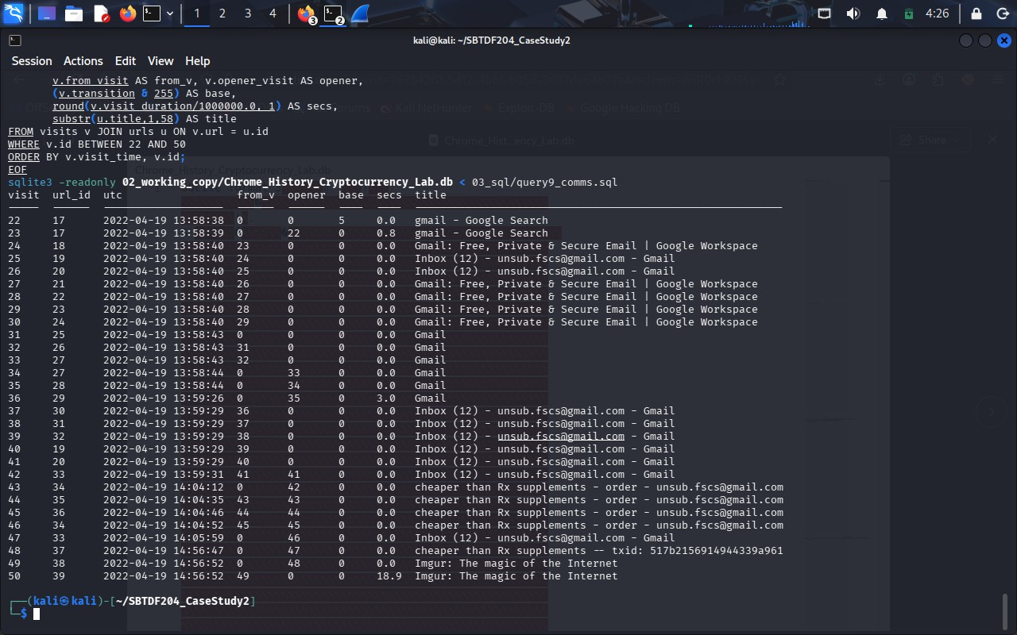
Figure 9 query9_comms.sql: Gmail access, e-mail threads and the Imgur visit, visits 22–50 (E08–E11).

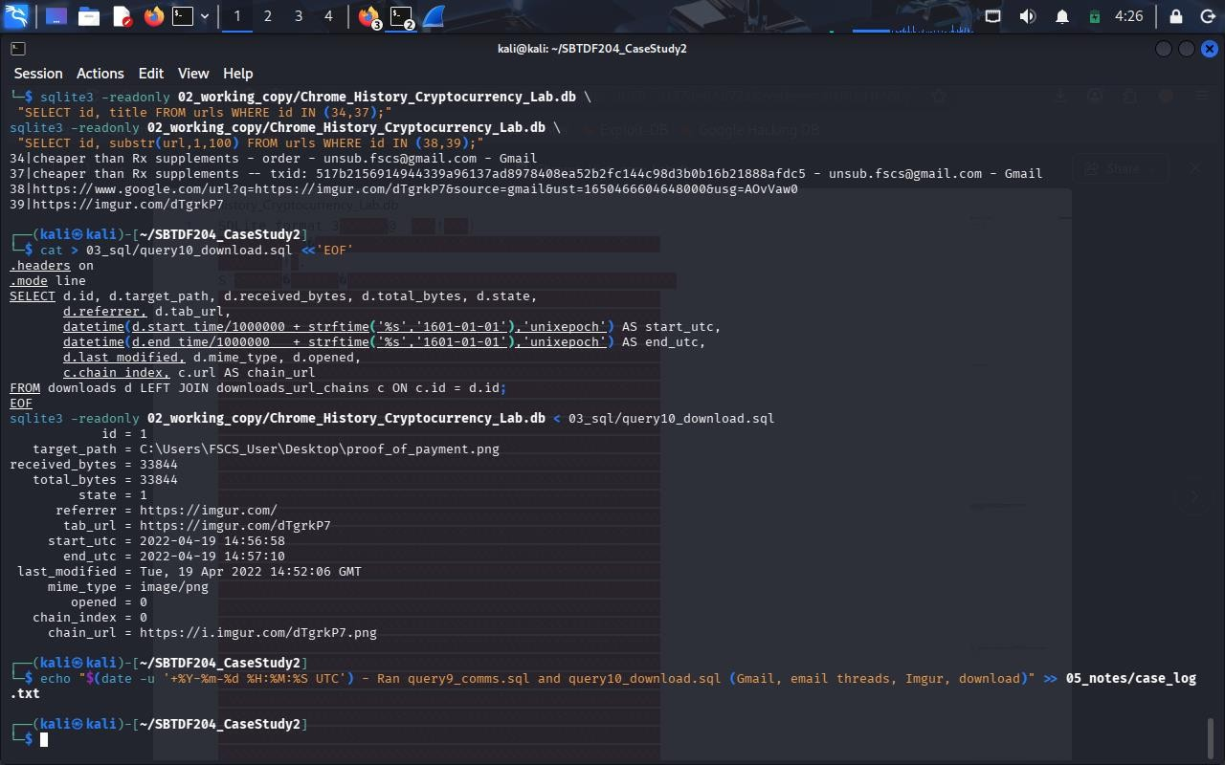
Figure 10 Full e-mail thread titles (including the transaction ID), the Imgur URLs, and the query10_download.sql record for download id 1 (E09–E12).
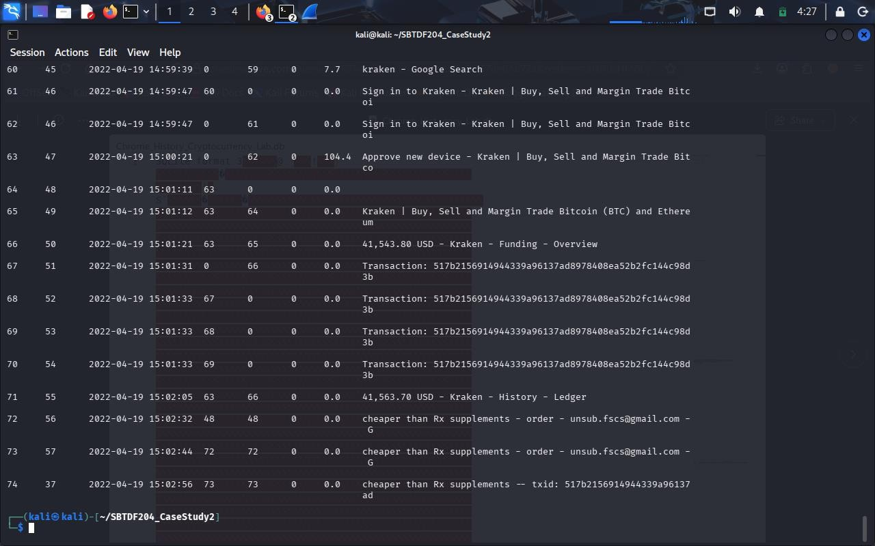
Figure 11 query11_payment.sql: Kraken pages, the redirect chain to mempool.space and the return to Gmail, visits 60–74 (E14–E16). Visits 51–59 are in the exported visits_timeline.csv.

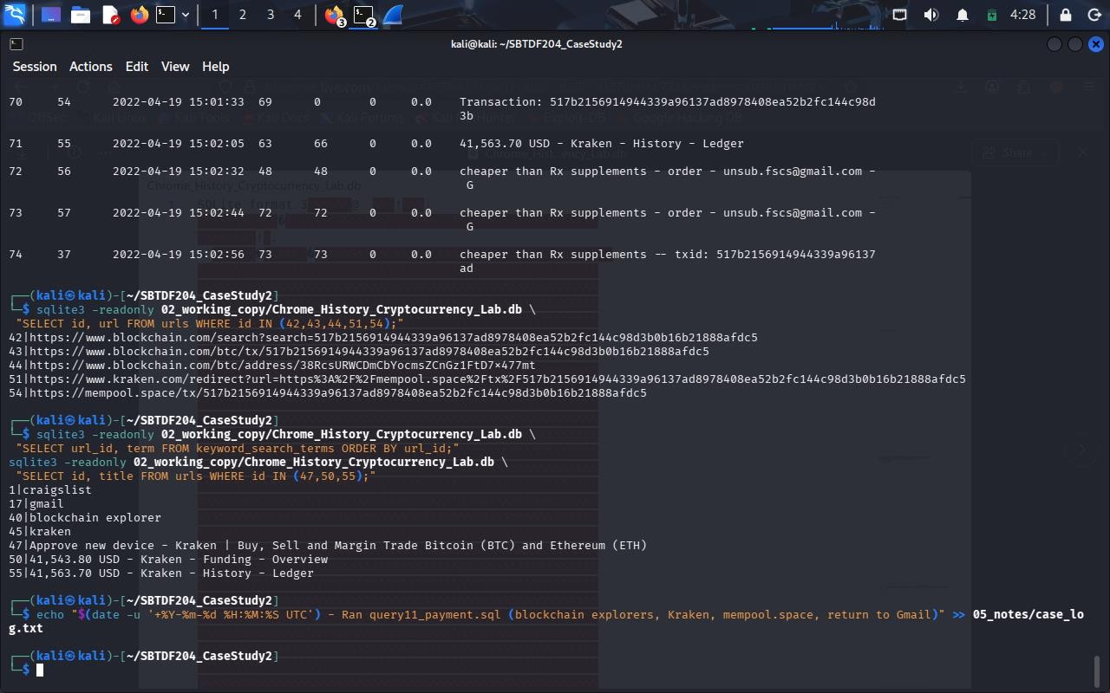
Figure 12 Full URLs of the explorer and redirect pages (U42, U43, U44, U51, U54), the four search terms, and the Kraken page titles (E04, E13–E15).

Q7 Reconstructed timeline
See Section 6 (stage-level, observation vs interpretation) and Appendix C (all 74 visits).

Q8 Defensible conclusion
A cautious, evidence-based conclusion is given in Section 2 and the confidence and limitations are in Section 7.

Timeline (UTC, 19 April 2022)
"Visit" = visits.id; "URL" = urls.id; transition shown as base type (qualifiers). Observed facts are what the table fields record; interpretation is analytical and labelled with its limit.

Stage | UTC (19 Apr  2022) | Visit / URL ID | Artefact | Observed fact | Interpretation and limit
Research / access | 13:54:18 | V1 / U1 | Google search "craigslist" | Base 5 GENERATED (chain start+end), no from_visit;  keyword_search_terms = "craigslist". | Intent to reach Craigslist. Search results content not stored.
Research / access | 13:54:19 | V2–V5 / U1–U4 | Results page again; craigslist.org → geo → baltimore.craigslist.org | V2 link to the same results URL (opener V1); V3 (from V2) chain start; V4 server redirect; V5 server redirect + chain end; V5 on page 2.5 s. | Click-through from the search results, then an automatic regional redirect to the Baltimore site.
Account access | 13:54:22 | V6–V7 / U5–U6 | accounts.craigslist.org/login/home → log-in page | V6 chain start; V7 server redirect + chain end, title "craigslist - account log in", 17.5 s on page. | Browser was not already signed in to Craigslist at this moment.
Account access | 13:54:39 | V8 / U5 | "craigslist account" | Base 7 FORM_SUBMIT, from_visit 7; 23.4 s on page. | Consistent with log-in form submission. Credentials/outcome not recorded; title shows no account name.
Posting | 13:55:03–  13:55:05 | V9–V13 /  U2,U4,U7–U9 | Return to baltimore home; post.craigslist.org/c/bal → draft key URL →  ?s=type | V9 link, V10 server redirect; V11 chain start ("choose type"); V12 server redirect to key URL titled "posting confirmation"; V13 server redirect + chain end ?s=type. | Start of posting wizard. Title at V12 is a generic page name, not proof of a published ad.
Posting | 13:55:10 | V14 / U10 | ?s=cat "choose category" | Base 7 FORM_SUBMIT, from_visit 13; 5.6 s. | Posting type submitted; category chosen next.
Posting | 13:55:15 | V15 / U11 | ?s=edit "create posting" | Base 7 FORM_SUBMIT, from_visit 14; 177.7 s on page. | Time consistent with composing the ad text (content not stored).
Posting | 13:58:13–  13:58:19 | V16–V18 / U12–U14 | ?s=geoverify "add map"; ?s=editimage; ?s=preview | Three consecutive FORM_SUBMITs (from_visit 15, 16,  17); 4.4 s, 1.6 s, 3.2 s. | Map, image and preview steps completed in rapid sequence. Whether images were attached is not recorded.
Posting | 13:58:22 | V19 / U8 | "posting confirmation" | Base 7 FORM_SUBMIT, from_visit 18; 5.0 s. | Posting submitted to Craigslist. Same URL as V12, so the later form-submit transition is what indicates completion.
Posting | 13:58:27 | V20 / U15 | post.craigslist.org/manage/7473121658 | Link, from_visit 19; 5.6 s. | Posting management page for ad 7473121658.
Posting | 13:58:31 | V21 / U16 | Listing "cheaper than Rx supplements - health and beauty - by owner" | Link, from_visit 0, opener 20 (new tab/window). | Public listing viewed from the manage page. Listing text/price/images not stored; "Rx" is only a title word.

SBT-DF204 Case Study 2 — Chrome History reconstruction — page 14

Stage | UTC (19 Apr  2022) | Visit / URL ID | Artefact | Observed fact | Interpretation and limit
Communications | 13:58:38–  13:58:40 | V22–V30 / U17–U24 | Search "gmail"; google.com/gmail → mail.google.com → … → Gmail about page | V22 base 5 + address bar; V23 link (opener V22); V24 chain start; V25–V29 server redirects; V30 server redirect  + chain end (www.google.com/gmail/about/). | The attempt to open the inbox ended on the public about page, consistent with no active Gmail session at that moment.
Communications | 13:58:43–  13:59:31 | V31–V42 / U25–U33 | Account chooser → sign-in → password challenge → CheckCookie → inbox | V36 signin/v2/challenge/pwd at 13:59:26; V37 title "Inbox  (12) - unsub.fscs@gmail.com - Gmail" at 13:59:29; V42  #inbox at 13:59:31. | Consistent with a successful Gmail sign-in for the account named in the titles. Authentication result inferred from titles only.
Communications | 14:04:12–  14:05:59 | V43–V47 / U34–U36, U33 | Gmail thread "cheaper than Rx supplements - order"; compose fragments; inbox | V43 chain start (opener V42); V44–V45 client redirects with ?compose=; V46 client redirect + chain end; V47 #inbox. | Subject links the thread to the listing. Sender, text, and whether any reply was sent are not recorded.
Gap | 14:05:59 →  14:56:47 | — | No visits for ≈ 50.8 min | V47 → V48 time difference 3,048.7 s. | Unobserved period. Offline, other browser/profile, or deleted history all possible.
Payment evidence | 14:56:47 | V48 / U37 | Gmail thread titled "…-- txid: 517b2156…8afdc5" | Chain start, opener V47. Title contains a 64-hex value. | Message carrying a transaction identifier, presented in the context of the same listing subject. Direction and wording unknown.
Payment evidence | 14:56:52 | V49–V50 / U38–U39 | google.com/url?q=imgur.com/dTgrkP7 → imgur.com/dTgrkP7 | V49 chain start (opener V48, source=gmail); V50 server redirect + chain end, 18.9 s. | Link in the e-mail was opened. Image content not stored.
Payment evidence | 14:56:58–  14:57:10 | Download id 1 | proof_of_payment.png on Desktop (C:\Users\FSCS_User) | 33,844/33,844 bytes; state 1; referrer imgur.com; chain i.imgur.com/dTgrkP7.png; last_modified 14:52:06 GMT; opened 0; hash blank. | Image saved locally; its filename suggests it was treated as proof of payment. The file itself was not examined and the name does not prove its content.
Verification | 14:58:59–  14:59:02 | V51–V54 / U40–U41 | Search "blockchain explorer"; blockchain.com/explorer | V51 base 5 + address bar; V52 link; V53–V54 explorer page (V54 from_visit 0, opener 53; 18.7 s). | Intent to check a transaction publicly.
Verification | 14:59:06 | V55–V57 / U42–U43 | blockchain.com/search?search=<txid> → /btc/tx/<txid> | V55 chain start (from V54); V56 server redirect + chain end; V57 same tx URL (from V54, opener V56). Titles "Transaction: 517b2156…". | The txid from the e-mail subject was looked up. Amount, confirmations and addresses not stored.
Verification | 14:59:21 | V58 / U44 | blockchain.com/btc/address/38RcsURWCDmCbYocmsZCnGz1FtD7x477mt | Link, from_visit 54, opener 57. | Address page opened after the transaction page; its role (sender/recipient/user wallet) is not shown.
Exchange | 14:59:38–  15:00:21 | V59–V63 / U45–U47 | Search "kraken"; sign-in; "Approve new device" | V59 base 5 + address bar; V61–V62 sign-in; V63 device-approval, 104.4 s on page. | Consistent with signing in to a Kraken account from an unrecognised device. Account owner not shown.

SBT-DF204 Case Study 2 — Chrome History reconstruction — page 15

Stage | UTC (19 Apr  2022) | Visit / URL ID | Artefact | Observed fact | Interpretation and limit
Exchange | 15:01:11–  15:01:21 | V64–V66 / U48–U50 | kraken.com/u/trade, /u/instant, /u/funding | Links from V63; V66 title "41,543.80 USD - Kraken - Funding - Overview". | Account holds a USD-denominated balance as displayed in the title. Composition and fluctuation unknown.
Verification | 15:01:31–  15:01:33 | V67–V70 / U51–U54 | kraken.com/redirect?url=…mempool.space/tx/<txid> →  mempool.space/tx/<txid> | V67 chain start (opener V66); V68 client redirect; V69 server redirect; V70 server redirect + chain end; title "Transaction: 517b2156… - mempool - Bitcoin Explorer". | Same txid checked in a second explorer reached from an exchange link.
Exchange | 15:02:05 | V71 / U55 | kraken.com/u/history/ledger | Link, from_visit 63, opener 66; title "41,563.70 USD - Kraken - History - Ledger". | Ledger reviewed. Title balance differs by +19.90 USD vs V66 see Section 7 (not evidence of a credit).
Communications | 15:02:32–  15:02:56 | V72–V74 / U56,U57,U37 | Gmail txid thread with ?compose= fragments | V72–V73 client redirects (from_visit 48, 72); V74 client redirect + chain end on the thread at 15:02:56. | Return to the transaction-ID thread after verification, with compose activity. Whether a message was sent is unknown.

SBT-DF204 Case Study 2 — Chrome History reconstruction — page 16

Attribution assessment

Overall confidence.

Proposition | Confidence | Basis
This Chrome profile executed the Craigslist posting workflow, then Gmail, Imgur, explorer and Kraken activity, in this order | Moderate–high | Internally consistent from_visit/opener_visit chains, consistent timestamps, a form-submit sequence, and a download linked to the Imgur visit.
The activity amounts to advertising and selling a controlled drug | Low–moderate | Only evidence is the title "cheaper than Rx supplements" (health and beauty). Page content, e-mail content and the product are not stored.
A payment was made, received and confirmed | Low–moderate | Txid in an e-mail subject, an image named proof_of_payment, and the same txid in two explorers show checking activity, not outcome.
The activity was carried out by a specific named person | Low | Account name unsub.fscs@gmail.com (titles) and the path C:\Users\FSCS_User\  identify a profile/account, not a human.

Limitations and alternative explanations.
- Browser profile ≠ human identity. History shows what a profile loaded. Anyone with access to the logged-in profile, the Windows account FSCS_User or the Gmail/Craigslist/Kraken sessions could produce it; no biometric, camera or login-challenge outcome is recorded.
- Shared or remote use. A shared computer, remote access, or a second person using the same profile would look identical in the database. The Kraken "Approve new device" page suggests the exchange did not recognise the device, but not who approved it.
- Redirects and automatic loads. Many rows are server/client redirects (22 visits carry a server-redirect bit; 8 carry a client-redirect bit), which are generated by sites and not by user clicks. Titles such as "posting confirmation" appear on the draft URL before final submission.
- Missing and cached content. The database holds URLs, titles and timing only. No Craigslist ad text, e-mail body, Imgur image, explorer output (amounts, addresses, confirmations) or exchange balances beyond titles are stored. Page titles can be cached or out of date.
- Ambiguous balance figures. Kraken titles show 41,543.80 USD (V66) and 41,563.70 USD (V71). A +19.90 USD change could reflect a credited deposit, but a displayed total portfolio value also moves with market prices, so it is not evidence of a payment.
- Titles are stored per URL, not per visit. urls.title holds the most recent title for a URL, so an earlier visit can display a later title (for example, visits 25–26 and 30–32 show "Inbox (12) - …" although they are redirect hops before the 13:59:29 sign-in). Titles were therefore treated as supporting, not decisive, evidence.
- Gap and completeness. A ≈50.8-minute gap (14:05:59–14:56:47) is unobserved; other browsers, profiles, devices, private/incognito windows or deleted history entries would not appear. visit_source is empty, which Chrome treats as locally browsed, so synced-device activity is not indicated.
- Timestamp context. Times are device-reported and converted to UTC; no clock verification was possible. The local-time offset of the device is unknown.
- Hypothesis bias. The case brief frames the activity as drug trafficking. The records also fit an ordinary online sale of legal supplements paid for in Bitcoin; the history cannot distinguish the two, so corroboration (device image, page caches, e-mail content, the downloaded image, blockchain data obtained lawfully) is needed.

SBT-DF204 Case Study 2 — Chrome History reconstruction — page 17

Appendices

Appendix A SQL used
Each query was saved as a .sql file in 03_sql/ and run with sqlite3 -readonly 02_working_copy/Chrome_History_Cryptocurrency_Lab.db < 03_sql/<file>. The .headers on and .mode lines set the output format. Inline queries are shown last.
query1_schema.sql tables, schemas, integrity
SELECT name FROM sqlite_master WHERE type='table' ORDER BY name; PRAGMA table_info(urls); PRAGMA table_info(visits);
PRAGMA table_info(downloads); PRAGMA table_info(downloads_url_chains); PRAGMA integrity_check;

query2_counts.sql row counts
SELECT 'urls' AS tbl, COUNT(*) AS rows FROM urls UNION ALL SELECT 'visits', COUNT(*) FROM visits
UNION ALL SELECT 'downloads', COUNT(*) FROM downloads
UNION ALL SELECT 'downloads_url_chains', COUNT(*) FROM downloads_url_chains UNION ALL SELECT 'keyword_search_terms', COUNT(*) FROM keyword_search_terms;

query3_timerange.sql first and last visit (UTC)
SELECT datetime(MIN(visit_time)/1000000 + strftime('%s','1601-01-01'),'unixepoch') AS first_utc, datetime(MAX(visit_time)/1000000 + strftime('%s','1601-01-01'),'unixepoch') AS last_utc, COUNT(*) AS total_visits FROM visits;

query4_timeline.sql full timeline exported to CSV
.mode csv
.output 05_notes/visits_timeline.csv SELECT v.id AS visit_id, u.id AS url_id,
datetime(v.visit_time/1000000 + strftime('%s','1601-01-01'),'unixepoch') AS visit_utc, v.from_visit, v.opener_visit, v.transition, (v.transition & 255) AS base_type, v.visit_duration/1000.0 AS duration_ms, u.title, u.url
FROM visits v JOIN urls u ON v.url = u.id ORDER BY v.visit_time, v.id;
.output stdout

query5_transitions.sql distinct transition values
SELECT transition, printf('0x%08X', transition & 4294967295) AS hex,
(transition & 255) AS base_type, COUNT(*) AS n, GROUP_CONCAT(id) AS visit_ids FROM visits GROUP BY transition ORDER BY MIN(id);

query6_chains.sql visit-to-parent chain
SELECT v.id AS visit, v.from_visit AS from_v, v.opener_visit AS opener, printf('0x%08X', v.transition & 4294967295) AS hex, (v.transition & 255) AS base, substr(u.url,1,50) AS url, substr(pu.url,1,35) AS came_from
FROM visits v JOIN urls u ON v.url = u.id
LEFT JOIN visits pv ON v.from_visit = pv.id LEFT JOIN urls pu ON pv.url = pu.id ORDER BY v.visit_time, v.id;

SBT-DF204 Case Study 2 — Chrome History reconstruction — page 18

query7_decode.sql qualifier flags
SELECT printf('0x%08X', transition & 4294967295) AS hex, (transition & 255) AS base,
CASE transition & 255 WHEN 0 THEN 'LINK' WHEN 1 THEN 'TYPED' WHEN 5 THEN 'GENERATED' WHEN 7 THEN 'FORM_SUBMIT' ELSE 'OTHER' END AS base_name,
(transition & 33554432) > 0 AS addr_bar, (transition & 268435456) > 0 AS chain_start, (transition & 536870912) > 0 AS chain_end, (transition & 1073741824) > 0 AS client_redir, (transition & 2147483648) > 0 AS server_redir, COUNT(*) AS n
FROM visits GROUP BY transition ORDER BY MIN(id);

query8_posting.sql Craigslist log-in and posting (visits 5–21)
SELECT v.id AS visit, u.id AS url_id,
datetime(v.visit_time/1000000 + strftime('%s','1601-01-01'),'unixepoch') AS utc, v.from_visit AS from_v, v.opener_visit AS opener, (v.transition & 255) AS base, round(v.visit_duration/1000000.0, 1) AS secs, substr(u.title,1,60) AS title
FROM visits v JOIN urls u ON v.url = u.id
WHERE v.id BETWEEN 5 AND 21 ORDER BY v.visit_time, v.id;

query9_comms.sql Gmail, e-mail threads, Imgur (visits 22–50)
-- same SELECT as query8_posting.sql, with substr(u.title,1,58) and: WHERE v.id BETWEEN 22 AND 50 ORDER BY v.visit_time, v.id;

query10_download.sql download and URL chain
.mode line
SELECT d.id, d.target_path, d.received_bytes, d.total_bytes, d.state, d.referrer, d.tab_url, datetime(d.start_time/1000000 + strftime('%s','1601-01-01'),'unixepoch') AS start_utc, datetime(d.end_time/1000000 + strftime('%s','1601-01-01'),'unixepoch') AS end_utc, d.last_modified, d.mime_type, d.opened, c.chain_index, c.url AS chain_url
FROM downloads d LEFT JOIN downloads_url_chains c ON c.id = d.id;

query11_payment.sql explorers, Kraken, return to Gmail (visits 51–74)
-- same SELECT as query9_comms.sql, with substr(u.title,1,62) and: WHERE v.id BETWEEN 51 AND 74 ORDER BY v.visit_time, v.id;

Inline queries full titles, URLs and search terms
SELECT id, title FROM urls WHERE id IN (34,37);
SELECT id, substr(url,1,100) FROM urls WHERE id IN (38,39); SELECT id, url FROM urls WHERE id IN (5,6,7,8,15,16); SELECT id, url FROM urls WHERE id IN (42,43,44,51,54);
SELECT url_id, term FROM keyword_search_terms ORDER BY url_id; SELECT id, title FROM urls WHERE id IN (47,50,55);

Appendix B Screenshot index
All screenshots were taken from the examiner's Kali terminal while the queries in Appendix A were run. They are placed beside the finding they support in Sections 3 and 5.

SBT-DF204 Case Study 2 — Chrome History reconstruction — page 19

Figure | What it shows | Evidence ID | Placed in
1 | Assignment folder structure, first case-log entry, tools installed | E01 | Section 3
1a | Source file in ~/Downloads and the failed first copy attempt (placeholder file name) | E01 | Section 3
2 | Original copied read-only; size; SHA-256 of original and working copy | E01 | Section 3
3 | End of schema listing, integrity check, row counts | E02 | Q2
3a | Earlier part of the schema listing (visits and downloads fields) | E02 | Q2
4 | Timeline export to CSV; first visit 13:54:18 UTC | E03 | Q3
5 | Distinct transition values | E04 | Q4
6 | from_visit / opener chains, visits 1–38 | E04–E06 | Q4
7 | Qualifier flags per transition value | E04 | Q4
8 | Craigslist log-in and posting workflow (visits 5–21); posting URLs | E05–E07 | Q5
9 | Gmail, e-mail threads, Imgur (visits 22–50) | E08–E11 | Q6
10 | Full thread titles, Imgur URLs, download record | E09–E12 | Q6
11 | Kraken, mempool.space chain, return to Gmail (visits 60–74) | E14–E16 | Q6
12 | Explorer/redirect URLs, search terms, Kraken titles | E04, E13–E15 | Q6

SBT-DF204 Case Study 2 — Chrome History reconstruction — page 20

Appendix C Visit register (all 74 visits, UTC date 2022-04-19)
Columns: V = visits.id; U = urls.id; "From" = from_visit; "Open" = opener_visit; Stored = visits.transition as returned by SQLite; Base/qualifiers decoded as in Section 4.3; Dur = visit_duration in seconds. URLs shortened; 64-hex transaction IDs are shown as the first 8 characters + "…".
V | U | UTC | From | Open | Stored | Base + qualifiers | Dur (s) | URL (short) | Title
1 | 1 | 13:54:18 | 0 | 0 | 805306373 | 5 GENERATED + CHAIN_START + CHAIN_END | 0 | www.google.com/search?q=craigslist&rlz=1C1ONGR_enUS989US989&… | craigslist - Google Search
2 | 1 | 13:54:19 | 0 | 1 | 805306368 | 0 LINK + CHAIN_START + CHAIN_END | 0.7 | www.google.com/search?q=craigslist&rlz=1C1ONGR_enUS989US989&… | craigslist - Google Search
3 | 2 | 13:54:19 | 2 | 0 | 268435456 | 0 LINK + CHAIN_START | 0 | www.craigslist.org/ | craigslist: baltimore jobs, apartments, for sale, services, community,
4 | 3 | 13:54:19 | 3 | 0 | -2147483648 | 0 LINK + SERVER_REDIRECT | 0 | geo.craigslist.org/ | craigslist: baltimore jobs, apartments, for sale, services, community,
5 | 4 | 13:54:19 | 4 | 0 | -1610612736 | 0 LINK + CHAIN_END + SERVER_REDIRECT | 2.5 | baltimore.craigslist.org/ | craigslist: baltimore jobs, apartments, for sale, services, community,
6 | 5 | 13:54:22 | 5 | 0 | 268435456 | 0 LINK + CHAIN_START | 0 | accounts.craigslist.org/login/home | craigslist account
7 | 6 | 13:54:22 | 6 | 0 | -1610612736 | 0 LINK + CHAIN_END + SERVER_REDIRECT | 17.5 | accounts.craigslist.org/login?rp=%2Flogin%2Fhome&rt=L | craigslist - account log in
8 | 5 | 13:54:39 | 7 | 0 | 805306375 | 7 FORM_SUBMIT + CHAIN_START + CHAIN_END | 23.4 | accounts.craigslist.org/login/home | craigslist account
9 | 2 | 13:55:03 | 8 | 0 | 268435456 | 0 LINK + CHAIN_START | 0 | www.craigslist.org/ | craigslist: baltimore jobs, apartments, for sale, services, community,
10 | 4 | 13:55:03 | 9 | 0 | -1610612736 | 0 LINK + CHAIN_END + SERVER_REDIRECT | 2.7 | baltimore.craigslist.org/ | craigslist: baltimore jobs, apartments, for sale, services, community,
11 | 7 | 13:55:05 | 10 | 0 | 268435456 | 0 LINK + CHAIN_START | 0 | post.craigslist.org/c/bal | baltimore | choose type
12 | 8 | 13:55:05 | 11 | 0 | -2147483648 | 0 LINK + SERVER_REDIRECT | 0 | post.craigslist.org/k/sHbOUOi_7BG68qUDIbeTbQ/bQTi5 | baltimore | posting confirmation
13 | 9 | 13:55:05 | 12 | 0 | -1610612736 | 0 LINK + CHAIN_END + SERVER_REDIRECT | 4.3 | post.craigslist.org/k/sHbOUOi_7BG68qUDIbeTbQ/bQTi5?s=type | baltimore | choose type
14 | 10 | 13:55:10 | 13 | 0 | 805306375 | 7 FORM_SUBMIT + CHAIN_START + CHAIN_END | 5.6 | post.craigslist.org/k/sHbOUOi_7BG68qUDIbeTbQ/bQTi5?s=cat | baltimore | choose category
15 | 11 | 13:55:15 | 14 | 0 | 805306375 | 7 FORM_SUBMIT + CHAIN_START + CHAIN_END | 177.7 | post.craigslist.org/k/sHbOUOi_7BG68qUDIbeTbQ/bQTi5?s=edit | baltimore | create posting
16 | 12 | 13:58:13 | 15 | 0 | 805306375 | 7 FORM_SUBMIT + CHAIN_START + CHAIN_END | 4.4 | post.craigslist.org/k/sHbOUOi_7BG68qUDIbeTbQ/bQTi5?s=geoverify | baltimore | add map
17 | 13 | 13:58:17 | 16 | 0 | 805306375 | 7 FORM_SUBMIT + CHAIN_START + CHAIN_END | 1.6 | post.craigslist.org/k/sHbOUOi_7BG68qUDIbeTbQ/bQTi5?s=editimage | baltimore | create posting
18 | 14 | 13:58:19 | 17 | 0 | 805306375 | 7 FORM_SUBMIT + CHAIN_START + CHAIN_END | 3.2 | post.craigslist.org/k/sHbOUOi_7BG68qUDIbeTbQ/bQTi5?s=preview | baltimore | create posting
SBT-DF204 Case Study 2 — Chrome History reconstruction — page 21

V | U | UTC | From | Open | Stored | Base + qualifiers | Dur (s) | URL (short) | Title
19 | 8 | 13:58:22 | 18 | 0 | 805306375 | 7 FORM_SUBMIT + CHAIN_START + CHAIN_END | 5 | post.craigslist.org/k/sHbOUOi_7BG68qUDIbeTbQ/bQTi5 | baltimore | posting confirmation
20 | 15 | 13:58:27 | 19 | 0 | 805306368 | 0 LINK + CHAIN_START + CHAIN_END | 5.6 | post.craigslist.org/manage/7473121658 | baltimore | manage posting
21 | 16 | 13:58:31 | 0 | 20 | 805306368 | 0 LINK + CHAIN_START + CHAIN_END | 0 | baltimore.craigslist.org/hab/d/baltimore-cheaper-than-rx-sup… | cheaper than Rx supplements - health and beauty - by owner -...
22 | 17 | 13:58:38 | 0 | 0 | 838860805 | 5 GENERATED +  FROM_ADDRESS_BAR + CHAIN_START + CHAIN_END | 0 | www.google.com/search?q=gmail&rlz=1C1ONGR_enUS989US989&oq=gm… | gmail - Google Search
23 | 17 | 13:58:39 | 0 | 22 | 805306368 | 0 LINK + CHAIN_START + CHAIN_END | 0.8 | www.google.com/search?q=gmail&rlz=1C1ONGR_enUS989US989&oq=gm… | gmail - Google Search
24 | 18 | 13:58:40 | 23 | 0 | 268435456 | 0 LINK + CHAIN_START | 0 | www.google.com/gmail/ | Gmail: Free, Private & Secure Email | Google Workspace
25 | 19 | 13:58:40 | 24 | 0 | -2147483648 | 0 LINK + SERVER_REDIRECT | 0 | mail.google.com/mail/ | Inbox (12) - unsub.fscs@gmail.com - Gmail
26 | 20 | 13:58:40 | 25 | 0 | -2147483648 | 0 LINK + SERVER_REDIRECT | 0 | mail.google.com/mail/u/0/ | Inbox (12) - unsub.fscs@gmail.com - Gmail
27 | 21 | 13:58:40 | 26 | 0 | -2147483648 | 0 LINK + SERVER_REDIRECT | 0 | accounts.google.com/ServiceLogin?service=mail&passive=120960… | Gmail: Free, Private & Secure Email | Google Workspace
28 | 22 | 13:58:40 | 27 | 0 | -2147483648 | 0 LINK + SERVER_REDIRECT | 0 | mail.google.com/intl/en/mail/help/about.html | Gmail: Free, Private & Secure Email | Google Workspace
29 | 23 | 13:58:40 | 28 | 0 | -2147483648 | 0 LINK + SERVER_REDIRECT | 0 | www.google.com/intl/en/mail/help/about.html | Gmail: Free, Private & Secure Email | Google Workspace
30 | 24 | 13:58:40 | 29 | 0 | -1610612736 | 0 LINK + CHAIN_END + SERVER_REDIRECT | 0 | www.google.com/gmail/about/ | Gmail: Free, Private & Secure Email | Google Workspace
31 | 25 | 13:58:43 | 0 | 0 | 268435456 | 0 LINK + CHAIN_START | 0 | accounts.google.com/AccountChooser/signinchooser?service=mai… | Gmail
32 | 26 | 13:58:43 | 31 | 0 | -2147483648 | 0 LINK + SERVER_REDIRECT | 0 | accounts.google.com/AccountChooser?service=mail&continue=htt… | Gmail
33 | 27 | 13:58:43 | 32 | 0 | -1610612736 | 0 LINK + CHAIN_END + SERVER_REDIRECT | 0 | accounts.google.com/ServiceLogin?continue=https%3A%2F%2Fmail… | Gmail
34 | 27 | 13:58:44 | 0 | 33 | 805306368 | 0 LINK + CHAIN_START + CHAIN_END | 0 | accounts.google.com/ServiceLogin?continue=https%3A%2F%2Fmail… | Gmail
35 | 28 | 13:58:44 | 0 | 34 | 805306368 | 0 LINK + CHAIN_START + CHAIN_END | 0 | accounts.google.com/signin/v2/identifier?continue=https%3A%2… | Gmail
36 | 29 | 13:59:26 | 0 | 35 | 805306368 | 0 LINK + CHAIN_START + CHAIN_END | 3 | accounts.google.com/signin/v2/challenge/pwd?continue=https%3… | Gmail
37 | 30 | 13:59:29 | 36 | 0 | 268435456 | 0 LINK + CHAIN_START | 0 | accounts.google.com/CheckCookie?continue=https%3A%2F%2Fmail.… | Inbox (12) - unsub.fscs@gmail.com - Gmail
38 | 31 | 13:59:29 | 37 | 0 | -2147483648 | 0 LINK + SERVER_REDIRECT | 0 | mail.google.com/accounts/SetOSID?authuser=0&continue=https%3… | Inbox (12) - unsub.fscs@gmail.com - Gmail
39 | 32 | 13:59:29 | 38 | 0 | -2147483648 | 0 LINK + SERVER_REDIRECT | 0 | accounts.youtube.com/accounts/SetSID?ssdc=1&sidt=ALWU2ctdRyP… | Inbox (12) - unsub.fscs@gmail.com - Gmail
40 | 19 | 13:59:29 | 39 | 0 | -2147483648 | 0 LINK + SERVER_REDIRECT | 0 | mail.google.com/mail/ | Inbox (12) - unsub.fscs@gmail.com - Gmail
41 | 20 | 13:59:29 | 40 | 0 | -2147483648 | 0 LINK + SERVER_REDIRECT | 0 | mail.google.com/mail/u/0/ | Inbox (12) - unsub.fscs@gmail.com - Gmail
42 | 33 | 13:59:31 | 41 | 41 | 1610612736 | 0 LINK + CHAIN_END + CLIENT_REDIRECT | 0 | mail.google.com/mail/u/0/#inbox | Inbox (12) - unsub.fscs@gmail.com - Gmail
43 | 34 | 14:04:12 | 0 | 42 | 268435456 | 0 LINK + CHAIN_START | 0 | mail.google.com/mail/u/0/#inbox/WhctKKXXDrfCqXBGCnHkHGxZnZbk… | cheaper than Rx supplements - order - unsub.fscs@gmail.com - Gmail
SBT-DF204 Case Study 2 — Chrome History reconstruction — page 22

V | U | UTC | From | Open | Stored | Base + qualifiers | Dur (s) | URL (short) | Title
44 | 35 | 14:04:35 | 43 | 43 | 1073741824 | 0 LINK + CLIENT_REDIRECT | 0 | mail.google.com/mail/u/0/#inbox/WhctKKXXDrfCqXBGCnHkHGxZnZbk… | cheaper than Rx supplements - order - unsub.fscs@gmail.com - Gmail
45 | 36 | 14:04:46 | 44 | 44 | 1073741824 | 0 LINK + CLIENT_REDIRECT | 0 | mail.google.com/mail/u/0/#inbox/WhctKKXXDrfCqXBGCnHkHGxZnZbk… | cheaper than Rx supplements - order - unsub.fscs@gmail.com - Gmail
46 | 34 | 14:04:52 | 45 | 45 | 1610612736 | 0 LINK + CHAIN_END + CLIENT_REDIRECT | 0 | mail.google.com/mail/u/0/#inbox/WhctKKXXDrfCqXBGCnHkHGxZnZbk… | cheaper than Rx supplements - order - unsub.fscs@gmail.com - Gmail
47 | 33 | 14:05:59 | 0 | 46 | 805306368 | 0 LINK + CHAIN_START + CHAIN_END | 0 | mail.google.com/mail/u/0/#inbox | Inbox (12) - unsub.fscs@gmail.com - Gmail
48 | 37 | 14:56:47 | 0 | 47 | 268435456 | 0 LINK + CHAIN_START | 0 | mail.google.com/mail/u/0/#inbox/WhctKKXXDrfCqvtRjhGdkMBqVNFn… | cheaper than Rx supplements -- txid: 517b2156914944339a96137ad8978408e
49 | 38 | 14:56:52 | 0 | 48 | 268435456 | 0 LINK + CHAIN_START | 0 | www.google.com/url?q=https://imgur.com/dTgrkP7&source=gmail&… | Imgur: The magic of the Internet
50 | 39 | 14:56:52 | 49 | 0 | -1610612736 | 0 LINK + CHAIN_END + SERVER_REDIRECT | 18.9 | imgur.com/dTgrkP7 | Imgur: The magic of the Internet
51 | 40 | 14:58:59 | 0 | 0 | 838860805 | 5 GENERATED +  FROM_ADDRESS_BAR + CHAIN_START + CHAIN_END | 0 | www.google.com/search?q=blockchain+explorer&rlz=1C1ONGR_enUS… | blockchain explorer - Google Search
52 | 40 | 14:59:00 | 0 | 51 | 805306368 | 0 LINK + CHAIN_START + CHAIN_END | 1 | www.google.com/search?q=blockchain+explorer&rlz=1C1ONGR_enUS… | blockchain explorer - Google Search
53 | 41 | 14:59:01 | 52 | 0 | 805306368 | 0 LINK + CHAIN_START + CHAIN_END | 0 | www.blockchain.com/explorer | Blockchain Explorer - Search the Blockchain | BTC | ETH | BCH
54 | 41 | 14:59:02 | 0 | 53 | 805306368 | 0 LINK + CHAIN_START + CHAIN_END | 18.7 | www.blockchain.com/explorer | Blockchain Explorer - Search the Blockchain | BTC | ETH | BCH
55 | 42 | 14:59:06 | 54 | 0 | 268435456 | 0 LINK + CHAIN_START | 0 | www.blockchain.com/search?search=517b2156… | Transaction: 517b2156914944339a96137ad8978408ea52b2fc144c98d3b0b16b218
56 | 43 | 14:59:06 | 55 | 0 | -1610612736 | 0 LINK + CHAIN_END + SERVER_REDIRECT | 0 | www.blockchain.com/btc/tx/517b2156… | Transaction: 517b2156914944339a96137ad8978408ea52b2fc144c98d3b0b16b218
57 | 43 | 14:59:06 | 54 | 56 | 805306368 | 0 LINK + CHAIN_START + CHAIN_END | 0 | www.blockchain.com/btc/tx/517b2156… | Transaction: 517b2156914944339a96137ad8978408ea52b2fc144c98d3b0b16b218
58 | 44 | 14:59:21 | 54 | 57 | 805306368 | 0 LINK + CHAIN_START + CHAIN_END | 0 | www.blockchain.com/btc/address/38RcsURWCDmCbYocmsZCnGz1FtD7x… | Address: 38RcsURWCDmCbYocmsZCnGz1FtD7x477mt | Blockchain Explorer
59 | 45 | 14:59:38 | 0 | 0 | 838860805 | 5 GENERATED +  FROM_ADDRESS_BAR + CHAIN_START + CHAIN_END | 0 | www.google.com/search?q=kraken&rlz=1C1ONGR_enUS989US989&oq=k… | kraken - Google Search
60 | 45 | 14:59:39 | 0 | 59 | 805306368 | 0 LINK + CHAIN_START + CHAIN_END | 7.7 | www.google.com/search?q=kraken&rlz=1C1ONGR_enUS989US989&oq=k… | kraken - Google Search
61 | 46 | 14:59:47 | 60 | 0 | 805306368 | 0 LINK + CHAIN_START + CHAIN_END | 0 | www.kraken.com/en-us/sign-in | Sign in to Kraken - Kraken | Buy, Sell and Margin Trade Bitcoin (BTC)
62 | 46 | 14:59:47 | 0 | 61 | 805306368 | 0 LINK + CHAIN_START + CHAIN_END | 0 | www.kraken.com/en-us/sign-in | Sign in to Kraken - Kraken | Buy, Sell and Margin Trade Bitcoin (BTC)
63 | 47 | 15:00:21 | 0 | 62 | 805306368 | 0 LINK + CHAIN_START + CHAIN_END | 104.4 | www.kraken.com/en-us/device-approval | Approve new device - Kraken | Buy, Sell and Margin Trade Bitcoin (BTC)
64 | 48 | 15:01:11 | 63 | 0 | 805306368 | 0 LINK + CHAIN_START + CHAIN_END | 0 | www.kraken.com/u/trade?i=true

SBT-DF204 Case Study 2 — Chrome History reconstruction — page 23

V | U | UTC | From | Open | Stored | Base + qualifiers | Dur (s) | URL (short) | Title
65 | 49 | 15:01:12 | 63 | 64 | 805306368 | 0 LINK + CHAIN_START + CHAIN_END | 0 | www.kraken.com/u/instant | Kraken | Buy, Sell and Margin Trade Bitcoin (BTC) and Ethereum (ETH)
66 | 50 | 15:01:21 | 63 | 65 | 805306368 | 0 LINK + CHAIN_START + CHAIN_END | 0 | www.kraken.com/u/funding | 41,543.80 USD - Kraken - Funding - Overview
67 | 51 | 15:01:31 | 0 | 66 | 268435456 | 0 LINK + CHAIN_START | 0 | www.kraken.com/redirect?url=https%3A%2F%2Fmempool.space%2Ftx… | Transaction: 517b2156914944339a96137ad8978408ea52b2fc144c98d3b0b16b218
68 | 52 | 15:01:33 | 67 | 0 | 1073741824 | 0 LINK + CLIENT_REDIRECT | 0 | www.kraken.com/redirect?t=-_F22IhwssFD | Transaction: 517b2156914944339a96137ad8978408ea52b2fc144c98d3b0b16b218
69 | 53 | 15:01:33 | 68 | 0 | -2147483648 | 0 LINK + SERVER_REDIRECT | 0 | www.kraken.com/redirect?t=-_F22IhwssFD | Transaction: 517b2156914944339a96137ad8978408ea52b2fc144c98d3b0b16b218
70 | 54 | 15:01:33 | 69 | 0 | -1610612736 | 0 LINK + CHAIN_END + SERVER_REDIRECT | 0 | mempool.space/tx/517b2156… | Transaction: 517b2156914944339a96137ad8978408ea52b2fc144c98d3b0b16b218
71 | 55 | 15:02:05 | 63 | 66 | 805306368 | 0 LINK + CHAIN_START + CHAIN_END | 0 | www.kraken.com/u/history/ledger | 41,563.70 USD - Kraken - History - Ledger
72 | 56 | 15:02:32 | 48 | 48 | 1073741824 | 0 LINK + CLIENT_REDIRECT | 0 | mail.google.com/mail/u/0/#inbox/WhctKKXXDrfCqvtRjhGdkMBqVNFn… | cheaper than Rx supplements - order - unsub.fscs@gmail.com - Gmail
73 | 57 | 15:02:44 | 72 | 72 | 1073741824 | 0 LINK + CLIENT_REDIRECT | 0 | mail.google.com/mail/u/0/#inbox/WhctKKXXDrfCqvtRjhGdkMBqVNFn… | cheaper than Rx supplements - order - unsub.fscs@gmail.com - Gmail
74 | 37 | 15:02:56 | 73 | 73 | 1610612736 | 0 LINK + CHAIN_END + CLIENT_REDIRECT | 0 | mail.google.com/mail/u/0/#inbox/WhctKKXXDrfCqvtRjhGdkMBqVNFn… | cheaper than Rx supplements -- txid: 517b2156914944339a96137ad8978408e

SBT-DF204 Case Study 2 — Chrome History reconstruction — page 24

Appendix D Evidence log

Evidence ID | Source record | Finding | Why it matters | SQL / screenshot reference
E01 | File Chrome_History_Cryptocurrency_Lab.db  (196,608 bytes) | SHA-256 b991b0fa…cde3fd19 for the original and the working copy (identical); original set read-only (mode 444); queries run with sqlite3 -readonly. | Establishes integrity and provenance of the evidence. | Figures 1, 1a, 2; Section 3
E02 | sqlite_master; PRAGMA table_info; integrity_check; row counts | 7 populated tables; urls 57, visits 74, downloads 1, downloads_url_chains 1, keyword_search_terms 4; integrity ok; history version 53. | Confirms the schema and that the file is not corrupt. | query1, query2; Figures 3, 3a
E03 | visits.visit_time (first/last) | First 2022-04-19 13:54:18 UTC (V1); last 15:02:56 UTC (V74); 74 visits. | Defines the investigation window and shows the UTC conversion. | query3, query4; Figures 4, 11
E04 | visits V1, V22, V51, V59; transition values; keyword_search_terms | Nine distinct transition values; four base-5 omnibox searches (craigslist, gmail, blockchain explorer, kraken); no base-1 (typed) visits; typed_count = 0. | Shows user-initiated entry points and how each page was reached. | query5, query6, query7; Figures 5–7, 12
E05 | visits V6–V8; urls U5–U6 | Redirect to log-in page (V7), then FORM_SUBMIT (V8) to  accounts.craigslist.org/login/home at 13:54:39. | Consistent with Craigslist account log-in before posting. | query6, query8; Figures 6, 8
E06 | visits V11–V19; urls U7–U14, U8 | Posting wizard: type → category → edit (177.7 s) → map → image → preview → confirmation; V14–V19 are FORM_SUBMIT in an unbroken from_visit chain, 13:55:05–13:58:22. | Shows a complete multi-step posting workflow. | query8; Figure 8
E07 | visits V20–V21; urls U15–U16 | Manage page for ad 7473121658 (V20); public listing titled "cheaper than Rx supplements - health and beauty - by owner" opened from V20 (V21). | Identifies the advertisement and its only descriptive text. | query8; Figure 8
E08 | visits V22–V42; urls U17–U33 | Gmail searched; redirected to the about page; account chooser, sign-in and password challenge; inbox titled with unsub.fscs@gmail.com at 13:59:29. | Shows access to a Gmail account after the listing was created. | query9; Figure 9
E09 | visits V43–V47; urls U34–U36 | Thread "cheaper than Rx supplements - order" at 14:04:12; compose fragments 14:04:35–14:04:46; inbox at 14:05:59. | Subject ties the thread to the listing; indicates reading or replying to an order-related message. | query9, inline titles; Figures 9, 10
E10 | visit V48; url U37 | Thread title containing "txid: 517b2156…8afdc5" at 14:56:47, after a ≈ 50.8 min gap. | Introduces the transaction identifier used in all later verification. | query9, inline titles; Figures 9, 10
E11 | visits V49–V50; urls U38–U39 | Gmail link wrapper (source=gmail) → imgur.com/dTgrkP7 at 14:56:52, 18.9 s on page. | Links the e-mail to the image page that preceded the download. | query9, inline URLs; Figures 9, 10
E12 | downloads id 1; downloads_url_chains id 1 | C:\Users\FSCS_User\Desktop\proof_of_payment.png; 33,844 B; complete; 14:56:58–  14:57:10; chain https://i.imgur.com/dTgrkP7.png; last-modified 14:52:06 GMT. | Shows an image saved locally from the Imgur page, named as proof of payment. | query10; Figure 10
E13 | visits V51–V58; urls U40–U44 | Explorer search; txid search → /btc/tx/<txid>; address page 38RcsURW…x477mt at 14:59:21. | Shows lookup of the e-mailed transaction ID in a public explorer. | query11, inline URLs; Figure 12, CSV
E14 | visits V59–V66, V71; urls U45–U50, U55 | Kraken search; sign-in 14:59:47; device approval 15:00:21 (104.4 s); funding title 41,543.80 USD (15:01:21); ledger title 41,563.70 USD (15:02:05). | Shows exchange access and ledger review after the explorer check. | query11, inline titles; Figures 11, 12

SBT-DF204 Case Study 2 — Chrome History reconstruction — page 25

Evidence ID | Source record | Finding | Why it matters | SQL / screenshot reference
E15 | visits V67–V70; urls U51–U54 | kraken.com/redirect?url=…mempool.space/tx/<txid> (opener V66) → client + server redirects → mempool.space/tx/<txid> at 15:01:33. | Shows the same txid checked in a second explorer from the exchange. | query11, inline URLs; Figures 11, 12
E16 | visits V72–V74; urls U56–U57, U37 | Compose fragments in the txid thread (15:02:32–15:02:56), from_visit 48 → 72 → 73. | Indicates return to the communication thread after verification; sending not proven. | query11; Figure 11
E17 | downloads.target_path; urls titles; rlz parameter | Windows user folder FSCS_User; account in titles unsub.fscs@gmail.com; rlz=1C1ONGR_enUS989US989 in Google URLs. | Basis for the attribution assessment (profile/account, not person). | query4, query10; Section 7

SBT-DF204 Case Study 2 — Chrome History reconstruction — page 26

