**Software Design Document - MEAN APP for RVCE-ISE-Hub Mobile Application**

Contents

1. RVCE-ISE-Hub Application Overview 2

2. SYSTEM ARCHITECTURE 2

3. Front End Design (AngularJS and/or Ionic Framework) 3

A. Screen Design 3

B. Models 10

C. Services 10

4. Back End Design 10

A. Database Design (MongoDB) 10

B. NodeJS Application REST API's 11

C. Authentication Module 11

5. Git Repository Commands 11

## RVCE-ISE-Hub Application Overview

This mobile application caters following requirements for an academic institution, department.

* Department can enter and broadcast list of events, seminars, workshops
* Students can register, rate (based on time feasibility) for these events online
* Faculty can share their profile details as well as any announcements

The objective of this application is to remove confusion about venue, timings with respect to various activities in department and provide one point of reference for staff as well as students.

## SYSTEM ARCHITECTURE

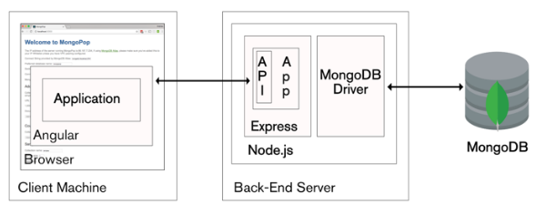

Figure 1: MEAN stack architecture

MEAN stack is an abbreviation for MongoDB, Express, AngularJS and NodeJS. These four components constitute the front and back end of entire application. RVCE- ISE-Hub mobile application is based on MEAN stack technology.

MongoDB is a NoSQL database which consists of collections and documents to store information relevant to back end storage. Express provides a web server framework for NodeJS. NodeJS constitutes the server side application to handle incoming REST API requests and generate responses to client.

AngularJS is used to develop the entire front end application which consists of GUI screens, validation as well as posting requests and receiving response from server side.

## Front End Design (AngularJS and/or Ionic Framework)

### Screen Design

This section covers prototype mobile screens for front end application. These screens may undergo changes during development phase. These have been prototyped using "Ionic Creator" online portal.

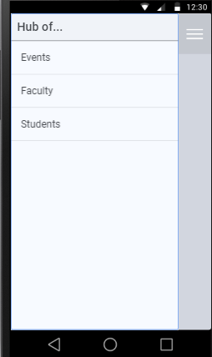

Figure 1: Side Menu For Application

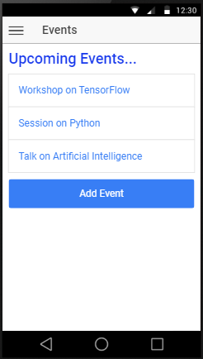

Figure 2: EventsList Screen

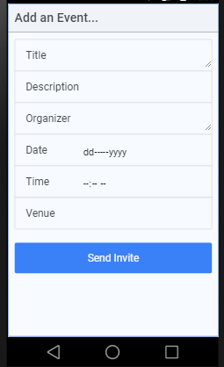

Figure 3: EventsForm Screen

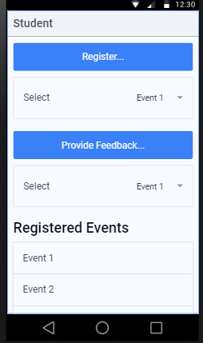

Figure 4: StudentsMain Screen

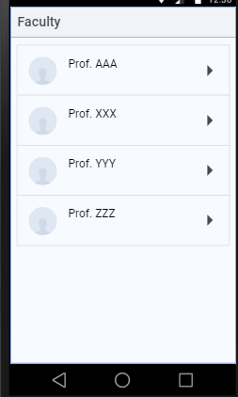

Figure 5: FacultyList Screen

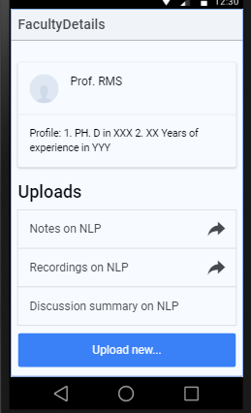

Figure 6: FacultyViewDetails Screen

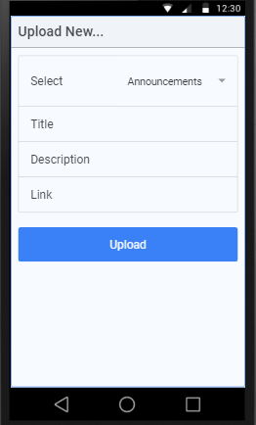

Figure 7: FacultyUploadForm Screen

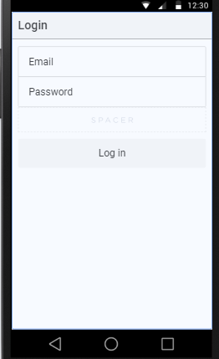

Figure 8: LoginForm Screen

### Models

**TBD**; This section will cover "data models" for data that is shared across components in AngularJS.

### Services

**TBD**; This section will cover common methods and services which can be used across components to retrieve data that is shared across components and required at system level.

## Back End Design

### Database Design (MongoDB)

This section captures list of collections and their respective fields (in BSON format) used to hold data related to above application at the back end side. Mongoose ODM is used to interact with MongoDB database."ISE-Hub" database will consist of following collections,

* 1. Events Collection:

|  |  |
| --- | --- |
| EventName | String |
| EventDescription | String |
| EventOrganizer | String |
| EventDate | Date |
| EventLocation | String |
| EventStatus | String (Open/ Close) |
| EventRatings | Numeric |
| EventDomain | String |
| EventRegisteredCount | Numeric |
| EventPictures | Binary (Images) |

* 1. Faculty Collection:

|  |  |
| --- | --- |
| FacultyName | String |
| FacultyProfile | String |
| FacultyImage | Binary |
| FacultyInputs | { String, String } |

* 1. Student Collection:

|  |  |
| --- | --- |
| StudentUSN | String |
| StudentName | String |
| RegisteredEvents | String |
| RatedEvents | String |

### NodeJS Application REST API's

**TBD**

### Authentication Module

**TBD**

## Git Repository Commands

Enter the directory to be tracked via Git tool.

$ git init

$ git config --global user.name "Suma K"

$ git config --global user.email sumazmailbox@rediffmail.com

## Ionic CLI Commands

> ionic start rvceisehub sidemenu --type=angular

> ionic g page PageName Note: "PageName" includes page name for specific screen