Statistics: The Science of Decisions Project Instructions

Name: Sen Zhuang

1. What is our independent variable? What is our dependent variable?  
     
   Independent: Conditions (Congruent or Incongruent)  
   Dependent: Time it takes to name the ink colors
2. What is an appropriate set of hypotheses for this task? What kind of statistical test do you expect to perform? Justify your choices.  
     
   Null Hypothesis: The amount of time it takes to name the ink colors is the same for congruent and incongruent lists of words.

H0: μC = μI

Alternative Hypothesis: The amount of time it takes to name the ink colors is different for congruent and incongruent lists of words.

Ha: μC ≠ μI

Statistical test: Paired two- sample T-test

I expect to perform T test because the population means are unknown for the two conditions. And since there is only one independent variable with 2 levels, a two-sample t test seems to be the most appropriate.

1. Report some descriptive statistics regarding this dataset. Include at least one measure of central tendency and at least one measure of variability.  
   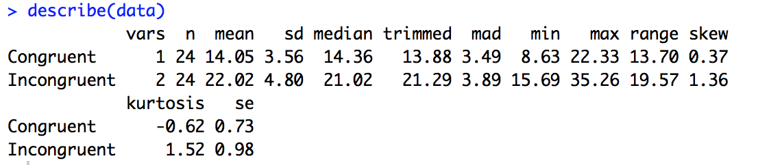

Congruent cases have a mean of 14.05, standard deviation of 3.56.  
Incongruent cases have a mean of 22.02, standard deviation of 4.80.

1. Provide one or two visualizations that show the distribution of the sample data. Write one or two sentences noting what you observe about the plot or plots.

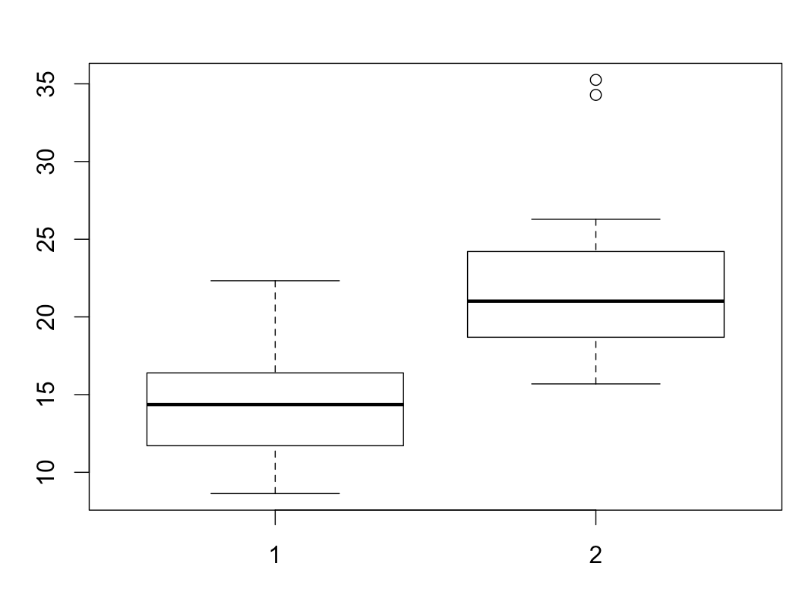  
“1” is congruent and “2” is incongruent. The time it takes for participants to recognize the colors of words is significant higher for incongruent lists with 2 upper outliers.

1. Now, perform the statistical test and report your results. What is your confidence level and your critical statistic value? Do you reject the null hypothesis or fail to reject it? Come to a conclusion in terms of the experiment task. Did the results match up with your expectations?  
   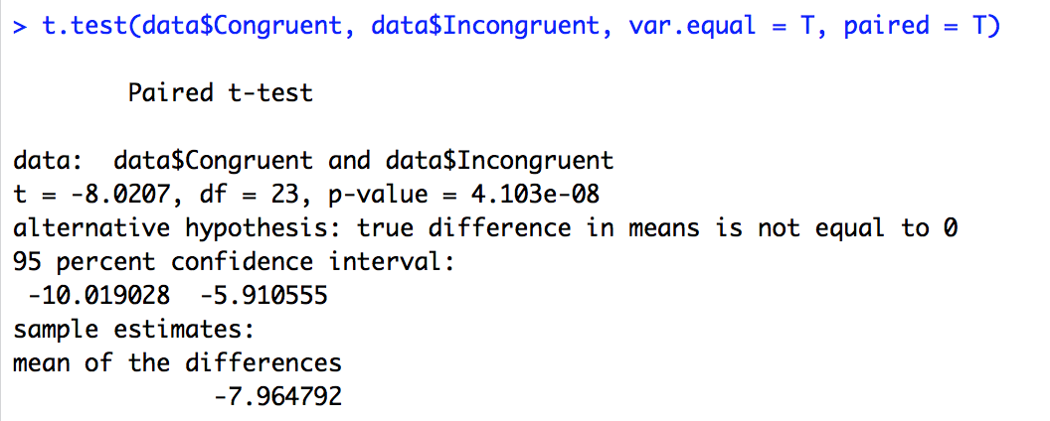

We have a p-value less than .001 which means at a confidence level of 95% percentage, we can reject the null hypothesis. We can conclude that the means of amount of time differ between the 2 groups and congruent lists take less time to recognize.