Project #1:
Stopwatch with Wait Loop and Interrupts
CPSC-538 / Dumas
Sumit Khanna
2/2/2006

Introduction
The goal of this first project is to gain familiarity with the HC12 embedded processor by building a simple stopwatch using both a wait loop and interrupts to keep time. The stopwatch works purely on the console serial port interface to the chip and will respond to keyboard commands in order to start, stop, set lap, release lap and reset the clock.

There will be two version of the program. The first version will have a wait function which will issue blank instructions to make up the time between each 1/10 of a second for clock updates. The second version will attach the clock updating procedure to an interrupt vector which will be set to issue interrupts ever 1/10 of a second.

The program will be written in CPU12 assembly, must be small enough to fit into the 768 bytes of user memory found on the chip and will be assembled using the MKTek asm12.exe assembler.

Project Design

Hardware Requirements
Either a computer or dumb terminal needs to be hooked to the EVB board in order to run the program. A computer must be connected to initially load the program. Other than the machine connected to the board via serial, there are no hardware components which need to be attached to the board for this project.

Software Requirements

Program Variables
The same variables are used for both versions of the program:

Variable | Type | Initial Value | Purpose
CLOCKON | Byte (Boolean) | $00 | 1-bit on/off for Clock
LAPON | Byle (Boolean) | $00 | 1-bit on/off for Lap
FORMAT | Byte (Array) | "%02d:%02d.%d",0 | Argument for Printf
TSEC | Byte | $00 | Milliseconds
SEC | Byte | $00 | Seconds
MIN | Byte | $00 | Minutes
LTSEC | Byte | $00 | Lap Milliseconds
LSEC | Byte | $00 | Lap Seconds
LMIN | Byte | $00 | Lap Minute

Function Calls
Many of the same function calls are utilized in both programs, however in the interrupt based code, some end with "rti" (Return From Interrupt) instead of "rts" (Return from subroutine). In my code, none of the subroutines protect registers, therefore if something needs to be saved, it should be pushed before the subroutine is called. Arguments are passed by registers, however those registered may get clobbered. Generally all return values are written to predefined locations in memory.

The following chart lists all the functions (excluding standard dbug-12 functions), indicates if they are used in the wait-loop (WL) code, the interrupt code (I) or both (WL/I) and weather they are subroutines (SR), interrupt service routines (ISR) or both (subroutines in program one and interrupt service routines in program two) . Note that ISRs prefixed by # are pseudo ISRs, meaning they are not called by an interrupt directly, but are branched to by an ISR and therefore must return an "rti".

Procedure | Code | Sub/ISR | Inputs | Description
Main | WL/I | - | - | Either preforms a polling loop or establishes and waits for interrupts (wai)
IntTime | I | ISR | - | Calls AdjustTime, ClearScreen, PrintTime and unsets interrupt flag (should be called once per ms)
KeyPoll/IntKey | WL/I | SR/ISR | - | Checks for input and calls the appropriate keyboard function
StartClock | WL/I | SR/#ISR | none | Sets the CLOCKON bit to 1
StartStopLap | WL/I | SR/#ISR | none | Toggles the LAPON bit between 0/1 and sets the lap variables if turned on
StopClock | WL/I | SR/#ISR | none | Sets the CLOCKON bit to 0
ResetClock | WL/I | SR/#ISR | none | Resets all clock variables
PutChar | WL/I | SR | Register B | Writes the character in register b (similar to dbug-12 routine)
PrintTime | WL/I | SR | none | Writes either current time or lap time to screen
ClearScreen | WL/I | SR | none | Clears the screen by typing a CR without LF
AdjustTime | WL/I | SR | none | Adjusts clock time (should be run once per ms)
Wait | WL | SR | none | Burns cycles for remainder of ms
AdjustWithCarry | WL/I | SR | Registers X,Y,A | Place pointer to variable with low value in X, high in Y and break number in A. For example X=TSEC, Y=SEC, A=10 to adjust for 10ms=1sec (used by AdjustTime)

Allocation Maps
The following table describes all the EQU definitions at the beginning of the program and what they're used for. Code refers to either the Wait Loop implementation (WL) or the Interrupt implementation (I) or both (WL/I).

Name | Code | Value | Description
PRINTF | WL./I | $F686 | dbug-12 printf routine
SETUVEC | I | $F69A | dbug-12 interrupt assignment routine
SREADY | WL/I | $C4 | SCI0 status bits
SDATA | WL/I | $C7 | SCI0 data input
SINMASK | WL/I | $20 | SCI0 apply to SREADY to get input charcters
SOUTMASK | WL/I | $80 | SCI0 apply to SREADY to output charcters
SCTRL | I | $C3 | SCI0 control register to enable interrupts
KEYSS/S | WL./I | $53 / $73 | ASCII S / s
KEYLL/L | WL/I | $4C / $6C | ASCII L / l
KEYRR/R | WL/I | $52 / $72 | ASCII R / r
KEYGG/G | WL/I | $47 / $67 | ASCII G / g
KEYCR | WL/I | $0D | Carriage Return
TIMER7 | I | $10 | Timer7 enum used for dbug-12 SETUVEC
TIOCS | I | $80 | In capture/Out compare Select
TSCR | I | $86 | Timer System Control Register
TCTL1/2/3/4 | I | $88 / $89 / $8A / $B | Timer In/Out Pins (must be disabled)
TMSK1 | I | $BC | Timer Interrupt Mask Register 1
TMSK2 | I | $8D | Timer Interrupt Mask Register 2
TFLG1 | I | $8E | TFLG1 Offset
TC7 | I | $9E | Timer Compare Register 7
TEN | I | %10000000 | Timer Enable Bit
C7F | I | %10000000 | Output Compare 2 Flag
C7I | I | C7F | Interrupt Enable
IOS7 | I | %10000000 | Select OC2
TCRE | I | %00001100 | TCRE bitmask

Control Flow (Wait-Loop)
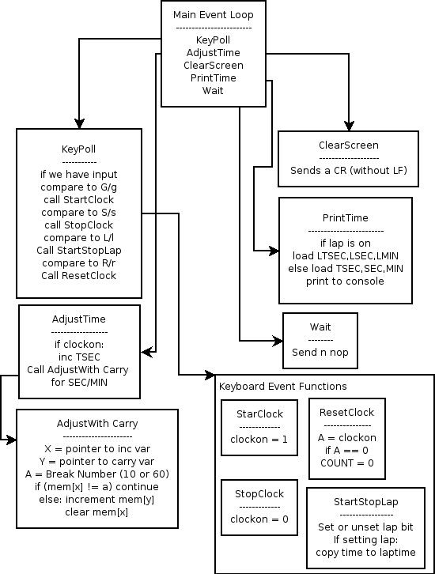

Control Flow (Interrupt)
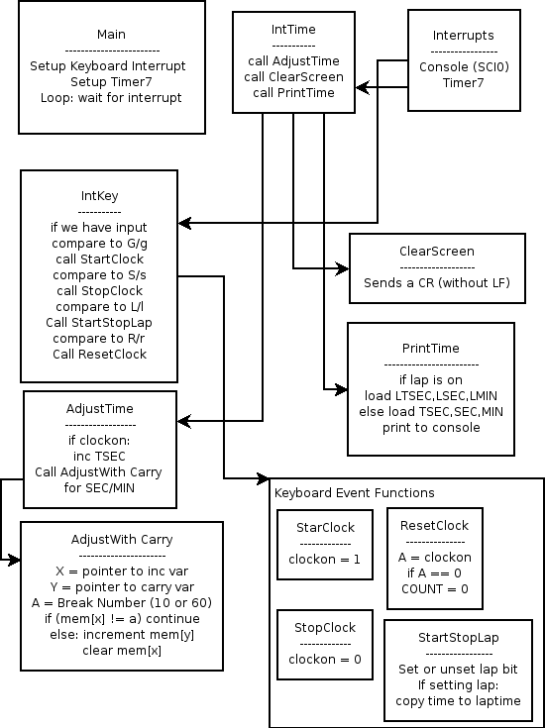

Results
During the demonstration, the interrupt based implementation of the program preformed within specifications as expected. The wait-loop based program was off by just over 1th of a second, which was outside of specifications. By changing the amount of cycles in the wait delay loop from $FA23 to $F63B, I was able to bring the clock within accuracy of less than once second per minute, brining the program within specification.

Another problem which was pointed out to me during the demonstration was that in the wait-loop implementation of the program, I entered the wait loop after the keyboard poll and the adjust time subroutines, which would allow for a tenth of a second increment even when the clock had not run that long, reducing accuracy. By moving the wait subroutine between the keyboard poll and adjust time routines, I eliminated this accuracy problem.

Finally, during the demonstration, I had trouble explaining exactly how the timer interrupts. The setup for the timer was fairly complicated, and although I tried to follow as best I could, learning from other students, I honestly didn't understand fully how it worked.

During the demonstration I learned that by setting the Timer Mask Register 2 ($8D), with the mask %00001100, I enabled the TCRE and set the prescaler to 16. Setting TC7 ($9E) is what actually adjusts the interval at which the timer will issue an interrupt. However you can only mask it with at most the value of $FFFF which still isn't large enough to give you a 1 millisecond interval. By setting the prescaler to 16, the 8Mhz clock is in effect scaled down by a factor of 16, allowing a mask of $c350 applied to TC7 to yield a timer interrupt once every 1 millisecond.

Conclusion
This first project is a good introduction to the HC12 microcontroller. At first I was overwhelmed by just how little user accessible memory there was on the chip. From the beginning I desgined my program to have a small footprint and separated out my functionality into subroutines, identifying which subroutines I could later attach to interrupts.

There were also challenges with different assemblers creating different s19 files. With assemblers being so much simpler than compilers, translating instructions line at a time with a simple symbol table as opposed to compilers with their large parse trees, intermediate languages and optimization routines, one would think you could count on assemblers to produce reliable machine code. This is not necessarily the case.

I found two Linux assemblers, one written in Perl that when given an "ORG $0800" instruction, would actually start placing data at "$A800" making it unusable. Another written in C worked fairly well except when attempting to jump to the built-in dbug-12 routines. The MKTek asm12.exe which comes with TinyIDE is what I eventually used, however it had its own caveats such as not understanding ! to be a decimal symbol. (On a side note, you can configure TinyIDE to use a different assembler in its options menu). For this reason I noted, as I will note for all future projects, which assembler I used in the comments/headings at the top of the assembly source code file.

As expected the interrupt based code is much more accurate than the code based on a wait loop. For my interrupt based program I also moved the keyboard command handler from polling to an interrupt, which was very simple. Setting an interrupt for the timer was substantially more difficult.

I realized that in the future, to be able to extend my code for more functionality, I need to fully understand how it works. Being overwhelmed by the number of operations required to achieve a simple result is no excuse for not asking questions about why the code is able to do what is does. I've also learned the importance of specifications and how even a tenth of a second can be crucial in time critical applications.

Overall, I am satisfied that my first program is well designed and written. I had no problems running out of memory due to the size of my program and believe that I can use these as templates for future programs.

Appendix Prelude
A note about comments: I try to keep my comments to a minimum as with all programming languages. All too often I see comments like the following:

i = i + 1; /* Adds 1 to i */

or even worse:

/**************
* *
* adds 1 to i *
* *
**************/
i = i + 1;

Don't laugh. I've seen it done. In this program as with my other assembly programs in other classes, I try to place a large block on comments explaining a large block of code, minimizing the need for comments in the code itself. The goal is to comment as well as possible while being brief, concise and keeping the code readable.

Appendix A
Attached to this report is the source code listing generated by the assembler for both versions of the program.

